Attachment A – DCIS Data Entry Errors; Instructional Information

The following contains the Top 10 FPDS-NG errors, the Top 10 FPDS-NG “Critical Field” errors, and the Top 10 FPDS-NG FFATA Field errors.

Field | Name | Nature of Error | Significance | Cause
7A | Clinger-Cohen Act | Entering “N” when field should usually be left blank | May distort statistics for Clinger-Cohen Act acquisitions | Other fields in this FPDS-NG section require an “N” when not applicable; this field requires a blank instead
9K | Zip Code – Place of Performance | Usually entering the zip code for the HHS office instead of the contractor’s zip code (for products) | Distorts geographic & Congressional district statistics for business activity | Not understanding that “performance” means the location where the product is made or the service is performed
10A | Extent Competed | Selecting incorrect code/description of competition | Distorts statistics for competition | Not understanding the definition/usage of each code/description
10M | Solicitation Procedures | Selecting the incorrect code/description for the solicitation procedure | Distorts statistics for solicitation procedures | Not understanding the definition/usage of each code/description
6A | Contract Type | Selecting wrong code/description for contract type; often classifying labor hour and T&M as FFP actions | Distorts statistics for types of contracts awarded | Not understanding which code is appropriate; some errors result from system default values
2C | Current Completion Date | Date entered in FPDS-NG did not agree with date in the order/contract | May mislead prospective contractors who use this date to prepare for the next solicitation | Failure to verify the actual completion date from the contractual document; possible typos in some cases
9C2 | Place of Performance City | Selecting the wrong location, usually entering the HHS office’s city instead of the contractor’s (for products) | Distorts geographic & Congressional district statistics for business activity | Not understanding that “performance” means the location where the product is made or the service is performed
9C1 | Place of Performance State | Selecting the wrong location, usually entering the HHS office’s state instead of the contractor’s (for products) | Distorts geographic & Congressional district statistics for business activity | Not understanding that “performance” means the location where the product is made or the service is performed
Field | Name | Nature of Error | Significance | Cause
2A | Date Signed | Date entered in FPDS-NG did not agree with date in the order/contract | May distort calculation of administrative lead time statistics | Possible timing issue between the date entered into PRISM and date that signature actually occurs; possible typographical errors in some cases
2D | Ultimate Completion Date | Date entered in FPDS-NG did not agree with date in the order/contract | May mislead prospective contractors who use this date to prepare for the next solicitation | Not understanding the definition of this field; possible typographical errors in some cases.
6M | Description of Requirements | Incorrect, vague, or unclear descriptions | Difficult for average person to know what was being purchased | “Cut-and-paste” from RFC; repeating PSC title; describing the action, not the products/services; use of jargon/codes
3A | Value of Base Contract plus Options | Typically re-entering the entire contract value for modifications rather than just the change in value | Greatly over-values the total estimated amount of the contract | Not understanding how to fill out the dollar value fields (3A, 3B, 3C)
11A | CO’s Determination of Business Size | Selecting the incorrect descriptor for business size | Distorts small business statistics | Failure to confirm/check awardee business size
4C | Funding Agency | Entering an HHS OPDIV code when field should be left blank | May result in invalid data when compiling statistics for acquisitions funded by another Department/Agency | Not understanding that the field should only be completed when funding comes from a non-HHS Department/Agency
12C | Reason for Modification
9A | DUNS Number
4D | Funding Office | Field should not contain an HHS Agency or Office code.
3C | Amount of Obligation
8G | NAICS Code

The following list removes overlap of fields contained in the above list. While complete data entry is essential, NIH will concentrate on these fields in FY 08:

COMBINED LIST OF ERRORS (19)
7A | Clinger-Cohen Act
9K | Zip Code - Place of Performance
10A | Extent Competed
10M | Solicitation Procedures
6A | Contract Type
2C | Current Completion Date
9C2 | Place of Performance City
9C1 | Place of Performance State
2A | Date Signed
2D | Ultimate Completion Date
6M | Description of Requirements
3A | Base + Options Value
11A | CO's Determination of Business Size
4C | Funding Agency
12C | Reason for Modification
9A | DUNS Number
4D | Funding Office
3C | Amount of Obligation
8G | NAICS Code

In addition, since fields 3A and 3C are on the list, field 3B has been added to the instructions. Together those three fields create a lot of confusion so dealing with them all together is necessary. Add:
3B | Base and Exercised Options Value

Definition (with discussion), Nature of Error, and Cause of Error for Fields on the Combined List
This information is provided to help understand what is needed for correct data entry. The information consists of the following:
- definition
- information from the LMI review that addresses the nature of the error and observed cause(s) of the error
- table identifying applicability of item by type of action
- whether the field is populated by PRISM
- Solution

7A – Clinger-Cohen Act: A code indicating the funding office has certified that the information technology purchase meets the planning requirements in 40 USC 1422 and 1423.
This field is relevant only when the contracting agency or the funding agency is DOD and this procurement is for computer hardware or services. Then, select a value, Yes or No, as certified by the DOD funding office as to whether the planning requirements have been met.
LMI Review:
Field | Name | Nature of Error | Significance | Cause
7A | Clinger-Cohen Act | Entering “N” when field should usually be left blank | May distort statistics for Clinger-Cohen Act acquisitions | Other fields in this FPDS-NG section require an “N” when not applicable; this field requires a blank instead

Note: identification of error, while technically correct, is unenforceable until such time as the field
is changed so it can be left blank. DHHS is working on establishing an edit that addresses this.

DCIS/FPDS-NG Item Use Case by Action Type:
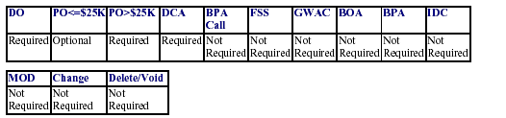

PRISM POPULATED FIELDS = P NOT POPULATED - NP
PO<$25K | PO>$25K | DO/TO | BPA  Call | Stand  Alone  Contract | Stand  Alone  Contract  R&D | BPA  Set  Up | IDV  Contract | GWAC
NP | NP | NP | NP | NP | NP | NP | NP | NP

Solution: This field should not be “Yes” unless HHS is buying IT products/services on behalf of the Department of Defense (DoD) (Item 8A should be an IT code and item 4C should be a DoD Agency code). This item is a Boolean field, which means it cannot be blank. Although this item is not applicable to DHHS, since it cannot be blank select “No” from the drop-down.

9K – Zip Code - Place of Performance: For U.S. Place of Performance: indicates the ZIP Code. If the Place of Performance is U.S, enter ZIP+4 code. Otherwise, enter the postal code available for the foreign location.
LMI Review:
Field | Name | Nature of Error | Significance | Cause
9K | Zip Code – Place of Performance | Usually entering the zip code for the HHS office instead of the contractor’s zip code | Distorts geographic & Congressional district statistics for business activity | Not understanding that “performance” means the location where the product is made or the service is performed

DCIS/FPDS-NG Item Use Case by Action Type:
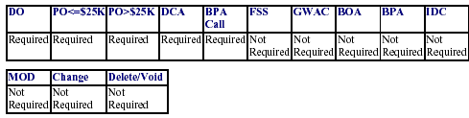

PRISM POPULATED FIELDS = P NOT POPULATED - NP
PO<$25K | PO>$25K | DO/TO | BPA  Call | Stand  Alone  Contract | Stand  Alone  Contract  R&D | BPA  Set  Up | IDV  Contract | GWAC
NP | NP | NP | NP | NP | NP | NP | NP | N

Solution: For services, select the City, State & Country Code where the work is being performed. For supplies, select the supplier’s location.

For U.S., the Place Of Performance ZIP Code must use the ZIP+4 format (nnnnn-nnnn) , where ‘n’ is a numeric digit) and the last four digits cannot be '0000' or blank.

10A – Extent Competed: A code that represents the competitive nature of the contract.
LMI Review:
Field | Name | Nature of Error | Significance | Cause
10A | Extent Competed | Selecting incorrect code/description of competition | Distorts statistics for competition | Not understanding the definition/usage of each code/description

DCIS/FPDS-NG Item Use Case by Action Type:
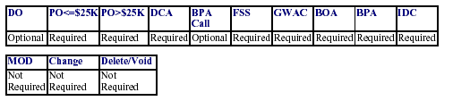

PRISM POPULATED FIELDS = P NOT POPULATED - NP
PO<$25K | PO>$25K | DO/TO | BPA  Call | Stand  Alone  Contract | Stand  Alone  Contract  R&D | BPA  Set  Up | IDV  Contract | GWAC
NP | NP | NP | NP | NP | NP | NP | NP | NP

Solution: Applies to the base award of a stand alone contract. Applies to the base award of an IDIQ multiple award contract and the award of any individual task order off of an IDIQ such as a GWAC or our own internal vehicles.

A -- Full and Open Competition (FAR Part 6 not 8)

B -- Not Available for Competition (QIO, 8A offering, Hubzone, JWOD, STARZS, other statutorily mandated vendor)

C -- Not Competed (JOFOC under FAR 6-- not 8 or 16)
D -- Full and Open After Exclusions (set asides for small businesses only, 8A competitions, STARZS…)

E -- Follow-on to Competed (only if FAR 6.302-1--your original contract was competed and now there is only One Source so you did a JOFOC for the follow-on-- DOES NOT APPLY TO FAR 8 GSA efforts) If this is done using a modification to the existing base award, check with CDMP to determine whether the base award designation remains or Code E then overrides the base award.
F - Competed Under SAT(Competition under $100K)

G -- Not Competed under Simplified Threshold (JOFOC under $100K)

CDO -- Competitive Delivery Order (fair opportunity under multiple award contracts using FAR 16 or FAR Part 8 for GSA competitions), Orders under Strategic Sourcing Contracts.

NDO – Non-Competitive Delivery Order (award to one vendor under CMS multiple award contract to hit the minimum guarantee, logical follow-on under GSA or logical follow-on under our CMS multiple award contract)

10M – Solicitation Procedures: Report this code for the type of solicitation procedure used.
LMI Review:
Field | Name | Nature of Error | Significance | Cause
10M | Solicitation Procedures | Selecting the incorrect code/description for the solicitation procedure | Distorts statistics for solicitation procedures | Not understanding the definition/usage of each code/description

DCIS/FPDS-NG Item Use Case by Action Type:
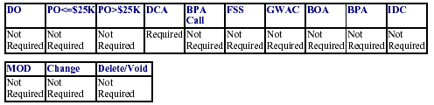

PRISM POPULATED FIELDS = P NOT POPULATED - NP
PO<$25K | PO>$25K | DO/TO | BPA  Call | Stand  Alone  Contract | Stand  Alone  Contract  R&D | BPA  Set  Up | IDV  Contract | GWAC
NP | NP | NP | NP | NP | NP | NP | NP | NP

Solution: Only code this item on the initial award.
NOTE: None = no RFP/RFQ. Leave blank for FAR 8 & 16.

NP | Negotiated Proposal | Report this code for contract award over $100K using negotiated procedures. FAR 12, FAR, 13, FAR 15
SB | Sealed Bid | Report this code for contract award over $100K using seal bidding procedures. FAR 14
TS | Two Step | Report this code for contract awards over $100K that uses a combination of sealed bids and negotiated procedures. FAR 6.102  Poi
SP1 | Simplified Acquisition | Report this code for a competitive acquisition when the Procedures –Competitive simplified acquisition procedures in FAR 13 are used
AE | Architect - Engineer | Report this code if the action resulted from selection of sources for architect-engineer contracts pursuant to FAR 6.102(d)(1).
BR | Basic Research | Report this code if the action resulted from competitive selection of basic research proposals pursuant to FAR 6.102(d)(2).
AS | Alternative Sources | Report this code if the action resulted from the use of procedures that provide for full and open competition after exclusion of sources to reduce overall costs pursuant to FAR 6.202(a)(1), to have a facility available for national defense or industrial mobilization pursuant to FAR 6.202(a)(2), to establish or maintain an essential engineering, research, or development capability pursuant to FAR 6.202(a)(3), to ensure the continuous availability of a reliable source of supply for such property or service pursuant to FAR 6.202(a)(4), to satisfy projected needs for such product or service based on a history of high demand pursuant to FAR 6.202(a)(5), to satisfy a critical need for medical, safety, or emergency supplies pursuant to FAR 6.202(a)(6).
SP2 | Simplified Acquisition Procedures -Non-Competitive | Report this code if the action was non-competitive and only to Delivery Orders) Report this code for a non-competitive acquisition of commercial items when the simplified acquisition procedures in FAR 13 are used. (when the action was non-competitive and only to Delivery Orders)Report this code for a non-competitive acquisition of commercial items when the simplified acquisition procedures in FAR 13 are used.

6A – Contract Type: The type of contract as defined in FAR Part 16 that applies to this procurement.
LMI Review:
Field | Name | Nature of Error | Significance | Cause
6A | Contract Type | Selecting wrong code/description for contract type; often classifying labor hour and T&M as FFP actions | Distorts statistics for types of contracts awarded | Not understanding which code is appropriate; some errors result from system default values

DCIS/FPDS-NG Item Use Case by Action Type:
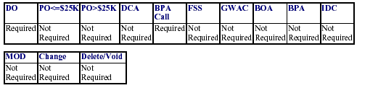
PRISM POPULATED FIELDS = P
PO<$25K | PO>$25K | DO/TO | BPA  Call | Stand  Alone  Contract | Stand  Alone  Contract  R&D | BPA  Set  Up | IDV  Contract | GWAC
P | P | P | P | P | P | P | P | p

Solution: Enter the code that best describes the contract type.
The following apply to all Awards and IDVs
A Fixed Price Redetermination
B Fixed Price Level of Effort
J Fixed Price
K Fixed Price with Economic Price Adjustment
L Fixed Price Incentive
M Fixed Price Award Fee
R Cost Plus Award Fee
S Cost No Fee
T Cost Sharing
U Cost Plus Fixed Fee
V Cost Plus Incentive
Y Time and Materials
Z Labor Hours

- The following apply to IDVs only:
- Select whatever the specific order is; for the parent, select "Order Dependent" if you can issue different types of orders. Order Dependent (IDV allows pricing arrangement to be determined separately for each order)
- The following apply to Awards only:
- Combination (Applies to Awards where two or more of the above apply)
- Other (Applies to Awards where none of the above apply)
- If Commercial Item Acquisition Procedures equals Yes, then Type of Contract must be Fixed Price or Fixed Price with Economic Price Adjustment.

2C – Current Completion Date: The completion date of the base contract plus options that have been exercised. Report the contract completion date based on the schedule in the contract. For an initial award, report the scheduled completion date for the base contract and for any options exercised at time of award. For modifications that exercise options, report the revised scheduled completion date for the base contract including exercised options.
LMI Review:
Field | Name | Nature of Error | Significance | Cause
2C | Current Completion Date | Date entered in FPDS-NG did not agree with date in the order/contract | May mislead prospective contractors who use this date to prepare for the next solicitation | Failure to verify the actual completion date from the contractual document; possible typos in some cases

DCIS/FPDS-NG Item Use Case by Action Type:
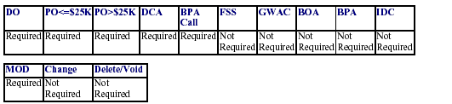

PRISM POPULATED FIELDS = P
PO<$25K | PO>$25K | DO/TO | BPA  Call | Stand  Alone  Contract | Stand  Alone  Contract  R&D | BPA  Set  Up | IDV  Contract | GWAC
P | P | P | P | P | P | P | P | P

Solution: Verify the actual, current completion date. If the contract has options, this date would only be through the base award or whatever options had been exercised. Use PRISM to enter DCIS for new awards made in NBS since its deployment.

9C2 – Place of Performance City: The code from the FPDS-NG table (combined FIPS Pub. 10 and FIPS Pub. 55) that identifies the City where the work is being performed. The FIPS Publications are located at http://www.census.gov/geo/www/fips/fips.html
LMI Review:
Field | Name | Nature of Error | Significance | Cause
9C2 | Place of Performance City | Selecting the wrong location, usually entering the HHS office’s city instead of the contractor’s (for products) | Distorts geographic & Congressional district statistics for business activity | Not understanding that “performance” means the location where the product is made or the service is performed

DCIS/FPDS-NG Item Use Case by Action Type:
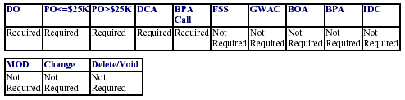

PRISM POPULATED FIELDS = P NOT POPULATED - NP
PO<$25K | PO>$25K | DO/TO | BPA  Call | Stand  Alone  Contract | Stand  Alone  Contract  R&D | BPA  Set  Up | IDV  Contract | GWAC
NP | NP | NP | NP | NP | NP | NP | NP | NP

Solution: For Services, select the City Code where the work is being performed. For supplies, select the supplier’s location.

9C1 – Place of Performance State: The code from the FPDS-NG table (combined FIPS Pub. 10 and FIPS Pub. 55) that identifies the State where the work is being performed.
LMI Review:
Field | Name | Nature of Error | Significance | Cause
9C1 | Place of Performance State | Selecting the wrong location, usually entering the HHS office’s state instead of the contractor’s (for products) | Distorts geographic & Congressional district statistics for business activity | Not understanding that “performance” means the location where the product is made or the service is performed

DCIS/FPDS-NG Item Use Case by Action Type:

PRISM POPULATED FIELDS = P NOT POPULATED - NP
PO<$25K | PO>$25K | DO/TO | BPA  Call | Stand  Alone  Contract | Stand  Alone  Contract  R&D | BPA  Set  Up | IDV  Contract | GWAC
NP | NP | NP | NP | NP | NP | NP | NP | NP

Solution: For Services, select the State Code where the work is being performed. For supplies, select the supplier’s location. If Country is not U.S., State, then leave blank. If Item 9H Place of Manufacture = Foreign, then Principal Place of Performance must be a valid foreign country code.

2A – Date Signed: The date that a mutually binding agreement was reached.
The date signed by the Contracting Officer or the Contractor, whichever is later.
LMI Review:
Field | Name | Nature of Error | Significance | Cause
2A | Date Signed | Date entered in FPDS-NG did not agree with date in the order/contract | May distort calculation of administrative lead time statistics | Possible timing issue between the date entered into PRISM and date that signature actually occurs; possible typographical errors in some cases

DCIS/FPDS-NG Item Use Case by Action Type:
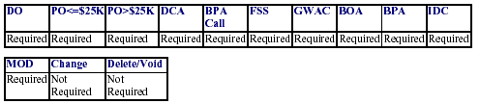

PRISM POPULATED FIELDS = P
PO<$25K | PO>$25K | DO/TO | BPA  Call | Stand  Alone  Contract | Stand  Alone  Contract  R&D | BPA  Set  Up | IDV  Contract | GWAC
P | P | P | P | P | P | P | P | P

Solution: Enter the date that the transaction was signed. For a bilateral transaction, this is the later of the date signed by the Contractor or the Contracting Officer. For a unilateral transaction, this is the date signed by the Contracting Officer.
Note: Since PRISM does not actually allow for entry of the date the Contracting Officer signs the contract, differences between the FPDS date and the CO signature date will continue to exist on occasion. However, typographical errors must be corrected.

2D – Ultimate Completion Date: The estimated or scheduled completion date including the base contract or order and all options (if any) whether the options have been exercised or not.
Enter the mutually agreed upon completion date for the entire contract or order including all options or other modifications. For a delivery order, this refers to the delivery order completion only, not the referenced indefinite delivery vehicle.
LMI Review:
Field | Name | Nature of Error | Significance | Cause
2D | Ultimate Completion Date | Date entered in FPDS-NG did not agree with date in the order/contract | May mislead prospective contractors who use this date to prepare for the next solicitation | Not understanding the definition of this field; possible typographical errors in some cases.

DCIS/FPDS-NG Item Use Case by Action Type:
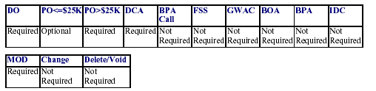

PRISM POPULATED FIELDS = P NOT POPULATED - NP
PO<$25K | PO>$25K | DO/TO | BPA  Call | Stand  Alone  Contract | Stand  Alone  Contract  R&D | BPA  Set  Up | IDV  Contract | GWAC
P | P | P | P | P | p | NP | NP | NP

Solution: The completion date of the base contract plus all options, including options that have not been exercised. If a Task Order, this is specific only to the order and not the parent contract dates.
Note: Confusion also may exist between Ultimate Completion Date and Current Completion Date, especially on an option contract. In the case of an option contract, the Current Completion Date is the date that the current year of performance (base or option) ends. The Ultimate Completion Date is the date the contract would end if all options were exercised.

6M – Description of Requirements: A brief description of the contract or award. Enter a brief description of the goods or services that you are buying or for award of an Indefinite Delivery Vehicle, a brief description of the goods or services available.
LMI Review:
Field | Name | Nature of Error | Significance | Cause
6M | Description of Requirements | Incorrect, vague, or unclear descriptions | Difficult for average person to know what was being purchased | “Cut-and-paste” from RFC; repeating PSC title; describing the action, not the products/services; use of jargon/codes

DCIS/FPDS-NG Item Use Case by Action Type:
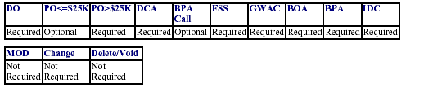
PRISM POPULATED FIELDS = P
PO<$25K | PO>$25K | DO/TO | BPA  Call | Stand  Alone  Contract | Stand  Alone  Contract  R&D | BPA  Set  Up | IDV  Contract | GWAC
P | P | P | P | P | P | P | P | P

Solution: Enter the Project Title specific to the effort or product. Do not use acronyms.
Note: Identification of this as an error field obviously is subjective to an extent. Do your best to be accurate and helpful in your description, while still maintaining consistency with the documentation trail supporting the buy.

3A – Value of Base Contract plus Options: The mutually agreed upon total contract or order value including all options (if any).
LMI Review:
Field | Name | Nature of Error | Significance | Cause
3A | (Ultimate)Value of Base Contract plus Options | Typically re-entering the entire contract value for modifications rather than just the change in value | Greatly over-values the total estimated amount of the contract | Not understanding how to fill out the dollar value fields (3A, 3B, 3C)

DCIS/FPDS-NG Item Use Case by Action Type: NOTE: Contact CDMP to obtain this information.
PRISM POPULATED FIELDS = P NOT POPULATED – NP NOTE: Contact CDMP to obtain this information.

Solution: If the (Ultimate) contract value has not changed, do not make an entry. If the (Ultimate) contract value is increased by a modification, then enter only the increase. Exercising an option or funding an increment is not an increase in (Ultimate) contract value.

For Indefinite Delivery Vehicles, this would be the estimated value for all orders expected to be placed against the vehicle (the ceiling/maximum). If the ceiling/maximum is increased by a modification, enter only the increase. See Table Below

ITEM 3B. BASE AND EXERCISED OPTIONS VALUE
The contract value for the base contract and any options that have been exercised.
For a new award: ‘Enter the total value (in dollars and cents) of the base contract plus all options (if any) that have been exercised at the time of award.’ For a modification: ‘Enter the CHANGE (positive or negative, if any) in the current contract value that result from this modification. Note that this field deals with “value” of the action, not amount obligated. It addresses a situation where the amount obligated is less than the value of the contract.
LMI Review: LMI did not identify this item as one of the top 30 errors. It is included here because 3A, 3B and 3C need to be addressed together.

DCIS/FPDS-NG Item Use Case by Action Type:
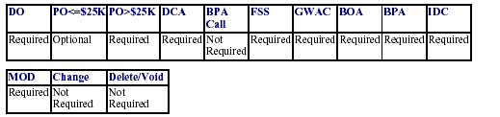

PRISM POPULATED FIELDS = P NOT POPULATED - NP
PO<$25K | PO>$25K | DO/TO | BPA  Call | Stand  Alone  Contract | Stand  Alone  Contract  R&D | BPA  Set  Up | IDV  Contract | GWAC
P | P | P | P | P | P | NP | NP | NP

Solution: For a new award enter the total value of the base contract plus any options that are exercised at the time of award. For a modification enter any change (positive or negative) in the current contract value that results from the modification. Exercising and option or funding an increment is an increase in base and exercised options value. See Table Below

3C – Amount of Obligation: The amount that is obligated or de-obligated by this transaction. Enter the net amount of funds (in dollars and cents) obligated or de-obligated by this transaction. If the net amount is zero, enter zero. If the net amount is a de-obligation, enter a minus sign in addition to the net amount.
LMI Review:
Field | Name | Nature of Error | Significance | Cause
3C | Amount of Obligation |  |  | Not understanding how to fill out the dollar value fields (3A, 3B, 3C)

DCIS/FPDS-NG Item Use Case by Action Type:
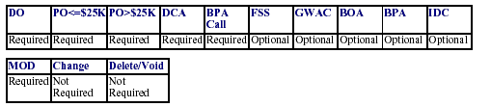

PRISM POPULATED FIELDS = P NOT POPULATED - NP
PO<$25K | PO>$25K | DO/TO | BPA  Call | Stand  Alone  Contract | Stand  Alone  Contract  R&D | BPA  Set  Up | IDV  Contract | GWAC
P | P | P | P | P | P | NP | NP | NP

Solution: Enter the amount you are obligating or de-obligating on the contract/order for the action being reported. Do not enter any change in total or ultimate contract value. See Table Below
Note: The user should only fill in the amounts in the “Current” Column. The System (DCIS/FPDS-ng) has been programmed to calculate the amounts (cumulatively) in the “Total” Column based on user input.

Examples for 3A, 3B, 3C:
Action | Field | Amount |  | Definition
Initial Contract |  | Current | Total
 | 3A | $100 | $100 | Ultimate Contract Value w/ all Options Exercised
 | 3B | $ 20 | $ 20 | Ceiling of Base Award
 | 3C | $ 10 | $ 10 | Amount Obligated on this action at time of award
Mod 0001 | 3A | $ 0 | $100 | No change to this field if Ultimate Contract Value has not changed; if it does change, enter only the increase in value.
 | 3B | $ 0 | $ 20 | No change until an Option is exercised.
 | 3C | $ 10 | $ 20 | Amount obligated on this action is $10; total obligated now is $20.
Mod 0002 | 3A | $ 0 | $100 | Again, no change to this field if Ultimate Contract Value has not changed; if it does change, enter only the increase in value.
 | 3B | $ 20 | $ 40 | First option is exercised; current shows value (not necessarily amount obligated) of option being exercised and total shows value of previous ceiling(s) plus this ceiling.
 | 3C | $ 20 | $ 40 | Amount obligated on this action is $20. Total obligated for initial award plus subsequent modifications is $40. Column shows value of previous ceiling(s) plus this ceiling, or Total Amount Exercised to Date.
 | 3C | $ 20 | $ 40 | The “Current” column shows the Amount obligated on this action is $20. The “Total column shows the amount obligated for initial award plus subsequent modifications is $40, or the Amount Obligated to date.

Note: The parent contract and DOs awarded under it are tracked separately, i.e. the $ in DOs are treated as a separate entity, and they do not track directly back to nor are they accumulated with the IDV record.

11A – CO’s Determination of Business Size: The Contracting Officer’s determination of whether the selected contractor meets the small business size standard for award to a small business for the NAICS code that is applicable to the contract.
LMI Review:
Field | Name | Nature of Error | Significance | Cause
11A | CO’s Determination of Business Size | Selecting the incorrect descriptor for business size | Distorts small business statistics | Failure to confirm/check awardee business size

DCIS/FPDS-NG Item Use Case by Action Type:
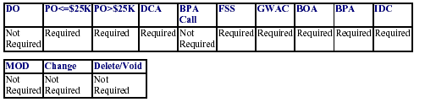

PRISM POPULATED FIELDS = P NOT POPULATED - NP
PO<$25K | PO>$25K | DO/TO | BPA  Call | Stand  Alone  Contract | Stand  Alone  Contract  R&D | BPA  Set  Up | IDV  Contract | GWAC
NP | NP | NP | NP | NP | NP | NP | NP | NP

Solution: Report the Contracting Officer’s determination of whether the selected contractor is a small business for this contract.
Small Business - Select S, if the CO determines that the awardee is a small business.
Other than Small Business – Select O, if it is other than small business.
NOTE: The information used by the CO comes from the CCR. The contractor must code the information correctly in CCR.
This is a simple and, it is hoped, easy field to enter correctly. The fields numbered in the 13s, identifying types of small businesses, are more problematic and require greater care, particularly since only one can be selected for any particular award.

4C – Funding Agency (Program/Funding Agency Code): This code should be left blank unless the funding for this transaction was provided by another agency. If it was, then enter the code from FIPS Pub 95 that identifies the agency that provided the preponderance of the obligated funds. Must be a valid code from the FPDS-NG Agency Code Table.
LMI Review:
Field | Name | Nature of Error | Significance | Cause
4C | Funding Agency | Entering an HHS OPDIV code when field should be left blank | May result in invalid data when compiling statistics for acquisitions funded by another Department/Agency | Not understanding that the field should only be completed when funding comes from a non-HHS Department/Agency

DCIS/FPDS-NG Item Use Case by Action Type:
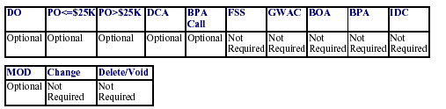
PRISM POPULATED FIELDS = P NOT POPULATED - NP
PO<$25K | PO>$25K | DO/TO | BPA  Call | Stand  Alone  Contract | Stand  Alone  Contract  R&D | BPA  Set  Up | IDV  Contract | GWAC
NP | NP | NP | NP | NP | NP | NP | NP | NP

Solution: Usually blank, only required if we received $ from another Agency to fund action, then select the agency code of the agency providing the funds.

4D – Funding Office (Program/Funding Office Code): The code provided by the funding agency that identifies the office (or other organizational entity) that provided the preponderance of funds. If the Funding Agency is a non-DOD agency, the code is defined by the agency. If the Funding Agency is a DOD agency, the code is the DOD Activity Address Code (DODAAC). Obtain the code to report from the office (or other organizational entity) that is funding this transaction. Must be a valid code from the FPDS-NG Funding Office Code Table.
LMI Review:
Field | Name | Nature of Error | Significance | Cause
4D | Funding Office | Field should not contain an HHS Agency or Office code. | May result in invalid data when compiling statistics for acquisitions funded by another Department/Agency | Not understanding that the field should only be completed when funding comes from a non-HHS Department/Agency

DCIS/FPDS-NG Item Use Case by Action Type:
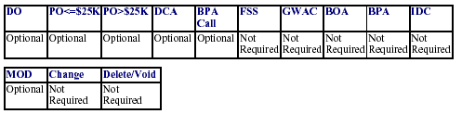

PRISM POPULATED FIELDS = P NOT POPULATED - NP
PO<$25K | PO>$25K | DO/TO | BPA  Call | Stand  Alone  Contract | Stand  Alone  Contract  R&D | BPA  Set  Up | IDV  Contract | GWAC
NP | NP | NP | NP | NP | NP | NP | NP | NP

Solution: Usually blank because no entry is made for an HHS or NIH-funded award. Only required if we received $ from an Agency other than HHS to fund action; then enter the office code of the agency providing the funds.

12C – Reason for Modification: The type of, or reason for, modification to an award or IDV.
LMI Review:
Field | Name | Nature of Error | Significance | Cause
12C | Reason for Modification

DCIS/FPDS-NG Item Use Case by Action Type:
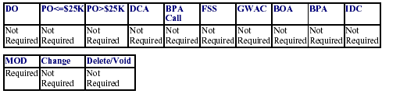

PRISM POPULATED FIELDS = P NOT POPULATED - NP
PO<$25K | PO>$25K | DO/TO | BPA  Call | Stand  Alone  Contract | Stand  Alone  Contract  R&D | BPA  Set  Up | IDV  Contract | GWAC
NP | NP | NP | NP | NP | NP | NP | NP | NP

Solution: Select the code that most accurately describes the reason this modification was awarded.
A Additional Work (new agreement, FAR part 6 applies)
B Supplemental Agreement for work within scope
C Funding Only Action
D Change Order
E Terminate for Default (complete or partial)
F Terminate for Convenience (complete or partial)
G Exercise an Option
H Definitize Letter Contract
J Novation Agreement (does not apply to BPA Calls and delivery orders)
K Close Out
L Definitize Change Order
M Other Administrative Action
N Cancellation

9A – DUNS Number: The DUNS number of the contractor. Used as a key to CCR. Maps to the DUNS Number or DUNS + Four in CCR. Report the DUNS number for the contractor location that received the award.
LMI Review:
Field | Name | Nature of Error | Significance | Cause
9A | DUNS Number

DCIS/FPDS-NG Item Use Case by Action Type:
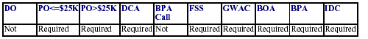

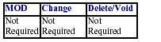
PRISM POPULATED FIELDS = P
PO<$25K | PO>$25K | DO/TO | BPA  Call | Stand  Alone  Contract | Stand  Alone  Contract  R&D | BPA  Set  Up | IDV  Contract | GWAC
P | P | P | P | P | P | P | P | P

Solution: Always use the hyperlink menu to ensure the most current CCR data carries over when entering the initial award.
NOTE: The contractor must be registered in the CCR.

8G – NAICS Code:

The North American Industry Classification System (NAICS) codes designate major sectors of the economies of Mexico, Canada, and the United States. Report the code that was used in the solicitation. Must be a valid code from the NAICS table.
LMI Review:
Field | Name | Nature of Error | Significance | Cause
8G | NAICS Code

DCIS/FPDS-NG Item Use Case by Action Type:
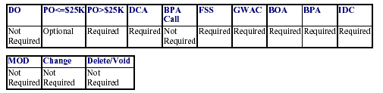
Prism Populated Fields = P
PO<$25K | PO>$25K | DO/TO | BPA  Call | Stand  Alone  Contract | Stand  Alone  Contract  R&D | BPA  Set  Up | IDV  Contract | GWAC
P | P | P | P | P | P | P | P | P

Solution: NAICS must be in the FPDS-NG NAICS Look-up Table. If Performance-Based Service Contract = ‘Y’, then the first three positions of NAICS must not be certain types of construction (may not begin with 233 [except 233110], 234 or 235). The North American Industry Classification System (NAICS) codes designate major business sectors. Use the drop-down menu to select code that best identifies the product or service procured. Make sure the code is same as the one used in Fed-Biz-Ops, the solicitation, and PRISM. NAICS Code website: http://www.census.gov/epcd/www/naics.html.

