Department of Health and Human Services
National Institutes of Health
NIH Enterprise Information Portal

Community Leader Guide

May 2006

Provided By: Center for Information Technology/NIH

Contents

Who Should Use This Document and What It’s About 1
Contact Information 1
I’m a Community Leader, Now What? 2
Membership Decisions 3
Membership Access 3
Restricted Access to Your Community 3
Working on Active Directory (AD) Group 3
How do I modify memberships from a mail-enabled AD group? 3
Unrestricted Access to Your Community 4
How Do I Let People Know About My Community? 4
Mandatory Vs. Non-mandatory Communities 4
Adding a Non-mandatory Community 5
I Want to Customize My Community 6
What Are Portlets? 6
How Do I Add Portlets to My Community? 7
How Do I edit Portlet Preferences? 8
How Do I create Portlet available to this Community? 8
How Do I add members to a Community? 9
Community Security Privilege 9
What is a Subcommunity? 9
How to create a Subcommunity within your Community? 10
What are Related Communities? 10
Community Guidelines 12

Figures
Figure 1 – Community Organization Diagram 2
Figure 2 – Distribution List Membership 3
Figure 3 – Mandatory Communities Listing 5
Figure 4 – Adding a Community 6
Figure 5 – Selecting a Community 6
Figure 6 – Community With No Portlets 7
Figure 7 – Portlet Folders 8
Figure 8 – Community with Portlets 8
Figure 9 – Edit Portlet Preferences 9
Figure 10 – Edit Security in Community 9
Figure 11 – Related Communities 11

Who Should Use This Document and What It’s About
The intended audience for this document is Community Leaders of the NIH Portal located at https://my.nih.gov.

In this guide, Community Leaders are defined as those individuals who create and maintain information for specific audiences within the NIH Portal. Special emphasis is given to those Community Leaders who create and maintain Projects in the portal collaboration environment known as Collaboration Server. Collaboration Server allows portal users to work together on joint Projects—a Project being a main unit of collaboration. The features of a Project (e.g., calendaring, document sharing, online discussions) facilitate teamwork. By changing the information that Project Members see, Project changes can be immediately reflected.

Community Leader tasks described in this document include:
- Membership Access
- Community Customization
- Sub Communities
- Related Communities

Note: A community is a collective meeting space in the portal where portlets and links to various internal/external resources are made available to members by Community Leaders. In order to collaborate within the portal on documents, tasks, calendar items, discussions and announcements, a project must be created that will be associated with your Community. Please utilize the form on the Portal Information Center Community to either request a community or projects.

The Portal Information Center Community, already in all user Community drop down menus, has a wealth of additional information, including the NIH Portal User Guide for Project Leaders and Members, which features in depth information on portal collaboration.

Contact Information
- The Portal Administrator can be contacted by sending email to Portaladmin@nih.gov.

I’m a Community Leader, Now What?
As a Community Leader, you’ll need to determine the following:

- Who’s going to be a Member of your Community (See “Membership Decisions” on page 1.)
- Whether the Community is Restricted or Non-restricted
- How to customize your Community with portlets (See “How Do I Add Portlets to My Community?” on page 6.)
- How to edit Portlets Preferences
- How to add members to a Community
- What are Related Communities and Subcommunties
Figure 1 – Community Organization Diagram

Membership Decisions
As a Community Leader, you must decide whether the Community will be open to all registered NIH Portal users (anyone with an account in the NIH Active Directory) or to selected users only. If you hope to recruit new Community Members as new users login to the NIH portal, you may want to consider making your Community an open one. By using the Projects feature, you can create subsets of your Community (“Projects”) that are dedicated to specific tasks and open those Projects to specific users of your choosing. Thus, you can open Membership to all users interested in your Community; yet keep certain discussions, documents, and tasks available to only a select few.

Membership Access

Restricted Access to Your Community
  - Once your Community is set up by the Portal Administrators, you will be given the rights to add Members. If the Members you propose to add are already included in an Active Directory group that will be the simplest way to restrict access.

Working with Active Directory (AD) Groups
- You should use existing AD groups or create new ones to secure your Community to just the users you want to see it
If you need to create a new AD group, send a request to the NIH Help Desk (nihhelpdesk@mail.nih.gov) for group creation and and request the group be “mail-enabled.”
2. Why the group should be “mail-enabled”?
a. You can manipulate memberships via Microsoft Outlook (see below).
b. You can easily send email to your community members via your regular mail software.
- After the group is created, you can secure your community with this group.

How do I modify memberships from a mail-enabled AD group?
1. Open your Microsoft Outlook mail.
2. Type in the group name in the address bar to search.
3. Click on the group name to open the Properties window, if not already opened.
4. From the group Properties window, click on button.
5. A “Distribution List Membership” window will open.
6. Click to add user(s) or clickto remove user(s).
7. Click the buttons when finished. The name will appear on the list.
Figure 2 – Object Search Administration Page

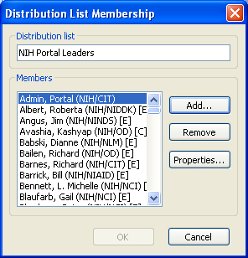

Unrestricted Access to Your Community
If you choose not to restrict access to your Community, it will be open to all portal users if they choose to add it to their profile. For more information about adding a Community, see “Mandatory Vs. Non-mandatory Communities.”

How Do I Let People Know About My Community?
Communities can be either restricted or unrestricted, mandatory or non-mandatory. You will choose the combination for your Community.
- For a restricted Community, the Portal Administrator (contact via helpdesk@nih.gov) gives users permission to access the Community. The user then must “subscribe” to the Community by adding it to his/her My Pages home page (see “Adding a Non-mandatory Community”). You can then create an announcement about the new Community’s availability for dissemination via email.
NOTE: Portal Members who are not Members of your Community will not see your Community in their Communities pull-down menu and be unable to subscribe to it.
- Any portal user can access an unrestricted community. Unrestricted communities are listed below the tab (see Figure 3).

Mandatory Vs. Non-mandatory Communities
A Community can be either Mandatory or Non-mandatory. Mandatory or Mandatory Communities with tab appear in the Communities pull-down menu (see Figure 3). Non-mandatory Communities will not appear in the Community pull-down menu until the user subscribes to it by adding the Community to his/her My Pages. (See “Adding a Non-mandatory Community.”)

- To go to a mandatory Community, on your My Pages, click ; then select the desired Community name.

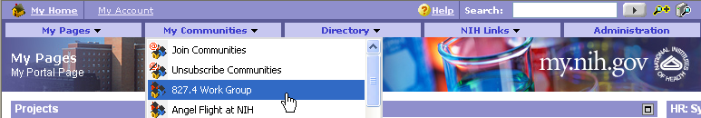

Figure 3 – Mandatory Communities Listing

Adding a Non-mandatory Community

- Click .
- Click .
NOTE: Only those Communities to which a registered user has access will appear on the Join Communities page. 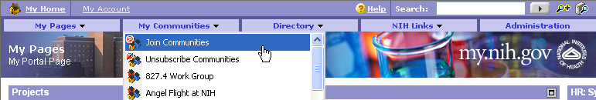

Figure 4 – Adding a Community

- Click a folder to expand its Communities or enter keywords in the Search for Communities text box
and click and click .

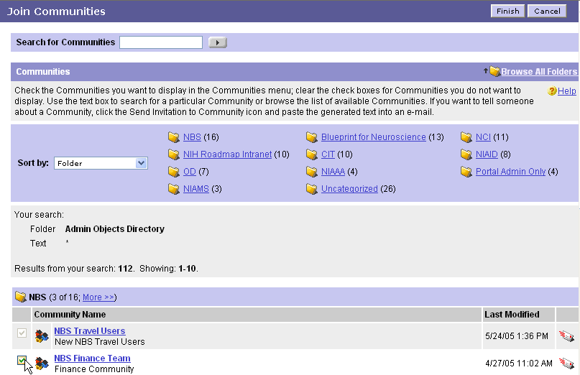
Figure 5 – Selecting a Community

- To see more communities from one of the folders that is already open, click More >>.
- To select a Community, click the Check () beside the community(ies).
- Click . (To exit without saving your selections, click .)

- The Community appears in the Communities pull-down menu.

I Want to Customize My Community
A newly created Community is blank until you, the Community Leader, add portlets and Projects. Once the Portal Administrator creates your Community, you need to decide what kinds of portlets and Projects you will provide to your Membership.

What Are Portlets?
A portlet is a service or an application that you select to help customize your Community. Following is a selected list of portlets you might use to populate your Community:

- Collaboration Server
- Community Announcements
- Community Calendar
- Community Documents
- Community Projects (required if your community will have Projects)

- Community
- Community Links—must be custom-developed for each Community
- Community Bookmarks
- Community Leader (fill out with your contact information)

- Search
- Search Google
- HHS Employee Search
- NIH Enterprise Directory

- References
- Books in Print
- PubMed Central
- Dictionary and Thesaurus
- High Tech Dictionary

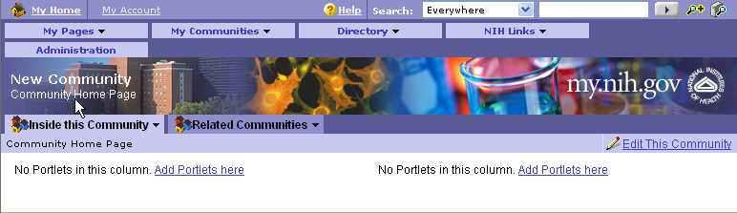
Figure 6 – Community With No Portlets

How Do I Add Portlets to My Community?
- To begin, go to your Community and click .

A listing of folders appears. Each folder contains numerous “portlets” or web services such as document folders, threaded discussion areas, calendaring, task lists, news feeds, publications, contact tools, references, etc.:
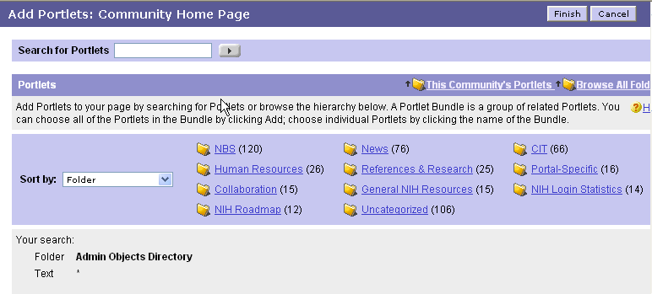
Figure 7 – Portlet Folders

- Click folders of categories that interest you or enter keywords in the Search for Portlets text box
and click .
- To select a portlet, click its checkbox ().
NOTE: To preview the portlet before you add it to your Community, click on the portlet link
- To add the selected portlet(s), click . (To exit without saving your selections, click .)

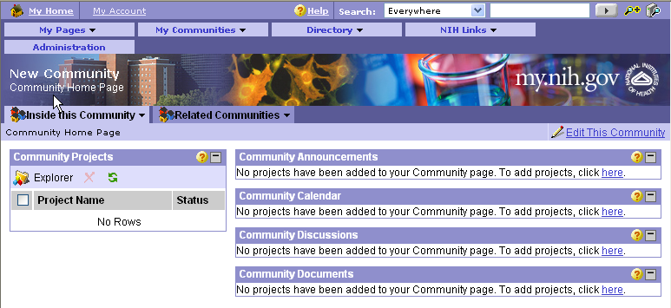

Figure 8 – Community with Portlets

How Do I edit Portlet Preferences?
- From your Community, click on the upper right corner.
- Click on the link. Click OK to proceed.
- If a portlet in your community has community preferences, a pencil icon appears in the Edit column. To set the preferences, click on theicon..
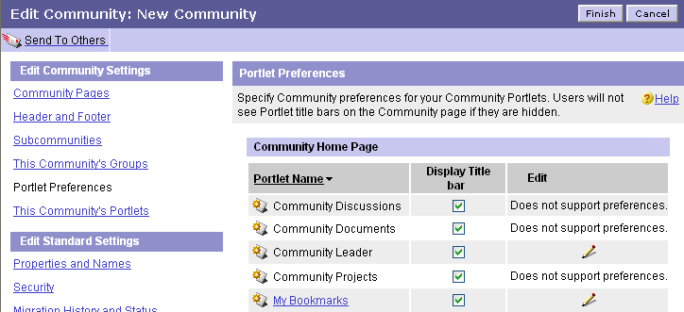

Figure 9 – Edit Portlet Preferences

How do I create portlets available to this community?
- From your Community, click on the upper right corner.
- On the left side, click link.
- Under This Community's Portlets, click to display the Create Portlet page.
- Select a portlet template from the list and click to display the Create Portlet page.
- After creating your portlet, click

Note: If necessary, specify what type of portlet this is:
  - Narrow: Narrow portlets can be added to narrow or wide columns. Columns extend to fit portlet content; therefore, if you choose narrow for a portlet that produces wide content your portal might look awkward.
  - Wide: Wide portlets can be added only to wide columns.
You will now need to add your newly created portlets to where you would like them to appear in the Community. At this point follow instructions on page 7: How do I add Portlets to My Community?

How Do I add members to a Community?
- From your Community, click on the upper right corner.
- On the left side, click link.
- In the edit security page section, click .
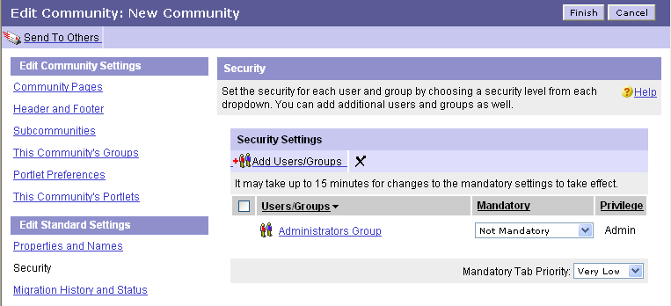
Figure 10 – Edit Security in Community

Note: To search for a user you should be entering the actual portal username (e.g. doej) not the proper name (e.g. John Doe). Entering “doe*” will return a list of users, but you will still need to determine if it is the correct name. To be certain, you can find the user in the Global Address List via Outlook. The field “Alias” is typically that used by the portal to identify the user.
- Type in the username (ex: doej)
- Select the user and click to add user.

Community Security Privilege

- Read allows users or groups to see the Community, but cannot select it to join.

- Select allows users or groups to both see and join the Community and personalize their portlet preferences.

- Edit allows users or groups to create and modify the Community.

- Admin allows users or groups full administrative control of this Community. Users or groups with this right can create a Subcommunity and create Community portlets.

Note: Access privileges to the Community are based on the security of the folder in which the community is stored. It is now also possible to secure pages individually. Simply choose Edit this community, click the page you want to secure differently and then select Security. There you can add or remove users as you would with any portal object.

NOTE: The portal uses groups that currently exist in the Active Directory. It is highly possible that a group you would like to use already exists and you can just assign it rights. If your group only exists in the Global Address List (viewable via Outlook) then it is a Distribution List, not a Security Group. Send an email to the NIH Help Desk and instruct them to convert the Distribution List to a “mail-enabled security group”. If no group already exists, send an email to the Help Desk and instruct them to create a “mail-enabled security group” for use in the portal. Once this group is converted or created, the portal will need up to 24 hours to see it. You will be able to add or delete members via Outlook and continue to email to your group while it is being used to secure your community or project.

What is a Subcommunity?

A subcommunity allows you to have differently secured subsections in a community. You must have the proper rights in order to create a subcommunity.

How to create a Subcommunity within your Community?
- From your Community, click on the upper right corner.
- On the left side, click on link. Under the Subcommunities section,
click to display the Create Community page.
- In the Community Pages section, click .
- In the Community Templates dialog box, select a community template and click OK.
- If this community template does not include a home page, click Create Home Page; then, in the New Page dialog box, choose a page template and click OK.

What are Related Communities?

Related Communities display any communities that are stored in the same administrative object folder as the current community. The tab showing Related Communities only appears if there are multiple communities in a single folder.

- To see related Communities, go to your Community and click .
- A listing of related Communities will appear in the Related Communities tab.

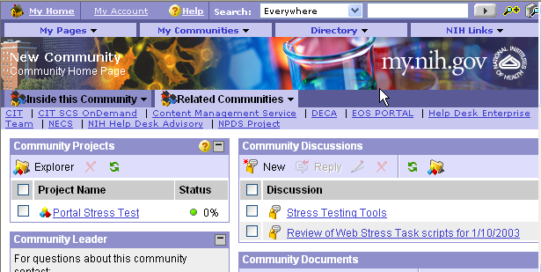
Figure 11 – Related Communities

Community Guidelines

- The purpose of all NIH Portal Communities must be directly relevant to and consistent with the activities, mission, and objectives of NIH; to request an NIH Portal Community you must submit a request form from the Portal Information Center. This provides written justification outlining the intended purpose and function of the Community.
- The purpose of all NIH Portal Communities must be deemed by the NIH Portal Team to be an appropriate use of government IT facilities and resources. For more guidance on the appropriate use of government IT facilities and resources, please go to http://irm.cit.nih.gov/policy/e-mail&i.html.
- It is preferable that all NIH Portal Communities are established to serve pre-established, official NIH groups, entities, boards, committees, and other communities of interest or practice. If, however, you would like to establish an NIH Portal Community that does not meet these criteria, it should serve an unofficial NIH community of no fewer than 5 members.
- Each NIH Portal Community must have a named Community manager responsible for establishing the Community and for providing long-term maintenance and monitoring of Community activities.

The NIH Portal Team reserves the right to archive or remove NIH Portal Communities that become inactive, irrelevant, or are poorly maintained.

