Support an Earmark Moratorium
Become a Cosponsor of H.Res. 727

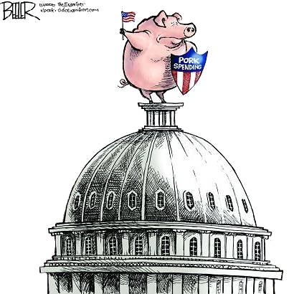

Dear Colleague,

Appropriations bills continue to come to the floor with thousands of earmarks spending millions of taxpayer dollars. Conference reports continue to contain airdropped earmarks that Members of Congress cannot challenge. Rules to ensure transparency in the earmarking process continue to be waived. The media continues to publish reports raising critical ethical concerns regarding how earmarks are handed out. Simply put, it is time to put a halt to the broken earmarking process.

At the beginning of last month, Representative Jerry Moran and I introduced H.Res. 727. H.Res. 727 represents a moratorium on earmarks. This resolution would prohibit the consideration of any legislation that includes earmarks until a bipartisan panel comprised of Members issues a report making recommendations to the House on how to better provide oversight of the congressional earmarking process to prevent waste, fraud, and abuse of taxpayer funds.

I urge you to cosponsor H.Res. 727, which represents an essential step in restoring integrity to the appropriations process. Please contact Chandler C. Morse (x5-2635) for more information.

Sincerely

JEFF FLAKE JERRY MORAN
Member of Congress Member of Congress

