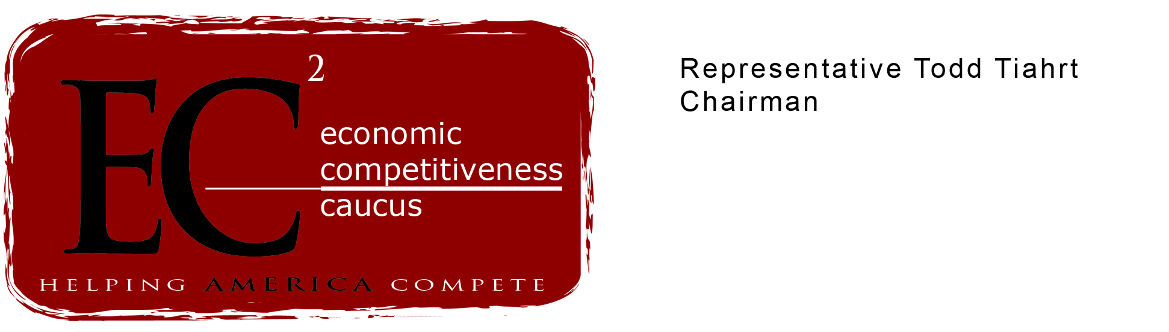

“It should really be called ‘spend and tax as you go.’”

Dear Colleague: January 5, 2007
I would like to draw your attention to the following editorial in today’s Wall Street Journal, “this version of paygo is a budget trapdoor, designed not to control expenditures but to make it easier to raise taxes while blocking future tax cuts.” Blocking these tax cuts will prevent the economic growth we have seen over the past few years. More importantly, the Democrats’ Paygo rule will stifle job growth.
Companies want to grow and they want to higher new workers but high taxes prevent their efforts. Too often companies feel forced to move work out of the United States and out of the normal tax system if they wish to stay in business.

All over the United States companies want to be able to invest and grow but state and federal taxes haunt their every step. The less the government taxes, the more companies are able to invest, and the more Americans they are able to hire. Congress should embrace opportunities to reduce the federal tax burdens and allow companies to compete.

It is because of the historic tax cuts of 2001 and 2003 that our economy recovered from the $2 trillion hit it took after September 11, 2001. It is because of the tax cuts that more Americans are working today than ever before in the history of our nation. It is because of the tax cuts that we have made enormous progress in reducing the deficit “in the wake of those capital gains and dividend tax-rate cuts, federal revenues climbed by a record $550 billion over the past two fiscal years.”

Unfortunately, CBO does not use dynamic scoring when predicting the effect of tax reductions, so the true benefit of tax cuts to the economy will not be expressed under this Paygo rule. Without an exemption for tax cuts, Paygo would threaten our long-term economic growth.

The Economic Competitiveness Caucus will continue to promote the economic competitiveness agenda in the 110th Congress. We will again press for a true debate on how to prepare the United States economy to compete in the global economy of the twenty first century.
Republicans offer real solutions. We invite our colleagues to join us in moving America forward and providing opportunity for U.S. businesses and working families.

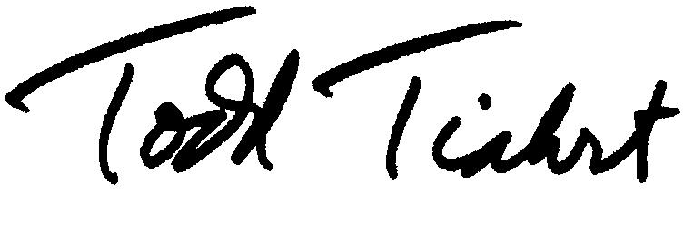
Sincerely,

Todd Tiahrt
Member of Congress

Tax As You Go

5 January 2007
The Wall Street Journal

Congressional Democrats are dashing out of the gates to establish their fiscal conservative credentials. And as early as today House Speaker Nancy Pelosi will push through so-called "pay-as-you-go" budget rules for Congress. Keep an eye on your wallet.
"Paygo," as Washington insiders call it, sounds like a fiscally prudent budget practice: If government spends more on program A, it has to spend less money on program B, and thus budget deficits will be restrained. We're all for that. But when Republicans proposed exactly that budget rule in recent years, House Democrats voted it down.
Ms. Pelosi has something different in mind. Under her paygo plan, new entitlement programs and all new tax cuts would have to be offset by either cutbacks in other entitlement programs or tax increases. This version of paygo is a budget trapdoor, designed not to control expenditures but to make it easier to raise taxes while blocking future tax cuts.
Supporters of paygo claim it will help restrain entitlement spending. It won't. Paygo doesn't apply to current entitlements that will grow automatically over the next several decades. Ms. Pelosi's version of paygo applies only to new entitlements or changes in law that expand current programs. And on present trajectory, Medicare, Medicaid, Social Security, food stamps and the like are scheduled to increase federal spending to almost 38% of GDP by 2050, up from 21% today. Paygo won't stop a dime of that increase. This may explain why one of the leading supporters of paygo is the Center on Budget and Policy Priorities, a liberal outfit that favors far more social spending.
Paygo enthusiasts also claim that when these rules were in effect in the 1990s the budget deficit disappeared and by 2001 the budget recorded a $121 billion surplus. Sorry. The budget improvement in the late 1990s was a result of three events wholly unrelated to paygo: the initial spending restraint under the Republican Congress in 1995 and 1996 as part of their pledge to balance the budget; a huge reduction in military spending, totaling nearly 2% of GDP, over the decade; and rapid economic growth, which always causes a bounce in revenues. Paygo didn't expire until 2002, but by the late-1990s politicians in both parties were already re-stoking the domestic spending fires.
What paygo does restrain are tax cuts, by requiring that any tax cut be offset dollar-for-dollar with some entitlement reduction. Congressional budgeteers always overestimate the revenue losses from tax cuts, which under paygo would require onerous budget cuts to "pay for" the tax cuts. As a political matter, those spending cuts will never happen.
First on the chopping block, therefore, would be the investment tax cuts of 2003 that are set to expire in 2010. Last year Democrat David Obey of Wisconsin, the new Appropriations Committee chairman and a prodigious spender, gave this strategy away when he urged paygo rules so he could enact new social spending and pay for it by canceling the Bush tax cuts for those who make more than $1 million.
Never mind that, in the wake of those capital gains and dividend tax-rate cuts, federal revenues climbed by a record $550 billion over the past two fiscal years. Incidentally, thanks to the current economic expansion and the surge in tax revenues, the budget deficit has fallen by $165 billion in just two years -- without paygo.
Given all of this, it's especially puzzling that even some conservatives seem tempted by paygo's fiscal illusions. Our friends at the Heritage Foundation have of late become obsessed with future entitlement forecasts and have advised Ms. Pelosi to enact paygo rules to stop it. But Heritage notably did not insist that tax increases be excluded from any paygo rule. Had such logic prevailed in 1980 or 2003, it's possible that neither the Reagan nor Bush tax cuts would ever have become law. As a political matter, paygo is about returning Republicans to their historical minority role as tax collectors for the welfare state.
That's not to say that new budget rules aren't highly desirable. The line-item veto, a new Grace Commission to identify and eliminate the billions of dollars of waste and failed programs, and an automatic spending sequester if the budget rises above agreed baselines would all help to restore spending discipline. But it is precisely because these rules would restrain spending that they are not on the Democratic agenda.
Paygo, by contrast, gives the appearance of spending discipline while making it all but impossible to let taxpayers keep more of their money. It should really be called "spend and tax as you go."

