

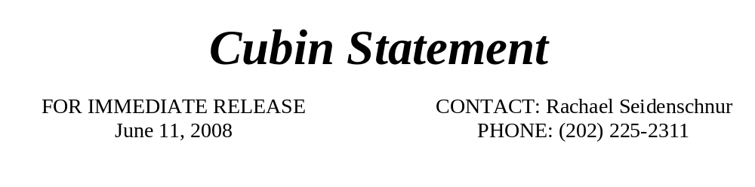
Congress Needs to Lay Off Extending Unemployment Benefits
Washington, DC—Congresswoman Cubin (R-WY) voted against H.R. 5749, the Emergency Extended Unemployment Compensation Act of 2008, which would extend unemployment benefits for up to 52 weeks. Fortunately, this bill did not pass with the two-thirds majority needed for suspension votes. Congressman Cubin offered the following statement about H.R. 5749:
“Democrats’ actions today again demonstrate their utter disregard for fiscal responsibility. It is one thing for the federal government to offer unemployment benefits when hardworking employees lose their jobs because of circumstances out of their control. The problem is not the concept of unemployment benefits, but that H.R. 5749 goes too far.
As you and I both know, Wyoming has one of the lowest unemployment figures in the country at 2.6%. Our nation’s overall unemployment rate is 5.5%, and over half of the states are within 1 percent of their lowest unemployment rate ever. These unemployment figures certainly do not justify spending $12 billion of hard earned taxpayer money, just so that some can receive unemployment benefits for up to year. The Democrat-led Congress has spent a lot of money carelessly, but H.R. 5749 has to be one of the worst examples.
This bill creates a ‘temporary’ program to provide extended unemployment benefits for up to an additional 13 weeks in every state for individuals who have exhausted their regular unemployment compensation. On top of that, states with high unemployment receive an additional 13 weeks. This bill makes it possible for some people to claim a total of 52 weeks of unemployment benefits (including regular and extended). That is an entire year!
And if this is not troublesome enough, in certain states this bill provides unemployment benefits to a person who worked for as short a time as two weeks. Unlike unemployment extensions in the past, this one lacks the 20-week work requirement for individuals claiming federal unemployment benefits. Due to the omission of the 20-week work requirement, this bill also allows seasonal and other temporary workers to receive unemployment benefits.
As you might have already guessed, these benefits come at quite the cost. The Congressional Budget Office estimates the cost will be almost $12 billion over 5 years. In order to make this spending possible, Democrats waive their own PAY-GO rules. Democrats instituted PAY-GO rules when they took control of Congress in hopes to offset any additional spending by either an increase in tax dollars or a cut in spending elsewhere. Their actions today demonstrate they are more than happy to suspend these rules when they see fit. Thankfully, the Democrat leadership failed to receive the necessary votes to pass this legislation.”
###

