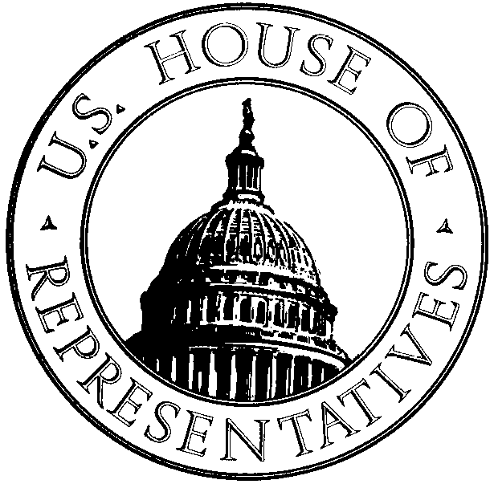
NEWS

From the Office of John Sullivan
Member of Congress
Oklahoma, First District

__________________________________________________________________________________________

114 Cannon House Office Building Phone: 202-225-2211
Washington, DC 20515 Fax: 202-225-9187
__________________________________________________________________________________________

FOR IMMEDIATE RELEASE CONTACT: Jay B. Wiley
May 22, 2003 202-225-2211

Sullivan Focuses on Waste in Government

Congressman addresses failed and obsolete bureaucracies and programs that fleece American taxpayers

WASHINGTON, D.C. – This week, Congressman John Sullivan joined Majority Leader Tom DeLay, Budget Chairman Jim Nussle (R-Iowa), and other Committee Chairmen to announce a waste elimination initiative to identify and eliminate wasteful government spending.

“When the government runs more like a business, it serves the American people more effectively,” Sullivan said later. “Real businesses throughout America could never manage their bottom lines the way we do in Washington. We owe it to taxpayers to be better stewards of their money.”

DeLay, Nussle, Republican Conference Chair Deborah Pryce (R-Ohio), Energy and Commerce Chairman Billy Tauzin (R-Louisiana), and Government Reform Chairman Tom Davis (R-Virginia) today announced an initiative calling for House and Senate committees to identify means of eliminating waste, fraud and abuse within their jurisdiction by September 1, 2003.

Earlier this year Sullivan introduced H.Res. 133, the House Deficit Reduction Safeguard Resolution, which would permit members to dedicate money saved from any appropriations amendment to the reduction of the deficit. Unlike similar legislation introduced in recent years, the House Deficit Reduction Safeguard Resolution would apply to both discretionary and mandatory spending. Currently, money saved through House amendments is spent elsewhere against the will of Members of Congress, resulting in wasteful spending.

“The Federal Government spends $70 million per second,” Sullivan added. “It’s time we address this problem. We can’t afford to continue passing along a bloated and inefficient government along to our children and grandchildren.

“In post-September 11th America, we can’t afford to be wasteful. We need a focused, disciplined approach to government in the 21st Century.”

# # #

