Appendix D
National information on the educational opportunity centers program

In addition to conducting a national evaluation of the Talent Search program, MPR was also obligated, as part of our contract with the U.S. Department of Education’s Planning and Evaluation Service, to conduct a survey of all Educational Opportunity Centers (EOCs). This appendix summarizes some background information on the EOC program, describes issues associated with our research, and presents the results from the survey along with some data from annual performance reports (APRs).

BACKGROUND ON THE EOC PROGRAM
The Educational Opportunity Center program was established as the fourth TRIO program in 1972, about six years after the establishment of Talent Search. The goal of the EOC program is to increase the number of adult participants who enroll in postsecondary institutions. EOCs focus on serving people at least 19 years old, typically adults who may not have completed high school, or who have a high school diploma (or equivalency) but who have never enrolled in a postsecondary institution, or who have enrolled at some point but have “stopped out.” Two-thirds of the participants in each EOC must be low-income and a potential first-generation college student; the remaining one-third must meet one of these two criteria.

To aid participants, EOCs may provide a wide range of services, including:

- Academic advice
- Personal counseling
- Career workshops
- Information on postsecondary education opportunities
- Information on financial aid
- Assistance in completing applications for college admissions, testing, and financial aid
- Media activities designed to involve and acquaint the community with higher education opportunities
- Tutoring
- Mentoring
- Coordination with nearby postsecondary institutions
From the beginning, the Talent Search and EOC programs have been perceived as closely linked in that they are both low-intensity programs that foster postsecondary entrance and assist participants in securing federal financial aid. Currently, the two programs share the same TRIO grant cycle and the same performance report. The chief difference is that EOCs focus on out of school adults, while Talent Search focuses on students enrolled in grades 6-12.

EOCs may be operated by institutions of higher education; public and private not-for-profit agencies; a combination of institutions, agencies, and organizations; and, in exceptional cases, secondary schools. Many of the tables in this appendix present data by type of host institution, using the following three groups: centers hosted by 4-year colleges or universities; centers hosted by 2-year colleges; and all other types of host institutions, which we refer to as community organizations.

EOCs served an average of about 1,860 people in 1998-99 (see table D.1). Centers hosted by 4-year colleges were the smallest, serving an average of about 1,470 participants, and those hosted by community organizations were the largest, serving an average of about 3,000 participants. The average EOC grant amount in 2000 was about $372,000. Although the average EOC serves more participants than any other TRIO program, the funding per participant (under $200 in 2000) is lower than any other TRIO program (see table 1.1 in the main body of this report).

Table D.1—EOC participant levels, by host type: 1998–99
Host institution | Number of centers | Total number of participants servedª | Average number of participants served
4-year | 40 | 58,931 | 1,473
2-year | 23 | 36,516 | 1,588
Community org. | 19 | 56,897 | 2,995
All centers | 82 | 152,344 | 1,858
ªNumber actually served, as reported in APRs, rather than number expected/funded to serve.
Source: U.S. Department of Education, Office of Federal TRIO Programs.

RESEARCH methods and data
A survey was distributed to all EOC directors and collected between spring 1999 and spring 2000. The questions in the EOC survey were very similar to those in the Talent Search survey, covering topics such as program and host institution characteristics, staff characteristics and responsibilities, participant characteristics, recruitment, services, outcomes, record keeping, and budget issues. Respondents could complete either the hard copy or an online version. The overall response rate was 91 percent (75 of 82). Table D.2 presents the survey response rates by type of host.

Table D.2—Number of EOCs, distribution of participants, and response rates to national survey and performance reports, by host type
Host institution | Number of centers | Percentage of centers | Percentage of all EOC participants served | Percent of EOCs responding to survey | Percent of EOCs completing 1998-99 performance report
4-year | 40 | 49% | 39% | 93% | 95%
2-year | 23 | 28 | 24 | 96 | 96
Community org. | 19 | 23 | 37 | 84 | 95
All centers | 82 | 100 | 100 | 91 | 95
Source: U.S. Department of Education, Office of Postsecondary Education, A Profile of the Educational Opportunity Centers Program: 1998–99, Washington, DC: February 2002; National Survey of Educational Opportunity Centers, 1999–2000.

For certain topics, including participant outcomes, we also used data from EOCs’ annual performance reports for 1998-99. Ninety-five percent of centers submitted an APR (table D.2).

Survey nonresponse, missing APRs, and item nonresponse on either of these sources account for minor fluctuations in the number of EOCs on which our results are based. The relatively small number of EOCs operating to begin with, plus nonresponse, together mean that some results should be interpreted with caution. For example, with only 15 survey respondents hosted by community organizations, one or two EOCs answering differently could lead to relatively large percentage change in the responses.

Throughout this appendix, percentages that should sum to 100 may not, due to rounding.

FINDINGS
This appendix is intended as a reference document that will (1) provide officials with national data that may not have existed before, (2) serve as a point of comparison for any future research, and (3) allow individual center staff to compare their own structure and operations to those of other centers with similar host institutions and to all centers nationwide. Because our research involved only a survey and some analysis of APR data (not a literature review, case studies, or conversations with EOC directors), we are limited in our ability to draw conclusions from or interpret the significance of our findings. Nonetheless, one overarching observation is that EOCs operated by community-based organizations differ substantially, on certain dimensions, from those operated by postsecondary institutions. EOCs at community organizations are much more likely to be located in a large city; are much less likely to operate other programs for disadvantaged individuals; are much more likely to have an external advisory board; tend to serve a higher proportion of racial/ethnic minorities; have much higher participant-to-staff ratios; are much more likely to use volunteers; and are much more likely to have had an external evaluation conducted. However, when it comes to services, EOCs at community organizations did not differ systematically from other EOCs.

Below we summarize the major findings about EOCs from the national survey and 1998-99 annual performance reports. The narrative focuses on overall results, but most tables present data both for all centers combined and by type of host institution.

Host Institutions, Project Operations, and Target Area
Size and host type. EOCs operated by community-based organizations are almost twice as large as those operated by higher education institutions, serving an average of about 3,000 participants; they account for 23 percent of all centers but serve 37 percent of all EOC participants nationwide (table D.2). This appears to be related to program longevity, since grantees tend to grow over time. Ten of 16 centers hosted by community organizations started operating in 1980 or earlier, compared with 4 of 35 EOCs at 4-year colleges and 6 of 21 at 2-year colleges.

Area served. More than four of ten EOCs (42 percent) primarily served a large or very large city (with populations of over 100,000); one-third served small or medium-sized cities (with populations of less than 100,000); and nearly one-fourth (24 percent) served rural or farming communities (see table D.3).

Table D.3—Primary area served by EOCs
 |  | Host institution
 | All centers | 4-year | 2-year | Community org.
A large or very large city (over 100,000 people) | 42% | 43% | 23% | 67%
A small or medium-sized city (up to 100,000 people) | 33 | 29 | 45 | 27
A rural or farming community | 24 | 29 | 27 | 7
A suburb of a medium, large, or very large city | 1 | 0 | 5 | 0
Source: National Survey of Educational Opportunity Centers, 1999–2000.

Other programs for disadvantaged persons. Nearly all EOC host institutions (92 percent) also administered other programs for disadvantaged persons (see table D.4). The most common were Student Support Services (75 percent), Talent Search (71 percent), and Upward Bound (64 percent).

Table D.4—Host institutions’ sponsorship of other programs for disadvantaged persons
 |  | Host institution
 | All centers | 4-year | 2-year | Community org.
Host had other program(s) for disadvantaged persons | 92% | 97% | 100% | 67%
Of all EOC programs:
Student Support Services | 75 | 91 | 82 | 9
Talent Search | 71 | 69 | 68 | 82
Regular Upward Bound | 64 | 86 | 59 | 19
Other college preparation or support programs | 40 | 54 | 27 | 18
Upward Bound Math/Science | 28 | 46 | 14 | 0
Other | 22 | 20 | 32 | 9
Veterans Upward Bound | 21 | 31 | 14 | 0
Source: National Survey of Educational Opportunity Centers, 1999–2000.

First year of operation. As of 2000, nearly nine of ten EOCs had been operating for more than ten years: 47 percent began operation between 1990 and 1994, and 40 percent began in 1989 or earlier (see figure D.1).

Figure D.1—Year that EOCs operating in 2000 first started operating

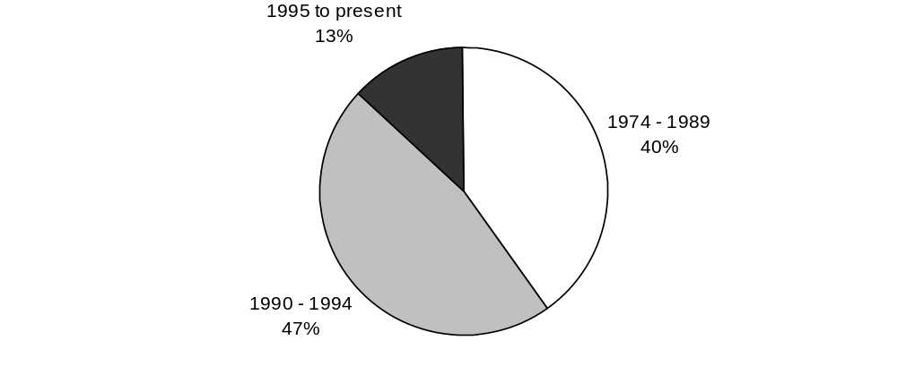
Source: National Survey of Educational Opportunity Centers, 1999–2000.

Advisory boards. Forty-eight percent of all EOCs had a board of directors or another external group that provides advice and/or support; they were most common among centers hosted by a community-based organization (see figure D.2).

Figure D.2—Percentage of EOCs that had a board of directors or external group providing advice/support
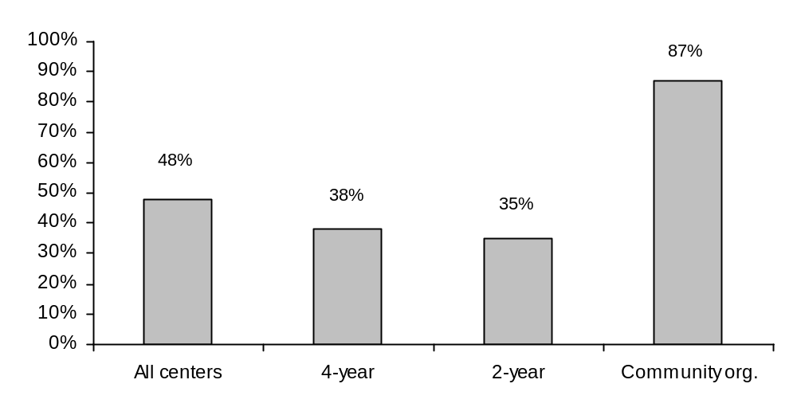

Source: National Survey of Educational Opportunity Centers, 1999–2000.

Allocation of EOC grant money. EOCs spend, on average, about two-thirds of their grant funds on staff salaries—13 percent for the project director/coordinator and 53 percent for other staff (see figure D.3). In addition, 6 percent goes for staff and participant travel, and another 6 percent goes for supplies.

Figure D.3—Allocation of EOC grant money by budget category: 2000
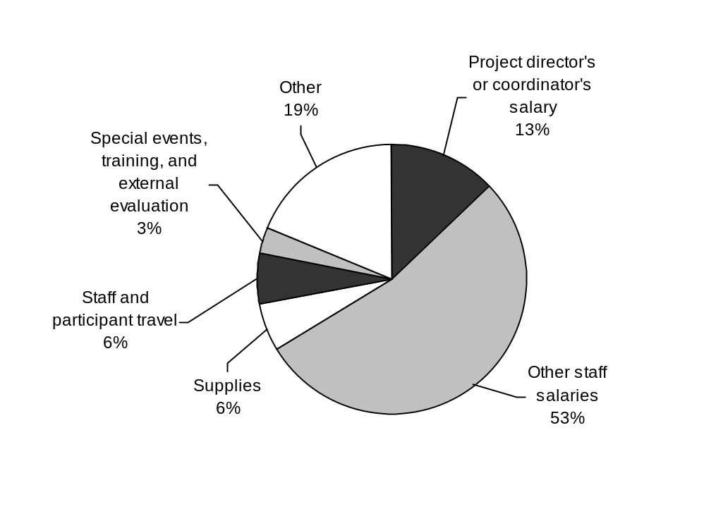
Source: National Survey of Educational Opportunity Centers, 1999–2000.

Staff
Race/ethnicity. Nearly half (48 percent) of all EOC staff were white, about one-third (34 percent) were black, and 13 percent were Hispanic/Latino (see table D.5). Among directors/coordinators, however, 57 percent were white, 27 percent were black, and 9 percent were Hispanic/Latino (see figure D.4).

Sex. About 70 percent of all EOC staff were female (see table D.5), although 58 percent of directors were female (see figure D.5).

Table D.5—Demographic profile of all EOC staff, 1999-2000
 |  | Host institution
 | All centers | 4-year | 2-year | Community org.
Race/ethnicity
White | 48% | 48% | 58% | 39%
Black or African American | 34 | 34 | 27 | 40
Hispanic or Latino | 13 | 13 | 10 | 16
American Indian or Alaska Native | 3 | 4 | 3 | 3
Asian | 1 | 1 | 1 | 1
Native Hawaiian or other Pacific Islander | 1 | 1 | 2 | 2
Sex
Female | 71 | 69 | 75 | 71
Male | 29 | 31 | 25 | 29
Source: U.S. Department of Education, Office of Postsecondary Education, A Profile of the Educational Opportunity Centers Program: 1998–99, Washington, DC: February 2002.

Figure D.4—Race/ethnicity of EOC directors/coordinators

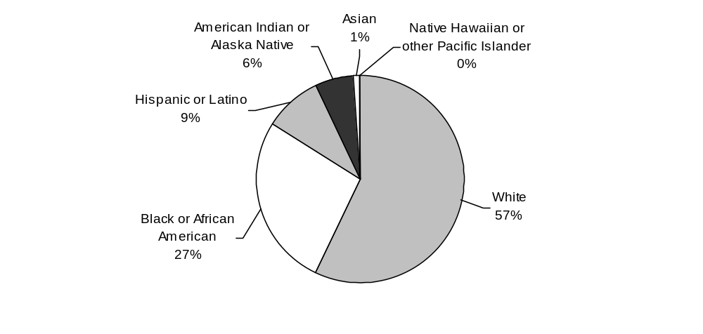
Source: National Survey of Educational Opportunity Centers, 1999-2000.

Figure D.5—Sex of EOC directors/coordinators

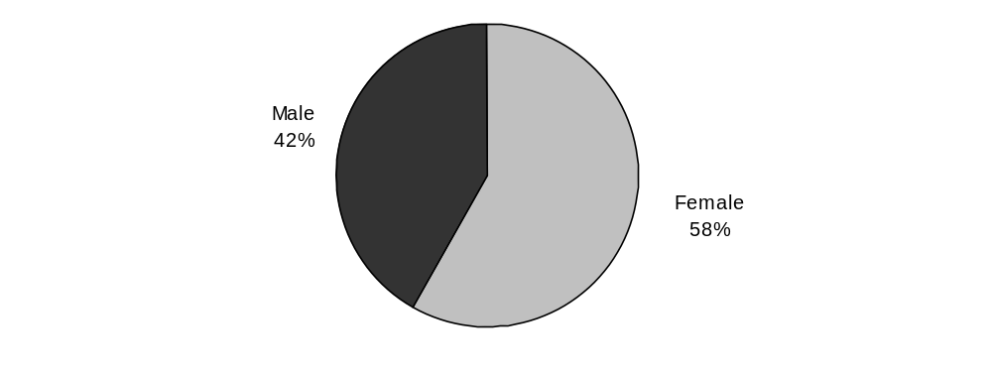

Source: National Survey of Educational Opportunity Centers, 1999-2000.

Educational attainment. Overall, 20 percent of EOC staff had less than a bachelor’s degree, 36 percent had a bachelor’s, and 44 percent had an advanced degree (master’s or higher). Advanced degrees were held by 61 percent of directors/coordinators, 47 percent of counselors, and 22 percent of other professionals (see table D.6).

Table D.6—Highest level of education completed by EOC staff, by type of host institution and by position, 1999-2000
 | Less than bachelor’s degree | Bachelor’s degree | Master’s degree | Ph.D. or other professional degree
Host institution
All centers | 20% | 36% | 39% | 5%
4-year | 15 | 39 | 40 | 5
2-year | 23 | 34 | 39 | 5
Community org. | 24 | 35 | 39 | 3
Position or title
Directors/coordinators | 0 | 21 | 61 | 19
Assistant or associate directors/coordinators | 0 | 11 | 72 | 17
Counselors/advisors | 6 | 45 | 47 | 1
Other professionals | 39 | 37 | 22 | 1
Support staff | 13 | 54 | 33 | 0
Tutors | 48 | 24 | 29 | 0
Source: U.S. Department of Education, Office of Postsecondary Education, A Profile of the Educational Opportunity Centers Program: 1998–99, Washington, DC: February 2002.

Languages used with participants. One or more staff members in 52 percent of all EOCs used a language other than English to communicate with participants (see table D.7). Spanish was the most commonly used language; 41 percent of all projects used Spanish to communicate with participants.

Table D.7—Use of languages other than English to communicate with participants
 |  | Host institution
 | All centers | 4-year | 2-year | Community org.
Percent of centers where staff use language(s) other than English | 52% | 44% | 53% | 69%
Of all EOCs, percent using:
Spanish | 41 | 37 | 43 | 50
Other | 25 | 7 | 25 | 56
Chinese | 5 | 0 | 0 | 20
American Indian language | 5 | 6 | 8 | 0
Source: National Survey of Educational Opportunity Centers, 1999–2000.

Staff levels. EOCs employed an estimated 599 staff members nationwide, an average of about seven people (6.3 full-time equivalent staff) per center. Centers had an average of 254 participants per staff member (see table D.8).

Table D.8—EOC staff levels: 1999–2000
Host institution | Estimated total number of staff | Number of staff per center | FTE staff per center | Number of participants per staff
4-year | 267 | 6.7 | 5.7 | 221
2-year | 165 | 7.2 | 6.2 | 221
Community org. | 167 | 8.8 | 7.6 | 342
All centers | 599 | 7.3 | 6.3 | 254
*Adjusted upward from the responding EOCs to reflect the total number of centers overall and for each type of host institution.
Note: In reporting on staff, centers were instructed not to include undergraduate work-study or other part-time student employees or volunteers. However, the data should include graduate students who might have been employed as tutors or in other roles.
Sources: U.S. Department of Education, Office of Postsecondary Education, A Profile of the Educational Opportunity Centers Program: 1998–99, Washington, DC: February 2002; National Survey of Educational Opportunity Centers, 1999–2000.

Volunteer and undergraduate staff. Relatively few EOCs (12 percent) used volunteers. The average number of volunteers at those centers was about two, and those volunteers reportedly contributed a total of about 24 hours of labor per week. However, a majority of EOCs (53 percent) employed work study students; those centers used an average of about two work study students and those students contributed a total of almost 28 hours of labor per week. Slightly fewer EOCs used other undergraduate students, but those students worked an average of about 36 total hours per week (see table D.9).

Table D.9—EOCs’ use of different types of staff: 1998–99
 | Percentage of centers using these staff | Among centers using these staff, average number used per center | Average total hours of labor per week that these staff provide, per center
Volunteers
4-year | 9% | 1.3 | 8.3
2-year | 5 | 1.0 | 20.0
Community org. | 31 | 3.3 | 37.5
All centers | 12 | 2.3 | 24.4
Work study students
4-year | 55 | 2.7 | 30.4
2-year | 62 | 2.0 | 26.5
Community org. | 36 | 2.2 | 19.2
All centers | 53 | 2.4 | 27.5
Other undergraduate students
4-year | 45 | 2.7 | 32.9
2-year | 52 | 2.6 | 39.3
Community org. | 14 | 3.0 | 40.0
All centers | 41 | 2.7 | 35.9
Source: National Survey of Educational Opportunity Centers, 1999–2000.

Staff levels and experience, by position. The average center had 1.3 director/coordinator, 2.1 counselors, and almost three other professionals. Directors/coordinators accounted for 18 percent of total full-time equivalent (FTE) staff, counselors for 31 percent, and other professionals for 41 percent. Directors/coordinators had an average of 6.6 years of experience at their current centers, counselors averaged 5.6 years of experience, and other professionals had 4.7 years of experience on average (see table D.10).

Table D.10—Average number of EOC staff, number of FTEs, and years of experience, by position: 1999–2000
Position | Average number per center | Average FTEs per center | Average percentage of total FTEs | Average years of experience in current center
Directors/coordinators | 1.3 | 1.1 | 18% | 6.6
Associate or assistant directors/coordinators | 0.2 | 0.2 | 4 | 8.2
Counselors | 2.1 | 1.9 | 31 | 5.6
Other professionals | 2.8 | 2.5 | 41 | 4.7
Support staff | 0.3 | 0.3 | 4 | 4.9
Tutors | 0.3 | 0.1 | 2 | 2.0
Source: National Survey of Educational Opportunity Centers, 1999–2000.

Salaries. The average annual salary for directors/coordinators was about $41,200, while associate or assistant directors/coordinators had average salaries of about $44,200, and EOC counselors earned about $31,400 on average (see table D.11). The explanation for why associates/assistants earned more than directors/coordinators has to do with their respective numbers and different staffing structures. First, there were 98 directors/coordinators in our database, indicating that some centers have co-directors, co-coordinators, or both a director and a coordinator, who have relatively lower salaries because they share some key responsibilities. Indeed, at centers with more than one director/coordinator, their average salary was $32,639. Second, there were only 16 associates/assistants, and the directors/coordinators at these EOCs earned substantially more than their associates/assistants: the average salary of directors at EOCs that also had an assistant/associate director was $55,667, whereas directors/coordinators at EOCs with no associate/assistant on staff earned an average of $37,077.

Table D.11—Salaries for full-time EOC staff, by position: 2000*
Position | Mean | Median | 75th percentile
Directors/coordinators | $41,205 | $40,739 | $44,445
Associate or assistant directors/coordinators | 44,194 | 44,445 | 49,096
Counselors | 31,389 | 29,032 | 35,143
Other professionals | 25,548 | 25,564 | 29,768
Support staff | 30,286 | 25,840 | 31,008
*Full time is defined as working 37 or more hours per week. Salaries were reported for 1999, but adjusted for inflation. Salaries include all sources, not just money paid out of the EOC grant.
Source: National Survey of Educational Opportunity Centers, 1999–2000.

Leadership experience of directors/coordinators. As of 2000, 70 percent of EOC directors/coordinators had served as director of their centers at least two years, including 13 percent who had been in that position for 11 or more years (see table D.12). Thirty-four percent and 27 percent had served as directors of Talent Search and Upward Bound projects, respectively, and 66 percent had previously directed some other program serving disadvantaged persons.

Table D.12—Experience of EOC directors/coordinators running this and other programs
 | 11 years or more | 6–10 years | 4–5 years | 2–3 years | Fewer than 2 years | Never
This EOC | 13% | 26% | 16% | 16% | 30% | 0%
Another EOC | 2 | 2 | 0 | 0 | 2 | 95
Talent Search | 8 | 10 | 2 | 3 | 11 | 66
Upward Bound | 5 | 4 | 5 | 2 | 11 | 73
Other projects serving disadvantaged persons | 23 | 9 | 9 | 13 | 11 | 34
Source: National Survey of Educational Opportunity Centers, 1999–2000.

Other experience of directors/coordinators. Before taking on their current leadership roles, 52 percent of all EOC directors/coordinators had served at their current centers in some other capacity, including 10 percent who had done so for at least 11 years (see table D.13). Only 2 percent had previously served as a staff member at another EOC.

Table D.13—Experience of EOC directors/coordinators working in another capacity (other than director) for this and other programs
Worked at | 11 years or more | 6–10 years | 4–5 years | 2–3 years | Fewer than 2 years | Never
This EOC | 10% | 10% | 7% | 16% | 10% | 48%
Another EOC | 0 | 0 | 0 | 0 | 2 | 98
Talent Search | 2 | 2 | 5 | 4 | 4 | 84
Upward Bound | 0 | 4 | 4 | 2 | 5 | 86
Other projects serving disadvantaged persons | 15 | 12 | 10 | 10 | 10 | 44
Source: National Survey of Educational Opportunity Centers, 1999–2000.

Director/coordinator responsibility for other programs. About one-third of all EOC directors/coordinators (32 percent) also simultaneously serve as the director or administrator for one or more other programs operated by their host institution (see figure D.6).

Figure D.6—Percentage of EOC directors/coordinators who also direct or administer other programs at the host institution
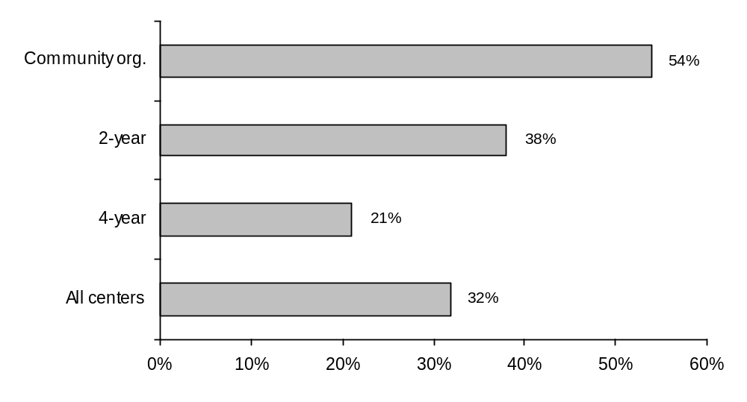

Source: National Survey of Educational Opportunity Centers, 1999–2000.

Staff time allocation. EOC staff nationwide spent, on average, 55 percent of their time providing services, including counseling, directly to participants (see figure D.7). Seventeen percent of staff time was used for participant recruitment and 10 percent was spent on record keeping and paperwork.

Figure D.7—Estimated average time allocation of total project staff

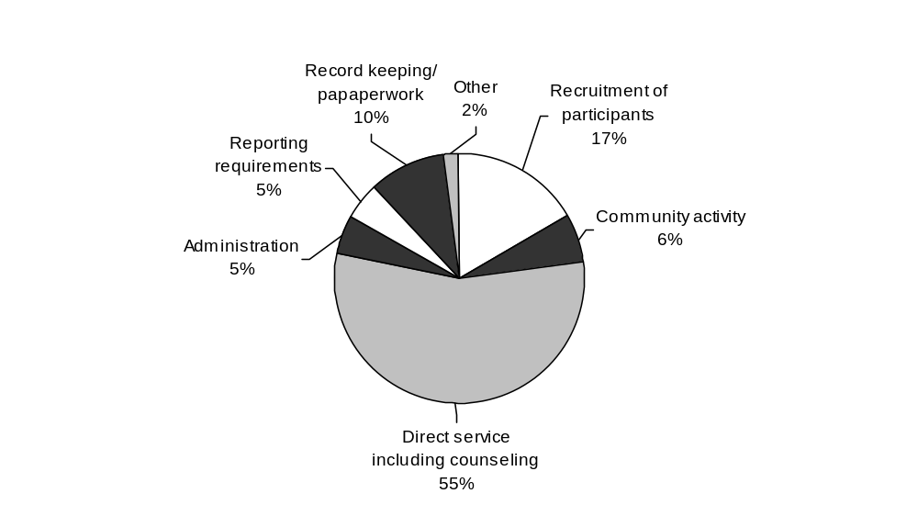
Source: National Survey of Educational Opportunity Centers, 1999–2000.

Actual and ideal time allocation of directors/coordinators. Overall, the amount of time that EOC directors/coordinators spend on various tasks is close to the amount they would prefer to spend on those tasks (see figure D.8). Program administration takes up, on average, 44 percent of their time, while only 15 percent of their time is spent on direct services to participants.

Figure D.8—How EOC directors/coordinators spend—and would like to spend—their time
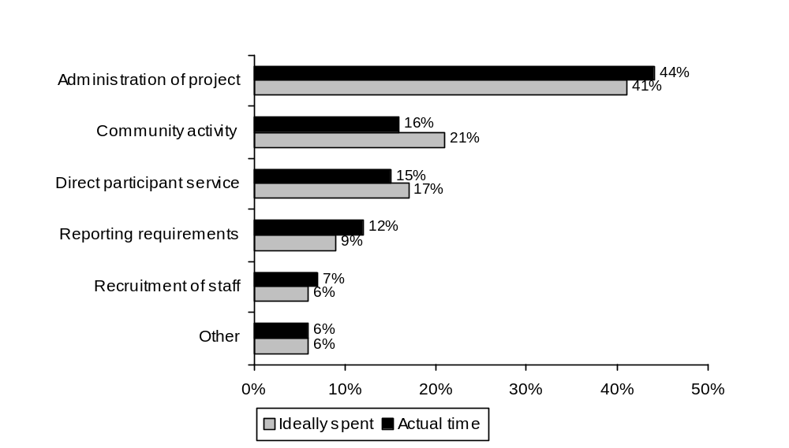

Source: National Survey of Educational Opportunity Centers, 1999–2000.

Staff hiring/training. Thirty-seven percent of all EOCs reported having a specific performance objective pertaining to hiring and/or training staff (34 percent of centers hosted by 4-year colleges, 33 percent of those hosted by 2-year colleges, and 47 percent of those hosted by community organizations).

Participants
Eligibility. Seventy-one percent of participants were both low-income and potential first-generation college students, 13 percent met only the first-generation criterion, and 11 percent met only the low-income criterion (see table D.14).

Race/ethnicity. Whites constituted a plurality of participants, accounting for 41 percent; blacks were close behind at 36 percent; and Hispanics/Latinos accounted for 14 percent of participants (see table D.14).

Sex. Nearly two-thirds (64 percent) of participants were female (see table D.14).

Age. Forty-four percent of participants were age 28 or older, 40 percent were 19-27 years old, and the remaining 16 percent were 14-18 years old (see table D.14).

School enrollment and grade level. When they were first served by an EOC, 37 percent of EOC participants were high school graduates or GED recipients who had never enrolled in a postsecondary education program, 28 percent were either secondary or postsecondary dropouts, 21 percent were postsecondary students, and 13 percent were enrolled in high school (see table D.14).

Veteran status. Four percent of EOC participants were veterans (see table D.14).

Table D.14—Demographic profile of EOC participants, 1998-99
 |  | Host institution
 | All centers | 4-year | 2-year | Community org.
Eligibility
Low-income and potential first-generation college student | 71% | 73% | 70% | 72%
Potential first-generation college student only | 13 | 13 | 13 | 12
Low-income only | 11 | 10 | 12 | 11
Other | 5 | 4 | 5 | 5
Race/ethnicity
White | 41 | 44 | 44 | 36
Black or African American | 36 | 32 | 29 | 46
Hispanic or Latino | 14 | 15 | 16 | 12
American Indian or Alaska Native | 4 | 6 | 4 | 2
Asian | 2 | 1 | 3 | 2
Native Hawaiian or other Pacific Islander | 1 | 0 | 2 | 0
More than one race/ethnicity reported | 2 | 1 | 2 | 3
Sex
Female | 64 | 64 | 67 | 63
Male | 36 | 36 | 33 | 37
Age
28 or older | 44 | 42 | 43 | 45
19-27 | 40 | 38 | 45 | 39
14-18 | 16 | 19 | 12 | 16
Grade level
Postsecondary student | 21 | 17 | 16 | 28
Postsecondary dropout | 14 | 11 | 16 | 15
High school graduate or GED recipient | 37 | 42 | 45 | 28
Secondary school dropout | 14 | 15 | 16 | 12
12th grade student | 11 | 12 | 5 | 13
9th-11th grade student | 2 | 2 | 2 | 3
Veteran status | 4 | 5 | 4 | 3
Source: U.S. Department of Education, Office of Postsecondary Education, A Profile of the Educational Opportunity Centers Program: 1998–99, Washington, DC: February 2002.

Targeting of potential participants. Seventy-seven percent of EOCs place “much” or “very much” emphasis on recruiting current or former welfare recipients, and 66 percent place that degree of emphasis on people who dropped out of school (see table D.15). Another highly emphasized group is low achievers with ability for college. Conversely, relatively few EOCs placed much or very much emphasis on recruiting people with a particular subject area strength/interest (5 percent), or on non-native speakers of English (14 percent).

Table D.15—EOCs’ emphasis on recruiting people with various characteristics
 | None or very little emphasis | Moderate emphasis | Much or very much emphasis | Not applicable
Welfare recipients or former recipients | 8% | 14% | 77% | 0%
Those who dropped out of school | 10 | 22 | 66 | 1
Low achievers with ability for college | 21 | 27 | 43 | 9
All those in specific schools or programs | 30 | 24 | 39 | 7
Rural | 32 | 22 | 38 | 9
Urban | 24 | 25 | 36 | 15
Racial/ethnic minorities | 26 | 36 | 35 | 3
At-risk due to fragile family situation | 27 | 34 | 30 | 10
Middle achievers | 35 | 26 | 29 | 9
Low achievers | 43 | 19 | 29 | 9
Veterans | 35 | 37 | 28 | 0
Persons in specific service programs such as drug rehabilitation | 44 | 30 | 24 | 1
Females | 45 | 28 | 22 | 6
Males | 47 | 26 | 21 | 6
High achievers or gifted and talented | 52 | 21 | 20 | 8
Those with disabilities | 37 | 40 | 16 | 7
Non-English speaking or English as a second language | 53 | 27 | 14 | 6
Specific subject area interest/strength (e.g., math/ science) | 68 | 12 | 5 | 15
Source: National Survey of Educational Opportunity Centers, 1999–2000.

Disqualifying factors for participation. Relatively few factors would disqualify people from receiving services from an EOC. Twenty-seven percent of EOCs disqualified individuals from participating in the program if they are enrolled in another precollege program and 26 percent disqualify those who have no specific interest in college (see table D.16). On the other hand, no responding EOCs disqualify individuals on the basis of their GPA or for past drug/alcohol abuse.

Table D.16—Percent of EOC projects that listed the following as disqualifying factors for potential participants
 |  | Host institution
 | All centers | 4-year | 2-year | Community org.
Enrollment in other precollege program | 27% | 32% | 14% | 33%
No specific interest in college | 26 | 24 | 38 | 13
Other | 16 | 14 | 15 | 20
Family income too high | 13 | 12 | 14 | 13
Not first generation in family to attend college | 6 | 3 | 5 | 14
English language proficiency below a specified minimum | 4 | 3 | 0 | 13
Low achievement or ability test scores | 3 | 3 | 0 | 7
High achievement or ability test scores | 1 | 3 | 0 | 0
A history or behavioral or emotional problems | 1 | 0 | 0 | 7
Gang activity | 1 | 0 | 5 | 0
A history of alcohol or drug abuse | 0 | 0 | 0 | 0
Pregnancy or parenthood | 0 | 0 | 0 | 0
A record of disciplinary actions | 0 | 0 | 0 | 0
Grade point average below a specified minimum | 0 | 0 | 0 | 0
Grade point average above a specified maximum | 0 | 0 | 0 | 0
Source: National Survey of Educational Opportunity Centers, 1999–2000.

Recruitment methods/sources. EOCs use a wide variety of methods or sources to find potential participants (see table D.17). Virtually all centers (99 percent) rely on presentations to GED classes, training programs, and community organizations. More than nine of ten projects also rely on word of mouth, for example getting referrals from current participants and social workers or career counselors.

Table D.17—EOCs’ recruitment methods or sources
 |  | Host institution
 | All centers | 4-year | 2-year | Community  org.
Presentations to GED classes or training programs | 99% | 97% | 100% | 100%
Presentations/programs at community organizations | 99 | 100 | 100 | 93
Current participants | 96 | 97 | 95 | 93
Social worker or career counselor recommendation | 94 | 94 | 95 | 93
Word of mouth, informal network | 93 | 97 | 86 | 93
Newspaper stories or advertisements | 84 | 82 | 76 | 100
Radio announcements, programs or advertisements | 71 | 76 | 48 | 93
Campus visits | 67 | 59 | 90 | 50
Teacher recommendation | 67 | 71 | 67 | 57
Parent recommendation | 62 | 71 | 52 | 57
Other | 28 | 26 | 19 | 43
Incentives such as cash, movie tickets, or donated prizes | 12 | 9 | 14 | 14
Source: National Survey of Educational Opportunity Centers, 1999–2000.

Overall recruitment strategies. The most common strategy for recruiting participants, employed by half of all EOCs, is to reach as many applicants as possible and then screen for those who meet eligibility requirements (see table D.18). Slightly fewer EOCs, however, use a different approach, focusing their recruitment efforts only on individuals most likely to meet their program eligibility requirements (40 percent).

Table D.18— EOCs’ overall recruitment strategies, with regard to eligibility requirements
 |  | Host institution
 | All centers | 4-year | 2-year | Community org.
Target recruiting efforts at only those participants most likely to meet this project’s eligibility requirements | 50% | 56% | 38% | 53%
Reach as many participants as possible, then screen for those who meet eligibility requirements | 40 | 41 | 48 | 27
Recruit a number of eligible participants up to the number of program openings | 6 | 0 | 5 | 20
Other | 4 | 3 | 10 | 0
Source: National Survey of Educational Opportunity Centers, 1999–2000.

Determining who is a participant. In order to count someone as a program participant (e.g., in the annual performance report), a majority of EOCs (56 percent) use a guideline that specifies a minimum number of service contacts (see table D.19). Ten percent of EOCs require attendance at particular events or activities.

Table D.19—EOCs’ guidelines for determining who can be reported as a participant
 |  | Host institution
 | All centers | 4-year | 2-year | Community org.
Having a specified number of service contacts | 56% | 49% | 70% | 53%
Other | 17 | 23 | 6 | 25
Attendance at specific events or specific activities | 10 | 17 | 5 | 0
Remaining in EOC program for a specific length of time | 7 | 6 | 5 | 13
Source: National Survey of Educational Opportunity Centers, 1999–2000.

Needs assessment. Three-fourths (76 percent) of all EOCs reported having a specific performance objective pertaining to conducting needs assessments for participants (80 percent among centers hosted by 4-year colleges, 67 percent among those hosted by 2-year colleges, and 80 percent among those hosted by community organizations).

Retention challenges. Eighty-five percent of EOCs indicated that retaining participants is important to achieving program goals. Roughly one-fourth of these centers reported that it is very difficult to retain participants until they complete the GED and about the same proportion also reported that retaining participants until they enroll in a postsecondary program is very difficult (see table D.20).

Table D.20—How difficult EOCs find it to retain participants until they achieve various outcomes
 | Very difficult | Moderately difficult | Not difficult | Not applicable
Retain through to completion of GED | 27% | 50% | 18% | 5%
Retain through to enrollment in postsecondary program | 25 | 70 | 5 | 0
Retain through to return to high school | 18 | 42 | 2 | 38
Retain through to completion of financial aid application | 0 | 40 | 60 | 0
Source: National Survey of Educational Opportunity Centers, 1999–2000.

Services and Activities
Academic support services. About 90 percent of EOCs provided academic advising/course selection services, 66 percent provided test-taking and study-skills development, 44 percent provided assisted (computer) labs, and 39 percent provided tutoring; 17 percent provided all four of these academic support services (see table D.21).

Table D.21—EOCs’ provision of academic support services
 |  | Host institution
 | All centers | 4-year | 2-year | Community org.
Percentage of centers providing:
Academic advising/course selection | 91% | 85% | 95% | 100%
Test-taking and study-skills development | 66 | 79 | 48 | 60
Assisted (computer) labs | 44 | 38 | 52 | 47
Tutoring | 39 | 50 | 29 | 27
Percentage of centers providing:
All four of the above | 17 | 26 | 5 | 13
Three of the above | 27 | 24 | 33 | 27
Two of the above | 37 | 32 | 43 | 40
One of the above | 16 | 12 | 19 | 20
None of the above | 3 | 6 | 0 | 0
Source: National Survey of Educational Opportunity Centers, 1999–2000.

Personal and career development services. Virtually all EOCs provided referral services and counseling; college orientation activities and visits to college campuses were sponsored by a large majority of centers; mentoring, cultural activities, and family activities were provided by one-third or less of all EOCs; 19 percent provided six or seven of the seven personal and career development services listed in the survey (see table D.22). About 25 percent of EOCs reported frequently referring individuals to other TRIO programs in the area (see table D.23).

Table D.22—EOCs’ provision of personal and career development services
 |  | Host institution
 | All centers | 4-year | 2-year | Community org.
Percentage of centers providing:
Referrals | 99% | 97% | 100% | 100%
Counseling | 97 | 97 | 95 | 100
College orientation activities | 81 | 74 | 90 | 87
Visits to college campuses | 70 | 76 | 71 | 53
Mentoring | 34 | 38 | 38 | 20
Cultural activities* | 27 | 35 | 29 | 7
Family activities** | 19 | 15 | 19 | 27
Percentage of centers providing:
All seven of the above | 9 | 9 | 10 | 7
Six of the above | 10 | 15 | 5 | 7
Five of the above | 19 | 18 | 33 | 0
Four of the above | 36 | 32 | 29 | 53
Three of the above | 20 | 18 | 19 | 27
Two or fewer of the above | 7 | 9 | 5 | 7
*For example, field trips, special lectures, and symposiums
**For example, events, workshops, meetings, and counseling designed to provide families with information on postsecondary educational opportunities or financial aid.
Source: National Survey of Educational Opportunity Centers, 1999–2000.

Table D.23—EOCs’ referrals to other TRIO programs in the area
 |  | Host institution
Percentage of centers that provide referrals | All centers | 4-year | 2-year | Community org.
Frequently | 24% | 26% | 29% | 13%
Regularly | 48 | 43 | 57 | 47
Occasionally | 28 | 31 | 14 | 40
Never | 0 | 0 | 0 | 0
Source: National Survey of Educational Opportunity Centers, 1999–2000.

Ability to meet demand for services. Most EOCs do not have trouble meeting the demand for key services. For all four academic support services and all seven personal and career development services, a substantial majority of EOCs that provided a service are able to provide it to all participants who request it. Of the centers that are unable to provide any given service to all who request it, relatively few—typically 10 to 30 percent—maintain waiting lists (see table D.24).

Table D.24—EOCs’ ability to provide requested services
 | Of the EOCs that offered service |  | Of the EOCs unable to provide it to all who requested it, percentage that maintained a waiting list for the service
 | Percentage able to provide it to all who requested it | Percentage unable to provide it to all who requested it
Academic support services
Academic advising/course selection | 89% | 11% | 20%
Test-taking and study-skills development | 91 | 9 | 29
Assisted (computer) labs | 71 | 29 | 21
Tutoring | 78 | 22 | 15
Personal and career development services
Referrals | 94 | 6 | 0
Counseling | 97 | 3 | 0
College orientation activities | 80 | 20 | 11
Visits to college campuses | 81 | 19 | 25
Mentoring | 75 | 25 | 33
Cultural activities | 68 | 32 | 21
Family activities | 77 | 23 | 10
Source: National Survey of Educational Opportunity Centers, 1999–2000.

Financial aid services. Virtually all EOCs provided financial aid counseling, workshops and scholarship searches, and a large majority also provided assistance with the Free Application for Federal Student Aid (FAFSA); 44 percent provided all seven of the financial aid services listed in the survey (see table D.25).

Table D.25—EOCs’ provision of financial aid services: 1998–99
 |  | Host institution
 | All centers | 4-year | 2-year | Community org.
Percentage of centers providing:
Individual financial aid counseling for participants | 100% | 100% | 100% | 100%
Participant financial aid workshop | 99 | 100 | 95 | 100
Scholarship searches | 99 | 97 | 100 | 100
Assistance with pencil-and-paper FAFSA* | 94 | 91 | 95 | 100
Assistance with Internet-based FAFSA* | 83 | 86 | 75 | 87
Individual financial aid counseling for parents | 64 | 63 | 50 | 87
Parent financial aid workshop | 54 | 57 | 30 | 80
Percentage of centers providing:
All seven of the above | 44 | 43 | 25 | 73
Six of the above | 14 | 14 | 15 | 13
Five of the above | 31 | 37 | 40 | 7
Four of the above | 10 | 6 | 20 | 7
*Free Application for Federal Student Aid.
Source: National Survey of Educational Opportunity Centers, 1999–2000.

Fee waivers. Just over one-half of EOCs provided participants with waivers for college application fees, and 37 percent provided waivers for SAT or ACT registration fees (see table D.26). Nationwide, EOCs provided SAT/ACT fee waivers to over 1,100 participants and application fee waivers to over 2,500 participants.

Table D.26—EOCs’ provision of fee waivers
 |  | Host institution
 | All centers | 4-year | 2-year | Community org.
Percentage of centers providing waivers for:
SAT or ACT registration feesª | 37% | 45% | 0% | 58%
College application fees^{b} | 52% | 69% | 8% | 64%
Average number of participants provided with waivers for:
ACT or SAT registration fees | 24 | 11 | 0 | 73
College application fees | 50 | 56 | 2 | 94
Total number of participants provided with waivers for:
ACT or SAT registration fees | 1,126 | 251 | 0 | 875
College application fees | 2,516 | 1,456 | 25 | 1,035
ªNumber of EOCs with data on this survey item = 46.
^{b}Number of EOCs with data on this survey item = 50.
Source: National Survey of Educational Opportunity Centers, 1999–2000.

Summer services. Only two EOCs, one hosted at a 4-year institution and one hosted at a community organization, reported providing a summer component that is different from their fall and spring services.

Current and future service priorities. Forty-seven percent of EOCs currently place a high priority on using technology to facilitate college admissions and financial aid, but 79 percent reported a high likelihood of increasing their emphasis on this service if they had more resources (see table D.27). In addition, only seven percent currently place a high priority on college campus visits, but 43 percent reported a high likelihood of increasing their emphasis on this service if they had more resources.

Table D.27—EOCs’ ratings of current priorities for working with various participants and providing various services, and how likely they would be to increase their emphasis on these groups and services if they had more resources
 | Current priority level |  |  | Likelihood of increasing emphasis if center had more resources
 | High | Medium | Low | High | Medium | Low
Participants
Work with welfare recipients or former welfare recipients | 69% | 24% | 7% | 90% | 8% | 2%
Work with dropouts or returning students | 57 | 38 | 6 | 80 | 12 | 8
Work with veterans | 15 | 31 | 54 | 33 | 48 | 19
Senior high component | 11 | 23 | 66 | 35 | 22 | 44
Serving more target schools | 8 | 21 | 70 | 22 | 35 | 43
Work with parents | 5 | 26 | 69 | 23 | 30 | 46
Services
Time for EOC counselors to meet one-on-one with participants | 79 | 17 | 4 | 76 | 24 | 0
Workshops | 47 | 36 | 17 | 73 | 23 | 5
Use of technology to facilitate college admissions and financial aid | 37 | 47 | 16 | 79 | 19 | 2
Campus visits | 7 | 32 | 60 | 43 | 42 | 15
Tutoring services | 6 | 16 | 78 | 27 | 52 | 21
Provision of mentors | 2 | 12 | 86 | 28 | 47 | 25
Source: National Survey of Educational Opportunity Centers, 1999–2000.

Use of computer technology. A majority of EOCs use computerized career guidance programs, help with online college applications, and have a Web page, but less than half use e-mail to communicate with participants (see table D.28).

Table D.28—EOCs’ use of computer technology in services and communications
 |  | Host institution
 | All centers | 4-year | 2-year | Community org.
Percentage of centers that had or made use of:
Assistance with Internet-based FAFSA | 83% | 86% | 75% | 87%
Computerized career guidance programs | 79 | 71 | 100 | 67
College applications online | 67 | 74 | 65 | 53
Project Web page | 60 | 63 | 45 | 73
Assisted (computer) labs | 44 | 38 | 52 | 47
E-mail communication with target school | 44 | 37 | 55 | 47
E-mail communication with participants | 33 | 37 | 30 | 27
Interactive distance-learning activities | 3 | 3 | 5 | 0
Percentage of centers that had or made use of:
Seven or eight of the above | 9 | 12 | 5 | 7
Six of the above | 13 | 9 | 11 | 27
Five of the above | 19 | 21 | 26 | 7
Four of the above | 25 | 21 | 32 | 27
Three of the above | 19 | 24 | 16 | 13
Two of the above | 10 | 15 | 11 | 0
One or none of the above | 4 | 0 | 0 | 20
Source: National Survey of Educational Opportunity Centers, 1999–2000.

Services for persons with disabilities. Less than one-fourth of EOCs provide special services to participants with mental or physical disabilities (see table D.29).

Table D.29—EOCs’ services to participants with mental or physical disabilities
Percentage of centers providing special services | 22%
Of all centers providing special services, percentage providing:
Assistive devices/educational technology | 54
Transportation | 15
Specialized instruction | 8
Of all centers providing special services, percentage providing:
All three of the above | 8
Two of the above | 8
One of the above | 42
None of the above | 42
Source: National Survey of Educational Opportunity Centers, 1999–2000.

Hours of service received. EOC participants typically receive a small amount of service—measured in terms of hours—during the course of a year. According to directors’ estimates, 60 percent of participants spent four hours or less in EOC activities during the 1998-99 program year, including 19 percent whose involvement with the program lasted one hour or less (see figure D.9). Only nine percent received 20 or more hours of service.

Figure D.9—Percentage of EOC participants receiving various amounts of service: 1998-99
Source: National Survey of Educational Opportunity Centers, 1999–2000.

Objectives, Outcomes, and Evaluation Data
Survey data on outcome objectives. Far more centers set goals concerning postsecondary application/admission (100 percent) or financial aid application (97 percent) than for high school re-entry (48 percent) or high school graduation (34 percent) (see table D.30).

Table D.30—EOC survey data on the percentage of centers with specific performance objectives concerning various outcomes
 |  | Host institution
 | All centers | 4-year | 2-year | Community org.
Postsecondary applications/admission | 100% | 100% | 100% | 100%
Financial aid applications completion | 97 | 97 | 95 | 100
GED completion | 61 | 69 | 48 | 60
High school reentry | 48 | 46 | 38 | 67
High school graduation | 34 | 29 | 33 | 47
Participant college retention rates | 31 | 34 | 24 | 33
Source: National Survey of Educational Opportunity Centers, 1999–2000.

APR data on outcome objectives. EOCs’ average goals for the percentage of percentage of high school graduates and equivalency recipients who will enroll in a postsecondary education program was 49 percent; the average goal for the percentage of postsecondary “stopouts” who will re-enter a postsecondary education program was 46 percent (see table D.31). But there was variability around these averages; for example, one quarter of EOCs set their postsecondary admissions goal at or below 33 percent, and a quarter set it at or above 65 percent.

Table D.31—APR data on goals set by EOCs for major participant outcomes: 1998–99
Outcome objective | Average goal | 25th percentile | 75th percentile
Secondary school retentionª  (percentage of secondary school participants who will continue in secondary school) | 55% | 45% | 70%
Secondary school graduation^{b}  (percentage of high school seniors and GED or alternative education students who will graduate or receive equivalency certificate) | 58 | 40 | 78
Secondary school re-entry^{c}  (percentage of secondary school dropouts who will re-enter secondary education program) | 51 | 35 | 64
Postsecondary admissions^{d}  (percentage of high school graduates and equivalency recipients who will enroll in postsecondary education program) | 49 | 33 | 65
Postsecondary re-entry^{e}  (percentage of postsecondary “stopouts” who will re-enter postsecondary education program) | 46 | 30 | 60
ªNumber of EOCs with information on this outcome objective = 8.
^{b}Number of EOCs with information on this outcome objective = 13.
^{c}Number of EOCs with information on this outcome objective = 18.
^{d}Number of EOCs with information on this outcome objective = 65.
^{e}Number of EOCs with information on this outcome objective = 55.
Sources: U.S. Department of Education, Office of Postsecondary Education, A Profile of the Educational Opportunity Centers Program: 1998–99, Washington, DC: February 2002, and additional analyses of APR data.

Success in meeting outcome goals. Nationwide, 51 percent of high school graduates (and equivalency recipients) served by the EOC program enrolled in a postsecondary education program, and 56 percent of postsecondary “stopouts” served re-entered a postsecondary education program (see table D.32) The results for individual centers show that 62 percent of EOCs met their goals for postsecondary admission, while 76 percent met their goals for postsecondary re-entry.

Table D.32—EOCs’ success in meeting goals for major participant outcomes: 1998–99
 | Aggregated,  national-level data |  | Disaggregated, center-level data
Outcome objective | Average goal | Percentage of participants that achieved the outcome | Percentage of centers that met or exceeded their goal | Percentage of centers that missed their goal by five percentage points or less | Percentage of centers that missed their goal by more than five percentage points
Secondary school retentionª | 55% | 86% | 100% | 0% | 0%
Secondary school graduation^{b} | 58 | 93 | 100 | 0 | 0
Secondary school re-entry^{c} | 51 | 35 | 39 | 0 | 61
Postsecondary admission^{d} | 49 | 51 | 62 | 5 | 34
Postsecondary re-entry^{e} | 46 | 56 | 76 | 5 | 18
ªNumber of EOCs with information on this outcome objective = 8.
^{b}Number of EOCs with information on this outcome objective = 13.
^{c}Number of EOCs with information on this outcome objective = 18.
^{d}Number of EOCs with information on this outcome objective = 65.
^{e}Number of EOCs with information on this outcome objective = 55.
Sources: U.S. Department of Education, Office of Postsecondary Education, A Profile of the Educational Opportunity Centers Program: 1998–99, Washington, DC: February 2002, and additional analyses of APR data.
Note: Like other analyses Mathematica has performed on APR outcome data (e.g., U.S. Dept. of Education, February 2002), the analyses followed a two-part strategy. First, centers were included only if they reported data on their outcome goal, number of relevant participants, and number of participants achieving the outcome. Second, apparently erroneous data were corrected. Specifically, when the number of participants reported as achieving an outcome exceeded the relevant number of participants reported earlier in the APR, we capped the outcome number as equal to the participant number, resulting in a 100 percent success rate for these cases. Data problems such as these should be eliminated with the new, Internet-based APR form.

Survey data on postsecondary placements. For participants who had graduated from high school or received a GED by spring 1999, the most common expected outcome for the following fall was to enroll in a community college (35 percent), while 19 percent were expected to enroll in an 4-year college (see table D.33). However, 21 percent were not expected to continue in school, and centers reported not knowing the education status for 11 percent.

Table D.33—Expected fall 1999 status of participants who had graduated from high school or received a GED by spring 1999
 |  | Host institution
 | All centers | 4-year | 2-year | Community org.
Average percent who would:
Enroll in a 4-year college | 19% | 22% | 12% | 22%
Enroll in a community college | 35 | 28 | 52 | 24
Enroll in a vocational or proprietary school | 10 | 12 | 7 | 13
Enroll in a tribal collegeª | 1 | 2 | * | 0
Enroll in some other program or institution | 3 | 5 | * | 3
Not continue their schooling | 21 | 24 | 13 | 29
Education status unknown | 11 | 8 | 16 | 10
Source: National Survey of Educational Opportunity Centers, 1999–2000.
ªThe survey noted that participants who would be entering a tribal college that was also a community college should be listed in the tribal college response category.
*Less than .5 percent.

APR data on postsecondary placements. Of all the eligible participants who reportedly were going on to a postsecondary program, more than half (55 percent) were expected to enroll at a 2-year institution, and about a quarter (26 percent) were expected to enroll at a public 4-year institution (see table D.34). EOCs hosted by 2-year institutions were especially likely to have their participants go on to 2-year colleges.

Table D.34—APR data on postsecondary placements: 1998–99
 |  | Host institution
 | All centers | 4-year | 2-year | Community org.
Percentage admitted or readmitted to:
Public 4-year institution | 26% | 29% | 11% | 33%
Private 4-year institution | 5 | 6 | 4 | 5
Public or private nonprofit 2-year institution | 55 | 47 | 73 | 49
Proprietary school or public or private nonprofit vocational/technical institution | 14 | 18 | 11 | 12
Source: U.S. Department of Education, Office of Postsecondary Education, A Profile of the Educational Opportunity Centers Program: 1998–99, Washington, DC: February 2002.

GED preparation and outcomes. All responding EOCs reported that they had one or more participants preparing for a GED. The average number preparing was equal to about 68 percent of the average number of secondary school dropouts served (see table D.35).

Table D.35—GED preparation and outcomes: 1998–99
 |  | Host institution
 | All centers | 4-year | 2-year | Community org.
Percentage of centers with participants preparing for a GED | 100% | 100% | 100% | 100%
Average number of participants who were preparing | 153 | 156 | 155 | 141
Number preparing as a percent of number of secondary school dropouts served | 68% | 77% | 82% | 43%
Average number that received a GED | 86 | 85 | 77 | 100
Number of GED recipients as a percent of the number who were preparing | 56% | 54% | 50% | 71%
Source: National Survey of Educational Opportunity Centers, 1999–2000.

Keeping track of what participants do in preparing for college enrollment. Nine out of ten of EOCs have attempted to measure whether their participants complete financial aid forms and college applications, but only about one in four have attempted to measure the college preparatory classes that participants take in secondary school or whether they take the SAT/ACT (see table D.36). In addition, 80 percent of EOCs track enrollment in college for all participants and 70 percent monitor completion of college applications for all participants, whereas 73 percent do not monitor high school grades for any participants and 80 percent do not monitor year-to-year progression through high school for any participants (see table D.37).

Table D.36—Participant information that EOCs have attempted to measure
 |  | Host institution
 | All centers | 4-year | 2-year | Community org.
Percentage of centers that have attempted to measure:
College financial aid form completion | 91% | 91% | 95% | 87%
College application completion | 90 | 89 | 95 | 87
GED course preparation completion | 70 | 69 | 60 | 87
College aspirations | 57 | 46 | 60 | 80
Financial aid awareness | 54 | 49 | 55 | 67
Participant self-esteem | 39 | 37 | 35 | 47
SAT/ACT test taking | 27 | 29 | 10 | 47
Number of college preparatory courses taken | 26 | 20 | 30 | 33
Percentage of centers that have attempted to measure:
All eight of the above | 10 | 9 | 5 | 20
Seven of the above | 7 | 9 | 0 | 13
Six of the above | 17 | 14 | 15 | 27
Five of the above | 20 | 20 | 30 | 7
Four of the above | 13 | 6 | 25 | 13
Three of the above | 17 | 23 | 15 | 7
Two or fewer of the above | 16 | 20 | 10 | 13
Source: National Survey of Educational Opportunity Centers, 1999–2000.

Table D.37—Information that EOCs tracked or monitored on program participants
 | Yes, for all participants | Yes, for some participants | Not for any participants
Percentage of centers that tracked or monitored:
Enrollment in college | 80% | 16% | 4%
Completion of college applications | 70 | 27 | 3
Contact hours participation in program | 49 | 14 | 37
High school graduation | 28 | 28 | 44
Graduation from college | 26 | 32 | 42
Year-to-year progression through high school | 9 | 11 | 80
Course selection of participants | 6 | 45 | 49
Grades | 4 | 23 | 73
Percentage of centers that tracked or monitored:
All eight of the above | 9
Seven of the above | 10
Six of the above | 13
Five of the above | 23
Four of the above | 16
Three of the above | 19
Two or fewer of the above | 11
Source: National Survey of Educational Opportunity Centers, 1999–2000.

Paper versus computer records. A majority of EOCs maintain only paper copies of participants’ career survey results, financial aid applications, and college applications, but about 30 percent of centers maintained these records in both hard copy and in a computer database (see table D.38). A majority maintain the following participant records in both paper and computerized formats: demographic data, services received, postsecondary enrollment, assessment forms, and follow-up data on former participants.

Table D.38—How EOCs maintained data on active participants
 | Maintained on paper only | Maintained in a computer database only | Maintained both on paper and in a computer database | Not maintained in either form
Demographic information | 1% | 1% | 97% | 0
Records of services received | 15 | 2 | 84 | 0
Individual participant contact sheets | 33 | 0 | 65 | 2
Career-survey results | 70 | 0 | 28 | 2
Financial aid applications | 52 | 2 | 41 | 6
College or postsecondary school enrollment | 18 | 3 | 72 | 7
Project’s assessment records | 39 | 0 | 54 | 7
Follow-up data on former participants | 22 | 0 | 69 | 8
College or postsecondary school applications | 56 | 2 | 31 | 11
Recommendations or commendations | 47 | 0 | 14 | 40
Other standardized test scores | 40 | 0 | 18 | 42
Diagnostic test data | 39 | 2 | 14 | 45
High school or postsecondary transcripts | 41 | 2 | 11 | 46
ACT scores | 25 | 4 | 14 | 57
SAT scores | 19 | 4 | 14 | 63
Attitude scale profiles | 22 | 2 | 5 | 71
Source: National Survey of Educational Opportunity Centers, 1999–2000.

Retaining participant records. Ninety percent of EOCs retain the kinds of information mentioned above for more than 24 months (see figure D.10).

Figure D.10—How long EOCs retain information after participants are removed from active files

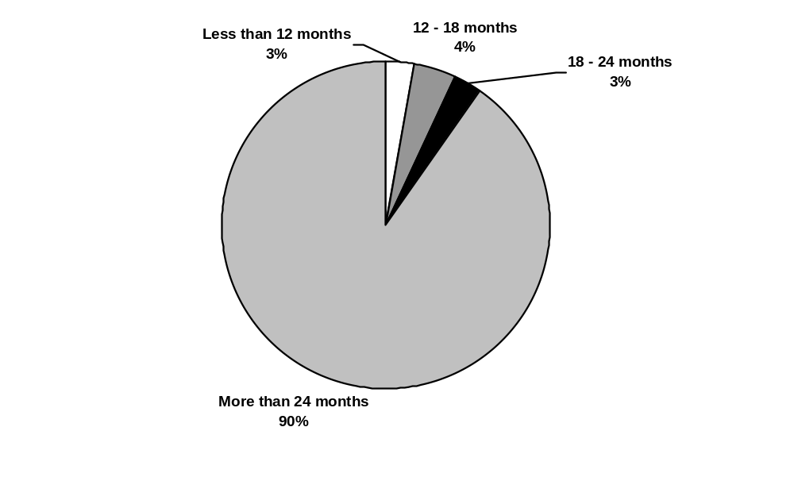

Source: National Survey of Educational Opportunity Centers, 1999–2000.

External evaluations. At the time of the survey, 53 percent of all EOCs had undergone an external evaluation (see figure D.11).

Figure D.11—Percentage of EOCs that have had an external evaluation conducted
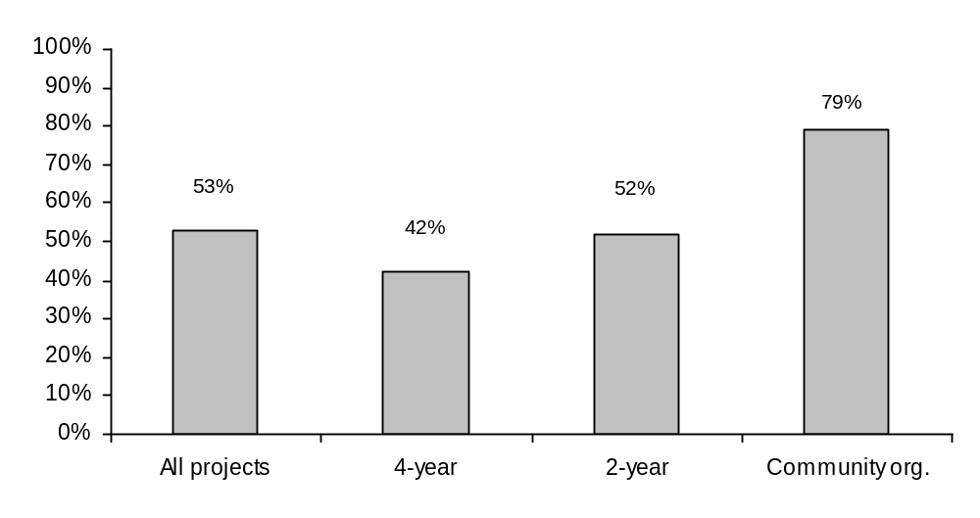

Source: National Survey of Educational Opportunity Centers, 1999–2000.

Formative versus summative evaluations. About 90 percent of EOCs utilize ongoing assessments of their operations and 64 percent utilize a comprehensive year-end study; 63 percent use both methods (see table D.39).

Table D.39—Types of evaluations performed for EOCs
 |  | Host institution
 | All centers | 4-year | 2-year | Community org.
Percentage of centers using:
Ongoing assessment of program operation and success | 91% | 91% | 86% | 100%
Comprehensive year-end study | 64 | 72 | 55 | 60
Percentage of centers using:
Ongoing assessment only | 28 | 22 | 30 | 40
Year-end study only | 1 | 3 | 0 | 0
Both of the above | 63 | 69 | 55 | 60
Neither of the above | 7 | 6 | 15 | 0
Source: National Survey of Educational Opportunity Centers, 1999–2000.

Data used in evaluating center success. To evaluate EOCs’ success in meeting program goals, a variety of indicators are used. For example, virtually all centers consider the percentage of applicable clients that enroll in a postsecondary program and apply for financial aid (see table D.40). In addition, about three-fourths rely on written evaluations by staff and/or clients. Twenty-four percent of EOCs use all six of the types of information listed in the survey.

Table D.40—Information used to evaluate EOCs’ success in meeting their goals and objectives
 |  | Host institution
 | All centers | 4-year | 2-year | Community org.
Percentage of centers using:
Analysis of postsecondary enrollment for applicable clients | 100% | 100% | 100% | 100%
Analysis of financial aid application completion rates for applicable clients | 96 | 97 | 95 | 93
Analysis of GED completion rates for applicable clients | 82 | 85 | 75 | 86
Written client evaluations of services | 75 | 76 | 65 | 86
Written staff evaluations | 73 | 73 | 70 | 79
Analysis of high school reentry rates for applicable clients | 36 | 36 | 35 | 36
Percentage of centers using:
All six of the above | 24 | 21 | 30 | 21
Five of the above | 28 | 36 | 5 | 43
Four of the above | 33 | 30 | 40 | 29
Three of the above | 15 | 12 | 25 | 7
Source: National Survey of Educational Opportunity Centers, 1999–2000.

If there is no Talent Search project in the area, an EOC may serve people under age 19. Veterans are eligible for the EOC program regardless of age. EOCs may also serve individuals already in college, according to the regulations found in 34 CFR 644.3(a)(3).
There were too few EOCs served by private 4-year higher education institutions to allow us to present data separately on them, as we did with regard to Talent Search projects.
Sixty-three directors/coordinators worked full-time and had salary data.

