U.S. Department of Agriculture
Natural Resources Conservation Service

FARMLAND PROTECTION
POLICY ACT
ANNUAL REPORT
FOR
FY 2006

REPORT FROM THE SECRETARY OF AGRICULTURE

TO THE COMMITTEE ON
AGRICULTURE, NUTRITION, AND FORESTRY
UNITED STATES SENATE

AND

THE COMMITTEE ON AGRICULTURE
UNITED STATES HOUSE OF REPRESENTATIVES

April 2007

TABLE OF CONTENTS

- Progress of Federal Agencies in Implementing the Farmland
Protection Policy Act (FPPA) 3

Review and Revision of Federal Policies-Procedures Affecting Farmland Conversion 6

- Federal, State, and Local Efforts to Protect Farmland 7

Figures:

Figure 1- FY 2006 FRPP Financial Assistance Dollars Obligated 7

Figure 2- FY 2006 FRPP Acres Protected 8

Tables:

Table 1- FPPA and Important Farmland Numbers, 1997-2006 4

Table 2- Top Ten States Acres of Farmland Converted 5

Table 3- Acres of Farmland Proposed for Conversion by State 5

Table 4- Breakdown of Acres and AD-1006 forms received 6 by Federal Agencies in 2006

The fiscal year (FY) 2006 Farmland Protection Policy Act (FPPA) Annual Report consists of three components:

I. Progress of Federal agencies in implementing farmland protection;
- Review and revision of Federal policies and procedures affecting farmland conversion; and
III. Federal, State, and local efforts to protect farmland.

I. Progress of Federal Agencies in Implementing Farmland Protection

According to the FPPA final rule, Federal agencies are required to evaluate the impacts of Federally funded projects that may involve converting farmlands to nonagricultural uses and to consider alternative actions that would lessen the adverse effects of the land’s conversion (7 CFR Part 658 and 675). Federal agencies request assistance from the Natural Resources Conservation Service (NRCS) in complying with the FPPA by submitting a Farmland Conversion Impact Rating Sheet (Form AD-1006). The Agency then conducts a Land Evaluation and Site Assessment (LESA) of the project area. NRCS provides land evaluation information, while the responsible Federal agency completes the site assessment portion of the analysis. In order to implement the FPPA, Federal agencies address the potential conversion of agricultural land when reviewing internal projects or providing assistance to local communities.

Prime farmland is land that has the best combination of physical and chemical characteristics for producing food, feed, forage, fiber, and oilseed crops and is available for these uses (the land could be cropland, pastureland, rangeland, forestland, or other land, but not urban built-up land or water). Land used for a specific high-value food or fiber crop is classified as unique farmland. Generally, additional farmlands of statewide importance include those that are nearly prime farmland and that economically produce high yields of crops when treated and managed according to acceptable farming methods. In some local areas, there is concern for certain additional farmlands, even though these lands are not identified as having national or statewide importance. These farmlands are identified as “local importance” by local ordinance or adoption by local government. When jurisdictions adopt local Land Evaluation and Site Assessment systems (LESA), Federal agencies use these systems to review activities that may impact farmland. Less than 10 percent of the reviews offered alternative sites or were able to use a local LESA system for the conversion evaluation and site assessment.
Alaska, Hawaii, the Caribbean, and Pacific Basins Reported No Acres Proposed for conversion.
According to the 2001 USDA National Resources Inventory (NRI) data, in the period between 1992 and 2001 about 6 million acres (28 percent) of the new land developed was prime farmland. Between 1982 and 1992, about 4 million acres (29 percent) was prime farmland.

Correspondingly, the rate of prime farmland development increased from an average of 400,000 acres per year between 1982 and 1992 compared to 600,000 acres per year between 1992 and 2001. For more information about the NRI, visit http://www.nrcs.usda.gov/technical/NRI/.

The following table summarizes the land evaluated as a result of Federal projects from 1997-2006.

Table 1 – FPPA and Important Farmland Numbers 1997-2006

 | % IMPORTANT FARMLAND  (of total land evaluated) | IMPORTANT FARMLAND (within land evaluated) | AGENCIES SUBMITTING REQUESTS
Year | % Total Acres | Acres | No. of Agencies
1997 | 41% | 61,172 | 16
1998 | 45% | 114,382 | 13
1999 | 45% | 83,452 | 13
2000 | 54% | 134,975 | 22
2001 | 34% | 102,604 | 26
2002 | 30% | 75,151 | 26
2003 | 30% | 76,892 | 28
2004 | 52% | 60,040 | 38
2005 | 67% | 73,007 | 25
2006 | 62% | 65,989 | 26

In FY 2006, NRCS received 1,835 AD-1006 forms from 26 Federal agencies requesting assistance to evaluate the impact of proposed conversions of lands that would result from their projects. A total of 106,984 acres of land from 41 States were proposed for conversion to nonagricultural uses. Sixty-two percent of the acres reviewed were identified as important farmland (as defined in 7 CFR Part 657). Of the 65,989 important farmland acres reviewed, 55,538 were prime or unique farmland and 10,451 were State or locally important soils. Federal agencies proposed projects resulting in conversion of 106,984 of farmland. Of the farmland acres proposed for conversion, Florida and North Carolina reported the greatest number of acres with over 26,000 and 8,000 acres respectively. Nine States reported no acres, and five States reported less than 100 acres with Federal impact actions that proposed farmland conversion (Tables 2 and 3).

In FY 2006, the Federal Highway Administration reported the greatest amount of important farmland proposed for conversion with 19,819 acres. Rural Development reported the second greatest amount of proposed conversion, 17,891. These two agencies account for 57 percent of all proposed important farmland conversion (Table 4).

Table 2 - Top Ten States with Acres of Farmland Proposed for Conversion by Federal Projects

STATES | ACRES
Florida | 26,740
North Carolina | 8,171
Texas | 5,956
Georgia | 3,316
Kansas | 2,871
Illinois | 2,726
Missouri | 1,552
California | 1,486
South Dakota | 1,415
Minnesota | 1,392

Table 3 - Acres of Farmland Proposed for Conversion by State

State | Total Land Acres Proposed | Percentage Land Acres Proposed | Total Important Farmland Acres Proposed | Percentage Important Farmland Acres Proposed |  | State | Total Land Acres Proposed | Percentage Land Acres Proposed | Total Important Farmland Acres Proposed | Percentage Important Farmland Acres Proposed
AK | 0 | 0.00% | 0 | 0.00% |  | MT | 686 | 0.64% | 545 | 0.83%
AL | 1,246 | 1.16% | 846 | 1.28% |  | NC | 12,712 | 11.88% | 8,171 | 12.38%
AR | 287 | 0.27% | 20 | 0.03% |  | ND | 159 | 0.15% | 85 | 0.13%
AZ | 0 | 0.00% | 0 | 0.00% |  | NE | 674 | 0.63% | 535 | 0.81%
CA | 4,338 | 4.05% | 1,486 | 2.25% |  | NH | 431 | 0.40% | 3 | 0.00%
CO | 0 | 0.00% | 0 | 0.00% |  | NJ | 0 | 0.00% | 0 | 0.00%
CT | 2 | 0.00% | 2 | 0.00% |  | NM | 128 | 0.12% | 0 | 0.00%
DE | 0 | 0.00% | 0 | 0.00% |  | NV | 0 | 0.00% | 0 | 0.00%
FL | 26,740 | 24.99% | 26,740 | 40.52% |  | NY | 240 | 0.22% | 248 | 0.38%
GA | 5,339 | 4.99% | 3,316 | 5.03% |  | OH | 1,700 | 1.59% | 1,167 | 1.77%
HI | 380 | 0.36% | 445 | 0.67% |  | OK | 619 | 0.58% | 226 | 0.34%
IA | 1,293 | 1.21% | 692 | 1.05% |  | OR | 15 | 0.01% | 17 | 0.03%
ID | 114 | 0.11% | 91 | 0.14% |  | PA | 462 | 0.43% | 296 | 0.45%
IL | 3,021 | 2.82% | 2,726 | 4.13% |  | RI | 2,745 | 2.57% | 10 | 0.02%
IN | 3 | 0.00% | 2 | 0.00% |  | SC | 300 | 0.28% | 30 | 0.05%
KS | 4,043 | 3.78% | 2,871 | 4.35% |  | SD | 1,883 | 1.76% | 1,415 | 2.14%
KY | 1,268 | 1.19% | 1,076 | 1.63% |  | TN | 2,995 | 2.80% | 677 | 1.03%
LA | 1,567 | 1.46% | 1,031 | 1.56% |  | TX | 11,408 | 10.66% | 5,956 | 9.03%
MA | 0 | 0.00% | 0 | 0.00% |  | UT | 0 | 0.00% | 0 | 0.00%
MD | 1,155 | 1.08% | 1,151 | 1.74% |  | VA | 180 | 0.17% | 84 | 0.13%
ME | 646 | 0.60% | 194 | 0.29% |  | VT | 80 | 0.07% | 76 | 0.12%
MI | 90 | 0.08% | 69 | 0.10% |  | WA | 174 | 0.16% | 103 | 0.16%
MN | 1,467 | 1.37% | 1,392 | 2.11% |  | WI | 560 | 0.52% | 342 | 0.52%
MO | 2,141 | 2.00% | 1,552 | 2.35% |  | WV | 9,375 | 8.76% | 0 | 0.00%
MS | 4,318 | 4.04% | 301 | 0.46% |  | WY | 0 | 0.00% | 0 | 0.00%
 |  |  |  |  |  | Totals | 106,984 | 100.00% | 65,989 | 100.00%

Table 4 - Breakdown of Acres and AD-1006 Forms Received by Federal Agencies in FY 2006

Department | Federal Agency | AD1006 Requests Received | Total Land Acres Proposed | Total Important Farmland Acres Proposed | Prime or Unique Acres | State and Local Farmland Acres Proposed
DHS | Federal Emergency Management Agency | 42 | 60 | 48 | 41 | 7
DOA | Army Corps of Engineers | 39 | 15,612 | 14,894 | 14,551 | 343
DOC | Econ Development Administration | 0 | 0 | 0 | 0 | 0
DOD | Department of Defense | 2 | 351 | 226 | 106 | 120
DOE | Department of Energy | 25 | 5,714 | 1,210 | 1,180 | 30
DOI | Bureau of Indian Affairs | 12 | 446 | 302 | 51 | 251
DOI | Bureau of Land Management | 4 | 0 | 0 | 0 | 0
DOI | Department of Interior | 12 | 6,509 | 2,582 | 2,582 | 0
DOI | Fish & Wildlife Service | 3 | 183 | 167 | 132 | 35
DOI | Indian Housing Authority | 70 | 407 | 126 | 126 | 0
DOI | National Park Service | 2 | 91 | 90 | 25 | 65
DOI | Office of Service Mining | 0 | 0 | 0 | 0 | 0
DOJ | Bureau of Prisons | 12 | 72 | 71 | 67 | 4
DOJ | Dept. of Justice | 2 | 3 | 3 | 3 | 0
DOT | Dept. of Transportation | 80 | 2,593 | 1,552 | 1,246 | 306
DOT | Fed Aviation Administration | 55 | 5,859 | 1,745 | 1,180 | 565
DOT | Federal Highway Administration | 455 | 32,074 | 19,819 | 13,918 | 5,901
DOT | Federal Railroad Administration | 0 | 0 | 0 | 0 | 0
EPA | Environmental Protection Agency | 28 | 114 | 65 | 56 | 9
HUD | Housing Urban Development | 191 | 663 | 538 | 428 | 110
HUD | Federal Housing Administration | 21 | 1,330 | 1,199 | 781 | 418
USDA | Farm Service Agency | 1 | 0 | 0 | 0 | 0
USDA | Forest Service | 3 | 9,644 | 0 | 0 | 0
USDA | Natural Resources Conservation Service | 150 | 4,193 | 2,549 | 1,451 | 1,098
USDA | Rural Development | 509 | 19,942 | 17,891 | 16,946 | 945
USDA | Rural Utilities Service | 117 | 1,124 | 912 | 668 | 244
 | TOTALS | 1,835 | 106,984 | 65,989 | 55,538 | 10,451

II. Review and Revision of Federal Polices and Procedures Affecting Farmland Conversion

In order to implement FPPA more efficiently and to implement e-Government initiatives, NRCS has deployed a web-based version of the Farmland Conversion Impact Rating Form (AD-1006). The web-based form is located at http://fppa.nrcs.usda.gov/lesa/. The site allows Federal agencies and agency representatives to register with NRCS and receive site evaluations in a timely manner via the web. This is the first step to fully automating the FPPA process.

III. Federal, State, and Local Efforts to Protect Farmland

The Farm and Ranch Lands Protection Program (FRPP), first authorized by Congress in 1996, provides financial assistance to farmers and ranchers enabling them to keep their land in agriculture. More specifically, the FRPP provides matching funds to State, Tribal, and local governments and non-governmental organizations with existing farmland protection programs to purchase conservation easements from farmers and ranchers. These entities purchase easements from landowners in exchange for a lump sum payment, not to exceed the appraised fair market value of the land’s development rights. Participating landowners agree not to convert their land to non-agricultural uses and to develop and implement a conservation plan for any highly erodable land. Landowners retain all rights to use the property for agriculture. Since program inception in 1996, 49 States have received nearly $451.6 million in FRPP funds to protect approximately 481,000 acres on 2,470 farms. It is estimated that 311,602 acres of prime and unique farmland have been or will be permanently protected from conversion to nonagricultural uses with FRPP easements.

The following two figures display information on programmatic accomplishments through FRPP cooperative agreements that obligated $70 million in FY 2006 FRPP funds to protect 57,930 acres on 277 farms.

Figure 1 - FY2006 FRPP Financial Assistance Dollars Obligated

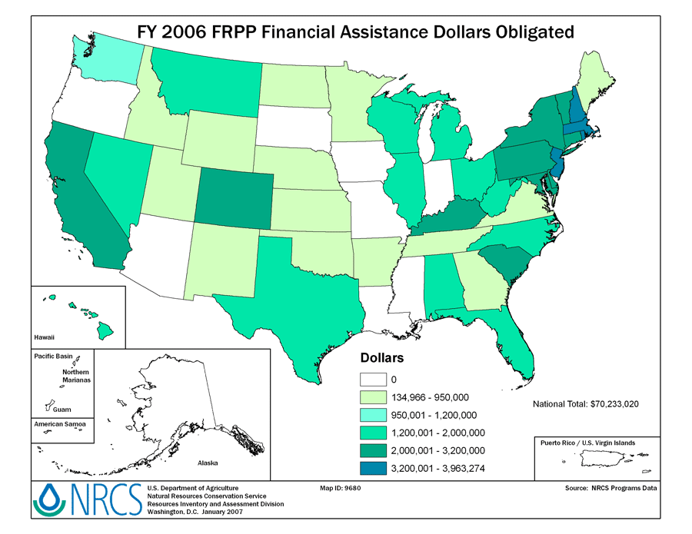

More information on FRPP can be found at http://www.nrcs.usda.gov/programs/frpp/.
For States and local efforts under the provisions of the Farmland Protection Policy Act, [Section 1544(b), Public Law 97-88], the Farmland Information Center (FIC) provides general information, technical assistance, and targeted research based on inquiries from stakeholders to provide answers for communities trying to protect agricultural land resources from unnecessary conversion to nonagricultural uses. The Farmland Information Library is an electronic library located on the web at: http://www.farmlandinfo.org/ .

Figure 2 - FY2006 FRPP Acres Protected
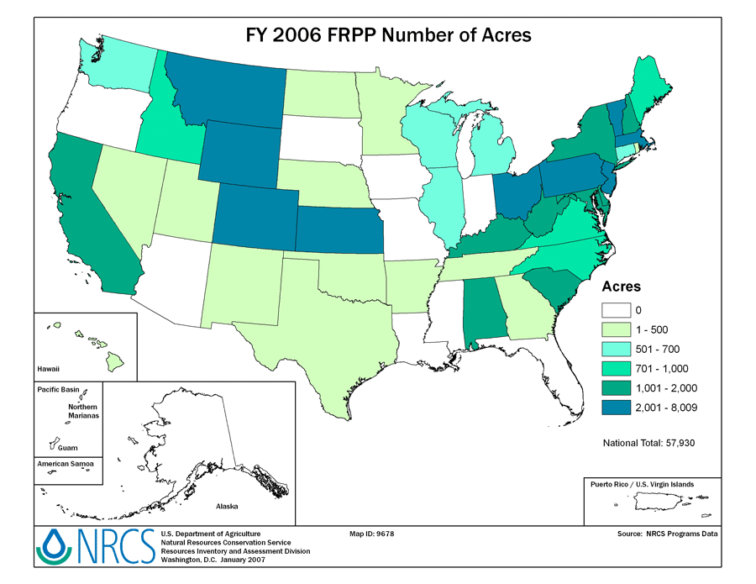

In FY 2006, NRCS invested $200,000 to help maintain the FIC, and the American Farmland Trust (AFT) matched this investment. Web traffic and answer service use remained high. During July, August, and September there were 686,745 hits on the FIC Web site generated during 57,615 visits by 19,424 unique visitors. At the same time, staff served 160 individuals from 38 States, the District of Columbia, and Canada. Direct technical assistance was down 15 percent from last quarter, but up 10 percent from the same quarter last year. Since last October, staff responded to 797 requests for information, up 4 percent from the year-end total reported last year (766).

AFT works with Land Grant Universities to protect farmland and use pilot communities to test tools that help compare the costs of purchasing an easement to the benefits the farm could provide in the future. Efforts to reach out to groups to improve stewardship of easements nationwide are gaining momentum.

The AFT is also continuing to document the impacts of the Purchase of Agricultural Conservation Easement program nationwide.

