Expanded Federal Parent Locator Service

Interstate Roster and Referral Guide

Release 01-01 – Minor

November 19, 2001

Interface Specifications
Interim Phase

August 20, 2001

TABLE OF CONTENTS

PART 1.0 Interstate Roster and Referral Guide

1.1 Introduction 1-1

PART 2.0 State Regional Offices, County Courts and Prosecutor Offices
Addresses

2.1 Overview 2-1
2.2 Implementation 2-1
2.3 IRG Processing 2-1
2.4 Impact on States for New Address Types 2-3

PART 3.0 Standardization of State Address Types

3.1 Overview 3-1
3.2 Implementation 3-1
3.3 IRG Processing 3-1
3.4 Impact on States 3-2

PART 4.0 CSENet Exchange Agreement

4.1 Overview 4-1
4.2 Exchange Agreement Matrix 4-1
4.3 CSENet State Transaction Type Overview 4-1
4.4 CSENet State Exchange Agreement Function Code 4-2
4.5 CSENet 2000 Exchange Agreement Impact on States 4-3

APPENDICES

Appendix A Download Record Layouts A-1
Appendix B Screen Prints B-1

LIST OF CHARTS
Chart 4-1: IRG Public Map – CSENet 2000 State Status Map 4-2
Chart 4-2: CSENet State Exchange Agreement by Function Code 4-2
Chart A-1: Downloading FIPS Codes and Addresses to States A-1

FIGURES
Figure B-1: Addresses and FIPS Codes B-1
Figure B-2: Figure B-2: New Region Address Data B-2
Figure B-3: Select State Region Address B-3
Figure B-4: Edit Region Address Data B-4

PART 1.0

Interstate Roster and Referral Guide

Introduction
The Interstate Roster and Referral Guide (IRG) is an information resource tool used to facilitate the exchange of information relevant to child support enforcement between States. IRG data includes States’ profiles of services and valid Federal Information Processing Standard (FIPS) codes and addresses, Federal and Regional Office data, and demographic data on international Child Support Enforcement agencies.

This document will provide specifications to Interstate Roster and Referral Guide (IRG) Online users for the capability of adding, viewing and modifying addresses for State Regional Offices, county courts and prosecutor offices. In addition, this document will provide the standardized address types. It will also provide an explanation of the new link being provided to the CSENet 2000 Exchange Agreement.

Part 2.0, “State Regional Offices, County Courts, and Prosecutor Offices Addresses,” describes the system modification to allow the capability of adding, viewing and modifying addresses for State Regional Offices, county courts and prosecutor offices. It contains an explanation of the impact on States for the changes.

Part 3.0, “Standardization of State Address Types,” describes the system modification to standardize address types. It contains an explanation of the impact on States for the changes.

Part 4.0, “CSENet 2000 Exchange Agreement,” describes the system modifications to provide the access to the CSENet 2000 Exchange Agreement. It includes an explanation of the impact on States for the changes.

The appendices provide a layout of the format in which States will receive IRG data and the new screen prints associated with the changes.

PART 2.0

State Regional Offices, County Courts and Prosecutor Offices Addresses

Overview
States have requested that the IRG allow State Administrators the capability of adding and modifying address descriptions for State Regional Offices, county courts and prosecutor offices. In addition, the States requested that the State user have the capability of viewing addresses for the State Regional Offices, county courts and prosecutor offices. The addresses for county courts and prosecutor offices will not be available for Public View.

Implementation
Upon implementation of the request, States will have the option to enter a pre-defined number of addresses for State Regional Offices, county courts, and prosecutor offices. An OCSE Administrator and State Administrator will be able to add, modify and delete addresses for Regional Offices, county courts and prosecutor offices.

IRG Processing
This section describes the changes being made to allow the adding, editing and searching for the new address types.

2.3.1 State Regional Offices

The following is a list of valid State Regional Offices address descriptions and their associated address type codes:

- Regional Office I (RON),
- Regional Office II (RTW),
- Regional Office III (RTH),
- Regional Office IV (RFO),
- Regional Office V (RFV),
- Regional Office VI (RSX),
- Regional Office VII (RSV),
- Regional Office VIII (RET),
- Regional Office IX (RNN), and
- Regional Office X (RTN).

New Mode

In New Mode, the State Administrator will see a new “Region” button on the navigation panel. Refer to Appendix B, Figure B-1, “Address and FIPS Codes,” for the revised screen. If this button is clicked, the “New Region Address Data” screen for the State listed in the “Select State” box will display. Refer to Appendix B, Figure B-2, “New Region Address Data,” for the revised screen. On the right side of the box displaying “Select State Region”, click on the down arrow to display a list of valid Regional Offices. Highlight the desired Regional Office and that Regional Office will fill the “Select State Region” box. The new address data will be entered on this screen. The following data is required: Address Description, Address, City, State/Province and Zip Code.

Edit Mode

In Edit Mode, the State Administrator will see a new “State Region” button on the navigation panel. If this button is clicked, the “Select State Region Address” screen for the State listed in the “Select State” box displays. Refer to Appendix B, Figure B-3, Select State Region Address,” for the revised screen. On the right side of the “Select Region From List” box, click on the down arrow to display a list of valid State Regional Offices. Highlight the desired State Regional Office and that Regional Office will be displayed in the “Select Region From List” box. Click on the “Search” button and the desired “Edit Region Address Data” screen will display. Refer to Appendix B, Figure B-4, “Edit Region Address Data,” for the revised screen. The Administrator clicks the appropriate field and makes the desired changes. The following data is required: Address Description, Address, City, State/Province and Zip Code.

Search Capabilities

The State user can search for a State Regional Office address by clicking on the new “State Region” button located on the navigation panel. If this button is clicked, the “Select State Region Address” screen for the State listed in the “Select Region From List” box is display. On the right side of the “Select Region From List” box, click on the down arrow to display a list of valid State Regional Offices. Highlight the desired State Regional Office and that Regional Office will be displayed in the “Select Region From List” box. Click on the “Search” button and the desired State regional address data will display on the “View Region Address Data (View Only) screen.

2.3.2 County Courts and Prosecutors Offices

The following is a list of valid State county courts address descriptions and their associated address type codes:

- Clerk of the Court (CLC),
- Friends of the Court (FRC),
- Circuit Court (CTC),
- District Court (DTC),
- Family Court (FAC),
- Juvenile and Domestic Relations Court (JDR), and
- Tribal Court (TLC).

In addition, the following is a list of valid State prosecutor address descriptions and their associated address type codes:

- Attorney General (AGO),
- District Attorney (DAO),
- State Prosecutor (SPO), and
- Prosecuting Attorney (PAO).

New Mode

After selecting the State on the navigation panel, press the “County” button. The “New County Address Data” screen appears. On the right side of the “Select Address Description” box, click on the down arrow to display a list of valid county address descriptions. The county courts offices and prosecutors offices have been added to this list. Click on the desired address description and that address description will populate the “Select Address Description” field. Tab or click to the next fields and enter, at minimum, the required data: Address Description, County FIPS Code, Address, City and Zip Code.

Edit Mode

After selecting the State on the navigation panel, press the “County” button to display the “Select County Addresses” screen. The Edit user can search by “County Name”, “Contact Name” or “City”. When searching by County Name, select an address description from the “Address Description” drop-down list to narrow the search. On the right side of the “Address Description” box, click on the down arrow to display a list of valid county address descriptions. The new county court offices and prosecutor offices have been added to this list. Highlight the desired Address Description and click on the “County Search” button to display the associated county address data. The address description is displayed and cannot be changed. To select a different address description, the State Administrator must return to the “Select County Address” menu screen.

Search Capabilities

The State user can search for a county address by “County Name”, “Contact Name”, or “City”. If the user searches by “County Name”, the search can be narrowed, by selecting an address description from the “Address Description” drop-down list. On the right side of the “Address Description” box, click on the down arrow to display a list of valid county address descriptions. The county court offices and prosecutor offices have been added to this list. Highlight the desired address description and click on the “County Search” button to display the associated county address data.

Impact on States for New Address Types
The enhancement may require that the States modify their State system to accommodate the new address types for State Regional Offices, county courts and prosecutor offices.

The States may not be prepared to implement the State system modification immediately. A State may elect to delay the entry of the new address types. In making this decision, the State must consider that the additional information will not be available to other States for searching. When the information is entered, they will be available in the download.

In order to allow States additional time to prepare, the download process will however provide two options. The first option, the IRG will allow a State user to select the current download process. In this process, the State will be able to download only the current standard addresses. Any Address Type 2 with an identifier as OTH will not be available. The download available to the States via CSENet 2000 will use this option. The second option, the new standardized download process, will include the new Address Type 2 codes described in the revised record layout. The State must have the ability to recognize the new Address Type 2 codes in its download if selecting this option.

PART 3.0

Standardization of State Address Types

Overview
States have requested that the IRG standardize address types by limiting the number of address types, exclude the OTH option from the download, and not allow the option to add other address types. The standardization of the address types will eliminate inconsistent naming of like addresses across the States, expedite case processing, increase dialog between the States, and reduce the programming modifications for the download process.

Implementation
Upon implementation of this request, the State Administrator will not be able to add other types of address types to the address description. All States will have the same address types available for selection. The OTH address type will be eliminated from the download. The States will have the option for the Administrator to remove the non-standard address types from the web site. In the future, all new address types must be submitted to the OCSE Administrator for approval.

IRG Processing
State Address Types

The following is a list of the new valid State Address Types and Descriptions with its identifier:
- Payment Record Contact (PYR),
- Employer Income Withholding Contact (EIW),
- Bureau of Vital Statistics Contact (BVS),
- Electronic Funds Transfer Contact (EFT),
- Financial Institution Data Match Contact (FDM),
- Guideline Calculations Contact (GCL),
- Non IV-D Contact (NVD), and
- Interstate Roster and Referral Guide Contact (IRG).

In the Administrative section of the IRG, the Administrator has the option of selecting the “State Address Descriptions Admin Screen” link. The link will display the “Online IRG State Address Descriptions” screen. The Administrator may modify or delete an address description by using the Modify or Delete buttons. The New button has been eliminated. The Administrator cannot delete a standard address type. The delete option is allowed for the previously “other” categorized non-standard address types. The Modify button will continue to allow the indication of an address type as Public View. The State Administrator must delete all of the non-standard address types and reenter the address information with the correct address type.

Impact on States

The enhancement may require that the States modify their State system to accommodate the new standardized address types including addresses for State Regional Offices, county courts and prosecutor offices. Also, the States must eliminate all non-standard address types. The download record layout will no longer have the option of providing the “OTH” address type.

The States may not be prepared to implement the State system modification immediately. Therefore, there were no critical modifications to the system that would hinder the retrieval of address information. A State may elect to delay the implementation of these changes. In making this decision, the State must consider the following issues:

- The download results may be incomplete or inaccurate.
- Non-standard addresses will remain on the system as view only.
- Increase in the number of unidentified (OTH) address types in the Address Type 2 codes that will not be part of the download process. The OTH option is eliminated.

In order to allow States additional time to prepare, the download process will provide two options. The first option, the IRG will allow a State user to select the current download process. In this process, the State will be able to only download the current standard address types. Any Address Type 2 with an identifier as OTH will not be available. The second option, the new standardized download process will include the new Address Type 2 codes described in the revised record layout. The State must have the ability to recognize the new Address Type 2 codes in its download if selecting this option. For those States electing to receive the downloaded information via CSENet 2000, only the current standard address types will be available.

PART 4.0

CSENet 2000 Exchange Agreement

Overview
The IRG web site will be enhanced to include a link to the CSENet 2000 State Exchange Agreement Matrix for view only purposes. States requested this matrix during the IRG conference calls and during the Phase II Consensus Plan Work Group sessions.

States requested the expansion of the current exchange agreement process to allow two matching States the option of determining for which of the seven transaction types (L01, CSI, MSC, ENF, PAT, EST, and COL) an exchange agreement exists.

Exchange Agreement Matrix
The CSENet 2000 State Transaction Type Overview page will contain overview information about the Function codes (Transaction Types) along with a matrix showing the functions States exchange and their status with Phase I (LO1, CSI), Phase II (LO1, CSI, ENF, MSC), and Full Functionality (LO1, CSI, ENF, MSC, PAT, EST, COL).

The States will access the CSENet 2000 State Transaction Type Overview page from the IRG Map Page. They will also link from the State Profile page to the CSENet 2000 State Agreement by Function Code page. From the new CSENet 2000 pages, there will also be a link to the CSENet 2000 State Status Map Page http://www.acf.shhs.gov/programs/cse/newhire/csenet/csenet.htm.

The user can click on a CSENet 2000 link from the IRG Map Page or State Profile. A menu will be displayed and allow the user to view the information based on selecting the following options:

- Enter a State to see all its Exchange Agreements.
- Enter two States to see their Exchange Agreements.
- Enter a CSENet 2000 transaction function type to see all States with an Exchange Agreement for that type.
- Enter Phase I (LO1 and CSI) functions to see all States with Exchange Agreements for both function types.
- Enter Phase II (LO1 and CSI and MSC and ENF) functions to see all States with Exchange Agreement functions.
- Enter ALL to display States with all 7 functions programmed.

A help function will be available on the CSENet State Exchange Agreement by Function Code page. The help function will define the description of the CSENet 2000 function codes.

4.3 CSENet State Transaction Type Overview
The following chart illustrates the types of transactions each State exchanges. Also included is information if a State communicates Phase I (LO1, CSI) and Phase II (LO1, CSI, ENF, MSC) transactions, and if a State is Fully Functional (communicates LO1, CSI, ENF, MSC, PAT, EST, COL transactions).

For Specific information regarding what types of transactions are being exchanged among States, click on the State in the left-hand column to display a detailed chart.

Chart 4-1: IRG Public Map – CSENet 2000 State Status Map
State | LO1 |  | CSI |  | ENF |  | MSC |  | PAT |  | EST |  | COL |  | Phase I  (LO1, CSI) |  | Phase II  (LO1, CSI,  ENF, MSC) |  | Fully Functional
State 1
State 2
State 3
Etc.
Totals

4.4 CSENet State Exchange Agreement by Function Code
The following chart illustrates the types of transactions a State has agreed to accept from one or more States. A State will only appear in the list if an agreement exists with the State requested. An indicator will appear in the function code column where an agreement exists for that transaction type.

Chart 4-2: CSENet State Exchange Agreement by Function Code

Sample Name State
Does not communicate using CSENet 2000

Comments:

States | LO1 | CSI | ENF | MSC | PAT | EST | COL | Date  Changed

CSENet 2000 Exchange Agreement Impact on States
The posting of the Exchange Agreement Matrix will provide States with a ready source of information concerning States’ abilities to send and receive interstate communication electronically.

This expansion will provide States with more flexibility compared to the all-or-nothing exchange agreement process presently in place. This encourages opening electronic communications between States for some types of transactions while other CSE system functionality may still be in development.

States may need to modify their internal exchange agreement tables to support this change.

APPENDICES

A. Download Record Layouts
This record format provides the specifications for downloading FIPS Codes and addresses to the States. Type “A” is alphabetic, type “N” is numeric, and type “A/N” is alphanumeric.

Chart A-1: Downloading FIPS Codes and Addresses to States
Label Fields | Position in Record | Length | Type | Description
ADDRESS TYPE 1 | 1-3 | 3 | A | Type of Address:  STA - State  LOC - County/Local  FED - Federal
ADDRESS TYPE 2 | 4-6 | 3 | A | Type of Address:  Address Type 1 LOC  COL - Collection  RES - Responding  CLC - Clerk of the Court  FRC - Friends of the Court  CTC - Circuit Court  DTC - District Court  FAC - Family Court  JDR - Juvenile and Domestic  Relations Court  TLC - Tribal Court  AGO - Attorney General  DAO - District Attorney  SPO - State Prosecutor  PAO - Prosecuting Attorney  Address Type 1 STA  AIP - Automated Interstate Case  Payment Requests  AIS - Automated Interstate Case  Status Requests  CDC - Collection and Distribution  Contact  CEJ - Continuing Exclusive  Jurisdiction Contact  COC - Copy of Order Contact  CRG - Central Registry Contact  EAC - Employer Assistance  Contact  GTI - Genetic Testing and Interstate Teleconferencing Contact  IPC - Interstate Policy Contact  IVD - State IV-D Director  NHR - New Hire Reporting Contact  PRW - PRWORA-Administrative  Policies, Procedures Contact  PAF - Paternity Acknowledgement  Forms Contact  PAT - Paternity Acknowledgement  Copies Contact  PFR - Putative Father Registry  PRC - Privatization Contact  SDU - State Disbursement Unit  SLA - State Long Arm Statute and  Process Contact  SPA - State Paternity  Acknowledgement Hospital  Contact  SPC - Service of Process Contact  SPL - State Parent Locator Service  TOC - Tax Offset Coordinator  UCW - Unemployment  Compensation Withholding  WCW - Workers Compensation  Withholding  PYR - Payment Records Contact  EIW - Employer Income  Withholding Contact  BVS - Bureau of Vital Statistics  Contact  EFT - Electronic Funds Transfer  Contact (EFT)  FDM - Financial Institution Data  Match Contact  GCL - Guideline Calculations  Contact  NVD - Non IV-D Contact  IRG - Interstate Roster and  Referral Guide Contact  RON - Regional Office I  RTW - Regional Office II  RTH - Regional Office III  RFO - Regional Office IV  RFV - Regional Office V  RSX - Regional Office VI  RSV - Regional Office VII  RET - Regional Office VIII  RNN - Regional Office IX  RTN - Regional Office X  Address Type 1 FED  CEN - OCSE Central Office  REG - OCSE Region
STATE CODE | 7-8 | 2 | N | State or Territory Code (e.g., 04)
COUNTY CODE  (Local Code) | 9-11 | 3 | N | County FIPS Code (e.g., 000)
STATE EXTENSION CODE  (Sub Local Code) | 12-13 | 2 | N | Assigned by State (e.g., 00)
DEPARTMENT NAME | 14-48 | 35 | A | Department Name
TITLE | 49-83 | 35 | A | Title
STREET ADDRESS LINE 1 | 84-118 | 35 | A/N | First Line of Street Address
STREET ADDRESS LINE 2 | 119-153 | 35 | A/N | Second Line of Street Address
CITY | 154-183 | 30 | A | Name of the City
STATE OR COUNTRY | 184-203 | 20 | A | State Abbreviation or Country Name
ZIP CODE | 204-212 | 9 | N | U.S. Zip Code
AREA CODE | 213-215 | 3 | N | Telephone Area Code
EXCHANGE | 216-218 | 3 | N | Telephone Exchange
SEQUENCE NUMBER | 219-222 | 4 | N | Telephone Number
EXTENSION NUMBER | 223-227 | 5 | N | Telephone Extension
ACTION CODE | 228-228 | 1 | A | A – Address added  C – Address changed  D – Address deleted
FACSIMILE AREA CODE | 229-231 | 3 | N | Facsimile Telephone Area Code
FACSIMILE EXCHANGE 1 | 232-234 | 3 | N | Facsimile Telephone Exchange
FACSIMILE SEQUENCE NUMBER | 235-238 | 4 | N | Facsimile Telephone Number
RECORD DATE | 239-246 | 8 | N | System generated date when record is added, changed or deleted: CCYYMMDD
FILLER | 247-247 | 1 | A/N | Filler

Screen Prints

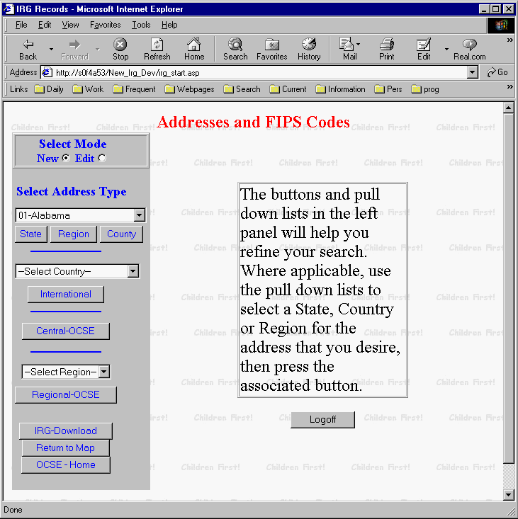

Figure B-1: Addresses and FIPS Codes

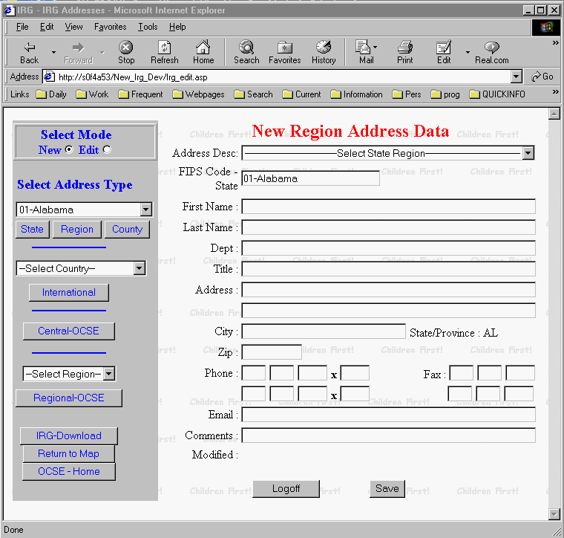

Figure B-2: New Region Address Data

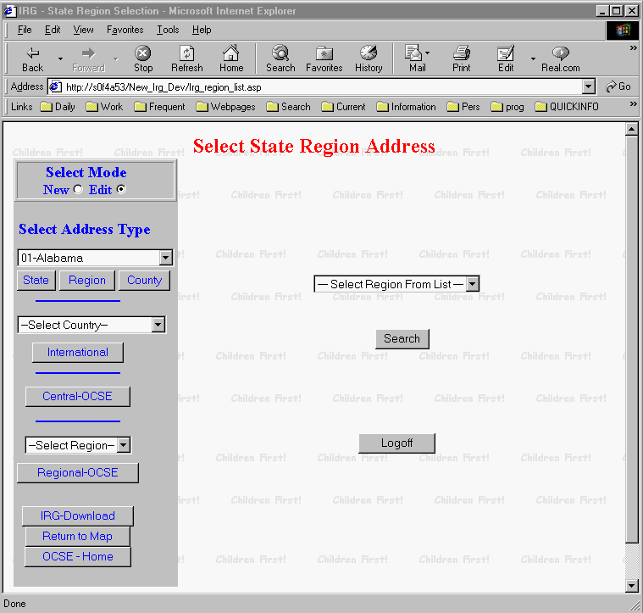

Figure B-3: Select State Region Address

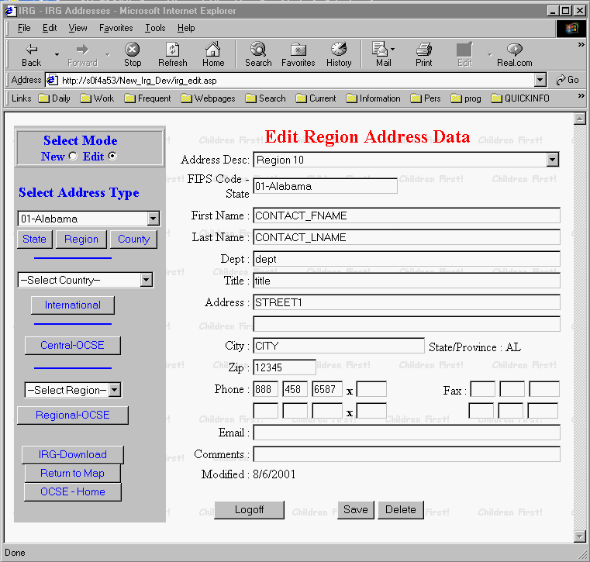

Figure B-4: Edit Region Address Data

