State Financing of Child Support
Enforcement Programs

Final Report

Contract Number 100-96-0011

Prepared for:

Assistant Secretary for Planning and Evaluation

and Office of Child Support Enforcement

Department of Health and Human Services

Prepared by:

Michael E. Fishman

Kristin Dybdal

The Lewin Group, Inc.

John Tapogna

ECONorthwest

State Financing of Child Support
Enforcement Programs

Final Report
Contract Number 100-96-0011

Prepared for:
Assistant Secretary for Planning and Evaluation
and Office of Child Support Enforcement
Department of Health and Human Services

Prepared by:
Michael E. Fishman
Kristin Dybdal
The Lewin Group, Inc.

John Tapogna
ECONorthwest

MEMORANDUM

To: Linda Mellgren, ASPE
Gaile Maller, OCSE

From: Mike Fishman
Kristin Dybdal
John Tapogna

Subject: Final Report:
State Financing of Child Support Enforcement Programs

Enclosed is the final report, State Financing of Child Support Enforcement Programs. This version of the report contains the material previously presented in our briefings for this project and includes additional analysis regarding the distribution of retained TANF collections to families. It also incorporates an executive summary and your other helpful comments on the draft report.

If you have any additional comments or concerns with this deliverable, please let us know. We will work to address them as quickly as possible in order to make this report available for public distribution.

TABLE OF CONTENTS
EXECUTIVE SUMMARY i
I. INTRODUCTION 1
A. Background on the Financing of State Child Support Enforcement Programs 1
B. Purpose of this Study 2
C. Description of this Report 2
II. Issues Framework, information collection Strategy, and time period of
analysis 3
A. Issues Framework 3
B. Information Collection Strategy 4
C. Time Period of Analysis 5
III. STUDY RESULTS 5
A. Composition of State and Local Share of Child Support Enforcement Expenditures 6
1. Nationwide 8
2. State- and County-Administered Programs 9
3. States Anticipating Financing Change and States Not Anticipating Financing Change 10
B. Distribution of Federal Incentive Payments 14
1. Nationwide 14
2. State- and County-Administered Programs 15
C. Distribution of the State Share of Retained TANF Collections 16
1. Nationwide 16
2. State- and County-Administered Programs 17
D. Child Support Enforcement Program Investment or Savings 18
1. State and County Perspective 19
2. State and County Perspective Excluding Payments to Families 21
3. IV-D Program Perspective 23
E. Composition of IV-D Revenues and Recoupments 24
IV. Summary of major Findings 25

APPENDICES:

A: Existing Information Sources
B: States Anticipating Changes in Program Financing
C: Distribution of Federal Incentive Payments
D: Distribution of the State Share of Retained TANF Collections
E: State Child Support Enforcement Program Profiles and Spreadsheet Analyses

EXECUTIVE SUMMARY
Background on the Financing of State Child Support Enforcement Programs
The primary goal of the Child Support Enforcement (CSE) program, established in 1975 under Title IV-D of the Social Security Act, is to ensure that children are supported financially by both parents. The CSE program is a shared undertaking involving Federal, State, and local efforts. While the Federal Government plays a prominent role in setting program standards and policy, evaluating state performance, and providing technical assistance and training to states, states assume basic responsibilities related to program administration. State CSE agencies (or IV-D agencies) work directly with families and/or through local administrative agencies and family and domestic courts to: (1) locate parents; (2) establish paternity; (3) establish child support obligations; and (4) enforce child support orders.
Child support enforcement activities conducted by states under the IV-D program are financed by several streams of revenue. Federal Financial Participation, or FFP, is the largest stream of program revenue. The Federal government reimburses states for 66 percent of allowable child support outlays. Higher matching rates exist for activities such as management information systems development and blood testing in paternity cases.
States finance the remaining 34 percent (or the State share) of CSE expenditures. How states finance their share of the cost of program activities is the subject of this report. There are four types of funding streams that contribute to a greater or lesser degree, depending on the state, to the financing of the State share:
- State and Local Government Appropriations
- Federal Incentive Payments. Under current law, each State receives Federal incentive payments based on the ratio of collections to administrative expenditures (cost-effectiveness) equal to at least six percent of total child support collections. The structure and level of these Federal incentive payments will change dramatically as the provisions of the Child Support Performance and Incentive Act of 1998 (H.R. 3130) are phased-in beginning October 1, 1999. Under H.R. 3130, a state’s annual incentive payments will be based on its paternity establishment, support order, current and arrearage collections, and cost-effectiveness performance levels. Further, as H.R. 3130 provides for a fixed annual payment pool for states (adjusted each year for inflation), each state’s annual incentive payments will depend on other states’ performance levels in these areas. H.R. 3130 also requires that Federal incentive payments be used for IV-D purposes exclusively.
- State Share of Retained TANF Collections. When families apply for the Temporary Assistance for Needy Families (TANF) program, the custodial parent assigns to the State the right to child support obligations collected while the family is receiving welfare benefits. States retain a share of these TANF-related child support collections, returning a share of collections to the Federal Government.
- User Charges and Fees. Several States generate a small amount of program revenue by levying application fees as well as fees for Federal and State tax refund offset and paternity testing services.
Study Purpose and Design
In light of the great latitude States now have in designing assistance programs for families with dependent children under welfare reform, both Congress and the Administration have pointed to the need to simplify the complex financing structure of the CSE program. For example, in the President’s Fiscal Year 1999 Budget, the Administration stated that it would “hold a dialogue with the stakeholders of the child support program to look at ways to address these [financing] problems and, working with Congress, [would] prepare legislation.” The Administration considered detailed information related to the State and local financing of CSE programs across the country critical to understanding the impact of any changes in Federal financing policy on the structure of the CSE program. The overall purpose of this study was to examine the relationship between the Federal CSE program financing structure and the resources allocated to the CSE program at the State and local level by providing factual information on the financing of the CSE program. Our study addressed the following primary study topics:
- What are the various sources of funding for the State and local share of IV-D expenditures? What share of the expenditures does each source represent?
- How is the State share of retained TANF collections allocated at the State and local level?
- How are Federal incentive payments allocated at the State and local level?
In addition, we investigated the extent to which State CSE programs employ cost recovery mechanisms such as user charges and fees and how these funds are used. We also examined the extent to which states “pass-through” child support collections to families who receive public assistance, disregard child support payments in determining TANF benefit levels, or utilize “fill-the-gap” policies. Lastly, we explored whether states were anticipating significant changes to their CSE financing structures in light of: (1) the Personal Responsibility and Work Opportunity Reconciliation Act of 1996 (PRWORA); (2) rapidly declining TANF rolls; (3) the movement toward centralized collections; and (4) H.R. 3130 and the new Federal incentives provision.
Our analysis does not capture State and local resources devoted to child support enforcement activities that are not claimed for Federal matching purposes under the IV-D program. It is equally silent in describing how states utilize the retained TANF collections that are distributed to State and local TANF programs (IV-A programs), except to the extent that these monies are passed on to families.
We collected information through telephone contacts with State IV-D Directors and/or IV-D fiscal staff in every state and the District of Columbia. In a limited number of states with complicated financing structures, we expanded our discussions to include State-level staff outside of the IV-D program such as State Budget Officers, State Human Service Finance Officers, and State legislative finance analysts as well as County IV-D Program Administrators and fiscal staff. Our study approximates a point-in-time analysis for FFY 1997, but it is based on state information from several different time periods, including FFY 1997, SFY 1997, and SFY 1998. Please note that this information may not reflect current State CSE financing structures if significant changes have been made by states since our analysis in the summer and fall of 1998.
Study Results
State and local CSE financing structures are complex. Most programs utilize at least three different funding sources to finance the State and local share of CSE expenditures. In many states, complex intergovernmental financing arrangements exist among the State CSE agency, County and other local administrative agencies, and the family and domestic court system. Twelve states reported having County-administered programs, including: Arizona, California, Colorado, Indiana, Michigan, Minnesota, Nevada, New Jersey, New York, North Carolina, North Dakota, and Ohio. However, 29 states reported having some degree of county-level financial participation in the CSE program.
State and local CSE financing structures are diverse. States and localities mix funding sources in a variety of ways. In 25 states, some combination of general revenue fund appropriations and earmarked Federal incentive payments finance the State and local share of IV-D program costs. Twelve states utilize some combination of general revenue fund appropriations, earmarked Federal incentive payments, and retained TANF collections. Ten states ⎯ Colorado, Connecticut, Delaware, Indiana, Kansas, New Jersey, New York, Rhode Island, South Dakota, and Virginia ⎯ rely solely upon State and or County general revenue fund appropriations to finance their CSE programs. Four states ⎯ Illinois, Kentucky, Oklahoma, and Texas ⎯ appropriate little to no general revenue funds and rely upon Federal incentive payments and the State share of retained TANF collections to fund their share of program costs.
While the mix of funding sources for each state is different, financing for the State and local share of child support expenditures for the nation as a whole comes from State general fund appropriations (42%), Federal incentive payments (25%), the State share of retained TANF collections (15%), and County general fund appropriations (9%). Overall, fees and other cost recoveries finance a negligible proportion (2%) of State and local shares of child support expenditures. While a significant proportion of State and local CSE expenditures are financed with State and County general fund appropriations, in many cases, non-earmarked CSE revenues flowing into State and County treasuries more than offset these appropriations.
Nationally, 74% of Federal incentive payments are earmarked for the CSE program and 26% of the State share of retained TANF collections are earmarked for the CSE program at the State- and local-level. In most states, the largest proportion of the State share of retained TANF collections is returned to the IV-A program.
We derived three approaches to estimating whether the CSE program represents a net investment or savings to states; these three views of CSE program investment or savings fall along a continuum. On one end of this continuum, states as a group appear to reap large net savings from the program; on the other end of this continuum, states as a group appear to make a substantial net investment in the program.
The first approach to estimating State CSE program investment or savings compares all program revenues (excluding FFP) flowing into states and localities, irrespective of administering entity, to the State and local share of CSE expenditures. Using this approach, net program savings across all levels of government totaled $486 million for our time period of analysis. Twenty-one State programs were net investors in the CSE program, 29 were net savers, and one broke even.
Given that nearly half of the states operate pass-through or fill-the-gap programs, the second approach to estimating State CSE program investment or savings – consistent with historical presentations in the U.S. House Ways and Means Green Book – excludes State payments to families from total program revenues. After excluding these State payments to families, net program savings across all levels of government drops by roughly 38%, to $301 million. Using this approach, 25 State programs were net investors in the CSE program, 25 were net savers, and one broke even.
The last approach to estimating State CSE program investment or savings is from the perspective of the IV-D program and counts as revenue only amounts that lawmakers earmark to the IV-D program. Here, the difference between the State and local share of IV-D expenditures and the portion of CSE revenues that are directly earmarked for the IV-D program is the amount of general/special revenue funds appropriated to the IV-D program through the legislative process in states and counties. General/special funds appropriations totaled roughly $671 million for our time period of analysis. Some of these State and County appropriations are offset indirectly by non-earmarked retained TANF collections and Federal incentive payments.
Seventeen states anticipate significant changes to their financing structures as a result of declining TANF caseloads and uncertain incentive funding streams under the Child Support Performance and Incentive Act of 1998 (H.R. 3130). States that anticipate such financing changes rely to a greater extent upon Federal incentive payments and the State share of retained TANF collections to fund their programs than do states that do not anticipate financing changes. Although we found that the financing changes proposed or enacted recently by states are generally consistent with past practice within the program, the effects of PRWORA and H.R. 3130 have not yet fully materialized.
In the body of this report, we present in further detail background on the financing of State CSE programs and the purpose of this study (Section I); our issues framework, information collection strategy, and time period of analysis (Section II); the results of our fact-finding effort related to each of our primary and secondary study topics (Section III); and our major findings (Section IV). Lastly, within several appendices to this report, we provide sources of existing information related to this topic as well as State-specific program financing information for the reader’s reference.

INTRODUCTION

Background on the Financing of State Child Support Enforcement Programs
The primary goal of the Child Support Enforcement (CSE) program, established in 1975 under Title IV-D of the Social Security Act, is to ensure that children are supported financially by both parents. The CSE program is a shared undertaking involving Federal, State, and local efforts. While the Federal Government plays a prominent role in setting program standards and policy, evaluating state performance, and providing technical assistance and training to states, states assume basic responsibilities related to program administration. State CSE agencies (or IV-D agencies) work directly with families and/or through local administrative agencies and family and domestic courts to: (1) locate parents; (2) establish paternity; (3) establish child support obligations; and (4) enforce child support orders.
Child support enforcement activities conducted by states under the IV-D program are financed by several streams of revenue. Federal Financial Participation, or FFP, is the largest stream of program revenue. The Federal government reimburses states for 66 percent of allowable child support outlays. Higher matching rates exist for activities such as management information systems development and blood testing in paternity cases.
States finance the remaining 34 percent (or the State share) of CSE expenditures. How states finance their share of the cost of program activities is the subject of this report. There are four types of funding streams that contribute to a greater or lesser degree, depending on the state, to the financing of the State share:
- State and Local Government Appropriations
- Federal Incentive Payments. Under current law, each State receives Federal incentive payments based on the ratio of collections to administrative expenditures (cost-effectiveness) equal to at least six percent of total child support collections. The structure and level of these Federal incentive payments will change dramatically as the provisions of the Child Support Performance and Incentive Act of 1998 (H.R. 3130) are phased-in beginning October 1, 1999. Under H.R. 3130, a state’s annual incentive payments will be based on its paternity establishment, support order, current and arrearage collections, and cost-effectiveness performance levels. Further, as H.R. 3130 provides for a fixed annual payment pool for states (adjusted each year for inflation), each state’s annual incentive payments will depend on other states’ performance levels in these areas. H.R. 3130 also requires that Federal incentive payments be used for IV-D purposes exclusively.
- State Share of Retained TANF Collections. When families apply for the Temporary Assistance for Needy Families (TANF) program, the custodial parent assigns to the State the right to child support obligations collected while the family is receiving welfare benefits. States retain a share of these TANF-related child support collections, returning a share of collections to the Federal Government.
- User Charges and Fees. Several States generate a small amount of program revenue by levying application fees as well as fees for Federal and State tax refund offset and paternity testing services.

Purpose of this Study
In light of the great latitude States now have in designing assistance programs for families with dependent children under welfare reform, both Congress and the Administration have pointed to the need to simplify the complex financing structure of the CSE program. For example, in the President’s Fiscal Year 1999 Budget, the Administration stated that it would “hold a dialogue with the stakeholders of the child support program to look at ways to address these [financing] problems and, working with Congress, [would] prepare legislation.”
The Administration considered detailed information related to the State and local financing of CSE programs nationwide critical to understanding the impact of any changes in Federal financing policy on the structure of the CSE program. This basic description of State CSE financing across the country would inform both the Administration’s discussions with program stakeholders as prescribed in the President’s Budget, and an anticipated policy debate between the Department of Health and Human Services (DHHS), the Office of Management and Budget (OMB), and Congress. The overall purpose of this study, then, was to examine the relationship between the Federal CSE program financing structure and the resources allocated to the CSE program at the State and local level by providing factual information on the financing of the CSE program. Our study neither explores nor recommends options for changing the current financing scheme.

Description of this Report
In the remainder of this report, we describe our issues framework, information collection strategy, and time period of analysis (Section II); present the results of our fact-finding effort related to each of our primary and secondary study topics (Section III); and summarize our major findings (Section IV). Finally, within several appendices to this report, we provide sources of existing information related to this topic as well as State-specific program financing information for the reader’s reference.

Issues Framework, information collection Strategy, and time period of analysis

Issues Framework
Several existing studies, as well as IV-D fiscal data and related information available from the Federal Office of Child Support Enforcement (OCSE), depict the complex manner in which the child support program is financed. These existing sources of information were utilized as a launching point for further fact gathering and analysis through this task order. It is important to note that while informative, existing sources do not provide a complete picture of the financing of State CSE programs. For example, while certain studies list the various sources of funding for State and local IV-D expenditures, they do not report what share of expenditures each funding stream represents. Further, existing analyses do not illustrate in sufficient detail the manner in which program revenue streams such as the State share of retained TANF collections and Federal incentive payments are allocated within states, counties, and other local administering entities.
This project addressed these information needs by exploring the following primary study topics:
- What are the various sources of funding for the State and local share of IV-D expenditures? What share of the expenditures does each source represent?
- How is the State share of retained TANF collections allocated at the State and local level?
- How are Federal incentive payments allocated at the State and local level?
In addition to addressing the topics listed above, we collected information related to several secondary study topics. For instance, we investigated the extent to which State CSE programs employ cost recovery mechanisms such as user charges and fees and how these funds are used. We also examined the extent to which states “pass-through” child support collections to families who receive public assistance, disregard child support payments in determining TANF benefit levels, or utilize “fill-the-gap” policies.
Lastly, in commissioning this study, OCSE was particularly interested in exploring whether states were anticipating significant changes to their CSE financing structures in light of: (1) the Personal Responsibility and Work Opportunity Reconciliation Act of 1996 (PRWORA); (2) rapidly declining TANF rolls; (3) the movement toward centralized collections; and (4) H.R. 3130 and the new Federal incentives provision. Determining whether a state was anticipating a change or not was a somewhat subjective process. For example, some IV-D Directors anticipated the need of a significant funding increase but anticipated legislative support through existing revenue sources. Other states were requesting smaller increases but predicted difficulty in obtaining them. In the end, we classified a state as “anticipating a change” if the IV-D Director was considering an alternative means to pay for his or her program based on a perceived funding shortfall. Through our selection process, we identified 17 states that were anticipating a financing change. Examples include State IV-D Directors who were:
- Proposing the use of State or local general funds for the first time;
- Considering an expansion in fees or user charges;
- Attempting to tap an increased share of retained TANF collections or Federal incentive payments; and
- Requesting a share of the State’s Medicaid appropriation based on estimated savings generated through the enforcement of medical support orders.
It is important to note what our analysis does not capture. Our analysis does not capture State and local resources devoted to child support enforcement activities that are not claimed for Federal matching purposes under the IV-D program. It is equally silent in describing the relationship between the level and structure of State child support enforcement financing and program performance. Furthermore, our study does not illuminate how states utilize the retained TANF collections that are distributed to State and local TANF programs (IV-A programs), except to the extent that these monies are passed on to families.

Information Collection Strategy
To begin our work on this project, we met with several experts in the area of State child support financing. Over the course of two weeks, we spoke directly with eight State IV-D Directors; numerous stakeholders from State and advocacy organizations such as the American Public Human Services Association, the National Association of Counties, the National Conference of State Legislators, the National Governors’ Association, the National Child Support Enforcement Association, the Center for Budget and Policy Priorities, the Center for Law and Social Policy, the Children’s Defense Fund, and the National Women’s Law Center; as well as Congressional staff. Through these individual meetings, we were able to determine the utility of our study to those in the field and refine our initial study topics accordingly, collect sources of additional State and local information, and uncover any other analysis needs among key stakeholders. Based on the input of these experts, we also determined the method by which we would collect information related to our primary and secondary study topics.
We collected information through telephone contacts with State IV-D Directors and/or IV-D fiscal staff in every state and the District of Columbia. In a limited number of states with extremely complicated financing structures, we also spoke with State-level staff outside of the IV-D program such as State Budget Officers, State Human Service Finance Officers, and State legislative finance analysts. In certain County-administered programs, namely California, Colorado, Indiana, and Michigan, we expanded our discussions to include County Program Administrators and fiscal staff because local financing information was not easily obtained through our initial State-level conversations.
Although the length of time it took to collect all pertinent information varied considerably by State program, our general process for collecting information in most states was quite similar. To begin the process, we made an initial contact with the State IV-D Director to describe our study and to schedule a longer telephone conversation. During this longer telephone conversation, which often involved the IV-D Director as well as his or her fiscal staff, we gathered background information and financial figures related to our primary and secondary study topics. Next, we organized the information we had collected for each program into a child support enforcement financing profile and spreadsheet analysis; these documents were sent to all State contacts for review and verification. In some cases, our contacts had only minor revisions to how we had depicted the financing structure in their state. In other cases, verification was a back-and-forth process involving several additional conference calls and consultation with staff outside of the IV-D system. As of the date of this final report, we have obtained final verification from our program contacts in all but one state.

Time Period of Analysis
Whenever possible, we collected figures related to the composition of the State and local share of CSE expenditures, the distribution of Federal incentive payments and the State share of retained TANF collections, and other study topics for Federal Fiscal Year (FFY) 1997. However, several states found information from State Fiscal Year (SFY) 1997, and in some cases SFY 1998, much easier to access and report. As we were primarily interested in computing nationwide proportions related to the State financing of child support enforcement programs, we accepted SFY figures from programs without adjustment. To summarize, our study approximates a point-in-time analysis for FFY 1997, but it is based on state information from several different time periods, including FFY 1997, SFY 1997, and SFY 1998.

STUDY RESULTS
Our primary task was to describe the composition of the State and local share of child support expenditures across the county. We aggregated the information collected from CSE programs in all states and the District of Columbia, computing nation-wide totals or percentages for relevant areas of interest. In a number of cases, we used two methods to calculate national averages: 1) weighting each state equally, and 2) weighting each state according to its dollar contribution to total child support expenditures.
The example below illustrates how the methods can yield different averages. In our example, State A finances its child support program with general fund dollars, Federal incentives, and retained TANF collections. State B – a larger state that spends considerably more on enforcement – relies on general funds and incentives. To calculate the two-state composition of expenditures – weighting each state equally – we take the simple average of each revenue source’s contribution to the State’s total IV-D budget. For the general fund, our estimate of 63% is the average of State A’s 50% general fund share and State B’s 75% general fund share.
When we recalculate the two-state average on the general fund – this time weighting the average by the States’ dollar contributions – our answer is 73%, an increase of ten percentage points. We derive that share by dividing total general funds appropriated in the two states ($16 million) by total child support spending in the two states ($22 million).
Much of the difference in averages produced by the two methods in our study can be explained by the financing behavior in California and New York. These two states have the largest child support programs – in dollar terms – and dominate the averages calculated by the second method.
Example of Methods used to Calculate the Average Composition of
the State and Local Share of Child Support Expenditures

Method | General Fund Appropriations | Federal  Incentive  Payments | Retained TANF Collections | Total: State and Local Share of Expenditures
State A Dollars | $1,000,000 | $500,000 | $500,000 | $2,000,000
State A Composition | 50% | 25% | 25%
State B Dollars | $15,000,000 | $5,000,000 | -- | $20,000,000
State B Composition | 75% | 25% | 0%
Average Composition:
Method 1: States Weighted Equally | 63% | 25% | 13% | 100%
Method 2: States Weighted by Dollars | 73% | 25% | 2% | 100%

In addition to examining information on a nationwide basis, we compared our results for State-administered versus County-administered programs whenever this comparison was meaningful. Twelve states reported having County-administered programs, including: Arizona, California, Colorado, Indiana, Michigan, Minnesota, Nevada, New Jersey, New York, North Carolina, North Dakota, and Ohio. These CSE programs account for approximately 44% of IV-D costs and 49% of collections.

Composition of State and Local Share of Child Support Enforcement Expenditures
Through our review, we identified eight specific revenue sources that states and localities use to finance their share of child support enforcement expenditures. The Federal share of CSE program expenditures, or FFP, is not included in this analysis by design.
Below, we list each source of financing for the State and local share of CSE expenditures and describe how we determined whether a program employed a particular source.
- Federal Incentive Payments. These amounts consist of Federally-financed incentive payments that were directly earmarked to the IV-D program at either the state or local level. We did not count incentive payments that were deposited into general funds, mingled with other revenue streams, and appropriated to the IV-D program.
- Retained TANF Collections. Amounts of TANF collections — retained by the state or local government—that are explicitly earmarked to the IV-D program.
- State General Funds. Amounts appropriated to the IV-D program from the state general fund. In some cases, the size of the appropriation is based — implicitly — on the level of IV-D incentive or retained-collection revenues.
- State General Funds Paid as Incentives. These amounts typically consist of state-financed incentive payments that fund county-level IV-D activities.
- County General Funds. These amounts represent a direct appropriation from county general funds to the IV-D program. As is the case at the state level, these appropriations are often supported — implicitly — by IV-D incentive or collection revenues.
- Fees/Recoveries. The amounts represent fees or charges paid by clients of the IV-D system. Examples include application fees, payment-processing charges, and blood-testing fees.
- Other. This category includes a number of financing mechanisms that were unique to a limited number of states. For example, a handful of states finance their IV-D activities — in part — with special social service funds. Such funds function like general funds but fund only social service programs e.g., TANF, Medicaid, child support.
We carefully avoided double-counting State and local resources available to the IV-D program, which is a common pitfall of these types of analyses. The total investment we report for each state is comparable with the amount recorded by OCSE as the State’s share of annual spending in FFY 1997.

Nationwide

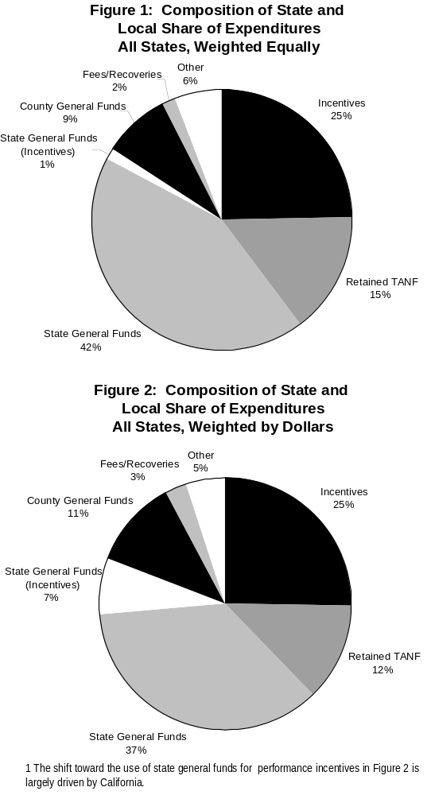
Exploring the first of our primary study topics, we compiled the various sources of funding for the State and local share of IV-D expenditures across the country, and determined what share of the expenditures each source represents.
As Figure 1 illustrates, across all states (weighted equally), the major sources of financing for State and local shares of child support expenditures are State general funds (42%), Federal incentive payments (25%), the State share of retained TANF collections (15%), and County general funds (9%). One can also see that fees and other cost recoveries finance a negligible proportion (2%) of State and local shares of child support expenditures.
Also depicting the composition of State and local financing across the country, this time weighting states by dollars, Figure 2 reflects a shift toward the use of State general fund performance incentives to finance State and local IV-D expenditures. The State of California is largely responsible for this result. Aside from this difference, the distributions represented in Figures 1 and 2 are comparable.

State- and County-Administered Programs

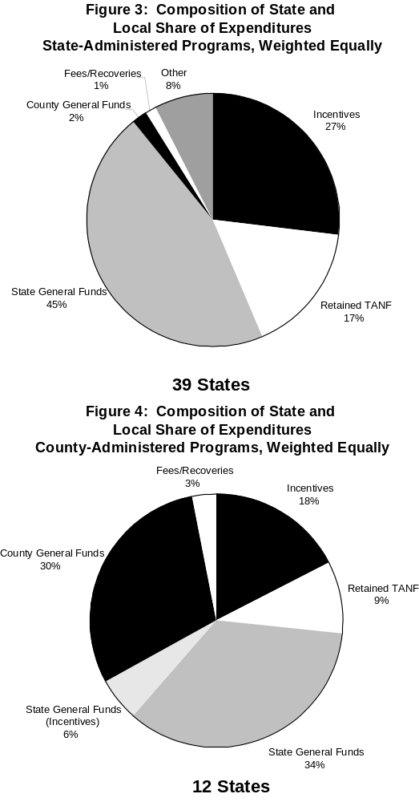
Figures 3 and 4 present the composition of sources of financing for State and local shares of child support expenditures (states weighted equally) in State- and County-administered programs respectively. In general, there appears to be less earmarking of IV-D revenues such as Federal incentive payments and the State share of retained TANF collections in County-administered than in State-administered programs.
In addition, County-administered programs also rely upon County general fund appropriations to a far greater extent than do State-administered programs.
Figure 4 understates the importance of incentives in the financing of county-administered programs to some extent. In several jurisdictions, officials reported that lawmakers appropriated county general funds with the implicit understanding that part or all of the appropriation would be reimbursed with federal incentive payments – transferred from the state to the county. Nevertheless, in these cases, the counties did not earmark incentive payments to the IV-D program.

States Anticipating Financing Change and States Not Anticipating Financing Change
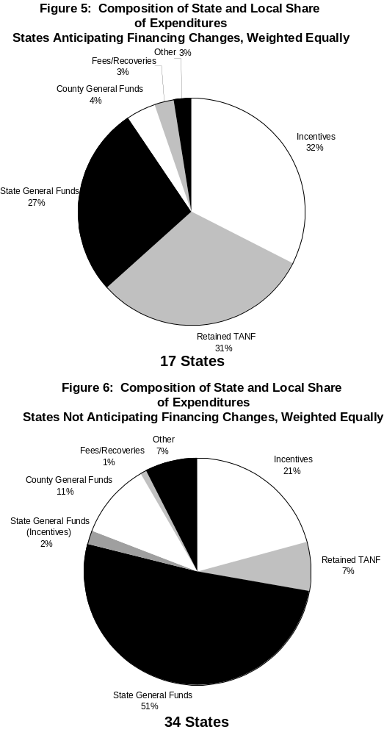

Seventeen states reported that they anticipate significant changes to their CSE program financing structures; most of these states cited declining TANF caseloads as the chief reason behind these changes.
Although the consequences of welfare reform have not yet been fully realized, the financing changes proposed or enacted recently by states are generally consistent with past practice within the program. For example, most of these states plan to request general revenue fund appropriations from their legislatures for the first time or to increase cost recovery efforts.
We were interested in whether or not the composition of the State and local share of child support enforcement expenditures is different for states that anticipate financing changes than for states that do not anticipate financing changes. As presented in Figures 5 and 6 below, states that anticipate financing changes rely upon Federal incentive payments and the State share of retained TANF collections to a greater extent than do states that do not anticipate financing changes. States that do not anticipate financing changes fund most of their share of child support expenditures with State and County general fund appropriations.

This point can be developed in further detail by examining a taxonomy we defined to categorize states by “type” of CSE program financing structure (see Figure 7). Ten states ⎯ Colorado, Connecticut, Delaware, Indiana, Kansas, New Jersey, New York, Rhode Island, South Dakota, and Virginia ⎯ rely solely upon State and or County general revenue fund appropriations to finance their CSE programs. We have classified these states as “Category 1” states. In contrast, four states ⎯ Illinois, Kentucky, Oklahoma, and Texas ⎯ appropriate little to no general revenue funds to finance their CSE programs, instead relying solely upon Federal incentive payments and the State share of retained TANF collections. We have classified these states as “Category 4” states. As one can see from the table, the majority of states are classified as “Category 2” or “Category 3”; these categories represent states that are reliant upon some combination of general revenue fund appropriations, earmarked Federal incentive payments, and earmarked retained TANF collections.

Figure 7: Taxonomy of Financing Structures
Category 1:  States Reliant Upon  General/Special Funds | Category 2:  States Reliant Upon General/Special Funds and Earmarked Federal Incentives
CO, CT, DE, IN, KS, NJ, NY, RI, SD, VA | AK, AL, CA, FL, GA, HI, IA, MA, MD, MI, MN, MS, ND, NE, NH, NV, OH, PA, SC, TN, UT, VT, WA, WI, WV
Category 3:  States Reliant Upon General/Special Funds, Earmarked Federal Incentives, and Retained TANF Collections | Category 4:  States Reliant Upon Federal Incentive Payments and Retained TANF Collections:
AR, AZ, DC, ID, LA, ME, MO, MT, NC, NM, OR, WY | IL, KY, OK, TX

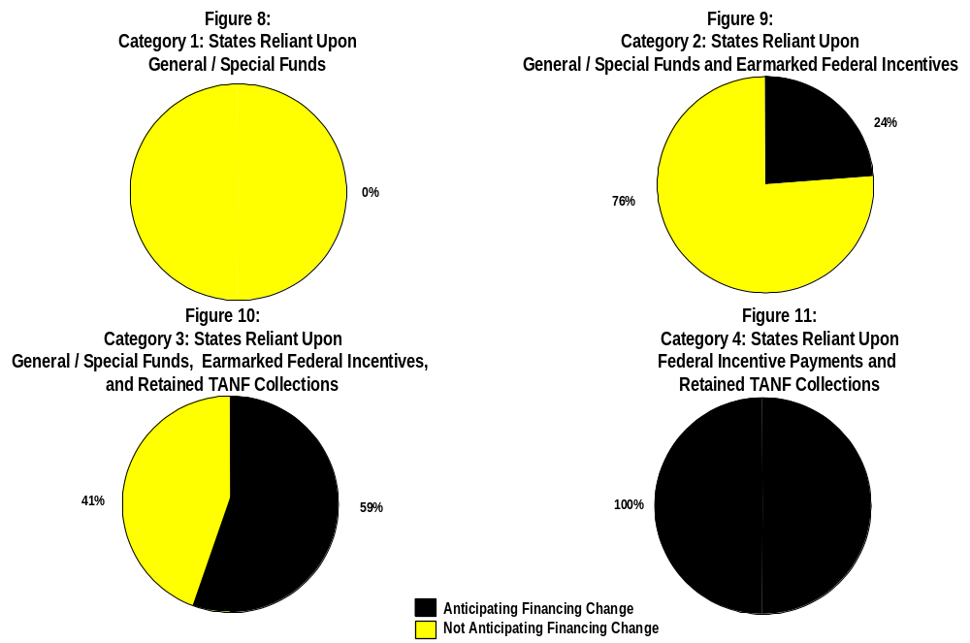
As Figure 8 below illustrates, none of the states in Category 1, states reliant solely upon State and County general revenue fund appropriations to finance CSE program activities, anticipate financing changes. However, those states with more diverse sources of program revenue including Federal incentives and the State share of retained TANF collections are more likely to anticipate financing changes (see Figures 9 and 10). All four of the states in Category 4, states that rely almost solely upon Federal incentives and retained TANF collections, anticipate financing changes in the future (see Figure 11).
The responses by IV-D Directors indicate that the recent, sharp declines in TANF rolls have had a significant impact on child support financing in a number of states. A decline in the number of families receiving TANF inevitably affects TANF-related collections. While TANF caseloads fell by 30 percent during 1997-1998, child support collections made on behalf of TANF families remained about the same or declined modestly in most states. OCSE officials believe collections have not fallen as rapidly as the overall caseload because states have improved their enforcement of child support for the smaller number of families who remain on TANF. Moreover, arrears collections have not yet been affected by the “Families First” provision within PRWORA, effective October 1, 2000, whereby families no longer receiving public assistance will have priority in the distribution of child support arrears. Nevertheless, after years of steadily increasing TANF collections, these slight declines have disrupted the financing structures in a number of states.
A decline in TANF collections affects local financing in two ways. First, declining TANF collections restrict revenues in the 16 states that earmark such collections to the IV-D program. These states, which had become accustomed to consistent and large increases in collections in the past, are experiencing the equivalent of a funding freeze or cut. Federal legislation ensures that the amount a state receives in TANF collections will not fall below its 1995 level; however, strong growth in TANF collections during 1995-1998 has rendered this so-called “hold-harmless” provision meaningless in many states. That is, a state may experience a decline in collections during 1997-1998 with the 1998 collection level still well above the 1995—or hold harmless—level. Second, declining TANF collections affect the amount of federal incentive payments a state receives for both TANF and non-TANF collections. Under current law, effective until October 1, 1999, the Federal government calculates incentive payments as a percentage of TANF and non-TANF collections, with non-TANF incentive payments capped at 115 percent of TANF incentive payments for each state. As such, the amount of incentives received by a state for both TANF and non-TANF families declines as the amount of child support the state collects on behalf of TANF families declines.
State IV-D directors expressed further concern over the new Federal incentives payment structure provided by the Child Support Performance and Incentive Act of 1998 (H.R. 3130), which will be phased-in beginning October 1, 1999. Their primary concern was the lack of predictability of future incentive funding streams that stems from two changes to the Federal incentive payment structure. First, as described in the introduction to this report, states receive Federal incentive payments under current law based on their performance in only one area: cost-effectiveness. Under H.R. 3130, a state’s annual incentive payments will be based on its performance in five key areas: establishment of paternities, establishment of child support orders, collections on current support owed, collections on previously or past due child support owed, and cost-effectiveness. Second, because H.R. 3130 provides for a fixed annual payment pool for states (adjusted each year for inflation), each state’s annual incentive payments will also depend on other states’ performance levels.

Distribution of Federal Incentive Payments

Nationwide

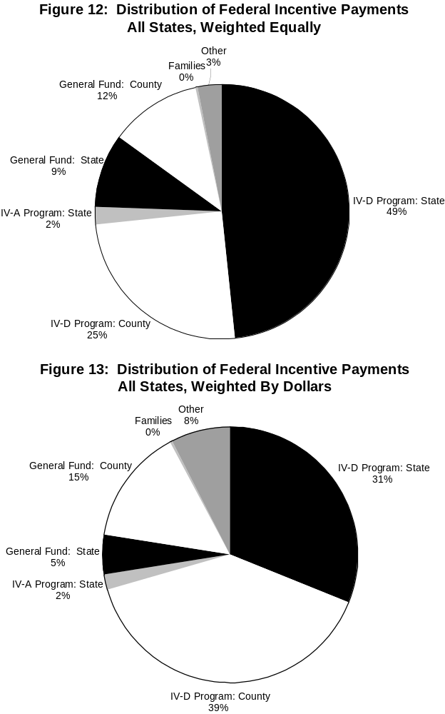
Our next primary study topic addresses how States and localities allocate the Federal incentive payments that they receive. Both Figures 12 and 13 show that across all states, most Federal incentive payments are directly allocated to the IV-D program. For instance, when weighting states equally (Figure 12), 74% of Federal incentive payments are earmarked for the IV-D program at the State or local level.
Further, a large percentage of Federal incentive payments that are not earmarked for the IV-D program, such as the monies that flow to State and County general funds, reimburse these entities for general fund appropriations to the program.
As one can see by comparing Figure 12 (all states weighted equally) and Figure 13 (all states weighted by dollars), counties in large states receive a larger proportion of Federal incentive payments to finance IV-D and other activities than do counties in smaller states. Again, much of this difference can be explained by child support enforcement financing structures in California and New York.

2. State- and County-Administered Programs

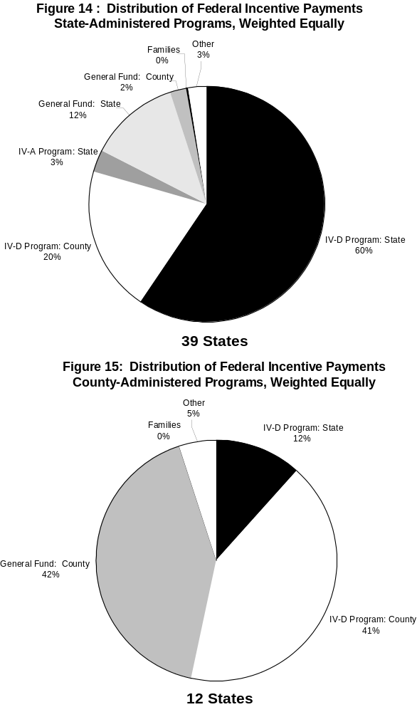
Federal law requires states to pass incentives through to local child support agencies if these agencies accumulate child support enforcement costs. Unsurprisingly, more Federal incentive payments are transferred to counties in County-administered programs than in State-administered programs (see Figures 14 and 15). Across County-administered programs, 83% of Federal incentive payments are either earmarked for County IV-D activities or transferred to County treasuries, while across State-administered programs, only 22% of Federal incentive payments flow to the local level.
However, as the Federal incentive payments that are allocated to County general funds largely reimburse counties for their IV-D expenditures, Federal incentive payments are less likely to be earmarked for IV-D activities in County-administered programs than in State-administered programs.
Because Federal incentive payments are based on collections, not expenditures, it is possible for incentives to exceed a State or County’s share of IV-D expenditures. Certain counties receive incentive payments in excess of their IV-D expenditures, others do not. While we have not identified the individual “winners” and “losers” here, in certain cases, states can distinguish between these counties.
.

Distribution of the State Share of Retained TANF Collections

Nationwide

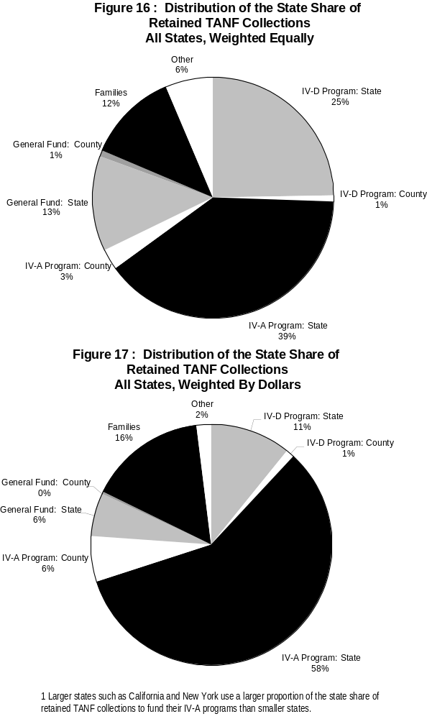
Representing how the State share of retained TANF collections are allocated, both Figures 16 and 17 illustrate that the largest proportion of the State share of retained TANF collections is returned to the IV-A program. Moreover, it is the State level of government that claims the majority of these collections as they typically finance the original welfare benefit expenditure. This is especially true among larger states like California and New York.
Nationally, states earmarked only 12% of retained TANF collections (weighted by dollars) to IV-D programs. This relatively small share suggests that most states – and particularly the larger spenders – view retained TANF collections as an offset to their TANF budget rather than revenue to the IV-D or other social service programs.
Approximately 16% of the State share of retained TANF collections, or roughly $180 million, is passed on to families throughout the country under $50 pass-through/ disregard and “fill-the-gap” policies (see Figure 17). This amount does not represent the full cost of $50 pass-through/disregard and fill-the-gap policies, however, as a few states finance their family payments with State general fund appropriations. Beginning in 1997, State pass-through programs were optional and the Federal government no longer shared in the cost of passing collections through to TANF families. At the time of our survey, 22 states opted to run such programs.

State- and County-Administered Programs

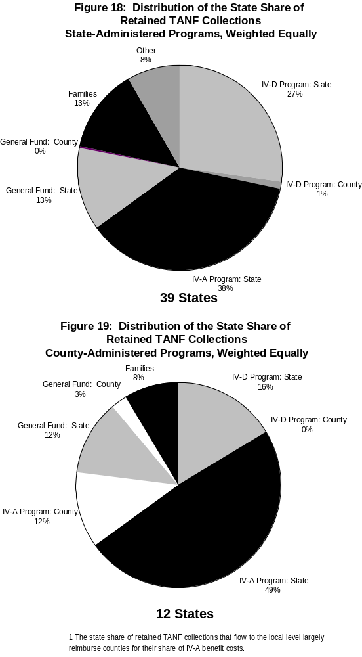
As it does for all states in the aggregate, the IV-A program receives the largest proportion of the State share of retained TANF collections in both State- and County-administered programs (see Figures 18 and 19, respectively).
Our conversations with IV-D directors and their staff also suggested that in county-administered programs (Figure 19), the State share of retained TANF collections that flow to local treasuries largely reimburse counties for their share of IV-A benefit costs.

Child Support Enforcement Program Investment or Savings
Together with ensuring financial support to children, an original goal of the child support enforcement program was to recover or reduce transfers made to families receiving cash welfare. Given that mission, lawmakers at the State and Federal levels have frequently asked administrators to estimate whether the program represents a net cost or savings to their respective budgets.
Utilizing the IV-D program information we collected through this task order, we derive below three views of CSE program investment or savings across both State and County-levels of government. These three views of CSE program investment or savings fall along a continuum. On one end of this continuum, states appear to reap large net savings from the program, while on the other end, states appear to make a substantial net investment in the program.
The first method of estimating CSE program investment or savings compares the State’s share of administrative expenditures with child support revenues – defined as Federal incentive payments and the State’s share of retained TANF collections. Given that nearly half of the states operate pass-through or fill-the-gap programs, the second method – consistent with historical presentations in the U.S. House Ways and Means Green Book – excludes payments made to families from the definition of IV-D revenues. Finally, the third method counts as IV-D revenue only amounts that lawmakers earmark to the IV-D program. This approach isolates the amount of State and County general fund monies that are appropriated to the IV-D program through the legislative process.

State and County Perspective
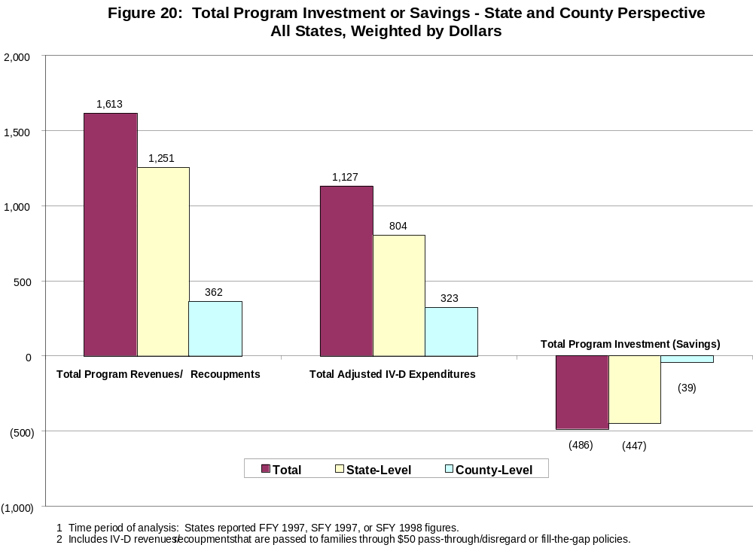Figure 20 provides an analysis of CSE program investment or savings from the perspective of states and counties overall. Total program revenues/recoupments – which includes all incentives, TANF collections, and fees and recoveries retained by the state regardless of their distribution – equaled more than $1.6 billion, with about three-quarters of that total ($1.25 billion) accruing to state governments. Meanwhile, non-federal expenditures equaled ($1.1 billion) with state governments contributing about $800 million and localities spending more than $300 million. Subtracting the expenditures from the revenues and recoupments, we find non-federal levels of government saved a total $486 million with the bulk of those savings ($447 million) being realized by state governments. However, these savings are largely the result of the State share of retained TANF collections, and states are the main contributors to the State and local share of IV-A program expenditures. Because the original intent of the CSE program was to use child support collections to reimburse welfare outlays, many would argue that retained TANF collections simply reimburse earlier State expenditures and do not represent savings for the State.

The following figure (Figure 21) displays the number of State CSE programs that invested, saved, or broke even from the perspective of states and counties. Overall, 21 State programs invested, 29 saved, and one broke even. Similarly, the State-level of government in 20 states invested, the State-level of government in 30 states saved, and the State-level of government in one state broke even. Lastly, the County-level of government in 15 states invested, the County-level of government in 11 states saved, and the County-level of government in three states broke even. Note that a total of 29 State CSE programs reported having some degree of local participation.

Figure 21: Analysis of Total Program Investment or Savings
(State and County Perspective)

 | Number with Program Investment | Number with Program Savings | Number that  Break-Even
State Programs Overall | 21 | 29 | 1
State-Level of Government | 20 | 30 | 1
County-Level of Government¹ | 15 | 11 | 3
¹Reflects 29 states with county-level participation.

State and County Perspective Excluding Payments to Families
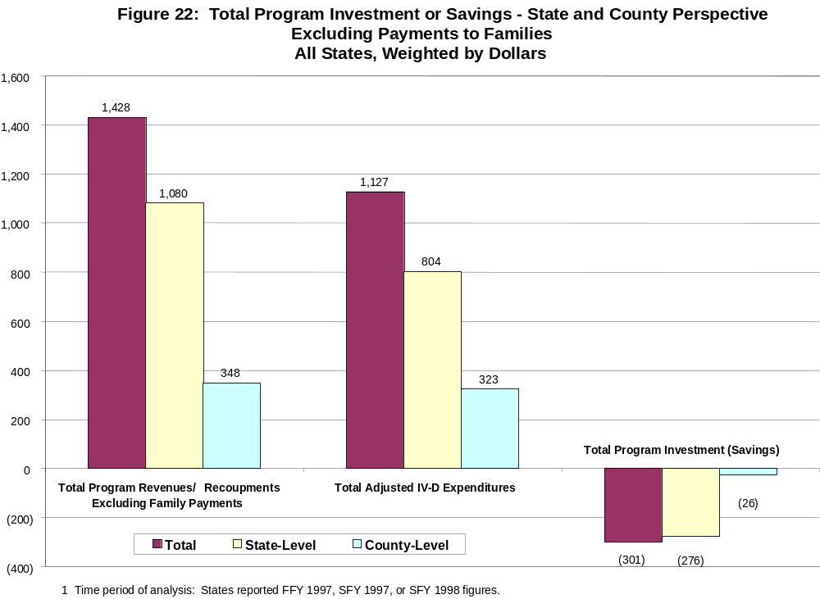Another method for calculating State CSE program investment or savings excludes State payments to families from program revenues. In Figure 22, for example, total program revenues/recoupments do not include the State share of retained TANF collections or Federal incentive payments that are transferred to families through $50 pass-through/disregard or “fill-the-gap” policies. As a result, Figure 22 shows states realizing a smaller savings from the program than does the analysis above in Figure 20. After excluding payments to families, total program savings across all levels of government drop by roughly 38%, though states continue to yield a larger program surplus than do counties.

As one can see in Figure 23, the distribution of investors and savers does not change substantially relative to the previous method. Overall, 25 states invested, 25 saved, and one broke even. The State-level of government in 24 states invested, the State-level of government in 26 states saved, and the State-level of government in one state broke even. Again, the County-level of government in 15 states invested, the County-level of government in 11 states saved, and the County-level of government in three states broke even.

Figure 23: Analysis of Total Program Investment or Savings
(State and County Perspective Excluding Payments to Families)

 | Number with Program Investment | Number with  Program Savings | Number that  Break-Even
State Programs Overall | 25 | 25 | 1
State-Level of Government | 24 | 26 | 1
County-Level of Government¹ | 15 | 11 | 3
¹Reflects 29 states with county-level participation.

IV-D Program Perspective
Through our third method, we calculate State CSE investment or savings from the perspective of the IV-D program. Here, we define total program revenues/recoupment as Federal incentive payments, retained TANF collections, and fees and recoveries that lawmakers earmark explicitly for the IV-D program. Under this definition, IV-D program revenues that are returned to the
IV-A program or that flow directly to state and county treasuries would not be included in the “total program revenues/recoupment” columns in Figure 24. Nationwide, states and localities earmarked only 28% of total retained TANF collections and Federal incentive payments, or about $456 million, to the IV-D program during our time period of analysis.
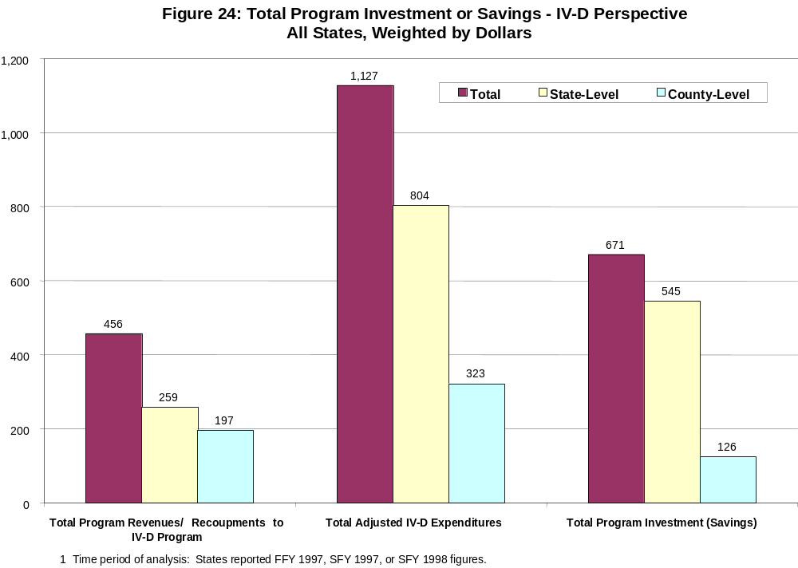State and local investment in the IV-D program is the difference between the State and local share of IV-D expenditures and the portion of CSE revenues that go to the IV-D program. General/special funds appropriations by states and counties for the IV-D program totaled roughly $671 million for our time period of analysis. Some of these State and County appropriations are offset indirectly by non-earmarked retained TANF collections and Federal incentive payments. In certain cases, retained TANF collections flow to the IV-A program and have no connection to the IV-D program; in other cases, counties that appropriate general fund revenue receive Federal incentive funds through the State that may or may not cover their IV-D program costs.

Composition of IV-D Revenues and Recoupments
Figures 25 – 30 illustrate the composition of IV-D program revenues and recoupments flowing into states and counties overall (State and County Perspective, Figures 25 – 27) and into the
IV-D program specifically (IV-D Perspective, Figures 28 – 30) at all levels of government, the state-level of government, and the county-level of government.
Figure 25 illustrates that the majority of program revenues and recoupments going to states and counties overall are retained TANF collections. This is also true for the State-level of government (Figure 26). In contrast, Figure 27 illustrates that the majority of program revenues and recoupments going to the County-level of government are Federal incentive payments. Finally, the majority of CSE revenues and recoupments going to the IV-D program itself are Federal incentive payments (Figure 28). This is especially true at the County-level of government
(Figure 30).
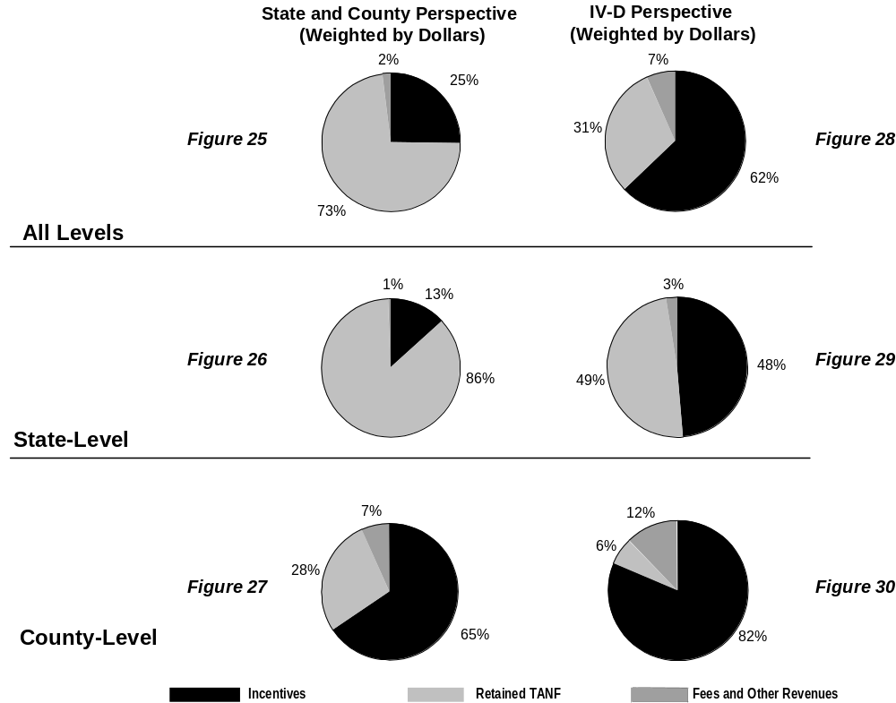

Summary of major Findings
State and local CSE financing structures are complex. Most programs utilize at least three different funding sources to finance the State and local share of CSE expenditures. In many states, complex intergovernmental financing arrangements exist among the State CSE agency, County and other local administrative agencies, and the family and domestic court system. Twelve states reported having County-administered programs, including: Arizona, California, Colorado, Indiana, Michigan, Minnesota, Nevada, New Jersey, New York, North Carolina, North Dakota, and Ohio. However, 29 states reported having some degree of county-level financial participation in the CSE program.
State and local CSE financing structures are diverse. States and localities mix funding sources in a variety of ways. In 25 states, some combination of general revenue fund appropriations and earmarked Federal incentive payments finance the State and local share of IV-D program costs. Twelve states utilize some combination of general revenue fund appropriations, earmarked Federal incentive payments, and retained TANF collections. Ten states ⎯ Colorado, Connecticut, Delaware, Indiana, Kansas, New Jersey, New York, Rhode Island, South Dakota, and Virginia ⎯ rely solely upon State and or County general revenue fund appropriations to finance their CSE programs. Four states ⎯ Illinois, Kentucky, Oklahoma, and Texas ⎯ appropriate little to no general revenue funds and rely upon Federal incentive payments and the State share of retained TANF collections to fund their share of program costs.
While the mix of funding sources for each state is different, financing for the State and local share of child support expenditures for the nation as a whole comes from State general fund appropriations (42%), Federal incentive payments (25%), the State share of retained TANF collections (15%), and County general fund appropriations (9%). Overall, fees and other cost recoveries finance a negligible proportion (2%) of State and local shares of child support expenditures. While a significant proportion of State and local CSE expenditures are financed with State and County general fund appropriations, in many cases, non-earmarked CSE revenues flowing into State and County treasuries more than offset these appropriations.
Nationally, 74% of Federal incentive payments are earmarked for the CSE program and 26% of the State share of retained TANF collections are earmarked for the CSE program at the State- and local-level. In most states, the largest proportion of the State share of retained TANF collections is returned to the IV-A program.
We derived three approaches to estimating whether the CSE program represents a net investment or savings to states; these three views of CSE program investment or savings fall along a continuum. On one end of this continuum, states as a group appear to reap large net savings from the program; on the other end of this continuum, states as a group appear to make a substantial net investment in the program.
The first approach to estimating State CSE program investment or savings compares all program revenues (excluding FFP) flowing into states and localities, irrespective of administering entity, to the State and local share of CSE expenditures. Using this approach, net program savings across all levels of government totaled $486 million for our time period of analysis. Twenty-one State programs were net investors in the CSE program, 29 were net savers, and one broke even.
Given that nearly half of the states operate pass-through or fill-the-gap programs, the second approach to estimating State CSE program investment or savings – consistent with historical presentations in the U.S. House Ways and Means Green Book – excludes State payments to families from total program revenues. After excluding these State payments to families, net program savings across all levels of government drops by roughly 38%, to $301 million. Using this approach, 25 State programs were net investors in the CSE program, 25 were net savers, and one broke even.
The last approach to estimating State CSE program investment or savings is from the perspective of the IV-D program and counts as revenue only amounts that lawmakers earmark to the IV-D program. Here, the difference between the State and local share of IV-D expenditures and the portion of CSE revenues that are directly earmarked for the IV-D program is the amount of general/special revenue funds appropriated to the IV-D program through the legislative process in states and counties. General/special funds appropriations totaled roughly $671 million for our time period of analysis. Some of these State and County appropriations are offset indirectly by non-earmarked retained TANF collections and Federal incentive payments.
Seventeen states anticipate significant changes to their financing structures as a result of declining TANF caseloads and uncertain incentive funding streams under the Child Support Performance and Incentive Act of 1998 (H.R. 3130). States that anticipate such financing changes rely to a greater extent upon Federal incentive payments and the State share of retained TANF collections to fund their programs than do states that do not anticipate financing changes. Although we found that the financing changes proposed or enacted recently by states are generally consistent with past practice within the program, the effects of PRWORA and H.R. 3130 have not yet fully materialized.

Appendix A
Existing Information sources

Appendix A
Existing Information Sources
The following table summarizes existing information sources related to child support enforcement financing structures and how these sources establish a base of critical data for the completion of this task order.
Citation | Relevant Data Collected
(December, 1989), Carmen D. Solomon, “CRS Report for Congress: The Child Support Enforcement Program – Policy and Practice” | - Review of Child Support Enforcement (CSE) program’s history and operations  - Description of Federal-State financing structure
(September, 1993), Child Support Enforcement Issue Sub-Group on Financing and Incentives, “Child Support Enforcement Financing and Incentives” | - Description of Federal-State financing structure  - Analysis of financing components including: Federal Financial Participation, Performance Incentives, Distribution of Collections, and Fees and Cost Recovery
(December, 1993), Ruth Krueger, “Fees for Non-AFDC Child Support Cases: IV-D and Wage Withholding” | - Use of application fees, collection and disbursement service fees, and other cost recovery mechanisms in eleven states
(May, 1991), Office of the Inspector General, Department of Health and Human Services, “Child Support Enforcement Incentive Payments” | - Legislation or regulations in all 50 states, the District of Columbia, Guam, Puerto Rico, and the Virgin Islands pertaining to the use and dissemination of Federal CSE incentive payments  - Summary of state uses of incentive payments
(April, 1998), Vicky Turetsky, CLASP, “State Use of Child Support Program Revenues” (Draft) | - Factors correlated with state surpluses or deficits  - Funding sources for State matching share of expenditures including local jurisdictions  - Local jurisdictions that include IV-D revenues in their budgets and the type of IV-D revenues included  - Extent to which state programs are centralized or decentralized  - Basic organizational structures of IV-D programs  - State and local agencies involved in IV-D Paternities, Support Orders, and Enforcement  - Organization of Collection, Disbursement, and Distribution of Support activities
(June, 1998), Vicky Turetsky, CLASP, “Child Support Funding Issues” (Memorandum) | - Insights into the relationship between IV-D collections per case, costs per case, and cases per FTE
46 Lexis-Nexis articles pertaining to child support financing in 15 states | - Insights into the process by which counties finance their child support programs  - Local-level perspectives on the effect of recent child support policy changes

APPENDIX b
States Anticipating ChangeS
in Program Financing

Appendix B
States Anticipating Changes in Program Financing

State | Chief Reason Cited | Funding Change
Alaska | Declining TANF collections and federal incentive payments | Implementation of cost-saving measures; possible request of supplemental appropriation from the legislature
Arizona | Declining TANF collections | Expansion in general fund contribution
Arkansas | Declining TANF collections | State general fund appropriation to IV-D program for the first time in this biennium
Florida | Declining TANF collections and federal incentive payments | Retained collections financing IV-D activities
Georgia | Declining TANF collections and federal incentive payments | IV-D program financed entirely through general fund appropriations (proposed)
Illinois | Declining TANF collections and federal incentive payments; increasing expenditures | Request for a significant increase in appropriated funds from the legislature
Kentucky | Declining TANF collections; increasing non-TANF caseloads | Request for general fund appropriations for the first time in the next biennium
Louisiana | Declining TANF collections | Increased cost recovery efforts at the direction of the legislature
Missouri | Declining TANF collections | Request for state general funds from the legislature in the next session
Montana | Declining TANF collections and federal incentive payments | Request for general fund appropriations for the first time in SFY 1999; new fee policy
New Mexico | Declining TANF collections and federal incentive payments; increasing expenditures due to PRWORA mandates | Increase in general fund appropriations to the program
North Carolina | Declining TANF collections | Cost recovery mechanisms
Ohio | HR 3130; movements toward centralized collections | Distribution of federal incentive payments to counties based on performance measures; potential change in administrative fee structure
Oklahoma | Declining TANF collections and federal incentive payments | Request for state general appropriations for the first time in FY 1999
Pennsylvania | Declining TANF collections | State anticipates increased general funds to meet system automation requirements
Texas | Decreasing IV-D revenues due to distribution of payments policy under PRWORA and declining TANF caseloads; increasing expenditures associated with the implementation of PRWORA mandates | Request for state general funds for the first time in recent history
Wisconsin | HR 3130 | Distribution of federal incentive payments to counties based on performance measures

Appendix c
Distribution of Federal Incentive Payments

Appendix C
Distribution of Federal Incentive Payments

 | IV-A Program |  | IV-D Program |  | General Fund |  | Other
State | State | County | State | County | State | County | State | County | Families
Alabama |  |  | x | x |  | x
Alaska |  |  | x
Arizona |  |  | x | x
Arkansas |  |  | x | x
California |  |  |  | x |  |  |  | x
Colorado |  |  |  |  |  | x
Connecticut |  |  |  |  | x
Delaware | x |  | x |  | x
District of Columbia |  |  | x
Florida |  |  | x |  |  | x
Georgia |  |  | x | x
Hawaii |  |  | x | x
Idaho |  |  | x
Illinois |  |  | x | x
Indiana |  |  |  |  |  | x
Iowa | x |  |  | x |  | x
Kansas |  |  |  |  |  |  | x
Kentucky |  |  | x
Louisiana |  |  | x | x |  | x
Maine | x |  | x |  |  |  |  |  | x
Maryland | x |  | x | x
Massachusetts |  |  | x
Michigan |  |  |  | x |  | x
Minnesota |  |  |  | x
Mississippi |  |  | x
Missouri |  |  |  | x | x | x
Montana |  |  | x
Nebraska |  |  | x | x
Nevada |  |  |  | x
New Hampshire |  |  | x
New Jersey |  |  |  |  |  | x
New Mexico |  |  | x
New York |  |  |  |  |  | x | x
North Carolina |  |  | x | x
North Dakota |  |  | x |  |  | x
Ohio |  |  |  | x
Oklahoma |  |  | x
Oregon |  |  | x | x
Pennsylvania |  |  | x |  |  | x
Rhode Island |  |  |  |  | x
South Carolina |  |  | x | x
South Dakota |  |  |  |  | x
Tennessee |  |  | x | x
Texas |  |  | x
Utah |  |  | x
Vermont |  |  | x
Virginia |  |  |  |  | x
Washington |  |  | x
West Virginia |  |  | x
Wisconsin |  |  |  | x
Wyoming |  |  | x
Total | 4 | 0 | 34 | 21 | 6 | 12 | 2 | 1 | 1

Appendix D
Distribution of the State Share of Retained TANF Collections

Appendix D
Distribution of the State Share of Retained TANF Collections

 | IV-A Program |  | IV-D Program |  | General Fund |  | Other
State | State | County | State | County | State | County | State | County | Families¹
Alabama |  |  |  |  |  |  | x
Alaska | x |  |  |  |  |  |  |  | x
Arizona |  |  | x |  |  |  |  |  | x
Arkansas |  |  | x | x
California | x | x |  |  |  |  |  |  | x
Colorado |  | x |  |  | x
Connecticut | x |  |  |  |  |  |  |  | x
Delaware | x |  | x |  | x |  |  |  | x
District of Columbia |  |  | x
Florida | x
Georgia |  |  |  |  | x |  |  |  | x
Hawaii | x
Idaho | x |  | x
Illinois |  |  | x | x |  |  |  |  | x
Indiana |  |  |  |  | x | x
Iowa | x
Kansas |  |  |  |  |  |  | x |  | x
Kentucky |  |  | x
Louisiana |  |  | x
Maine |  |  | x |  |  |  |  |  | x
Maryland | x
Massachusetts | x |  |  |  |  |  |  |  | x
Michigan | x
Minnesota | x
Mississippi | x
Missouri | x |  | x
Montana |  |  | x
Nebraska | x
Nevada |  |  | x |  | x |  |  |  | x
New Hampshire | x |  |  |  |  |  | x
New Jersey | x | x |  |  |  |  |  |  | x
New Mexico |  |  | x
New York | x | x |  |  |  |  |  |  | x
North Carolina |  | x | x
North Dakota | x
Ohio | x
Oklahoma |  |  | x |  | x | x |  |  | x
Oregon | x |  | x
Pennsylvania | x |  |  |  |  |  |  |  | x
Rhode Island |  |  |  |  | x |  |  |  | x
South Carolina |  |  |  |  |  |  | x
South Dakota |  |  |  |  | x
Tennessee | x |  |  |  |  |  |  |  | x
Texas |  |  | x |  |  |  |  |  | x
Utah |  |  |  |  | x
Vermont | x |  |  |  |  |  |  |  | x
Virginia |  |  |  |  | x |  |  |  | x
Washington | x
West Virginia | x |  |  |  |  |  |  |  | x
Wisconsin | x |  |  |  |  |  |  |  | x
Wyoming |  |  | x
Total | 27 | 5 | 18 | 2 | 10 | 2 | 4 | 0 | 22
¹Includes payments to families under $50 pass-through/disregard policies and fill-the-gap policies, does not include payments to families through general fund appropriations.

Appendix E
STATE CHILD SUPPORT
ENFORCEMENT PROGRAM PROFILES
and spreadsheet analyses

As stated on the Office of Child Support Enforcement’s internet home page.
Under the current Federal incentive payments formula, a State can receive up to 10 percent of TANF and non-TANF child support collections as it increases its ratio of collections to administrative costs; non-welfare incentive payments are capped at 115 percent of welfare incentive payments for each state.
States may also pursue child support arrears after the family leaves welfare to pay for TANF benefits previously paid to the family. However, under the Personal Responsibility and Work Reconciliation Act (PRWORA) of 1996, families who are no longer receiving public assistance will have priority over the State in the distribution of child support arrears.
The Federal reimbursement rate for Medicaid benefit costs, the Federal Medical Assistance Percentage (FMAP), is used to calculate the Federal share of TANF collections retained by states.
As stated on the Office of Child Support Enforcement’s internet home page.
Under the current Federal incentive payments formula, a State can receive up to 10 percent of TANF and non-TANF child support collections as it increases its ratio of collections to administrative costs; non-welfare incentive payments are capped at 115 percent of welfare incentive payments for each state.
States may also pursue child support arrears after the family leaves welfare to pay for TANF benefits previously paid to the family. However, under the Personal Responsibility and Work Reconciliation Act (PRWORA) of 1996, families who are no longer receiving public assistance will have priority over the State in the distribution of child support arrears.
The Federal reimbursement rate for Medicaid benefit costs, the Federal Medical Assistance Percentage (FMAP), is used to calculate the Federal share of TANF collections retained by states.
A table summarizing existing information sources related to child support enforcement financing structures and how these sources established a base of critical data for the completion of this task order is included in Appendix A.
Prior to the Personal Responsibility and Work Opportunity Reconciliation Act of 1996 (PRWORA), states were required to pass-on the first $50 (per month) of child support collections to families on public assistance and disregard that income in determining families’ AFDC benefit levels. States were allowed to calculate the Federal share of retained AFDC collections after subtracting the amount they passed-on to families under this policy. PRWORA eliminated the “$50 pass-through” policy and required states to share all TANF-related child support collections with the Federal Government. States have the option to pass-on collections to TANF families and many states continue to do so. Additionally, in certain states, retained TANF collections are used to fund “fill-the-gap” payments to families who receive less TANF assistance than the State standard of need.
We have not obtained final verification from Illinois.
Child support enforcement financing profiles and spreadsheet analyses included in Appendix D note the time period of analysis examined for each state and the District of Columbia.

