Instructions for Reprojecting MDOQ Tiles
And
MrSID Compressed County Mosaics

Prepared by the Digital Section, Geospatial Services Branch
Aerial Photography Field Office

April 7, 2004

Part 1: Instructions for reprojecting MDOQ Tiles and MrSID images “On The Fly” using ArcGIS 8.3

Part 2: Instructions for reprojecting MDOQ Tiles by converting to an ESRI Grid using ArcGIS 8.3

Part 1

Instructions for reprojecting MDOQ Tiles and MrSID images “On The Fly” using ArcGIS 8.3

The MDOQ Tiles and the MrSID compressed county mosaic are projected according to what zone the county falls in. There are counties that are split between two zones. If this situation occurs, the county is projected in the zone where the majority of the imagery lies. Therefore, the county Tiles and MrSID are created in this zone. There may be situations when it is useful to have the MDOQ Tiles and MrSID projected in the other zone.

There are several ways to reproject imagery in ArcGis. One method is to reproject the image on the fly. This method is fairly straightforward and accomplished easily. You may save your work in an .mxd file to reference later but you will be unable to permanently reproject the image and save it. To do this you would need to use another method which is to turn the image into a grid.

The following instructions pertain to reprojecting on the fly using ArcGIS 8.3.

- First bring up your image in ArcMap. You may either use the CD or you can load the image on the hard drive of your computer. Loading the image on the hardrive of the computer will help things draw up faster if you have a slower computer.

- Open ArcCatalog and navigate to the image file name and Right-click on the file (Figure 1).

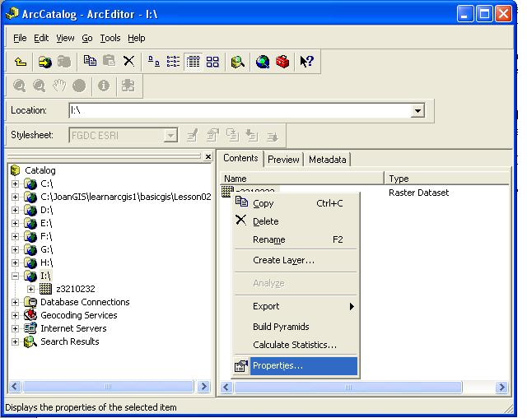
Figure 1

Click on Properties and the Raster Dataset Properties Dialog opens up (Figure 2). If the Spatial Reference tab is not already active click on it.

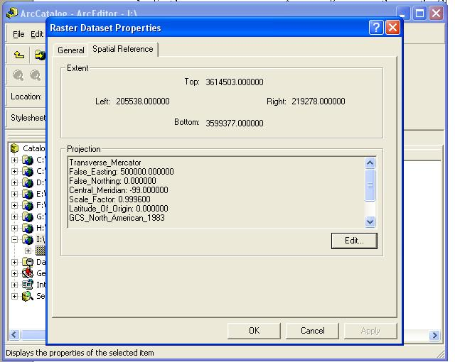

Figure 2

Click on the Edit… button and the Spatial Reference Properties Dialog opens up. (Figure 3)

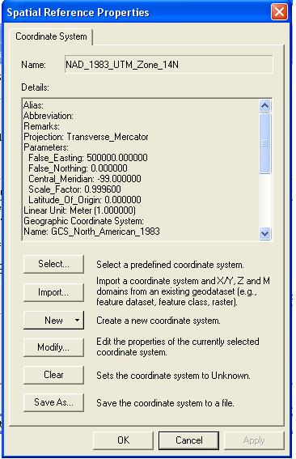
Figure 3

This is where you define the spatial reference or what zone the image was originally made in. This needs to be done so that ArcMap can project the image on the fly correctly. When you first bring in an image to ArcMap, the spatial reference will most likely be listed as unknown. If you try to project on the fly starting with an unknown coordinate system then the image will not draw up correctly.

Next click on the Select… button and the Browse for Coordinate System dialog box comes up. Double click on the Projected Coordinate Systems Folder, then double click on the UTM folder, then NAD 83 and finally choose the Zone that the image was created in and click the Add button. (Figure 4)

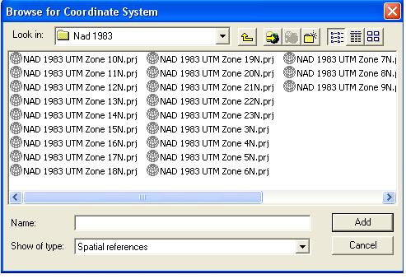
Figure 4

This brings you back to the Spatial Reference Properties box and here you can see that you have now defined the Spatial Reference (i.e. the correct UTM Zone) of the image. (Figure 5)

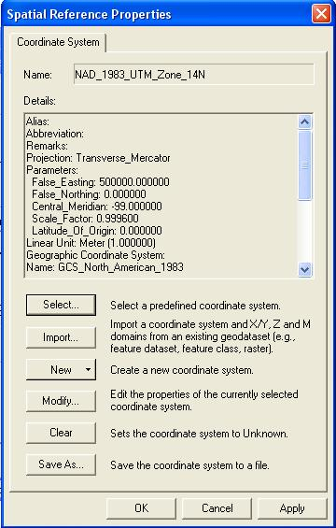

Figure 5

Now that you have defined the spatial reference of the image you can view the image in ArcMap in an alternate UTM Zone.

- Return to your image in ArcMap. In the table of contents, right click either on Layers or right click directly in the Data Frame. This brings up the Data Frame Properties dialog box. (Figure 6) You can see the current coordinate system of the image in the lower half of the dialog box in the section titled Select a Coordinate System. You can change the zone to whatever alternate zone you want to view the image in. Click on the Predefined folder, then on the Projected folder, then on UTM, then Nad 83, and finally on whatever zone you would like. Then hit OK to close the Data Frame Properties Dialog Box. Your image is now projected to the zone you have chosen.

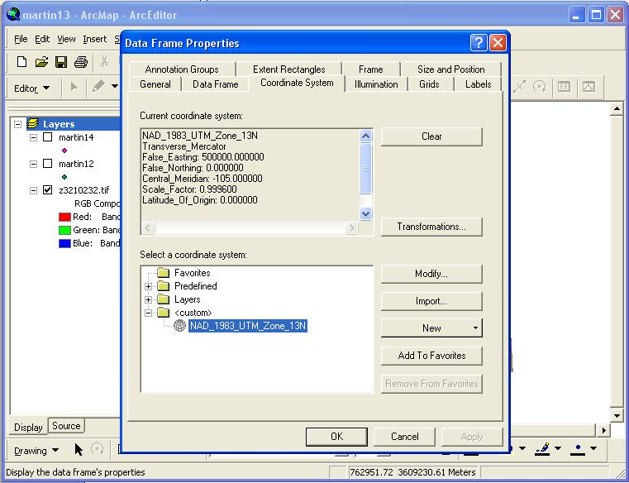
Figure 6

- You may also save your project as an .mxd file to view later. Your settings will be saved for the project. Also if you are viewing the image from the CD Rom drive you will need to be sure the CD is loaded when you bring up your .mxd project or you will get an error saying the source is not available.

Another situation that is likely to happen is that you may need to bring in shapefiles to view with your image. If the Spatial Reference of a shapefile is not defined it will not draw up correctly.

Defining the spatial reference for shapefiles

The following instructions are for defining the spatial reference for shapefiles using ArcGIS 8.3.

If you have already added the shapefile to ArcMap delete it from the project otherwise you will get an error message telling you that the file cannot be changed because it is in use.

- Open up ArcToolbox and navigate to Projections, and expand the folder. Double Click on Define Projection Wizard (shapefiles, geodatabase). (Figure 1)

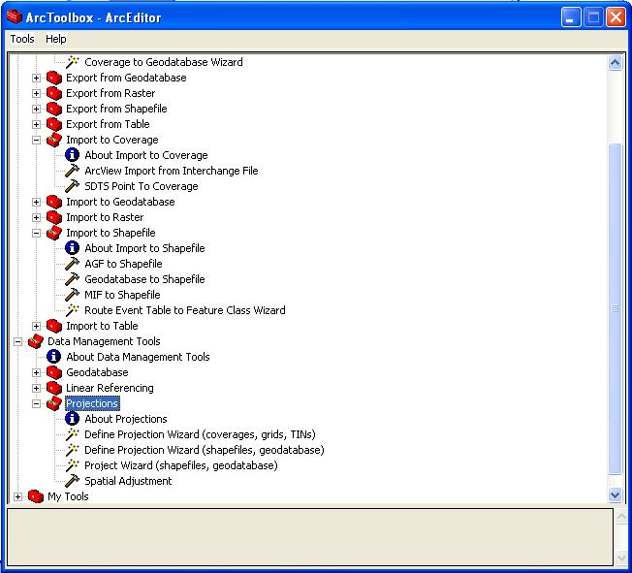

Figure 1

The Define Projection Wizard dialog box comes up. Select the data you want to assign a coordinate system to by clicking on the open folder near the top of the box. Navigate to the file you want to use and click add. The file will show up under Data and the Coordinate System will say unknown. If Coordinate System does not say unknown, the projection has already been defined. Click the Next button. (Figure 2)

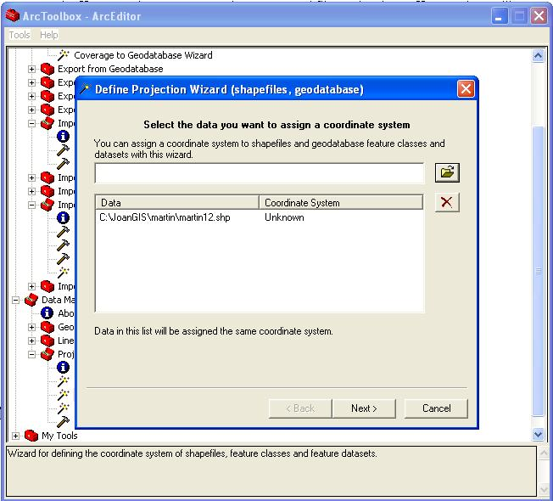
Figure 2

2. Now the Spatial Reference Properties Dialog comes up. Click on the Select… button.
(Figure 3)

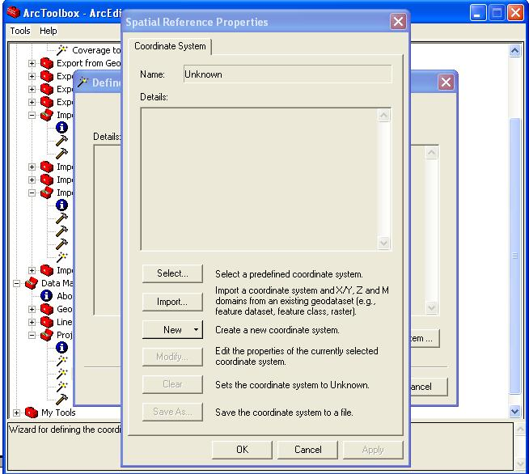

Figure 3

3. Next the dialog box appears where you select the coordinate system. (Figure 4)

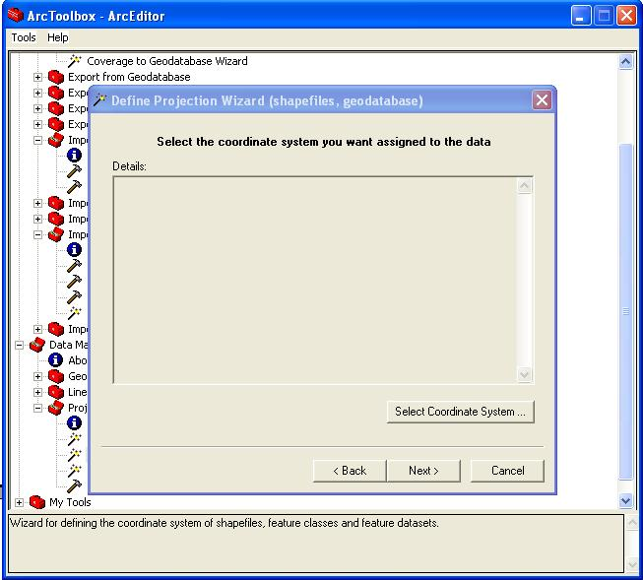

Figure 4
4. Now click on the Select Coordinate System… button. The Spatial Properties Dialog Box opens. Click on the Select… button, and the Browse for Coordinate System box comes up. (Figure 5)

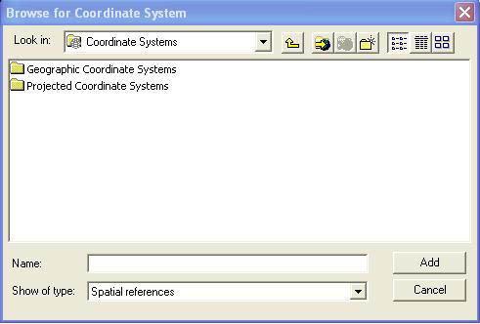
Figure 5

Double click on the Projected Coordinate Systems folder, double click the UTM folder, double click NAD83, and then select the appropriate zone. Click the Add button. (Figure 6)
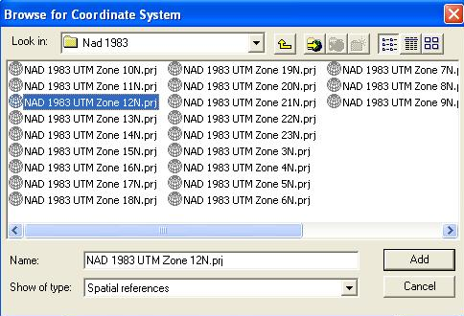
Figure 6

5. The Spatial Reference Properties box again comes up and this time you see that the coordinate system has been defined. Click OK. (Figure 7)

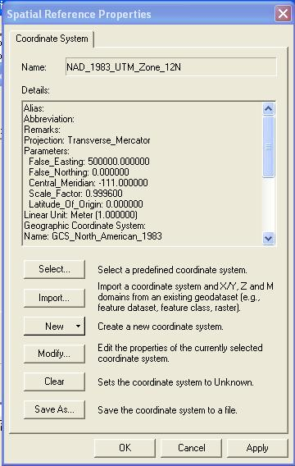

Figure 7
6. The Define Projection Wizard (shapefiles, geodatabase) dialog box again comes up showing the Coordinate System you have just selected. If it is correct then click on the Next button. (Figure 8)

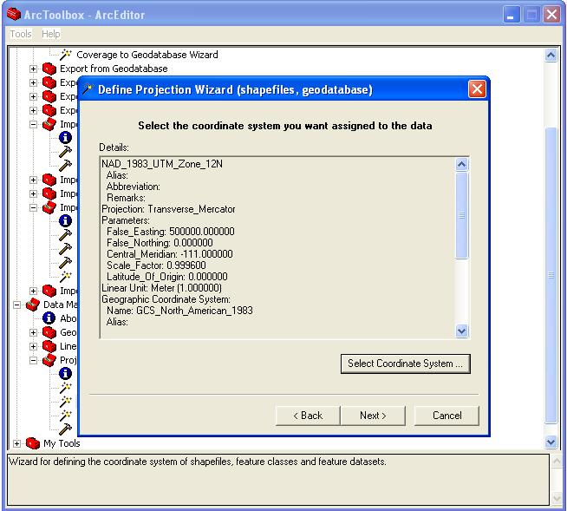
Figure 8

You are then given a summary of your input. (Figure 9)

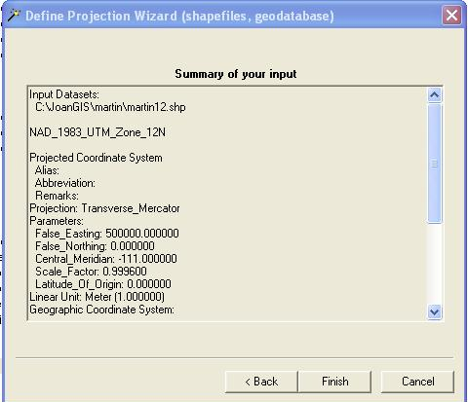

Figure 9
7. Then click the Finish button and your data is ready to use in ArcMap with your imagery.

To find out more about raster images and how to work with them in ArcGIS, see the ArcGIS help sections using the keyword searches raster, MrSID, and images. Another valuable resource available is the online support located at http://support.esri.com/. Here you will find technical articles, downloads, and user forums. This is one of the best resources available to get answers to ArcGIS questions.

Part 2

Instructions for reprojecting MDOQ Tiles by converting to an ESRI Grid using ArcGIS 8.3

There is a method which allows you to reproject raster images in ArcGIS, if you want to change the projection and save the image independently from an .mxd. This method requires you to change the .tif image into an ESRI Grid. An ArcInfo license is required to use this method so if you do not have this available then you will need to use Projection on the fly. Changing an image to an ESRI Grid can be a lengthy process. There are some limitations using this method of reprojection when you are working with MrSID images. Processing time is very lengthy and the image resolution can become degraded. The suggestion would be to use the MDOQ Tiles if you need to convert them to a GRID.

The following instructions are for ArcGIS version 8.3.

If your image is a black and white single band image skip step 3 and 4 and add your image directly into ArcMap.
- Open ArcCatalog and navigate to the raster image (MDOQ Tile).
Right-click on the image and select Export > Raster to Different Format.
Select ESRI Grid from the Save as type drop-down list (see Figure 1). A grid will be created for each band in the imagery.
Figure 1
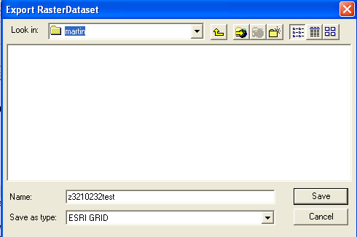
This process may take a few minutes depending on the speed of your system and the size of the image. A small box will come up which tells you the raster image is being processed and indicates the progress. You also have the option to cancel.
- Open ArcToolbox and use the Project Wizard (coverages, grids) to reproject each grid. Choose the grid in the next dialog box. (Figure 2) The dialog box shows you what parameters are associated with the grid, so you don’t try to project the image to the same zone as it was made in.

Figure 2
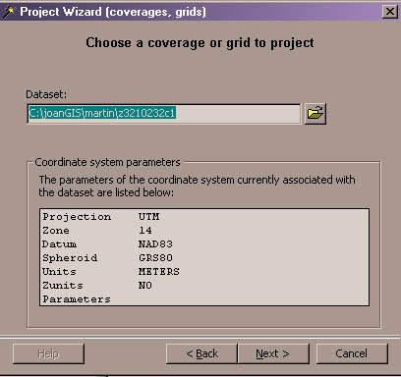

Click the Next > button and you have a choice of what projection you now want to use. (figure 3)

Figure 3
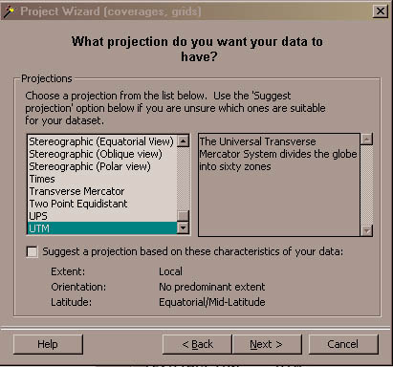

Next you will choose the zone you want to project the image in. (Figure 4)

Figure 4
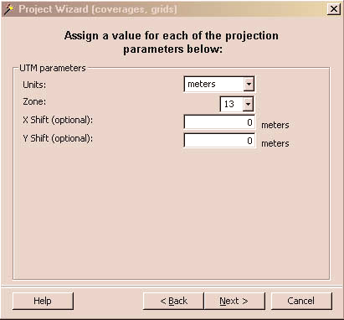

Next you will choose the Datum you want the image in. (Figure 5)

Figure 5
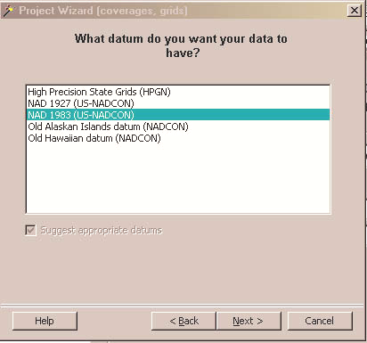

The next dialog that comes up asks you to specify an output dataset. (Figure 6)

Figure 6
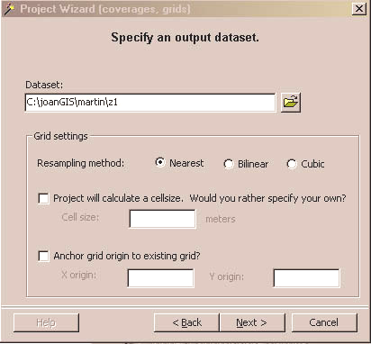
Click the Next > button and you get a summary of your input projection and what output projection you have chosen. Click the Finish button and ArcToolbox processes your request. Repeat this procedure for each grid. This can be a very lengthy process if your system is slow.
- Add each grid to ArcMap. The three output bands resulting from the conversion to grid will be named in the form <gridname>c1 <gridname>c2 <gridname>c3

- Open the Raster Calculator which is located in the Spatial Analyst Toolbar. Use the following syntax where Stack1 is the name of the output grid:
MAKESTACK Stack1 LIST [Grid1] [Grid2] [Grid3]
An example is shown in Figure 7

Figure 7
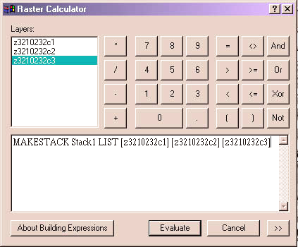
Click Evaluate. If you get an error message concerning the output file click on the Spatial Analyst Toolbar and go under options and navigate to the working directory where you want the image. Most likely the image will draw up and the color will be off. To fix this Right-Click on STACK in the table of contents and go to properties, then click on the Symbology tab and under the Stretch drop down box click none and your image should draw up with the correct colors.

Reprojecting any raster image can be a lengthy and complicated process. To find out more about raster images and how to work with them in ArcGIS, see the ArcGIS help sections using the keyword searches raster, MrSID, and images. Another valuable resource available is the online support located at http://support.esri.com/. Here you will find technical articles, downloads, and user forums. This is one of the best resources available to get answers to ArcGIS questions.

