4. Tech-Prep Education

Tech-Prep began as an effort to upgrade vocational education. Early proponents envisioned it as a structured, planned program of study that would integrate challenging academic and vocational courses and link high school studies to related, advanced technical education in two-year postsecondary programs (Parnell 1985, 1991). Their vision of Tech-Prep included a close collaboration between secondary and postsecondary institutions in developing articulated course sequences that spanned the two levels, and between academic and vocational faculty in offering applied, hands-on instruction. Students who chose to enter Tech-Prep programs would commit to taking the rigorous high school academic and vocational courses and to following the postsecondary path included in the program design.

This framework was incorporated first into Perkins II in 1990 and then, with modest changes, into Perkins III as Title II, the Tech-Prep Education Act. The initiative sought to address (1) the need for better and more technically trained workers, (2) high school students’ academic deficiencies, and (3) concerns about the “neglected majority”—students in the middle half of the academic achievement distribution who had historically received little attention from policymakers, school staff, and support services. In establishing Tech-Prep as a separate title with its own funding stream, Congress clearly intended it to be different from, and potentially better than, traditional vocational education.

This chapter examines the distinct organizational structure of Tech-Prep (Section A) and addresses three questions relevant to policy:

- What does it mean to participate in Tech-Prep and how has participation grown? (Section B)

- To what extent is Tech-Prep implemented in ways that are consistent with the legislation and different from traditional vocational education? (Section C)

3. What evidence exists that Tech-Prep contributes to student outcomes or has benefits above and beyond those of vocational education? (Section D)

Key Findings

► Reported participation in Tech-Prep measures diverse student experiences; thus, increases in student counts should be viewed cautiously.
Gauging the extent to which students participate in Tech-Prep remains problematic. Although state and local definitions of a “Tech-Prep student” vary widely, the most common measure is student enrollment in a single high school vocational course for which an articulation agreement exists. In some states, Tech-Prep students are identified after they have completed high school based on their course-taking patterns, and students are unaware of having participated in a program. The number of students considered to be “in Tech-Prep” has increased significantly, partly as a result of new federal reporting requirements. The most recent estimates suggest that Tech-Prep students may represent about 10 percent all high school students, but the accuracy of these figures is uncertain.

► Access to and funding of Tech-Prep do not reflect the Perkins Act’s targeting criteria.
Schools with high proportions of students from racial or ethnic minority groups or from low-income families are less likely to offer Tech-Prep. Moreover, in contrast to the ways in which most Perkins funds are allocated, few states use a definition of poverty as a criterion in awarding Tech-Prep funds to local consortia.

► Tech-Prep is rarely implemented as a comprehensive program of study; implementation focuses on individual components of Tech-Prep, some of which are becoming more common in vocational education in general.
Few consortia or schools implement Tech-Prep as a structured program with at least two years of clearly linked high school course work and at least two years of related postsecondary course work (the “two-plus-two” design). More typically schools implement components of the Tech-Prep model—maintaining articulation agreements, providing professional development on integration to academic or vocational teachers, and improving career guidance and planning. Many of these activities are becoming part of secondary vocational education more broadly, and little change has occurred at the postsecondary level to accommodate Tech-Prep students. As a result, Tech-Prep efforts have become less distinct from those of regular vocational education.

► Tech-Prep and non-Tech-Prep students attend college at roughly comparable rates.
The few studies conducted on Tech-Prep indicate that students identified as program participants generally pursue postsecondary education at rates similar to or slightly higher than those of other students, whether compared to statewide or national averages or to non-Tech-Prep students. However, because no rigorous impact studies have been conducted as yet, the effects of Tech-Prep on postsecondary enrollment and completion are unknown.

A. Organization of Tech-Prep

Perkins III promotes considerable overlap between Tech-Prep and the basic state Perkins grants. The most important local institutions involved in Title II, the Tech-Prep Education Act are school districts and community colleges, the same institutions that receive funds under Title I (state grants) of Perkins. Funds under Title I can be spent on each of the components of Tech-Prep (they are “allowable activities”). The organization and administration of Tech-Prep at the local level, however, differs from that of the basic state grant. Whether this separate structure should continue or be modified is an important consideration for policymakers interested in improving Title II or the objectives it promotes.

Tech-Prep is administered at the local level by about 1,000 consortia nationwide; most are organized geographically, but some are organized by career field.

Perkins III, like its predecessor, allocates money for Tech-Prep to states and then allows them to use either a formula or competition to award grants to local consortia. These consortia are required to include at least one secondary district or area vocational school and at least one postsecondary institution, with an emphasis on two-year degree-granting institutions. A comparison of consortium counts from an earlier Tech-Prep evaluation (Hershey et al. 1998) and survey data provided by state Tech-Prep coordinators (White et al. forthcoming) suggest that some states have been increasing the number of grants awarded. Nationally, there are more than 1,000 Tech-Prep consortia (see Chapter 5).

Perkins III gives states considerable latitude in creating systems of consortia. Most often, consortia are geographic in scope, covering either established regions or counties or the service delivery area of one or more community colleges. This strategy seems to reflect the intent of the law, which is to promote greater collaboration between community colleges and their local school districts in order to improve the quality of both vocational education in secondary schools and high school students’ transitions into postsecondary education.

However, evidence suggests a shift is occurring toward using statewide consortia organized around career areas. In these cases, interested schools and colleges—often not matched geographically—collaborate to update lists of skill requirements, articulation agreements, and in some cases, curricula for related sets of occupations (e.g., health or agriculture). Often schools and colleges participate in more than one Tech-Prep career consortium.

The use of geographic and statewide career-based strategies for organizing consortia appears to have both advantages and disadvantages. Statewide efforts may be more efficient than those in which each region in a state independently develops articulation agreements in the same occupational areas. However, there is probably less focus on local collaboration in these situations, as there is when consortia consist of many school districts and postsecondary institutions in the same geographic area.

Tech-Prep consortium boundaries cover most secondary school districts and community colleges and include about half of all public high schools.

Although they vary in size both within and across states, consortia count a large number of the nation’s school districts as members. According to the most recent national evaluation of Tech-Prep (Hershey et al. 1998), in the mid-1990s about 70 percent of all secondary school districts were included in at least one local consortium. Given that some consortia were still relatively early in their development at that time, it is likely that an even larger proportion of school districts are now considered members of Tech-Prep consortia. In theory, then, Tech-Prep has been introduced to at least some degree throughout the United States.

However, it is clear from national surveys as well as site visits conducted for NAVE in 2001 and 2002 that there is great variation in the extent to which districts and schools are actually aware of and involved in Tech-Prep. Only 47 percent of all high schools in 2000 reported offering something they call “Tech-Prep.” Moreover, as will be discussed later, the set of activities pointed to as evidence of Tech-Prep are quite modest in many schools, and some preceded federal support for Tech-Prep.

A similar pattern seems to hold true at the postsecondary level, although there have been no national surveys of community and technical colleges about their Tech-Prep efforts. Even by 1995, consortia reported having nearly 1,400 two-year postsecondary Tech-Prep members—a figure roughly equivalent to the total number of two-year institutions of higher education in the country, most of which are public community colleges. While some community colleges are members of multiple consortia, the number suggests that many of them are at least tangentially involved in Tech-Prep. As will be discussed later, however, consortium membership does not necessarily translate into activity on postsecondary campuses that is related to Tech-Prep.

Community or technical colleges have coordinating and fiscal authority for about two-thirds of consortia.

Although most Tech-Prep activities are implemented at the secondary level (see Section C), postsecondary institutions are more likely to have responsibility for local consortium funding and structures. A review of state Tech-Prep consortium directories indicates that community colleges and other types of postsecondary institutions are the fiscal agents in more than 65 percent of consortia. These institutions most often house the individual(s) who are the consortium staff, an expense that is paid for out of Title II funds (see Chapter 5 for more details about Tech-Prep funding). There is some evidence that federal Tech-Prep funds have helped spur community colleges to work with local secondary schools on a variety of issues including student recruitment and articulation agreements (Hudis, Blakely, and Bugarin forthcoming).

B. Access and Participation

Tech-Prep was originally conceived as an initiative to improve the academic and technical skills and workforce preparation of the “middle majority” of American high school students—those who complete high school but most likely do not earn four-year college degrees. Although the law did not specifically target this segment of the student population, its emphasis on technical occupations and on completing at least a two-year degree or apprenticeship suggests that policymakers were interested in this group. More than 10 years after Tech-Prep first became a federal program, it is useful to examine how states, consortia, and schools identify Tech-Prep students and the extent to which students are involved in the program.

1. Defining and Counting Tech-Prep Participants

To document how many students actually participate in Tech-Prep, states and consortia must develop a clear definition of which students are to be considered “in Tech-Prep.” Unlike participation in vocational education—which can be defined primarily by the number and type of Carnegie units students earn—participation in Tech-Prep is more difficult to pinpoint. Both the ability to define the term “Tech-Prep” and the actual definition of a “Tech-Prep participant” depend largely on how the program is implemented, which will be discussed in more detail in Section C. However, it is important to clarify the process used to report the numbers of Tech-Prep students and the challenges that underlie such reporting.

Measures of “participation” vary widely from enrollment in one course to, in rare cases, a program of study spanning high school and postsecondary education; counts, therefore, should be viewed with caution.

Although the law lays out the components of Tech-Prep and the general structure for a distinct program of integrated academic and vocational high school study linked to a related postsecondary program, states and their local consortia emphasize different elements. As a result, Tech-Prep takes on diverse forms and creates quite varied experiences for students, as explained in more detail in Section C (Hershey et al. 1998; White et al. forthcoming; Stasz and Bodilly forthcoming; Hudis, Blakely, and Bugarin forthcoming).

Studies also confirm that there are substantial discrepancies between the kinds of Tech-Prep activities consortia and schools implement and the way they report the numbers of students who participate. For example, in some schools, implementation may focus on improving career planning, but when they try to identify “a Tech-Prep student,” the schools count any student enrolled in an articulated vocational course. In other schools, Tech-Prep is ostensibly targeted to secondary vocational programs linked to programs at community colleges, but even students in programs that do not have postsecondary counterparts are included in participation tallies.

Defining Tech-Prep students at the postsecondary level is also problematic. Although many states view students as participating in a postsecondary Tech-Prep program when they are continuing an articulated vocational sequence begun at the secondary level, the students who are actually counted locally vary considerably from this description. As an extreme example, a community college participating in case studies conducted for NAVE reported in 2001 that the students in their postsecondary Tech-Prep programs ranged in age from 15 to more than 50. Both earlier and more recent studies document the lack of consistency in the way Tech-Prep students are identified for reporting within states and consortia at both the secondary and postsecondary levels (Hershey et al. 1998; White et al. forthcoming; Stasz and Bodilly forthcoming; Hudis, Blakely, and Bugarin forthcoming).

National surveys of states and consortia illustrate—but probably underestimate—the diversity of “Tech-Prep participation.” To begin, about one-quarter of state Tech-Prep coordinators do not specify a definition for local consortia of who is to be counted as a secondary Tech-Prep student, and 35 percent of states do not have a definition for a postsecondary Tech-Prep student (White et al. forthcoming). Among those with state definitions to guide local reporting, there are numerous ways in which the various elements of Tech-Prep—e.g., a program students explicitly choose, planned sequences of courses that span secondary and postsecondary education, articulated courses, any vocational courses, applied academics, worksite experiences—are combined (Table 4.1). When local Tech-Prep consortia were asked a similar question in the earlier national Tech-Prep evaluation, they provided more than 30 different combinations of criteria used to define participants (Hershey et al. 1998). Only rarely does being “in Tech-Prep” reflect participation in a distinct, cohesive program of related academic and vocational course work articulated to postsecondary course sequences (Hershey et al. 1998; Stasz and Bodilly forthcoming; White et al. forthcoming).

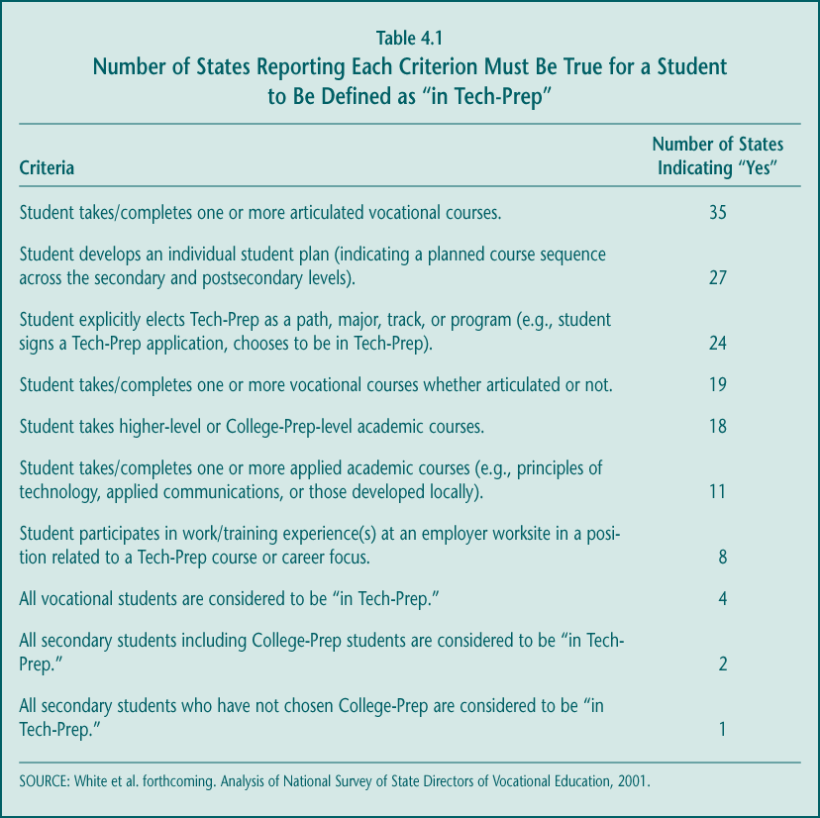

Tech-Prep participation is most often defined by enrollment in an articulated course, an increasingly common feature of vocational education in general.

Articulation plays the most important role in defining who participates in Tech-Prep. Regardless of how Tech-Prep funds are spent or the initiative is implemented in a school or consortium, participation counts are most often based on the number of students who enroll in a vocational course or program for which articulation agreements allow completers to receive advanced standing or credit at a local postsecondary institution. Among states that have defined participation and responded to a national survey, the vast majority (35 of 42, or 83 percent) report that enrollment in at least one articulated vocational course is a necessary criterion for a student to be considered “in Tech-Prep” (Table 4.1). Site visits confirm the frequency with which articulated courses are used to identify Tech-Prep participants (White et al. forthcoming; Stasz and Bodilly forthcoming).

By relying on counts of students in articulated courses, however, it is becoming more difficult to differentiate participants in Tech-Prep from participants in vocational education in general. Since Tech-Prep was first established as a federal program, articulation agreements have been developed for an increasing share of secondary vocational courses and programs (see Section C). Because of the substantial coverage of articulation agreements and the inability of many administrative systems to separate enrollments in articulated vocational courses from enrollments in nonarticulated ones, Tech-Prep participation—in fact and as reflected in student counts—is increasingly similar to participation in regular vocational education courses and sequences.

Many consortia and their members have difficulty reporting counts of Tech-Prep students.

Even using their own locally established definitions of Tech-Prep participation, consortia and schools face challenges in reporting the numbers of participants. Based on surveys of local consortia, only 36 percent of Tech-Prep consortia nationwide could report counts of participants in 1993, and they could do so for only 17 percent of the secondary districts they identified as consortium members (Hershey et al. 1998). The same evaluation indicates that in 1995, 65 percent of all consortia reported counts, but only 42 percent of their districts did so. While no comparable surveys of consortia were conducted after 1995, eight states did not report any counts of Tech-Prep participants to the Department of Education (ED) in 2000, and four states did not do so in 2001. Moreover, site visits conducted for NAVE suggest that many state reports in 2000 and 2001 could not cover all of their Tech-Prep consortia or the districts and schools that are considered consortium members (White et al. forthcoming).

The difficulty faced by consortia and schools in reporting Tech-Prep counts can be traced to practical constraints as well as the nature of implementation. As noted above, secondary school records often are not organized or electronically coded in a way that allows ready identification of students in particular vocational courses or a combination of vocational and “applied” academic courses (Hershey et al. 1998). Tracking students as they progress from the secondary to postsecondary levels of Tech-Prep is particularly problematic (White et al. forthcoming; Hudis, Blakely, and Bugarin forthcoming). Because Tech-Prep is rarely a distinct program that students apply for, schools cannot rely on application or registration forms to provide them with counts of participants. In cases in which Tech-Prep is considered more of a process than a program, for example, a strategy for keeping articulation agreements up-to-date, introducing new vocational courses, and improving career guidance, consortia will continue to struggle to define which students are actually “in Tech-Prep” and to count them. These challenges raise questions not only about the quality of data reporting to ED but also about defining the nature of Tech-Prep and the ability of state and local officials to monitor its progress.

2. Trends in Participation

Despite the difficulties in counting the number of students who participate in Tech-Prep, states are required to do so under Perkins III and to report those numbers to the U.S. Department of Education. Because definitions and counting methods have changed over time, trends in participation should be viewed with caution.

Reported high school participation in Tech-Prep seems to have increased since the early 1990s.

According to state and local consortia, students’ exposure to Tech-Prep has expanded since its inception in the 1990 Perkins Act. The number of high school students identified by consortia as “in Tech-Prep” grew from about 173,000 in 1993 to almost 740,000 in 1995 (Hershey et al. 1998). The most recent estimates, provided by officials in 48 states in their annual reporting to ED, indicate that about 1,260,000 high school students participated in Tech-Prep in 2001 (Table 4.2).

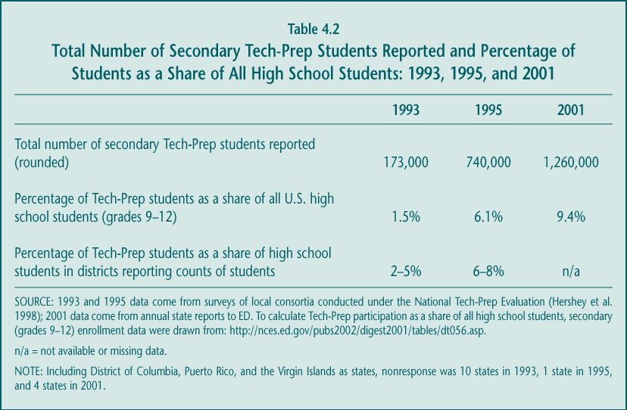

As reported, about 10 percent of high school students participate in Tech-Prep.

Although the scale of Tech-Prep participation has grown, this initiative still does not reach the middle majority of high school students, a goal some early advocates promoted. Based on data provided by states in FY 2001, Tech-Prep students represented about 10 percent of all secondary students in grades 9–12 that year. That share has increased along with the numbers of participants since 1993 (Table 4.2). However, there is great variation in rates of participation across states. For example, a state evaluation of Kentucky’s Tech-Prep initiative found that in FY 1997, Tech-Prep participants represented approximately one-third of the students enrolled in schools offering Tech-Prep.

Not surprisingly, the share of Tech-Prep students at the postsecondary level, as defined by each state, is smaller than that at the secondary level. Relative to the numbers of students reported to be enrolled nationally in postsecondary education and training, 1.7 percent are postsecondary Tech-Prep participants, based on state reports. If all of the Tech-Prep students attend two-year institutions, as the Perkins Act appears to promote, then the reported number of postsecondary Tech-Prep participants would represent 4.6 percent of total enrollments at those institutions.

3. Access to Tech-Prep

In part because policymakers viewed Tech-Prep as an initiative that was distinct from and improved upon vocational education, they established not only a separate title for Tech-Prep but also special provisions to promote its availability to all students. For example, in defining the contents of a Tech-Prep program, Section 204 (6) of Title II specifies that each program “. . . provide equal access, to the full range of technical preparation programs to individuals who are members of special populations. . . .” Recent national data provide an indication of the extent to which some kind of Tech-Prep effort is available in different types of schools.

Tech-Prep is less likely to be offered in “disadvantaged” secondary schools than in other schools.

Secondary schools that are considered to be “disadvantaged”—those with high proportions of students who live in poverty, who are from a racial or ethnic minority group, or who have disabilities—are less likely than most other schools to provide offerings they call “Tech-Prep” (Table 4.3). However, the proportion of highly disadvantaged schools offering Tech-Prep is similar to that of highly advantaged schools doing so. The reasons why Tech-Prep is less common in both types of schools probably differ, though. One hypothesis is that highly advantaged schools, with very low levels of students living in poverty and from special population groups, likely send most of their students to four-year colleges and focus their curricula on preparation for that goal; thus, these schools may simply choose not to participate in Tech-Prep. Highly disadvantaged schools, on the other hand, may be less likely to offer Tech-Prep because of constrained resources or other educational priorities.

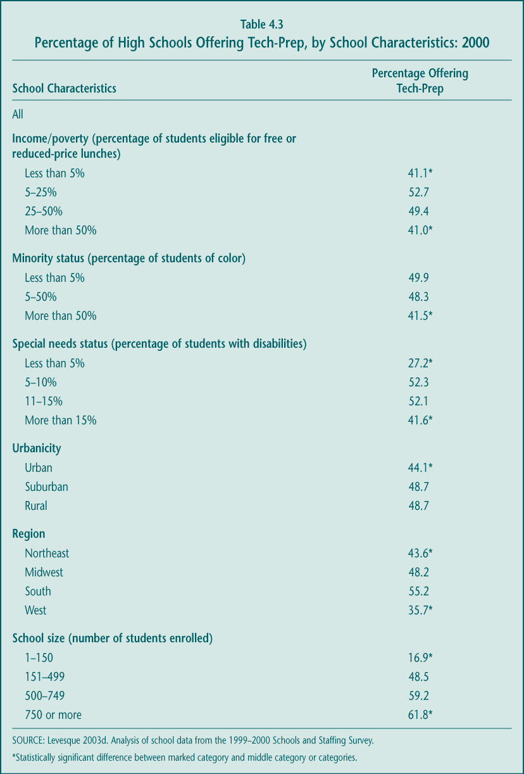

This pattern is not surprising, given the way states allocate funds to local consortia, as will be discussed in more detail in Chapter 5. Unlike the legislated formula that guides how Perkins basic state grants are distributed to districts and postsecondary institutions, few states consider school or community poverty levels in determining whether a Tech-Prep consortium receives a grant and how much it receives (White et al. forthcoming). Similarly, students’ race, ethnicity, and disability status are not factors that are considered in competitive or formula awards made by states to local consortia.

Tech-Prep is somewhat less available in urban schools than in schools in other types of communities.

Tech-Prep activity is about as likely to be offered in suburban as in rural schools but less likely to be offered in urban schools, based on the 1999–2000 Schools and Staffing Survey (Table 4.3). The results in 2000 appear to differ from those of the earlier national Tech-Prep evaluation; that evaluation found that in the mid-1990s Tech-Prep grants were distributed relatively evenly across types of locale (Silverberg, Hulsey, and Hershey 1997), as required by a provision (Title II, Section 205(e)) that states ensure the “equitable distribution of assistance between urban and rural consortium participants.” Such results are not necessarily inconsistent: consortium grants may be awarded equitably by urbanicity, but the allocation of funds within a consortium—to individual schools—may differ between those in urban and those in suburban or rural areas.

C. Implementation

The definition and contents of Tech-Prep are specified in Title II of Perkins III (Sections 202, 204, and 205) and include activities that students are to engage in, outcomes they are to attain, and processes to support consortium and student activities. To a large extent, these components overlap with those promoted in Title I to help improve vocational education in general.

According to Title II (Section 202), a Tech-Prep program is a program of study that
(A) combines at a minimum two years of secondary education (as determined under state law) with a minimum of two years of postsecondary education in a nonduplicative, sequential course of study;
(B) integrates academic, and vocational and technical, instruction, and utilizes work-based and worksite learning where appropriate and available;
(C) provides technical preparation in a career field such as engineering technology, applied science, a mechanical, industrial, or practical art or trade, agriculture, health occupations, business, or applied economics;
(D) builds student competence in mathematics, science, reading, writing, communications, economics, and workplace skills through applied contextual academics, and integrated instruction, in a coherent sequence of courses;
(E) leads to an associate or baccalaureate degree or a postsecondary certificate in a specific career field;
(F) leads to placement in appropriate employment or to further education.

Perhaps most importantly, Title II requires that a Tech-Prep program “. . . be carried out under an articulation agreement between the participants in the consortium” (Section 204). All of these program features are expected to be part of Tech-Prep implementation.

Articulation agreements remain the cornerstone of Tech-Prep.

The law describes the aim of Tech-Prep articulation as providing students with a “nonduplicative sequence of progressive achievement” across high school and postsecondary education, leading to a degree or certificate (Section 202). As described in Chapter 2, articulation typically involves aligning the content of a particular high school course with a similar community college course or aligning a series of courses that link a high school program to a college program. Articulation agreements formalize this process and are intended to help students make the transition from secondary to postsecondary institutions by eliminating redundancies in course work and providing them with opportunities to earn college credit or advanced standing in postsecondary programs for skills acquired in high school.

While Title II of Perkins promoted several practices in its vision of Tech-Prep, articulation is the most common and tangible component of Tech-Prep implementation. Site visits indicate that while some secondary schools may also pursue integrated or applied academic curricula, enhanced career guidance, or worksite experiences under the Tech-Prep banner, most school officials and vocational educators point to the establishment and updating of articulation agreements when asked to describe their Tech-Prep initiatives (Stasz and Bodilly forthcoming; Hudis, Blakely, and Bugarin forthcoming; White et al. forthcoming). State Web sites also highlight the prominent role articulation plays in Tech-Prep (see http://www.natpl.org). Most of these Web sites provide lists of and links to articulation agreements between each participating secondary school and local college, addressing to some extent a concern about the lack of promotion of articulation options first raised in the earlier national Tech-Prep evaluation (Hershey et al. 1998, p. 66).

National surveys also underscore the prevalence of articulation agreements. Among secondary vocational teachers, 41.1 percent worked with postsecondary faculty on articulation agreements at least once during the 2000–2001 school year, and more than one-third had a class for which an articulation agreement exists (Table 4.4). In contrast, only about 5 percent of academic teachers had a class for which an articulation agreement exists. Among vocational teachers who participated in a Tech-Prep, career academy, or other special career-focused program, 43 percent had articulated classes. The proportion of vocational teachers involved in articulation far exceeds that involved in other components promoted by Tech-Prep, as described below.

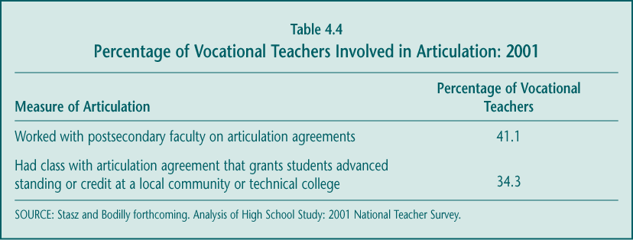

Despite the emphasis on articulation over the past decade, implementation of this core Tech-Prep feature has not had the anticipated impact, for several reasons:

► Emphasis has been on course-to-course articulation rather than on program articulation. Some of the expected benefits of articulation were predicated on linking a comprehensive high school program of study—including a sequence of challenging vocational or technical courses and academic courses—to a related program at the postsecondary level. The advantage of program-to-program articulation over course-to-course articulation is that it underscores the importance of taking appropriate academic classes and achieving the academic skills necessary to succeed in the postsecondary program. However, this form of articulation is rare; most articulation agreements specify college credits to be earned for taking a specific vocational course in high school (review of state Tech-Prep Web sites; Hershey et al. 1998).

► Despite having the opportunity, relatively few Tech-Prep students receive articulated college credit. While a majority of Tech-Prep students do pursue college, most of them do not appear to take advantage of the option of earning articulated postsecondary credit for high school course work (Hudis, Blakely, and Bugarin forthcoming; Hershey et al. 1998). There are many explanations for the fact that a small proportion of Tech-Prep students earn articulated credit—estimates have shown that only 15 percent of Tech-Prep students do so (Hershey et al. 1998). Some such reasons may include (1) procedural hurdles, such as waiting lists to get into high-demand postsecondary programs or having to apply or take an exam on a college campus to be granted the credit; (2) the diverse interests and paths of high school Tech-Prep students, which may or may not include a two-year postsecondary program at the specific community college or colleges to which their secondary vocational courses have been articulated; and (3) students’ concerns about their mastery of skills or desire to make their first-year college workloads easier by repeating instruction already taken in high school (Hershey et al. 1998).

► Inadequate data systems limit the tracking of Tech-Prep students into postsecondary partner institutions. Consortia and states have faced a variety of challenges in trying to identify Tech-Prep students who have matriculated in postsecondary institutions and are eligible for articulated credit. Most states do not have secondary and postsecondary data systems in which Tech-Prep students are flagged or that can pass information back and forth.

While the number of students earning articulated credit may be relatively small, articulation efforts have had some important benefits, including (1) stimulating communication between secondary and postsecondary vocational faculty and (2) improving the rigor and consistency of some secondary vocational curricula, by encouraging high schools to adopt college curricula and instructional materials as proof of course equivalency (Hershey et al. 1998).

Tech-Prep articulation is expanding beyond preparing students for technical careers.

Tech-Prep, particularly its articulation component, has come to encompass a broader set of careers and occupations than those specified in the law. While early proponents and members of Congress focused on increasing the number of well-trained technical workers, state and local officials have tended to view Tech-Prep as a reform relevant for all vocational education. These officials have not wanted to withhold the potential benefits of articulation agreements from students interested in less technical occupational programs or who might be seeking careers outside those traditionally associated with vocational education.

As a result, consortia in virtually every state have established Tech-Prep articulation agreements in such areas as child care, hospitality, interior or fashion design, and criminal justice (see http://www.natpl.org). Even in 1995, 32 percent of consortia offered Tech-Prep activities in the arts and humanities career area, and this type of offering appeared to be growing at that time (Silverberg, Hulsey, and Hershey 1997). By 2001, only a few states, such as Ohio, appeared to focus Tech-Prep and articulation efforts only on program areas that prepare students for high-tech occupations offering high wages.

Interest in applied academics is mostly weakening, although enthusiasm for other forms of curriculum integration continues.

Most other practices promoted in the Tech-Prep Education Act (Title II) have received less attention than articulation in the past several years. In particular, a form of integration referred to as “applied academics” (component (D) as defined in the law) was intended to “build student competence in mathematics, science, reading, writing, communications, economics, and workplace skills.”

State and consortium officials have greatly endorsed that ideal, but their early enthusiasm for this aspect of Tech-Prep has waned somewhat. The earlier national evaluation found that “off-the-shelf” applied curriculum packages were being replaced by efforts to develop applied lessons or units locally, a shift reflecting the expense of the packaged curricula and a rejection of earlier efforts to designate certain classes as “applied” because of the stigma attached to those classes. On the other hand, some states (e.g., Mississippi and Nebraska) continue to promote and support implementing these courses as one way to achieve the applied academic objectives of Tech-Prep. In addition, North Carolina is developing its own set of applied science courses for Tech-Prep students, in which students will ideally be grouped by the occupational focus of their studies.

Tech-Prep efforts to encourage academic teachers to develop and adopt applied approaches in traditional courses received support from the School-to-Work Opportunities Act, but implementation of these efforts has not been widespread (Hershey et al. 1998). In many states, the pressures of state academic standards and high school exit exams have made it more difficult to promote these approaches, particularly when little is known about their effectiveness. In 2001, only 11 state Tech-Prep officials reported that taking an applied academic class—with a commercial or locally developed curriculum—is necessary for a student to be classified as “in Tech-Prep” (see Table 4.1). Site visits conducted for NAVE in 12 states found little evidence that this form of Tech-Prep integration was being emphasized at the local level (Stasz and Bodilly forthcoming; White et al. forthcoming).

Instead of attempting to modify the content or delivery of academic course work, some states and localities have moved toward encouraging or requiring Tech-Prep students to meet certain academic course-taking standards (in addition to being enrolled in a vocational course sequence). For example, in North Carolina, Tech-Prep students must take college-preparatory mathematics, and in Florida, a student cannot be considered as “in Tech-Prep” unless that student is at grade level or above by the junior year in mathematics, science, and communications (Stasz and Bodilly forthcoming). This approach relies on the traditional academic course offerings at local schools in which Tech-Prep and other students are combined.

Tech-Prep officials also generally support other forms of integration, including strengthening the academic content of vocational courses, but they have not typically led these efforts in the last several years. Certainly, in some schools where Tech-Prep has been implemented as a separate, specialized program for interested students—such as in the Medical Laboratory Technology Program, a joint initiative of the New York City Board of Education and the City University of New York (College of Staten Island)—vocational curricula have been revised to emphasize the science, math, or reading and writing skills necessary to be successful in certain targeted careers (Shimony et al. 2002). However, in most states and communities, Tech-Prep is largely built around existing vocational courses that serve all vocational students, whether or not they are in Tech-Prep, and efforts to integrate more challenging academic content in vocational curricula have been broad and not directed at Tech-Prep specifically.

Worksite experiences are not a focus of recent Tech-Prep efforts.

Following the emphasis in the School-to-Work Opportunities Act of 1994, Perkins III encourages Tech-Prep initiatives to include worksite learning as appropriate. According to consortia reports, the number of Tech-Prep students who had paid school-year jobs related to their vocational studies grew from just over 9,000 in 1994 to more than 25,000 in 1995, representing close to 6 percent of all reported Tech-Prep students both years (Hershey et al. 1998). About 14 percent of Tech-Prep students in both years participated in work site visits. However, consortium members indicated that most of the workplace experiences in which Tech-Prep students engaged were available to all students in their schools rather than targeted specifically to Tech-Prep students.

As state and local grants under the School-to-Work Opportunities Act began to sunset around the year 2000, resources for and attention to this component have dwindled somewhat. Site visits to local consortia staff, secondary schools, and postsecondary institutions suggest that worksite experiences are not a priority for Tech-Prep in most communities (Stasz and Bodilly forthcoming; White et al. forthcoming; Hudis, Blakely, and Bugarin forthcoming). By 2001, 24 states (about half) reported work-based learning as a key Tech-Prep element, but only eight states (19 percent) required that a student be involved in a workplace experience to be counted as a Tech-Prep participant (Table 4.5).

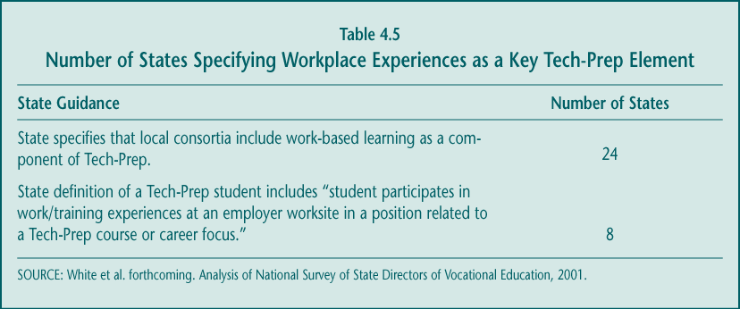

Few consortia or schools implement Tech-Prep as a comprehensive program of study.

Tech-Prep, as prescribed in Perkins III, appears to encourage a set of structured programs that combine the different elements outlined in the law for those students who choose to participate. The students would commit to a program’s career focus and expected outcomes and would follow a well-defined sequence of both academic and vocational courses specifically designed to prepare them for eventual employment in that career field after completing a relevant associate’s degree. To integrate academic and vocational instruction, each program would cluster its participants together in many if not most classes. The Tech-Prep program would identify the particular program(s) at the postsecondary level in which students are expected to continue, and articulation agreements would link the high school vocational and academic components to the postsecondary component.

If Tech-Prep merits being distinguished from other educational programs, its value lies in these coherent, structured programs of study that early proponents advocated. Case studies suggest that this model has benefits that set it apart from the more diffuse approaches to Tech-Prep implementation (Hershey et al. 1998). When students are actually required to participate in and commit to a sequence of academic and vocational courses that prepare them for a career, it is possible to set high standards for achievement. Comprehensive programs of study typically involve high school and college educators working closely together, which allows the kind of communication between teachers and students that can enhance students’ transition into the postsecondary stage of the program. These programs are often conceived and planned with strong support from employers, a collaboration that can strengthen the public image of a program. Clustering students in academic and vocational classes not only offers opportunities for the kind of integration that is most likely to improve their learning of rigorous theoretical concepts but also can also produce a sense of identity, pride, and seriousness of purpose among these students.

However, both the earlier national Tech-Prep evaluation and more recent studies conducted for NAVE indicate that this structured form of Tech-Prep is rarely found in U.S. high schools (Hershey et al. 1998; Stasz and Bodilly forthcoming; White et al. forthcoming). When last evaluated in a systematic manner, the results showed that only about 10 percent of consortia, representing 5 percent of all Tech-Prep participants reported (less than 1 percent of high school students overall), promoted this model (Hershey et al. 1998). Over the years, states, consortia, and schools have pursued diverse implementation strategies emphasizing and combining the individual elements of Tech-Prep to varying degrees, but infrequently have they used all of them together. In 2001, only about a quarter of states reported that they promote Tech-Prep as a distinct program to local consortia (Table 4.6). Even within those states, local consortia and schools are often inconsistent in how strictly they adhere to this vision (Stasz and Bodilly forthcoming).

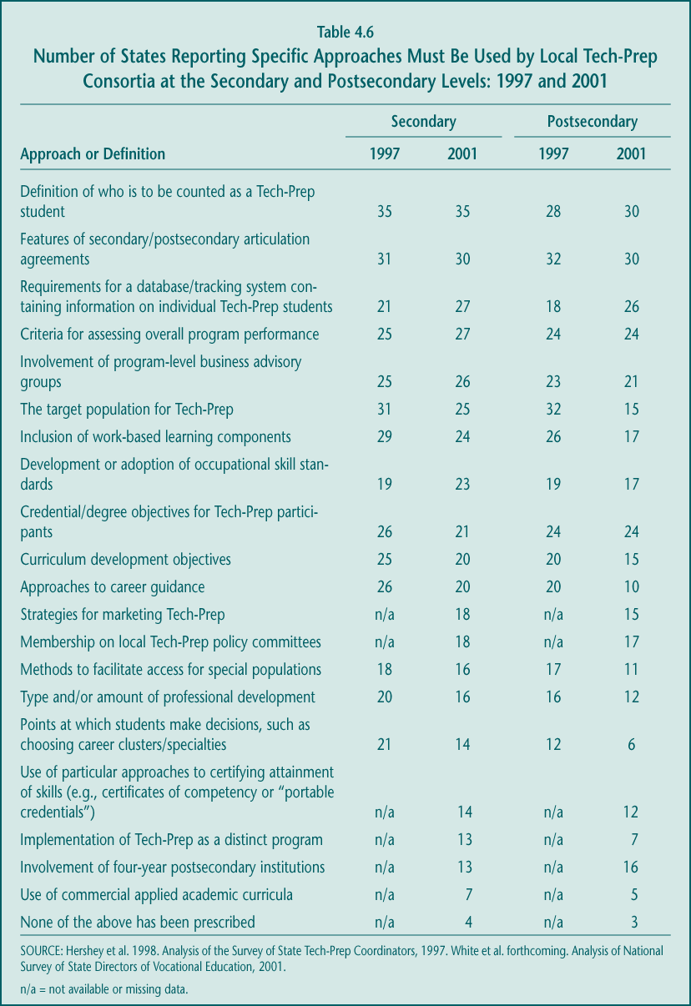

According to Tech-Prep officials and educators, several factors affect the relative lack of support for distinct programs of integrated academic and vocational study (Hershey et al. 1998):

► Some parents and educators are concerned that choosing a high school program of study organized around a career interest might limit students’ chances of pursuing another career in the future. This is consistent with the movement in high school vocational course taking in general (described in Chapter 2) toward more exploration and less concentration in a single career area.

► Most parents, even those of students with weak academic performance, want their children to go to a four-year college, and Tech-Prep’s focus on students’ transitions to community college is thought to undermine their prospects for earning a bachelor’s degree.

► Programs associated with vocational education, even those that emphasize high-skill, high-tech occupations, still evoke suspicions of tracking in some cases; grouping students by their academic and vocational courses can exacerbate this problem.

► Some schools are too small to group Tech-Prep students in academic courses by career program area or to tailor academic courses to a career focus.

► Educators acknowledge that students in vocational courses classified as Tech-Prep have diverse interests and abilities that lead them in many directions in terms of postsecondary study; as a result, participating faculty have been reluctant to emphasize one particular college program (the articulated path) over others.

► Because comprehensive programs involve more intensive efforts and resources, those that are offered include small numbers of students. For example, the comprehensive Med-Tech Tech-Prep program is offered in two Staten Island high schools, and the number of juniors who enrolled between 1994 and 1998 was just 265, or about 66 students each year (Shimony et al. 2002), representing about 4 percent of the juniors in those two schools.

For these and perhaps other reasons, consortia and schools have turned to less structured, programmatic approaches to Tech-Prep (Stasz and Bodilly forthcoming; Hershey et al. 1998). One common approach is an enhanced version of career guidance, in which schools develop course sequence guides, charts that display the available academic and vocational courses recommended as preparation for particular career areas and, sometimes, the types of postsecondary education or training appropriate for each of those paths. The academic courses are those traditionally offered by the schools and required for graduation. Vocational courses that have been articulated may be identified as such. Guidance counselors then use these course sequences to help students choose their electives in ways that support students’ career interests and postsecondary plans.

In other versions, implementation focuses on individual elements of Tech-Prep—maintaining articulation agreements, supporting applied academic courses, providing professional development to academic or vocational teachers—but rarely are these elements connected or do they involve the same sets of students.

Although community and technical colleges play a lead role in consortia, Tech-Prep is largely viewed as an effort to upgrade secondary vocational education; it has little impact on postsecondary courses.

Postsecondary partners appear to play supportive roles in Tech-Prep, particularly through consortium leadership, but there is less Tech-Prep activity on college campuses or perception of a need to change than in high schools and area vocational centers (Hudis, Blakely, and Bugarin forthcoming; White et al. forthcoming; Hershey et al. 1998). While under Tech-Prep, secondary schools may need to modify and update vocational curricula to satisfy articulation arrangements or make other changes consistent with their Tech-Prep objectives, typically Tech-Prep has little impact on college curricula and services. Relatively few postsecondary institutions have offered new courses for students entering with Tech-Prep experience or made other modifications that can be traced directly to the implementation of Tech-Prep.

In fact, surveys of state Tech-Prep coordinators suggest that states were providing less guidance to local consortia about postsecondary Tech-Prep in 2001 than they had done in 1997 (see Table 4.6). Fewer states in 2001 than in 1997 reported specifying for consortia such features as the development or adoption of occupational skill standards for postsecondary Tech-Prep programs (17 vs. 19), curriculum development objectives (15 vs. 20), career guidance approaches (10 vs. 20), or types and amounts of Tech-Prep professional development (12 vs. 16).

The more limited Tech-Prep activity of postsecondary partners appears to be a result of several factors. First, in most states, a relatively small number of students on community college campuses can be documented as having “completed a secondary Tech-Prep experience.” At the same time, many community colleges serve a predominantly older student population. These two trends have provided little incentive for colleges to make substantial modifications to curricula or other changes to address the particular needs of Tech-Prep students. In addition, community college offerings are driven by such external factors as the economy and local business needs. Local employers may or may not push to have Tech-Prep applied to the postsecondary level, which may involve implementing applied academics or related worksite activities that could lead to major alterations in postsecondary education.

D. Outcomes and Effects

According to both its advocates and Perkins III legislation, Tech-Prep is intended to offer several benefits. First, in a general sense, the implementation of Tech-Prep should result in higher numbers of students entering technical postsecondary study. Second, participation in Tech-Prep should “build competence in” or improve students’ academic and technical skills. Third, Tech-Prep is expected to raise the probability that a student attains an associate’s degree, certificate, or baccalaureate degree in a field related to his or her secondary program of study. Finally, articulation agreements and “nonduplicative, sequential courses of study” should allow Tech-Prep students to either complete postsecondary programs more quickly or complete them with higher skills because they entered with advanced standing, which would, in turn, result in higher earnings.

These expected outcomes, however, were predicated on the notion of Tech-Prep as a coherent program of related academic and vocational study that spanned both the secondary and postsecondary levels. At least as implemented in most communities, Tech-Prep does not appear to follow this model or reflect a consistent program with a core set of features; it is instead a varied set of practices that are generally available to students in regular vocational education courses.

In part because of its diverse implementation, no rigorous evaluation of the effects of Tech-Prep nationally has been conducted. The earlier national Tech-Prep evaluation documented the outcomes of students considered to be “in Tech-Prep,” as reported by all local consortia, and collected transcript and survey data on Tech-Prep students in 10 consortia. Evaluations of Tech-Prep students in several states (Ohio, New York, Texas, Florida, and Kentucky) and one study of eight “mature” Tech-Prep consortia have been carried out. A few evaluations of individual local Tech-Prep programs—those with more comprehensive programs of study—have also been conducted.

All of these evaluations have methodological limitations that preclude making judgments about the impact of Tech-Prep—that is, the extent to which the program leads to better or different outcomes than students would have achieved without participating in Tech-Prep. Still, some of the studies provide a basis for describing the postsecondary paths of Tech-Prep participants, particularly in cases where the preponderance of studies have found consistent results.

Tech-Prep and non-Tech-Prep students pursue college at roughly comparable rates, but the effects of Tech-Prep on postsecondary enrollment and completion are not known.

Student enrollment in postsecondary education has been a primary goal of Tech-Prep. Many Tech-Prep students do, in fact, enter college or training, and several studies suggest they do so at rates at least as high as those of other high school students (Table 4.7). Whether participation in Tech-Prep actually contributes to postsecondary enrollment cannot be determined from most evaluations; students who are involved in Tech-Prep may simply be higher achieving or more motivated than other students. One study of participation in Texas suggests some of the benefits of that state’s form of Tech-Prep: the analysis found that in 1998 students who were considered “in Tech-Prep” in 12th grade were more likely to enroll in a postsecondary program than were similar 12th-grade students who were not enrolled in Tech-Prep (Hoachlander et al. forthcoming).

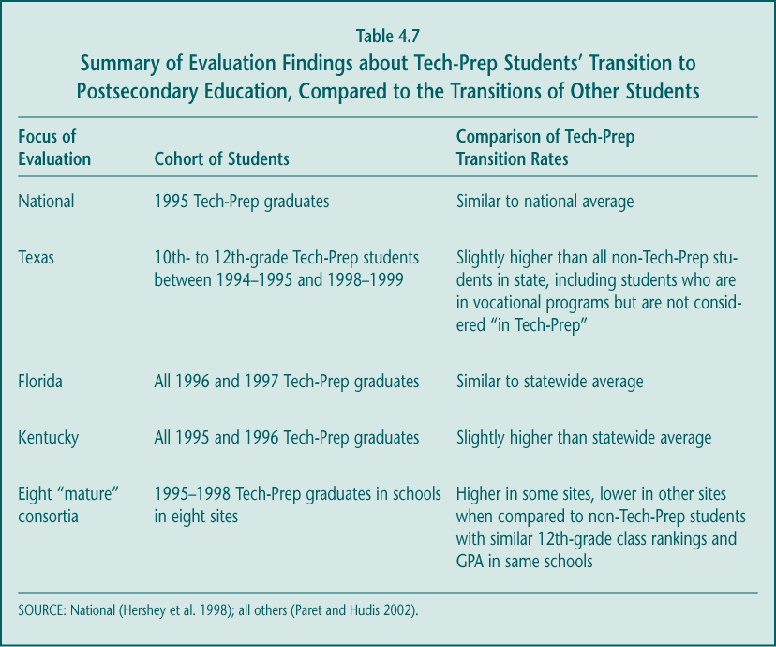

No data are available about the proportion of students who complete a two-plus-two program or the benefits of doing so.

Unfortunately, no evaluations have been conducted to examine the effects of completing the comprehensive program of study model that Tech-Prep proponents originally envisioned. Existing studies have generally tracked outcomes at most a year or two after high school graduation, and only one publicly available report examines whether students continue into related postsecondary programs, an outcome promoted in the legislation. In national data sets, the number of students who fulfill the requirements of related secondary and postsecondary occupational study is too small to conduct analysis. Most states that publish outcomes of Tech-Prep students do not differentiate among postsecondary programs and outcomes; only Ohio separately documents transitions into related and unrelated postsecondary programs.

The lack of information on rates of completion in two-plus-two programs appears to underscore, or perhaps reflect, the limited emphasis on comprehensive programs of study. On the other hand, as will be discussed further in Chapter 5, even the federal accountability provisions for Tech-Prep do not require such distinctions in state reporting of Tech-Prep student outcomes.

5. Program Management: Funding and Accountability

Federal legislation often relies on funding and accountability provisions to achieve specific policy goals and to signal priorities. Perkins III is no exception. The most significant difference between the 1998 law and its predecessor involved these program management tools. In particular, certain set-aside funding streams were eliminated in order to provide both a larger share of funds directly to local grantees and greater flexibility to state and local programs. The law also substantially increased the emphasis on program accountability, requiring states to set student performance targets and work toward achieving them or face funding consequences. Perhaps no other legislative requirements can affect grant recipients more directly than those governing funding and accountability.

This chapter first reviews the specific funding and accountability provisions in Perkins III (Section A) and then examines how they have been enacted, addressing three key questions:

1. Have the new provisions changed grant distributions or the use of funds at the secondary level, and are these changes consistent with congressional intentions (Section B)? What about at the postsecondary level? (Section C)

2. Has Perkins III affected how Tech-Prep funds are distributed? (Section D)

3. How have performance measurement and accountability systems been implemented in the early years of Perkins III? Are they likely to be effective in promoting program improvement? (Section E)

Key Findings

► The new law succeeded in sending a higher share of funds to the local level.
Between 1992 (early Perkins II) and 2001 (early Perkins III), the average size of a grant increased by approximately 34 percent for secondary grantees and by 26 percent for postsecondary grantees. This growth cannot be fully explained by increases in the inflation rate or in Perkins appropriations for the basic state grant (15.3 percent), or by a decline in the number of grants awarded. Higher grant amounts mostly reflect the new law’s requirement that 85 percent of state Perkins funds (up from 75 percent under Perkins II) go to local grantees.

► States are taking advantage of the law’s flexible funding options.
Perkins III continued several provisions that give states some discretion over how they distribute local funds. According to state directors, 29 states currently use at least one of these options at the secondary level, and 20 do so at the postsecondary level. The most common choice is the newly established “reserve fund,” which allows states under specified circumstances to award 10 percent of their Perkins allotment to local grantees without using the legislated intrastate funding formula.

► Targeting of funds to districts with the highest concentrations of poverty has declined somewhat over time.
Perkins III funding to the local secondary level remains targeted to areas where there are high concentrations of poverty, though the strength of this relationship has diminished over time. Adjusting for district size, grant amounts per pupil increased for low-, medium-, and high-poverty districts between 1992 and 2001, but high-poverty districts experienced less of an increase than did other types of districts. Perkins funding continues to favor rural, urban, and small school districts.

► Little has changed under Perkins III in how local grants are spent.
As was true under Perkins II, secondary local grants are most often used to purchase equipment and materials, perhaps because districts do not designate other funds for these needs. At the postsecondary level, keeping equipment up-to-date is more central to the missions of institutions, and Perkins funds are most likely to cover support services, particularly for special populations (e.g., child care, counseling) and professional development for vocational faculty.

► Federal funding represents a fraction of overall spending on vocational education.
In theory, the extent to which federal policy can affect practice is related to the federal share of spending. The best estimate is that Perkins III local grants represent, on average, about 5 percent of total expenditures on vocational education at the secondary level and about 2 percent at the postsecondary level. While these proportions are small, state and local administrators report that federal funds are used to fill essential needs.

► The quality of Perkins performance reporting varies considerably by indicator, by state, and sometimes even within states.
While much progress has been made in developing and implementing an accountability system since Perkins II, the accuracy and validity of the performance measures remain uneven. Some states use measures that are not well-matched to the performance sought (e.g., academic grade-point average (GPA) as an indicator of vocational-technical skill). And within states, local grantees may not use consistent definitions, measures, or data collection strategies, making judgments about aggregate state performance unreliable. States and local programs report that they have difficulty collecting data on various indicators, particularly for the vocational and technical skill indicator, and they often attribute their problems to rudimentary local data collection systems that depend heavily on hand counts.

► Early state performance results show significant variation in how high performance target levels were set but consistency in meeting those targets.
States reported an extremely wide range of performance levels for each indicator in Program Year 2000–2001, mainly because they used different definitions, measures, and data collection procedures. As required by Perkins III, states also established performance targets for subsequent years with a goal of improving student performance. Early results show that states negotiated modest levels of improvement—generally less than a 1 percentage point increase per year—and a majority of states met those targets.

► At least so far, most state and local administrators do not view Perkins III data as useful for program management and improvement.
States and local communities widely view Perkins III data collection as a compliance exercise consisting of gathering information that the federal government requires, not information that could be useful for state and local purposes. Few states and local entities use performance data to manage their programs or to identify districts and schools needing improvement.

A. Overview of Perkins Funding and Accountability Provisions

Perkins III reflects a trend in federal legislation toward greater flexibility in program funding and implementation in exchange for stricter emphasis on performance. Although many aspects of program management remain the same as under the previous law, some important modifications were made in Perkins III.

1. Perkins Funding

In many respects, the basic framework for federal vocational funding did not change when Perkins was modified in 1998 (Table 5.1). Each state receives a grant from the U.S. Department of Education (ED), based on population counts in several age categories. State agencies then allocate much of their grant to local programs, with the discretion to determine the share of Perkins funds allocated to institutions at the secondary versus postsecondary levels. Funds dedicated to secondary vocational education are distributed to secondary districts based largely on their proportion of low-income youths; money for postsecondary vocational education is distributed to community colleges and other eligible postsecondary institutions based largely on their share of Pell grant recipients. The compensatory nature of the funding formulas reflect both a desire to ensure equal access to vocational education and the reality that such courses and programs are often more costly to provide—perhaps by as much as 20 to 40 percent—than programs in most other subject areas.

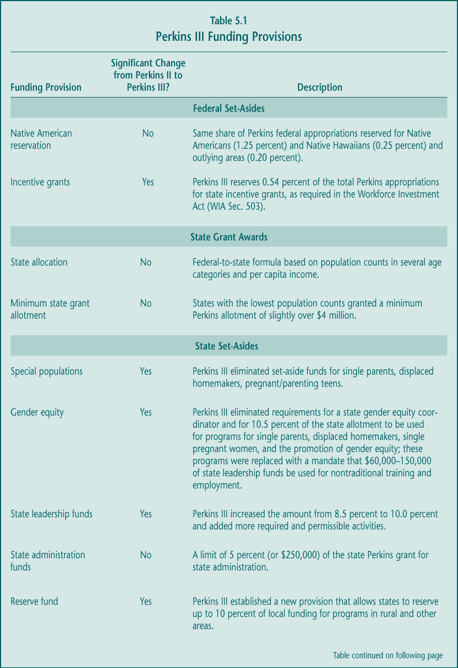
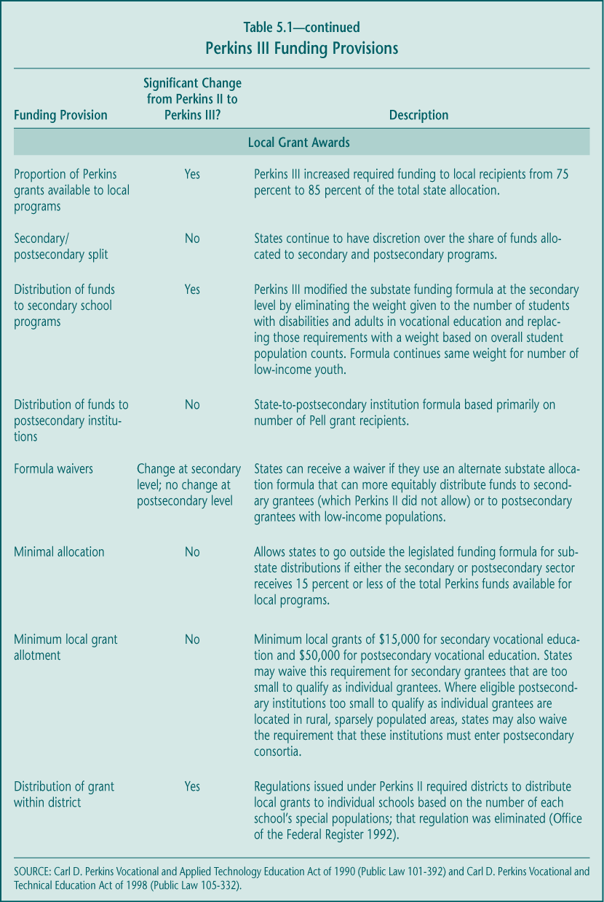

However, significant changes were made to Perkins III to further the goals of flexibility and increased local resources, including the following:

► Elimination of the set-aside funding streams for “special populations” (e.g., single parents, displaced homemakers, pregnant teenagers); a state gender equity coordinator; and requirements that local education agencies target funds to schools and programs with the greatest concentrations of special populations.

► Increase in the share of funds for local programs (from 75 percent in Perkins II to 85 percent in Perkins III).

► New local secondary funding formula, with less emphasis on the proportion of students with disabilities than previously.

► Introduction of a state reserve (up to 10 percent of the allocation to local programs) that may be distributed outside the local secondary funding formula to support programs in rural areas; areas with high percentages or numbers of vocational and technical education students; and communities negatively affected by changes in the in-state secondary school formula.

While these funding changes were being debated and enacted into law, federal appropriations for Perkins state grants increased along with appropriations for other federal education programs. Annual appropriations for Perkins basic state grants increased by 15.3 percent between 1992 and 2001 (Table 5.2), the two years NAVE uses for analysis. These increases generally translated into higher amounts for states. However, the increase did not keep pace with the rate of inflation or the funding increases of other federal education programs. The median state allotment was $13,368,617 in 1992 and $15,994,426 in 2001. Most of these funds were, in turn, distributed to local secondary and postsecondary programs, with the effect that, in 2001, federal vocational grants amounted to about 5 percent of local spending on secondary vocational education programs and about 2 percent of spending at the postsecondary level. The federal share remained relatively constant between 1992 and 2001.
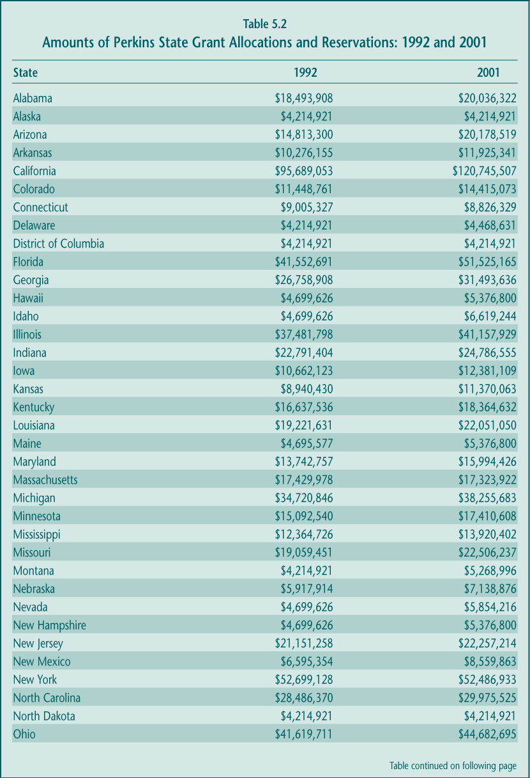

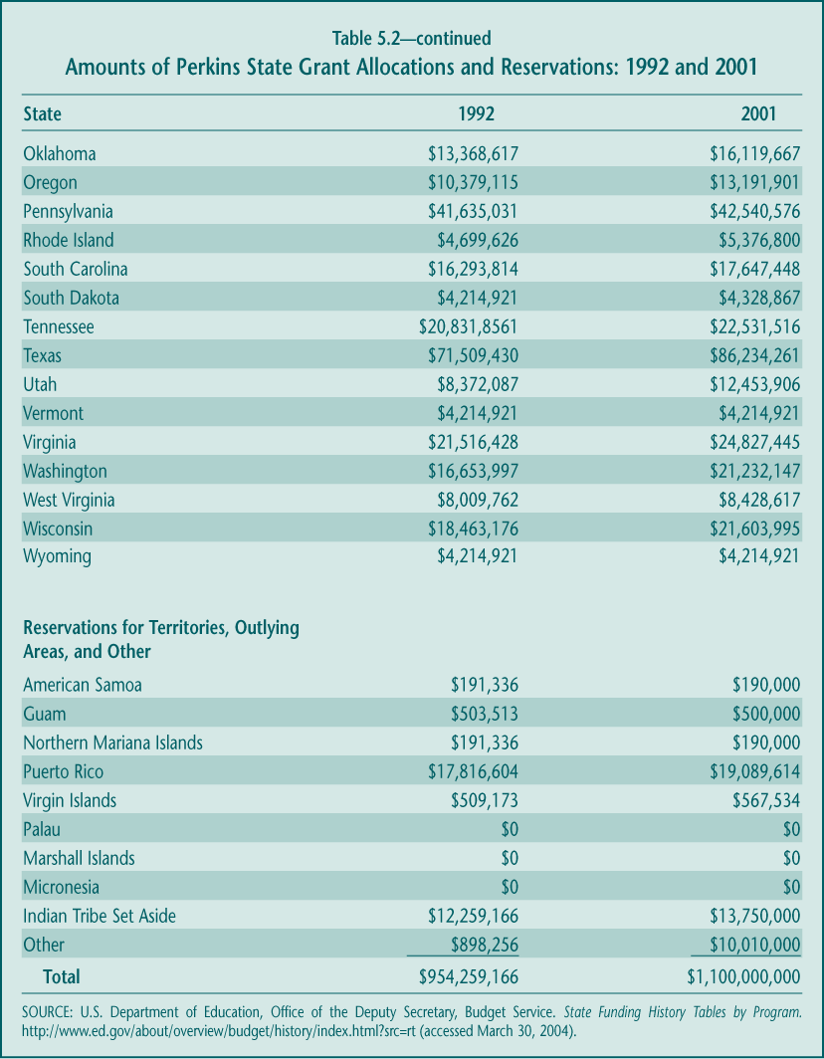

2. Perkins Accountability

On the surface, the general accountability requirements contained in Perkins III are similar to those in the earlier Perkins II (1990). However, the new accountability provisions are a much more significant instrument of federal policy than they were in the previous act and elevated the expectation of Congress that states would develop meaningful systems of performance measurement and improvement. Compared to Perkins II, Perkins III raises the requirements for state reporting of student outcome data (including mandating more measures of performance) and the potential rewards and consequences for states that do and do not improve their program performance (Table 5.3).

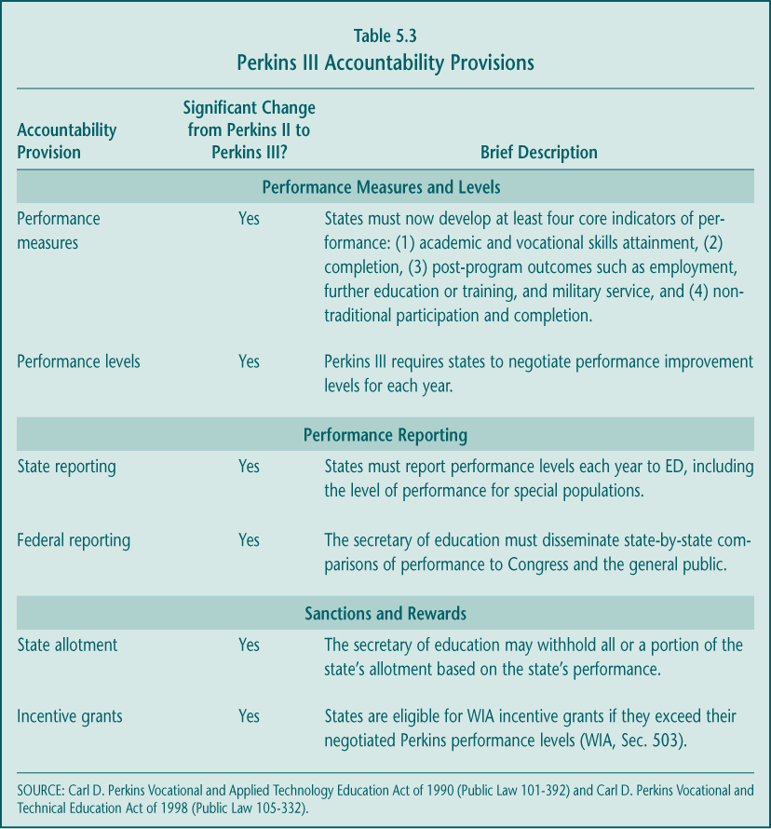

Perkins III requires each state to develop a system of measurements and to establish expected levels of performance in four categories:

- Student attainment of academic, vocational, and technical skill proficiencies.

- Completion of a secondary or postsecondary degree or credential.

- Placement and retention in postsecondary education, advanced training, employment, or the military.

4. Participation in and completion of programs that lead to nontraditional employment.

In addition, each state is required to report on the progress of special populations with respect to their performance in each of these categories.

However, the major changes in Perkins III accountability have less to do with the types of measures that are required than with how performance data, once collected, are to be used. Under Perkins III, for example:

► Performance goals are set. States must negotiate quantifiable levels of performance with ED and report yearly to the secretary of education on progress made in meeting these standards. The previous act simply required assurance from states that a system of measures had been implemented but did not require target performance levels.

► State data must be submitted. States are required to submit performance results to ED; the secretary of education must make this information available to the public and compile state-by-state comparisons. The previous act did not require states to submit data.

► Rewards and penalties are possible. Perkins III raises the potential stakes associated with performance. Under the law, failure to meet state-level performance standards could eventually result in loss of some or all of a state’s Perkins funds. As a reward, however, Section 503 of the Workforce Investment Act (WIA) provides incentive grants to states that exceed performance levels under the Perkins Act, Adult Education and Family Literacy Act, and Title I of WIA.

This chapter examines in greater depth the funding and accountability changes in Perkins III and their effects on states and vocational programs at the local level.

B. Perkins State Grant Funding at the Secondary Level

As noted earlier, the Congress that enacted Perkins III was driven by two main objectives with respect to the use and allocation of Perkins funding. First, Congress wanted a larger share of funding to go directly to local programs. Second, it wanted to give states more funding flexibility in order to better meet the needs of their communities. These preferences led Congress to legislate new funding provisions that can affect both grantee allocations and the distribution of money.

1. Basic Allocations and Use of Flexibility Provisions

Local grants made under the Perkins Act are shaped by a combination of legislative specification and state choices. The law mandates the local funding formula and the maximum proportion of the state allocation that can be retained for state administration (5 percent) and state leadership (10 percent). However, Perkins III includes several provisions that allow states and local grantees flexibility in distributing grant funds.

In Perkins III, states continue to have discretion over how Perkins money is split between the secondary and postsecondary sectors, but they have made few changes overall from the previous act.

As was true in previous legislation, Perkins III allows states to determine the relative share of the annual state allotment that goes to secondary and postsecondary vocational education. These preferences appear to be quite stable: nationally, states decided to distribute funds between secondary and postsecondary sectors in much the same way they did under Perkins II, with 62 percent of local Perkins funds allocated to the secondary level and 38 percent to the postsecondary level (Table 5.4).

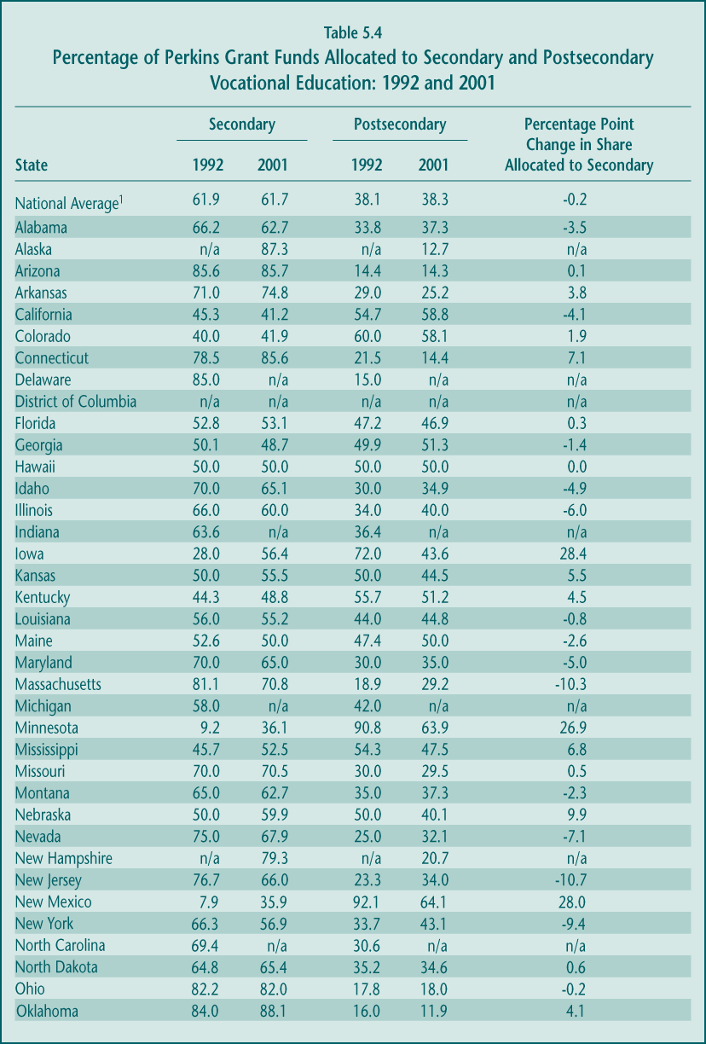

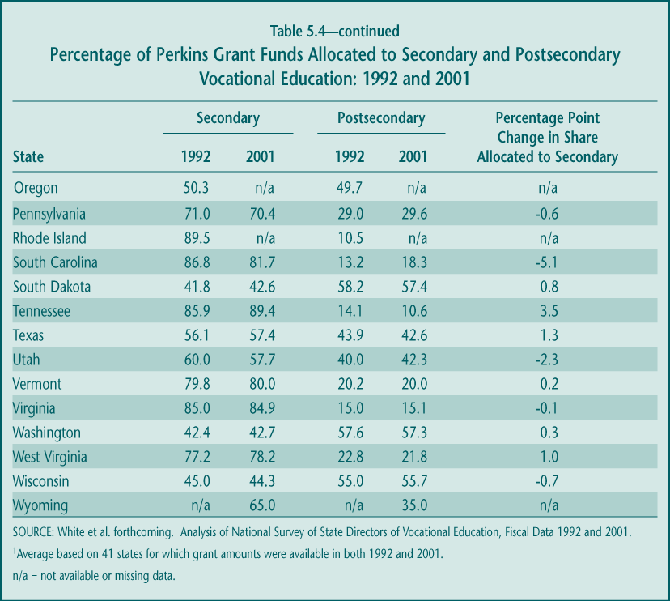

Most states continued their historical patterns of secondary-postsecondary allocations, with shifts of less than 5 percent over the last decade. But there were a few exceptions. Three states (Iowa, Minnesota, and New Mexico) reported a relatively large shift (over 25 percentage points) toward the secondary level. Two states (Massachusetts and New Jersey) increased the share of Perkins funding to postsecondary vocational education (by over 10 percentage points).

Consistent with congressional expectations, local secondary grantees received more funds under Perkins III.

One major change introduced in Perkins III was a requirement that a higher share of the state allocation go to local grantees (85 percent, compared to 75 percent under Perkins II). The new law appears to have succeeded in this goal. As shown in Table 5.5, a comparison of Perkins grant awards reported by state directors in 1992 and 2001 indicates the following:

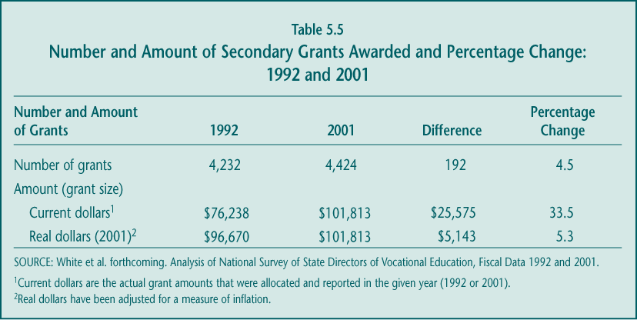

► The average grant size increased substantially. Nationally, the average secondary grant amount increased by one-third between Perkins II and Perkins III.

► More grants were awarded. The average amount grantees received did not increase simply because funds were awarded to fewer districts; generally, states awarded more Perkins grants at the secondary level during the same period.,

► The increase in the secondary grant size cannot be explained by a change in the secondary-postsecondary split or higher Perkins appropriations. If states chose to designate a higher proportion of Perkins funds to secondary vocational education, then average secondary grant sizes could increase even without a higher share of funds going to the local level. But, in fact, the secondary-postsecondary split remained the same between Perkins II and Perkins III. Also, the increase in Perkins appropriations for basic grants during the period was only 15.3 percent (Table 5.2), compared to a 33.5 percent increase in secondary grant amounts. Therefore, the higher grant amounts are not due solely to higher federal program budgets.

► Purchasing power expanded to some extent. The increase in the average grant size was slightly higher than inflation during the same period, suggesting that grantees had at least as much resource capacity from federal funds as they did a decade earlier under Perkins II.

► Secondary grant size increased in most states in 2001, although the average amounts varied considerably by state. In most states, the average grant size increased, with the exception of Montana, Nevada, and South Dakota (Table 5.6). However, as was true under Perkins II, compared to the national average of $101,813, the average Perkins III state grant ranged widely from a low of $26,224 in Montana to a high of $2,285,140 in Hawaii. This variation is partly attributable to several factors: each state’s secondary-postsecondary split, the number of grants made including the extent to which states use consortium grants to group small districts, and school district size. Even within states, actual grant size varied by a wide margin.

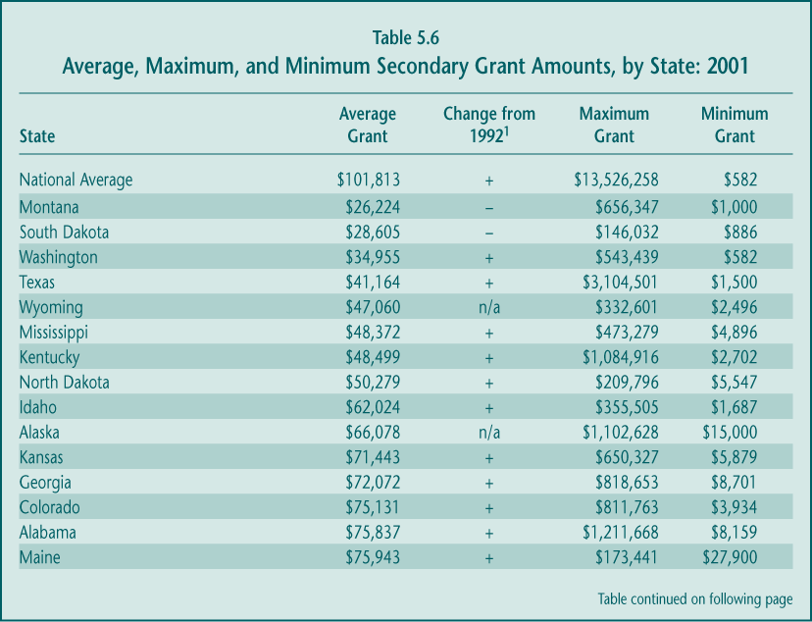
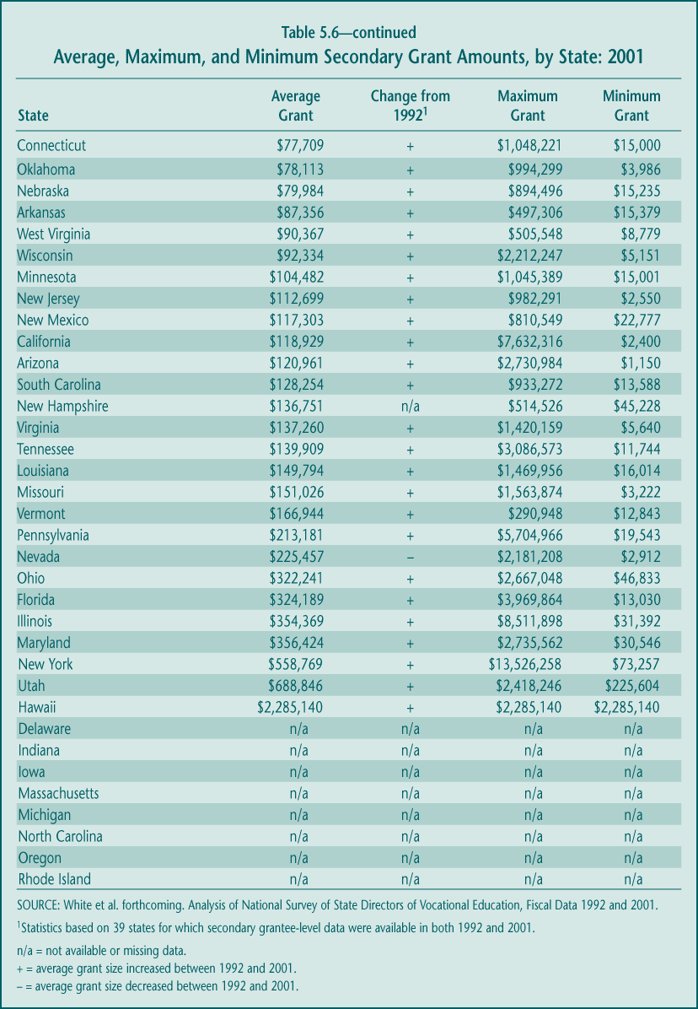

Although there was an increase in the number of secondary grants awarded, slightly fewer eligible districts seemed to be included.

Local education agencies (LEAs) can receive Perkins funding either through an individual grant or as part of a consortium grant. This occurs if the LEA is too small or does not have sufficiently high concentrations of poverty to otherwise qualify on its own for at least the minimum grant amount of $15,000. According to grant award data provided by state directors, not all LEAs receive Perkins funding in a given year (Table 5.7). In fact, 35.8 percent of LEAs did not receive any Perkins funding in 2001, a slightly larger proportion than in 1992.

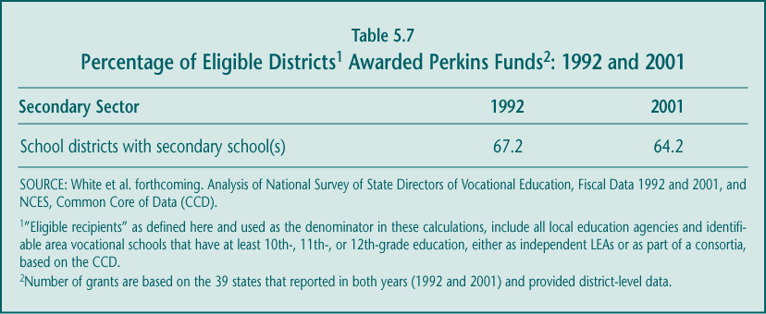

Local Perkins funding for secondary education primarily went to regular districts with comprehensive high schools in 2001.

A variety of institutions are eligible for secondary Perkins funds under Perkins III, as was true in the earlier legislation: LEAs, area vocational schools (AVSs), middle schools, Bureau of Indian Affairs (BIA) schools, and others. However, according to a survey of state directors, districts send nearly four out of five Perkins dollars to comprehensive high schools, the most common type of secondary school. AVSs, far less prevalent but still widespread in many areas of the country, receive a smaller share (15.6 percent) of Perkins secondary funds. Very few funds are distributed to schools that do not typically enroll high school students, such as middle schools and adult vocational programs (Table 5.8).

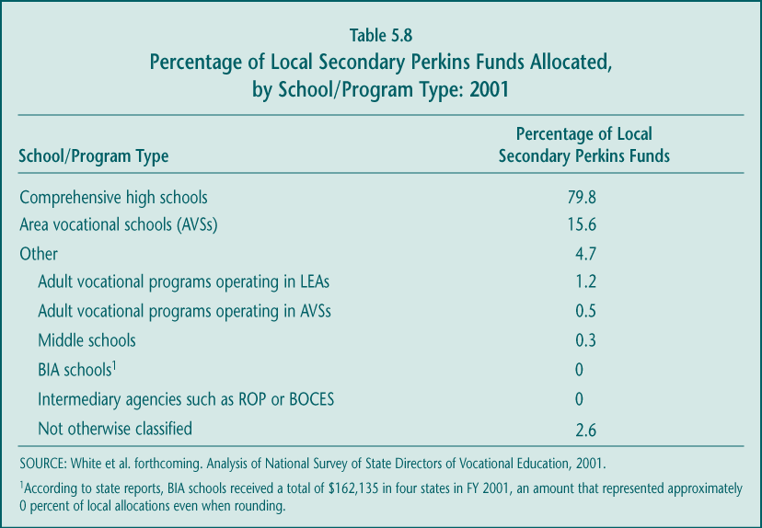

A very small number of Bureau of Indian Affairs- (BIA) funded schools received secondary Perkins grants in FY 2001.

Both Perkins II and III mandated a federal set-aside of 1.25 percent of the total Perkins appropriation to be allocated to programs serving Native Americans and Alaska Natives, including BIA-funded schools. However, Perkins III made BIA secondary schools ineligible for direct grants under the Native American set-aside but eligible for local Perkins grants as if they were separate LEAs. This potentially opened the door for more Perkins funding for BIA-funded secondary schools, although these schools are subject to the same formula and minimum grant provisions as are other LEAs.

A total of 15 states reported that they have BIA high schools in their states. However, only four indicated that they awarded state Perkins grants to BIA-funded secondary schools in FY 2001: Arizona, California, and North Dakota each have two such schools, and South Dakota has one. The most likely explanation is that the BIA schools are too small to qualify for funds as individual grantees, although some may have received funds as part of consortium grants.

District coordinators distribute Perkins funds to schools based on their perception of need.

Although a majority of districts have only one high school, Perkins III allows LEAs considerable discretion over how to apportion their local grants where they have multiple eligible schools and programs. Case studies suggest that these decisions are typically made by a person designated as the district’s “Perkins” or vocational education coordinator, often in consultation with the district superintendent (White et al. forthcoming). The choices typically reflect both a consideration of need and some cycle of rotation—i.e., the amount of time since the school or program received funds for equipment or other improvement; the desire to launch a new program in one or several schools (e.g., the popular information technology (IT) programs); or a key change in technology. Some very large districts use a competitive process to distribute funds; in Chicago, for example, schools submit proposals and must specify the particular programs and needs for which funding is requested. Districts typically do not take into account potential differences in resource disadvantage among schools when Perkins funds are distributed.

This process for allocating funds within LEAs does not appear to have changed with the implementation of Perkins III. However, Perkins coordinators interviewed in the case studies suggested that eliminating the Perkins regulatory requirement that LEAs target funds to programs with the greatest concentration of special populations has allowed districts to distribute Perkins funds to more schools, including schools with lower proportions of special populations.

States are taking advantage of some options for secondary funding flexibility—one of the pillars in Perkins III.

The primary flexibility provisions were carried forward from Perkins II, and policymakers introduced two additional tools—the reserve fund and the waiver of the secondary-level substate distribution formula—in the 1998 law. Many states took advantage of these options to fund secondary grantees in ways that deviated from federal prescription, with 29 states using at least one of three main options in FY 2001 (Table 5.9).

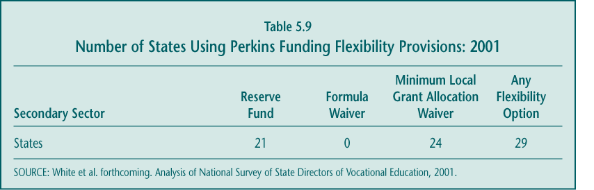

► Reserve Fund: This provision permits states to use up to 10 percent of the state’s required local grant funding (or 8.5 percent of the state allotment overall) to distribute outside of the legislated substate formula. Twenty-one states have chosen to use this option, with 13 states using the full 10 percent and 8 states reserving 7 percent or less of their local funding to distribute in this way.

By law, states are required to target reserve funds to programs with at least two out of four types of need: (1) rural areas, (2) areas with high percentages of vocational students, (3) areas with high numbers of vocational students, and (4) communities negatively affected by changes in the substate secondary school formula. States have used these criteria in diverse ways, with the greatest emphasis (12 states) placed on awarding funds to rural grantees (Table 5.10).

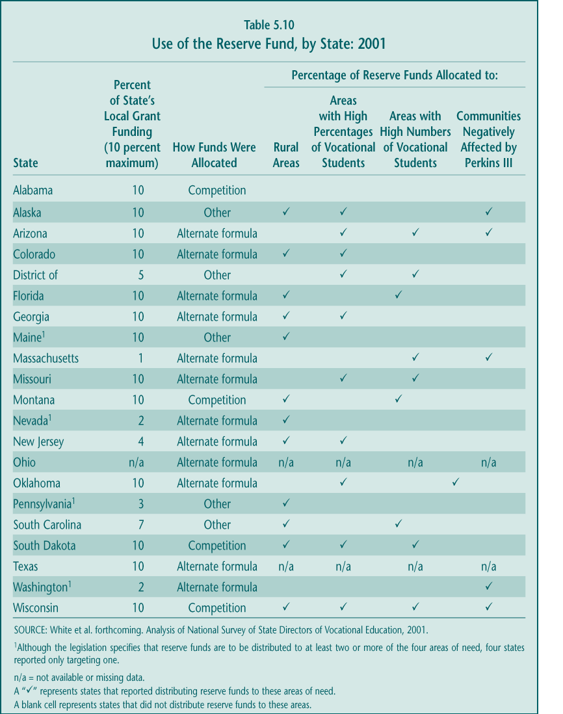

► Formula Waiver: This waiver allows states to use an alternate funding formula that would better target Perkins secondary funds to school districts with high concentrations of poverty. However, according to the Office of Vocational and Adult Education, no state received a waiver from the U.S. Department of Education to allocate secondary funds using a different formula in 2001.

► Minimum Local Grant Allocation Waiver: In order to ensure that federal funds are of sufficient scope to have an impact at the local level, both Perkins II and Perkins III set a minimum amount for local secondary grants ($15,000). Both laws also included waivers for this provision, giving states flexibility to award grants that are less than $15,000 if the LEA is (1) located in a rural, sparsely populated area or (a new category in Perkins III) is a public charter school operating a vocational program and (2) is unable to enter a consortium. According to the reports of state directors, nearly half of states (24) were using the waiver in 2001, making it the most commonly adopted flexibility option (White et al. forthcoming).

Case studies indicate that the minimum local grant waiver has been used in most cases to fund smaller districts and charter schools at levels considerably below $15,000 (White et al. forthcoming). In one state, for example, charter schools received an average of $3,000 in Perkins funds if they had a vocational program or could demonstrate they were starting one. Another state used the minimum grant waiver to support 73 small rural schools that were unable to form consortia due to the large distances that separated them.

2. Targeting

The Perkins III legislated funding strategy continues to reflect a compensatory emphasis and therefore policymakers are likely to be interested in how effectively resources are targeted. Under Perkins III, 70 percent of the secondary funding formula weighting is based on the number of low-income students in the community. However, Perkins III eliminates the lesser weights in the Perkins II formula on the number of students who have individualized education plans under the Individuals with Disabilities Education Act (20 percent) and the number of students in LEAs and adults in training programs (10 percent). Instead, 30 percent of the formula weight is based on counts of the general youth population (ages 15–19).

Perkins funding remains targeted to areas with high concentrations of poverty, but the strength of this relationship has diminished over time.

Local grants awarded under Perkins III continue to reflect policymakers’ interest in promoting equal access to vocational programs for students in low-income areas. However, the emphasis on poverty in the grant distribution process has lessened since Perkins II, when examined according to several different measures. In particular, when grant amounts are adjusted for the size of the secondary population of LEAs (a criterion in the funding formula), high-poverty districts do not appear to have benefited as much under Perkins III as have other districts.

► Amounts and shares of Perkins secondary funds were greatest for school districts with high concentrations of poverty in 2001. On a per secondary student basis, the amount of Perkins funds received by high-poverty school districts was $53 in 2001, well above the amount for low-poverty ($41) and medium-poverty ($32) school districts (Table 5.11). In addition, as might be expected under the legislated formula, high-poverty districts received a disproportionate share of Perkins funds in 2001: they represented 28.4 percent of grantees but received 42.0 percent of local funds nationally.

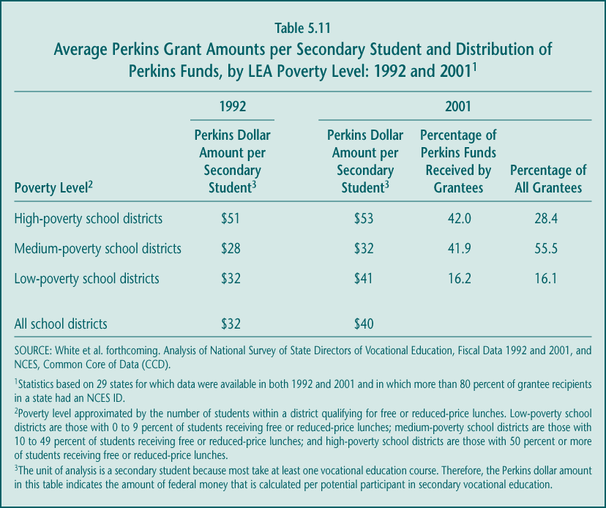

► The relative funding advantage of high-poverty school districts declined between Perkins II and Perkins III. As noted earlier, the average secondary grant size increased between 1992 and 2001, but this increase seems to have affected LEAs differentially. Among high-poverty districts, the average grant amount per secondary student increased by only $2, while the increase was $4 for medium-poverty districts and $9 for low-poverty districts (Table 5.11). As a result, the ratio of high- to low-poverty district amounts fell from 1.6 in 1992 ($51 / $32) to 1.3 in 2001 ($53/$41). It is also important to note that the more advantaged low-poverty districts actually received a higher per student grant amount than did the medium-poverty districts under both Perkins II and Perkins III.

Several factors probably account for the weakening emphasis on poverty in the distribution of Perkins funds to local areas. First, flexibility options allow states to award some local grants without using the poverty-based funding formula (e.g., the 10 percent reserve fund and the waiver of the minimum allocation), and many states are using these provisions. Second, if either the number of students with disabilities or the number of adults in training programs is correlated with poverty, then eliminating these two criteria as weights in the local funding formula may have had a somewhat regressive effect.

Perkins funding is well-targeted to urban and rural school districts.

Historically, Congress has been sensitive to concerns that rural and urban areas are underserved or face greater challenges in providing high-quality vocational programs. The introduction of the reserve fund in Perkins III was designed partly to help address this issue in rural communities, as was the waiver of the minimum grant allocation. These provisions seem to have been successful in channeling more funds to rural grantees.

Compared to suburban districts, rural and urban districts received higher grant amounts on a dollar per student basis under both Perkins II and Perkins III (Table 5.12). By 2001, rural LEAs received more per student ($54) than did urban ($50) or particularly suburban ($30) grantees. However, because of their small size, rural districts received a small share of total Perkins local funding (24.3 percent) relative to the proportion of rural grantees (59.3 percent).

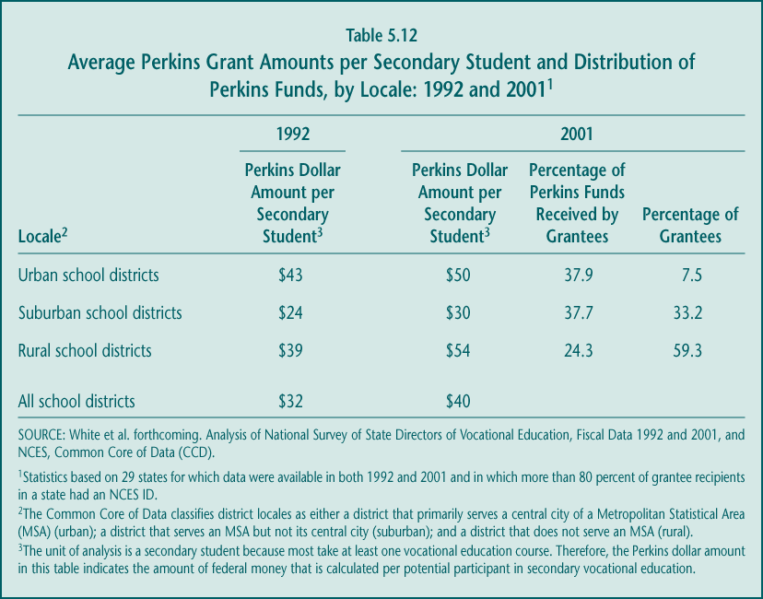

Small school districts are likely to receive more Perkins funding on a per student basis.

Small school districts are considered more limited in their ability to offer an array of vocational courses for students (see Chapter 2) and less able to take advantage of economies of scale in vocational programming. Although they received a small fraction of overall Perkins funding (2.8 percent) in 2001, districts with fewer than 500 students received a higher amount of Perkins funding per student ($88) than districts with more students ($53 and $37, respectively, for medium and large districts) (Table 5.13). Small districts also appear to be the primary beneficiary of the new reserve fund provision in Perkins III and were more likely to receive individual grants under the waiver of the minimum grant allocation than in previous years: the dollar per student amounts in small districts increased substantially from 1992 to 2001, more so than for other districts.

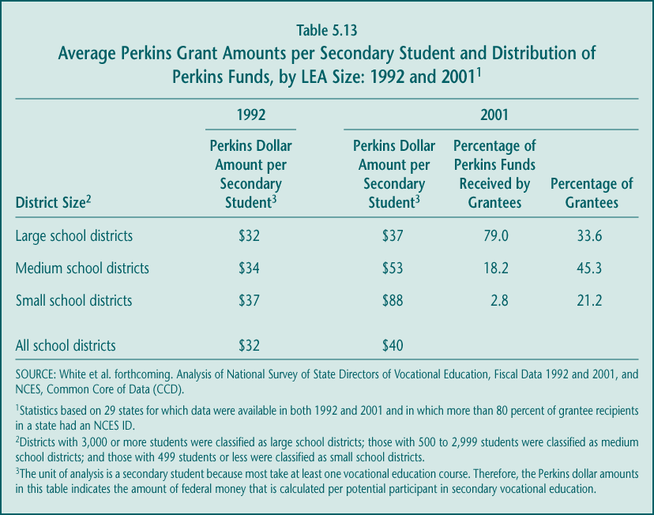

3. Use of Funds

Perkins III includes a long list of required and permitted activities and uses of funds for both state and local grantees. Like its predecessor, the law was intended to support program improvement rather than the basic maintenance of programs, which was considered a state and local responsibility. Distinguishing between these two efforts is often quite difficult, but understanding the ways in which funds are spent provides some indication of the impact of Perkins III.

States spread their leadership funds to support a wide variety of required state activities.

Funding for state leadership activities was increased from 8.5 percent of the state allocation under Perkins II to 10 percent under Perkins III, partly to offset the elimination of the set-asides for gender equity activities. However, of the state leadership funds, $60,000 to $150,000 must be used to serve individuals preparing for nontraditional training and employment, and up to 1 percent can be set aside for vocational education in state correctional institutions. The remaining funds must be used for eight required leadership activities and may be used for 12 additional activities. When calculated as 10 percent of state allotments, the amounts available for state leadership in 2001 ranged from $421,492 in small states to just over $12 million in a large state like California (Table 5.2).

At least according to a survey of state directors, leadership funds are dispersed to cover many of the activities, particularly those that are required by law, with little emphasis on one activity or another (Table 5.14). By a small margin, a higher proportion of these funds are used at the secondary level for strengthening the integration of academic and vocational instruction. Case studies also suggest that, in practice, state leadership funds may be used to support the salaries of staff who carry out these activities (White et al. forthcoming).

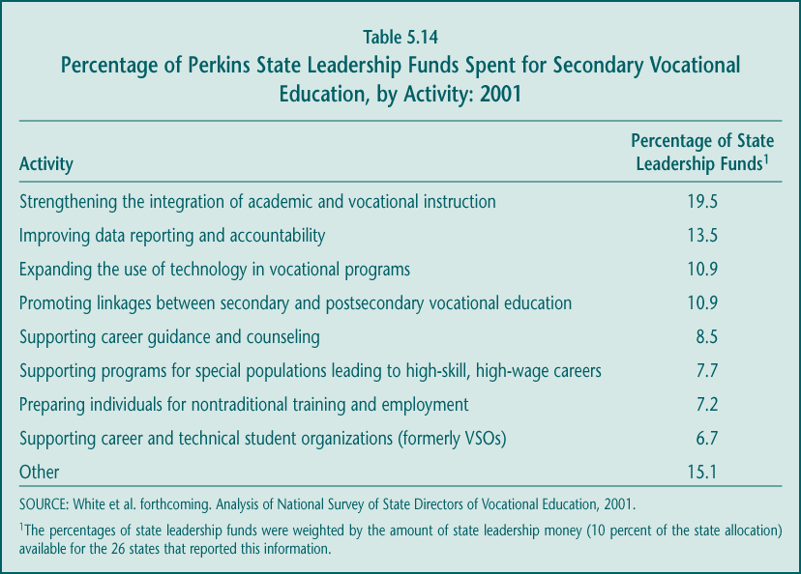

Perkins III may have led to fewer staff or targeted activities for gender equity, but the effects on students are unknown.

Perkins III introduced significant changes in how federal policy promotes the participation of both girls and boys in vocational education programs, particularly those that prepare students for nontraditional occupations. Prior to the new law, these gender equity activities were supported through two special legislative provisions: (1) a requirement that each state fund a gender equity coordinator and (2) set-aside funding streams amounting to 10.5 percent of each state’s allocation, including programs for single parents and displaced homemakers. These provisions were replaced in 1998 with a requirement that states spend between $60,000 and $150,000 “for services that prepare individuals for nontraditional training and employment” (Section 112).

Even with fewer federal requirements, many states have continued to support gender equity and nontraditional training efforts, although the amount of time devoted to these activities appears to have declined. At least in 2001, about half of the states (23) reported having a gender equity coordinator to oversee activities directed at the secondary level (Table 5.15), and most had one or two staff members working at least partially on these issues. Although no comparable data from Perkins II are available, recent case studies conducted for NAVE suggest that there has been a reduction in the number of state-level staff assigned to gender equity (and other special populations) concerns (Stasz and Bodilly forthcoming). California, for example, has reduced the gender equity position from full- to part-time, and in Ohio, two gender equity positions have been largely phased out. Still, on average in 2001, states spent 7.2 percent of their state leadership funds on activities preparing students for nontraditional training, a figure comparable to what they spent supporting other special populations (7.7 percent) and career and technical student organizations, formerly known as vocational student organizations (VSOs) (6.7 percent).

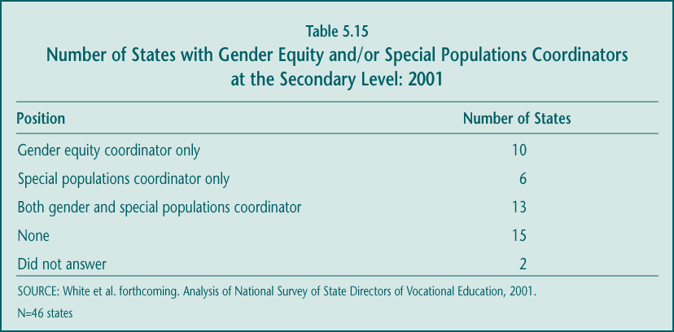

Perkins III seems to have had a mixed effect on gender equity at the local level (Stasz and Bodilly forthcoming). On the one hand, changes in state staffing were not always apparent to local grantees, and sometimes other funding sources—including an increase in the size of the Perkins local grant—made up for the loss of targeted Perkins funds. On the other hand, some communities reduced programs or services that had been previously funded by the set-aside.

At the local level, Perkins funds are used mainly for equipment but also for other purposes.

Case studies indicate that local secondary programs use their Perkins grants to support a diverse set of efforts: career guidance materials or counselors, professional development for teachers, release time to work on articulation agreements, student internship programs, and other activities. But as under Perkins II, the primary use of Perkins III is to purchase equipment and materials (White et al. forthcoming). According to local Perkins coordinators, such a use of funds at least partly reflects the greater costs of providing vocational courses and the reality of tight budgets for technology in many districts.

C. Perkins State Grant Funding at the Postsecondary Level

Although there appeared to be less concern to enact major funding changes at the postsecondary level, the same philosophical principles that drove Perkins III funding provisions were applied to the postsecondary level. Congress sought to give greater flexibility in the use of funds and a higher share of funds to local grantees.

1. Basic Allocations and Use of Flexibility Provisions

State and local grantees face the same legislated requirements and choices for postsecondary vocational education as they do for secondary vocational education. As indicated in the previous section, the law mandates the local funding formula; it also specifies the maximum proportion of the state allocation that can be retained for state administration (5 percent) and state leadership (10 percent), amounts that must accommodate the oversight of both secondary and postsecondary grant making. Perkins III also includes funding options that states can take advantage of at the postsecondary level.

Nationally postsecondary vocational education continues to receive approximately the same share as it did early in Perkins II.

As noted in a previous section, states continued their historical distribution of Perkins funds between the postsecondary and secondary sectors. Nationally about the same proportion of local Perkins funds (38 percent) were allocated to postsecondary vocational education in 2001 as in 1992 (Table 5.4).

Local postsecondary grantees also appear to have received a higher share of funds under Perkins III than under Perkins II.

Not only secondary grantees but also postsecondary institutions benefited from the higher share of state funds that Perkins III required to be distributed to local grantees (85 percent, up from 75 percent under Perkins II). Postsecondary grants awarded under the new law are consistent with congressional intent, and the changes since Perkins II are similar to those among secondary grantees. Comparing grant awards reported by state directors in 1992 and 2001 indicates the following (Table 5.16):

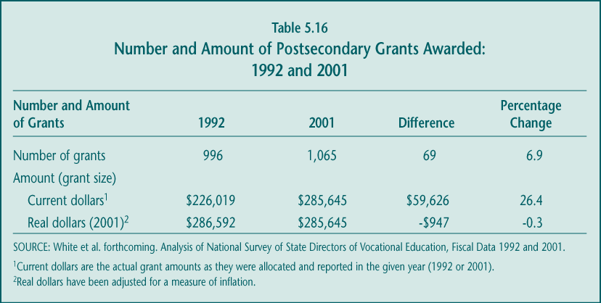

► The average grant size grew considerably. On average, the grant amount for postsecondary institutions increased by over one-quarter between Perkins II and Perkins III.

► There was no reduction in the number of postsecondary grants. States awarded slightly more postsecondary grants (6.9 percent) in 2001 than they did in 1992, so the average amount grantees received did not increase simply because funds were awarded to fewer institutions.

► The increase in postsecondary grant size cannot be explained by a change in the secondary-postsecondary split or higher Perkins appropriations for basic grants. If states chose to designate a higher proportion of Perkins funds to postsecondary vocational education, then average postsecondary grant sizes could increase even without a higher share of funds going to the local level. But, in fact, the secondary-postsecondary split remained the same between Perkins II and Perkins III. Also, the increase in Perkins appropriations for basic grants during the period was only 15.3 percent, compared to a 26.4 percent increase in postsecondary grant amounts; therefore, the higher grant amounts are not due solely to higher federal program budgets.

► Purchasing power was more or less maintained. In real terms (adjusted for inflation), the average grant size in 2001 was almost equal to that in 1992.

► Average Perkins postsecondary grant amounts vary widely by state. The average state grant size at the postsecondary level deviated widely from the national average of $285,645 in 2001 (Table 5.17). The average ranged from a low of $70,645 in Tennessee to a high of $2,285,140 in Hawaii and $1,973,707 in Maine. For the most part, states increased their Perkins grant amounts at the postsecondary level between 1992 and 2001. Only five states (California, Iowa, Minnesota, North Dakota, and South Dakota) decreased their average grant size during the period.

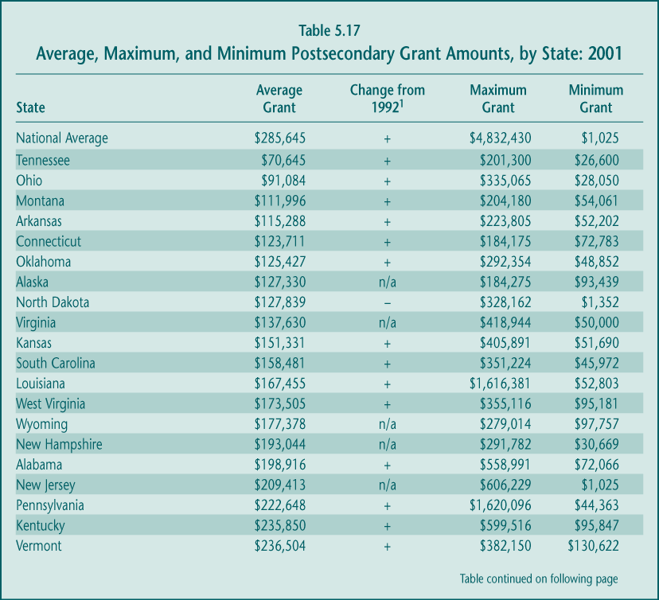

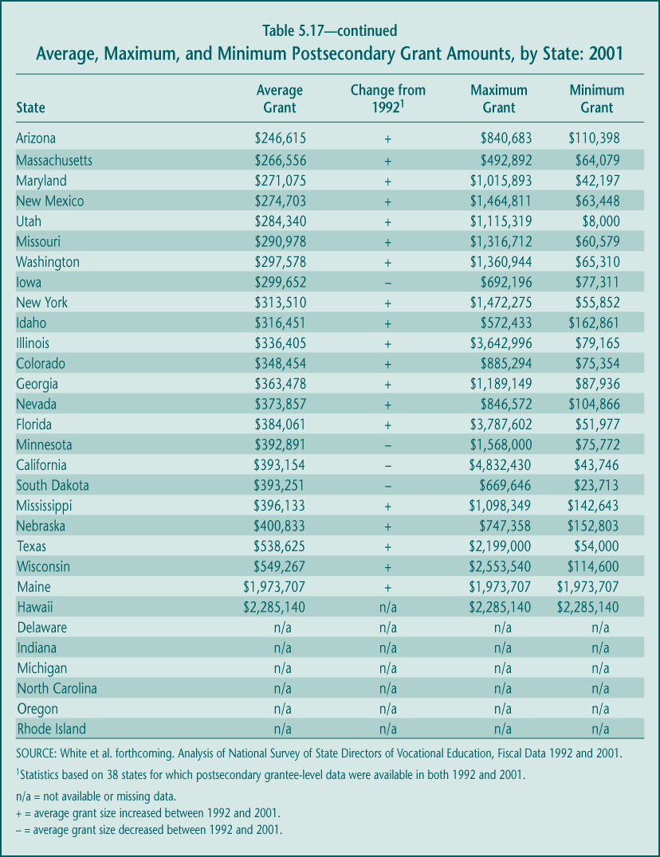

The percentage of eligible postsecondary institutions receiving Perkins funding seems to have increased somewhat between 1992 and 2001.

Postsecondary institutions were more likely to receive a grant in 2001 under Perkins III (83.3 percent) than in 1992 under Perkins II (75.8 percent) either as individual grantees or as part of a consortium (Table 5.18). These computed proportions likely overstate the actual magnitudes because the denominators are based only on public and private two-year and less-than-two-year postsecondary institutions and tribally controlled colleges, while Perkins grantees can also include four-year colleges and universities and private, nonprofit institutions that offer occupational certificate or two-year degree programs. However, there is little reason to believe that the extent of the change over time is biased.

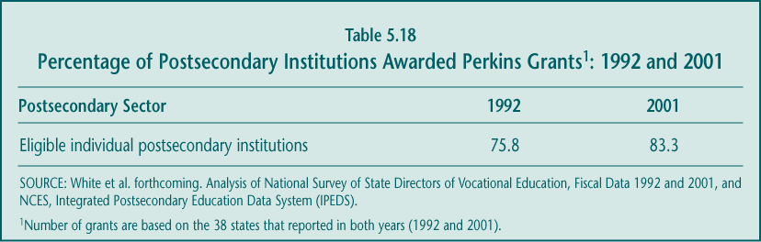

Local Perkins funding for postsecondary education primarily went to public two-year colleges in 2001.

While a variety of institutions are eligible for Perkins funding, states are most likely to allocate these funds to public two-year or public less-than-two-year colleges (Table 5.19). States allocated more than two out of three local Perkins dollars to public two-year colleges in FY 2001, of which there are just over 1,000 nationally. Public less-than-two-year postsecondary institutions, numbering a total of 240 nationwide, received the second largest share of postsecondary Perkins funds (20.2 percent). Four-year colleges, adult schools, and private nonprofit colleges received much smaller shares of Perkins funds, probably because the relatively small size of their vocational programs did not qualify them under the funding formula and the $50,000 minimum grant allocation.

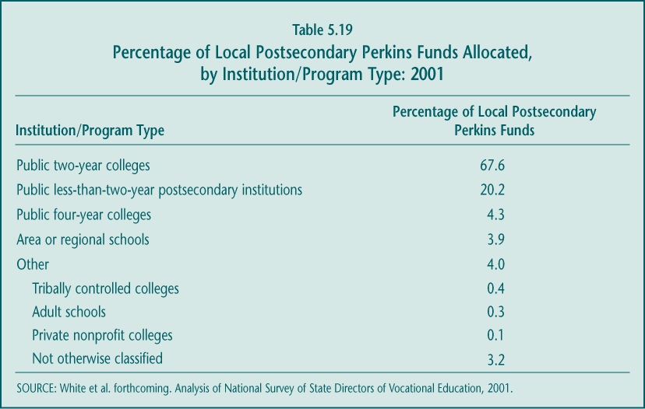

Fifteen federally recognized tribal colleges and universities received Perkins grants in 2001.

The federal government recognized 32 tribal colleges and universities in 2001, and all of them were eligible to receive Perkins grants (White House Initiative on Tribal Colleges and Universities 2002). Six states reported providing postsecondary Perkins grants to 15 of these institutions, for a total of $1,074,518 in FY 2001 (White et al. forthcoming). This total translates to roughly $70,000 per college, an amount that falls considerably below the national average of $285,645 for postsecondary grantees.

Local grants made under the funding formula are supplemented in two ways, however. Perkins III (as did Perkins II) authorizes a relatively small program (for example, $5.6 million in FY 2001) for tribally controlled postsecondary vocational and technical institutions for program operations and institutional support. In addition, the 1.25 percent federal set-aside for Native Americans provides assistance through competitive grants primarily to tribally controlled and Alaska Native colleges, universities, and organizations.

States are less likely to take advantage of the options for funding flexibility at the postsecondary level than at the secondary level.

A number of states (20) used at least one of three main options, as discussed below, for funding flexibility at the postsecondary level in 2001, compared to 29 states at the secondary level (Table 5.20).

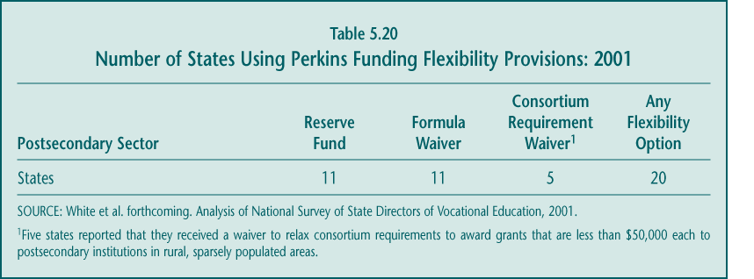

► Reserve Fund: The most common option adopted was the reserve fund. Seven of the 11 states drawing upon the reserve fund reported using the full 10 percent allowed, and they were equally likely to distribute these funds across the legislated eligible categories.

► Formula Waiver: Eleven states received a waiver for the legislated funding formula at the postsecondary level (based on the number of Pell grant recipients) in order to use an alternative that more effectively targets high-poverty areas. In comparison, no state received a formula waiver at the secondary level.

► Consortium Requirement Waiver: Only five states reported that they had waived consortium requirements to award grants that are less than the $50,000 minimum for some postsecondary grantees in FY 2001. Four states did so to serve rural, sparsely populated areas, while the fifth aimed to serve a high number of disadvantaged students (White et al. forthcoming).

2. Use of Funds

The legislated list of required and permitted activities and uses of funds applies to postsecondary efforts as well as those targeted to the secondary level. For postsecondary grantees, too, Perkins III emphasizes improving programs rather than just maintaining them.

Like the funds directed at the secondary level, state leadership funds used for postsecondary vocational education are spread widely across activities.

According to a survey of state directors, Perkins funds spent on postsecondary state leadership activities were dispersed across the required activities specified in the law and a small set of permissible activities (Table 5.21). The top three uses of state leadership funds—expanding technology, strengthening integration, and improving accountability reporting—are consistent with the priority uses at the secondary level (see Section B). Case studies found that, in particular, a large share of postsecondary leadership funds were supporting the salaries of staff helping to develop and implement data-reporting procedures and systems (White et al. forthcoming).

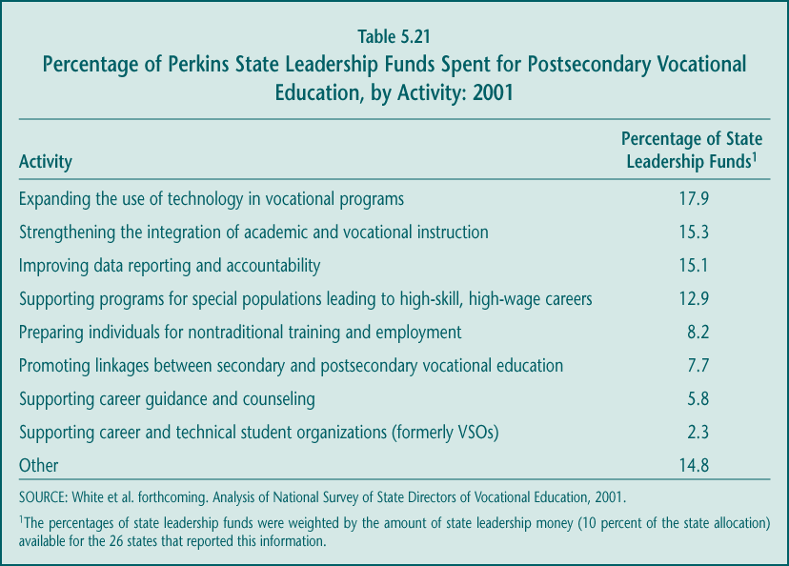

Promoting nontraditional training and employment is a relatively prominent part of state postsecondary efforts, with over 8 percent of postsecondary state leadership funds being spent on these activities. Eighteen states have a gender equity coordinator working at least part-time on these activities at the postsecondary level (Table 5.22).

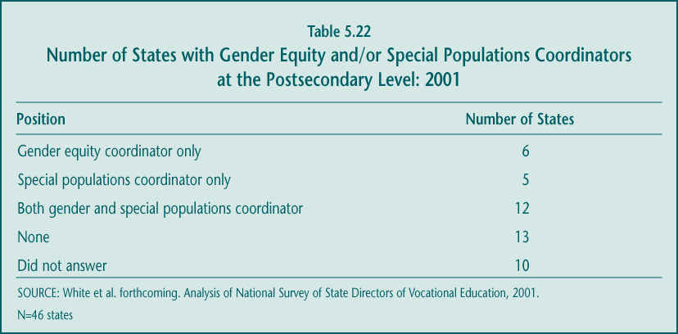

Local postsecondary Perkins funds are generally used for staffing and support services.

Perhaps even more so than at the secondary level, the ways in which local postsecondary grantees spend their Perkins grants vary substantially. Moreover, in contrast to secondary grantees, postsecondary institutions are far less likely to use Perkins funds for equipment and other supplies, perhaps because community colleges have more substantial and routine budgets to fund technology upgrades and their need to meet employer expectations depends more closely on whether their training technology is up-to-date (White et al. forthcoming). According to case studies, grantees by and large, use local Perkins postsecondary funds to cover administrative costs for staffing “coordinator” positions (i.e., special populations, gender equity, data systems) and to provide support services for vocational students in their institutions.

D. Perkins Tech-Prep Grant Funding

Tech-Prep was first established in 1990 (Perkins II) as a separate program to promote “two-plus-two” technical programs of study (see Chapter 4). Since that time, appropriations for the program—about 10 percent of the total amount for Perkins—have increased somewhat. Because the formula for state Tech-Prep allotments remained unchanged between 1992 and 2001, these state grants increased as well (Table 5.23).

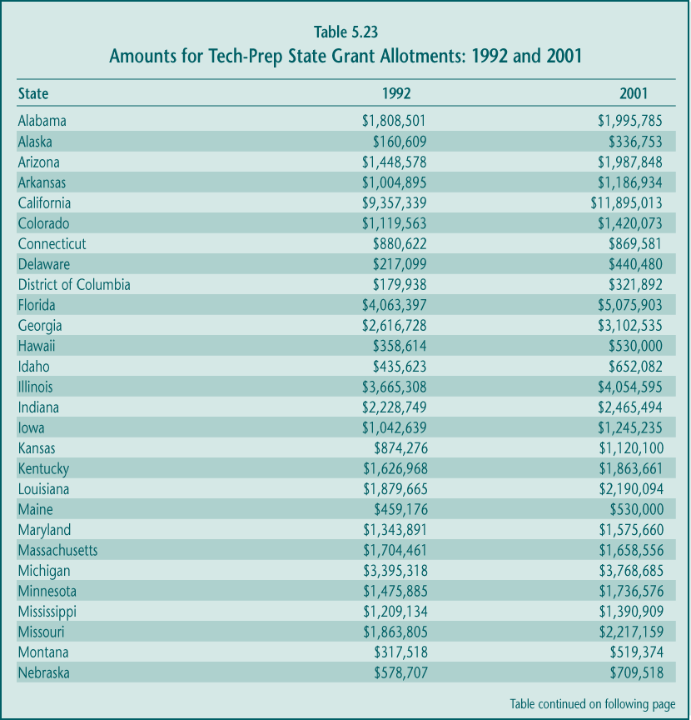
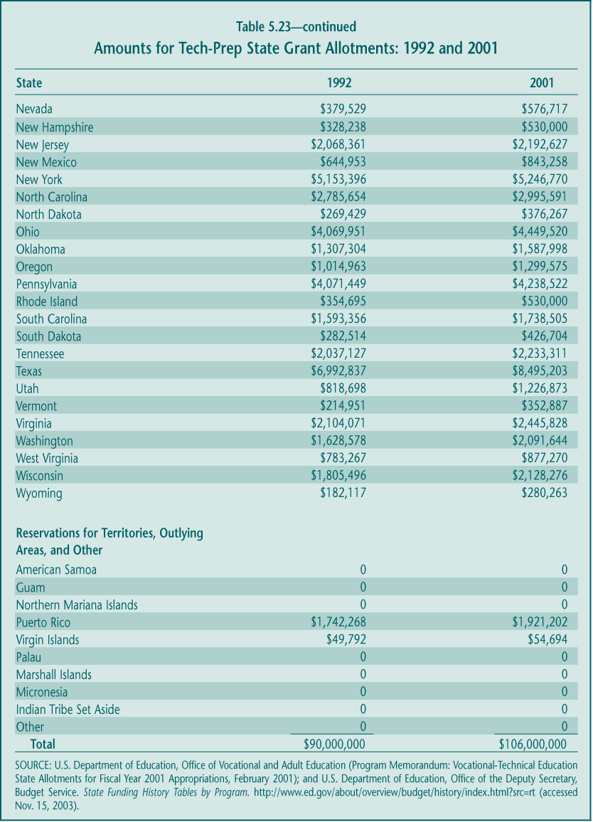
The same local institutions that receive funds under Title I (state grants) may receive funds under Tech-Prep, Title II—school districts, area vocational centers, community colleges, and other postsecondary institutions; however, they do so according to a different structure. Perkins III (and its predecessor) mandates that states award Tech-Prep grants to local consortia, entities that must include at least one secondary district or area vocational school and at least one postsecondary institution, with the emphasis on two-year degree-granting institutions. These consortia vary significantly in size, with about a third involving five or more school districts and multiple postsecondary institutions (Hershey et al. 1998). Some consortia may receive multiple grants, in states where Tech-Prep grants are project-based rather than, or in addition to, organized by geographic area.

States have complete discretion over how they allocate Tech-Prep (Title II) grants and rarely take poverty into consideration.

Perkins III gives states considerable flexibility in shaping many features of their Tech-Prep grant programs. State agencies have the latitude to determine the number and duration of grants awarded, their purpose (planning or implementation), and how consortia will be configured (see Chapter 4 for more details).

Unlike the basic Perkins grant, however, states also choose whether to award Tech-Prep grants on a formula or competitive basis. Most use a formula, either solely or in combination with a competitive process for some grants (Table 5.24). However, in contrast to the ways in which most Perkins funds are allocated, few states use poverty as a criterion in awarding Tech-Prep funds to local consortia (Table 5.25). Thus, the methods states use to allocate Tech-Prep funds appear to be inconsistent with the compensatory emphasis of the Perkins Act.

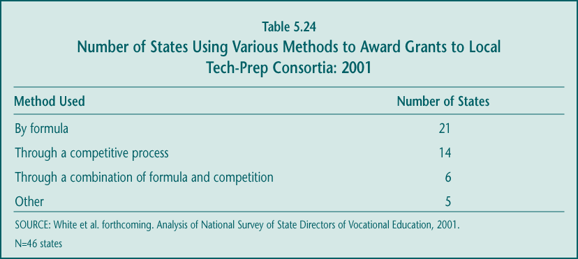

Nationally grants to local Tech-Prep consortia are similar in size to secondary basic grants.

Generally Tech-Prep consortia include, and Perkins grants must cover, multiple districts. In 2001, the size of the typical Perkins Tech-Prep consortium grant ($111,089; Table 5.26) was about the same as the typical basic secondary grant ($101,813). However, consortium grant amounts varied widely across states depending on, among other factors, the number of grants awarded (Table 5.27).

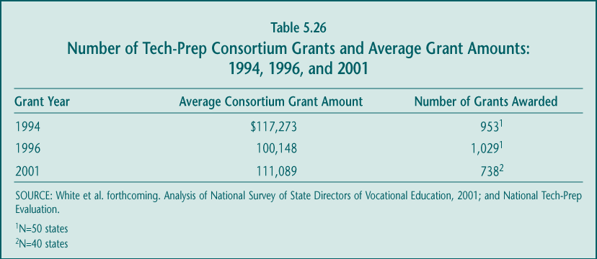

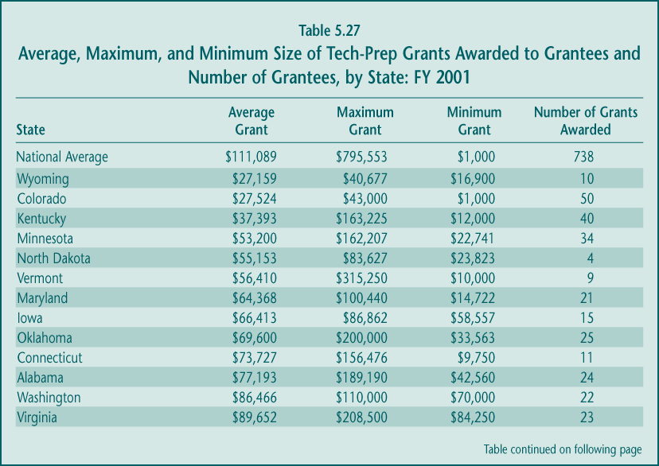

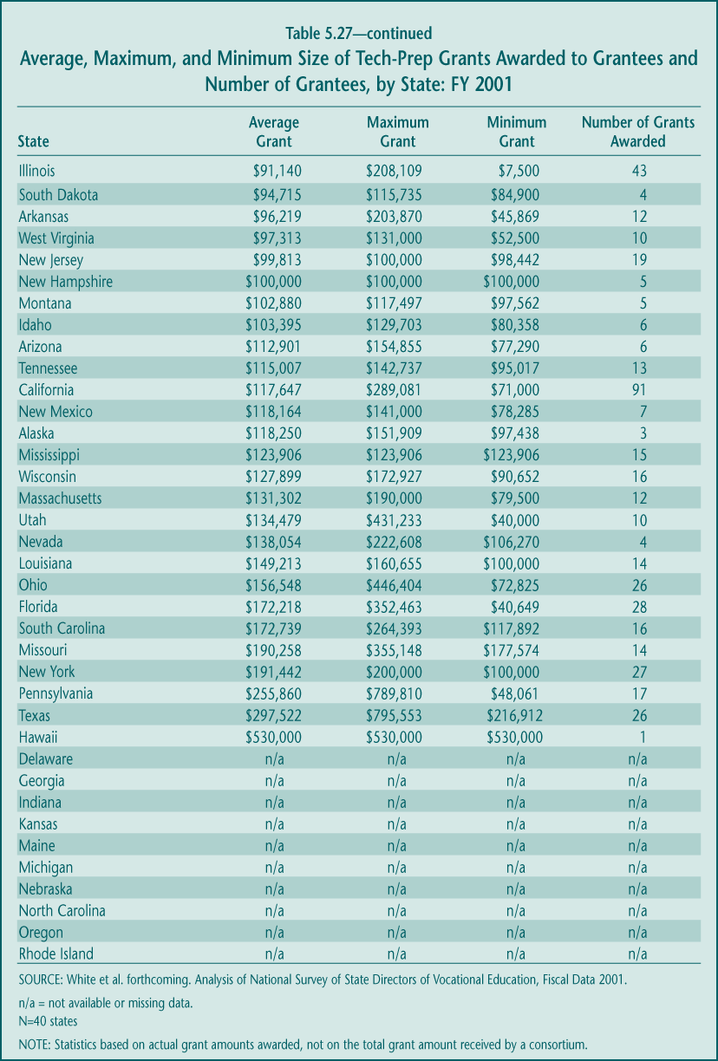

E. Perkins Accountability Systems and Their Implementation

Perkins III represented a clear attempt by policymakers to make accountability requirements stronger than those under the previous law. Perkins III specified four core indicators of performance and mandated that states (1) identify appropriate measures and establish quantifiable levels of performance for each of them, using the definitions listed in Table 5.28; (2) track progress of the measures over time; and (3) report performance results to ED, both for students in vocational programs overall and for key subgroups or special populations. In addition, the law included sanctions and incentives for states based on their performance (see Table 5.3 for a more detailed overview of the new provisions).

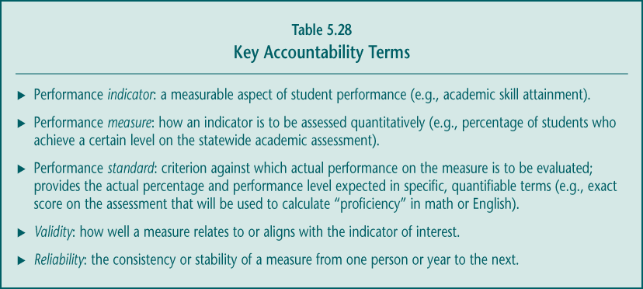

According to Section 113(a), the purpose of the accountability system was to

. . . establish a State performance accountability system . . . to assess the effectiveness of the State in achieving statewide progress in vocational and technical education, and to optimize the return of investment of Federal funds in vocational and technical education activities.

Given this intent, Congress gave states sole authority and, therefore, wide latitude in choosing measures and setting initial performance levels and targets (Section 113(b)(2)(D)). Section 324 of the law limited ED from issuing regulations regarding Perkins accountability. Instead, ED’s Office of Vocational and Adult Education convened a series of technical assistance meetings to educate states about their options and to encourage consensus on measurement where possible.

At the same time, the law required ED to issue “state-by-state comparisons” of their performance data. However, any expectations that these comparisons would provide a national picture of vocational education performance are in conflict with the law’s emphasis on state management of accountability. The autonomy under Perkins III is comparable to that given states in the No Child Left Behind Act but distinct from the more clearly specified federal accountability requirements established in the Adult Education and Family Literacy Act, Title I of WIA, and Title I of the Vocational Rehabilitation Act.

When compared to performance measurement and reporting under Perkins II, state vocational officials have made serious commitments to these efforts and considerable progress in implementing them. Challenges remain, however, in creating state-based vocational accountability systems with valid and reliable data that can be used for program management and that do not impose undue burdens on either state or local grantees.

1. Quality of Performance Measurement: Validity and Reliability

Data quality covers a broad range of issues related to the validity, reliability, and accuracy of information gathered. For accountability systems to actually promote change, the data collected must be valid and well-aligned with the type of performance that is to be improved. To use these systems appropriately for decision making, the data must be reliable and accurate—for example, consistent in their student coverage (how states and local programs determine which “vocational students” they will count and track) and in their procedures for monitoring student progress (e.g., record matching or survey response rates).

Certainly in the aggregate, nationally Perkins reporting does not have these qualities, but even the state systems face considerable barriers to establishing high-quality accountability systems. Most state and local officials interviewed during the case studies conceded that the quality of their Perkins data needed improvement (White et al. forthcoming). In some instances, state directors noted problems with the collection of data on most or all of the indicators. Some attributed poor data quality to rudimentary local data collection systems that depend heavily on hand counts, while others pointed to the time required to establish complex data collection systems and train local staff in their purpose and use. Still others indicated that differences in record-keeping practices, staff expertise, and the structure of vocational programs at the local level affected data quality adversely. Poor data quality may also be attributable to the inclusion of a large number of local practitioners (school district and school personnel as well as community college administrators) who typically bear the brunt of data collection and reporting responsibilities. Moreover, efforts to ensure reliability often collide with validity; for example, guided by ED, many states chose to use statewide academic assessments because of their reliability, even if the assessments were offered in too early a grade to be a valid indicator of vocational program outcomes.

States measure performance in many different ways, prohibiting national comparisons even if Congress wanted them.

As permitted in the law, the accountability system in Perkins III is inconsistent in its definitions of indicators and data collection strategies across states, thus limiting the potential to make national comparisons. Based on state reporting to ED, there are currently between two and seven different ways that states measure each Perkins indicator (Table 5.29). Even where there appears to be some commonality—for example, in use of national or state assessments to measure academic skill attainment—there are differences in the cut scores on the same test across states. In addition, states also vary in the extent to which their assessments are “high-stakes” versus diagnostic, which can create quite different standards for passing and lead to pass rates in states that range from less than 10 percent to nearly 100 percent.

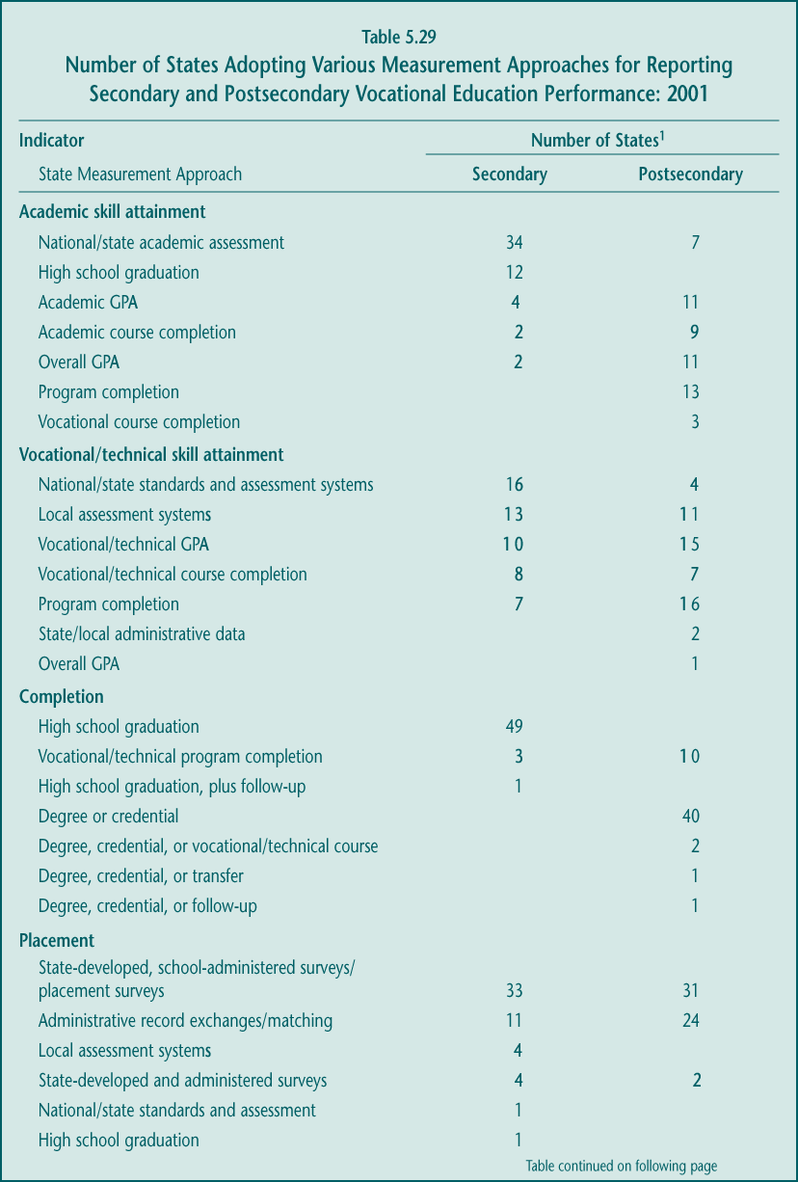

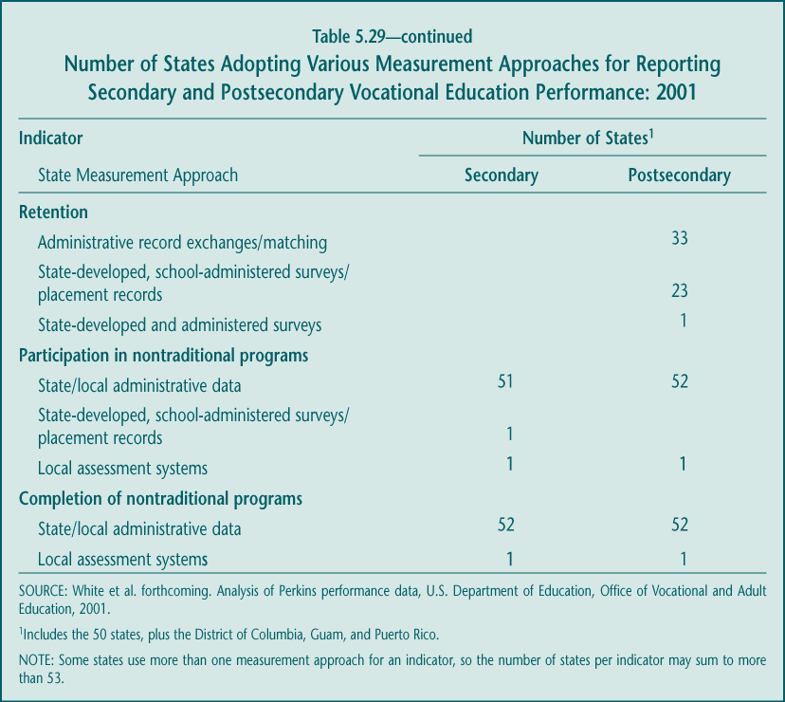

The diversity reflects the roles of federal and state staff in developing state accountability systems, the limited number of ways to measure certain indicators, and the unique circumstances and program environments in which Perkins operates at the state and local levels. Both state administrators and local practitioners acknowledged that the processes used to collect and compile Perkins data vary significantly by indicator (White et al. forthcoming). This lack of consistency across states, however, matters less than issues of validity and reliability in measurement within states.

Some Perkins measures do not accurately gauge the type of student performance sought, which creates a validity problem.

Building an accountability system that balances state flexibility, utility, and burden has proved challenging. In aiming to achieve that goal, state systems have often, sometimes with federal guidance, compromised the validity of their measures—that is, the extent to which the measures match the outcomes federal law and state interpretation promote (White et al. forthcoming). For example:

► Student academic attainment: ED encouraged the use of statewide academic assessments as a measure of students’ academic attainment because of the reliability of those measures. However, many state assessments are administered in the 10th grade even though most vocational course taking occurs later in high school; thus, the measure is more a reflection of the achievement of students attracted to vocational education than an outcome associated with their actual participation. At the postsecondary level, many states use students’ GPA to measure their attainment in a certificate or degree program, even though those programs may have little academic content.

► Completion: Congress’s inclusion of the secondary completion indicator reflects an expectation that vocational education would help students graduate from high school. However, because the definition of a vocational student in most states requires a student to have completed three or more yearlong vocational courses, only the graduation status of those students who have remained in high school long enough to meet this definition are counted; students who drop out of high school typically do not accumulate enough credits in vocational education to be included in this and other measures.

Similarly, states did not view the postsecondary completion rate as a very meaningful measure of performance in college because many students enroll in only the specific courses they need to get a job or promotion and, according to state and local officials, these students do not intend to earn a credential. In narrowing the group of students to be included in this measure, however, some states set a lower threshold (i.e., only those who have earned at least 12 credits); in contrast, other states set a higher threshold (only those who attend full-time or who earn 50 or more credits), thus ensuring that a higher proportion of the included students would inevitably complete a degree or certificate. A few states have included not only those who complete a degree or certificate program but also those who may not have done so but did meet other credit or GPA standards (White et al. forthcoming).

► Participation in and completion of nontraditional programs: Perkins III defines “nontraditional training and employment” as occupations or fields of work in which individuals from one gender make up less than 25 percent of the individuals employed in each such occupation or field of work (Section 3(17)). Although probably intended to promote the goal of encouraging female students to pursue male-dominated jobs that pay high wages, this indicator may also encourage males to enter training for female-dominated jobs with lower wages.

Within states, local programs may not use consistent definitions, measures, or data collection strategies, leading to substantial concerns about reliability.

Even more important for the quality of the overall system, substantial variation exists within many states in how local programs collect and report performance data (White et al. forthcoming). There are differences not only across local communities but also from year to year within a community (and therefore within a state), depending on who is responsible for overseeing the data collection efforts. These inconsistencies within states partly reflect a desire to maintain local flexibility but, at the same time, make it difficult for the states to track and compare local program performance in a reliable manner. To some extent, the reliability problems may diminish when states and local vocational educators become more accustomed to the measures and definitions, but there are currently several indicators for which the accuracy and consistency of data are a particular concern:

► Vocational-technical skill attainment: Few states have any direct measure of whether students have attained proficiency in their knowledge of vocational-technical subject matter. Even in states that provide a common tool (typically a list of competencies), the tool provides little or no assurance of consistent, comparable reporting. In one state, for example, local data collection methodologies ranged from teacher ratings and completion of competency profiles to student self-assessment and completion of these profiles.

Many other states use questionable proxies, such as class grades or course completion, to measure whether students have mastered a vocational subject. A number of states report using industry certifications as a measure of vocational skill attainment, but where the certification exams are provided by a third party (e.g., Microsoft), information on pass rates may not be collected systematically. In case studies, several states reported moving toward industry certification, but none described concrete plans or timelines for doing so. Several also noted the absence of widely recognized industry credentials in many vocational areas.

► Academic skill attainment: In states that have not chosen to use statewide assessments, many different interpretations and levels of performance are possible in local reporting. At least eight states are using secondary GPA or course completion—approaches that would not qualify as sufficiently reliable under the No Child Left Behind Act. According to ED, one state is using community college placement tests to assess whether high school vocational students meet academic standards, but each community college can set its own passing score. These consistency problems are also evident in the reporting of academic attainment for postsecondary vocational students, for which most states use locally or program-determined GPA or course or program completion as the measure.

► Placement and retention: More than 30 states at both the secondary and postsecondary levels use state or local surveys to obtain information on placement and retention (Table 5.29). Within states, local survey data are often not comparable across communities in the amount of time that has elapsed between graduation and data collection (i.e., the follow-up period used). In addition, response rates in any year can range from 17 percent to almost 90 percent, raising questions about the coverage of this performance measure and making year-to-year comparisons problematic. Moreover, case studies suggest that some surveys are informal—collected by local teachers and administrators through telephone calls or word-of-mouth reports from friends and family—an approach that is unlikely to yield reliable estimates. A small percentage of districts contract with a professional vendor to collect follow-up data (White et al. forthcoming).

There are, of course, indicators and measures that are implemented with more reliability and accuracy in some states. Statewide academic assessments, for example, are reliable, although perhaps not always valid, as described earlier. In some states, postsecondary enrollment and completion rates are determined by analyzing college records in a systematic way. A number of states are using administrative data from the Unemployment Insurance (UI) system to determine how many students in vocational programs are employed—applying a common definition of employment across a data collection system that has incentives to be accurate. This approach, however, has been called into question by a recent ED interpretation of the Family Educational Rights and Privacy Act (FERPA), as described in Chapter 3. Still many states report that they would like to move toward the matching of administrative records, both to increase reliability and reduce the burden of reporting.

In 2001, performance measurement systems were still providing challenges but evolving.

Perkins III was passed in late 1998, but given the necessary planning and negotiations with ED, it was not until 2000 that states had established the initial measures they would use and the specific data that would be reported as baseline information for the 1999–2000 school year. It is therefore not surprising that in spring 2001, many states reported great difficulty in collecting necessary data and, based on their experiences, expected to be making changes in data collection over the next several years (Table 5.30).

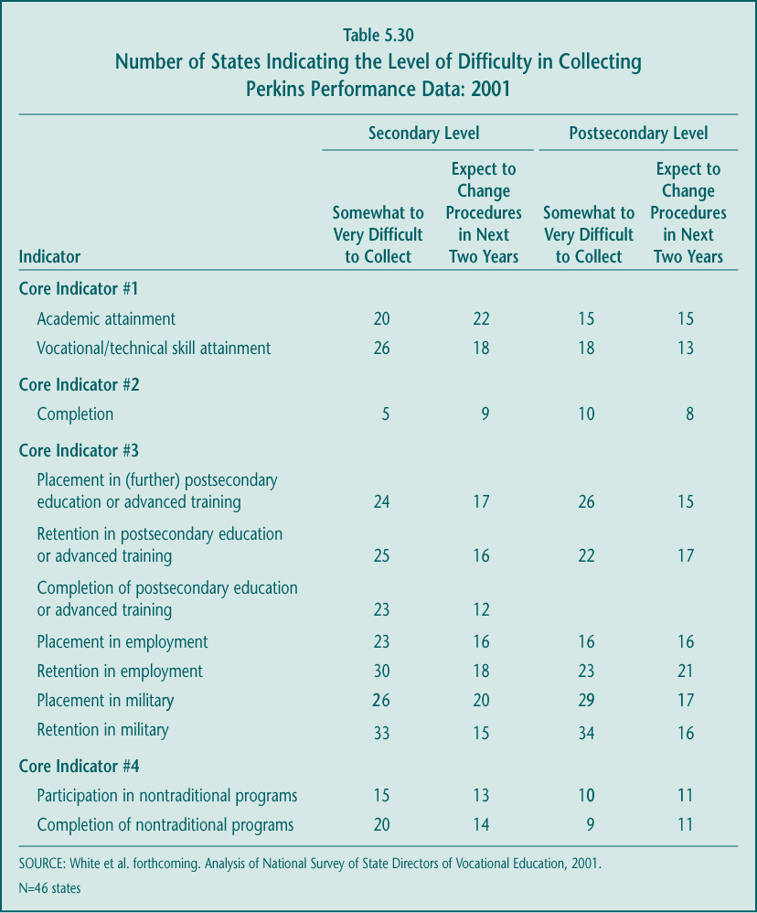

► At the secondary level, few states found it difficult to collect data on high school completion, but close to half the states reported great difficulty gathering information on the attainment of vocational-technical skills and placement and retention in postsecondary education or employment.

► At the postsecondary level, no indicator appeared relatively easy to collect by most or all states. States indicated having the least amount of difficulty reporting data on postsecondary nontraditional programs and postsecondary credential completion, perhaps because community and technical colleges are already required to track college retention and completion under the Higher Education Act. The indicators with the greatest number of states reporting data collection problems were placement and retention in further education and training and the military.

► Close to half the states reported that they expected to change some aspect of the performance measurement procedures at the secondary level, while a smaller number expected to make changes at the postsecondary level. States most often expected to change their ways of measuring or collecting information on retention in employment and, at the secondary level, the attainment of academic and vocational-technical skills.

Both the difficulty of data collection and the likelihood of state changes in measures have implications for the ongoing quality of the accountability system and for new legislation. Some of the challenges states and local programs face are likely to diminish as they become more familiar with data collection expectations and staff are trained in the new procedures; nonetheless, problems of validity and reliability will remain. Still a new law with completely different indicators or a different approach to accountability will likely interrupt the progress that has been made so far.

2. Early Performance Results

Responding to the new accountability provisions in Perkins III was a major activity for most state vocational officials and for many at the local level. States reported that improving data reporting and accountability was the second highest target of Perkins state leadership funds at both the secondary level (13.5 percent of all such funds nationally) and the postsecondary level (15.1 percent nationally) in 2001 (Tables 5.14 and 5.21). These figures may have reflected the focus in 2001 on reporting the first year of performance progress to ED under the new law.

Wide variation in state-reported performance results mostly reflects differences in measures and baseline data (starting points) because improvement goals were generally comparable across states and quite modest.

Performance variation across states is perhaps more a function of incomparable data than of gaps in performance progress. States used such different measures and standards and collected data of such uneven reliability that there is a huge range in baseline figures for the same indicators. Because of this variation, it is difficult to judge whether a state that appears to have high performance actually achieves better outcomes than a state that has seemingly low performance.

For example, one state reported that 6.9 percent of its secondary students met the state-defined performance level for academic achievement in 1999–2000, while another reported that 99.0 percent did so (Table 5.31). At the postsecondary level, states reported that a range of 5.0–97.8 percent of students met the state-defined performance level for postsecondary retention (Table 5.32). Most indicators had similar extremes, although two—secondary completion and secondary placement—had more narrow ranges.

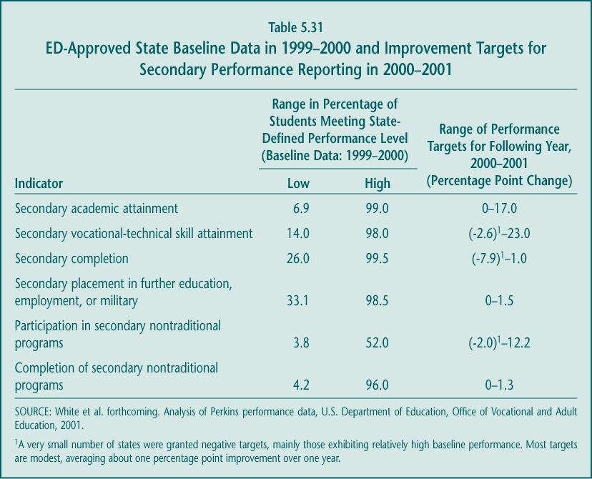

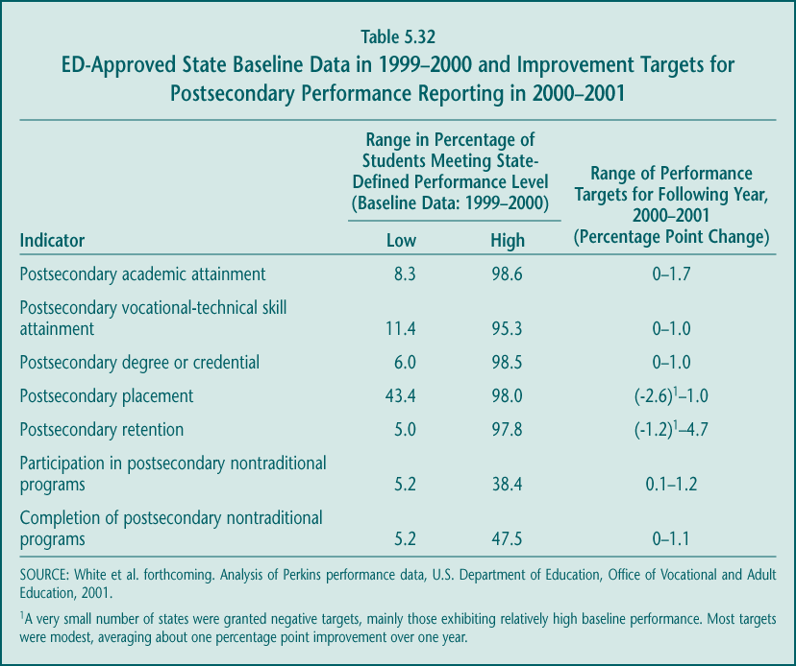

Despite the great variation in baseline data, most states have negotiated modest targets for performance improvement with ED. Similar to the process of negotiating acceptable performance measures, states must also consult with ED on the level of improvement for each indicator in subsequent years. For each of the secondary and postsecondary indicators, states agreed to an average of a 1.0 percent increase per year under Perkins III, although in some cases states were allowed to set negative targets. For the most part, states were hesitant to “raise the bar” further because they lacked sufficient historical data to set reliable baselines and were unsure how the following year’s data would turn out (White et al. forthcoming).

Despite the variation in performance, a majority of states met their targets.

Although states had various starting points and used different quality measures, most were able to achieve the goals they set for themselves. Whether this level of achievement reflects real improvement in performance, year-to-year fluctuations in data, or simply the low targets set is unclear. However, the newness and uncertainty of performance reporting under Perkins III makes these results unsurprising.

► At the secondary level, between one-half and three-quarters of states achieved their goals for particular indicators, including secondary completion (37), vocational-technical skill attainment (32), academic skill attainment (30), and placement in further education, employment, or the military (28) (Table 5.33).

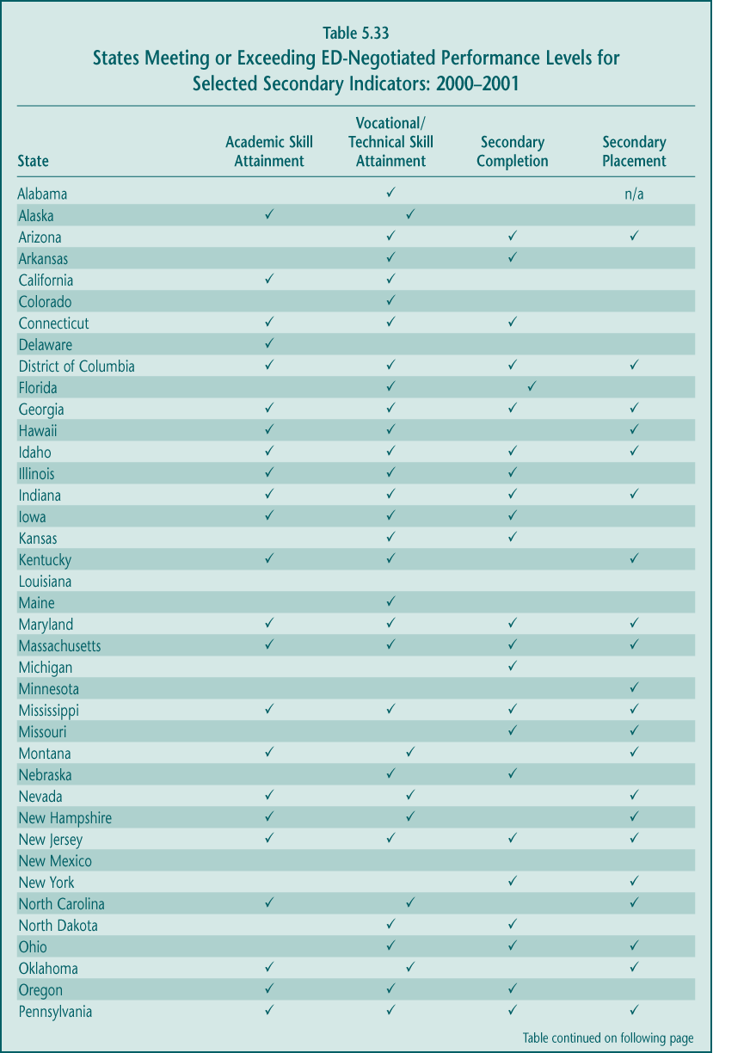

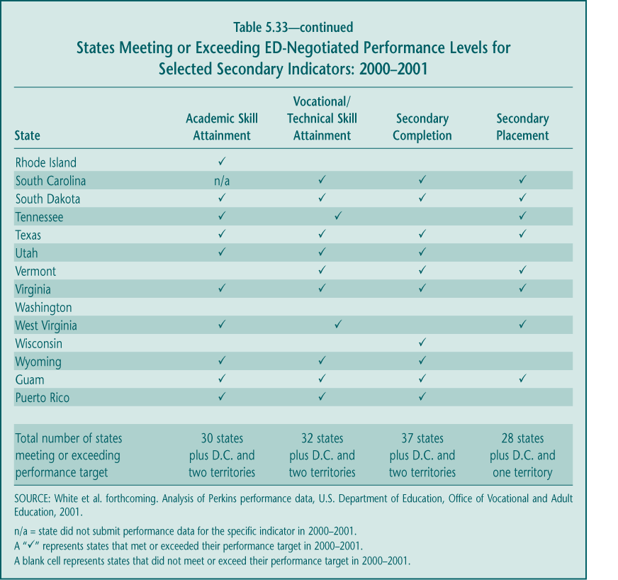

► Three states—Louisiana, New Mexico, and Washington—did not meet any of their performance targets for these four indicators; while eight states met only one.

Most states submitted performance data for special populations.

Perkins III requires performance reporting for vocational students in general and for various subgroups or “special populations” as defined in the law (Section 3(23)): (1) individuals with disabilities; (2) individuals from economically disadvantaged families; (3) individuals preparing for nontraditional training and employment; (4) single parents, including single pregnant women; (5) displaced homemakers; and 6) individuals with other barriers to educational achievement, including limited English proficiency. Although states were required to submit to ED disaggregated data for each group, the actual results for these groups were not individually held to the negotiated performance targets. Thus, it is possible for a single group to improve substantially while other groups maintain or fall behind, and yet states could still achieve their targets and incentive payments.

Despite widespread concern about this level of reporting detail, most states did submit data for each indicator by special population categories. A few states did not: five states did not report data on students with disabilities at the secondary level, while seven states did not do so at the postsecondary level.

Performance data were not available on Tech-Prep students in all states.

A number of states had difficulty providing all of the required performance data for Tech-Prep students, particularly on their enrollments in postsecondary education. As discussed in Chapter 4, many states and local programs had difficulty identifying which students are “in Tech-Prep” and therefore were unable to document how students perform in the program. Other states simply did not have the procedures or mechanisms to track students as they made the transition into postsecondary institutions. Because helping students make the transition into postsecondary education is a primary purpose of Tech-Prep, the inability of these states to provide the data indicates a much larger problem for the program.

3. Use of Data to Manage and Improve Vocational Programs

Perkins III clearly intended the accountability system to help states in “achieving statewide progress in vocational and technical education” (Section 113). The specification that states establish their own measures, levels of performance, and target goals suggests that Congress wanted states to have a substantial investment in the performance measurement system and to use the information to improve programs.

State and local administrators rarely viewed Perkins III data as useful for program improvement, but some do make use of the information.

Although surveys of state vocational officials suggest that some states have begun to use performance data to identify effective and ineffective programs and to target extra resources, case studies suggest otherwise (White et al. forthcoming; Stasz and Bodilly forthcoming). These same case studies indicate that few local practitioners are using the data for program improvement in their immediate communities or schools. Most state and local Perkins administrators viewed the legislation’s new reporting requirements as primarily a reporting obligation to the federal government. A number of state and local vocational administrators attributed their limited use of Perkins data to concerns about the quality of the data collected, suggesting that the data would be used more when their quality improved.

There were some promising practices, however. Several states compiled Perkins data and provided local grantees with aggregate and comparative information. The aggregate data provided a statistical snapshot of the state’s success in meeting its performance levels. The comparison data depicted how a grantee’s performance stacked up against that of the state as a whole. Local recipients indicated that such data would have been more helpful if their performance was compared to schools and districts serving similar students within the state.

Moreover, some states are using particular performance data for consequential decision-making, although in some cases the efforts to develop the data systems preceded, but are consistent with, Perkins III (Sheets forthcoming). Utah, for example, uses its skill certification system not only for Perkins reporting on vocational skill attainment but also to distribute state funds to vocational programs based on performance. Florida also uses outcomes data for performance-based funding decisions at the postsecondary level. Such states as Kentucky, Pennsylvania, and Oklahoma use their skill attainment data to provide students with state skill certificates or, in the case of Virginia, special endorsements on high school diplomas.

Very few states have actually identified individual districts or schools in their state as in need of improvement.

Perkins III lays out a strategy for state vocational program improvement based on the state-determined performance measures and their negotiated targets (Section 123). States are required to use the performance data to “evaluate annually” each eligible recipient of funds; if a grantee is not making “substantial progress in achieving the State adjusted levels of performance,” the state is expected to (1) conduct an assessment of the grantee’s needs, (2) work with the grantee to develop and implement an improvement plan, and (3) conduct additional evaluations of progress. The secretary of education may withhold some or all funds from the state under Section 123(d)(2) if grantees fail to make improvements. However, under Perkins III, a state cannot withhold funds from a local grantee for their failure to make performance improvements.

At least in 2001, few states had actually identified districts or schools in need of improvement (Table 5.34). In part, the Perkins accountability requirements were new, and more than half of the states simply did not have systems and procedures in place to diagnose local problems based on performance data. Some states, however, reported having appropriate systems but that no districts, schools, or postsecondary institutions were in need of improvement—i.e., that all of their grantees were performing at negotiated levels.

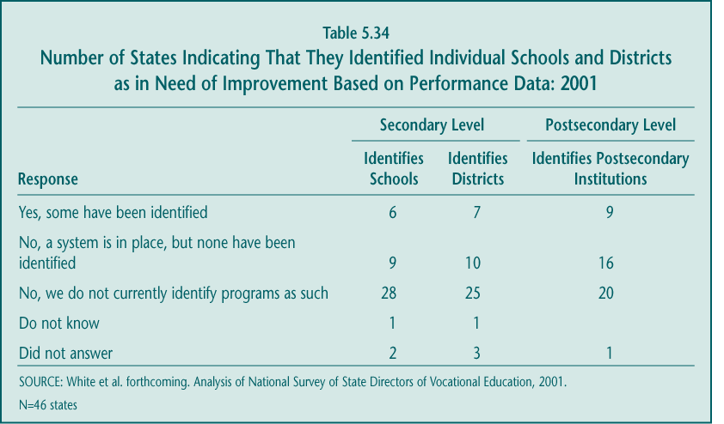

► Seven states reported identifying districts in need of improvement, and ten other states indicated having a system in place to determine local performance problems but had identified no districts in need of corrective action. Similarly, six states said that they identified schools in need of improvement; nine states had a system but identified no schools. Most states identified neither districts nor schools as in need of improvement.

► While over half of states reported using performance data to identify postsecondary institutions in need of improvement in FY 2001, only nine actually did so.

4. State and Local Capacity to Develop and Maintain Vocational Accountability Systems

Lack of capacity at the state and local levels to collect required performance information is one of the biggest hurdles to overcome in developing effective accountability systems. According to case studies, the capacity of states to report this information was highest when Perkins indicators were measured by data that the state had already collected for other purposes, and lowest when the measure used required new, time-consuming data collection activities (White et al. forthcoming). Similarly, local reporting capacity was highest when districts or postsecondary institutions had already collected indicator data for different purposes and lowest for measures needing development.

Case studies also revealed that many states attempted to limit the data collection burden placed on eligible recipients. Data compilation mechanisms were typically electronic at the state level but often manual at the local level, particularly among secondary grantees. A number of states created Web-based or disk-based reporting forms that were sent to Perkins recipients, who compiled data from various sources and then entered them into the forms provided by the state. Some states were able to “pre-fill” data on some indicators (e.g., standardized test scores), but local recipients were typically asked to provide student-specific information on vocational-technical skill attainment, placement, retention, and nontraditional participation and completion. In some cases, these efforts to streamline data collection included sharing information across agencies but most often they did not.

Limited coordination of definitions and measures between Perkins and related federal programs may be a barrier to developing effective accountability reporting.

During the 1990s, accountability became prominent in several pieces of federal legislation. The 1994 Amendments to the Elementary and Secondary Education Act (ESEA) introduced a requirement for states to define “adequate yearly progress” for districts and schools and to measure and report that information based on academic assessments linked to state standards. In 1998, both Perkins III and WIA were passed with strengthened requirements to report performance as well.

There is no specific language in the Perkins Act encouraging integration between Perkins accountability systems and those of other federal programs, but Congress expressed an intent that the federal education and training programs be better aligned. Perkins, for example, was designed to develop students’ academic and technical skills “by building on the efforts of States and localities to develop challenging academic standards” (Section 2(1)), efforts that were required under the 1994 Amendments to the Elementary and Secondary Education Act (ESEA). After debating whether Perkins and WIA should be combined into a single law, Congress passed separate acts with provisions to encourage coordination between activities funded under WIA Title I and Perkins III. Despite these intentions, however, efforts to coordinate accountability systems across multiple federal programs did not occur on a wide scale even around some of the more rudimentary data collection activities (White et al. forthcoming).

► Secondary-level coordination between Perkins and ESEA. Both federal programs include a requirement that states report on student academic skill attainment, although ESEA mandated that assessments must be linked to state standards and Perkins did not. Although ED encouraged states to adopt ESEA-approved statewide high school assessments for Perkins reporting, some states chose other measures they felt were better matched to their populations; in particular, because most vocational course taking occurs later in high school, many states wanted measures of academic attainment in the 12th grade rather than in the 10th grade, when high school academic assessments are typically administered. So, for example, some states are using ACT or SAT scores or assessments administered for community college placements for Perkins accountability measurement.

For these and other reasons, half the states indicated that there was little coordination between Perkins and ESEA on federal data reporting (Table 5.35). More than 30 states do not share data forms or development of performance benchmarks across programs. A majority of states do not use common data systems to retrieve comparable information. Moreover, case studies suggest that students in vocational programs are virtually never a subgroup for academic assessment reporting on school report cards, although those who invest in vocational education (take at least three credits) make up almost half of the high school population. States reported the greatest coordination in defining special populations, perhaps in part because of prior compliance with the Individuals with Disabilities Education Act.

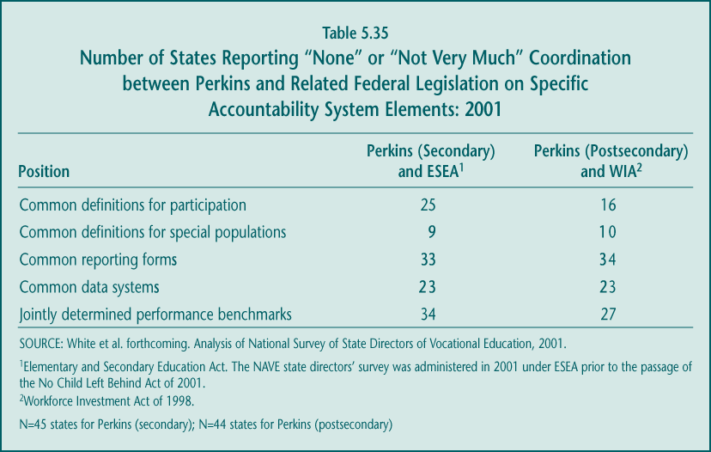

► Postsecondary-level coordination between Perkins and WIA. Although there appears to be some commonality in how participants and special populations are defined across Perkins and WIA, many other aspects of the two accountability systems are not well-coordinated (Table 5.35). First, the two laws mandate somewhat different outcome indicators: WIA requires employment and earnings outcomes, while Perkins requires educational, vocational skill attainment, and employment outcomes. Even where the indicators overlap—with employment—the measures states have required local programs to use to report Perkins and WIA performance are often different. For example, Section 136 of WIA specifies a six-month follow-up period to verify employment retention; however, Perkins allows states to determine the follow-up period, and many have chosen periods other than six months.

It is perhaps for these reasons that about half of the states or more report that Perkins and WIA accountability systems do not share reporting forms (34), data systems (23), or the setting of performance benchmarks (27). This lack of coordination results in an increased data collection burden for postsecondary Perkins grantees that also participate as WIA providers (Hudis, Blakely, and Bugarin forthcoming; White et al. forthcoming).

More than half of all states have not implemented and do not plan to implement several data collection mechanisms that could aid them in their Perkins reporting.

More than half of the secondary state directors indicated that they had neither implemented nor did they have a current plan to implement the following types of data systems or capabilities:

► Computerized secondary school transcripts (both academic and vocational).
► Computerized secondary school records with no or limited course data but including flags for vocational participation.
► Stand-alone computer systems for secondary vocational students.
► Ability to link high school records (vocational or all students) to computerized records for students in state postsecondary vocational institutions.
► Ability to link high school transcripts (vocational or all students) to computerized records for students in the states’ four-year colleges and universities.
► Ability to link high school records (vocational or all students) to military records.

Only 11 states reported that they had a fully implemented system to link high school records to unemployment insurance (UI) data, and another 17 states indicated that they had partially developed this capacity or planned to do so in the next two years (White et al. forthcoming).

States had better data collection capacity at the postsecondary level than at the secondary level, but systems are still being developed. Only about a quarter of states (19) reported in 2001 having a fully implemented computer system that includes both vocational and other students. Fifteen states had either a partially implemented system or planned to implement such a system in the next two years, while 11 states had neither implemented nor planned to use this particular type of resource for performance reporting (White et al. forthcoming).

States vary considerably in what they report spending on their accountability systems, with no clear relationship between the population size of a state and reported costs.

Most states reported collecting at least some of the Perkins III data before the passage of the law, but most also reported needing to make substantial adjustments or additions to meet the new requirements (White et al. forthcoming). These changes resulted in new investments in data systems, training of staff, or sometimes reassignment of staff to accountability functions. As noted earlier, state officials reported spending 13.5 percent of Perkins state leadership funds at the secondary level and 15.1 percent of those funds at the postsecondary level on improving data collection and accountability.

Data collected from 10 states during the case studies and telephone interviews indicate that the amount spent on developing and maintaining accountability systems varied widely in 2001. For example, two states spent less than $25,000, while one state invested $743,800 (Table 5.36). Small states reported feeling most burdened by the Perkins requirements: they receive proportionately small federal Perkins grants but are expected to collect the same number of indicators as larger states with bigger grants and, presumably, larger state education budgets. Still, examining the recent expenditures on performance measurement systems across states suggests they are more likely to reflect prior investments in developing the systems (i.e., the sophistication and scope of existing data collection) than the size of the state.

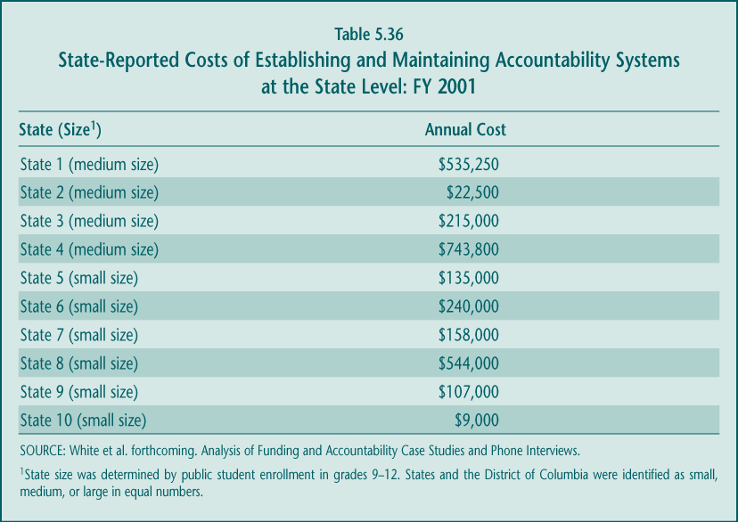

6. Conclusions and Potential Future Directions
for the Perkins Act

The Carl D. Perkins Vocational and Technical Education Act of 1998 (Perkins III) is the most recent stage in an 85-year history of federal support for career preparation in American schools. The law introduced new funding and accountability provisions, but otherwise did not alter the basic structure of the previous legislation (Perkins II). Whether more significant changes are needed as part of the upcoming reauthorization depends largely on policymakers’ sense of what vocational education has achieved, or could achieve in the future, and their priorities for an ongoing federal role.

This chapter synthesizes the current research and its implications for policy, the two issues NAVE is expected to address:

1. What conclusions can be drawn about the role and effects of secondary and postsecondary vocational education and the implementation of Perkins III? (Section A)

2. What options might policymakers consider for future federal vocational legislation? (Section B)

A. Conclusions

The National Assessment of Vocational Education (NAVE) was charged with evaluating the status of vocational education in the United States and the impact Perkins III has had on it. After more than three years of study NAVE finds that, for many students, vocational education has important earnings benefits at both the secondary and postsecondary levels, and these benefits extend to economically disadvantaged students and several other populations of special policy interest. In addition, over the last decade of academic reforms secondary students who participate in vocational programs have increased their academic course taking and achievement, making them better prepared for both college and careers than were their peers in the past. In fact, students who take both a strong academic curriculum and a vocational program of study—still a small fraction of high school graduates—have somewhat better outcomes than those who pursue either one or the other.

However, while positive change is certainly happening in high schools, which have been the focus of most policy concern, secondary vocational education itself is not likely to be a widely effective strategy for improving academic achievement or college attendance without substantial modifications to policy, curriculum, and teacher training. The current legislative approach of encouraging “integration” as a way to move secondary vocational education toward supporting academics has been slow to produce significant reforms.

In large part, the pace and path of improvement are hampered by a lack of clarity over the program’s fundamental purpose and goal. Perkins III offers a conflicted picture of federal priorities for vocational education improvement—academic achievement, technical skills, high school completion, postsecondary enrollment and degree completion, and employment and earnings. Without a clearer focus for the federal investment—amounting to about 5 percent of local spending—around which to rally the commitment and efforts of vocational teachers, counselors, and administrators, ongoing program progress in any particular direction is less certain.

This overall assessment draws on evidence addressing three key NAVE questions:

1. How does, or can, vocational education improve the outcomes of secondary students who choose to enroll in vocational and technical programs?
2. What is the nature and impact of vocational education at the sub-baccalaureate level, and what is its relationship to current workforce development efforts?
3. Is the policy shift from set-asides and legislative prescription to flexibility and accountability likely to improve program quality and student outcomes? How do special populations fare?

1. How does, or can, vocational education improve the outcomes of secondary students who choose to enroll in vocational and technical programs?

Perkins III and its legislative predecessors have largely focused on improving the prospects for students who take vocational education in high school, a group that has historically been considered low achieving and noncollege-bound. However, students who participate most intensively in vocational programs are actually quite diverse; certainly, about a quarter never enroll in postsecondary education, but a substantial number (18 percent) go on to complete at least a baccalaureate degree. The vocational courses most high school students take improve their later earnings, but have no effect on other outcomes that have become central to the mission of secondary education—such as improving academic achievement or college transitions (Table 6.1). Whether the program as currently supported by federal legislation is judged successful depends on which outcomes are most important to policymakers.

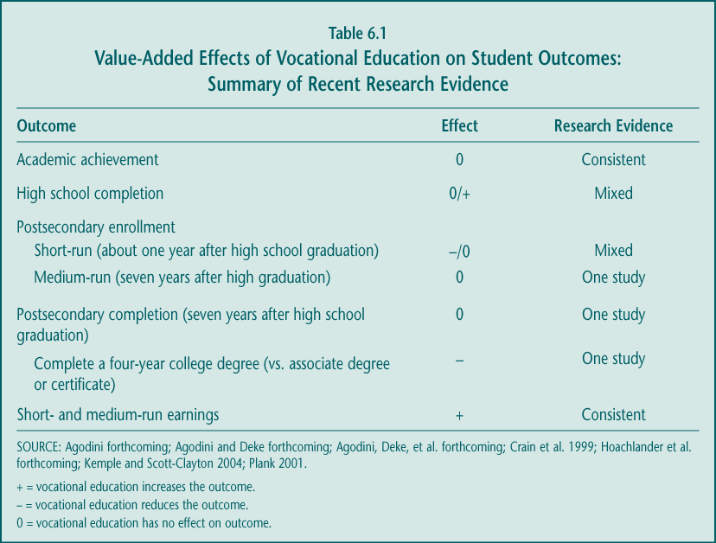

► The short- and medium-term benefits of vocational education are most clear when it comes to its longstanding measure of success—earnings. Several recent studies highlight the positive average effects of vocational course taking on annual earnings, measured just over a year or several years after high school graduation. Seven years after graduation, for example, students earned almost 2 percent more for each extra high school vocational course they took. That translates into about $450 per course, based on average earnings of about $24,000 (Figure 6.1); the benefit would be $1,350 more for the 45 percent of all high school graduates who take at least three occupational courses, including the quarter of graduates who concentrate their course taking in one program area (occupational concentrators).

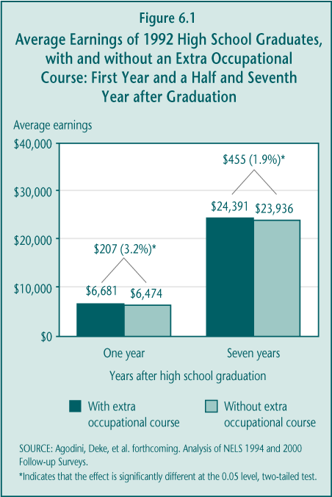

To varying extents, the studies indicate that these benefits extend to the large group of high school graduates who enroll in postsecondary education or training, to both economically and educationally disadvantaged students, to those with disabilities, and to both men and women. In addition, students who complete the “New Basics” academic curriculum as well as occupational courses—about 11 percent of all graduates—earn more than similar students who complete the New Basics and little vocational education. However, the studies are more mixed on whether secondary vocational courses benefit the one-quarter of high school graduates who never enroll in postsecondary education, a group that has historically been the focus of vocational policy.

There are also some important caveats to these earnings results. First, the evidence that vocational courses increase wages, which might be considered a proxy for a “better” job, is somewhat weak; on average, for the national groups of students examined, the higher earnings appear to be the result of the greater number of hours worked by students who had enrolled in secondary vocational education. On the other hand, taking occupational courses in high school may be associated with higher wages for young men and for students who are economically or educationally disadvantaged. Second, the period over which earnings can be calculated with available data (at most seven years) do not provide much opportunity for those who stay in postsecondary education longer and attain higher level credentials to reap the benefits in the labor market. Finally, in percentage terms, the estimated effects on earnings about one year after graduation (about 3 percent) and seven years after graduation (about 2 percent) suggest a decline over time.

► Students in vocational programs of study have significantly increased academic course taking and achievement over the last decade, although gaps remain. During the 1990s, successive groups of occupational concentrators took more, and more rigorous, academic courses along side their vocational curriculum (Table 6.2). By the end of the decade, the academic credit gap between them and students who took little or no vocational education had narrowed substantially. However, there were still differences between concentrators (51.1 percent) and non-concentrators (60.3 percent) in the proportion who completed the extensive New Basics core academic curriculum and larger gaps in the percentage that completed a rigorous college preparatory curriculum (29.2 percent versus 46.2 percent).

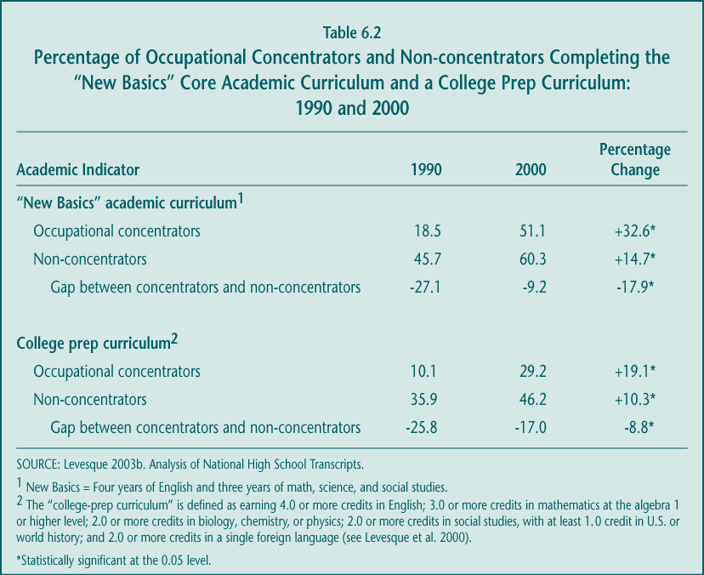

More importantly, occupational concentrators also made substantial progress on academic achievement (Figure 6.2). The NAEP 12th-grade test scores of occupational concentrators increased during the decade, by about eight scale points in reading and 11 scale points in math. Students who took little or no vocational education increased their reading achievement by about four points in reading and experienced no increase in math achievement. As a result of these trends, the gap between concentrators and non-concentrators remained roughly stable in reading, while the gap in math achievement was reduced significantly.

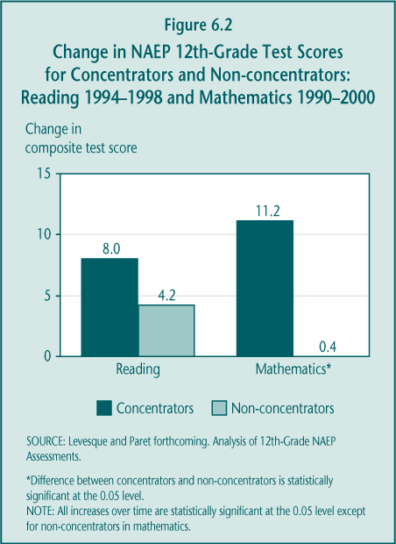

The NAEP assessments indicate that there has been substantial progress, but more work is necessary to raise the achievement levels of all students, particularly those in vocational programs. Most importantly, occupational concentrators are far less likely than non-concentrators to be proficient in reading or math, as defined by their most recent NAEP test scores (Figure 6.3). If proficiency on the 12th-grade NAEP assessments is associated with readiness for postsecondary education or success in the labor market, then these figures suggest a greater focus on academic improvement is needed.

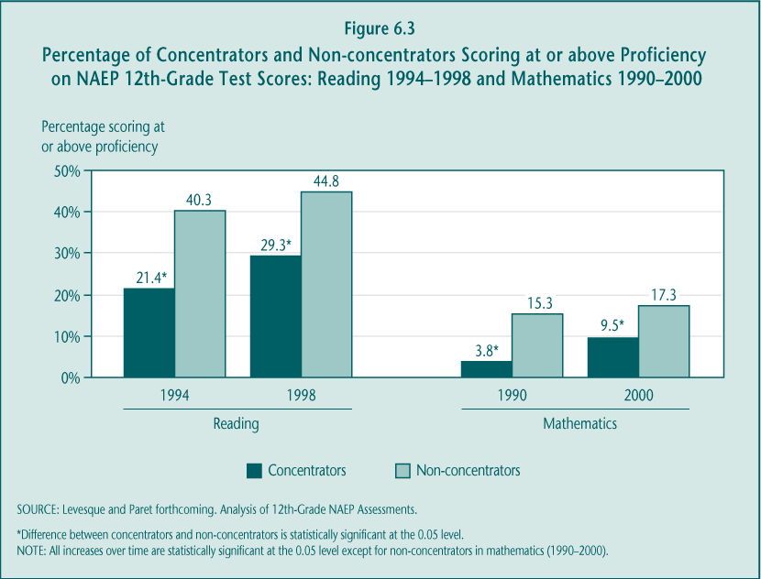

► There is little evidence that vocational courses contribute to improving academic outcomes. The noted improvements in performance are likely due to higher academic graduation requirements and increased emphasis on academic reforms. Both analyses of high school student data and randomized controlled studies indicate that, on average, vocational courses and programs do not themselves “add value” to academic achievement as measured by test scores. Not surprisingly, substituting additional academic courses for occupational courses does raise achievement. Moreover, although there is mixed evidence that vocational education reduces dropping out of school, the more rigorous studies suggest there is no effect. In an era of heightened interest in academic improvement, courses lacking a clear academic focus are being questioned and case studies suggest that vocational enrollments may decline in the future.

► Postsecondary transition rates have increased; vocational courses neither hurt nor help most students’ chances of going on to college but are associated with a shift from earning a bachelor’s degree to earning an associate’s degree or certificate. Vocational education has long been stigmatized as for the “noncollege bound” or as a deterrent to college, although NAVE finds that neither of these concerns is well founded. The best available national trend data indicate that higher proportions of occupational concentrators are moving on to some form of postsecondary education or training, although they still participate overall at lower rates than do other students and in particular in four-year colleges and universities (Table 6.3). Many concentrators enroll later, so that by seven years after graduation nearly three-quarters versus 90 percent of all other students have participated to some extent.

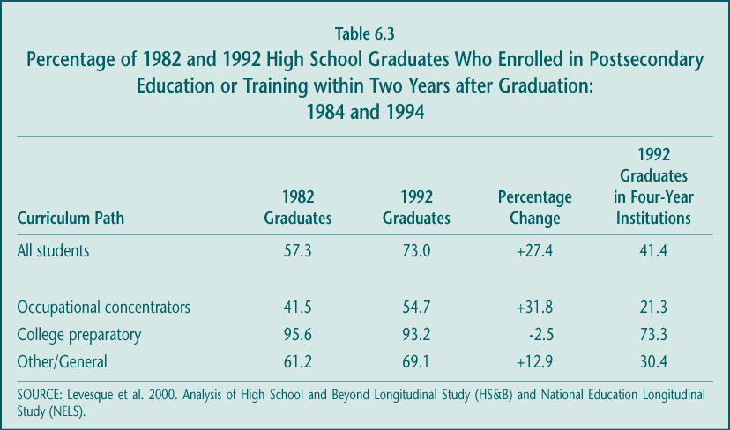

However, improvements in postsecondary enrollment do not appear related to vocational course taking. Studies of graduates in both the early and later 1990s indicate that vocational education itself has no effect on whether students ever attend postsecondary education or training. Moreover, among those who enroll, high school vocational education is associated with a lower likelihood of completing a bachelor’s degree program and a corresponding higher likelihood of completing an associate’s degree or certificate program.

► Secondary vocational education is a large component of high school course taking and serves a diverse set of students, but it is an increasingly smaller share of the overall curriculum. Nearly every student (96.6 percent) leaves high school having taken some vocational education, although the extent of student involvement varies. By almost any measure, participation remained stable during the last decade after an earlier period of decline, withstanding schools’ ongoing focus on academic improvement. While there was little change in the amount of vocational course work taken by high school students during the 1990s, students earned more academic credits thus lowering vocational education’s share of the overall high school curriculum—from 21.8 percent in 1982 to 17.8 percent in 1990 to 16.2 percent in 2000 (Figure 6.4). Still, high school students earn, on average, more credits in vocational education (4.0) than in math (3.4) or science (3.1).

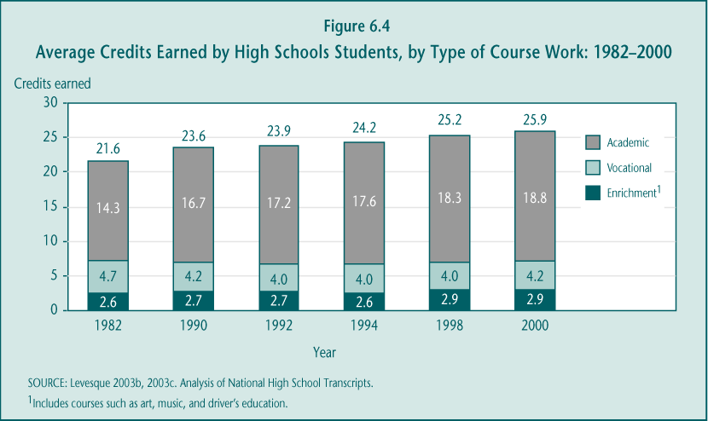

Those who participate most intensively—occupational concentrators—are a varied set of students. However, those who have disabilities or are male, come from lower-income or rural schools, or arrive at high school with low academic achievement participate more substantially than do other students. These patterns were generally stable during the last decade, although vocational education appeared to attract relatively more academically talented students during the 1990s. Less progress was made on overcoming gender differences in vocational course participation.

► Diversity in program objectives makes it more difficult to find “average” effects. Local vocational programs are designed to achieve different outcomes and therefore implemented in widely different ways and targeted to different groups of students. This diversity makes determining the national effects of vocational education on any particular outcome somewhat like aggregating apples and oranges. Average estimates are an appropriate measure of vocational education’s overall performance. Undoubtedly though, in some communities vocational courses are organized to enhance students’ academic achievement and do have such an impact; in many other places the focus is on improving occupational or technical skills and those programs would want to be judged on that basis. Perkins III accountability provisions currently hold vocational education responsible for—with equal weight—all of the desirable high school outcomes.

► The Perkins quality improvement strategies may be too vague to drive change without clear direction. Perkins III carried over a variety of strategies from Perkins II—such as integration of academic and vocational instruction, learning all aspects of an industry, linking secondary and postsecondary programs, collaborating with employers, and expanding the use of technology. Several of these strategies, including integration, are ill defined and that may be a barrier to wider implementation. In addition, little is known about their effectiveness in improving student outcomes. Perhaps more importantly, the practices are potentially targeted toward different outcomes: for example, technology might be expected to affect occupational-technical skills, integration to affect student’s academic achievement. The list does not reflect a focused purpose to the federal investment.

► Standards-based reform in vocational education may have the potential to improve outcomes, once the priorities are established. Although occupational standards have been in existence in some form and fields for decades, they have only recently been given systematic attention at the state level. A small handful of states have so far developed standards for most or all of their secondary vocational programs, made them mandatory, developed or purchased assessments to evaluate student and program performance, and begun to attach consequences to performance—an approach similar to that encouraged under the No Child Left Behind Act for elementary and secondary academic education. Perkins III only hints that occupational standards are desirable and implementation of the federal accountability requirements currently allows states and local programs to use any measure—including high school grade point average or course completion—as an indicator of occupational skill. Applying a standards-based reform approach to vocational education would require policymakers to more clearly specify vocational education’s primary objective and to invest resources in assessing progress toward it.

► Improving teacher quality will be important if vocational education is expected to alter its mission. Teachers have the most direct impact on instruction and the earnings benefits for many vocational students suggest that vocational teachers may be effective in promoting that outcome. However, federal legislation over the past decade has tried to guide vocational education toward providing greater support for academic achievement; student outcomes and program implementation suggest that these efforts have been less successful. Current vocational teachers are less likely than academic teachers to have a bachelor’s degree and many do not feel they have received sufficient professional development on the key strategy of integration. Moreover, prospective high school vocational teachers (in vocational teacher training programs) score lower on basic reading and writing tests than do those preparing to be elementary school teachers and lower than other secondary teachers in math (Figure 6.5). Substantial investments in new recruitment and in-service training approaches may be required if federal legislation continues to make supporting academic achievement a priority for vocational education.

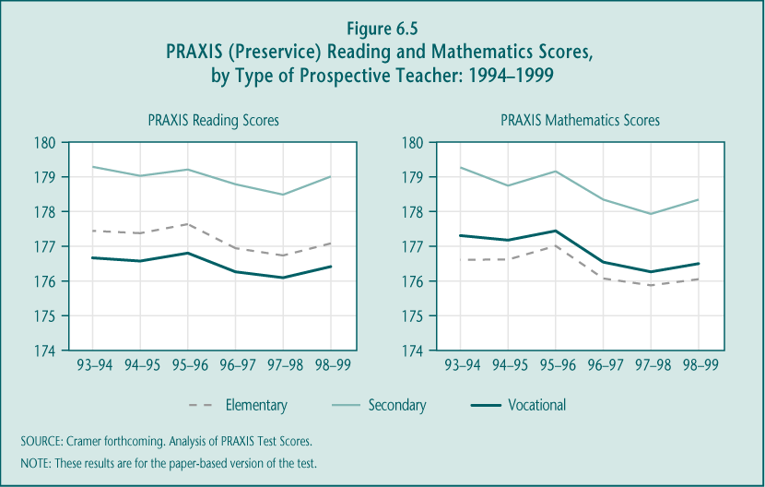

► Tech-Prep was a catalyst for certain vocational reform activities but, because few schools implement it as a comprehensive program of study, it is now playing less of a distinctive role. Efforts to promote both integration of academic and vocational instruction and articulation between secondary and postsecondary education were stimulated by the Tech-Prep Education Act in Perkins II. However, 12 years later, few schools implement Tech-Prep as a structured program with at least two years of clearly linked high school course work and at least two years of related postsecondary course work (the “two-plus-two” design). The most recent estimates suggest that about 10 percent of Tech-Prep consortia, representing 5 percent of Tech-Prep students overall, may be promoting this comprehensive two-plus-two approach. In 2001, only seven states reported that they require local programs to implement Tech-Prep as a distinct program.

More typically schools implement individual components of the Tech-Prep model—maintaining articulation agreements, providing professional development on integration to academic or vocational teachers, or improving career guidance and planning. Many of these activities are becoming part of secondary vocational education more broadly, and little change has occurred at the postsecondary level to accommodate Tech-Prep students. As a result, Tech-Prep efforts now overlap substantially with those of regular vocational education.

2. What is the nature and impact of vocational education at the sub-baccalaureate level, and what is its relationship to current workforce development efforts?

Given the labor market value of college credentials, “life long learning,” and flexibility in skills, the role of sub-baccalaureate vocational education is increasingly important. Many different types of students, with different intentions, cross the doors of community colleges and other Perkins-eligible postsecondary institutions; even with this diversity, the institutions provide services from which most participating students benefit. Relatively low rates of retention are a concern, however, not only because federal policy has long encouraged postsecondary degree completion as a strategy for maintaining American economic competitiveness but also because individual participants would reap much greater earnings advantage from staying long enough to earn a credential. An emphasis on degree completion may be at odds with the shorter-term training emphasized by the Workforce Investment Act (WIA). But at least so far, integration of decision-making and services between Perkins and WIA has been limited in most states.

► There are significant economic returns to postsecondary vocational education, with the greatest benefits for those who earn a credential. As was true at the secondary level, vocational education in community colleges appears to produce a substantial positive effect on earnings for the vast majority of participants. There are differences in these returns, depending on how much course work is completed (Table 6.4). Some postsecondary vocational participants do benefit from a year’s worth of vocational course taking even without attaining a credential, earning between 5 and 8 percent more than do high school graduates with similar characteristics. However, much higher economic rewards go to those who pursue significant amounts of postsecondary vocational education and earn a degree or certificate; female associate’s degree holders, for example, earn 47 percent more than similar students with a high school degree and males earn 30 percent more. These results represent the average effects of earning postsecondary degrees. Although many economists argue that the effects vary widely by occupational field, the available data did not permit fields of study to be analyzed separately.

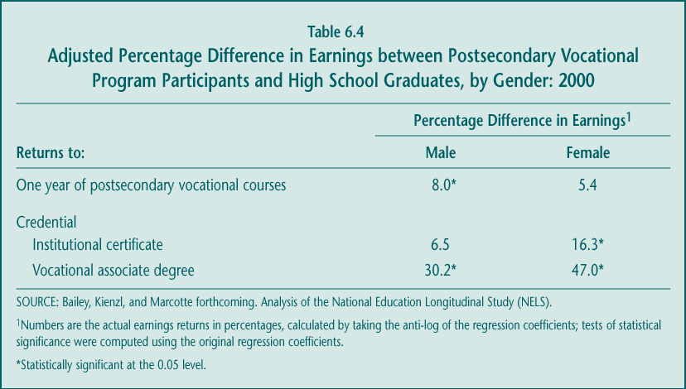

► Fewer than half of postsecondary vocational participants seeking a degree or certificate take enough courses to earn a credential. Like their academic counterparts, many vocational participants leave sub-baccalaureate institutions and programs having completed few courses; more than two-thirds of vocational majors complete the equivalent of a year or less of course work within a five-year time period. Even among those who enroll with the goal of earning a degree or certificate, fewer than half actually complete a credential of any kind (Figure 6.6). Taking student goals and characteristics into account, the completion rate for vocational majors is similar to that of academic majors, although vocational participants are more likely to earn a shorter-term credential (e.g., certificate) than they originally set out to attain. The relatively low completion rate among postsecondary vocational students is consistent across categories of students, including those in special population groups.

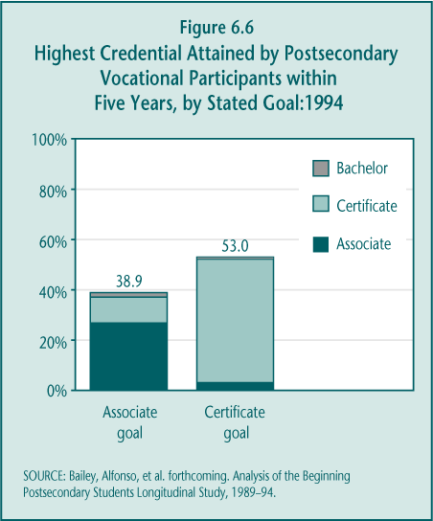

► Postsecondary vocational education serves a large and diverse population with varied expectations. About one-third of all students in undergraduate postsecondary education are considered to be in postsecondary vocational programs. These sub-baccalaureate vocational students vary in age, income, work experience, and previous college activity. Not surprisingly, then, they enroll with different goals—to get an associate’s degree or institutional certificate, to transfer and pursue a bachelor’s degree, to enhance their job skills, or to engage in personal enrichment activities; older students are more interested in obtaining job skills while younger students are more likely to aim for a credential (Figure 6.7). To accommodate this diversity, community colleges have to be particularly flexible institutions. Perkins III funds, which represent just 2 percent of vocational education expenditures in public two-year colleges, can be used to support any part of the enterprise.

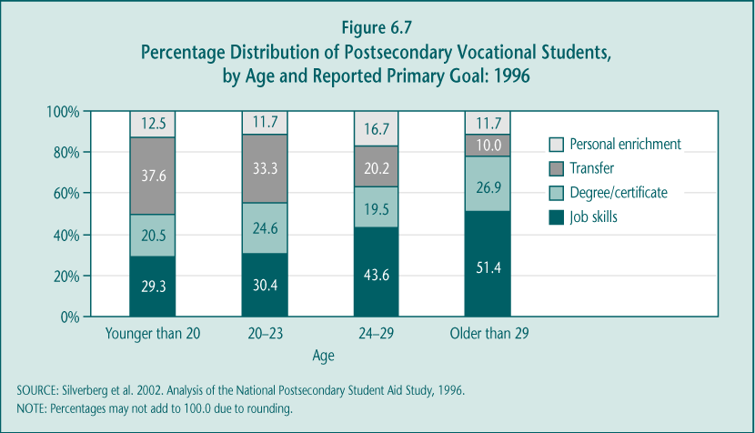

► Community colleges have had limited involvement in early implementation of WIA, citing both low emphasis on training and reporting requirements as disincentives. Early WIA implementation, during a period of economic expansion and job growth, primarily emphasized the development of new procedures and the delivery of employment information over the kinds of training activities Perkins-eligible institutions typically provide. There is some evidence that, with the recent economic downturn, training vouchers and policy interest in training are increasing, but the lack of coordination between WIA and Perkins accountability measures reportedly still lead to substantial burden for participating institutions.

3. Is the policy shift from set-asides and legislative prescription to flexibility and accountability likely to improve program quality and student outcomes? How do special populations fare?

The funding and accountability changes enacted under Perkins III have been partially successful in addressing policymakers’ objectives, although much is still in development. Local grantees are receiving larger dollar amounts and case studies suggest they are able to distribute secondary Perkins funds to more schools, outcomes consistent with the goal of directing more money to the local rather than state levels. However, both the traditional ways in which grantees use their funds and early implementation of the higher stakes accountability system forecast at best slow change in vocational program quality. Despite serious commitment among state administrators, technical measurement and data quality problems hinder widespread use of performance data for program management at either the state or local levels. Given these deficiencies, it seems unlikely that, in the short run, the accountability system will have particular benefits for special population students, especially since identifying and collecting data on these students has proven to be particularly difficult for state and local officials. The effects of eliminating targeted set-asides intended to promote gender equity is currently unknown.

► The new law succeeded in sending a higher share of funds to the local level. The average size of local grants grew substantially between Perkins II and Perkins III (approximately 34 percent for secondary and 26 percent for postsecondary grantees) (Table 6.5). These increases cannot be fully explained by increases in federal appropriations that go to state grants (just over 15 percent) or a reduction in the number of grants awarded.

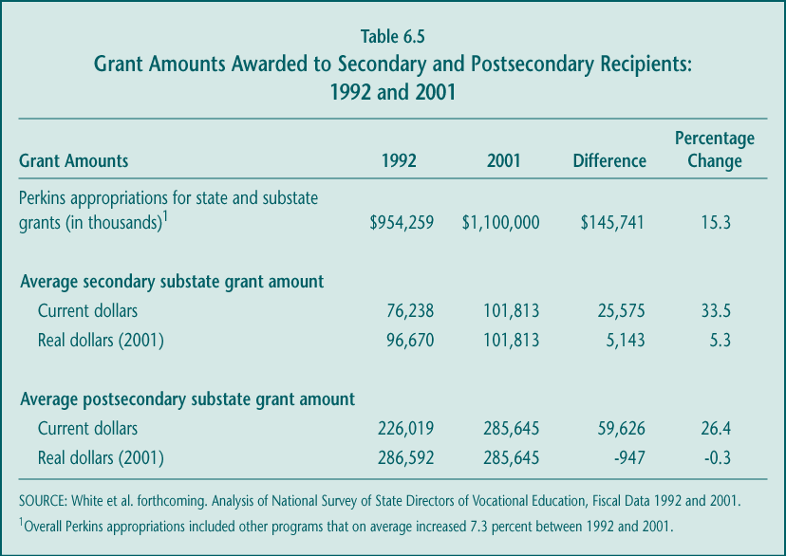

► Flexibility provisions are popular but may be weakening the targeting of funds to high-poverty communities. Nearly 30 states at the secondary level and 20 at the postsecondary level use at least one of the flexibility provisions in Perkins III. The most common choice is the newly established “reserve fund” provision, which allows states to award 10 percent of local funds to programs in rural and other areas without using the poverty-weighted legislated formula. Perhaps as a result, the dollar advantage of high-poverty districts has declined since Perkins II (Table 6.6).

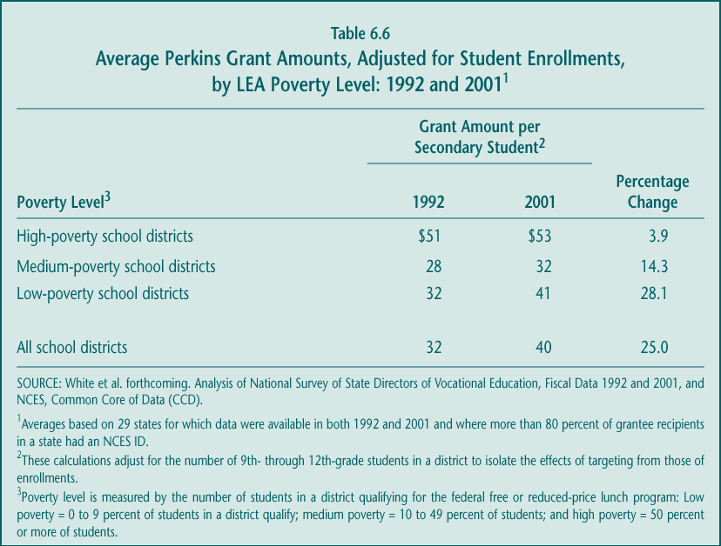

Perkins III also included several options to allow states to better coordinate federal vocational funds and activities with those of other federal programs. Only one state submitted to ED a “consolidated” plan to integrate vocational education with other education programs, and 12 states submitted “unified” plans in which they described their expected activities under some combination of the Perkins, WIA, Adult Education, and Vocational Rehabilitation laws. Although, under the ED-Flex program, states received authority to waive Perkins requirements, states generally did not exercise that authority.

► Implementation is progressing, but so far, the performance measurement system is rarely viewed as a tool for program improvement. The current system, perhaps the first legislated accountability effort with significant “teeth,” is still evolving and state officials have demonstrated a serious commitment to it. However several factors limit its likely impact on vocational programs and student outcomes in the next few years: (1) difficulty collecting data, (2) lack of validity or reliability of many adopted performance measures, and (3) inconsistent approaches to data collection and reporting within states. Certainly, the current system cannot provide a reliable, national picture of vocational education performance. Overall, the quality and reach of the Perkins accountability measures vary considerably by indicator, by state, within states, and sometimes even within local grantees’ programs. It is therefore unsurprising that relatively few states or districts use the performance data for consequential decision-making.

► Although there have been some cutbacks in staffing dedicated to special population services, the full effects on programs and students are unknown. Even with the elimination of the gender equity set-asides and coordinator requirements, many states continued to support these efforts though the amount of staff time seems to have declined. In 2001, 23 states reported having at least one gender equity coordinator working full- or part-time, but case studies suggest these figures represent reductions from Perkins II. There were fewer observed effects at the local level, with other funding sources sometimes making up for the loss of Perkins gender equity grants. There were cutbacks in targeted programs and services in some communities but how these might affect student outcomes cannot be known for several more years.

B. Options for Future Directions

Despite the current strengths of the vocational education system supported by Perkins III, there remain ongoing challenges for further improvement. Policymakers may wish to consider a variety of ways—encompassing broad or more specific strategies—in which to shape the course of these improvements. The approaches discussed here are based on evidence gathered through NAVE research activities, as described below.

1. Broad Strategies for Promoting Change

There are several possible options that have implications for the structure of a new or revised law. These broad strategies share a common goal of providing a clearer focus to federal priorities.

Transform Perkins into a program with clear, focused, and limited objectives.

The Perkins legislation is a stream of funds that provides wide latitude to state and local grantees in terms of implementation and goals. Historically, federal legislation has been built around two competing models: (1) a compliance model that holds grantees responsible for adhering to required inputs and strategies without regard for outcomes and (2) an accountability model that specifies one, or a small set of outcomes and allows grantees flexibility regarding the means for achievement. Perkins III contains elements of both models but does not appear to be clearly committed to either approach.

Perkins III reporting requirements reflect the historical accumulation of purposes that have been laid out for vocational education: improving students’ academic and technical skills, enhancing high school completion and postsecondary enrollment, college completion, and successful labor market entry and retention. All of these, it could be argued, are worthy objectives for federal policy to address at either the high school or college level, or both.

However, it is reasonable to question the capacity of any single law or any single program strategy to succeed on all of these fronts. The diffuse nature of federal priorities for this stream of funds both reflects and contributes to ambivalence among policymakers and educators about what “problem” is being addressed by the Perkins legislation, and impedes efforts to develop clear, focused, and tested education interventions designed to ameliorate the identified problem.

The federal investment could be more effective if directed toward a narrower set of goals around which program improvement strategies and accountability systems could be developed. There are some choices in moving in that direction:

► Emphasize immediate goal of education or workforce development. Decision-makers may want to weigh whether vocational education, or the activities the Perkins legislation supports, should most directly and immediately contribute to:

• Education, in which the emphasis is primarily on learning academic or occupational skills (or both) while enrolled in school; or

• Workforce development, in which the emphasis is primarily on job and other post-school outcomes.

These various objectives are certainly interrelated and clarifying the priorities does not imply that vocational education cannot also have other benefits. Studies clearly link higher levels of learning and of educational attainment to success in the workplace (see NAVE Interim Report [Silverberg et al. 2002]). The language in Perkins III and of vocational advocacy groups suggest that effective technical skills rest on a strong foundation of academic proficiency. The question is, however, which of these goals is most critical for Perkins-funded activities? A focus is important for the federal role of promoting continuing improvement.

► Separate the high school and postsecondary components of the Perkins Act versus keeping them joined in the structure of the law. In some sense, secondary and postsecondary vocational education share many qualities. Both are elective choices rather than a required curriculum. Both serve an increasingly diverse set of students, who have widely varying purposes for participating and hopes for what they will accomplish. When secondary vocational education was clearly a program for developing occupational skills and preparing for immediate employment, the strategies at the two levels were similar. However, that may no longer be the case. Since the mission of high schools and community and technical colleges differ, as do the challenges they face, policymakers may decide that federal vocational education should play a different role at each level. For example, although federal policy may charge secondary vocational education with reinforcing high schools’ learning objectives, policymakers may choose to more clearly tie postsecondary vocational education to workforce development outcomes.

Establishing separate policies and goals for vocational education at the two levels need not undermine the current federal emphasis on developing clear pathways from high school to postsecondary education. On the contrary, with two separate titles or sections, the law could more clearly articulate the specific responsibilities of secondary and postsecondary institutions to create and maintain those pathways.

___________________

Policy Option: Focus Perkins legislation more clearly

NAVE Supporting Research Evidence

■ Federal vocational dollars are an important but relatively small share of both federal and local budgets: (1) Perkins appropriations declined from 6 percent of total Department of Education budgets in 1981 to 2 percent in 2004 (Chapter 1), and (2) best estimates suggest that local Perkins grants correspond to only about 5 percent of district spending on secondary vocational education and a somewhat smaller proportion of average community college expenditures (Chapter 5).

■ Students in secondary and postsecondary vocational courses are diverse, enroll for different reasons, and expect different outcomes to result (Chapters 2 and 3); limited Perkins funds attempt to support the full range of efforts and students.

■ Perkins III accountability requirements place responsibility for almost all possible secondary school outcomes on vocational education, perhaps because Perkins remains the largest single source of federal funds for high schools. Similar accountability requirements place the burden on postsecondary institutions to support a broad array of possible student outcomes (Chapter 5).

■ In contrast, Title I of the Elementary and Secondary Education Act, with funding more than 10 times greater than Perkins, has been transformed by federal policymakers from a “stream of funds” into one that is unambiguously focused on one core goal: raising academic achievement (Chapter 1).

■ Although high schools see preparing students for careers as an important mission, their primary focus over the last decade has been on improving academic achievement and transitions to college and the latter is at least a stated goal of most high school students (Chapter 1). In contrast, a primary goal of community and technical colleges, adult centers, and other eligible Perkins postsecondary recipients is job training; more than two-thirds of sub-baccalaureate vocational students enroll to upgrade their job skills or to get a terminal credential (Chapter 3).

___________________

Eliminate Tech-Prep as a separate title, folding its key activities into postsecondary institutions’ responsibilities.

Tech-Prep has spurred some important efforts but has not lived up to its promise of creating rigorous programs of technical study. The Tech-Prep title of the Perkins Act has become a funding stream like the larger state grant title in Perkins, allowing local consortia to supplement vocational education or other efforts associated generally with the spirit of the law (e.g., career development). Rarely are funds focused on developing the well-defined two-plus-two (2+2) programs that early Tech-Prep advocates promoted: integrated high school academic and vocational curricula that are “articulated”—linked through credit transfer agreements—to postsecondary programs. Instead, integration and articulation have been implemented more on a course-by-course basis. Moreover, these two key components of Tech-Prep have become more common priorities for vocational education generally, diminishing the distinctive role that Tech-Prep efforts might play. Finally, there is some evidence that Tech-Prep funds are not as well targeted to high poverty as are the formula-driven basic grant funds under the Perkins Act.

Despite these limitations, Tech-Prep remains the catalyst for some initiatives and strategies that many consider worth preserving. Two, in particular, could instead become required activities for postsecondary Perkins grantees, many of whom already play this role as part of Tech-Prep consortia:

► Convening local partners to collaborate on postsecondary transition issues. Some Tech-Prep consortia periodically convene local secondary and postsecondary institutions, employers, and community-based organizations to provide opportunities to coordinate professional development, talk about curriculum, or keep updated on changing requirements for college admission or entry-level workplace skills.

► Establishing and maintaining articulation agreements to promote students’ more efficient acquisition of college credit. The expansion of articulation arrangements and the rapid changes in technology and economic conditions that generate modifications in postsecondary curricula make keeping articulation current more challenging. Some states have moved or are moving toward statewide articulation agreements in which the responsibilities for these agreements are already largely in the hands of postsecondary institutions.

This strategy could, in effect, focus the Perkins-funded efforts of eligible postsecondary institutions on serving their younger students (those transitioning from high school) rather than on the older adult population. Such an emphasis might be warranted, since the younger students are less likely to be on a stable trajectory toward labor market success: they have more limited work histories and less previous college or job training experience, and there is some evidence that earning a credential matters more for them than for older students. Given that Perkins grants represent about 2 percent of local community college spending on occupational education, a focus for federal funds on younger students might also strengthen current efforts to develop rigorous cross-level course sequences, pathways, or programs of study.

___________________

Policy Option: Eliminate Tech-Prep

NAVE Supporting Research Evidence

■ Definitions of a “Tech-Prep student” vary widely; enrollment in a single articulated vocational course is the most common measure (Chapter 4).

■ Few consortia or schools implement Tech-Prep as a structured two-plus-two (2+2) program; implementation focuses on individual elements of Tech-Prep—articulation agreements, professional development on integration, improving career guidance and planning (Chapter 4).

■ Tech-Prep funds are spent primarily on staffing a coordinator position—to oversee and organize meetings and articulation agreements—and on allocations to consortium members for new vocational programs, equipment, curriculum materials, and professional development. State grants to consortia are commonly awarded by a formula, but the formula rarely takes poverty into account (Chapter 5).

■ In a majority of states, articulation agreements either exist or are underway for most vocational courses and programs (Chapter 4).

■ Nearly half of younger vocational students (24 years of age or less) leave postsecondary education with eight or fewer months of course work (Chapter 3).

■ Only 13 percent of younger vocational students have a prior college credential (usually a certificate), compared to 45 percent of older students (Chapter 3).

___________________

Streamline accountability requirements to align with the more focused objectives.

The current accountability provisions in Perkins III require secondary and postsecondary grantees to report on a broad array of student outcomes, both those that students achieve while in school (academic achievement, occupational-technical skill development, school completion) and those that define their paths after they leave (further education or training and employment). There are two reasons for reducing the number of indicators:

► Limit burden and improve performance data quality. Some states are using administrative records (centralized college records and records from state Unemployment Insurance systems), and more might do so with federal encouragement. However, many states without those options are finding it burdensome to meet all of the reporting obligations and currently their performance measures and data collection approaches have limited validity and reliability, impeding reliance on them for significant program management decisions. Improvements in data quality and use are more likely if state and local grantees could concentrate their efforts on a smaller set of indicators.

► Focus program improvement activities. The accountability system is intended to motivate states, districts, and postsecondary institutions to manage their programs more effectively. A more limited set of performance indicators, closely aligned to policymakers’ priorities for the federal investment, could encourage more targeted improvement efforts.

___________________

Policy Option: Streamline accountability requirements

NAVE Supporting Research Evidence

■ State and local grantees have difficulty reporting several indicators—particularly occupational-technical skill attainment, further education, and employment; the reliability and validity of much of the data are poor (Chapter 5).

■ State administrators report that poor data quality is one reason they do not currently view the performance data as useful for program improvement (Chapter 5).

___________________

2. Specific Strategies for Improved Performance

Although there are broad changes to the structure of the law that policymakers could pursue, there are also individual practices and strategies new legislation could promote that might improve particular outcomes (Table 6.7). Ideally, one set of strategies would be emphasized, tied to a clear declaration of federal priorities. However, the strategies could also be implemented in combination.

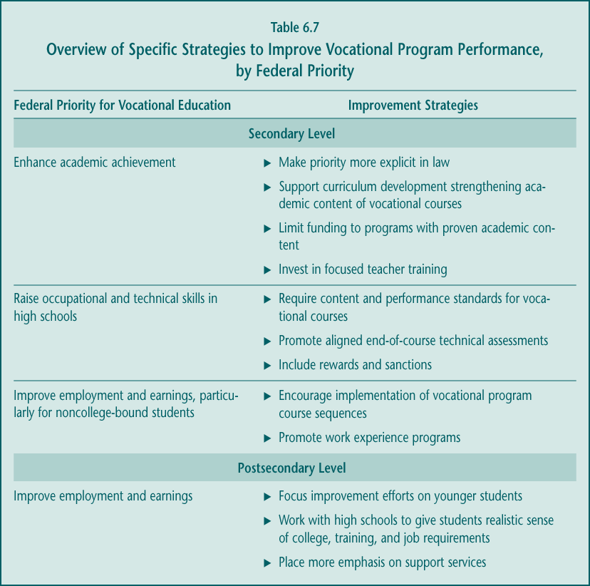

Secondary Vocational Education

Enhance academic achievement, promote incentives for curriculum change and strategic investments in teacher training.

Improving academic achievement as a way to better prepare students for both college and careers is widely accepted as a primary objective of secondary schools. Over time, federal policy has increasingly emphasized the use of vocational education to support academic objectives at the high school level. However, although vocational students are clearly performing better academically than in the past, there is little evidence that vocational education has contributed to improved academic or postsecondary outcomes of most students, or that the academic emphasis in federal policy has so far significantly changed practice.

If policymakers intend vocational education to be primarily, or more of, an instrument for academic improvement, several very substantial changes would be required:

► Identify the priority. Federal legislation would need to identify academic improvement as its primary objective, giving post-high school employment and earnings outcomes less emphasis. Having a clear, focused goal might help build consensus among vocational educators.

► Support curriculum development directly or through incentives. The content of most vocational courses and programs would have to evolve substantially, and teachers could not do it themselves. In fact, one barrier to greater integration of academic and vocational education has been that teachers have been left largely on their own to modify their curricula. Inducement might be necessary to encourage change. One approach might be to restrict federal funds to vocational courses that demonstrated sufficient academic content to enable students to earn academic credit toward high school graduation. Such an approach would have to be reconciled with the new teacher qualification requirements under the No Child Left Behind Act.

► Invest in teacher training. Upgrading the vocational teacher workforce would be necessary, particularly given the relatively weak academic preparation of current and prospective vocational teachers. A policy similar to the “highly qualified teacher” requirement in the No Child Left Behind Act might be an important support.

___________________

Policy Option: Promote curriculum change and teacher training

NAVE Supporting Research Evidence

■ On average, vocational courses do not seem to contribute to students’ academic achievement (as measured by test scores) or the likelihood of enrolling in postsecondary education. Taking more academic courses, even lower level math and science courses, does enhance academic achievement (Chapter 2).

■ Adjusting for student characteristics, students taking vocational education in high school eventually enroll and complete postsecondary education at rates similar to comparable students, but they enroll later and are less likely to attend four-year colleges (Chapter 2).

■ After a decade of federal promotion, academic and vocational education are only somewhat better integrated, even within programs such as career academies and Tech-Prep, where integration is a goal (Chapter 2).

■ Increasing numbers of states include academic content in vocational curriculum guidelines. But the guidelines tend to support basic skills, not higher-level academic competencies in math and science, and are not necessarily linked to core academic standards (Chapter 2).

■ The vocational teacher workforce seems poorly prepared to deliver academic instruction: at least 9 percent of vocational teachers overall, and a higher fraction in area vocational schools, lack a bachelor’s degree; vocational teachers preparing to enter the field score lower than prospective elementary school teachers in basic reading and writing tests. They score only slightly higher than prospective elementary school teachers in math but still lower than other secondary school teachers (Chapter 2).

■ Although vocational educators widely acknowledge the importance of academic skills, many do not believe that it is their primary responsibility to help students in this area (Chapter 2).

___________________

Develop high school students’ occupational and technical skills, require states to focus on whether students are actually learning—by establishing content and performance standards and assessments.

Vocational courses are electives in which students enroll for many different reasons. Some students are hoping for careers directly after high school, others are considering potential college majors, and still others are pursuing a personal interest. Although students envision widely varying benefits from vocational courses, they are all expecting to learn. Likewise, although vocational educators may disagree about most other outcomes, they generally agree that their primary objective is for students to acquire occupational knowledge and skills regardless of the path students take after leaving school.

Policymakers may therefore choose to focus on this most direct indicator of vocational program success as the way to promote program improvement. Unfortunately, this NAVE report, like all earlier ones, has little evidence about the impact of vocational education on students’ knowledge of occupational and technical skills, largely because there are few well-validated ways of assessing those skills. Most states rely on vocational program completion, course grades, or high school completion for performance reporting to the Department on occupational-technical competency. Yet, these same types of teacher-assigned or “seat time” measures have largely been rejected by federal policymakers as unreliable indicators of academic learning.

One strategy is for policymakers to apply the standards-based reform model to vocational education. Federal support for high school vocational programs would be contingent on state implementation of standards and exams to directly assess whether students have learned the intended subject matter at a specified performance level. The components might include:

► Require content and performance standards for vocational courses. Although some states already have vocational standards in place, and many others have voluntary curriculum guidelines, several years would be needed to establish review committees of employers and educators to create and certify content and performance for every vocational subject the state wished to support with federal funds. This would encourage educators and employers to engage in a healthy debate over the kinds of occupational learning most appropriate at the secondary school level. And, just as is the case under the No Child Left Behind Act, states might make very different choices about the scope of learning to be promoted in vocational education and the levels of performance expected.

► Promote aligned end-of-course assessments. Within a specified time period—perhaps four or five years—states would be required to adopt and put in place an end-of-course exam system that students would be required to take upon completing a year’s worth of course work. The growing use of industry-developed certification exams is a step in the right direction, but some states might purchase assessments from private developers such as the National Occupational Competency Testing Institute (NOCTI) or ACT, and others might create their own.

Developing and implementing an assessment system is a particularly difficult and expensive undertaking in vocational education given the variety of subjects, the need to continually update to reflect changes in the field, and the desirability of combining paper and pencil with authentic assessments. Federal resources might be set aside for competitive awards to states, as they are under the No Child Left Behind Act, to support test development and administration. States might be encouraged to form consortia for this purpose.

► Include rewards and sanctions. A variety of performance incentives at the state and local program level could be introduced. For example, like the No Child Left Behind Act, if programs failed to achieve an acceptable student pass rate for two consecutive years, certain sanctions might apply. Initially grantees could be required to adopt an improvement plan (as is the case in Perkins III), but if student performance failed to reach satisfactory performance levels for three consecutive years, such programs might be required, for example, to use federal funds to enable high school students to obtain training at community colleges, online, or from other providers.

___________________

Policy Option: Encourage standards-based reform of vocational education

NAVE Supporting Research Evidence

■ At most, 16 states use statewide assessments for federal reporting on students’ occupational-technical competencies; most states allow local programs and teachers to determine whether students have acquired requisite vocational skill (Chapter 5).

■ State interest in developing standards and assessments is growing; the association representing state directors of vocational education is leading an effort to identify knowledge and skills for 16 career clusters and eventually to develop assessments for each of them (Chapter 2).

___________________

Improve employment and earnings for the noncollege bound, emphasize coherence of vocational programs and work experience opportunities.

Not only do most students say they want to attend college, but increasing proportions are doing so. In addition, most high school students work and traditional distinctions between the work-bound and college-bound students are eroding. Consistent with these trends, federal policy and many local programs have moved away from emphasizing vocational education as preparation for entry-level jobs directly after high school.

On the other hand, a significant share of students may not reap the benefits of a postsecondary education or training experience. The official U.S. Department of Education dropout rate in 2001 was about 11 percent, although the percentage of students who fail to obtain a high school diploma is much higher. Recent studies suggest that the dropout rate may be closer to one-quarter of entering freshmen (Sum and Harrington 2003; Greene and Forster 2003). Even among high school graduates, about one in five will not enroll in any postsecondary education and other students will attend but not complete. Students who do not plan to attend or who are unlikely to be successful in college are often disadvantaged in the labor market and have historically been the target group for vocational programs. If federal policymakers choose to focus on this sizable group, they might:

► Encourage student completion of vocational program course sequences. Although increasing proportions of vocational students “explore” by enrolling in courses in two or more occupational fields, there is some evidence (although mixed) suggesting that earnings benefits may be higher for students who concentrate their course taking in one program area.

► Promote cooperative education and other work experience programs. Nearly one-third of all high school graduates participate in some kind of work experience program, and a high share of these students choose not to enroll in postsecondary education. Preliminary analyses in one state suggest that taking cooperative education has a positive effect on earnings at least during the first year or two after high school graduation.

___________________

Policy Option: Emphasize vocational program sequences and work experience
for noncollege bound students

NAVE Supporting Research Evidence

■ Among high school graduates in 1992, about 12 percent had never enrolled in any postsecondary education by 2000 (Agodini, Uhl, and Novak 2002)

■ Students who take at least three occupational courses are increasingly less likely to concentrate those courses in one program area (Chapter 2).

■ State data suggest that the higher the degree of specialization and concentration in vocational course taking, the higher the earning effects (Chapter 2).

■ Some analysis indicates that taking cooperative education as part of the vocational education experience may contribute to short-run earnings (Chapter 2).

___________________

Postsecondary Vocational Education

Postsecondary vocational participants are diverse and so is the set of options sub-baccalaureate institutions provide for them. Students enroll for different reasons (to earn college credentials, to upgrade job skills, to satisfy a personal interest) and have different characteristics—varying in age, work experience, and their need to balance career, school, and family responsibilities. Community and technical colleges offer short-term programs leading to certificates and longer-term programs culminating in associate’s degrees; some of the courses are for-credit while others are not, and they are offered during the day and at night.

Despite this diversity in students and program strategies, the concern over clarity of purpose for Perkins is less compelling at the postsecondary level than at the high school level. Certainly, the federal investment in postsecondary vocational education is small and policymakers may want to focus that investment where it can do the most good. But postsecondary vocational education is more clearly connected to workforce development, with even students seeking a credential interested in their immediate or long-term job prospects. Thus, continuing to emphasize earnings and employment as key priorities is likely to be appropriate.

One clear way to improve earnings of postsecondary participants, though, is to increase their chances of getting a credential. More than two-thirds leave sub-baccalaureate institutions completing less than a year’s worth of course work and fewer than half obtain a degree or certificate. Some evidence suggests that the economic value of just a single year in a community college vocational program is comparable to the value of a year in a baccalaureate-granting college. However, for those who complete more credits and earn a credential the economic returns are substantially greater. At least for women, the returns to earning a vocational associate degree were twice as large as for those taking similar amounts of course work but not earning a degree. Community college students who complete a vocational associate degree earn on average between 30 and 47 percent more than a similar high school graduate with no postsecondary education.

Charging community colleges with responsibility for improving earnings through credential attainment might involve the following components:

► Focus on younger postsecondary students. Compared to older participants (more than 24 years old), younger students accumulate more course credits, are more likely to enroll seeking a credential or to transfer to a senior institution, and are less likely to have a substantial work history to fall back on. There is some evidence that a certificate or degree matters more for younger than for older students in producing economic returns to vocational education.

► Work with high schools. Perkins postsecondary institutions could help ensure that incoming students have a realistic sense of how well prepared they are for their intended programs of study. All too often students meet high school graduation requirements but, when tested upon enrolling in community college, still require remedial courses before beginning course work in their major field. Anecdotal evidence suggests that some of these postsecondary students, seeing a long and difficult road ahead of them, become discouraged and often drop out or enroll in shorter, less demanding programs. In this role, postsecondary institutions might:

• Administer a college placement exam to high school juniors so that prospective students would have an accurate read on the extent to which they are prepared for community college and time to cure their deficiencies;

• Continue to extend articulation and dual enrollment programs to enable more high school students to experience the rigors of college-level course work and the potential for entering postsecondary education programs with earned credits.

► Emphasis on support services. Local Perkins postsecondary grantees often use federal funds to assist students in special populations, including help with child care and transportation. This funding focus is appropriate and should, perhaps, include an emphasis on academic tutoring and counseling services. A recent NCES publication suggests that changes in work and family status are among the most common reasons that students give for leaving postsecondary programs before completing them, although academic preparedness is also an issue (Bradburn 2002).

___________________

Policy Option: Increase credential attainment to promote earnings

NAVE Supporting Research Evidence

■ Students enroll for various reasons; older students are generally seeking job skills and may already have earned a college credential; more than half of younger students hope to earn a college degree (Chapter 3).

■ Degree completion rates are low for both academic and vocational majors in public two-year colleges; more than half leave without a credential (Chapter 3).

■ Economic returns to postsecondary vocational education are positive and are particularly large for students who complete credentials (Chapter 3).

■ The federal investment is small—about 2 percent of local postsecondary vocational expenditures (Chapter 5).

■ Many postsecondary institutions use Perkins grants to cover support services for special populations, in addition to professional development (Chapter 5).

___________________

3. Promising Research and Evaluation Investments

Many questions about vocational education, particularly about how to improve it, remain unanswered. Given the time frame, resources, and broad set of questions given to this NAVE assessment, there is little opportunity to identify and rigorously test promising practices or programs in the field. Such efforts require focused investments and at least four years to find sites implementing strategies of interest (or put them in place through demonstrations), design the evaluations, and collect and analyze the data. However, these types of investments might begin to build a body of evidence about what works for improving the outcomes of high school and sub-baccalaureate students and, in particular, those who pursue vocational education as a major part of their studies. Policymakers may want to consider ways to ensure that some longer-term research and evaluation activities are pursued.

Among the topics that might be considered are:

► What is the impact of well-known, and now longstanding, vocational interventions such as Tech-Prep, career academies, High Schools That Work, and cooperative education?

► What specific curriculum strategies would help strengthen the academic content and impact of vocational courses?

► Would broadening vocational courses beyond job-specific skills training, as promoted by the “career clusters” movement, affect the observed labor market benefits of vocational education?

► What are effective strategies for career development, and how important is it to setting high school students on a successful path?

► What constitutes a “highly qualified” vocational teacher?

► What are effective strategies for increasing postsecondary retention and completion rates at the sub-baccalaureate level?

4. Closing

Vocational education, increasingly known as career and technical education, is a longstanding program whose place in American education continues to evolve. The broadening of its goals, the ongoing diversity of participants, and the changing education and labor market climate in which it operates, suggests vocational education is a flexible option for schools and students.

With this flexibility comes some challenges, however. At the high school level, participation in vocational education is an elective choice that faces increasing pressure from emphasis on academic improvement. For both secondary and postsecondary vocational education, the wide range of participants and objectives raises a question about how effective a role federal policy plays and whether that policy can or should promote a clearer set of priorities. This final NAVE report is designed to contribute to that discussion, by providing the most up-to-date and comprehensive assessment of vocational education in the United States and of the effects of the Carl D. Perkins Vocational and Technical Education Act of 1998.

►References

Adelman, Clifford. 2000. A Parallel Postsecondary Universe: The Certification System in Information Technology. Washington, D.C.: U.S. Department of Education, Office of Educational Research and Improvement. PLLI 2000–8011.
Adelman, Clifford. 2003. “A Growing Plurality: The ‘Traditional Age Community College Dominant’ Student.” Community College Journal (April-May): 27–32.
Administrative Data Research and Evaluation (ADARE) Project, Division of Research and Demonstration, Office of Policy Development Evaluation and Research, Employment and Training Administration, U.S. Department of Labor, May 15, 2003.
Agodini, Roberto. Forthcoming. Achievement Effects of Vocational and Integrated Studies. Princeton, N.J.: Mathematica Policy Research, Inc.
Agodini, Roberto, and John Deke. Forthcoming. The Relationship between High School Vocational Education and Dropping Out. Princeton, N.J.: Mathematica Policy Research, Inc.
Agodini, Roberto, John Deke, Timothy Novak, and Stacey Uhl. Forthcoming. Vocational Education and Postsecondary Outcomes: Eight Years After High School. Princeton, N.J.: Mathematica Policy Research, Inc.
Agodini, Roberto, Stacey Uhl, and Timothy Novak. 2002. Medium-Run Outcomes of Secondary Vocational Students. Tables prepared for the U.S. Department of Education, National Assessment of Vocational Education.
Agodini, Roberto, Stacey Uhl, and Timothy Novak. Forthcoming. Factors That Influence Participation in Secondary Vocational Education. Princeton, N.J.: Mathematica Policy Research, Inc.
Bailey, Thomas R., Mariana Alfonso, Marc Scott, and Timothy Leinbach. Forthcoming. Educational Outcomes of Occupational Postsecondary Students. New York: Columbia University, Teachers College, Institute on Education and the Economy.
Bailey, Thomas R., Katherine L. Hughes, and Melinda Mechur Karp. 2002. Multiple Missions of Community Colleges: Conflicting or Complementary? New York: Columbia University, Teachers College, Institute on Education and the Economy.
Bailey, Thomas R., Gregory Kienzl, and David Marcotte. Forthcoming. The Return to a Sub-Baccalaureate Education: The Effects of Schooling, Credentials, and Program of Study on Economic Outcomes. New York: Columbia University, Teachers College, Institute on Education and the Economy.
Bailey, Thomas R., Timothy Leinbach, Marc Scott, Mariana Alfonso, Gregory Kienzl, and Benjamin Kennedy. Forthcoming. The Characteristics of Occupational Sub-Baccalaureate Students Entering the New Millennium. New York: Columbia University, Teachers College, Institute on Education and the Economy.
Barnow, Burt S., and Christopher T. King. 2003. The Workforce Investment Act in Eight States: Overview of Findings from a Field Network Study. Albany, N.Y.: The Rockefeller Institute of Government.
Boesel, David, Beverly Farrar, Debra Hollinger, Lisa Hudson, Charles Masten, Ron Myers, Stefani Scheiderman, and Duc-Le To. 1994a. National Assessment of Vocational Education, Interim Report to Congress. Washington, D.C.: U.S. Department of Education, Office of Educational Research and Improvement. NLE 98–2023.
Boesel, David, Lisa Hudson, S. Deich, and Charles Masten. 1994b. National Assessment of Vocational Education, Final Report to Congress. Volume II: Participation in and Quality of Vocational Education. Washington, D.C.: U.S. Department of Education, Office of Educational Research and Improvement.
Bottoms, Gene. 2002. Putting Lessons Learned to Work: Improving Achievement of Vocational Students. Atlanta, Ga.: Southern Regional Education Board.
Bradburn, Ellen M. 2002. Short-Term Enrollment in Postsecondary Education: Student Background and Institutional Differences in Reasons for Early Departure, 1996–98. Washington, D.C.: U.S. Department of Education, Office of Educational Research and Improvement, National Center for Education Statistics. NCES 2003–153.
Bradby, Denise, and E. Gareth Hoachlander. 1999. 1998 Revision of the Secondary School Taxonomy. Washington, D.C.: U.S. Department of Education, Office of Educational Research and Improvement, National Center for Education Statistics. Working Paper NCES 1999–06.
Bragg, Debra D. 2001. Promising Outcomes for Tech-Prep Participants in Eight Local Consortia: A Summary of Initial Results. St. Paul, Minn.: National Research Center for Career and Technical Education.
Branch, Alvia Y. Forthcoming. Participation in Vocational Education: Students’ Perspectives. Philadelphia, Pa.: Branch Associates.
Bruening, Thomas H., Dennis C. Scanlon, Carol Hodes, Purandhar Dhital, Xioarong Shao, and Shih-Tsen Liu. 2001. The Status of Career and Technical Teacher Preparation Programs. Minneapolis, Minn.: National Center for Research on Career and Technical Education, University of Minnesota.
Bureau of Labor Statistics. 2001. 2000 National Occupational Employment and Wage Estimates. Washington, D.C.: U.S. Department of Labor. ftp.bls.gov/pub/news.release/history/
ocwage.11142001.news (accessed March 30, 2004).
Bureau of the Census. 2002. Tables prepared for the U.S. Department of Education, National Assessment of Vocational Education.
Chudowsky, Naomi, Nancy Kober, Keith S. Gayler, and Madlene Hamilton. 2002. State High School Exit Exams: A Baseline Report. Washington, D.C.: Center on Education Policy.
Chung, Ruth. Forthcoming. Is Standards-Based Reform a Strategy for Improving Vocational Education? Washington, D.C.: U.S. Department of Education, Office of the Under Secretary.
Coley, Richard J. 2000. The American Community College Turns 100: A Look at Its Students, Programs, and Prospects. Princeton, N.J.: Educational Testing Service, Policy Information Center.
Council of Chief State School Officers. 2000. Key State Education Policies on K–12 Education. Washington, D.C.: Council of Chief State School Officers.
Crain, R., A. Allen, R. Thaler, D. Sullivan, G. Zellman, J. Little, and D. Quigley. 1999. The Effects of Academic Career Magnet Education on High Schools and Their Graduates. Berkeley, Calif.: University of California, National Center for Research in Vocational Education.
Cramer, Kevin. Forthcoming. The Vocational Teacher Pipeline: How Academically Well- Prepared Is the Next Generation of Vocational Teachers? Washington, D.C.: U.S. Department of Education, Office of the Under Secretary.
D’Amico, Ronald, Deborah Kogan, Suzanne Krautzer, Andrew Wiegand, Alberta Baker, Garnder Carrick, and Carole McCarthy. 2001. A Report on Early State and Local Progress Towards WIA Implementation, Final Interim Report. A report prepared at the request of the U.S. Department of Labor, Employment and Training Administration. Oakland, Calif.: Social Policy Research Associates. Contract No. G-7681-9-00-87-30.
Darkenwald, Gordon, and Kwang Kim. 1998. Statistics in Brief: Adults’ Participation in Work-Related Courses: 1994–1995. Washington, D.C.: U.S. Department of Education, Office of Educational Research and Improvement, National Center for Education Statistics. NCES 98–309.
DuBois, Jacques H. Forthcoming. The Role of Distance Learning in Vocational Education. A paper commissioned for the U.S. Department of Education, National Assessment of Vocational Education.
Education Commission of the States. July 1990. Clearinghouse Notes. Denver, Colo.: Education Commission of the States.
Education Commission of the States. 2001. Postsecondary Options: Dual-Concurrent Enrollment. Denver, Colo.: Education Commission of the States.
http:/ecs.org/ecsmain.asp?page=/html/issues.asp?am=1 (accessed March 30, 2004).
Erard, Brian. Forthcoming. Study of Sub-Baccalaureate Labor Market Trends and the Relatedness of Postsecondary Enrollment Trends. Washington, D.C.: U.S. Department of Education.
Ferris State University. 2002. Decisions Without Direction: Career Guidance and Decision-Making Among American Youth, Comprehensive Report and Data Summary. Big Rapids, Mich.: Ferris State University Career Institute for Education and Workforce Development.
Goldhaber, Daniel D., and Dominic J. Brewer. 2000. “Does Teacher Certification Matter? High School Teacher Certification Status and Student Achievement.” Educational Evaluation and Policy Analysis, 22(2): 129–145.
Greene, Bernard, and Anne Meek. 1998. Distance Education in Higher Education Institutions: Incidence, Audiences, and Plans to Expand. Washington, D.C.: U.S. Department of Education, Office of Educational Research and Improvement, National Center for Education Statistics. Issue Brief NCES 98–132.
Greene, Jay, and Greg Forster. 2003. Public High School Graduation and College Readiness Rates in the United States. Education Working Paper 3. New York, N.Y.: Manhattan Institute.
Grubb, W. Norton. 2002. “Learning and Earning in the Middle, Part I: National Studies of Pre-Baccalaureate Education.” Economics of Education Review, 21: 299–321.
Grubb, W. Norton, Gary Davis, Jeannie Lum, Jane Plihal, and Carol Morgaine. 1991. The Cunning Hand, the Cultured Mind: Models for Integrating Vocational and Academic Education. Berkeley, Calif.: National Center for Research in Vocational Education, University of California.
Guarino, Cassandra M., Dominic Brewer, and Anders W. Hove. 2000. Who’s Teaching, and Who Will Teach, Vocational Education? Santa Monica, Calif.: RAND.
Haimson, Joshua. 2002. Tables prepared for the U.S. Department of Education, National Assessment of Vocational Education.
Haimson, Joshua, and Lara Hulsey. 1999. Making Joint Commitments: Roles of Schools, Employers, and Students in Implementing National Skill Standards. Princeton, N.J.: Mathematica Policy Research, Inc.
Haimson, Joshua, and Michelle Van Noy. Forthcoming. Developing the IT Workforce: Certification Programs, Participants, and Outcomes in High Schools and Two-Year Colleges. Washington, D.C.: U.S. Department of Education.
Hecker, Daniel E. November 2001. “Occupational Employment Projections to 2010.” Monthly Labor Review. Washington, D.C.: Bureau of Labor Statistics, Office of Occupational Statistics and Employment Projections.
Hershey, Alan, Tom Owens, and Marsha Silverberg. 1996. Promising Practices in Tech-Prep: Local Solutions to Common Problems. Princeton, N.J.: Mathematica Policy Research, Inc.
Hershey, Alan, Marsha Silverberg, Joshua Haimson, Paula Hudis, and Russell Jackson. 1999. Expanding Options for Students: Report to Congress on the National Evaluation of School-to-Work Implementation. Washington, D.C.: U.S. Department of Education, Office of the Under Secretary.
Hershey, Alan, Marsha Silverberg, Tom Owens, and Lara Hulsey. 1998. Final Report of the National Tech-Prep Evaluation. Washington, D.C.: U.S. Department of Education, Office of the Under Secretary.
Hoachlander, Gary. 1998. Toward a New Framework of Industry Programs for Vocational Education. Berkeley, Calif.: MPR Associates, Inc.
Hoachlander, Gary, Martha Alt, and Renee Beltranena. 2001. Leading School Improvement: What Research Says. Atlanta, Ga.: Southern Regional Education Board.
Hoachlander, Gary, Denise Bradby, Robert Fitzgerald, Marcel Paret, Peter Teitelbaum, W. Lee Holcombe, Christopher T. King, and Robert W. Glover. Forthcoming. Career and Technical Education in Two States: Participation and Student Outcomes. A report prepared by MPR Associates and the Ray Marshall Center for the Study of Human Resources, University of Texas at Austin for the National Assessment of Vocational Education. Washington, D.C.: U.S. Department of Education, Office of the Under Secretary.
Horn, Laura J. 1996. Nontraditional Undergraduates: Trends in Enrollment from 1986 to 1992 and Persistence and Attainment Among 1989–90 Beginning Postsecondary Students. Washington, D.C.: U.S. Department of Education, Office of Educational Research and Improvement, National Center for Education Statistics. NCES 97–578.
Horn, Laura, and Lawrence K. Kojaku. 2001. High School Academic Curriculum and the Persistence Path through College. Washington, D.C.: U.S. Department of Education, Office of Educational Research and Improvement, National Center for Education Statistics. NCES 2001–163.
Hudis, Paula M., Kelsey Blakely, and Rosio Bugarin. Forthcoming. Study to Assess the Quality of Vocational Education: Postsecondary Case Study Findings. Washington, D.C.: U.S. Department of Education.
Hudson, Lisa, and Linda Shafer. 2002. Vocational Education Offerings in Rural High Schools. Washington, D.C.: U.S. Department of Education, Office of Educational Research and Improvement, National Center for Education Statistics. Issue Brief NCES 2002–120.
Hulsey, Lara, Michelle Van Noy, and Marsha Silverberg. 1999. 1998 National Survey of Local School-to-Work Partnerships: Data Summary. Washington, D.C.: U.S. Department of Education, Office of the Under Secretary.
Hurst, David and Lisa Hudson. 2000. Statistics in Brief: Changes in High School Vocational Coursetaking in a Larger Perspective. Washington, D.C.: U.S. Department of Education, Office of Educational Research and Improvement, National Center for Education Statistics. NCES 2001–026.
Jacobs, James. 2001. “Description of Occupational Education at a Community College.” Informal communications with U.S. Department of Education.
Kane, Thomas K., and Cecilia Rouse. 1999. “The Community College: Educating Students at the Margin between College and Work.” Journal of Economic Perspectives, 13(1): 63–84.
Kemple, James. 2001. Career Academies: Impacts on Students’ Initial Transitions to Post- Secondary Education and Employment. New York: MDRC.
Kemple, James, and Judith Scott-Clayton. 2004. Career Academies: Impacts on Labor Market Outcomes and Educational Attainment. New York: MDRC.
King, Christopher. 2002. “Update on WIA Implementation.” Telephone discussion with U.S. Department of Education.
King, Jeff. Forthcoming. Academic Quality and Vocational Education: Evaluating Dual System Vocational Curricula. A report prepared by the United States-European Network for Education and Training for the National Assessment of Vocational Education. Washington, D.C.: U.S. Department of Education, Office of the Under Secretary.
Klein, Steven. 2001. Financing Vocational Education: A State Policymaker’s Guide. Berkeley, Calif.: MPR Associates.
Lengermann, Paul. 1996. How Long Do the Benefits of Training Last? Evidence of Long Term Effects Across Current and Previous Employers, Education Levels, Test Scores and Occupations. Ithaca, N.Y.: Cornell University, Center for Advanced Human Resource Studies. Working Paper #96-18.
Levesque, Karen. 2003a. Public High School Graduates Who Participated in Vocational-Technical Education: 1982–1998. Washington, D.C.: U.S. Department of Education, Institute of Education Sciences, National Center for Education Statistics. NCES 2003–024.
Levesque, Karen. 2003b. Trends in High School Vocational/Technical Coursetaking: 1982–1998. Washington, D.C.: U.S. Department of Education, Institute of Education Sciences, National Center for Education Statistics. NCES 2003–025.
Levesque, Karen. 2003c. “Analysis of 2000 High School Transcripts.” Tables prepared by MPR Associates for the National Assessment of Vocational Education. Washington, D.C.: U.S. Department of Education, Office of the Under Secretary.
Levesque, Karen. 2003d. “Analysis of SASS Data: 1988–2000.” Tables prepared by MPR Associates for the National Assessment of Vocational Education. Washington, D.C.: U.S. Department of Education, Office of the Under Secretary.
Levesque, Karen. Forthcoming. Teacher Quality in Vocational Education. A report prepared by MPR Associates for the National Assessment of Vocational Education. Washington, D.C.: U.S. Department of Education, Office of the Under Secretary.
Levesque, Karen, and Marcel Paret. Forthcoming. The Academic Achievement Gains of Occupational Concentrators and Nonconcentrators: 1990–2000. A report prepared by MPR Associates for the National Assessment of Vocational Education. Washington, D.C.: U.S. Department of Education, Office of the Under Secretary.
Levesque, Karen, Doug Lauen, Peter Teitelbaum, Martha Alt, and Sally Librera. 2000. Vocational Education in the United States: Toward the Year 2000. Washington, D.C.: U.S. Department of Education, Office of Educational Research and Improvement, National Center for Education Statistics. NCES 2000–029.
Light, Audrey. 1995. “The Effects of Interrupted Schooling on Wages.” Journal of Human Resources, 30(3): 472–502.
Lynch, Richard L. 1998. “Occupational Experiences as the Basis for Alternative Teachers Certification in Vocational Edcuation.” In The Quality of Vocational Education: Background Papers from the 1994 National Assessment of Vocational Education, ed. Adam Gamaron and Harold Himmelfarb. Washington, D.C.: U.S. Department of Education, Office of Educational Research and Improvement.
Mane, Ferran. 1998. “Trends in the Payoff to Academic and Occupation Specific Skills: The Short and Medium Run Returns to Academic and Vocational High School Courses for Non-College Bound Students.” Economics of Education Review, 18: 417–437.
Medrich, Elliott, Sarah Calderon, and Gary Hoachlander. 2002. Contextual Teaching and Learning in High Schools: Developing a Vision for Support and Evaluation. Paper prepared for the Roundtable on Instructional Strategies and Structures for Improved Learning in High Schools, sponsored by the American Youth Policy Forum and the Institute for Educational Leadership. Berkeley, Calif.: MPR Associates.
Millsap, Mary Ann, and Lana D. Muraskin. 1992. “United States: Federal Vocational Education Policy.” In The International Encyclopedia of Education, 2d. ed., ed. Torsten Husen and T. Neville Postlethwaite. Oxford, England: Pergamon Press.
Murnane, Richard J., and Frank Levy. 1996. Teaching the New Basics Skills: Principles for Educating Children to Thrive in a Changing Economy. New York: The Free Press.
National Association of Manufacturers. 2001. The Skills Gap 2001. Washington, D.C.: National Association of Manufacturers.
National Association of State Directors of Career and Technical Education. n.d. Career Technical Education: An Essential Component of the Total Educational System.
http://www.careertech.org/uploaded_files/Directors.pdf (accessed March 30, 2004).
Office of the Federal Register, National Archives and Records Administration. 1992. “Carl D. Perkins Vocational and Applied Technology Education Act Amendments of 1990.” Federal Register, 57(158): 36745–36761.
Paret, Marcel and Paula M. Hudis. 2002. Profile of the Tech Prep Initiative: Does Tech Prep Make a Difference for Student Success? Unpublished report prepared for the U.S. Department of Education, Office of Vocational and Adult Education.
Parnell, Dale. 1985. The Neglected Majority. Washington, D.C.: The Community College Press.
Parnell, Dale. 1991. “Every Student a Winner: The Case for TPAD.” In Tech-Prep Associate Degree, eds. Dan Hull and Dale Parnell. Waco, Tex.: Center for Occupational Research and Development.
Parsad, Basmat, and Elizabeth Farris. 2000. Occupational Programs and the Use of Skill Competencies at the Secondary and Postsecondary Levels, 1999. E.D. Tab. Washington, D.C.: U.S. Department of Education, Office of Educational Research and Improvement, National Center for Education Statistics. NCES 2000–023.
Phillippe, Kent A., and Michael J. Valiga. 2000. Faces of the Future: A Portrait of America’s Community College Students. Washington, D.C.: American Association of Community Colleges in conjunction with ACT, Inc.
Plank, Stephen. 2001. Career and Technical Education in the Balance: An Analysis of High School Persistence, Academic Achievement, and Postsecondary Destinations. St. Paul, Minn.: National Center for Research in Career and Technical Education, University of Minnesota.
Rasinski, Kenneth A., and Steven Pedlow. 1994. “Using Transcripts to Study the Effectiveness of Vocational Education.” Journal of Vocational Education Research, 19(3): 23–43.
Rowand, Cassandra. 2000. Statistics in Brief: Teacher Use of Computers and the Internet in Public Schools. Washington, D.C.: U.S. Department of Education, Office of Educational Research and Improvement, National Center for Education Statistics. NCES 2000–090.
Ruhland, Sheila K., and Christine D. Bremer. 2002. Alternative Teacher Certification Procedures and Professional Development Opportunities for Career and Technical Education Teachers. St. Paul, Minn.: National Center for Research in Career and Technical Education, University of Minnesota.
Sanderson, Allen, Bernard Dugoni, Kenneth Rasinski, and John Taylor. 1996. National Education Longitudinal Survey: 1988–1994, Descriptive Summary Report. Washington, D.C.: U.S. Department of Education, Office of Educational Research and Improvement, National Center for Education Statistics. NCES 96–175.
Scott, Marc, and Annette Bernhardt. 1999. Pathways to Educational Attainment and Their Effect on Early Career Development. Berkeley, Calif.: University of California, National Center for Research in Vocational Education. MDS–1296.
Sheets, Robert G. Forthcoming. The Role of State External Assessment Systems in Vocational Education: Implications for Policy and Research. A paper commissioned for the National Assessment of Vocational Education. Washington, D.C.: U.S. Department of Education, Office of the Under Secretary.
Shimony, Robert, Joseph W. Russo, Leonard Ciaccio, James. W. Sanders, Richard Rimpici, and Peter M. Takvorian. 2002. “Medical Laboratory Technology: A New York State Tech-Prep Model That Improves Academic Skills.” Journal of Educational Research, 95(5): 300–307.
Silverberg, Marsha. 1993. Tech-Prep: A Review of Current Literature. Princeton, N.J.: Mathematica Policy Research, Inc.
Silverberg, Marsha, Lara Hulsey, and Alan Hershey. 1997. Heading Students Towards Career Horizons: Tech-Prep Implementation Progress, 1993–1995. Princeton, N.J.: Mathematica Policy Research, Inc.
Silverberg, Marsha, Elizabeth Warner, David Goodwin, and Michael Fong. 2002. National Assessment of Vocational Education: Interim Report to Congress. Washington, D.C.: U.S. Department of Education, Office of the Under Secretary.
Snyder, Thomas D., et al. 1999. Digest of Education Statistics 1998. Washington, D.C.: U.S. Department of Education, Office of Educational Research and Improvement, National Center for Education Statistics. NCES 1999–036.
Snyder, Thomas D., et al. 2001. Digest of Education Statistics 2000. Washington, D.C.: U.S. Department of Education, Office of Educational Research and Improvement, National Center for Education Statistics. NCES 2001–034.
Snyder, Thomas D., et al. 2003. Digest of Education Statistics 2002. Washington, D.C.: U.S. Department of Education, Office of Educational Research and Improvement, National Center for Education Statistics. NCES 2003–060.
Stasz, Cathleen, and Susan Bodilly. Forthcoming. Efforts to Improve the Quality of Vocational Education in Secondary Schools: Impact of Federal and State Policies. Santa Monica, Calif.: RAND.
Stone, James R., and Stephen Plank. 2003. Analysis of the National Longitudinal Survey of Youth Administrator Surveys, 1996 and 2000. Tables prepared for the National Assessment of Vocational Education.
Sum, Andrew, and Paul Harrington. 2003. The Hidden Crisis in the High School Dropout Problems of Young Adults in the U.S.: Recent Trends in Overall School Dropout Rates and Gender Differences in Dropout Behavior. Paper prepared for the Business Roundtable. Boston, Mass.: Northeastern University, Center for Labor Market Studies. http://www.businessroundtable.org/pdf/914.pdf (accessed March 30, 2004).
Teitelbaum, Peter. 2001. “Descriptive Information from Florida State Data.” Informal communications with U.S. Department of Education.
Tinto, Vincent. 1993. Leaving College: Rethinking the Causes and Cures of Student Attrition. Chicago: University of Chicago Press.
U.S. Department of Education, Office of the Deputy Secretary, Budget Service. n.d. State Funding History Tables by Program. http://www.ed.gov/about/overview/budget/history/index.html?src=rt (accessed March 30, 2004).
U.S. Department of Education, Office of Vocational and Adult Education. 2002. Carl D. Perkins Vocational and Technical Education Act of 1998: Report to Congress on State Performance in Program Year 2000. Washington, D.C.: U.S. Department of Education, Office of Vocational and Adult Education.
U.S. Department of Education, Office of Vocational and Adult Education. n.d. Native American Vocational and Technical Education Program. http://www.ed.gov/programs/ctenavtep/awards.html (accessed March 30, 2004).
U.S. General Accounting Office. 1994a. Multiple Employment Training Programs: Conflicting Requirements Hamper Delivery of Services. Washington, D.C.: U.S. General Accounting Office.
U.S. General Accounting Office. 1994b. Multiple Employment Training Programs: Overlap Among Programs Raises Questions About Efficiency. Washington, D.C.: U.S. General Accounting Office.
U.S. General Accounting Office. 1994c. Multiple Employment Training Programs: Overlapping Programs Can Add Unnecessary Administrative Costs. Washington, D.C.: U.S. General Accounting Office.
U.S. General Accounting Office. 2000. Multiple Employment Training Programs: Overlapping Programs Indicate Need for Closer Examination of Structure. Washington, D.C.: U.S. General Accounting Office.
Wandner, Stephen A., and Chris O’Leary, eds. Forthcoming. Job Training in the U.S. Kalamazoo, Mich.: The W. E. Upjohn Institute for Employment Research.
Warburton, Edward C., Rosio Bugarin, and Anne-Marie Nuñez. 2001. Bridging the Gap: Academic Preparation and Postsecondary Success of First-Generation Students. Washington, D.C.: U.S. Department of Education, Office of Educational Research and Improvement, National Center for Education Statistics. NCES 2001–153.
White, Robin, Ivan Charner, Gail Promboin, Amy Johnson, Glenn Nyre, and Richard Phelps. Forthcoming. The Structures and Challenges of Vocational Education Funding and Accountability Systems. A report prepared by the Academy for Educational Development for the National Assessment of Vocational Education. Washington, D.C.: U.S. Department of Education, Office of the Under Secretary.
White House Initiative on Tribal Colleges and Universities. 2002. “White House Initiative on Tribal Colleges and Universities” (brochure). Washington, D.C.: U.S. Department of Education.
Wirt, John, et al. 2000. The Condition of Education 2000. Washington, D.C.: U.S. Department of Education, Office of Educational Research and Improvement, National Center for Education Statistics. NCES 2000–062.
Wirt, John, et al. 2003. The Condition of Education 2003. Washington, D.C.: U.S. Department of Education, Institute of Education Sciences, National Center for Education Statistics. NCES 2003–067.
Wonacott, Michael. 2000. “Standards: An Embarrassment of Riches.” In Brief: Fast Facts for Policy and Practice, no. 4. Columbus, Ohio: National Dissemination Center for Career and Technical Education.
Wonacott, Michael. 2002. Dropouts and Career and Technical Education: Myths and Realities No. 23. Columbus, Ohio: ERIC Clearinghouse on Adult, Career, and Vocational Education, Center on Education and Training for Employment.

►Independent Advisory Panel

Karl A. Anderson
Workforce Development Team Leader
Saturn Corporation

June S. Atkinson
Director of Instructional Services
North Carolina Department of Public Instruction

John H. Bishop
Professor of Human Resource Studies
Cornell University

Gene Bottoms
Senior Vice President
Southern Regional Education Board

Betsy Brand
Codirector
American Youth Policy Forum

Paul F. Cole
Secretary-Treasurer
New York State AFL-CIO

Jay Cummings
Dean of the College of Education
Texas Southern University

Philip R. Day, Jr.
Chancellor
City College of San Francisco

James H. Folkening
Director of the Office of Postsecondary Services
Michigan Department of Career Development

Stephen F. Hamilton
Professor of Human Development
Cornell University

James Jacobs
Director, Center for Workforce Development and Policy
Macomb Community College

Jack Jennings
Director
Center on Education Policy

Dale Kalkofen
Assistant Superintendent of Instruction
Chesterfield County Public Schools

Christopher T. King
Director of the Ray Marshall Center for the Study of Human Resources
University of Texas at Austin

Joanna Kister
State Director of Career-Technical and Adult Education (Retired)
Ohio Department of Education

Russ McCampbell
Assistant Commissioner for Vocational and Adult Education (Retired)
Missouri Department of Elementary and Secondary Education

Mark D. Milliron
President
League for Innovation in the Community College

Naomi Nightingale
Principal
Nightingale and Associates

Katharine M. Oliver
Assistant State Superintendent
Maryland State Department of Education

Robert A. Runkle
Administrative Director
Berks Career and Technology Center

Ellen O’Brien Saunders
Executive Director
Washington State Workforce Training and Education Coordinating Board

►NAVE Study Reports

Reports to Be Released in 2004

Secondary Vocational Education

Implementation and Quality

Efforts to Improve the Quality of Vocational Education in Secondary Schools: Impact of Federal and State Policies, RAND Corporation.
Teacher Quality in Vocational Education, MPR Associates.
The Vocational Teacher Pipeline: How Academically Well-Prepared Is the Next Generation of Vocational Teachers? U.S. Department of Education, Office of the Under Secretary.
Developing the IT Workforce: Certification Programs, Participants, and Outcomes in High Schools and Two-Year Colleges, Mathematica Policy Research, Inc.

Participation and Impacts

Trends in High School Vocational/Technical Coursetaking: 1982–1998, National Center for Education Statistics. NCES 2003-025.
Factors that Influence Participation in Secondary Vocational Education, Mathematica Policy Research, Inc.
Participation in Vocational Education: Students’ Perspectives, Branch Associates.
Vocational Education and Reading Achievement: Results from the 1994 and 1998 NAEP Assessments, MPR Associates.
Achievement Effects of Vocational and Integrated Studies, Mathematica Policy Research, Inc.
The Relationship between High School Vocational Education and Dropping Out, Mathematica Policy Research, Inc.
Vocational Education and Postsecondary Outcomes: Eight Years After High School, Mathematica Policy Research, Inc.
Career and Technical Education in Two States: Participation and Student Outcomes, MPR Associates and University of Texas at Austin.
Postsecondary Vocational Education

Implementation and Quality

Study to Assess the Quality of Vocational Education: Postsecondary Case Study Findings, MPR Associates.
Developing the IT Workforce: Certification Programs, Participants, and Outcomes in High Schools and Two-Year Colleges, Mathematica Policy Research, Inc.

Participation and Impacts

The Characteristics of Occupational Sub-Baccalaureate Students Entering the New Millennium, Teachers College, Columbia University.
Educational Outcomes of Occupational Postsecondary Students, Teachers College, Columbia University.
The Return to a Sub-Baccalaureate Education: The Effects of Schooling, Credentials, and Program of Study on Economic Outcomes, Teachers College, Columbia University.
Career and Technical Education in Two States: Participation and Student Outcomes, MPR Associates and University of Texas at Austin.

Funding and Accountability

The Structures and Challenges of Vocational Education Funding and Accountability Systems, Academy for Educational Development.
The Role of State External Assessment Systems in Vocational Education: Implications for Policy and Research, Robert G. Sheets.

Commissioned Papers

The Role of Distance Learning in Vocational Education, Jacques DuBois, Synergy Plus, Inc.
Efforts by Federal Agencies to Develop Occupational Curriculum for Entry-Level Workers, James Jacobs.

Because of small changes between Perkins II and Perkins III, local consortia are now encouraged to consider Tech-Prep initiatives that lead either directly or ultimately to a baccalaureate degree.
The 9.4 percent figure should be considered a lower-bound estimate of the share of high school students in Tech-Prep because it assumes that the states that did not report counts of Tech-Prep participants, in fact, did not have any. For the purposes of this report, the estimate is 11.1 percent if one makes the generous assumption that the eight states that did not report on participation had students involved in Tech-Prep at rates comparable to those in other states but simply were unable to collect the data.
As another way to think about the scale of Tech-Prep, according to state-reported data, in 2001 Tech-Prep students represented about 20 percent of all secondary vocational education participants. These figures appear to suggest that Tech-Prep is a selective program, but case studies indicate that the small numbers of Tech-Prep students are more likely to be the result of low levels of implementation and reporting in consortium districts and schools.
Denominator is from Snyder et al. 1999, p. 200, Table 173.
Figures on the percentage of vocational and academic teachers with classes that have articulation agreements are likely to underestimate those with at least one class that has been articulated. In a survey conducted for NAVE (see Stasz and Bodilly forthcoming), teachers were asked to report on the characteristics of the first class held on the day the survey was administered; if more advanced vocational classes—those more likely to be articulated—were offered later in the day, then this survey approach would have resulted in a systematic undercount.
Occasionally, two high school vocational courses must be completed in order to earn equivalent credit for a single postsecondary course.
In some states and communities (e.g., Ohio), articulated credit can only be awarded if a student pursues a postsecondary program that is similar to the vocational course work taken in high school, based on the assumption that only these students are truly continuing in Tech-Prep. In other states and localities, students can earn postsecondary credit even if their postsecondary program is unrelated to the occupational focus of their high school course work.
However, prominent programs certainly remain in which internships or summer work are integral to the Tech-Prep experience, such as the Boeing Tech-Prep program in Seattle and the UPS programs in Kentucky.
On the other hand, career academies—usually implemented as career-focused programs of study in which students are grouped in key academic and vocational courses—have grown in popularity (Kemple 2001).
A number of institutions, however, do offer courses to Tech-Prep administrators or faculty interested in learning about the Tech-Prep concept.
To different degrees, the studies suffer from weak (nonrandom) sampling approaches; lack of or inadequate statistical controls for demographic, achievement, and motivational differences between Tech-Prep and non-Tech-Prep students; poor construction of matched comparison groups; very low response rates to follow-up surveys that provide information about postsecondary education enrollment and employment; and the absence of tests of statistical significance to validate differences between sample groups.
A few studies focused only on high school outcomes (e.g., attendance, completion, or GPA), but there were too few of these studies and their shortcomings were too significant to report the findings.
The same study found, however, that a relatively high share of the state’s Tech-Prep seniors had not taken a sequence of occupational courses (at least three credits), suggesting substantial diversity in who is classified as Tech-Prep.
Unfortunately, postsecondary information is based on a survey with extremely low response rates.
Based on a review of national and state finance data, Klein (2001, p. 28) estimates the cost of providing vocational instruction as 20 to 40 percent higher than the cost of providing academic instruction. While salaries for academic and vocational instructors may be about the same, vocational class sizes are considerably smaller and equipment expenditures are higher.
However, Perkins III mandates that $60,000–150,000 of state leadership funds be used for services that prepare individuals for nontraditional training and employment.
Under Perkins II (Sec. 231) and in the first (transitional) year of Perkins III (Sec. 131), states were required to allocate funds to local secondary grantees using a formula with weights based on the number of Title I students (70 percent weight), the number of students eligible under the Individuals with Disabilities Education Act (20 percent weight), and the number of students and adults in the district who were in training programs (10 percent weight). The new formula dropped the weight for students eligible under IDEA; local funds are now allocated according to the total number of individuals aged 15–19 who reside in the grantee school districts (30 percent) and the number of those individuals whose family income falls below the poverty line (70 percent) (Sec. 131).
NAVE uses 1992 and 2001 for analysis of changes for two reasons: (1) these years reflect comparable early years of Perkins II (1990) and Perkins III (1998), and (2) funding data were collected under the previous NAVE in 1992, while the current NAVE collected comparable data in 2001.
Even though the legislated state allocation formula remained the same under Perkins II and III, increased appropriations did not affect states equally because of differences in state population growth, a factor in the formula for computing the funding allocations.
Inflation increased 26.8 percent between 1992 and 2001 based on the Consumer Price Index (CPI) school calendar year, compared to the 15.3 percent increase in Perkins appropriations (Table 5.2).
The federal share of local vocational spending at the secondary level was computed as the average district Perkins grant ($101,813 in 2001) divided by estimated average district spending on high school vocational education ($1,961,495). District spending was computed by multiplying the average expenditure per student in public school districts—$8,105 (Wirt et al. 2003, p. 77, Indicator 39)—by the number of high school students, divided by the number of districts, and then adjusted to reflect vocational education’s share of the high school curriculum (see Chapter 2) and the higher cost of those courses (Klein 2001).
The federal share of local vocational spending at the postsecondary level was calculated as the average Perkins postsecondary grant ($285,645) divided by estimated average community college spending on vocational programs. The latter figure was derived using data on total two-year postsecondary expenditures (Snyder et al. 2003, Table 344), divided by the number of such institutions, and then adjusted to reflect the portion of majors in those institutions that choose a vocational program of study (see Chapter 3).
See Perkins III, Sec. 113.
States can renegotiate levels of performance prior to the third program year covered by the state plan.
Decisions about the split have historically reflected the responsibilities of the sole state agency that oversees Perkins funding, the extent to which other funds support districts and postsecondary institutions, and political support for vocational education at either or both levels.
The 62–38 percent split is based on analysis of actual local grant allocation data from the 41 states that could provide the data in 1992 and 2001 (Table 5.4). A separate survey of state directors’ estimates of their allocations suggests that, nationally, the split is closer to 65 percent for secondary grantees and 35 percent for postsecondary grantees with the average split weighted by the size of each state (analysis of National Survey of State Directors of Vocational Education, 2001).
Comparisons of grants between 1992 and 2001 are based on states that provided grant data in both years.
Tracking the number of grantees can be difficult because in one year a state might combine school districts in consortia and in another year waive minimum grant requirements and give grants directly to small school districts in rural areas or to charter schools that cannot enter consortia.
State surveys indicate that 93 percent of all local applications for Perkins secondary funds in FY 2001 were approved and awarded Perkins funds. Only six states reported that they rejected one or more local application for Perkins secondary funds (analysis of National Survey of State Directors of Vocational Education, 2001).
Overall Perkins appropriations may authorize a number of other relatively smaller vocational programs each year, not just the basic grant program and special reservations as presented in Table 5.2. When accounting for all programs authorized under Perkins, the budget increased 7.3 percent between 1992 and 2001 (analysis of historical budget statistics, U.S. Department of Education, Office of the Deputy Secretary, Budget Service).
Hawaii is the only state with just one school district. Thus, Hawaii’s grant size is equal to the total amount of Perkins money allocated to the state’s secondary vocational education programs. If we were to examine states with more than one school district, however, then Utah would have the highest average Perkins grant size ($688,846.)
Some districts might not apply for a Perkins grant because they do not offer vocational programs or programs that meet Perkins criteria. States can also change their requirements for distributing Perkins grants. In one year, grants could be given to consortia if districts are too small to qualify. In another year, the requirement could be waived under certain, legislated circumstances, and small school districts could then qualify for individual grants.
In practice, however, most of the 30–35 competitive grants awarded each year under the federal 1.25 percent set-aside go to postsecondary programs serving high proportions of Native Americans, including programs offered by tribally controlled colleges (U.S. Department of Education, Office of Vocational and Adult Education. Native American Vocational and Technical Education Program. http://www.ed.gov/programs/ctenavtep/awards.html (accessed March 30, 2004)).
In 2001, five states were eligible for an additional flexibility provision, but only two exercised the option (analysis of National Survey of State Directors of Vocational Education, 2001). Called the minimal allocation, it is available only to those states that, in the secondary-postsecondary split, choose to allocate 15 percent or less of local funding to either sector. When there is this minimal allocation, for example to the secondary level, the law gives states the discretion to distribute local funds outside the legislated substate formula on a competitive basis or by using alternative methods that distribute funds to areas of greatest economic need.
Under Perkins III, states must award at least 85 percent of their total state Perkins allotment to local grantees. The 10 percent of this local pool of funds for the reserve fund option is equivalent to 8.5 percent of the total allotment.
The funding formula for secondary vocational programs under Perkins III also requires states to use data on the number of individuals aged 15 to 19 who resided in the school district in the preceding fiscal year. Because reliable data for this age group (e.g., Census 2000 data) were not available for states to use at the time, ED granted waivers for states to use alternative data sources, such as NCES enrollment or Census data on the number of individuals aged 5 to 17.
To estimate targeting by poverty level, the dollar per potential participant was calculated by dividing the Perkins grant amounts in LEAs by the number of secondary students enrolled in that LEA. This calculation provides the Perkins dollar amount per secondary student. Because most students take at least one vocational course at some point in secondary school, the amount takes into account students who potentially may participate in secondary vocational education.
The greater funding advantage for rural districts is consistent, however, with the fact that rural schools have a higher proportion of their students in vocational education than do urban or suburban schools (see Chapter 2).
Section 135(b) specifies the required activities that local recipients must fund, and Section 135(c) delineates permissible activities. The menu of required activities is comprehensive and can be categorized in three areas: (1) strengthening instructional and programmatic approaches, including professional development; (2) improving and expanding quality programs, services, and technology; and (3) carrying out an evaluation of programs supported by Perkins funds, including how the needs of special populations are being met.
Comparisons of grants between 1992 and 2001 are based on states that provided grant data in both years.
State surveys show that most states approved all of the postsecondary applications they received for Perkins funds in FY 2001. Only three states rejected one or more of their grant applications.
Overall Perkins appropriations may authorize a number of other relatively smaller vocational programs each year, not just the basic grant program and special reservations as presented in Table 5.2. When accounting for all programs authorized under Perkins, the budget increased 7.3 percent between 1992 and 2001 (analysis of historical budget statistics, U.S. Department of Education, Office of the Deputy Secretary, Budget Service).
Hawaii and Maine were the only two states that awarded just one Perkins grant each at the postsecondary level. Of states that awarded more than one grant to postsecondary institutions or consortia, Wisconsin had the highest average grant size ($549,267).
Perkins III defines eligible institutions as public and nonprofit institutions of higher education (as defined in Title IV of the Higher Education Act); BIA-funded colleges or tribally controlled colleges; and adult institutions that offer vocational programs.
To maintain comparability, the number of public two-year and public less-than two-year colleges are summed for the 38 states that reported grant information in 2001. There are 1,007 public two-year colleges in these states (1,197 for all states) and 240 public less-than-two-year colleges (261 for all states).
Fifteen states indicated that they had postsecondary institutions that did not qualify for funding under Perkins III. However, states may waive consortium requirements to provide local grants that are less than the minimum of $50,000 to postsecondary institutions located in rural, sparsely populated areas. Five states waived consortium requirements for postsecondary institutions.
To maintain comparability with Perkins grant data in 2001, information about tribal colleges and universities focused on the same year. Two additional tribal colleges and universities have been federally recognized since 2001.
Five states were eligible for the minimal allocation rule, but only two states exercised it (see discussion in footnote 19).
Five states reported that they had made a minimum grant allocation waiver in FY 2001 based on a national survey of states. However, an analysis of fiscal data collected from states revealed eight states awarded a grant that was less than $50,000 (White et al. forthcoming).
As noted in Section B, funding for state leadership activities increased from 8.5 percent of the state allocation under Perkins II to 10 percent under Perkins III, with a requirement that $60,000 to $150,000 be used to support individuals preparing for nontraditional training and employment and up to 1 percent be set aside for vocational education in state correctional institutions. When calculated as 10 percent of state allotments, in 2001 the amounts available for state leadership ranged from $421,492 in small states to just over $12 million in a large state like California (Table 5.2).
The formula for state Tech-Prep allotments is identical to that for the basic state grants under Perkins.
The incentives were included in the Workforce Investment Act of 1998 (WIA); states could receive a financial bonus if they met or exceeded performance targets for programs under WIA, Title I, Adult Education, and Perkins.
See Chapter 3 for a discussion of postsecondary student objectives and completion rates.
Each state negotiated annual performance targets with ED. Data were based on an analysis of Perkins performance data, U.S. Department of Education, Office of Vocational and Adult Education, 2001 (White et al. forthcoming).
Negative targets were allowed for states that submitted unusually high baseline performance.
The No Child Left Behind Act was not signed into law until early 2002; because NAVE data collection was conducted in late 2001, states were still operating under the 1994 ESEA.
For example, for reporting Perkins employment, Massachusetts requires information nine months after leaving education, while Michigan requires information after only three months—neither of which coincides with the WIA six-month definition (Hudis, Blakely, and Bugarin forthcoming).
About 62 percent of Perkins funds are spent at the high school level.
The “New Basics” academic curriculum, as measured here, is equivalent to four years of English or language arts, and three years each of math, science, and social studies. Many states are moving to this standard for core high school graduation requirements.
Some students enroll in high school vocational education because they do not plan to attend college, so a negative relationship between vocational courses and postsecondary education might be expected. However, even controlling for college plans and other student characteristics, vocational courses have no effect, on average, on postsecondary enrollment.
The comparable rate for all students entering four-year postsecondary programs seeking bachelor’s degrees is 61.9 percent; that is, almost two-thirds of students who enter these longer degree programs actually earn a credential of some kind (including those less than a baccalaureate), compared to about half of students who enter shorter-term vocational associate degree programs.
Perkins III requires the NAVE to provide “findings and recommendations resulting from the assessment” (Section 114(c)).
Since the first federal vocational education legislation was enacted in 1917, the law has responded to changing needs and acquired new objectives. Initially, support for vocational education was a way to prepare immigrant and rural populations to work in factories and on farms. At some point it became a form of training that might appeal to less academically oriented students, perhaps helping to keep them in school by engaging them in activities most relevant to future employment. Over time vocational education was supported as a strategy to keep the United States internationally competitive, by delivering advanced technical training to meet the needs of an increasingly high-tech economy. More recently, vocational education has been promoted as a strategy to enhance academic learning and provide a clearer pathway to success in college.
Requiring postsecondary institutions to be responsible would not preclude other Perkins institutions—secondary districts, high schools, area vocational centers, adult centers—from playing major roles in these activities, as is appropriate. However, designating the lead institutions in law may help ensure that the activities are a focus of funded efforts.
Some states might focus on the knowledge and skills needed to be successful in specific occupations; some might emphasize broader work readiness skills such as those highlighted by the SCANS report; still others might require students to demonstrate an appropriate level of technological literacy, an approach promoted by the Southern Regional Education Board.
The National Center for Education Statistics (NCES) relies on the Current Population Survey, a national survey of households, to determine the number of 16- to 24-year-old youths who left high school without earning a diploma. NCES includes the attainment of a General Education Diploma (GED) in its estimates of high school completion. See Wirt et al. 2003.
Although under Perkins III, funds cannot support single-course vocational programs, students have the option to enroll in only one course of an intended sequence of courses.
These reports will be available on the NAVE Web site: www.ed.gov/rschstat/eval/sectech/nave/reports.html.

