FOOD STAMP QUALITY CONTROL
AUTOMATED FNS-380

User’s Manual

Version 4.0

Table of Contents

Introduction…...……………..…………………………………………………………………….3
Data Entry …..………………………………………………………………………………………4
- Entering New Reviews ……………………………………………………………………………….4
- Viewing or Changing Previously Entered Reviews…………………………………….13
- Ending a Work Session………………………………………………………………………………13

Main Menu Utilities……..………………………………………………………………………14
- Computation Sheets …………………………………………………………………………………14
- Worksheet Completion Status ………………………………………………………………….15
- Preview Menu ……………………………………………………………………………………………16
- Print Menu ………………………………………………………………………………………………..17
- Delete Selected Review …………………………………………………………………………….18
- Import/Export Utility …………………………………………………………………………………19
- Save Entire Worksheet to a File ……………………………………………………………….21
- Appendix A ……………………………………………………………………………………………….22

INTRODUCTION

The FOOD STAMP QUALITY CONTROL ELECTRONIC WORKSHEET (FNS-380) consists of one database that contains single or multiple reviews for a specific period (ex: fiscal year 2001). It was developed using Microsoft Access 2000.
It allows users to:

- Enter a new review
- View previously entered reviews
- Delete an entire review
- Change a previously entered review
- Import from/export to an ASCII file
- Save entire worksheet to a file
- Print any page from the worksheet

To enter reviews for another period (ex: fiscal year 2002), the user needs to rename FNS-380 (ex: rename FNS-380 to FNS-380_2001 then download a new version from the USDA Food Stamps Quality Control homepage to use it for the new period. The address for this homepage is as follows:

To facilitate data entry, the system presents a full-screen data entry format; screen layouts resemble the pages of the Worksheet for Food Stamp Quality Control review.

DATA ENTRY

1. ENTERING NEW REVIEWS

STEP 1:

You must choose a review number before entering any review information. To enter a new review number, click on the box next to “CHOOSE A REVIEW NUMBER OR TYPE A NEW ONE”; then enter a new review number.

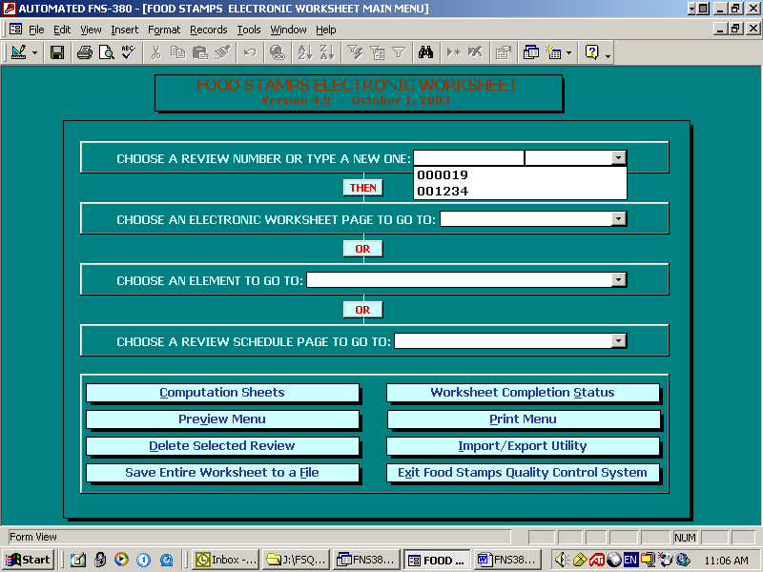

STEP 2:

To select a page from the electronic worksheet, go to the box to the right of CHOOSE AN ELECTRONIC WORK SHEET PAGE TO GO TO; click on the down arrow next to the box; and then choose a page from the drop down list.

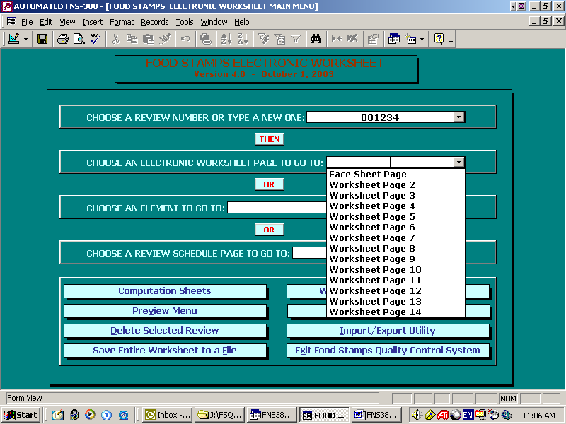

The selected page of the Food Stamp Electronic Worksheet appears.

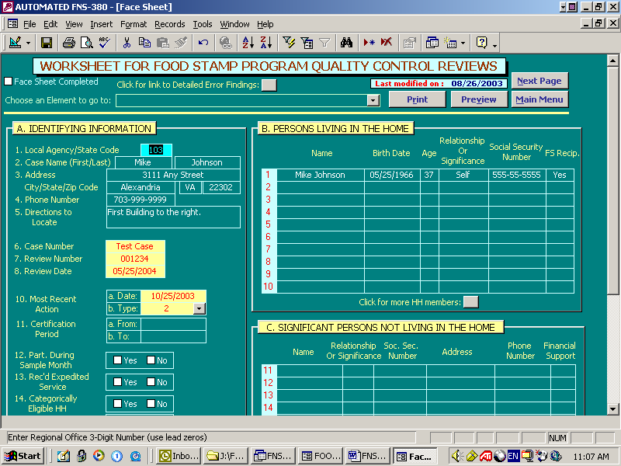

OR

To go to an Element of the electronic worksheet, click on the arrow next to the box beside CHOOSE AN ELEMENT TO GO TO: and then select an element from the drop down list. Or, you may type an element number (the system will automatically finish entering that element name in the block) and then click the box.

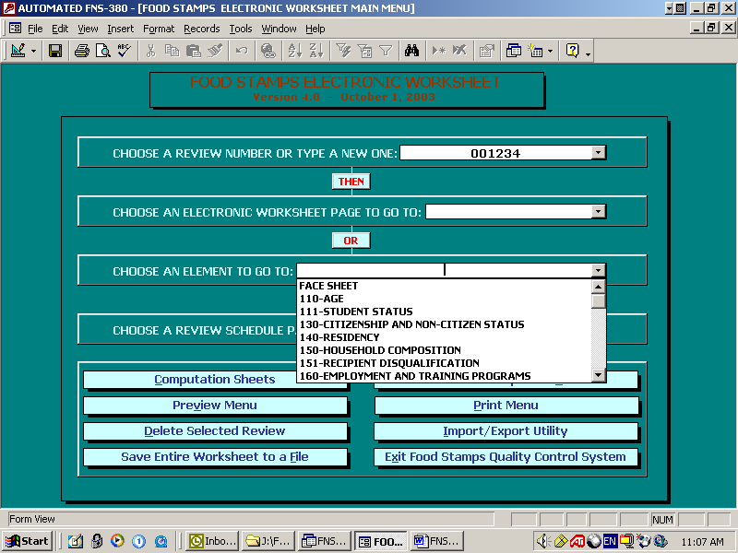

The selected page of the Food Stamp Electronic Worksheet appears.

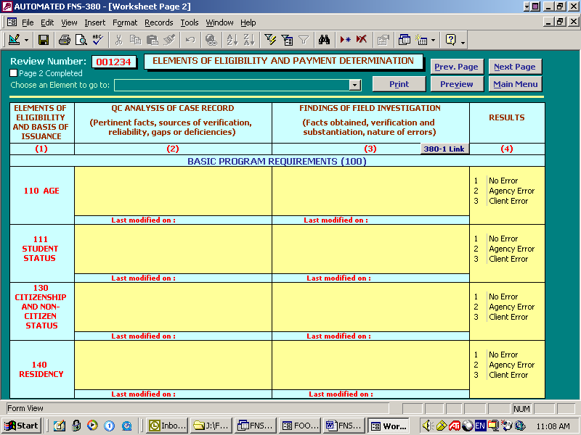

To select a Review Schedule page, go to the box next to CHOOSE A REVIEW SCHEDULE PAGE TO GO TO; click on the down arrow for the box and choose a page from the drop down list.

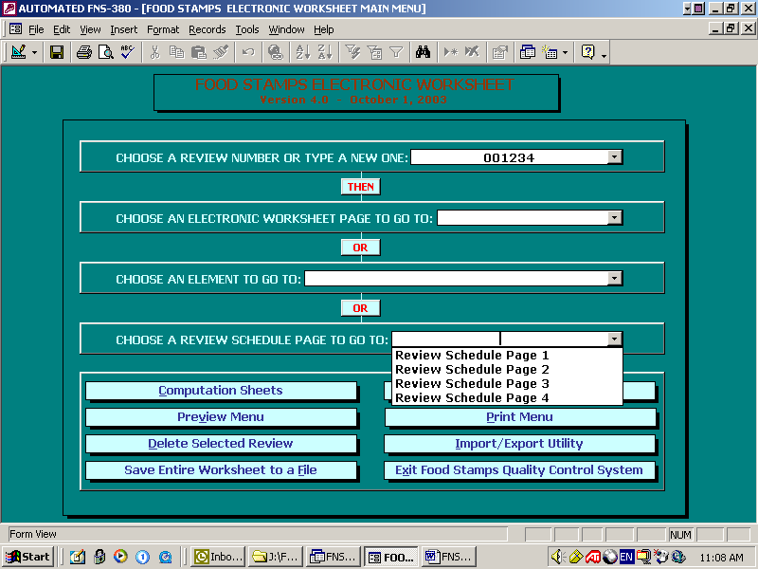

The selected page of the Review Schedule appears.

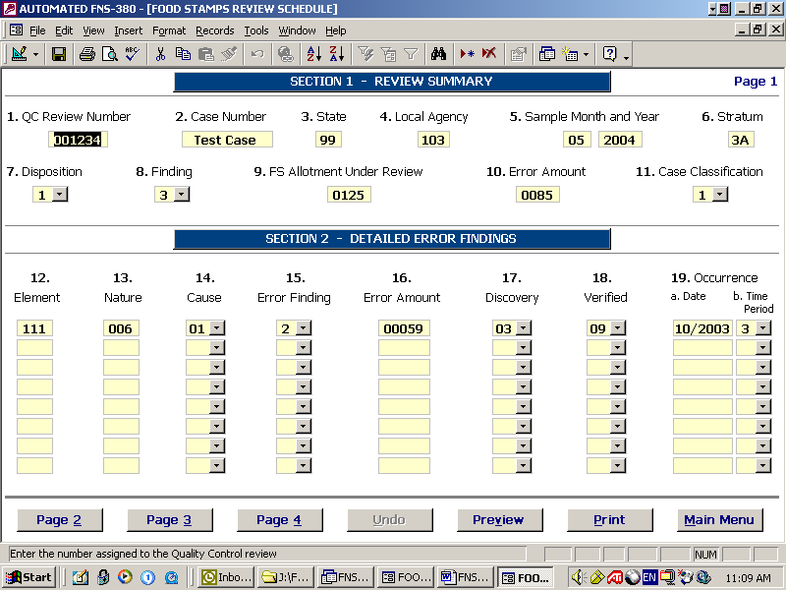

STEP 3:

To enter review data, simply begin typing.

Some items to remember while entering data:

- Press enter or Tab to skip over a field.

- Use the right and left cursor movement keys to move from position to position within a field.

- Amount fields are centered.

- Hit F1 on any field to get help on that field.

- A description of a field and/or the allowable range of characters that can be entered appears in the task bar on the bottom of the screen.

- If you are done entering data to the current page, check the box on the upper left corner to mark the page as completed.

The usual keyboard controls in a Windows environment are used in this program. Refer to Attachment A for more guidance on keyboard controls.

In addition, for this application, filling, or moving past, the last field on a screen automatically opens the next data entry screen. Many fields have range-checking or data validation, and will not allow invalid data to be entered. You may either blank out the field or use the escape key to allow you to continue.

These instructions above apply to using the cursor on all data entry screens.

The Selection Menu appears at the top of the page selected.
This menu allows the user to:

- Move to the Next Page
- Go back to the Previous Page
- Print the page
- Preview the page
- Choose an Element to go to from the list box
- Return to the Main Menu
STEP 4:

To enter review data appearing on the next page of the Electronic Worksheet, select Next Page at the top of the screen.

The next page of the Electronic Worksheet appears.

There are several things to remember when entering data to this screen:

- When the next page is displayed, the cursor is in the first position of the first field.

- Press Tab to move to the next field or to skip over a field.

- Press Shift + Tab to move to the previous field.

- To change data already entered to a field, move to the first position of the field, delete incorrect data and retype correct data.

- To remove all data appearing in the field press CtrL+Del keys.

- The data on the field is saved automatically when user advances to the next field.

STEP 5:

Continue entering data in the same manner on any selected page of the Electronic Worksheet.

STEP 6:

When data entry is complete, to add another review, return to the Main Menu and click on the Review Number list box to type a new review number, or click on the down arrow to select one from the list box.
If there are no more reviews to enter, click Exit Food Stamp Quality Control System to close the program.

2. VIEWING OR CHANGING PREVIOUSLY ENTERED REVIEWS

STEP 1:

At the main menu select a review number from the list box.

STEP 2:

Select either an Electronic Worksheet page, an element or a Review Schedule page to go to.
The selected page of the Food Stamp Electronic Worksheet for that particular review number will appear. Edit data on the Face Sheet page, pages 2-14 of the Food Stamp Electronic Worksheet, or the Review Schedule pages.

STEP3:

To view any additional reviews, click on Main Menu at the top of the screen and select another review number.

3. ENDING A WORK SESSION

To end the work session at any time, return to the Main Menu and click on Exit Food Stamp Quality Control System to close the application and exit the program. Data is automatically saved.

MAIN MENU UTILITIES

- Computation Sheets

Use the pull down box to select a review number, then click on Computation Sheets. Page 1 of the Food Stamp Program Quality Control Computation Sheet appears. Enter data or edit data as you need or do calculations manually. If you are using the automated version, calculations will be done automatically.

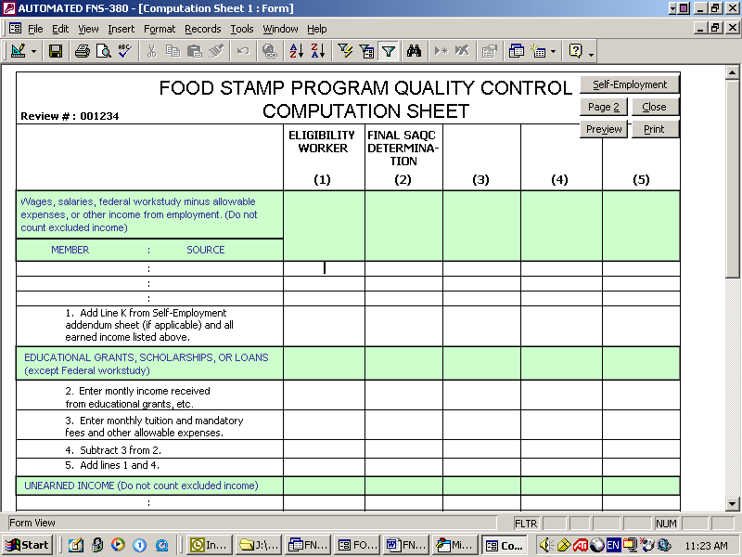

A selection menu is at the top and bottom of the page. It allows the user to go to page 2, self employment page, print and preview the current page. Use the scroll bar to view the rest of the page. When finished, click on the close button to go back to the main menu.
- Worksheet Completion Status

This utility allows the user to check his work progress. It lists the Electronic Worksheet pages (Face Sheet page and pages 2-14) with a checkbox next to each page. If the checkbox is checked, it means that the corresponding page is completed for the selected review number.

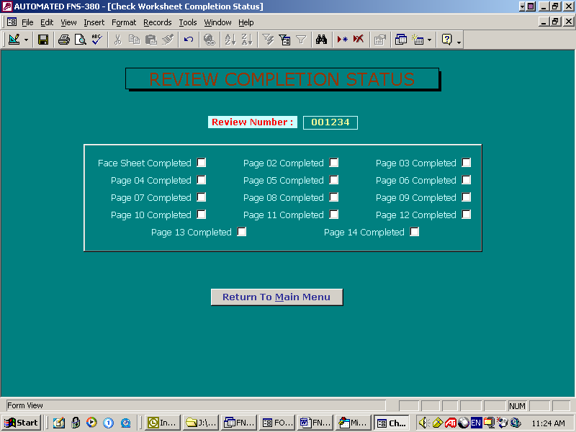

- Preview Menu

This utility has three sections:
- Choose to preview the face Sheet page or any page from pages 2-14 from the Preview Worksheet Pages section.
- Choose to preview the computation sheets from the Preview Computation Sheets section.
- Choose to preview the review schedule pages 1-3 from the Preview Review Schedule Pages section.

At the bottom of the page, there are three command buttons:
- Click on Main Menu button to go to the main menu.
- Click on Print Menu to go to the Print Menu page.
- Click on Exit Access to quit the application.

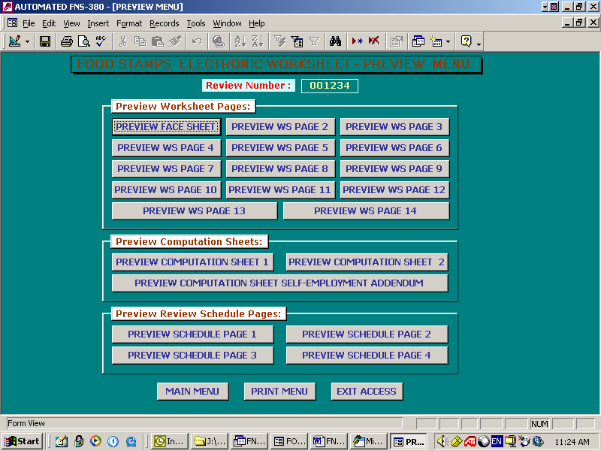
- Print Menu

This utility has three sections:

- Choose to print the face Sheet page or any page from pages 2-14 from the Print Worksheet Pages section.
- Choose to print the computation sheets from the Print Computation Sheets section.
- Choose to print the review schedule pages 1-3 from the Print Review Schedule Pages section.
At the bottom of the page, there are three command buttons:
- Click on Main Menu button to go to the main menu.
- Click on Preview Menu to go to the preview menu page.
- Click on Exit Access to quit the application.

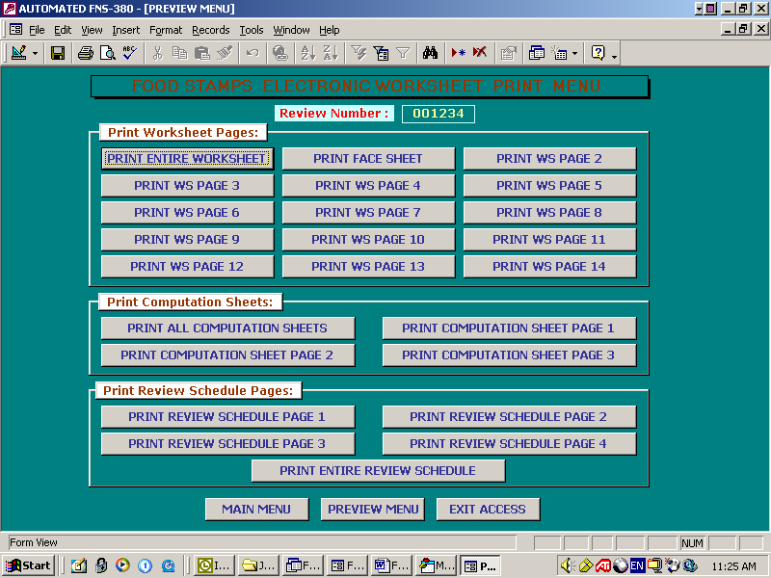
- Delete Selected review

Once a review is deleted from the Food Stamp Electronic Worksheet Program, it cannot be recovered.

To delete a review, at the Main Menu, select a review number from the list box, then press the Delete Selected Review button. A confirmation box appears that states the review number to be deleted. Click Yes to delete that review.

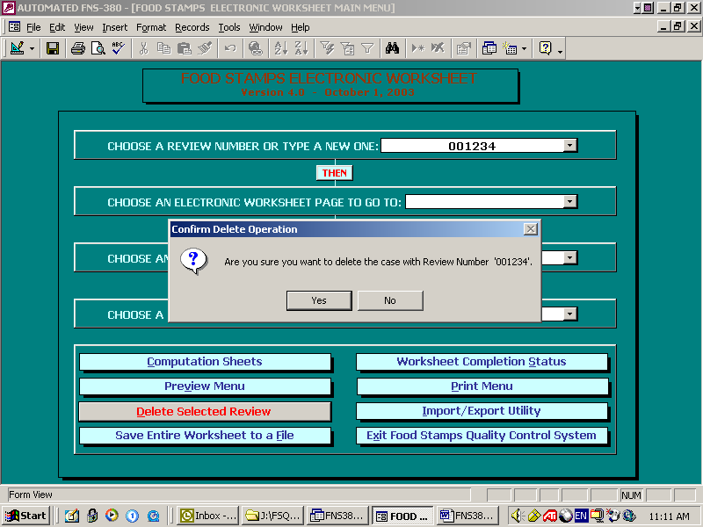

- Import/Export Utility

This utility allows the user to import cases from another database or export cases from this database to a text file (80 x 24).

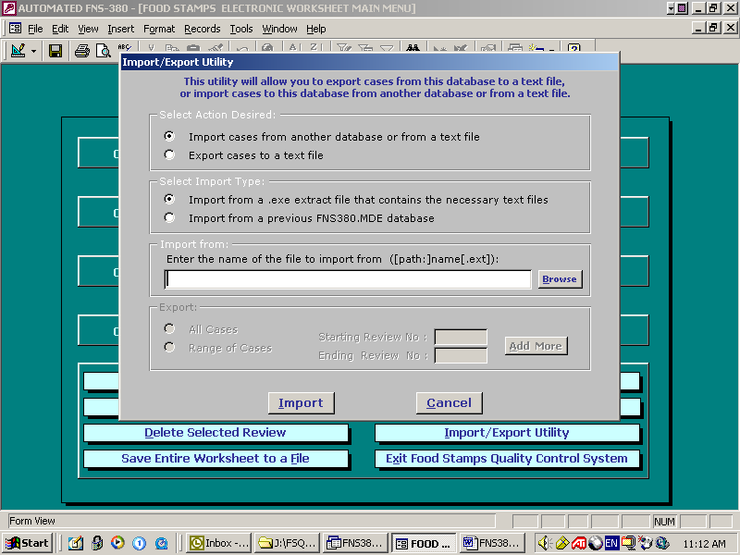

Step 1:

To import, choose Import cases from another database option.
To export, choose Export cases to an ASCII file option.

Step 2:

Under File Name to Import from/Export to, enter the name of the file to import from/export to in the text box provided. Specify the path and the extension of the file.

Step 3:

To import/export all cases, select All Cases option.
To import/export a range of cases, select Range of Cases option.
When this option is selected, Starting Review Number and Ending Review Number text boxes are enabled. Enter the review numbers then click OK. To import/export more than one range, click on Add More and enter the additional ranges then click OK. A window appears that confirms the import/export process and tells how many cases were imported/exported. Click OK to return to the Main Menu.

(7) Save Entire Worksheet to a File

This option allows the user to save the entire Electronic Worksheet Program to an executable file.
Click on Save Entire Worksheet to a File utility, A Save As Dialog Box appears. Type a name for your file in the File Name text box. The file name cannot be more than eight characters. Click on Save. The review will be saved as a snapshot of the Face Sheet, pages 2-14 and Computation Sheets of the selected review number. The snapshot of all the pages will be saved in an executable file that can be emailed to a supervisor or colleagues. To view the case, double-click on this executable file to extract all the pages.

Note: To be able to view these pages, Snapshot Viewer program must be installed on the computer. When viewing for the first time, the system will check to see if Snapshot Viewer program is installed. If it is not installed, it will ask to insert the Microsoft Office 2000 CD to install it.

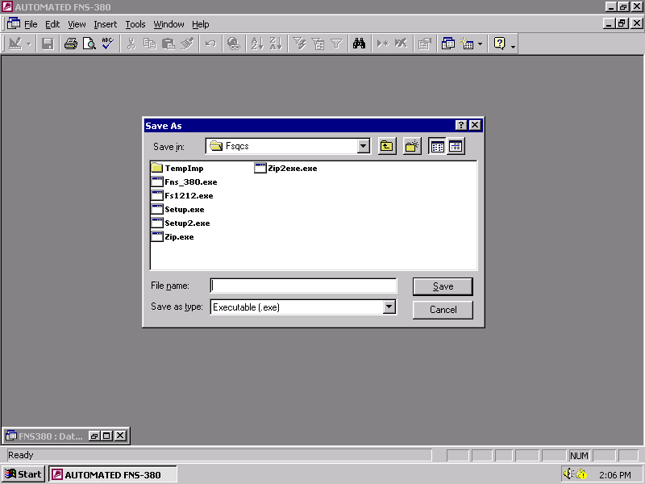
APPENDIX A

Keyboard Controls for the worksheet are the usual keyboard controls for the Windows environment, as follows:

Cursor control keys in the data entry / edit subsystem

<Tab>/
<Return> Complete an entry, or move to the next field without entering.
- Move one position right in the current field. Will move to the next field if current field is highlighted.
← Move one position left in the current field. Will move to the previous field if current field is highlighted.
↓ (down arrow) Goes 1 line down; will go to the next field if current field is highlighted.
- (up arrow) Goes 1 line up; will go to the
previous field if current field is highlighted.

[Ctrl+Del] Delete all characters from the current field.
<Esc> Undo all changes to current field.
<Del> Delete a character at cursor position.
<Ins> Inserts blank space at cursor position.
<BackSp> Delete character before cursor.

