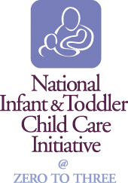 |  | KEY  FACTS  ABOUT | North Carolina  2005 estimated population: 8,683,242  U.S. Census 2005 Population Estimate  2000 population: 8,049,313  U.S. Census 2000
Children birth to 3 years,
their families, and
the child care system
that serves them
 | An average of 25,619 children 0–3 are served per month by the Child Care and Development Fund  (FY 2005 ACF-801 data)  In Federal Fiscal Year 2006 the Infant/Toddler Child Care and Development Fund Set-Aside = $3,187,075  (FY 2006 CCDF Allocations and Earmarks, U.S. Dept. of HHS, ACF) |  |  | U.S. Census 2005 Population Estimate
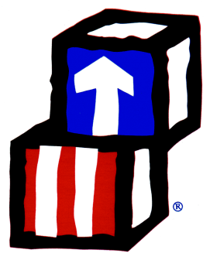 | 1,051 children served by 16 grantees are in Early Head Start  (2006 Early Head Start Funded Enrollment)  (EHSNRC Database—September 2006)  82% of all the requests for child care to the child care resource and referral programs were for infant and toddler care  (Child Care in America: 2006 State Fact Book, NACCRRA)
 |  |  |  | Current Population Survey, March 2001
6,698 children under 3 receive early intervention services under IDEA, Part C
(U.S. Dept. of Education, Office of Special Ed. Programs, Data Analysis System (DANS), 2005)
 | Early Learning Guidelines for 0-3: In development  Infant/Toddler Caregiver Credential: Yes  Infant/Toddler Child Development Associate (CDA)*: 41 issued in 2005  *Council on Professional Recognition 51 issued in 2002  49 issued in 1998  Infant/Toddler Specialist Network: Yes |  |  | Average annual fee for full-time child care for  an infant in center based care was not reported  Cost of child care for an infant as percent of  median income for two-parent families was not reported  Cost of child care for an infant as percent of  median income for single parent families was not reported  Child Care in America: 2006 State Fact Book, NACCRRA
 | In Center-Based Care the staff-to-child ratios are  1:5 for 0-12 months; 1:6 for 12 to 24 months; 1:10 for 2-year-olds; 1:15 for 3-year-olds  (State Licensing Regulations)  In Family Child Care Homes,  Up to 5 preschool children (including the operator’s own preschool-age children) may be enrolled, with up to 3 additional school-age children.  (State Licensing Regulations) |  |  | North Carolina Child Care Lead Agency  North Carolina Department of Health and Human Services  Division of Child Development  2201 Mail Service Center  Raleigh, NC 27699-2201  Voice: 919-662-4353  Fax: 919-662-4568  Website: http://ncchildcare.net  For the CCDF Administrator’s contact information go to:  http://nccic.acf.hhs.gov/statedata/dirs/display.cfm?title=ccdf  For more information about North Carolina go to:  http://nccic.acf.hhs.gov/statedata/statepro/display.cfm?state=North%20Carolina

