Performing Searches and Creating Ad Hoc Reports



CAIRS Reference Manual

February 2007

Table of Contents

Introduction 1
Purpose of the Course 1
Objectives 1
Search Selections 1
Creating a Search Selection 4
Using a Search Selection 7
Saving a Search Selection 8
Ad Hoc Reports 12
Listing 13
Accident Costs Error! Bookmark not defined.
Injury/Illness Costs 19
Organization Code Lists 24
Flush/Start Over 25
Exercise Solutions 26

Introduction

Purpose
This course will familiarize you with selecting search criteria to create specific subsets of the CAIRS database. After creating these subsets, you will learn how to create various reports on the resulting data. You will learn how to save a set of search criteria so that you can use it again later, or to edit the set and save it under a different name.

Objectives
The following topics will be discussed in this Reference Manual:

- Purpose and functionality of the CAIRS SEARCH AND DISTRIBUTION page
- Creating, saving, retrieving, using, editing, and deleting search criteria
- Creating listings, user-defined reports, accident cost reports, and injury/illness cost reports
- Clearing the contents of the CAIRS search page and reinitializing the search area to create a new search.

Search and Distribution
The Search and Distribution option on the CAIRS DATABASE MODULES menu is for performing data searches and detailed analysis of the CAIRS data. This option allows you to create a subset of the CAIRS database, called a search selection, that you can then sort and format into user-defined reports. This is the most powerful option in CAIRS, but also requires the most user input and knowledge to be effective. The SEARCH AND DISTRIBUTION menu provides five options as shown in Figure 1.

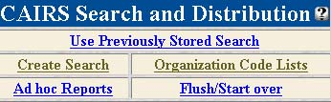
Figure 1: CAIRS SEARCH AND DISTRIBUTION Menu

Menu Option | Function
Use Previously Stored Search | Generate reports and distributions from a previously saved set of search criteria.
Create Search | Define, edit, or save the criteria used to create a subset of CAIRS records.
Ad Hoc Reports | Generate reports and distributions from a current set of search criteria.
Organization Code Lists | View a complete list of active DOE organizations and their associated codes as used in CAIRS. Organizations are grouped by field office and are listed in numerical order from lowest to highest.
Flush/Start Over | Completely eliminate any results obtained from previous searches, reset the selection screen, and start over in building a search criteria set.

Each of these selections is discussed in the following sections:

Using, Editing, or Deleting a Previously Stored Search
To generate a report from a previously stored search, select the Use Previously Stored Search link. A list of all your previously stored searches will be displayed, as shown in Figure 2:

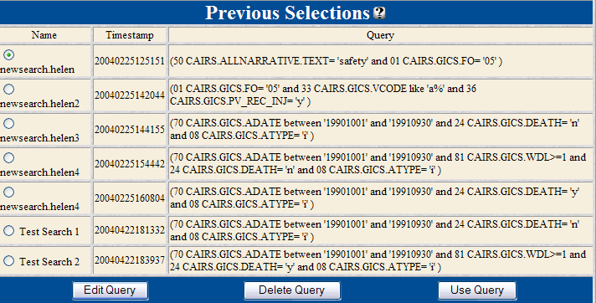

Click the radio button for the search criteria you wish to use, and select the USE QUERY command button at the bottom of the screen.

To modify a previous search, select the radio button for the search you wish to modify and click the EDIT QUERY command button.

To delete a previous selection, select the radio button for the selection you wish to delete and click the DELETE QUERY command button.

Creating a New Search
To create a new search, select Create Search from the CAIRS SEARCH AND DISTRIBUTION page. This option allows you choose a set of criteria that will define a search selection. This option also allows you to save or edit your criteria. When you select Create Search, CAIRS will display the CAIRS SEARCH SELECTIONS page containing a list of search criteria, divided into four general categories, as shown in Figure 2.
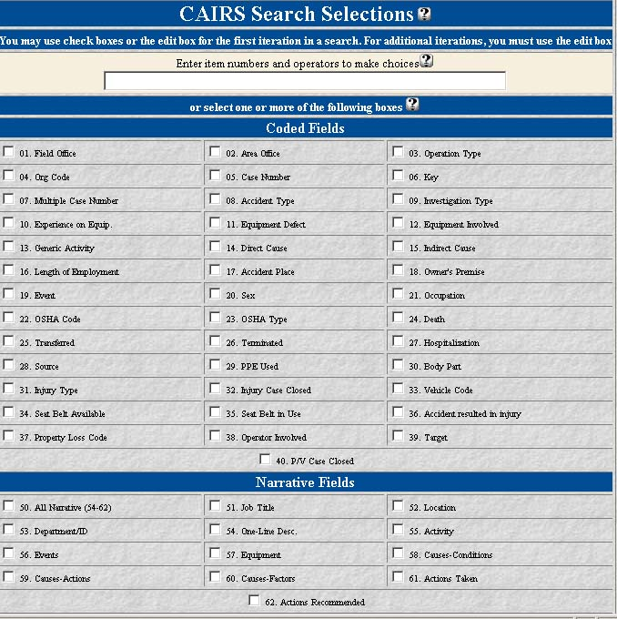
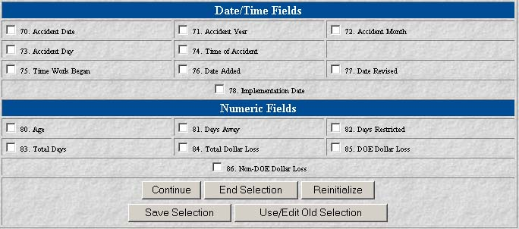
Figure 2: The CAIRS SEARCH SELECTIONS Screen
You can create a search selection by designating criteria from the CAIRS SEARCH SELECTIONS page as explained below.

Creating a Search Selection
The criteria listed on the SEARCH SELECTIONS page are divided into four general categories:

 coded fields (numbers 1 - 40)
 narrative fields (numbers 50 - 62)
 date/time fields (numbers 70 - 78)
 numeric fields (numbers 80 - 86)

To the left of each criterion, or field, on the SEARCH SELECTIONS page is a check box. By clicking in the check box, you are telling CAIRS to include the associated field in your set of search criteria. For example, by selecting the OPERATION TYPE field you are telling CAIRS that you want to designate a value or range of values for the operation type as a search criterion. (We will discuss designating the value on page .)

The list of fields and check boxes is provided as a simplified means of selecting search criteria. However, be aware that CAIRS uses a logical AND to associate the fields that you have checked in the check boxes. In other words, if you check ACCIDENT TYPE, FIELD OFFICE, and ACCIDENT DATE, you are telling CAIRS that you want all cases of a particular type (or range of types) that occurred at a specified field office (or range of field offices), on a specified date (or range of dates).

If you would rather construct a search using your own operators (AND, OR, and NOT), you must type the criteria and operators into the edit box at the top of the list rather than selecting them with the check boxes.


If you enter criteria in the edit box, it will override any selections you have made in the check boxes.

You can define search criteria manually by entering item numbers and operators in the edit box. For example, search criteria based on a direct cause or indirect cause at a specified field office would be (14 or 15) and 1.

Once you have selected a set of search criteria, you can choose one of the options at the bottom of the selection screen as shown in Figure 3 and defined in the table below.

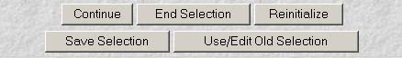
Figure 3: The Command Buttons at the Bottom of the CAIRS SEARCH SELECTIONS Screen

Command Button | Function
 | Accept the selected fields as the criteria set and go to the page where you can define each of the selected criteria.
 | After selecting and defining the search criteria, go to the AD HOC REPORTS page (see Ad Hoc Reports on page ).
 | Erase the previously selected search criteria and start with a clean selection page. You must use this option (or the Flush/Start Over option on the SEARCH AND DISTRIBUTION menu) before selecting a new set of criteria, as CAIRS will remember the old criteria as long as you are in CAIRS.
 | Save the selected criteria and the criteria definitions for later use with a user-specified file name. This button will display an edit box for naming the criteria set.
 | Retrieve a previously-saved criteria set. This button will display a file selection window where you can select a saved criteria set. After retrieving the file, you can use it as you would any criteria set, or you can modify and resave it, or you can save it with a different file name.

The name that you assign for your search query must be alphanumeric. The only special character that can be used is the apostrophe (’). Inserting other special characters such as hyphens, dashes, etc., will result in corruption of your access to your queries.

Normally, the next step in building a selection criteria set is to define the values of the criteria you have selected. When you click on the CONTINUE command button, CAIRS will present an input box for each criterion that you selected. You can define the value for each criterion in these input boxes. These boxes may be edit boxes, selection boxes, or radio buttons, depending on the type of information required to define the value. Figure 4 shows the boxes used to define values for the OPERATION TYPE, SEAT BELT IN USE, ALL NARRATIVE, and TOTAL DOLLAR LOSS fields.

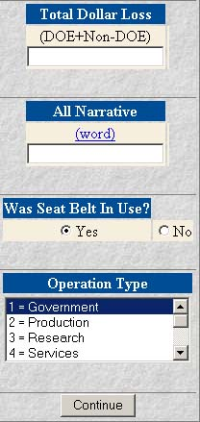
Figure 4: Sample Boxes Used to Define Values

You can use operators to help define the values entered into edit boxes. CAIRS supports four kinds of operators: logical, wildcard, range, and numeric. These operators are described in the CAIRS Operators section of the CAIRS Overview portion of this document, as well as in the on-line helps.

Narrative edit boxes have additional requirements for successful searches according to the following conventions:

1. When searching for a narrative word, the word must always be enclosed in double quotes.

2. A narrative search for “hammer” will recover “jackhammer,” “waterhammer,” “hammer,” “hammers,” “hammered,” etc.

After you have defined the values for your search criteria fields, you can press the CONTINUE button to return to the criteria selection page. You will notice that the top part of this box now contains additional information regarding the number of cases that match your criteria (see Figure 5.)

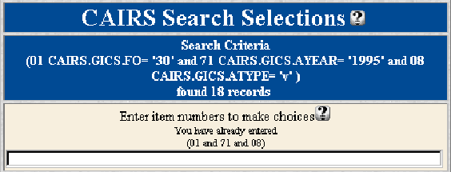
Figure 5: The Search Criteria Results

The parenthetical line directly below the words “Search Criteria” contains the values of your search criteria, listed by number and field name, and the logic by which those criteria were associated. The example in Figure 5 says that criterion 1, FIELD OFFICE, is the Idaho Field Office (30); criterion 71, ACCIDENT YEAR, is 1995; and criterion 8, ACCIDENT TYPE, is vehicle. CAIRS found 18 records that match accidents that were recorded in Idaho in 1995 involving vehicles.

Now that you have this information, you may choose one of the options at the bottom of the page, or you may choose to modify your criteria set. For example, if your first set of criteria recovered too few or too many cases, you may elect to refine your criteria and search again. Rather than starting over, you may append logical operators and criteria to your existing criteria set by typing the operators and criteria in the edit box as shown in Figure 6 to further define the selection.

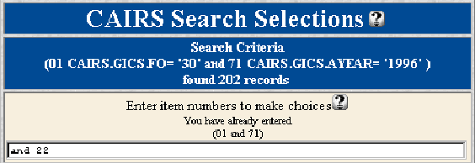
Figure 6: Example of Appending Criteria to Further Refine a Search

Once you are satisfied with the results, you will want to click on the END SELECTION button that will take you to the AD HOC REPORTS menu.

Using a Search Selection
After you are finished specifying and defining the criteria for your search, you can use the search results to generate reports. Clicking on the END SELECTION button at the bottom of the CAIRS SEARCH SELECTIONS page will take you to the AD HOC REPORTS page. From here, you can select and customize reports and distributions as discussed in the Ad Hoc Reports section on page .

Saving a Search Selection
Occasionally, you may want to save the criteria you have selected so that you can quickly create the search selection again. At the bottom of the CAIRS SEARCH SELECTIONS page is a command button called SAVE SELECTION that will take you to the menu shown in Figure 7.

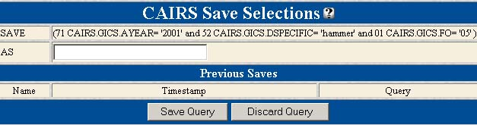
Figure 7: The CAIRS SAVE SELECTIONS Box

You can type a name in the edit box to represent this search selection. After you have typed the name, click on the SAVE QUERY command button to save your selection criteria. CAIRS will save the selection criteria and display it under the PREVIOUS SAVES list the next time you access this option.

The name that you assign for your search query must be alphanumeric. The only special character that can be used is the apostrophe (’). Inserting other special characters such as hyphens, dashes, etc., will result in corruption of your access to your queries.


Using a descriptive name rather than a cryptic one (like save1, save2, etc.) will help you easily locate specific selections in the future.

If you have not correctly specified the search criteria, or have not yet generated the search selection by pressing the CONTINUE command button, you will see the following warning:

“Your search criteria either “timed out” or has not been chosen yet. You need to make a search or choose previous query before you can begin.”

The DISCARD QUERY command button cancels the request to save the current selection and takes you back to the CAIRS SEARCH SELECTIONS page.


Creating a Search Selection

1. From the CAIRS DATABASE MODULES page, click on the Search & Distribution hyperlink.

2. Click on the Create Search hyperlink.

3. From the CAIRS SEARCH SELECTIONS screen, select the check boxes for all criteria required for your search.

4. Click on the CONTINUE command button.

5. Define the values for each of the criteria displayed by entering values in edit boxes or by selecting check boxes or radio buttons.

6. Click on the CONTINUE command button. The results of the search will appear at the top of the CAIRS SEARCH SELECTIONS page.

7. To further refine your search, append the operators and criteria onto the search string in the edit box at the top of the page.

Saving a Search Selection

- After building and generating a search criteria set, click on the SAVE SELECTION button at the bottom of the CAIRS SEARCH SELECTIONS page.
2. In the CAIRS SAVE SELECTIONS edit box, enter a descriptive name for your search criteria set.
3. Click on the SAVE QUERY button at the bottom of the page.

Editing a Search Selection

1. Click on the REINITIALIZE command button at the bottom of the CAIRS SEARCH SELECTIONS page.

2. Click on the USE/EDIT OLD SELECTION command button at the bottom of the CAIRS SEARCH SELECTIONS page.

3. Select a previously-saved search criteria set by clicking on the radio button next to its name.

4. Click on the EDIT QUERY command button.

5. Append new search criteria to the end of the criteria in the edit box at the top of the CAIRS SEARCH SELECTIONS page and click the CONTINUE command button.

6. Add or revise the selection values as desired and click the CONTINUE command button.

7. Click on the SAVE SELECTION command button to save this selection under a different name (or the same name).

Exercise 1

As you work, write down the steps you take. These notes will act as a reminder when you take similar actions in the future.

1. Create a new search selection that contains reports for 1995 where cases resulted in a transfer or termination.

2. Save the search selection as 1995 Tran or Term.

3. Reinitialize the CAIRS search selections.

4. Retrieve the search selection you just saved and add the criteria that the individual involved was female.

5. Save the search selection as 1995 TorT Female.

6. Record the number of cases found that match these criteria.

Creating Ad Hoc Reports from Search Results
You can display information about the records retrieved from your search by creating reports in various formats. You can access the report menu, shown in Figure 9, either from the CAIRS SEARCH AND DISTRIBUTION menu using the Use Previously Stored Search hyperlink or the Ad Hoc Reports hyperlink, or from the CAIRS SEARCH SELECTIONS page using the END SELECTION button.

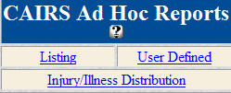
Figure 9: CAIRS Ad Hoc Reports Menu

If you select the Use Previously Stored Search link from the CAIRS SEARCH AND DISTRIBUTION menu, you will need to select a search criteria set and then click on the USE QUERY command button. If you click on the END SELECTION command button from the CAIRS SEARCH SELECTIONS page, the current selection shown on the search page will be used.

If you enter the CAIRS AD HOC REPORTS selection menu directly from the CAIRS SEARCH AND DISTRIBUTION page using the Ad Hoc Reports hyperlink, the selection criteria that you last entered (during the current browser session) will be used to generate the reports.

Each of the report types shown in Figure 9 is described briefly in the following sections. The main screen for each report type contains a help icon that will link you directly to the on-line help system that provides a more extensive description of the specification and content of each of the reports, as well as the definitions of the various fields included in the reports.

Listing Reports
A CAIRS listing provides a list of selected records in columnar format. When you select Listing from the CAIRS AD HOC REPORTS selection menu, you will see the screen in Figure 10. This screen will allow you to select the columns to be displayed in your report, as well as define other options to format your report.

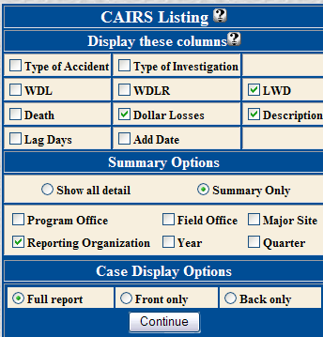
Figure 10: CAIRS Listing

To select columns to be displayed in the report, click the appropriate check boxes included in the DISPLAY THESE COLUMNS section at the top of the box. Columns that will be included in the report are identified by check marks in the associated boxes. You may deselect an undesired item by clicking on the item’s check box to remove the check mark. Definitions for these items are found in the on-line help by clicking on the Help icon.

Several summary options are also available in the report. You can mark one or more of the check boxes in the SUMMARY OPTIONS section to display a summary line at each of the selected levels. (Multiple levels can be selected.) If no summary is desired, you can click on the selection to remove the check mark. If you choose a summary option, you can also use the associated radio buttons to specify whether you want to display all of the records in addition to the summary line (SHOW ALL DETAIL), or only the summary information (SUMMARY ONLY).

If you select the option to display detail records, the displayed case numbers will be hyperlinked to a copy of the CAIRS report. The bottom section of the report definition box, CASE DISPLAY OPTIONS, allows you to specify whether you wish to see the full report, only the front, or only the back of the report when using these hyperlinks.

To generate the listing, click the CONTINUE command button. The listing will be displayed as shown in Figure 11:
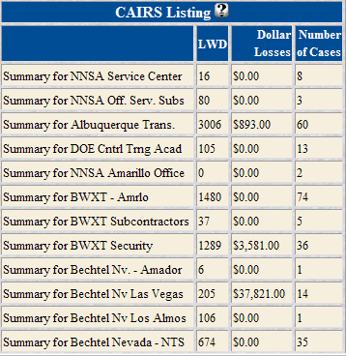
Figure 11: Listing

Creating an Ad Hoc Listing

1. From the CAIRS DATABASE MODULES page, click on the Search & Distribution hyperlink.

2. Click on the Create Search hyperlink.

3. Create a search selection and click the END SELECTION command button, (or retrieve a previously-saved selection and click on the USE QUERY button).

4. Select the Listing hyperlink from the AD HOC REPORTS menu.

5. Choose which columns you want to see, the level of detail to be included, and how much of the report you want displayed.

6. Click on the CONTINUE command button.

User Defined Reports
The User Defined option allows you to specify any of the columns from the SEARCH SELECTIONS page to be included in a columnar report. This report can be very useful if you desire to obtain specific data for each record in a form that can be easily imported into your favorite spreadsheet or database package. When you select the User Defined option from the AD HOC REPORTS menu, a screen similar to the SEARCH SELECTIONS screen will be displayed. The top portion of this screen is shown in Figure 12.

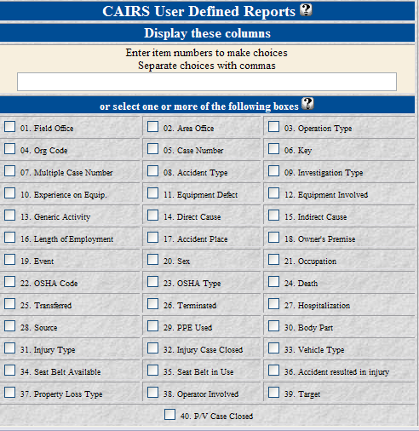
Figure 12: User Defined Report (Fields 1-40)
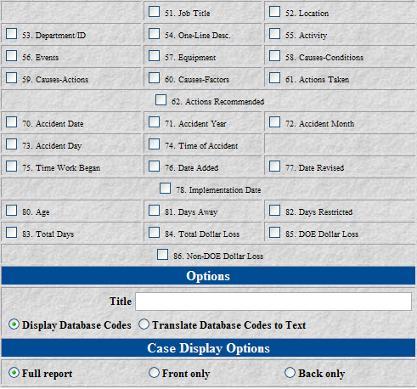
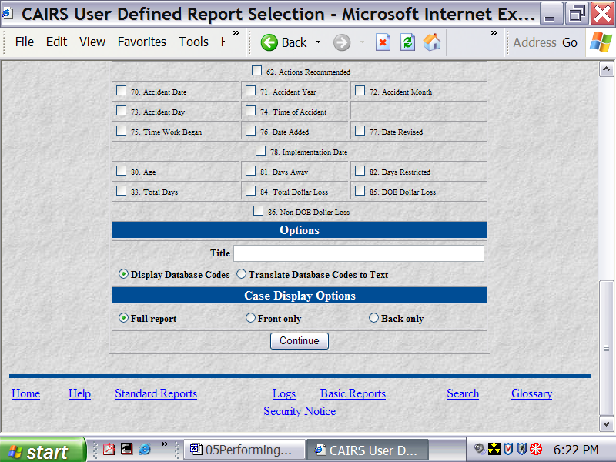
Figure 12 (Continued): User Defined Report (Fields 41-85)

You can select the fields to be included in your report in one of two ways. First, you can define fields by placing check marks adjacent to the desired items by clicking on the appropriate check box. When you make your selection in this manner, the order of display for the records will be determined by the system.

If you wish to specify a different order to display fields, you can enter the item numbers in the edit box separated by commas. The items will be displayed in the order they are entered.

Any entry in the edit box will override anything in the check boxes. If you desire to use the check boxes after making an entry in the edit box, all information in the edit box must be deleted.

Once you have selected the fields to include in your display, you may choose from several options at the bottom of the selection screen to enhance your report, e.g., add an optional title, display database codes or text, display full report or not. You can enter an optional title, that will appear at the top of the report, into the TITLE edit box. (See Figure 12).

The second option determines the display of coded fields in the database. Many of the fields in the database use simple codes to represent more complex, repetitive, textual descriptions. The organization code is an example of a coded field. You can instruct the system to include either the database codes (useful when you will be doing additional manipulation of the data), or the textual equivalent of the codes (more meaningful when you are simply viewing the list) in the output.

The final option determines the information you will see when you click on the hyperlink to display the CAIRS report. If you have selected the case number as an item to be displayed in the report, it will be hyperlinked to the CAIRS report. The CASE DISPLAY OPTIONS section of the report definition screen allows you to specify whether you wish to see the full report, only the front, or only the back of the report when using these hyperlinks.

Creating a User-Defined Report

1. From the CAIRS DATABASE MODULES page, click on the Search & Distribution hyperlink.

2. Click on the Create Search hyperlink.

3. Create a search selection and click the END SELECTION command button, (or retrieve a previously-saved selection and click on the USE QUERY button).

4. Select the User Defined hyperlink from the AD HOC REPORTS menu..

5. Check the boxes of the columns you want displayed in the report.

6. Provide a title for the report, if desired, in the edit box at the bottom of the screen.

7. Choose whether to display database codes or text; and/or choose how much of the report you want to display.

8. Click the CONTINUE command button.

Injury/Illness Distribution Report
To create the INJURY/ILLNESS DISTRIBUTION report, select the Injury/Illness Costs option from the AD HOC REPORTS menu. The report criteria screen shown in Figure 14 is displayed.

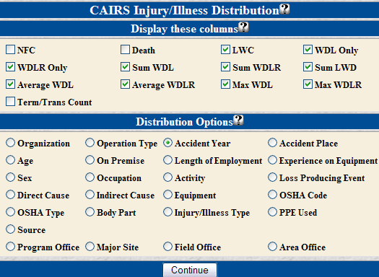
Figure 14: CAIRS INJURY/ILLNESS DISTRIBUTION REPORT Definition Screen

This screen contains two sections, DISPLAY THESE COLUMNS and DISTRIBUTION OPTIONS.

The DISPLAY THESE COLUMNS section allows you to specify which columns will appear in your report, and include additional counts, summaries, and averages.

The fields on which the data is to be distributed are selected from the DISTRIBUTION OPTIONS section at the bottom of the screen.

Definitions of each of the options in the DISTRIBUTION OPTIONS section can be obtained from the on-line help by clicking on the icon.
Creating an Injury/Illness Costs Report

1. From the CAIRS DATABASE MODULES page, click on the Search & Distribution hyperlink.

2. Click on the Create Search hyperlink.

3. Create a search selection and click the END SELECTION command button, (or retrieve a previously-saved selection and click on the USE QUERY button).

4. Select the Injury/Illness Costs hyperlink from the AD HOC REPORTS menu.

5. Make the desired selections from the CAIRS INJURY/ILLNESS COSTS report definition screen.

7. Click on the CONTINUE command button at the bottom of the page to view the report.

Exercise 2

As you work, write down the steps you take. These notes will act as a reminder when you take similar actions in the future.

1. Create a new search selection that contains CAIRS reports for the Strategic Petroleum Reserves from 1990 through 1995 involving individuals between the ages of 18 and 25.

2. Record the number of cases that match these criteria.

3. Using this search selection, create a listing that shows the lost work days, dollar losses, and a description for each case; contains the details by reporting organization; and will display the full report if you click on the case number hyperlink.

4. Record the total number of cases that were experienced by Wackenhut Services.

Exercise 3

As you work, write down the steps you take. These notes will act as a reminder when you take similar actions in the future.

1. Create a new search selection that contains CAIRS reports for the Oakland Operations in 1996 where weather was identified as either a direct or indirect cause.

2. Record the number of cases that match these criteria.

3. Using this search selection, create a user-defined report that shows the date of the accident, organization, case number, direct cause, and indirect cause; has a title of “1996 Oakland Weather-related Cases”; displays the text instead of the database codes; and will display the full report if you click on the case number hyperlink.

Exercise 4

As you work, write down the steps you take. These notes will act as a reminder when you take similar actions in the future.

1. Create a new search selection that contains CAIRS reports for the Richland Operations involving vehicle accidents resulting in total dollar losses greater than $5000.

2. Record the number of cases that match these criteria.

3. Using this search selection, create a report of accident costs that is sorted by occupation; uses vehicle multipliers; and shows the number of vehicle cases, the vehicle costs, and the average costs.

4. Record the specified occupation with the greatest number of incidents.

Organization Code Lists
This option on the CAIRS SEARCH AND DISTRIBUTION menu hyperlinks to a complete list of active DOE organizations and their associated codes as used in CAIRS. The organizations are grouped by field office and are listed in numerical order from lowest to highest. Figure 15 shows a partial listing of these organization codes.

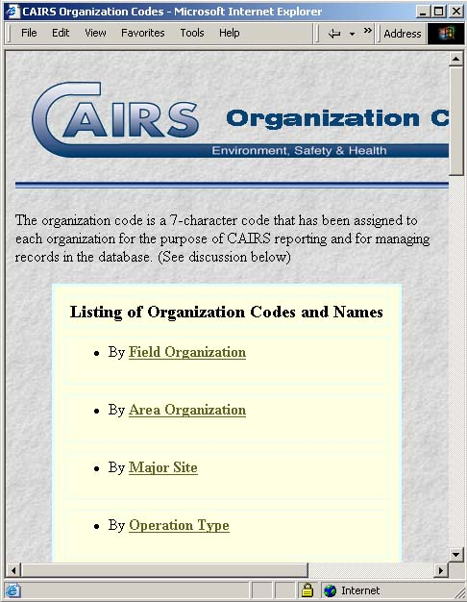
Figure 15: Listing of Organizational Codes and Names

Flush/Start Over
This option completely eliminates any results obtained from previous searches, resets the selection screen, and allows you to start over in building a search criteria set. Selecting this option takes you to a clean CAIRS SEARCH SELECTIONS menu as discussed previously in the Search Selections section. Since CAIRS maintains the search criteria selection as long as you are in CAIRS, you must reinitialize or start over before creating a new search selection.

Exercise Solutions

Exercise 1

1. Create a new search selection that contains reports for 1995 where cases resulted in a transfer or termination.
a. Select Create Search from the CAIRS SEARCH AND DISTRIBUTION page.
b. Enter (25 or 26) and 71 in the edit box at the top of the CAIRS SEARCH SELECTIONS screen.
c. Click the CONTINUE button at the bottom of the page.
d. Enter 1995 in the ACCIDENT YEAR edit box and leave the radio buttons marked as Yes.
e. Click the CONTINUE button at the bottom of the page.

2. Save the search selection as 1995 Tran or Term.
a. Click the SAVE SELECTION command button at the bottom of the page.
b. Enter 1995 Tran or Term in the edit box on the CAIRS SAVE SELECTIONS page.
c. Click on the SAVE QUERY command button.

3. Reinitialize the CAIRS search selections.
a. Click the REINITIALIZE command button at the bottom of the CAIRS SEARCH SELECTIONS page.

4. Retrieve the search selection you just saved and add the criteria that the individual involved was female.
a. Click the USE/EDIT OLD SELECTION command button.
b. From the PREVIOUS SELECTIONS list, click on the radio button next to the 1995 Tran or Term search selection.
c. Click on the EDIT QUERY command button.
d. Append and 20 to the text in the edit box at the top of the page.
e. Click the CONTINUE command button.
f. Mark the radio button next to Female in the SEX OF EMPLOYEE box.
g. Click the CONTINUE command button.

5. Save the search selection as 1995 TorT Female.
a. Click the SAVE SELECTION command button at the bottom of the page.
b. Enter 1995 TorT Female in the edit box.
c. Click on the SAVE QUERY command button.

- Record the number of cases found that match these criteria. (As of 2-10-98, the number was 6.)

Exercise 2

1. Create a new search selection that contains CAIRS reports for the Strategic Petroleum Reserves from 1990 through 1995 involving individuals between the ages of 18 and 25.
a. Select Flush/Start Over from the CAIRS SEARCH AND DISTRIBUTION page.
b. Click the check boxes next to item numbers 1, 71, and 80.
c. Click the CONTINUE button at the bottom of the page.
d. Enter 96 in the FIELD OFFICE CODE edit box, between 1990 and 1995 in the ACCIDENT YEAR edit box, and >=18 and <=25 in the AGE OF EMPLOYEE edit box.
e. Click the CONTINUE button at the bottom of the page.

2. Record the number of cases that match these criteria. (As of 2-10-98, the number was 28.)

3. Using this search selection, create a listing that shows the lost work days, dollar losses, and a description for each case; contains the details by reporting organization; and will display the full report if you click on the case number hyperlink.
a. Click the END SELECTION command button at the bottom of the page.
b. Select the Listing hyperlink on the CAIRS AD HOC REPORTS page.
c. In the DISPLAY THESE COLUMNS section of the CAIRS LISTING menu, put a check mark next to LWD, DOLLAR LOSSES, and DESCRIPTION.
d. In the SUMMARY OPTIONS section, click the SHOW ALL DETAIL radio button and make sure only the REPORTING ORGANIZATION check box is marked.
e. In the CASE DISPLAY OPTIONS section, click the FULL REPORT radio button.
f. Click the CONTINUE button at the bottom of the page.

4. Record the total number of cases that were experienced by Wackenhut Services. (As of 2-10-98, the number was 7.)

Exercise 3

1. Create a new search selection that contains CAIRS reports for the Oakland Operations in 1996 where weather was identified as either a direct or indirect cause.
a. Select Flush/Start Over from the CAIRS SEARCH AND DISTRIBUTION page.
b. Enter (14 or 15) and 1 and 71 in the edit box at the top of the list.
c. Click the CONTINUE button at the bottom of the page.
d. Enter dw in the DIRECT CAUSAL FACTOR CODES edit box, %iw% in the INDIRECT CAUSAL FACTOR CODES edit box, 80 in the FIELD OFFICE CODE edit box, and 1996 in the ACCIDENT YEAR edit box.
e. Click the CONTINUE button at the bottom of the page.

2. Record the number of cases that match these criteria. (As of 6-23-98, the number was 12.)

3. Using this search selection, create a user-defined report that shows the date of the accident, organization, case number, direct cause, and indirect cause; has a title of “1996 Oakland Weather-Related Cases”; displays the text instead of the database codes; and will display the full report if you click on the case number hyperlink.
a. Click the END SELECTION command button at the bottom of the page.
b. Select the User Defined hyperlink on the CAIRS AD HOC REPORTS page.
c. In the DISPLAY THESE COLUMNS section, enter 70, 4, 5, 14, 15 in the edit box at the top of the list.
d. Enter 1996 Oakland Weather-Related Cases in the TITLE edit box at the bottom of the list.
e. Click the radio button next to TRANSLATE DATABASE CODES TO TEXT.
f. In the CASE DISPLAY OPTIONS section, click the FULL REPORT radio button.
g. Click the CONTINUE button at the bottom of the page.

Exercise 4

1. Create a new search selection that contains CAIRS reports for the Richland Operations involving vehicle accidents resulting in total dollar losses greater than $5000.
a. Select Flush/Start Over from the CAIRS SEARCH AND DISTRIBUTION page.
b. Click the check boxes next to item numbers 1, 8, and 84.
c. Click the CONTINUE button at the bottom of the page.
d. Enter 75 in the FIELD OFFICE edit box, select Vehicle from the ACCIDENT TYPE selection box, and enter >5000 in the TOTAL DOLLAR LOSS edit box.
e. Click the CONTINUE button at the bottom of the page.

2. Record the number of cases that match these criteria. (As of 6-23-98, the number was 50.)

3. Using this search selection, create a report of accident costs that is sorted by occupation; uses vehicle multipliers; and shows the number of vehicle cases, the vehicle costs, and the average costs.
a. Click the END SELECTION command button at the bottom of the page.
b. Select the Accident Costs hyperlink on the CAIRS AD HOC REPORTS page.
c. In the OPTIONS section of the CAIRS ACCIDENT COSTS menu, select the SORT BY DISTRIBUTION radio button and leave the other two radio buttons marked Yes.
d. In the DISPLAY THESE COLUMNS section, select only the Avg Cost from the ALL CASES selection box and the Vehicle Case Count, Vehicle Cost, and Avg Vehicle Cost from the VEHICLE CASES selection box. To deselect the last item or to select multiple items from a selection box, hold down the control key while clicking with the mouse pointer.
e. Under DISTRIBUTION OPTIONS, click the OCCUPATION radio button.
f. Click the CONTINUE button at the bottom of the page.

4. Record the specified occupation with the greatest number of incidents. (As of 6-23-98, truck drivers recorded 50 incidents.)

