Configuring and Working
with a Browser



February 2007

Table of Contents

Introduction 3
Purpose 3
Launching Your Browser 3
The Browser Status Bar 3
Explaining the Menu Bar 4
Toolbar Buttons 6
Link Connection Failed 6
Using URLs 6
Exiting/Quitting Your Browser 8
Favorites 9
Creating and Retrieving Favorites 9
Organizing Favorites/Bookmarks 10
Adding a Favorite (Internet Explorer) 10
Organizing Favorites (Internet Explorer) 10
Managing Bookmarks (Netscape) 11
Bookmark Properties 12
Setting Internet Options (IE) 15
Setting the Home Page 16
Deleting Cookies 16
Deleting Files 16
Changing the Browser Settings 17
Clearing the Browser's History 17
Setting colors 18
Setting the Fonts 18
Setting the Language 19
Setting Accessibility 20
Editing Preferences (Netscape) 20
Appearance 21
Fonts 21
Colors 22
Languages 22
Table of Figures

Figure 1: Environment, Safety and Health Home Page 7
Figure 2: Organize Favorites 15
Figure 3: Move to Folder Box 16
Figure 4: Netscape Bookmarks Window 17
Figure 5: Internet Options 20
Figure 6: Settings 22
Figure 7: Colors Dialog 23
Figure 8: Fonts Dialog 23

Introduction

Purpose
This reference manual provides information about the more commonly used Internet browser functions that are required for CAIRS use. The manual focuses primarily on the Microsoft Internet Explorer (IE) browser, which is supported by the DOE Common Operating Environment (COE). A few tips are also provided about the Netscape browser. Only a subset of important browser commands will be described in this manual. For more information about a particular browser, please consult the browser’s online help.

The following functions will be discussed:

- Launching and exiting from a browser, using menus and toolbars, following hyperlinks, using Universal Resource Locators (URLs), downloading and saving files, and copying information from a browser.
- Adding, deleting, organizing, and using favorites (IE) or bookmarks (Netscape).
- Editing Options (IE) or Preferences (Netscape) to customize the appearance and operation of the browser.
- Performing Internet searches to locate information.

Launching Your Browser
To start your browser, double-click the INTERNET EXPLORER icon. The window that appears is the website that your organization's system administrator has set as its home page. For example, the Health, Safety and Security (HSS) home page is located at the following Internet address (URL): http://www.hss.energy.gov/index.cfm. To view this page, type the address into your browser's address field (see Figure 1), and press ENTER.

The Browser Status Bar
The browser status bar, located at the bottom of browser pages, displays messages about the progress or status of the current operation (i.e., Looking up Host, Contacting Host, Document Done, etc.).

If you initiate a hyperlink or URL and then change your mind and want to abort the retrieval, you can click on the browser’s STOP icon from the toolbar. This will halt the current network action.

Figure 1 shows the HSS website. Following are descriptions of the more important IE functions.

Side menu provides options via dropdown menus
Title bar shows the title of web pages currently in view
Tool bar containing frequently accessed commands
Browser's Address field containing URL of current page
Content area
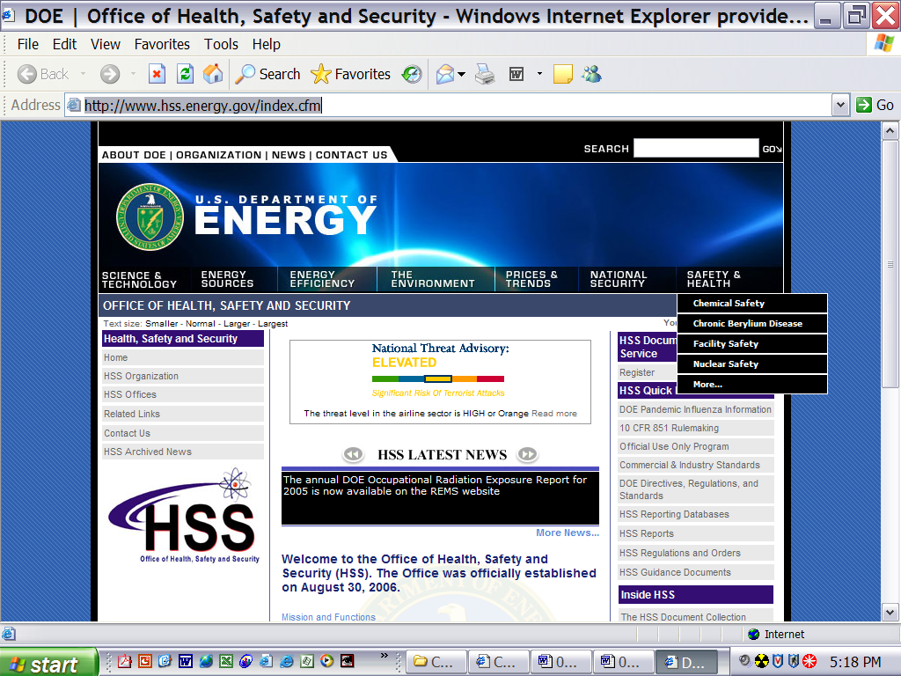
Hyperlinks jump to different internet sites
Status message displays here

Figure 1: Environment, Safety and Health Home Page

Explaining the Menu Bar

Buttons and menus will vary across browsers and browser versions. While other browsers and versions may name items differently, they will function in a similar way.

The menu bar, located at the top of most browser pages, provides various options via a pull-down list. Menu items common to both IE and Netscape are briefly described below.

Option | Description
 | The File, Edit, View, and Help menus will not be discussed further in this manual. For further information on these subjects, please consult your browser’s online help system. The Favorites and Tools menus will be discussed in this chapter.
FILE | This menu contains options that allow you to open a website, open a file, save a document to disk, specify printing characteristics, print a document, and exit the browser. For more information on these options, please consult your browser’s online Help.
EDIT | The edit menu contains options that allow you to cut or copy text to the “clipboard” and paste it into a new browser location or a different software application, and specify a word or phrase to locate within the current browser page. For more information on these options, please consult your browser’s online Help.
VIEW | This menu contains options that allow you to select which items will appear on the screen (i.e., toolbar, status bar, etc.). From this menu, you can also “reload” a fresh copy of the current browser page, or view the source HTML document of the page. For more information on these options, please consult your browser’s online Help.
FAVORITES/  BOOKMARKS | This menu provides fast and easy access to your favorite pages. As you add a page to a favorites list, the title of the page (or any other name you wish to supply as a favorites title) is appended as a menu item. Selecting the title brings the page to your screen. Additional information is discussed later in the Favorites section of this chapter.
TOOLS | From this menu, you can set your browser options. This chapter of the manual will focus on the Internet Options selection of the TOOLS menu. Additional information is discussed in the Tools section of this chapter.
HELP | This menu provides browser help. You can get information about the browser (e.g., version, copyright, and license information) and registration information. On-line help on specific topics and a tutorial are also available.

Toolbar Buttons

TOOLBAR buttons provide various shortcuts to the above-mentioned menu options. Buttons common to most browsers are briefly described below. For more information on these functions, please consult your browser’s online help.

Tool | Description
BACK | Goes back to the previous page in the history list. (A history list is a reference to a hierarchy of pages you have viewed.)
FORWARD | Goes forward to the next page in the history list. The FORWARD button is only offered after using the BACK button, or a history item.
STOP | Halts any ongoing transfer of page information.
REFRESH | Gets a fresh copy of the current page to replace the one originally loaded. Note that the reloaded page reflects any changes made to the source page from the time of the original loading.
HOME | Goes to the home page specified in the INTERNET OPTIONS under the TOOLS menu in Internet Explorer.
PRINT | Prints the content area of the current page. A dialog box lets you select printing characteristics.

Link Connection Failed
When a link is not working, this does not necessarily mean that the link is permanently disabled. The system where the information is stored may be temporarily down or the site may have too many people trying to access it at once. If a link appears to be broken, click the STOP button and try it again. If it still will not work, check back in an hour, or the next day. The link may be invalid (the information no longer exists at that Internet address) if you can’t get it to work after a period of time.

Using URLs
Internet browsers use URLs to link to any website. URLs connect you to websites containing desired information.

URL: URL is the acronym for Uniform Resource Locator. It gives the exact location (or address) of an Internet resource.

An URL contains the following three components:

- The type of Internet access method or protocol being used to transfer the information to you.
- The name of the computer being accessed (where the requested information resides).
- The requested information.

The most common access methods used by URLs are:

http | Hypertext Transfer Protocol (website containing hypertext with links to other documents). This is the method used for CAIRS access.
ftp | File Transfer Protocol (jumps to an FTP site where you can directly download information by entering a valid user ID and password)
news | Internet News Protocol (Usenet)

The URL http://tis-nt.eh.doe.gov/whs/whs.html-ssi can be subdivided into three portions as follows:

Part 1 – Protocol | Part 2 – Computer Name | Part 3 – Requested Information
http:// | www.hss.energy.gov/ | healthsafety/index.cfm

The order of the three parts of each URL is always the same. The first part of the URL (the part before the colon) tells the browser the method to use when accessing a particular resource. The part immediately following the two slashes is the name of the computer where the information is located. The words after the next slash (or sets of slashes) indicate subdirectories. The last word (usually ends with .html or .htm) is the actual file name of the website (sometimes this is omitted).

For example, the URL http://www.hss.energy.gov/healthsafety/index.cfm says that the website requested is a hypertext document which resides on the computer “www.hss.energy.gov" and is down one subdirectory, and its file name is “index.cfm”. (This is the address to locate the DOE WORKER HEALTH & SAFETY home page.).

Some URLs are case-sensitive, so if some letters are printed in uppercase, type those letters, and only those letters, in uppercase. Most letters are in lowercase.

Retrieving Information with an URL:
- Click on the current URL (the part in the browser’s ADDRESS box).
- Type in the new URL.
- Press [ENTER]. The browser will attempt to connect to the machine address indicated in the URL.
Alternatively, click any link on the current website. The requested information will be displayed.

Exiting/Quitting Your Browser
There are different ways to exit/quit your browser. You can: 1) select Close (or Exit) from the FILE menu (assuming you have only one browser window open); 2) double-click on the Control Icon, which is the small icon located in the top, left-hand corner of the browser window; 3) or click on the X icon located in the top, right-hand corner of the browser window.

Exercise 1

This exercise will help to reinforce what you have learned so far.

1. Please indicate what terms are being defined below:

Millions of computer networks connected together making hundreds of services available to us.

A pointer to a file or information that exists in another place (connection between two documents).

The first page loaded when you launch an Internet browser.

The exact location or address of an Internet resource.

2. Explain what an Internet browser is and why we use it.

3. List two other terms you learned in this section. Explain each one.

Favorites

NOTE: The term Favorites is used in Internet Explorer. Favorites are called Bookmarks in Netscape.

Creating and Retrieving Favorites
The Favorites function is a time-saving device that is used to keep track of important information located on the Internet that you wish to access in the future.

Favorites or Bookmarks: A browser allows you to store names and locations of interesting sites in a Favorites collection. Each Favorite (IE) or Bookmark (Netscape) marks a location of interest and allows you to return quickly to the location you marked.
Only static pages can be added to the favorites list. Most of the pages on CAIRS are dynamically created (i.e., pages that are a result of, or generated based upon, the selections that were made on the previous page(s)). Do not attempt to bookmark these dynamically created search and reports pages because they cannot be recovered with the bookmark feature of the browser.

Saved selection criteria, created within the CAIRS application, and system defaults are used to save this type of information.

With Internet Explorer:
- Load the page that you wish to add as a favorite.
- Select Add to Favorites from the FAVORITES menu.
- This adds the title of the page where you are currently located as a menu item in the FAVORITES menu.
- To return to a Favorite, open the FAVORITES menu and click on the page title.
REMINDER: Only static browser pages can be bookmarked. Do not attempt to bookmark the dynamically created pages in CAIRS.
With Netscape:
- Load the website that you wish to bookmark.
- Select Add Bookmark from the BOOKMARKS menu on the toolbar.
- This adds the title of page where you are currently located as an item in the BOOKMARKS list.
- To return to a bookmarked page, open the BOOKMARKS list and click on the page title.

Organizing Favorites/Bookmarks
When you add a Favorite, the title of the current browser page is listed alphabetically in the Favorites list. Netscape lists them by creation date. Eventually, as the list becomes extensive, it will become difficult to locate a particular favorite in the list. The ORGANIZE FAVORITES window in Internet Explorer and the BOOKMARKS window in Netscape provide a way to group favorites so they will be easier to find. The two menu items available in the Internet Explorer FAVORITES menu are ADD and ORGANIZE FAVORITES

Adding a Favorite (Internet Explorer)
To add a Favorite to the Favorites list, go to the page you wish to add to the favorites list, and select ADD. A data entry field will be provided to enter the name of the page – choose a name that will make it easy to remember the content of the page. Select ORGANIZE FAVORITES to group your favorites into folders to make them easier to locate.

Organizing Favorites (Internet Explorer)
To display the Organize Favorites window, select Organize Favorites from the Favorites menu.
The Organize Favorites window will be displayed, as shown In Figure 2.

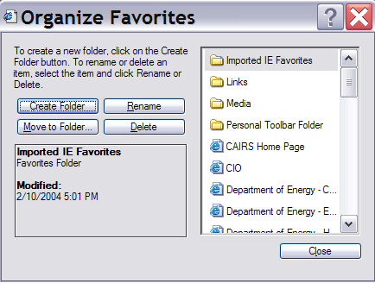
Figure 2: Organize Favorites

From this window you can create a new folder, move favorites to a specified folder, rename favorites or folders, and delete favorites or folders. The following table provides instructions for each of these functions:

Button | Description
Create Folder | Click the Create Folder Button. Your cursor will appear in the New Folder title box. Type a new name for the folder.
Move to folder | You can move favorites into separate folder so they will be easier to locate later. To move a favorite to a folder, highlight the favorite. Holding the left mouse button down, drag the favorite to the desired folder. Alternatively, highlight a favorite and click the Move to Folder button. The Browse for Folder box will be displayed, as shown in  Figure 3. Highlight the folder where you want to store the selected favorite, and click the OK button.
Rename | To rename a favorite or folder, highlight it and click the Rename button. The cursor will appear in the favorite’s name box. Type a new name for the favorite. Choose a name that will help you to remember the content of the website.
Delete | To delete a favorite, highlight it and click the Delete button.

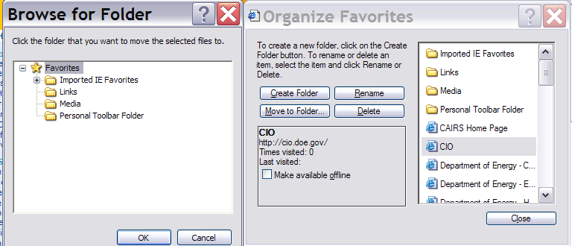
Figure 3: Browse for Folder Box

Managing Bookmarks (Netscape)
To manage your bookmarks in Netscape, select Manage Bookmarks from the BOOKMARKS menu to display the BOOKMARKS window shown in Figure 4 on the following page. There are five menu items available in the Netscape Navigator BOOKMARKS window. They are the FILE, EDIT, VIEW, WINDOW, and ITEM. All the essential functions contained in these menus are also contained on the toolbar below the menu. Selections on this toolbar include NEW FOLDER, NEW SEPARATOR, FILE BOOKMARKS, PROPERTIES, RENAME, and DELETE. These options are described in the following table:

Button | Description of use
New Folder | To create a new storage folder for your bookmarks, click the New Folder button. A data entry box will be displayed where you can type a folder name. Type a name for your folder, and click the OK button.
New Separator | To create a separator between bookmarks, highlight the bookmark above where you want the separator to appear, and click the new separator button.
File Bookmarks | To move bookmarks to a specific folder, click file bookmarks. A list of folders will be displayed. Click the folder where the bookmark is to be stored.
Properties | To determine the URL of a bookmark, highlight it and click properties. The URL will be shown along with the display name of the bookmark.
Rename | To rename a bookmark, highlight it and click RENAME. Type a new name for your bookmark. Choose a name that will help you to remember the content of the referenced web page.
Delete | To delete a bookmark, highlight it and click DELETE.

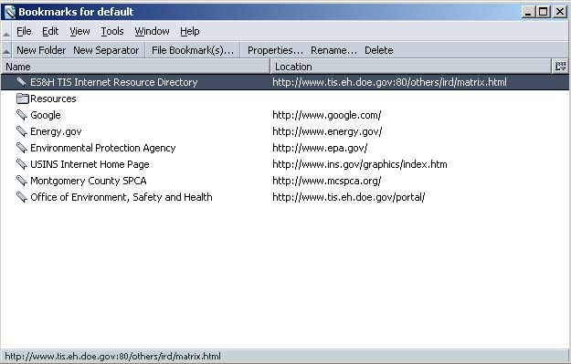
Figure 4: Netscape Bookmarks Window

Bookmark Properties

To change the information (such as name and location) associated with an item in the bookmarks list, change the item’s properties. To change bookmark properties:
- Choose the Properties button from the Manage Bookmarks window toolbar.
- Make the desired changes in the BOOKMARK PROPERTIES dialog box.
- Choose OK to save the changes.

Exercise 2

As you respond, write down the steps you take. These notes will act as a reminder when you take similar actions in the future.

1. Go to the location http://apollo.osti.gov/ and add this location as a Favorite.

2. From the DEPARTMENT OF ENERGY home page, click on the Departmental Resources hyperlink. Scroll down the page and click on the Access Home Pages via a U.S. map of Department sites link. Add this map page to your Favorites list.

3. Now, add the following Favorites. (These favorites may be used in later exercises).

US Environmental Protection Agency http://www.epa.gov/
The Building and Fire Research Lab http://www.bfrl.nist.gov/
National Library of Medicine http://www.nlm.nih.gov/
EM WWW Information Services http://www.em.doe.gov/
JPL Radiation Effects Database http://radnet.jpl.nasa.gov/
EnviroLink http://envirolink.org/
National Standards System Network http://www.nssn.org/
OSHA Home Page http://www.osha.gov/
SafetyLink - Product Safety Compliance http://www.safetylink.com/

4. Using the saved Favorite, go to the US ENVIRONMENTAL PROTECTION AGENCY home page. Follow the links to answer these questions. (“Browse” the EPA Topics.)

5. What is the function of the US EPA’s Office of Enforcement and Compliance Assurance? Who is currently the Assistant Administrator of this office? Return to the “Browse” EPA Topics page. What are the 7 most commonly recycled materials?

Exercise 3
As you respond, write down the steps you take. These notes will act as a reminder when you take similar actions in the future.

1. Add the following four folders to your Favorites list: Nuclear, Environment, Medical, Fire

2. Place the following items into the indicated folder:

Nuclear Environment
Department of Energy U.S. Environmental Protection Agency
JPL Radiation Effects Database EM WWW Information Services
EnviroLink

Medical Fire
U.S. National Library of Medicine Building and Fire Research Laboratory
Occupational Safety and Health Admin. National Standards Systems Network
Safety Link

3. Put the folders in the following order: Environment, Fire, Medical, Nuclear

Exercise 4

As you respond, write down the steps you take. These notes will act as a reminder when you take similar actions in the future.

1. Rename the bookmark called US DOE Server Map to Map of DOE Sites.

2. Delete the Safety Link Favorite from the FIRE folder.

Setting Internet Options (IE)

To set Internet Options in IE:

1. Select Tools from the main menu.
2. From the Tools menu, select Internet Options.

The Internet Options dialog box will be displayed, as shown in Figure 5.

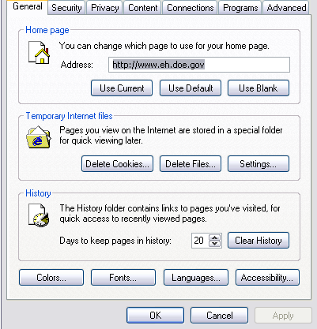
Figure 5: Internet Options

Note that the top of the Internet Options dialog box shows seven tabs, General, Security, Privacy, Content, Connections, Programs, and Advanced. General users should only be concerned with the General tab. System administrators will use the Security, Privacy, Content, and Advanced tabs to configure the settings of the DOE Common Operating Environment. Further details about these tabs are found in the IE online help. The General tab (which is displayed when you first open the INTERNET OPTIONS dialog) will be discussed in the following paragraphs.

Setting the Home Page

The home page is the website that will display when you launch your browser. This is usually preset by your system administrator, and there should be no need to change it (but you may if you wish). To change the home page:

1. Place your cursor inside the Address field.
2. Type the URL of the page you wish to set for the home page.
3. Click the OK button.

Deleting Cookies
Cookies are small files containing information about you (for example, login information) that many websites are designed to deposit onto your hard disk. Upon returning to the website, the cookies will allow the website to "recognize" you and "remember" information about you that you supplied in the past. For privacy and security reasons, it is recommended to clear the cookies directory regularly.

To clear cookies, click Delete Cookies. You will be prompted to confirm the deletion. Click Yes.

Deleting Files
When using a browser to perform Internet searches for information, websites will sometimes deposit html and image files onto the hard disk. These files are "cached" so that upon your return to the same website, your browser will look for and retrieve them from your hard disk (faster than retrieving from the internet). The problem with this is that your hard disk may not contain the latest version of the files. To ensure that the data you are accessing is always current, it is recommended to clear the files directory regularly.

To clear the files, click Delete Files. The system will prompt you to confirm the deletion. Click Yes.

Changing the Browser Settings

Click the Settings button. The Settings dialog will be displayed, as shown in Figure 6:

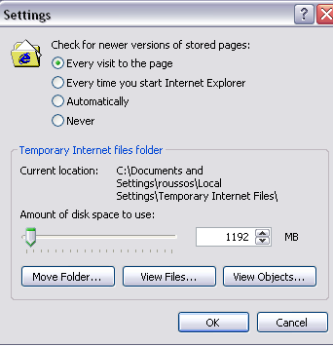
Figure 6: Settings
To ensure that the web pages you visit are always the latest versions, click the radio button beside "Every visit to the page". This will ensure that your browser will not rely upon versions of the web files that the browser has stored on your hard disk. All other selections will yield increased loading speeds but decreased insurance that the version you view will be the most current version.

To change the amount of disk space that the Temporary Internet Files folder may use, click and drag the disk space indicator to the right to increase the disk space, and to the left to decrease it. The browser is set to an optimal amount. If you clear your temporary files regularly, you will save disk space and not require more than the allotted amount.

To view the files and objects (images and multimedia files) that your browser has stored on your hard disk, click the View Files or View Objects button. All the files will be displayed alphabetically in a list.

Note: The Move Folder button is for System Administrator use only.

Clearing the Browser's History

Each time you visit a website, the URL of that website will be added to your history file, and will be listed if you click the arrow to the right of your browser's address field. To clear the history, click Clear History. You will be prompted to confirm the deletion of all history files. Click Yes. You can set your history to be cleared automatically at intervals. To do this, type the number of days you wish to keep your history records into the Days to Keep Pages in History field.

Note: Clearing the temporary internet files and the history files will cause web pages to load more slowly. However, you will be sure that the versions you are viewing are the latest versions and not cached versions from your hard disk.

Setting colors

Click the Colors button to set background and text colors which will display if colors are not specified in the website code.

The Colors dialog will be displayed, as shown in Figure 7.

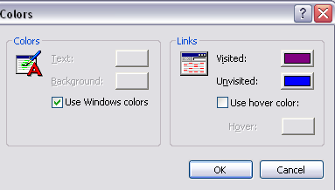
Figure 7: Colors Dialog

To set user-specified colors click the Windows Colors checkbox to deactivate it. Then click the color buttons to choose desired colors. Note that these colors will not override the existing formatting - they will only be applied if a website has no formatting.

Setting the Fonts

Click the Fonts button to set the font that will display if fonts are not specified in the website code. The Fonts dialog will be displayed, as shown in Figure 8:

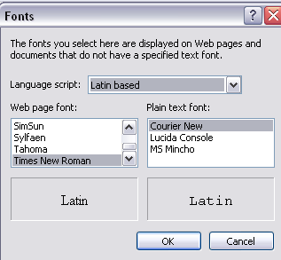
Figure 8: Fonts Dialog

To set user-defined fonts, click the Fonts button and choose the desired font.

Setting the Language

Click the Language button if you wish to set a default browser language other than English. The Language dialog will be displayed, as shown in Figure 9:

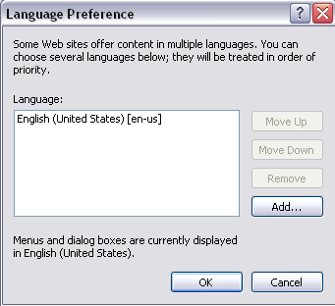
Figure 9: Language Preference Dialog Box

To add a language to your list of available languages, click the Add button. Then highlight it and click OK to set it as your default language.

Setting Accessibility

Click the Accessibility button to set your browser to ignore the formatting specified by web pages and use your own style sheet. This is especially valuable if you require high-contrast between text and background. The Accessibility dialog box will be displayed as shown in Figure 10:

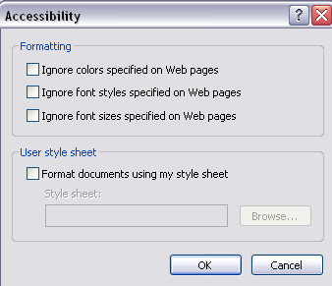
Figure 10: Accessibility Dialog Box
Click the checkbox beside the formatting that you wish to override. To apply your own user-specified formatting using a style sheet, click the checkbox beside Format Documents using my style sheet and browse to select your style sheet. This option is for advanced users.

Editing Preferences (Netscape)

Web browsers allow you to customize their appearance and operation to match your own style and needs by configuring the preferences. Once you set your preferences, they remain in effect each time you start the browser.

Preferences are found under the EDIT menu. From there, you can customize the appearance of the screen by setting toolbar display styles, changing screen fonts and colors, choosing the method for displaying images, configuring external helper applications to interpret and read various file formats, and determining language priorities when receiving websites.

To configure your preferences, select General Preferences from the OPTIONS menu. The PREFERENCES dialog box appears which is organized under preference seven headings: Appearance, Fonts, Colors, Images, Apps, Helpers, and Language. Each heading presents one or more panels that enable you to define preference settings which define Netscape Navigator’s operation.

From each panel, you can select desired preferences. Click the OK button to close the dialog box to accept any changes in the panel settings. Click CANCEL to close the dialog box without accepting any changes.

NOTE: In Internet Explorer, Preferences are known as Internet Options. To access IE Internet Options, click TOOLS and choose INTERNET OPTIONS.

Appearance

The APPEARANCE section of the Preferences window, shown in Figure 11, allows you to specify what your browser will look like. Attributes that you may control include fonts, colors, themes, and languages.

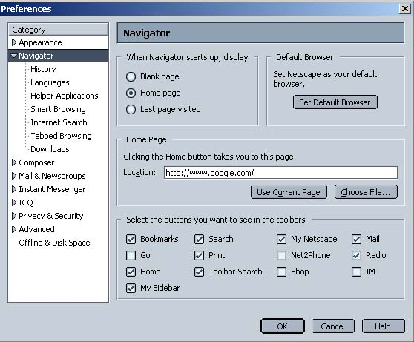
Figure 11: Netscape's Preferences Dialog

Fonts
You can specify the base font and font size Netscape will use to display text in websites by clicking on the FONTS dropdown menu.

Most pages display text in a proportional font because the proportional font defines the font of the primary type of text in the content area. Fixed font text is used in editable fields and certain paragraphs preformatted by the author of the page.

Changing the font size alters the base measure the browser uses to display text. The font size you specify will be used for the main body text, and titles and headings will retain their size relationship to the body text. For example, if the body text was originally set at 12 points and a heading on that page was set at 24 points (twice the size of the body text), a font size change to 16 points for the body text will result in a heading that is 32 points.

Leave the encoding setting at Latin1. This is the proper setting for the English language.

Fonts are selected by clicking on the FONTS option of the Appearance menu (see Figure 6). Font type and size selection menus are available for each text type. From these selection boxes, you can select another font or size by clicking on the desired selection. After selecting the font and/or size you desire, click on the OK command button.

Colors
You can select the colors that display within the browser window by selecting the COLORS option of the appearance menu, as shown in Figure 12. Color is used to highlight some types of text as well as add interest in the background. Click on any of the COLORS command buttons to pop up a color palette from which you can select colors to personalize your links, text, and background colors.

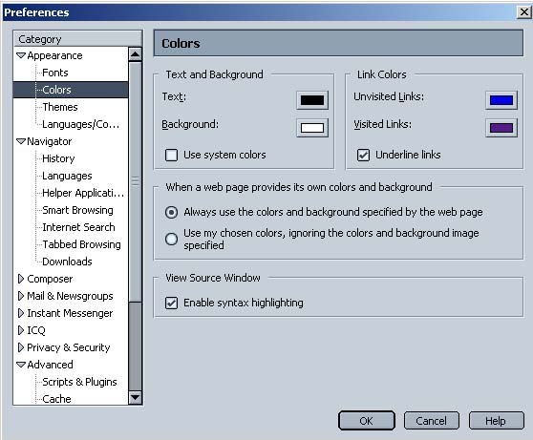
Figure 12: Colors

Languages
This feature included with most browsers allows the user to set the language that the browser will display. You can specify a desired language by clicking on the LANGUAGES menu selection, as shown in Figure 13.

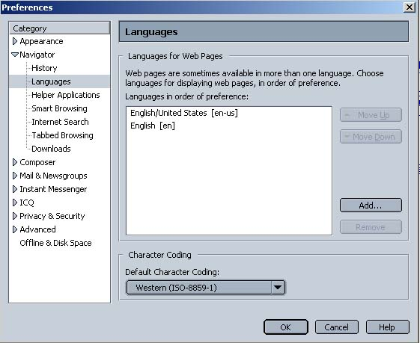
Figure 13: Languages

To build your language priority list, click the Add button, and select a language from the ADD LANGUAGES selection box shown in Figure 9.

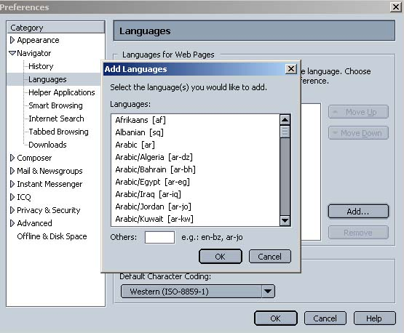
Figure 9: Add Languages

The selected language will then be displayed in the LANGUAGES IN ORDER OF PREFERENCE selection box. Multiple languages can be added to the list, in order of preference. You can remove a language from the list by highlighting it and then clicking on the left arrow button.

