
Helping States Determine Equitable Distributions Of Software Development Costs to Benefiting Programs Over the System Development Lifecycle
Cost
Allocation
Methodologies
CAM-TOOL User Guide
Release – May 2004

Guide to the Microsoft Excel tool to assist States in the creation of Cost Allocation Plans for shared system development

CAM-TOOL USER GUIDE - TABLE OF CONTENTS
CAM-TOOL INTRODUCTION 3
Starting the CAM-TOOL 3
An Overview of the CAM-TOOL 4
The CAM-TOOL Worksheet Format 6
The SYSTEM_INFORMATION Worksheet 7
The BENEFITING_PROGRAMS Worksheet 8
The ALLOCATION_STRUCTURE Worksheet 10
The FUNCTIONAL_MODULES Worksheet 12
The SUB_MODULES Worksheet 13
The DETAILS Worksheet 15
The WEIGHTING_SYSTEM Worksheet 16
The ALL_SYSTEM_USAGE Worksheet 17
The SYSTEM_USER_COUNTS Worksheet 22
The SHARED_USAGE_LOE Worksheet 27
The COST_ALLOCATION_PLAN Worksheet 29
The PROGRAM_SUMMARY Worksheet 32
The FORMAT_ALL_SYSTEM_USAGE Worksheet 32
The FORMAT_SHARED_USAGE Worksheet 34
The Help Menu Worksheet 36
CAM-TOOL Worksheet Required Fields 37
Glossary of Terms 38

CAM-TOOL INTRODUCTION

The CAM-TOOL is designed as a companion to the Cost Allocation Methodologies Handbook, which are both components of the CAM TOOLKIT. The CAM-TOOL can help assist States in creating a cost allocation plan for software development costs following the systematic cost allocation process indicated in the CAM Handbook. Use of the CAM-TOOL is most appropriate when there is a need to provide cost allocation justification that quantifies detailed benefit for multiple programs (e.g., during planning for the Implementation Advance Planning Document (IAPD) submission for a system used by multiple operating divisions). In contrast, the Preliminary Advance Planning Document (PAPD) submission allows for any reasonable cost allocation methodology (i.e., usually equal shares) among the benefiting programs.

The CAM-TOOL is a Microsoft Excel workbook with added macros (i.e., programming functionality) to provide easier navigation and to help automate tasks associated with cost allocation.

System Requirements

- The CAM-TOOL was created using Microsoft Excel 2000.
- The CAM-TOOL includes macro functionality. Therefore, macro functionality needs to be enabled on the user’s computer. Please contact your technical support division for assistance with enabling macro functionality.

User Requirements:

- Knowledge of the process of system cost allocation. Please refer the CAM Handbook for complete details.
- Intermediate-level proficiency in Microsoft Excel.

Starting the CAM-TOOL
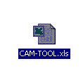

Double-click on the CAM-TOOL icon and Microsoft Excel will launch.

The user will be presented with the following dialog box:

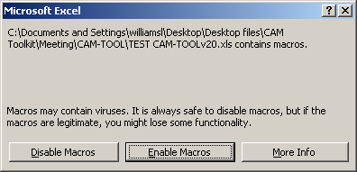

- Please click on the “Enable Macros” button
  - If this dialog box or a similar dialog box asking to “enable macros” does not appear, then contact your technical support division about Excel macro capabilities.

An Overview of the CAM-TOOL

Splash Screen Worksheet and Navigation

After clicking on the “Enable Macros” button, the user will be presented with the CAM-TOOL Splash Screen as shown below:

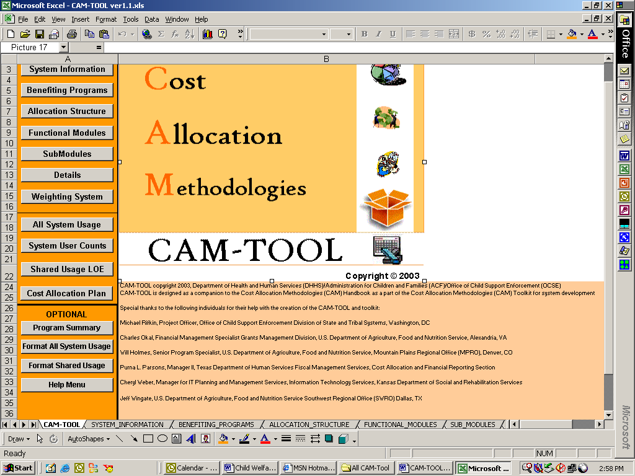

Users will see the standard Microsoft Excel menus and the names of the worksheets at the top and bottom of the screen in the CAM-TOOL.

The splash screen includes the CAM-TOOL image icon highlighted in black in the above image and CAM-TOOL copyright and acknowledgement information in the bottom-half of the screen.

The splash screen contains a navigation menu that indicates all of the standard worksheets provided in the CAM-TOOL. The navigation menu contains three sections:

- (Buttons 1 – 7): The top seven command buttons direct the user to the worksheets that capture data about the system under cost allocation. These worksheets contain data concerning system background information, the benefiting programs, and the methodology of allocation, which includes the ALLOCATION_STRUCTURE, FUNCTIONAL_MODULES, SUB_MODULES, Details, and the Weighting System worksheets.

- (Buttons 8 – 11): The middle four buttons direct the user to the worksheets that track system functionality usage by benefiting program. These sheets help determine and calculate the “fair share” of cost allocation for the benefiting programs.
- (Buttons 12 – 15): The bottom 4 buttons direct the user to the optional CAM-TOOL worksheets which include creating a summary by benefiting program, formatting data from the ALL_SYSTEM_USAGE and SHARED_USAGE_LOE worksheets, and accessing all files in the help menu.

- Users can use the navigation menu pictured below or click on the Excel worksheet tab names at the bottom of the screen to navigate to the following worksheets.
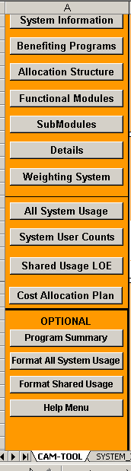
1. SYSTEM_INFORMATION: any relevant information supplied about the system undergoing cost allocation

2. BENEFITING_PROGRAMS: a listing of programs that will benefit from the system development and program related information

3. ALLOCATION_STRUCTURE: information on the methodology of allocation, which includes definitions of the levels of allocation (i.e., functional module, submodule, and detail) and the selected allocation base(s).

4. FUNCTIONAL_MODULES: all high-level system development categories

5. SUB_MODULES: all secondary-level system development categories

6. DETAILS: all third-level system development categories

7. WEIGHTING_SYSTEM: an explanation of how complexity of the system development effort will be measured, if the selected allocation base does not measure level of effort

8. ALL_SYSTEM_USAGE: the usage (i.e., benefit) of the system by each benefiting program

9. SYSTEM_USER_COUNTS: a copy of the ALL_SYSTEM_USAGE worksheet with the user counts (i.e., recipients or caseloads) assigned for each benefiting program

10. SHARED_USAGE_LOE: the calculated level of effort values for shared system usage used to calculate the cost allocation plan

11. COST_ALLOCATION_PLAN: the final cost allocation percentages based on the results in the SHARED_USAGE_LOE worksheet

12. PROGRAM_SUMMARY: a summary of the system functionality usage by benefiting program

13. FORMAT_ALL_SYSTEM_USAGE: is a copy of the ALL_SYSTEM_USAGE worksheet for formatting

14. FORMAT_SHARED_USAGE: is a copy of the SHARED_USAGE_LOE worksheet for formatting

15. HELP: provides a listing of the CAM-TOOL help files related to all of the worksheets

The CAM-TOOL Worksheet Format

- Each worksheet contains the navigation menu.
- A “?” (i.e., question mark) appears in cell B1 on each worksheet. Click on the “?” to access the help for the current worksheet.
- Worksheet information begins in cell “C3”.
- Row 1 and 2 will contain worksheet header information and possible command buttons to access the CAM-TOOL automated functions.

The following screenshot is an example of the SYSTEM_INFORMATION worksheet:

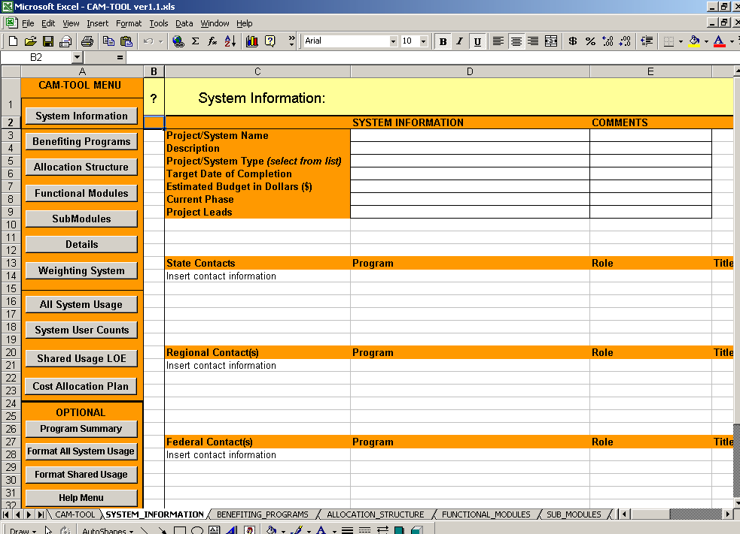
“?” – Click on the question mark to access the help information for the current worksheet

Navigation menu

- User will see the standard navigation bar that is available on all standard worksheets in the CAM-TOOL.

- User will also notice a “?” – question mark in a yellow box at the top of the screen. Click on the question mark box to access the help information specific to the current worksheet.
- IMPORTANT NOTE: PLEASE DO NOT CHANGE ANY COLUMN NAMES OR COLUMN ORDERING IN THE CAM-TOOL, except on the FORMAT_ALL_SYSTEM_USAGE and FORMAT_SHARED_USAGE worksheets. The CAM-TOOL uses the column names and the ordering of the columns to calculate and conduct automated tasks.

The SYSTEM_INFORMATION Worksheet

- Click on the System Information button.

The user will be presented with the SYSTEM_INFORMATION worksheet as shown below:

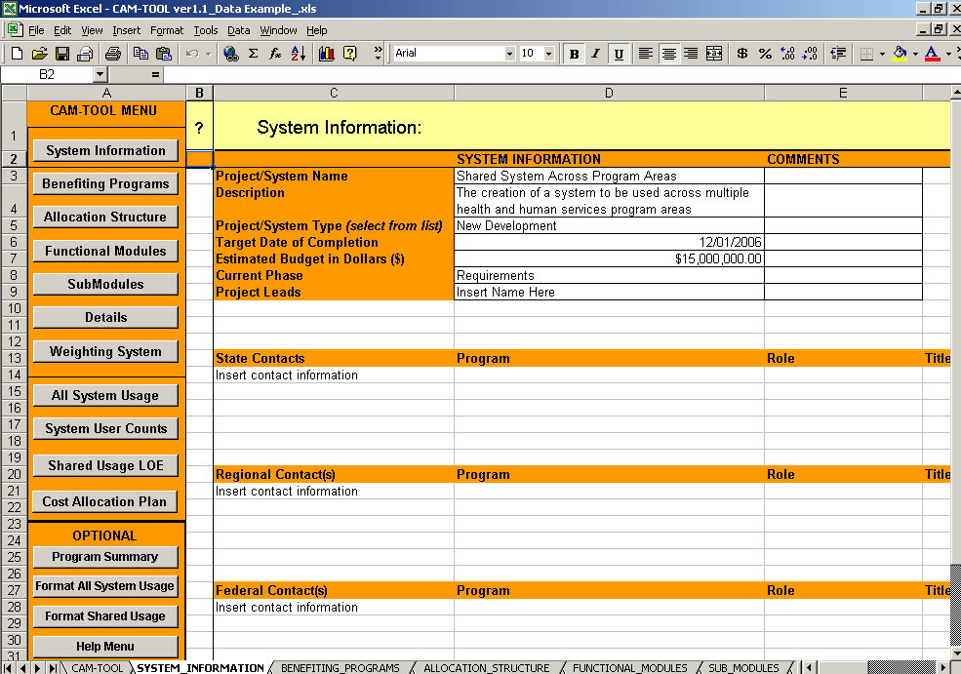

- Please enter any relevant or helpful information about the project/system that would be helpful in the cost allocation process.

- This worksheet captures the system name, a description of the project/system, the system type (e.g., new development, system upgrade, web front-end, other), the target date of completion, current phase (e.g., requirements, design, development, etc.), and project leads.

  - Both the system type and current phase capture cells are drop-down boxes for user selection.

    - If the system type or current phase options do not match your system, please select “Other” and provide an explanation.

- Please enter any necessary contact information that would be helpful in the cost allocation process.

- Add any other additional information that would be helpful in terms of the project/system.

The BENEFITING_PROGRAMS Worksheet

- Click on the Benefiting Programs button.

The user will be presented with the BENEFITING_PROGRAMS worksheet as shown below:

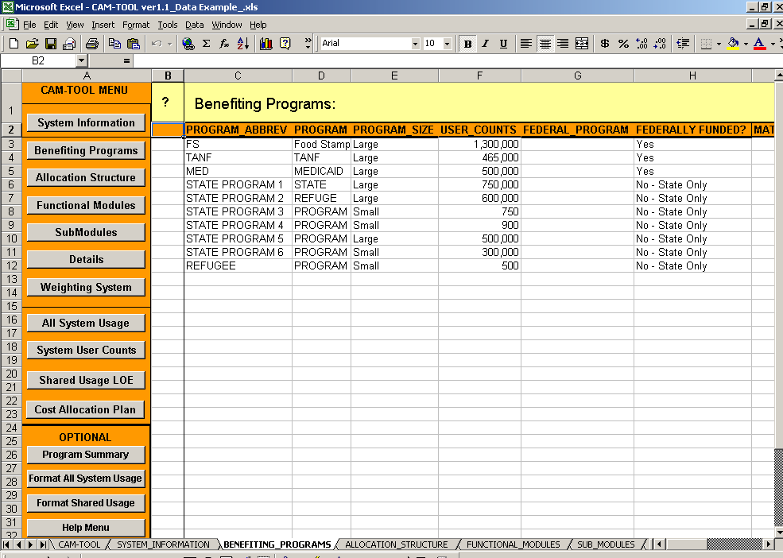
The PROGRAM_SIZE indicator is used by the CAM-TOOL to automatically determine the calculations for the Shared_Usage_LOE Worksheet

- Please enter information for all benefiting programs.

- This worksheet captures a program abbreviation, the full program name, the program size (e.g., Large or Small), the user counts (i.e., the number of recipients or the number of cases of a benefiting program), an indicator for federal funding (e.g., “yes” or “no-state only”), and the Federal match rate of the program, if applicable.

  - Both the PROGRAM_SIZE (e.g. Large or Small) and the FEDERALLY_FUNDED? capture cells are drop-down boxes for user selection.

  - USER_COUNTS should indicate number of recipients or number of cases.

  - A small program can be defined in one of two ways, whichever is smaller:
- A program with 1,000 (one-thousand) or fewer cases or recipients.
- A program that is 10% or less of the total cases or recipients of all benefiting programs.

  - Users should use the user count numbers to determine whether a program is large or small.

- The PROGRAM_SIZE designation is critical in the cost allocation process. Any cost allocation for small programs needs to be calculated before determining cost allocation for the larger programs. The user count numbers are used to calculate an “adjusted” cost allocation share (e.g., percentage of allocation) for small programs.

- Please ensure that all benefiting programs have the correct program size designation.

- IMPORTANT NOTE: The CAM-TOOL uses column “E” – the PROGRAM_SIZE indicator to determine the data that is calculated for the SHARED_USAGE_LOE Worksheet.

  - Therefore, column “E” must remain as the PROGRAM_SIZE indicator.

  - The CAM-TOOL will not be able to calculate the benefiting program shares that are located on the SHARED_USAGE_LOE worksheet, if columns are inserted into this worksheet that change the position of the PROGRAM_SIZE indicator.

  - Users may insert rows anywhere below the menu and header rows that include the name of the worksheet and the names of each of the columns.

Please proceed to the next page.

The ALLOCATION_STRUCTURE Worksheet

- Click on the Allocation Structure button.

The user will be presented with the ALLOCATION_STRUCTURE worksheet as shown below:
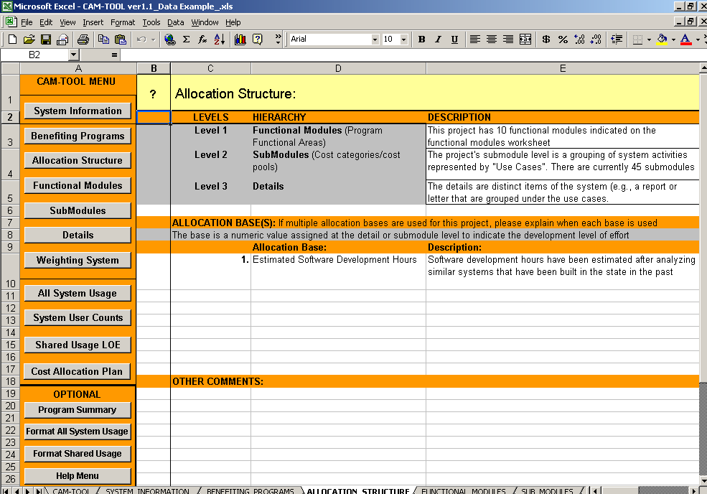

- The ALLOCATION_STRUCTURE worksheet captures the descriptions of the allocation methodology, which includes the three levels of detail supported by the CAM-TOOL (i.e., functional modules, submodules, and details), as well as the selection of the allocation base (e.g., development hours, lines of code, etc.)

- Users of the CAM-TOOL should provide a description of how the three available levels of detail are used in their cost allocation process, as show above in cells E3 through E5.

- The three allocation levels are similar to a work-breakdown structure for the system development. The three allocation levels can represent distinct levels and units of work during the system development.

An example of the three allocation levels in use is as follows:

  - Level 1 – Functional_Module: The system may have a functional module called “Alerts”. This Alerts functional module relates to the development (e.g., programming, testing, etc.) needed to generate system notifications to users about due dates or past due work.

  - Level 2 – SubModule: Within the Alerts functional module are two submodules called “Management” and “Staff” to differentiate the system notifications that will be developed for managerial purposes versus staff work.

  - Level 3 – Detail: Finally under the “Management” and “Staff” alert submodules are the names of specific alerts that are designed for management or for the staff using the system.

The following example of system functionality mapped to the allocation hierarchy would appear on the DETAILS worksheet:

FUNCTIONAL_MODULE | SUB_MODULE | DETAIL | DESCRIPTION
Alerts | Management | AL1 | Management Alert 1
Alerts | Management | AL2 | Management Alert 2
Alerts | Management | AL3 | Management Alert 3

    - It will be necessary for the project to categorize or map its system functionality into distinct levels of work and units of work in order to use the CAM-TOOL. The CAM-TOOL supports up to 3 levels of work. For example, all functional modules do not have to have submodules or details and all submodules do not have to have details. The CAM-TOOL will work with a combination of the three different levels.

    - The project should estimate or track software development level of effort (e.g., programming time, testing time, etc.) associated to the system functionality related to the allocation hierarchy. For example, if there is “Detail” level system functionality, then it is optimal to track the work expended on details like a specific report. However, if the system has only been divided into distinct submodules, then one can only capture level of effort at the submodule level.

- Any cost allocation methodology will use the estimated or tracked level of effort expended on system functionality to determine the “fair share” of costs for each of the benefiting programs.

- The selected allocation base(s) represents the work and/or level of effort that will be estimated or tracked for the system functionality related to the allocation hierarchy to allow for proper cost allocation.

  - Allocation Base Examples:
Allocation Base | Description
SOFTWARE DEVELOPMENT HOURS | Estimated or actual development hours expended on specific system functionality
STORAGE/DATABASE SIZE | Estimated or actual storage size or database size related to specific system functionality
LINES OF CODE (LOC) | Estimated or actual lines of code related to specific system functionality
FUNCTION POINTS | Estimated or actual function points related to specific system functionality
SCREENS | Estimated or actual screens related to specific system functionality

- It is optimal to capture estimated or actual development hours, which indicates both work and level of effort (i.e., benefit) of specific system functionality.

- If it is not possible to capture hours, then other allocation base options like lines of code (LOC) can be used in the cost allocation methodology. However, allocation base options like LOC measure size and do not indicate level of effort.

  - For example some very complex functionality of the system may only have 30 lines of code, but may have taken a lot of time to develop and test versus some simple functionality with 100 lines of code.

  - If the project selects an allocation base like LOC, that does not measure level of effort, then it will be necessary to create a weighting system to designate some level of effort for the system functionality related to the allocation hierarchy. The weighting system should be described on the WEIGHTING_SYSTEM worksheet. However, the actual weight values for the system functionality are entered on the ALL_SYSTEM_USAGE worksheet.

- Users need to enter the selected allocation base(s) and the description of the base(s) starting in Cell D10 of the ALLOCATION_STRUCTURE worksheet.

The FUNCTIONAL_MODULES Worksheet

- Click on the Functional Modules button.

The user will be presented with the FUNCTIONAL_MODULES worksheet as shown below:
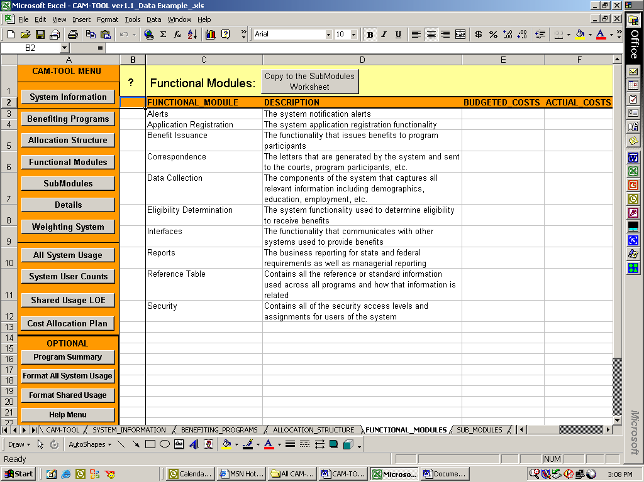
Functional Module names
Please enter information for all functional modules.

- This worksheet captures a functional module name, a description, and optional fields for the budgeted costs and actual costs for the functional module.

- Functional modules are typically high-level system development organizational categories.

- These functional modules may be further segregated into sub-modules (e.g., management or staff alerts for the Alerts functional module) that are captured on the SUB_MODULES worksheet.

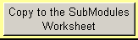
- The FUNCTIONAL_MODULE worksheet has one menu item “Copy to the SubModules Worksheet”. This button copies the functional module names to the submodule worksheet to document the relationship of the submodules to the functional modules in the system allocation hierarchy.

The SUB_MODULES Worksheet

- Click on the SubModules button.

The user will be presented with the SUB_MODULES worksheet as shown below:

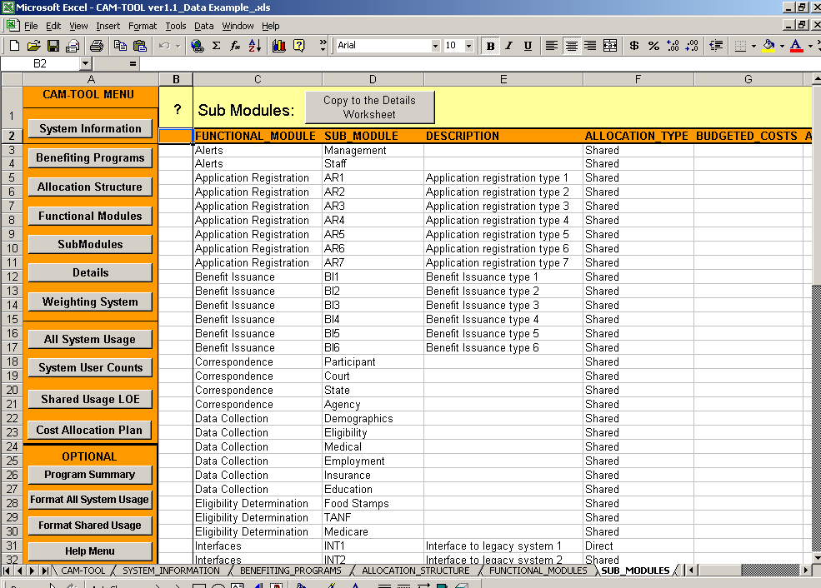
SubModule names

- Please enter information for all submodules.

- This worksheet captures the related functional module, submodule name, a description, allocation_type, and the optional fields for the budgeted or actual costs for the sub-module.

- Sub-modules can be used to provide a second-level aggregation for the allocation.

- Sub-modules (e.g., management or staff for the Alerts functional module) are captured on the SUB_MODULES worksheet as shown on the screenshot.

- IMPORTANT NOTE: The CAM-TOOL uses column “F” – the ALLOCATION_TYPE indicator to determine the information that should be inserted into the SHARED_USAGE_LOE Worksheet.

  - Therefore, column “F” must remain as the ALLOCATION_TYPE indicator.

  - To provide a complete view of the system functionality, the CAM-TOOL captures information about system functionality used by only one benefiting program and captures information on system functionality used by two or more benefiting programs on the ALL_SYSTEM_USAGE worksheet.

  - However, the actual cost allocation percentages calculated by the CAM-TOOL only include system functionality shared by two or more benefiting programs. The cost allocation percentages are calculated using data on the SHARED_USAGE_LOE worksheet.

  - The CAM-TOOL automatically extracts submodules that are direct charges to one benefiting program from the data that is inserted on to the SHARED_USAGE_LOE worksheet based on the designation in the ALLOCATION_TYPE field on the SUBMODULES worksheet.

- Users may insert rows anywhere below the header rows that include the worksheet name and the names of each of the columns

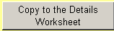
- The SUB_MODULE worksheet has one menu item “Copy to the Details Worksheet.” This button copies the functional module and submodule names to the DETAILS worksheet to document the relationship of the details to the functional modules and the submodules in the system allocation hierarchy.

The DETAILS Worksheet

- Click on the Details button.

The user will be presented with the DETAILS worksheet as shown below:

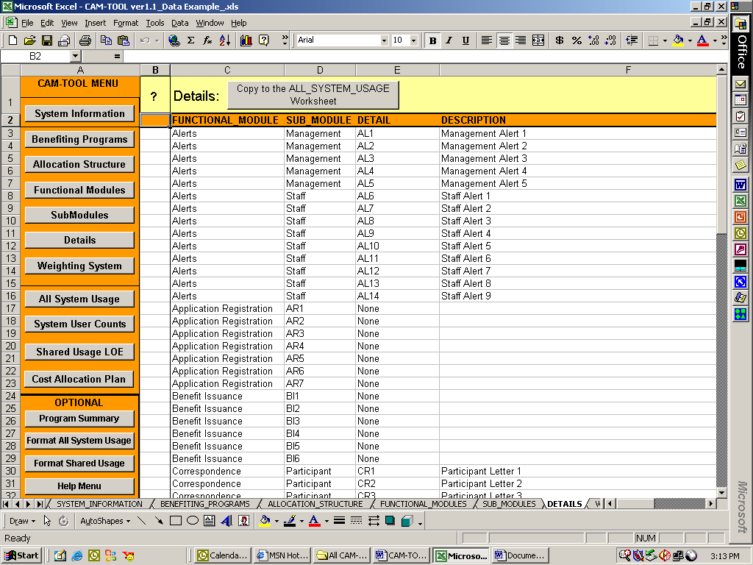
Detail names

- Please enter information for all Details.

- This worksheet captures the related functional module, submodule name, a description, and the optional fields for the budgeted or actual costs for the sub-module.

- Details can be used to provide a third-level aggregation for the system allocation.

- Details (i.e., the names of specific alerts contained within the Management (Alerts) submodule, such as “AL1” in the above screenshot) are captured on this worksheet.

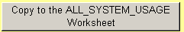
- The DETAILS worksheet has one menu item “Copy to the ALL_SYSTEM_USAGE Worksheet”. This button copies the functional module, submodule, and details names to the ALL_SYSTEM_USAGE worksheet for weight, base value, and program usage assignment.

The WEIGHTING_SYSTEM Worksheet

- Click on the Weighting System button.

The user will be presented with the WEIGHTING_SYSTEM worksheet as shown below:
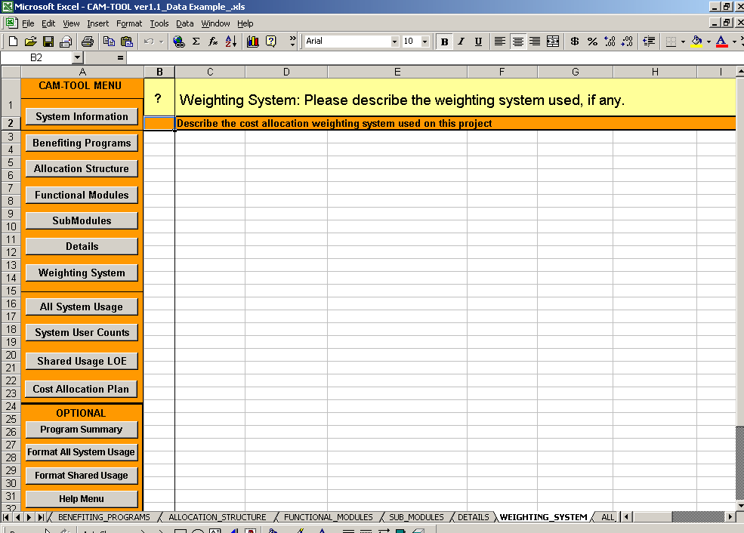

- Please enter the detail about the design and intention of the weighting system used for the system functionality, if the allocation base does not include level of effort.

  - The actual weights associated with the system functionality will be assigned on the ALL_SYSTEM_USAGE worksheet.

  - It is imperative that level of effort is measured or estimated in order to create cost allocation percentages that represent an equitable or “fair share” of benefit to the benefiting programs. Tracking an allocation base like lines of code (LOC) is a size measure and does not indicate level of effort. Therefore, in cases that the allocation base does not measure level of effort, a way to estimate level of effort (i.e., a weighting system) is necessary.

  - The example in the screenshot indicates that there was no need to use a weighting system because the selected allocation base, software development hours, already captures level of effort.

The ALL_SYSTEM_USAGE Worksheet

- Click on the ALL_SYSTEM_USAGE button.

The user will be presented with the ALL_SYSTEM_USAGE worksheet as shown below:
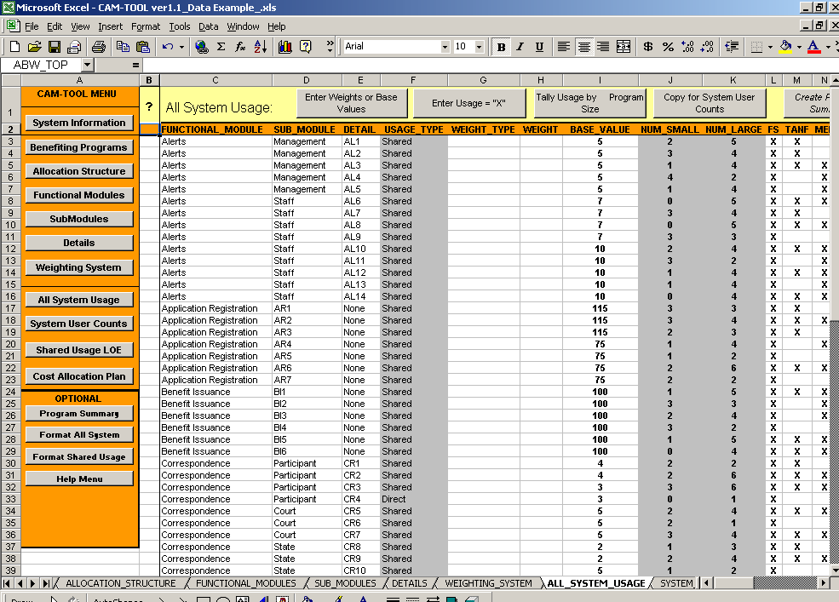
Benefiting program usage assignments indicated by “X”

- The above screenshot of the ALL_SYSTEM_USAGE worksheet has been pre-populated with data. The allocation hierarchy information has been copied to this worksheet using the “Copy to the ALL_SYSTEM_USAGE Worksheet” button located on the DETAILS worksheet.

- This worksheet captures:

  - The functional module, sub-module, and detail from the DETAILS worksheet.

  - The usage_type (e.g., direct or shared) - indicates whether the system functionality is shared by 2 or more programs (usage_type = shared) or is only used by one program (i.e., usage_type =Direct). The gray highlighting in this column indicates that this designation is determined by the CAM-TOOL based on program usage assignment, which is indicated by “X” in the program columns as shown in the screenshot.

  - The weight_type and weight – indicates the weight value and the type of weight associated to the specific system functionality. The weight type is the descriptive label of the weight entered into the weight column. These columns are used when the allocation base does not measure level of effort. The complete description of the weighting system should be indicated on the WEIGHTING_SYSTEM worksheet.

  - The num_small and num_large columns contain totals of the number of small programs and the number of large programs using the system functionality. This calculation is based on the PROGRAM_SIZE designation on the BENEFITING_PROGRAMS worksheet. The gray highlighting in these two columns indicate that these totals are calculated by the CAM-TOOL.

  - The remainder of the columns (e.g., FS, TANF) capture the benefiting program usage of the system functionality. Benefiting program usage is indicated by a capital “X”. Marking a cell with a “X” under a benefiting program column indicates that the program will use or benefit from the development of the system functionality located on that row. The CAM-TOOL will automatically insert the abbreviations of the benefiting programs that are located on the BENEFITING_PROGRAM worksheet into the ALL_SYSTEM_USAGE worksheet header when information from the DETAIL tab is copied to this worksheet.
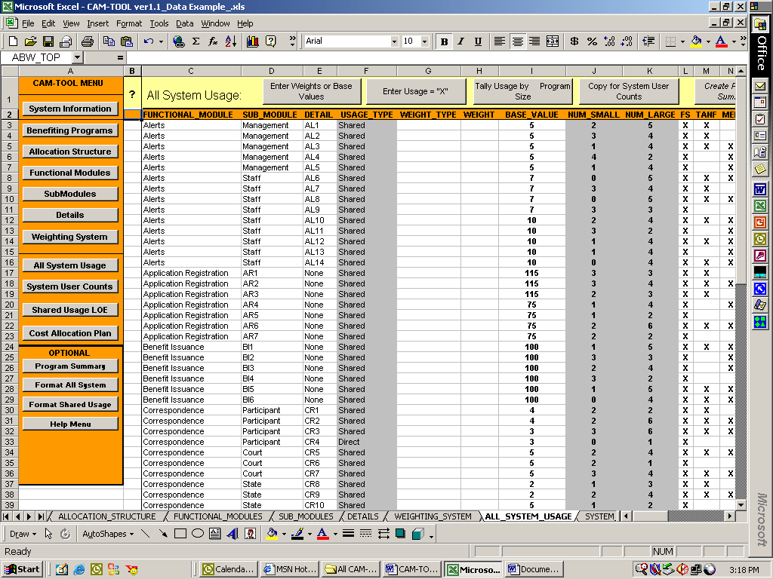
Benefiting program Column with usage marked as “X” (i.e., program usage assignments).

- This worksheet is intended to capture all usage (i.e., benefit) from the system functionality. This worksheet captures small and large program system usage as well as shared system usage and usage of submodule modules or detail functionality that only benefit one program. The worksheet provides the “complete” view of system functionality usage.
- The CAM-TOOL will automatically filter out the direct submodules usage (i.e., any submodules only used by one program) based on the ALLOCATION_TYPE indicator the on Sub_Modules worksheets to create the SHARED_USAGE_LOE worksheet data.

- IMPORTANT NOTE: The CAM-TOOL uses the information on this worksheet to create the data for the SYSTEM_USER_COUNTS worksheet and the SHARED_USAGE_LOE worksheets. Therefore, all columns must remain in their current position.

- ALL_SYSTEM_USAGE MENU FEATURES
  - The ALL_SYSTEM_USAGE worksheet has menu buttons to provide automated functionality to the user.
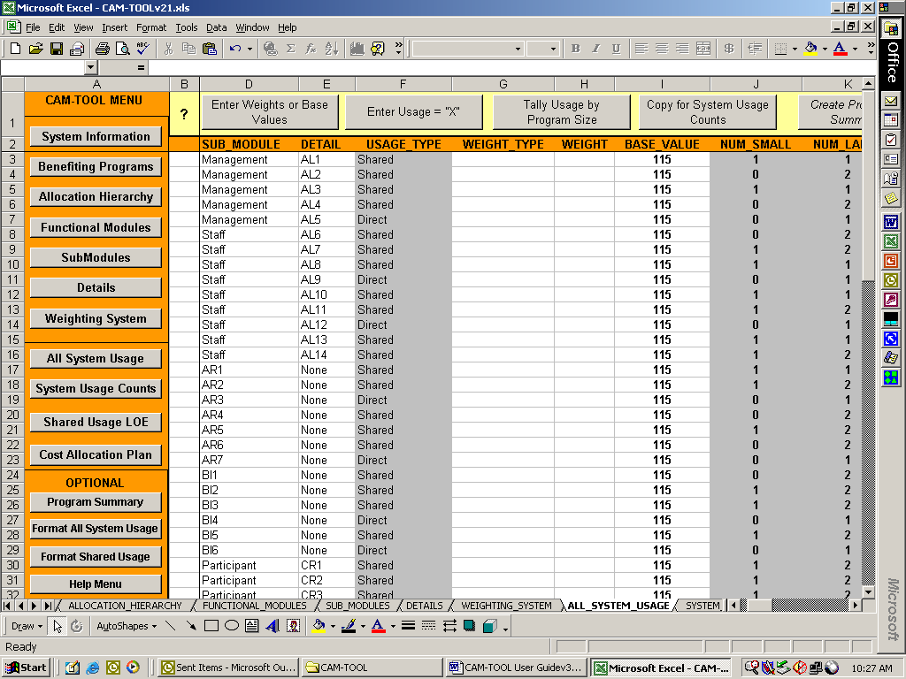
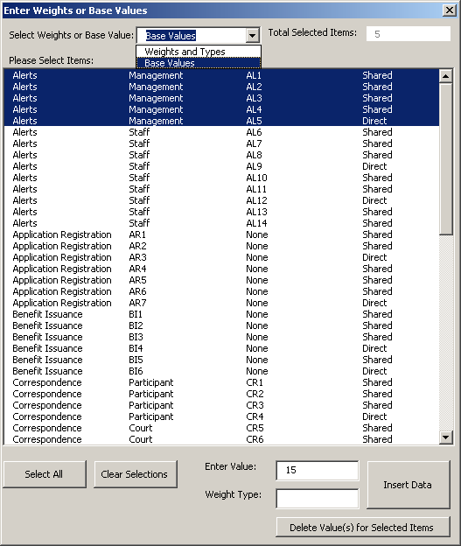
- Enter Weights or Base Values: Allows the user to enter multiple weight, weight type, and base value assignments for system functionality. The “Enter Weights or Base Values” window containing all of the system functionality on the ALL_SYSTEM_USAGE worksheet will appear after clicking on this button.

- The user can select to enter weights and types or base values and then select the system functionality components to insert weights and type or base values into the worksheet.

- In this screenshot, the user has selected to add base values. All “Management” alerts have been selected and a value of 15 has been entered. If the allocation base is hours, for example, then “15” means fifteen hours of development.

- The user clicks on the “Insert Data” button to insert the information on to the ALL_SYSTEM_USAGE worksheet for the selected system functionality.

- Entering weight types is optional when entering weight values.

- However, if the user has selected to insert base values, then the weight type field is disabled.

- The user has the option to “Select All” and “Clear Selections” in the list box of items. In addition, the user may delete values entered.

- The total items selected in the list box are indicated at the top of the “Enter Weights or Base Values” window.
- Enter Usage =”X”: Allows the user to enter multiple benefiting program usage assignments.
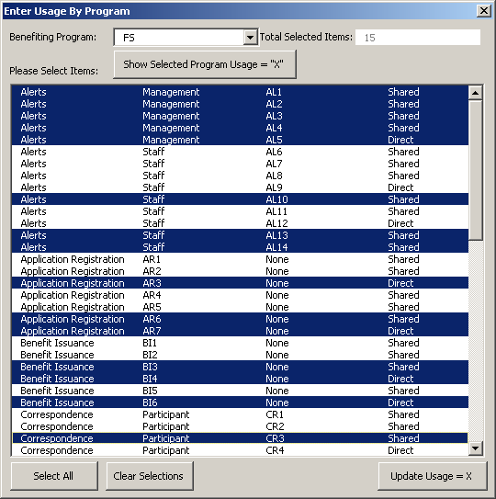
- The “Enter Usage By Program” window will appear after clicking on this button.

- The user selects to enter usage=”X” for the benefiting programs selected in the benefiting program drop-down box and selects system functionality that the program will use.

- In this screenshot, the user has selected the benefiting program “FS” for Food Stamps, and has selected 15 items in the list box to assign usage = “X”.

- The user clicks the “Update Usage = “X” to add Xs to the worksheet.

- To correct or update usage assignments the user can click on the ‘Show Selected Program Usage = “X”’ button. The ‘Show Selected Program Usage = “X”’ button will highlight the system functionality items that currently have usage=”X” on the worksheet for the benefiting program selected in the drop-down box. The user can update system functionality selections in the list box and click on “Update Usage = “X” button. The cells under the drop-down box program that are related to the system functionality selected in the list box will be updated with an “X”.

- When the user changes the selected benefiting program (e.g., FS) in the drop-down box, the CAM-TOOL will ask if the user wants the list box to display the system functionality items that currently have usage=”X” for the selected program.

- The user has the option to “Select All” and “Clear Selections” in the list box of items.

- The total items selected in the list box are indicated at the top of the window.
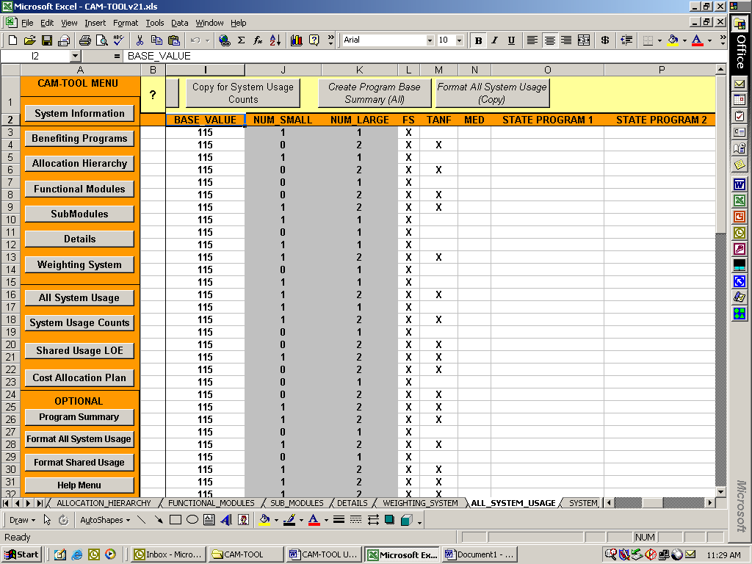
- Tally Usage by Program Size: Allows the user to calculate the number of small and the number of large programs using the system functionality based on the usage =”X” assignment in the benefiting program columns.

- This screenshot shows the CAM-TOOL calculations of the number of small and large programs that use the different system functionality in the worksheet rows.

- These calculations are based on the number of usage=”X” assignments in the benefiting program columns and the PROGRAM_SIZE indicator (e.g., Large or Small) on the Benefiting_Program worksheet as highlighted in the screenshots on the right.

Benefiting program usage=”X” on the All_System_Usage Worksheet

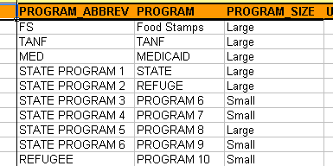

PROGRAM_SIZE indicator on the Benefiting_Programs Worksheet

- The CAM-TOOL will automatically initiate the “Tally Usage By Program Size” button when the “Copy for System User Counts” button is clicked. Therefore, the user does not have to use this button, unless they would like to have an interim calculation of the usage by program size.

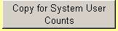
- Copy for System User Counts: Copies the information on this worksheet to the SYSTEM_USER_COUNTS worksheet for assignment of user counts to help calculate the “fair share” for all benefiting programs based on the benefiting program usage assignments.

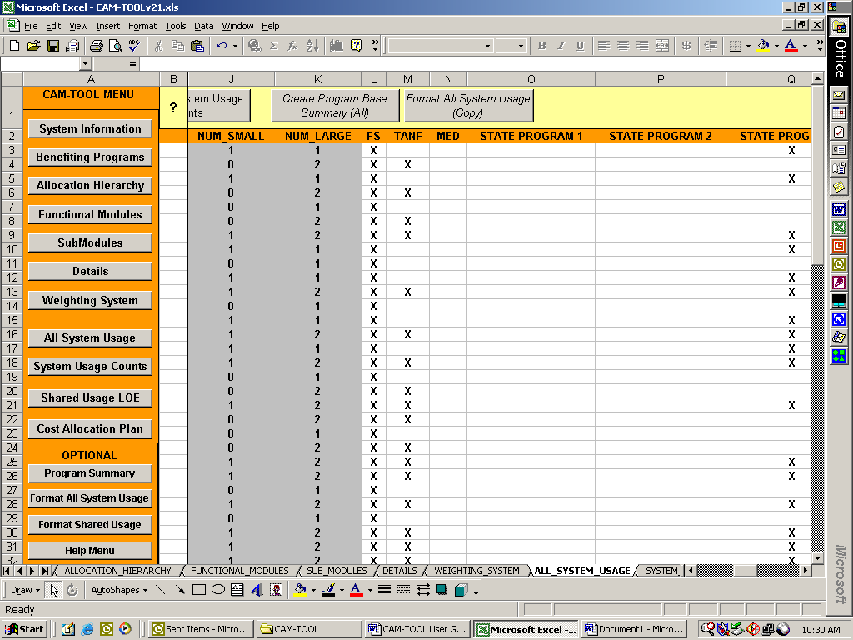
- Create Program Base Summary (ALL): is an optional button indicated by the italics of the button. This button will create a summary of usage by benefiting program on the PROGRAM_SUMMARY worksheet. For example, if a benefiting program only uses 45 of 100 system functionality components, then the 45 components will be listed for that benefiting program on the PROGRAM_SUMMARY worksheet. Read the section on the PROGRAM_SUMMARY worksheet for more details.

- Format ALL_SYSTEM_USAGE (Copy): is an optional button that allows the user to copy the information on this worksheet to the worksheet Format_ALL_SYSTEM_USAGE for any desired formatting purposes or other analysis. Read the section on the FORMAT_ALL_SYSTEM_USAGE worksheet for more details.

The SYSTEM_USER_COUNTS Worksheet

- Click on the System User Counts button.

The user will be presented with the SYSTEM_USER_COUNTS worksheet as shown below:
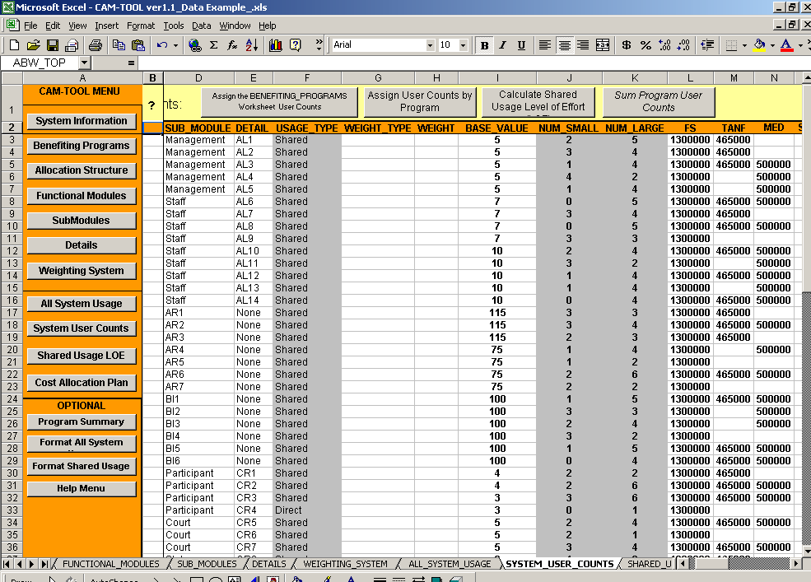

- The above screenshot of the SYSTEM_USER_COUNTS worksheet has been pre-populated with data. The ALL_SYSTEM_USAGE information has been copied to this worksheet using the “Copy for System User Counts” button located on the ALL_SYSTEM_USAGE worksheet.

- This worksheet is used to capture the number of benefiting program recipients or caseloads that will be using the system functionality in order to determine the “fair share” contribution for small and large programs.

- The usage=”X” markers in the benefiting program columns will be replaced by the actual user counts, which are either the benefiting programs’ number of recipients or the number of caseloads that will be benefit from or impact the use of the system functionality. For example, if the Food Stamps (FS) program has 500,000 recipients or caseloads then all of the usage=”X” markers under the FS column will be replaced with the value of 500,000.

- SYSTEM_USER_COUNTS MENU FEATURES
- The SYSTEM_USER_COUNTS worksheet has menu buttons to provide automated functionality to the user.

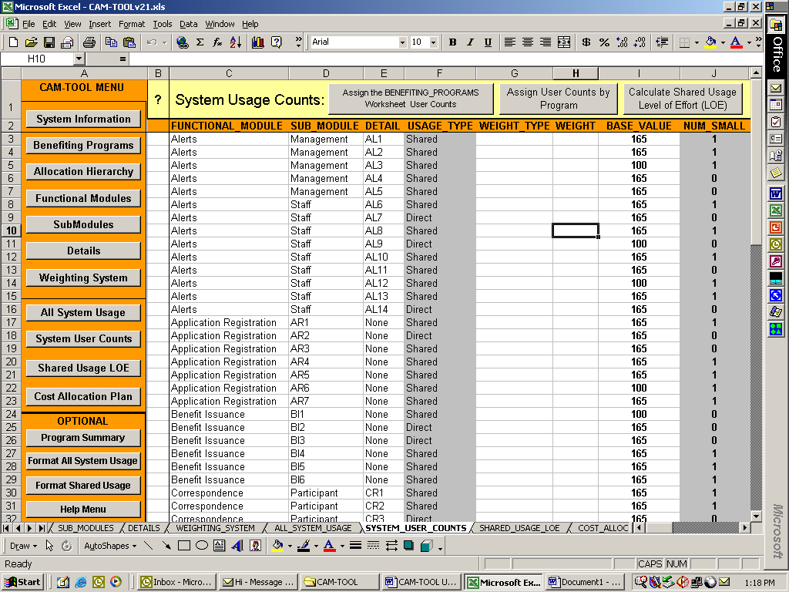
- Assign the Benefiting_Programs Worksheet User Counts: Users can use this button to insert the user counts captured on the Benefiting_Programs worksheet automatically.

- The following screenshot shows the use of the “Assign the BENEFITING_PROGRAMS Worksheet User Counts” button.

- Each cell with usage=”X” has been assigned the user counts for the benefiting programs that are located on the BENEFITING_PROGRAMS worksheet.
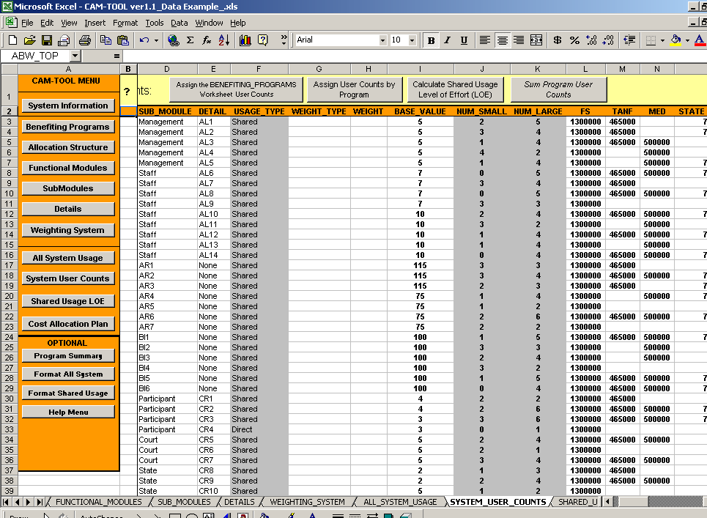
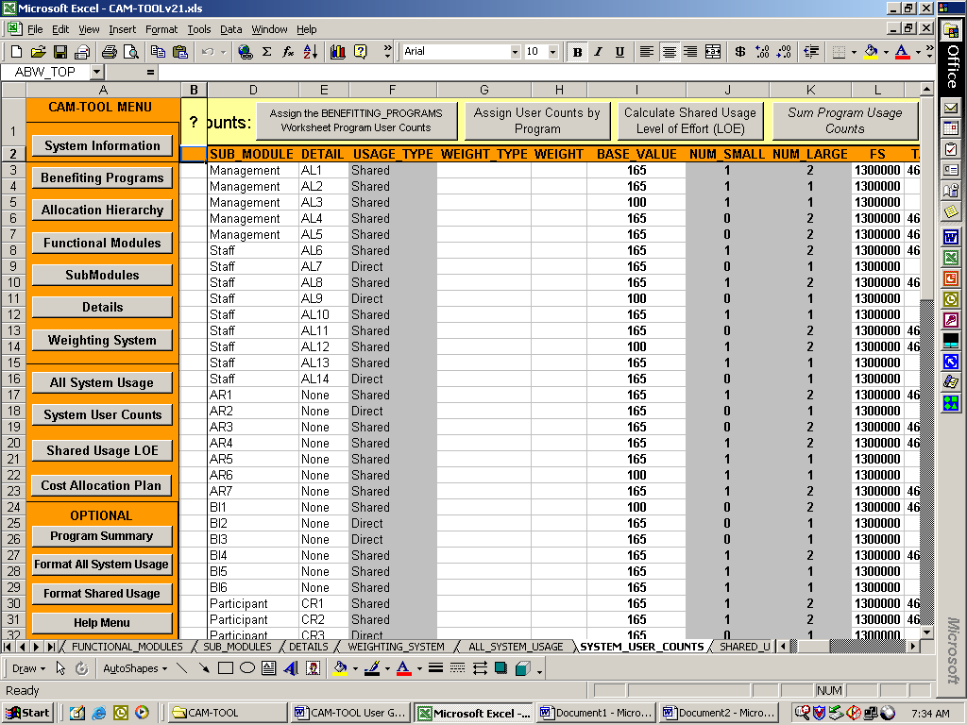
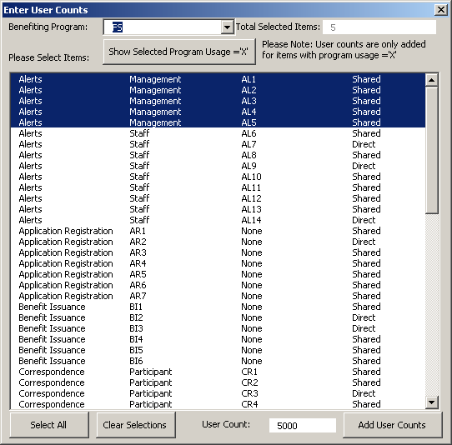
Assign User Counts by Program: Users use this button to enter user counts manually, if the user would like to capture the specific number of program participants that would actually benefit from the system functionality. The “Enter User Counts” window will appear after clicking on this button.

- Users select the benefiting program in the drop-down box, select the system functionality where usage =”X” for the program and enter a user count to insert.

- As an example, this option would be used if FS (e.g., Food Stamps) had a total user count of 500,000 but only 225,000 of the program participants would interact with the system functionality. So, instead of entering the standard of 500,000 where usage =”X”, then specific numbers like 225,000 would be entered. The benefiting programs involved in the cost allocation would need to determine actual users by system functionality.

- PLEASE NOTE: The use of this button may be rare because collection of such detail may not be cost effective. Having user counts of actual benefit would be more accurate. However, capturing user counts at this level of detail may have only a small impact on the cost allocation “fair share” for small and large programs.

- Calculate Shared Usage Level of Effort (LOE): Users use this button to calculate the data used to determine the final cost allocation “fair share” (i.e. percentages) for the benefiting programs. The user counts are used to calculate an “adjusted” level of benefit for any “small” programs that are involved in the system cost allocation. If a system only has large programs then the cost allocation will be divided equally among all programs using the specific system functionality. However, if the system has both small and large programs then the small programs’ percentage of total user counts are used to help determine the small program share and the large program share. Clicking this button creates and inserts the data for the SHARED_USAGE_LOE worksheet.

An example of how the “Calculate Shared Usage Level of Effort (LOE)” button uses the user counts to calculate the data for the SHARED_USAGE_LOE worksheets is as follows:

- Step 1: Assume that a system has 5 benefiting programs indicated on the Benefiting_Programs worksheet as follows: 2 Small and 3 Large programs

PROGRAM_ABBREV | PROGRAM | PROGRAM_SIZE | USER_COUNTS
FS | Food Stamps | Large | 500,000
TANF | TANF | Large | 465,000
MED | MEDICAID | Large | 500,000
PROGRAM 4 | PROGRAM 4 | Small | 750
PROGRAM 5 | PROGRAM 5 | Small | 900

- Step 2: The following program usage assignments are made on the ALL_SYSTEM_USAGE worksheet. Base values and weights are assigned on the ALL_SYSTEM_USAGE worksheet as well. However, these values will be shown later in this example.

Functional Module | SubModule | Detail | Usage  Type | Num  Small | Num  Large | FS | TANF | MED | Program 4 | Program 5
Alerts | Management | AL1 | Shared | 1 | 3 | X | X | X | X
Alerts | Management | AL2 | Shared | 2 | 2 | X |  | X | X | X
Alerts | Management | AL3 | Shared | 1 | 1 | X |  |  |  | X
Alerts | Management | AL4 | Shared | 2 | 2 | X | X |  | X | X
Alerts | Management | AL5 | Shared | 0 | 3 | X | X | X

- Step 3: The ALL_SYSTEM_USAGE worksheet information is copied to SYSTEM_USER_COUNTS worksheet and the user counts from the benefiting_program worksheet are assigned in cells where usage=”X”
Functional Module | SubModule | Detail | Num  Small | Num  Large | FS | TANF | MED | Program4 | Program5 | Total
Alerts | Management | AL1 | 1 | 3 | 500000 | 465000 | 500000 | 750 |  | 1465750
Alerts | Management | AL2 | 2 | 2 | 500000 |  | 500000 | 750 | 900 | 1001650
Alerts | Management | AL3 | 1 | 1 | 500000 |  |  |  | 900 | 500900
Alerts | Management | AL4 | 2 | 2 | 500000 | 465000 |  | 750 | 900 | 966650
Alerts | Management | AL5 | 0 | 3 | 500000 | 465000 | 500000 |  |  | 1465000

- Step 4: A user count percentage for all small programs is calculated by dividing the small program user counts by the total user counts.
  - For example in row 1, Program 4 user counts = 750. The percentage associated with Program 4’s user counts is 750/1465750 = 0.0005

Functional Module | SubModule | Detail | Num  Small | Num  Large | FS | TANF | MED | Program4 | Program5 | Total
Alerts | Management | AL1 | 1 | 3 |  |  |  | 0.0005
Alerts | Management | AL2 | 2 | 2 |  |  |  | 0.0007 | 0.0009
Alerts | Management | AL3 | 1 | 1 |  |  |  |  | 0.0018
Alerts | Management | AL4 | 2 | 2 |  |  |  | 0.0008 | 0.0009
Alerts | Management | AL5 | 0 | 3

- Step 5: The percentage for the large programs is calculated by equally dividing the remainder of the total share after deducting the total of the small programs share.
  - Using row 2 as an example, 1 (i.e.,100% of the Total) - [.0007+.0009] (i.e., the total share of small programs) = .9984

  - Each of the large programs’ share is .9984 divided by the number of large programs. In row 2, Num Large = 2. Therefore .9984/2 = .4992 and is the share designated for each of the large programs in row 2.

Functional Module | SubModule | Detail | Num  Small | Num  Large | FS | TANF | MED | Program4 | Program5 | Total
Alerts | Management | AL1 | 1 | 3 | .3332 | . 3332 | . 3332 | 0.0005 |  | 1
Alerts | Management | AL2 | 2 | 2 | .4992 |  | .4992 | 0.0007 | 0.0009 | 1
Alerts | Management | AL3 | 1 | 1 | .9982 |  |  |  | 0.0018 | 1
Alerts | Management | AL4 | 2 | 2 | .4991 | .4991 |  | 0.0008 | 0.0009 | 1
Alerts | Management | AL5 | 0 | 3 | .3333 | .3333 | .3333 |  |  | 1

- Step 6: Assume the allocation base selected for this cost allocation is software development hours. There is no need to create a weighting system. The “Num Small” and “Num Large” columns have been replaced by the “Base Value” and “Weight” columns. The weights column has been left blank because it does not apply.

Functional Module | SubModule | Detail | Base Value | Weight | FS | TANF | MED | Program4 | Program5 | Total
Alerts | Management | AL1 | 20 |  | .3332 | . 3332 | . 3332 | 0.0005 |  | 1
Alerts | Management | AL2 | 25 |  | .4992 |  | .4992 | 0.0007 | 0.0009 | 1
Alerts | Management | AL3 | 10 |  | .9982 |  |  |  | 0.0018 | 1
Alerts | Management | AL4 | 5 |  | .4991 | .4991 |  | 0.0008 | 0.0009 | 1
Alerts | Management | AL5 | 5 |  | .3333 | .3333 | .3333 |  |  | 1

- Step 7: The CAM-TOOL multiplies the base values of the system functionality by the benefiting program’s percent share in decimal format. If a weighting system is used, then the CAM-TOOL will multiply (base value X weight X program percent share in decimal format) to calculate the final values for the benefiting program cells.
  - For example in row 2, 25 [the base value] X .4992 [Food Stamp’s program percent share in decimal format, as shown previously] = 12.48

Functional Module | SubModule | Detail | Base Value | Weight | FS | TANF | MED | Program4 | Program5 | Total
Alerts | Management | AL1 | 20 |  | 6.664 | 6.664 | 6.664 | 0.01 |  | 20
Alerts | Management | AL2 | 25 |  | 12.48 |  | 12.48 | 0.0175 | 0.0225 | 25
Alerts | Management | AL3 | 10 |  | 9.982 |  |  |  | 0.018 | 10
Alerts | Management | AL4 | 5 |  | 2.4955 | 2.4955 |  | 0.004 | 0.0045 | 5
Alerts | Management | AL5 | 5 |  | 1.6665 | 1.6665 | 1.6665 |  |  | 5

- Step 8: Finally, the calculated data in the table above is inserted into the SHARED_USAGE_LOE worksheet automatically and is used to calculate the final benefiting program’s “fair share” contribution to the software development.
- Sum Program Usage Counts: is an optional button as indicated by the italics. Users can use this button to calculate the total user counts by row on the System_Usage_Counts worksheet. However, the total user counts by row are calculated automatically when the buttons “Assign the Benefiting_Program Worksheet Program User Counts” and “Calculate Shared Usage Level of Effort (LOE) are used. This button is intended to allow the user to total users by row when the “Assign User Counts By Program” button is used to add user counts manually. Therefore, this button may be rarely used.

The SHARED_USAGE_LOE Worksheet

- Click on the SHARED_USAGE_LOE button.

The user will be presented with the SHARED_USAGE_LOE worksheet as shown below:
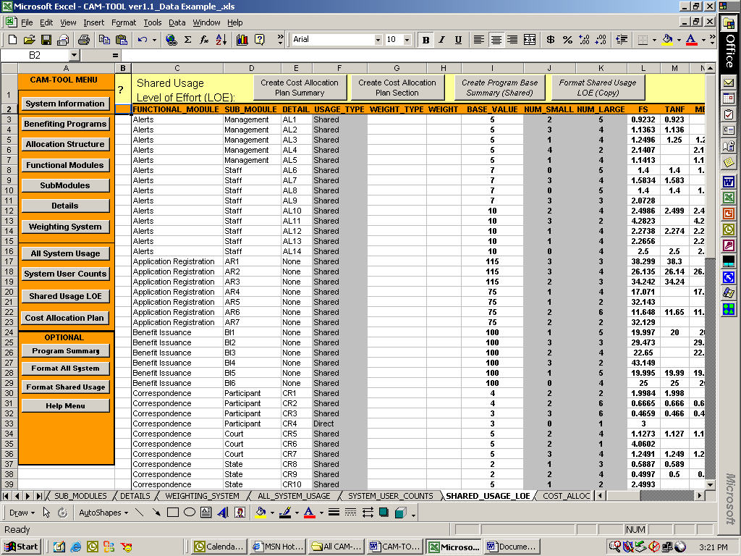
The level of effort values for the system functionality by each benefiting program

- The above screenshot of the SHARED_USAGE_LOE worksheet has been pre-populated with data by clicking on the “Calculate Shared Usage Level of Effort (LOE)” button on the SYSTEM_USER_COUNTS worksheet. The process of creating the level of effort values for this worksheet is explained in the description of the “Calculate Shared Usage Level of Effort (LOE)” button in the SYSTEM_USER_COUNTS worksheet section.

- At this point in the cost allocation process, the final shared usage level of effort values have been calculated. These numbers are used to create the cost allocation plan for all of the benefiting programs.
- SHARED_USAGE_LOE MENU FEATURES
  - The SHARED_USAGE_LOE worksheet has menu buttons to provide automated functionality to the user.
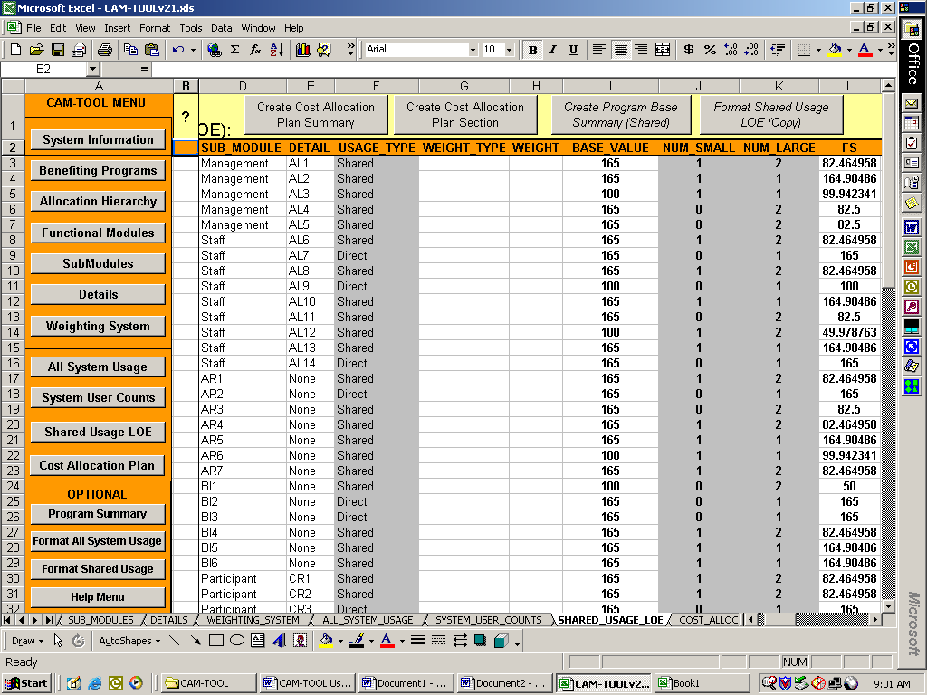
- Create Cost Allocation Plan Summary: Users use this button to generate a cost allocation summary for all of the system functionality and benefiting programs. This summary is inserted into the COST_ALLOCATION_PLAN worksheet. The CAM-TOOL will add up all of the shared usage level of effort values for each of the benefiting programs to determine the final percent share in decimal format as shown below.

Functional Module | SubModule | Detail | Base Value | Weight | FS | TANF | MED | Program4 | Program5 | Total
Alerts | Management | AL1 | 20 |  | 6.664 | 6.664 | 6.664 | 0.01 |  | 20
Alerts | Management | AL2 | 25 |  | 12.48 |  | 12.48 | 0.0175 | 0.0225 | 25
Alerts | Management | AL3 | 10 |  | 9.982 |  |  |  | 0.018 | 10
Alerts | Management | AL4 | 5 |  | 2.4955 | 2.4955 |  | 0.004 | 0.0045 | 5
Alerts | Management | AL5 | 5 |  | 1.6665 | 1.6665 | 1.6665 |  |  | 5
TOTALS: |  |  |  |  | 33.288 | 10.826 | 20.8105 | 0.0315 | 0.045 | 65
Percent Share in decimal format: |  |  |  |  | 0.5121 | 0.1666 | 0.3202 | 0.0005 | 0.0007 | 1.0000

- The totals and percent share in decimal format are calculated, but are not shown on the SHARED_USAGE_LOE worksheet. The percent share in decimal format is inserted on to the COST_ALLOCATION_PLAN worksheet. Please refer to the COST_ALLOCATION_PLAN section for a screenshot of the percent share values.

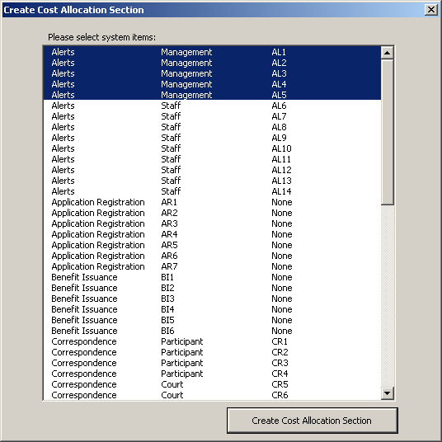
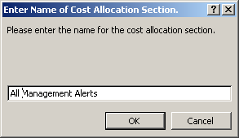
- Create Cost Allocation Plan Section: Users use this button to generate a cost allocation summary for a specific section of the system functionality. The “Create Cost Allocation Section” window will appear after clicking on this button.

- Users select specific system functionality to create a cost allocation summary. In the example in the screenshot, all Management alerts have been selected. A summary of the cost allocation for the management alerts will be inserted on to the COST_ALLOCATION_PLAN worksheet.

- After clicking the “Create Cost Allocation Section” button , users will be asked to provide a name for the cost allocation summary that will be inserted with the cost allocation summary on to the COST_ALLOCATION_PLAN worksheet.
- Create Program Base Summary (Shared): is an optional button indicated by the italics of the button. This button will create a summary of usage by benefiting program on the PROGRAM_SUMMARY worksheet. For example, if a benefiting program only uses 45 of 100 system functionality components, then the 45 components will be listed for that benefiting program on the PROGRAM_SUMMARY worksheet.
- Format Shared Usage LOE (Copy): is an optional button that allows the user to copy the information on this worksheet to the worksheet FORMAT_SHARED_USAGE_LOE for any desired formatting purposes or other analysis.

The COST_ALLOCATION_PLAN Worksheet

- Click on the Cost Allocation Plan button.

The user will be presented with the COST_ALLOCATION_PLAN worksheet as shown below:
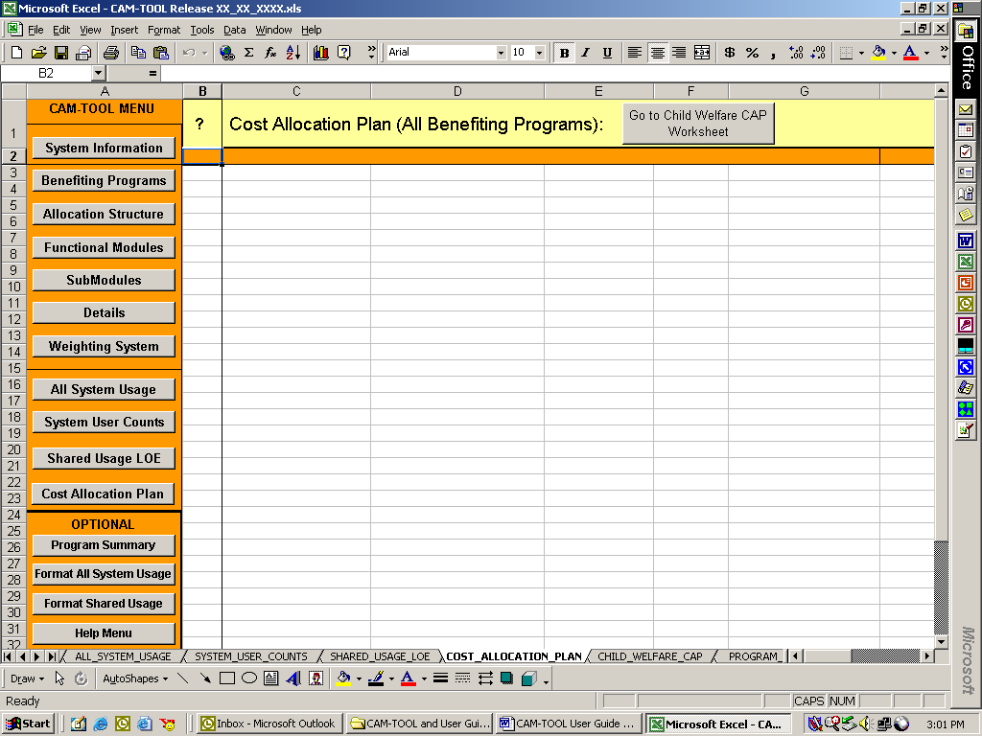
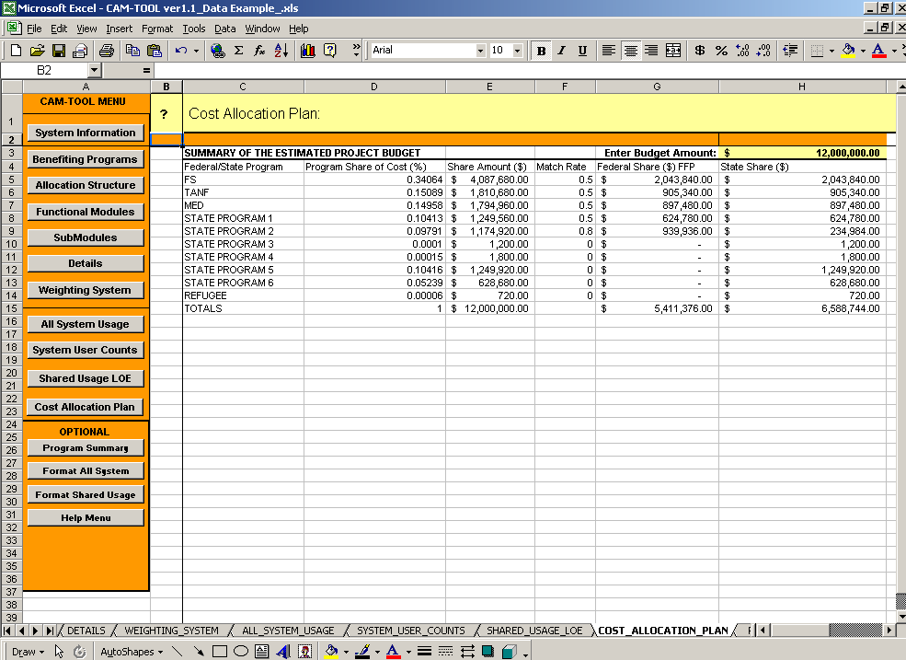

The Summary of the Estimated Project Budget table is created by clicking on the “Create Cost Allocation Plan Summary” or the “Create Cost Allocation Plan Section” buttons on the SHARED_USAGE_LOE worksheet.

- This summary table contains each of the benefiting programs, their final percentage share in decimal format, and the columns to calculate the dollar amounts for their contribution.

- Users must enter the “Budget Amount” and the appropriate match rates and the worksheet will calculate the Share Amount($), Federal Share($) FFP, and the State Share($) as shown below.

SUMMARY OF THE ESTIMATED PROJECT BUDGET |  |  |  | Enter Budget Amount: | $ 5,000,000.00
Federal/State Program | Program Share of Cost (%) | Share Amount ($) | Match Rate | Federal Share ($) FFP | State Share ($)
FS | 0.71536 | $ 3,576,800.00 | 0.5 | $ 1,788,400.00 | $ 1,788,400.00
TANF | 0.28432 | $ 1,421,600.00 | 0 | $ - | $ 1,421,600.00
STATE PROGRAM 3 | 0.00032 | $ 1,600.00 | 0 | $ - | $ 1,600.00
TOTALS | 1 | $ 5,000,000.00 | 0 | $ - | $ 5,000,000.00

Users can transfer the summary information shown above directly into their required exhibit (table) in their Cost Allocation Plan.

Go to Child Welfare CAP Worksheet: is an optional button that goes to a worksheet where the user can enter the cost allocation breakdown for child welfare funding streams, if child welfare is one of the benefiting programs.

- The Child Welfare CAP worksheet is an optional supplemental worksheet to the COST_ALLOCATION_PLAN Worksheet. The cost allocation summary table located on the COST_ALLOCATION_PLAN worksheet only provides high-level cost allocation for child welfare related functionality in a shared system used by multiple operating divisions. States must further allocate the child welfare costs indicated in the cost allocation plan summary table based on existing guidance.

The CHILD_WELFARE_CAP Worksheet
(An Optional Supplemental to the COST_ALLOCATION_PLAN worksheet)

- Click on the Go to Child Welfare CAP Worksheet button located on the COST_ALLOCATION_PLAN worksheet.

The user will be presented with the CHILD_WELFARE_CAP worksheet as shown below:
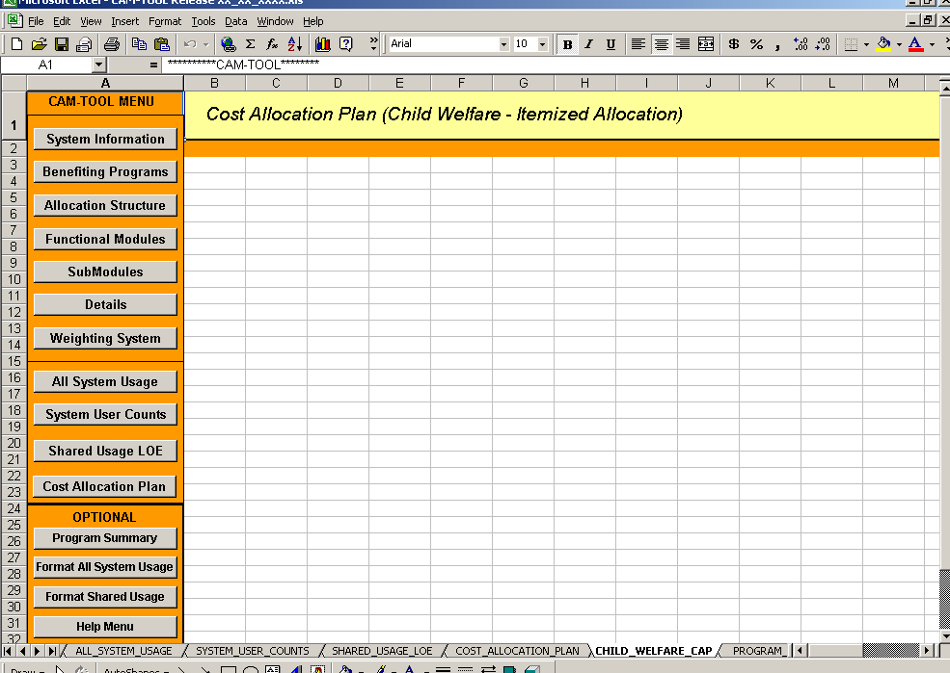

- The cost allocation summary table located on the COST_ALLOCATION_PLAN worksheet only provides high-level cost allocation for child welfare related functionality in a shared system used by multiple operating divisions. States must further allocate the child welfare costs indicated in the cost allocation plan summary table based on existing guidance.

- States may use this worksheet to document the itemized allocation of child welfare costs.

The PROGRAM_SUMMARY Worksheet

- Click on the Program Summary Button.

The user will be presented with the PROGRAM_SUMMARY worksheet as shown below:
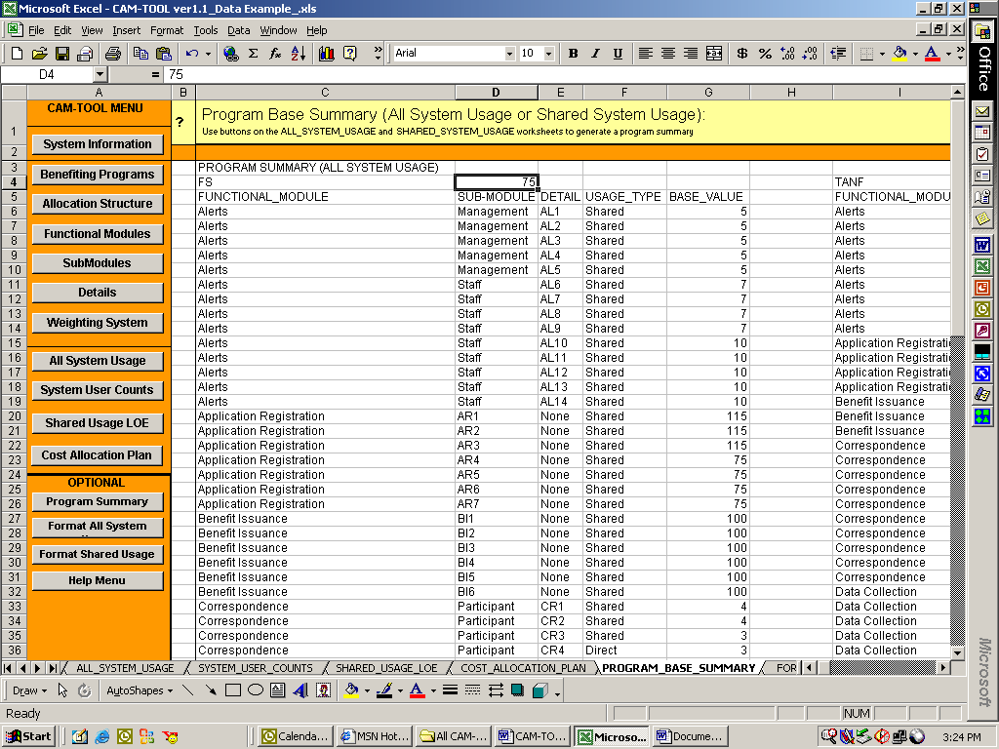

The above screenshot of the PROGRAM_SUMMARY worksheet has been pre-populated with data by clicking on the “Create Program Base Summary (ALL)” and “Create Program Base Summary (Shared”) buttons on the ALL_SYSTEM_USAGE and SHARED_USAGE_LOE worksheets respectively.

- A summary of usage for each program is generated on this worksheet. In the above screenshot any system functionality on the ALL_SYSTEM_USAGE worksheet with usage=”X” has been summarized for the Food Stamps (FS) program. There are 74 system items that benefit the Food Stamps program in this cost allocation example.

The FORMAT_ALL_SYSTEM_USAGE Worksheet

- Click on the Format All System Usage button.

The user will be presented with the FORMAT_ALL_SYSTEM_USAGE worksheet as shown below:

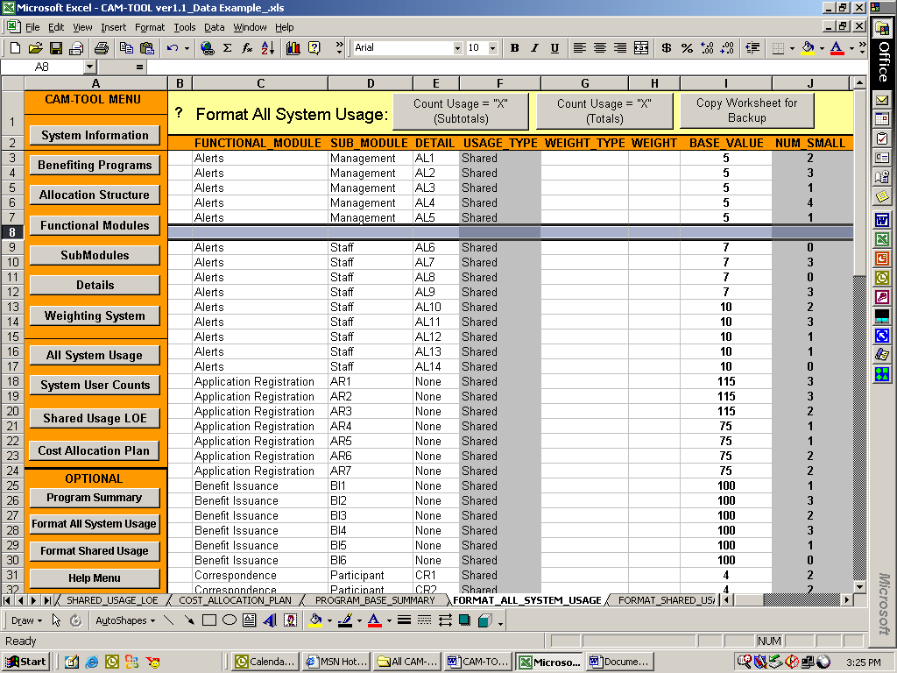

- The above screenshot of the FORMAT_ALL_SYSTEM_USAGE worksheet has been pre-populated with data by clicking on the “Format ALL_SYSTEM_USAGE”) button on the ALL_SYSTEM_USAGE worksheet.

- Use this worksheet to manipulate and format information from the ALL_SYSTEM_USAGE worksheet. The CAM-TOOL uses the ALL_SYSTEM_USAGE worksheet for calculations, so this sheet has been provided for any customized analysis that users would like to perform on the data (e.g., adding extra columns, adding row spaces, etc.)

- FORMAT_ALL_SYSTEM_USAGE MENU FEATURES
  - The Format_ALL_SYSTEM_USAGE worksheet has menu buttons to provide automated functionality to the user.
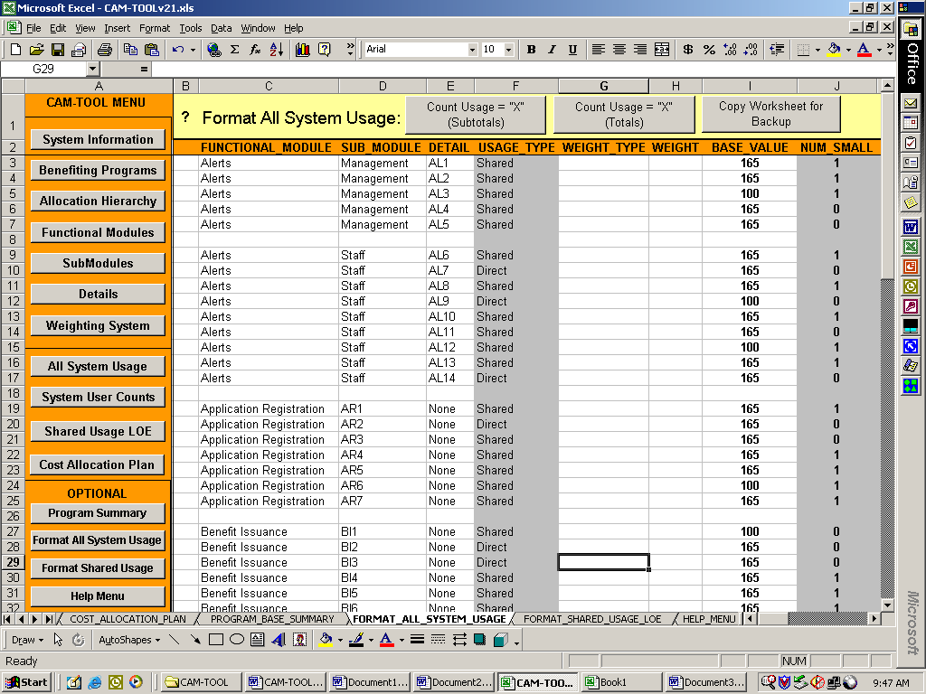
- Count Usage = “X” (Subtotals): allows the user to create subtotals for the benefiting program columns by counting the cells marked with a “X” that the user has selected.
- Count Usage = “X” (Totals): allows the user to create a total based on selected cells by counting the cells marked with a “X” that the user has selected.
- Copy Worksheet for Backup: copies the information in the Format_ALL_SYSTEM_USAGE worksheet to a backup worksheet.

The FORMAT_SHARED_USAGE Worksheet

- Click on the Format Shared Usage button.

The user will be presented with the FORMAT_SHARED_USAGE worksheet as shown below:
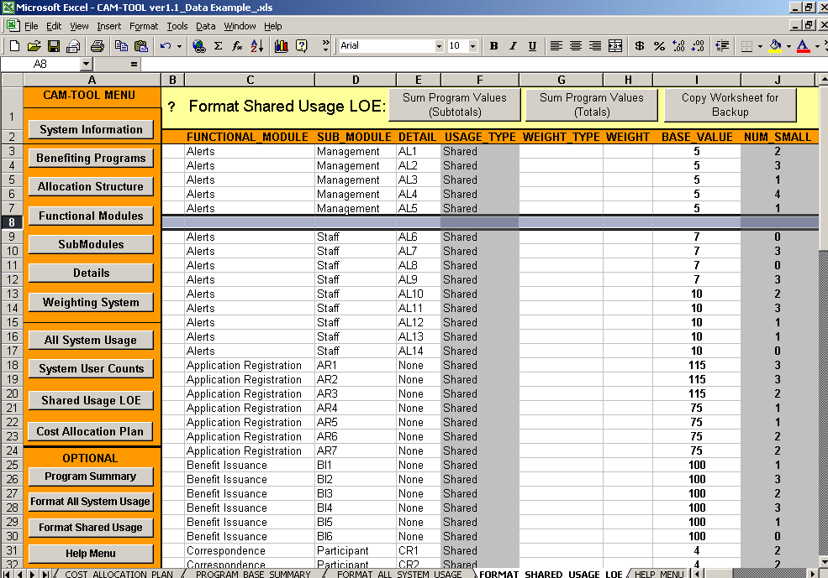
  - The above screenshot of the FORMAT_SHARED_USAGE worksheet has been pre-populated with data by clicking on the “Format Shared Usage” button on the SHARED_USAGE_LOE worksheet.

  - Use this worksheet to manipulate and format information from the SHARED_USAGE_LOE worksheet. The CAM-TOOL uses the SHARED_USAGE_LOE worksheet for calculations, so this sheet has been provided for any customized analysis that users would like to perform on the data (e.g., adding extra columns, adding row spaces, etc.)

- FORMAT_SHARED_USAGE MENU FEATURES
  - The Format_ALL_SYSTEM_USAGE worksheet has menu buttons to provide automated functionality to the user.
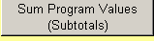
- Sum Program Values (Subtotals): allows the user to create subtotals for the benefiting program columns by adding all the cells that the user has selected.
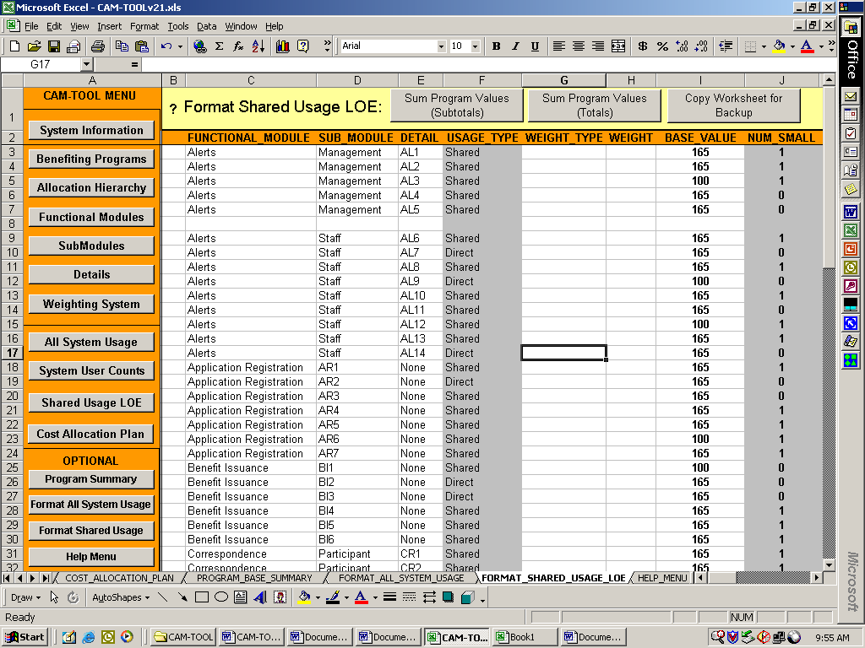
- Sum Program Values (Totals): allows the user to create a total based on selected cells by adding all the cells that the user has selected.

- Copy Worksheet for Backup: copies the information in the Format_Shared_Usage worksheet to a backup worksheet

The Help Menu Worksheet

- Click on the Help Menu button.

The user will be presented with the HELP_MENU worksheet as shown below:

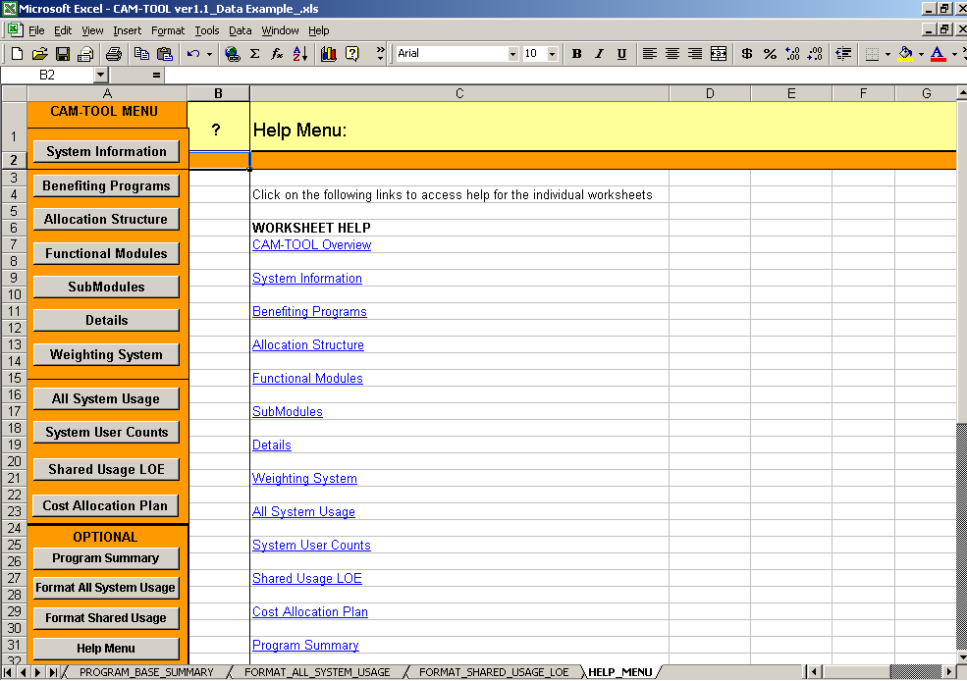

- Click on the worksheet name to access the help file. Again, each worksheet has a “?” (i.e., question mark) in cell “B1” that allows the users to access these files. These files are the pages of the user manual that relate the specific worksheet.

CAM-TOOL Worksheet Required Fields

The following table lists the CAM-TOOL Worksheet Required Fields. These fields are needed for the automated calculations completed by the tool. All of the required fields on the “All System Usage” worksheet are copied to the “System User Counts” and “Shared Usage LOE” worksheets.

Worksheet | Field | Status | Data Type and Value | Data Entry
Benefiting Programs | PROGRAM_ABBREV | Required | Alphanumeric | Yes
Benefiting Programs | PROGRAM | Required | Alphanumeric | Yes
Benefiting Programs | PROGRAM_SIZE | Required | Large or Small | Yes
Benefiting Programs | USER_COUNTS | Required | Numeric (greater than 0) | Yes
Benefiting Programs | MATCH RATE | Required | Decimal (greater than or equal to 0) | Yes
All System Usage | FUNCTIONAL MODULE | Required | Alphanumeric | Yes
All System Usage | USAGE_TYPE | Required | Not Applicable | No, calculated by CAM-TOOL
All System Usage | BASE_VALUE | Required | Numeric (greater than 0) | Yes
All System Usage | NUM_SMALL | Required | Not Applicable | No, calculated by CAM-TOOL
All System Usage | NUM_LARGE | Required | Not Applicable | No, calculated by CAM-TOOL

If level-of-effort is not captured by the allocation base then, the following fields are also required.

Worksheet | Field | Status | Data Type and Value | Data Entry
All System Usage | WEIGHT_TYPE | Required | Alphanumeric | Yes
All System Usage | WEIGHT | Required | Numeric (greater than 0) | Yes

Glossary of Terms

 | Term | Definition
 | All Usage: | Direct (used by only one program) and shared (used by two or more programs) system functionality use by benefiting programs
 | Allocation Base: | The cost allocation measurement selected to track and calculate the cost allocation for all benefiting programs. Development hours, lines of code (LOC), and number of screens are examples of allocation bases in software development.
 | Allocation Hierarchy: | The categorization of system functionality into levels of detail for cost allocation purposes. The allocation hierarchy is composed of three levels: Functional Module, SubModule, and Detail in the CAM-TOOL.
 | Base Value | The numeric value associated to specific system functionality. The meaning of the base depends on the selected allocation base. For example, if the allocation base is software development hours and specific system functionality has a base value = 100, the 100 means 100 software development hours was used on that system functionality.
 | Benefiting Program: | Any program that uses the system functionality
 | Direct Usage: | System functionality used by only one benefiting program
 | Level of Effort: | The development work or value associated to the system functionality
 | Program Usage Assignment: | The indication that a benefiting program uses a specific piece of system functionality that is indicated by cells marked with a capital "X" on the ALL_SYSTEM_USAGE worksheet.
 | Shared Usage: | System functionality used by two or more benefiting programs
 | System Functionality: | Specific components of the system for which development effort can be tracked. System functionality is mapped to the allocation hierarchy in the tool.
 | User Counts: | The number of recipients or the number of cases of each benefiting program. This number is used to determine an "adjusted" cost allocation share for small programs.
 | Weight | A numeric indicator for the level of effort associated with system functionality, if the allocation base does not include level of effort. For example, an allocation base like lines of code (LOC) is a size measure and does not signify the work or true value of the system functionality. Therefore, a weight (i.e., a complexity factor) needs to be assigned to the system functionality.
 | Weight Type | A descriptor for the weight being used for the system functionality. For example, if a project decides to use lines of code (LOC) and a weighting numeric scale of (1 to 5), 1 - meaning low complexity and 5 - meaning high complexity, the weight type is "low", "high,” etc. In addition, projects may choose to count the number of steps or decisions in specific system functionality. Therefore, the weight type could be "Steps" or "Decisions."

