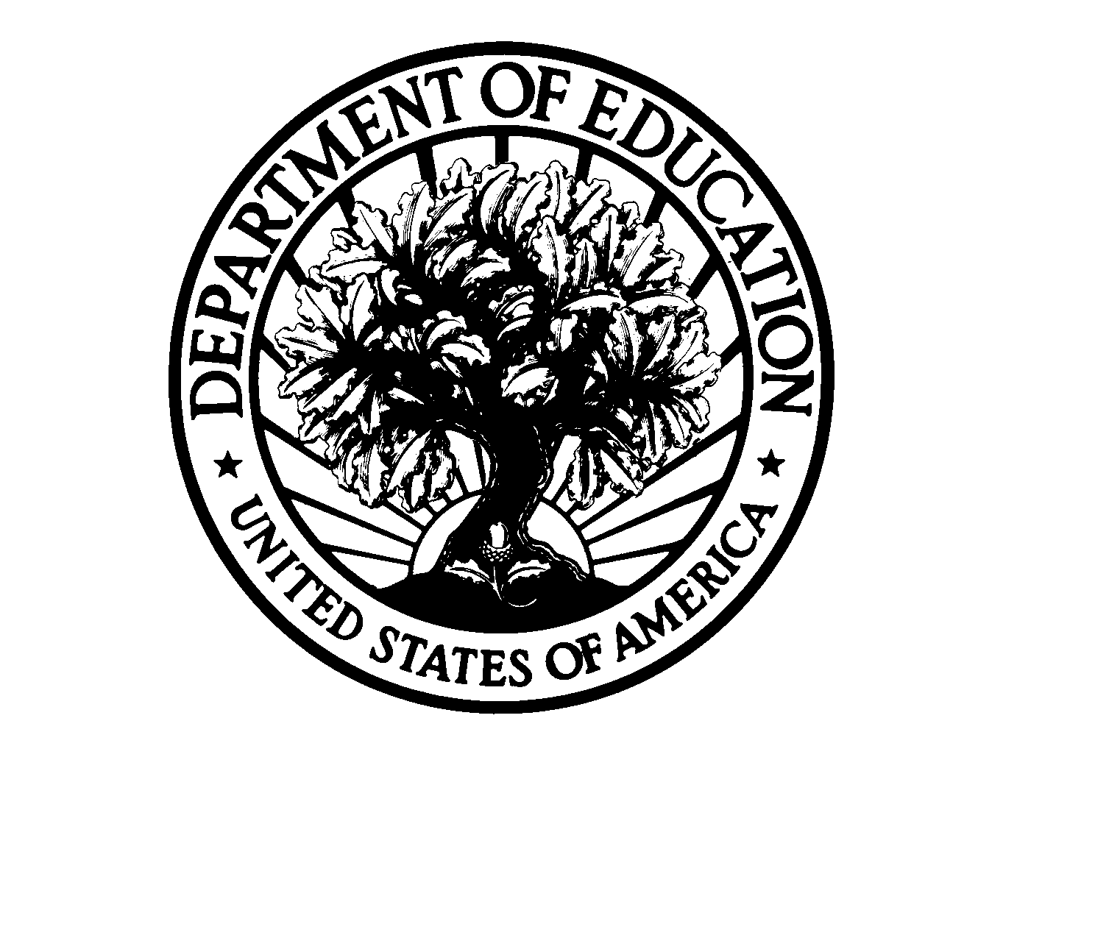
Certification of eligibility for federal assistance in certain programs

I understand that 34 CFR 75.60, 75.61, and 75.62 require that I make specific certifications of eligibility to the U.S. Department of Education (ED) as a condition of applying for Federal funds in certain programs and that these requirements are in addition to any other eligibility requirements that ED imposes under program regulations. Under 34 CFR 75.60 – 75.62:

- I certify that:

- I do not owe a debt, or I am current in repaying a debt, or I am not in default (as that term is used at 34 CFR Part 668) on a debt:

- To the Federal Government under a nonprocurement transaction (e.g., a previous loan, scholarship, grant, or cooperative agreement); or

- For a fellowship, scholarship, stipend, discretionary grant, or loan in any program of ED that is subject to 34 CFR 75.60, 75.61, and 75.62, including:

- Federal Pell Grant Program (20 U.S.C. 1070a, et seq.);
- Federal Supplemental Educational Opportunity Grant (SEOG) Program (20 U.S.C. 1070(b), et seq.):
- State Student Incentive Grant Program (SSIG) 20 U.S.C. 1070c, et seq.);
- Federal Perkins Loan Program (20 U.S.C. 1087aa, et seq.);
- Income Contingent Direct Loan Demonstration Project (20 U.S.C. 1087a, note);
- Federal Stafford Loan Program, Federal Supplemental Loans for Students [SLS], Federal PLUS, or Federal Consolidation Loan Program (20 U.S.C. 1071, et seq.);
- William D. Ford Federal Direct Loan Program (20 U.S.C. 1087a, et. seq.);
- Cuban Student Loan Program (20 U.S.C. 2601, et seq.);
- Robert C. Byrd Honors Scholarship Program (20 U.S.C. 1070d-31, et seq.);
- Jacob K. Javits Fellows Program (20 U.S.C. 1134h-1134l);
- Patricia Roberts Harris Fellowship Program (20 U.S.C. 1134d-1134g);
- Christa McAuliffe Fellowship Program (20 U.S.C. 1105-1105i);
- Bilingual Education Fellowship Program (20 U.S.C. 3221-3262);
- Rehabilitation Long-Term Training Program (29 U.S.C. 774(b));
- Paul Douglas Teacher Scholarship Program (20 U.S.C. 1104, et seq.);
- Law Enforcement Education Program (42 U.S.C. 3775);
- Indian Fellowship Program (29 U.S.C. 774(b));
- Teacher Quality Enhancement Grants Program (20 U.S.C. 1021, et seq.);

OR

- I have made arrangements satisfactory to ED to repay a debt as described in A.1. or A.2. (above) on which I had not been current in repaying or on which I was in default (as that term is used in 34 CFR Part 668).

- I certify also that I have not been declared by a judge, as a condition of sentencing under section 5301 of the Anti-Drug Abuse Act of 1988 (21 U.S.C. 862), ineligible to receive Federal assistance for the period of this requested funding.

I understand that providing a false certification to any of the statements above makes me liable for repayment to ED for funds received on the basis of this certification, for civil penalties, and for criminal prosecution under 18 U.S.C. 1001.

____________________________________________ ____________________________________
(signature) (Date)

____________________________________________
(typed or printed name)

Name or number of ED program under which this certification is being made: _____________________________

ED 80-0016 (Revised 2/01)

