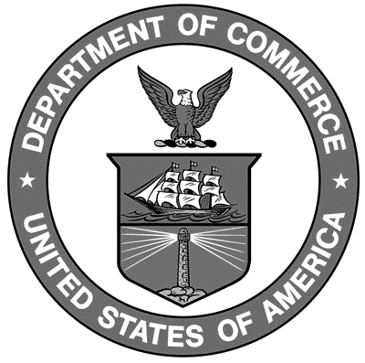

Uniform Laws and Regulations
in the areas of
legal metrology and
engine fuel quality

as adopted by the 92nd National Conference on Weights and Measures 2007

Editors:
Tom Coleman
Linda Crown
Lynn Sebring
Lisa Warfield

Carol Hockert, Chief
Weights and Measures Division

National Institute of Standards and Technology
Weights and Measures Division
Gaithersburg, MD 20899-2600

U.S. Department of Commerce
Carlos M. Gutierrez, Secretary

Technology Administration
Robert Cresanti, Under Secretary
of Commerce for Technology

National Institute of

Standards and Technology
William A. Jeffrey, Director
NIST Handbook₁₃₀
2008 Edition
Supersedes NIST Handbook 130, 2006 Edition
Certain commercial entities, equipment, or materials may be identified in this document in order to describe an experimental procedure or concept adequately. Such identification is not intended to imply recommendation or endorsement by the National Institute of Standards and Technology, nor is it intended to imply that the entities, materials, or equipment are necessarily the best available for the purpose.

National Institute of Standards and Technology Handbook 130, 2008 Edition
Natl. Inst. Stand. Technol. Handb. 130, 2008 Ed., 268 pages (October 2008)
CODEN: NIHAE2

WASHINGTON: 2007

