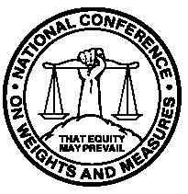
Report of the 92nd
National Conference
on Weights and Measures

Salt Lake City, Utah – July 8 through 12, 2007
as adopted by the 92nd National Conference on Weights and Measures 2007

Editors:
Linda Crown
Lynn Sebring
Technical Advisors to the Standing Committees

Carol Hockert, Chief
Weights and Measures Division

National Institute of Standards and Technology
Weights and Measures Division
Gaithersburg, MD 20899-2600

U.S. Department of Commerce
Carlos M. Gutierrez, Secretary

National Institute of

Standards and Technology
James Turner, Acting Director
NIST Special Publication ₁₀₇₀
November 2007

The National Conference on Weights and Measures is supported by the National Institute of Standards and Technology and is attended by officials from various states, counties, and cities, as well as representatives from the U.S. Government, other nations, industry, and consumer organizations.

