
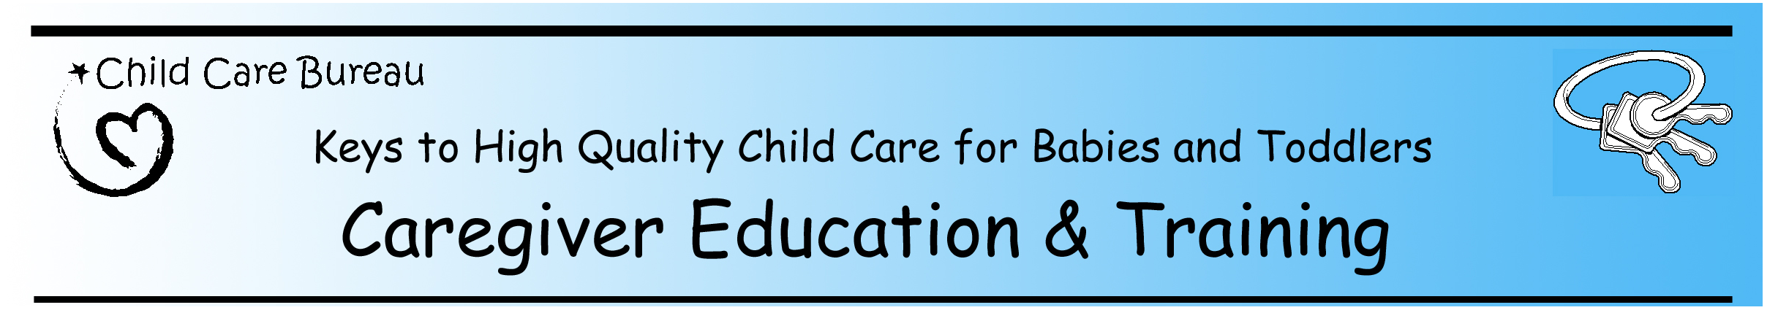.
Last Updated February 5, 2004

State Efforts that Support Infant & Toddler Caregiver Education and Training
Professional development is one of three goals included in the Good Start, Grow Smart initiative. As States are moving forward with their work, many are including professional development opportunities that are directed to infant and toddler caregivers. Below are a number of highlights taken from the Child Care Development Fund (CCDF) State plans and the Council for Professional Recognition’s Child Development Associate (CDA) program, that relate to education and training for providers who care for babies and toddlers.

CCDF State/Territory Plan Highlights
Efforts Directed to Infant & Toddler Caregivers:
- 51 offer training specific to infant & toddler care
- 31 use or are developing a specific curriculum for infant & toddler caregivers
- 18 indicated they use the Program for Infant and Toddler Caregivers (PITC) at WestEd curriculum
- 17 offer parent training/education specific to ages 0-3
- 12 offer or are working on an infant & toddler credential/certification
- 11 report they have one or more infant & toddler specialist

Efforts that Include Infant & Toddler Caregivers:
- 39 support CDA/accreditation
- 38 offer scholarships for CDA and/or other educational opportunities
- 27 are working on or have articulation agreements
- 25 have developed or are in the process of developing core competencies
- 23 have mentoring programs
- 21 offer the T.E.A.C.H. program
- 13 offer training for kith and kin caregivers

The information presented is taken from CCDF plans 2004/2005, and might not include all of the work being done by States
And Territories. Both proposed and current work is included. This information was taken from the available 48 of 51 State
plans and 4 of 5 Territory plans.

CDA Highlights

Percentages of CDAs* awarded in the past three years that include an infant & toddler focus:
- 7 States have 50% or more CDAs* with an Infant & Toddler (I/T) or Family Child Care** (FCC) focus
- 23 States have 40% or more of awarded CDAs* with an I/T or FCC** focus
- 41 States have 30% or more of awarded CDAs* with an I/T or FCC** focus
- FL has almost 3 times as many I/T as Pre-school CDA’s awarded

47 States accept CDA work as a qualification in State Child Care licensing regulations.

* Includes CDAs in infant & toddler, family child care and pre-school
** Family child care CDA includes a significant amount of infant & toddler work.

