SECTION III: Group Federal Officer Management Tools and Access to Advisory Committee Data

The Group Federal Officer (GFO) is not an official term with regards to the Federal Advisory Committee Act (FACA) or any other official government employee that we know of. The GFO title was created by the Committee Management Secretariat to identify the person holding an agency supervisory position over a group of committees, i.e., the National Park Service in the Department of the Interior, or the National Institutes of Health in the Department of Health and Human Services. The GFO uses the on-line system to manage the sub-group of advisory committees, manage agency users of the system within the sub-group, and, if necessary, to update the information on advisory committees during the current fiscal year and the Annual Comprehensive Review (ACR). FACA requires that information about the advisory committee be provided at least annually. The web-based database accommodates and builds upon that requirement by both allowing the continual updating of committee information throughout the fiscal year and providing committee management functionality. Keeping the data continuously up-to-date converts the system from a focus on history and records to a focus on management and immediate relevancy. With frequent and timely updates, the system becomes more useful to everyone, ranging from the public user to congressional staff with oversight responsibility.

What is the FACA Database?

The FACA database is a specialized database on the web. The Federal Advisory Committee Act originally required that specific data items about advisory committees be collected by the President annually and transmitted to Congress for review. From 1972 through 1996, this data was collected via collated, paper-based reports, produced in the fall of each year after the fiscal year closed. In 1997 and 1998, this on-line, web-based, database system was used by all the government agencies that have advisory committees to collect that data. In 1998, this on-line system was demonstrated to the House Oversight Committee on Government Reform. Since that year, this system has been used to continuously collect and report all of the advisory committee data and Congress no longer requires that a “printed and transmitted” annual report be produced, although the data must still be provided to facilitate a government wide Annual Comprehensive Review (ACR).

The “GFO” user has access with edit and update rights to the current fiscal year’s data for their specific committees via the Internet. The GFO is given their access rights, their logon (username) and their initial password by the agency Committee Management Officer (CMO). The GFO, like any public user, can view all of the information on all of the committees available for the current fiscal year in a read-only mode in the Public Access section of the system. At the same time, only the DFO, or their designee, the GFO or their designee, the agency CMO, or their designee, or a Committee Management Secretariat (CMS) staff member can edit or update the committee data being reported for the current year.

What kind of data is being collected and maintained?

For the GFO, the program collects, totals, and displays
- Committee charters and related information,
- Projected committee renewal or termination dates,
- Current Status reports to aid in committee management activities,
- Distribution of establishment authorities and committee functions,
- Committee members,
- Committee costs,
- Agency’s recommendations for continuation or termination of the committee,
- Report titles, publication dates, and electronic copies of the reports,
- Meeting dates, purposes, locations, whether the meetings were open or closed, and electronic copies of the meeting minutes,
- Ongoing committee justification information,
- Performance measurement data,
- GFO contact information,
- Agency users and editing rights, and
- Any web site addresses (URLs).
The database does not require meeting announcements or committee recommendations to the agency.

How does the GFO use the system?

The system is designed to capture relevant information when first entered by the CMO and DFO, and to carry that information forward from year to year until the information is no longer required.
1) When a committee is first established and chartered by the agency and added to the system by the CMO, the information entered addresses the committee’s general information, membership information, and estimated cost information requirements.
2) The CMO and/or the Committee Management Secretariat (CMS) use the Consultation process found on the Committee Menu page to complete the committee establishment. The GFO and DFO do have the Consultation hyperlink displayed on the Committee Menu page they normally view so they can review the consultation history, although they normally do not use the Consultation feature or conduct consultations with the Committee Management Secretariat,.
3) The CMO adds the DFO as a user to the system and provides the DFO access to the newly created committee.
4) The CMO creates a group of committees for intermediate management.
5) The CMO adds the new committee to the appropriate group (or, in some rare cases, more than one group).
6) The CMO adds the GFO as a user to the system and provides access to the committee group for which the GFO is responsible.
7) The CMO has the DFO or the GFO log onto the system and
- Edit the general information for completeness and accuracy which contributes to the annual report requirements and keeps the Renewal or Terminate Report timely and useful,
- Add meetings and reports as they occur,
- Add or delete members as they are appointed or as their appointments end,
- Add or update costs as they occur,
- Add or update the web address if a web site is created for the committee,
- Add or update their own contact information as it changes,
- Add or update the annual performance measurement data,
- Recommend the continuance or termination of the committee by the end of the fiscal year, and
- Verify the accuracy and completeness of the committee data for the closing year.
The guidance for the above data entry activities is found in the DFO Help manual, since the DFO or her designee normally does the committee level data entry and information maintenance. The GFO, or the CMO if she or he chooses to do any or all of the tasks above, would find that the general information data, cost information data, and member information data added during the establishment of the committee has been carried forward to the relevant report pages for each reportable year. At the end of the year being reported and closed, the program carries all of the data entered forward into the next year except for meetings and reports.

The GFO also has access to the public read-only section of the system. This section can be very helpful and useful to their management needs. Using the Search feature, the GFO can discover what other committees exist in other agencies with issues and concerns similar to committees they are responsible for or planning to charter. With that knowledge, the GFO can Drill Down to the specific committees of interest and determine if the system has information useful to them, or they can identify people in the other committee’s agency to contact for further investigation. In the Public Access section, the GFO also drills down from the general Year to the Agency to the specific Committee to view the desired information. At any time the GFO can Search the entire collection for any word or phrase, use Database Search to limit the data displayed based on selected criteria, and/or Download selected data to a spreadsheet with the Download Center.

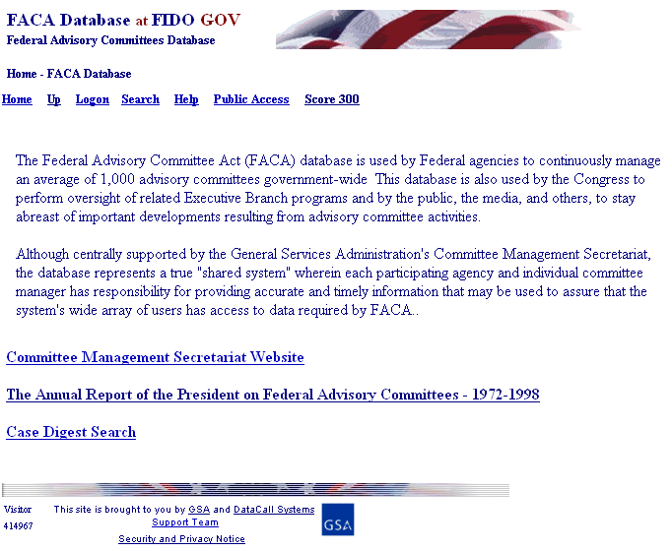
The opening screen for the FACA Database lets GFOs know that they have found the database and lists their options. The most direct address for the system is http://www.facadatabase.gov. The FACADatabase is part of a family of shared-interagency-databases located at http://www.fido.gov.
Hyperlinks and buttons control navigation throughout the system. The Navigation hyperlinks and buttons that are visible change depending upon the purpose of the page and the requirements (or rights) of the user. The navigation hyperlinks are located in the top border. GFOs should move from page to page with the navigation hyperlinks or buttons as much as possible and avoid use of the browser buttons (like the arrows to go back or forward).

The reason to avoid use of the browser button where possible is that the FACA Database is truly a database and an application running on the web. A database/application operates differently on the Internet than purely informational net pages. Browser buttons and menu options are designed and normally intended to take the user back to previously displayed pages of static, unchanged, and usually, minimally-related or completely unrelated content. On the other hand, while the pages of a database system might appear to change in content with every “selection, filter, edit, save, insert, or delete”, each page has a distinct, “keyed” relationship that is maintained with the preceding and following pages as the user drills down or moves up through the data.

The ten obvious hyperlinks on the opening screen navigate to the
Home page,
Up to the previous page in the navigation sequence,
Logon page,
Search page,
Help page,
Public Access page,
Score 300 page,
Committee Management Secretariat Website,
The Annual Report of the President on Federal Advisory Committees - 1972-1998 list, and the
Case Digest Search on-line db.
You will notice that the mouse pointer becomes a hand as the mouse moves over a hyperlink. There are hyperlinks on most of the pages to items which most web sites contain. The eight links on the Home page that are not explained include the FACA Database, FIDO, the picture of the American Flag, GSA, DataCall Systems, the GSA Logo, Support Team, and the Security and Privacy Notice link.

Home returns the user to the Home page shown above. It also serves as an exit or clean-up link, since clicking it causes the web application to close and erase from memory all established session variables.

Up from this screen (the Home page) moves the user up to the Federal Interagency Databases Online (FIDO) page. Generally, Up moves the user up to the previous page in the system hierarchy from which the user previously drilled down.

Logon, for users with GFO rights, logs the GFO on to the database, to view and update the management data for their group of committees for the current year. Users with GFO rights can update or otherwise edit their committees and users with CMO rights can edit all of their agency’s committees. A Logon is only needed if a user has to change, add, or delete data. This is because all the committee data in the system except for consultations with the Secretariat can be viewed in a read-only mode from the Public Access page.
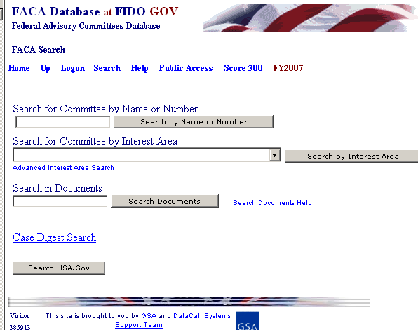
Search allows the user to Search six different ways: Search for Committee by Name or Number requires the committee number or part of a name; Search for Committee by Interest Area requires a topic; Search in Documents check for phrases in uploaded documents; Case Digest Search searches FACA Case Law; or use the USA.Gov search engine. Each search option provides a different access into the system and the committee data, so you should feel free to experiment with the possibilities.

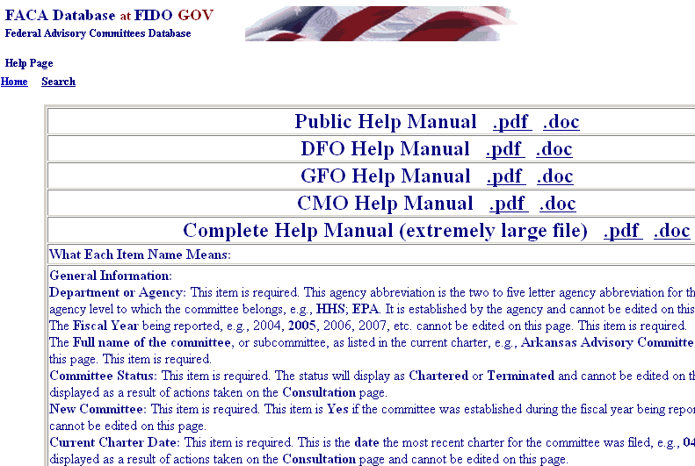
Help explains the syntax, terms, and meaning of items of information that were collected in the database to enable the ACR. Help also displays manuals that explain the system’s functionality for the different types of users. Each user sees a slightly different system customized for their work and use. The manuals can be viewed on the screen or printed. The manuals were created in Microsoft Word and saved as Word (DOC) or Adobe (PDF) documents. The Adobe files are smaller and generally load and print faster. The on-line manuals explain the functionality of the system.
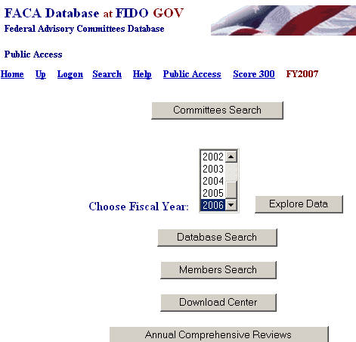
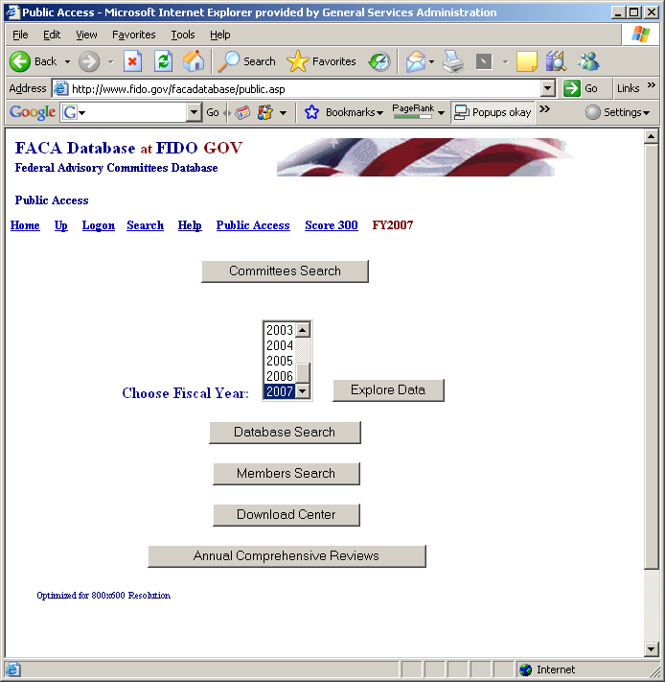
Public Access takes the user to the public part of the system. The Public Access page includes Committees Search, which repeats the search features described above. The page also lists the Fiscal Years of data in the system. The page produces reports via the Database Search, the Members Search, the Download Center, and the Annual Comprehensive Reviews available online. The ACR summaries have been posted online since 1999. All the data in the Public Access section is read-only. While data added to the system by the users is available for viewing in real time, any one reviewing the data for the current Fiscal Year should consider the data to be in draft status and essentially incomplete. Any committee being researched has probably been updated throughout the year as events take place, however the frequency and thoroughness of the updates is determined by the individual DFO and the demands upon his or her time. At the end of the fiscal year, however, each DFO, GFO, and the agency’s CMO are required to verify the accuracy and completeness of each committee’s data. The caution is that information on a committee should not be deemed official and complete until that committee’s data has been verified by the agency CMO for that fiscal year. The Help link provides a complete manual for the use of the Public Access section.

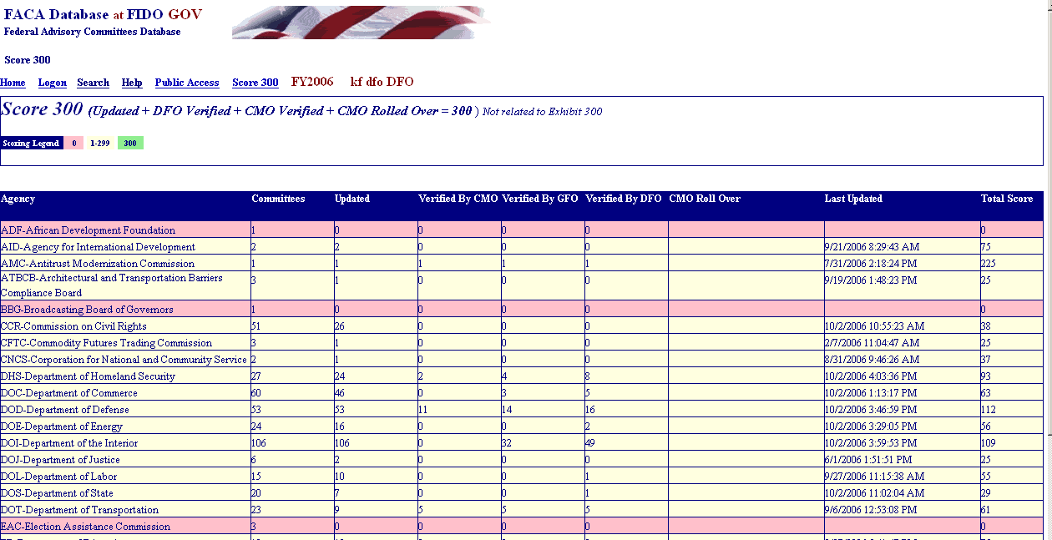
The “Score 300” link displays an agency ranking in terms of usage and completeness of the data for the current fiscal year to date. The score also reflects the last agency update. It is a quick way to survey the completeness and accuracy of the data. The viewer can tell from the color and the number of committees updated just how much data entry/updating activity has occurred. DFOs, GFOs, and CMOs could think of it as friendly competition while other users can tell the status of the completeness of the current data. The user returns from the Score 300 page by using the browser menu’s BACK Button. In all cases, like the page below, where the Up link is not visible, the browser Back Button or Back menu option can be used to return the previous page.

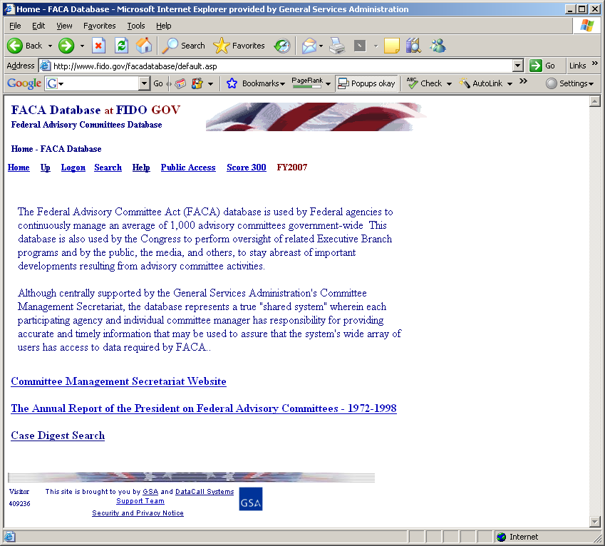
The Committee Management Secretariat Website links the user to the Committee Management Secretariat’s organizational page on the GSA Portal. The direct address or URL for the Committee Management Secretariat organizational page is either http://www.gsa.gov/committeemanagement or http://www.gsa.gov/faca.

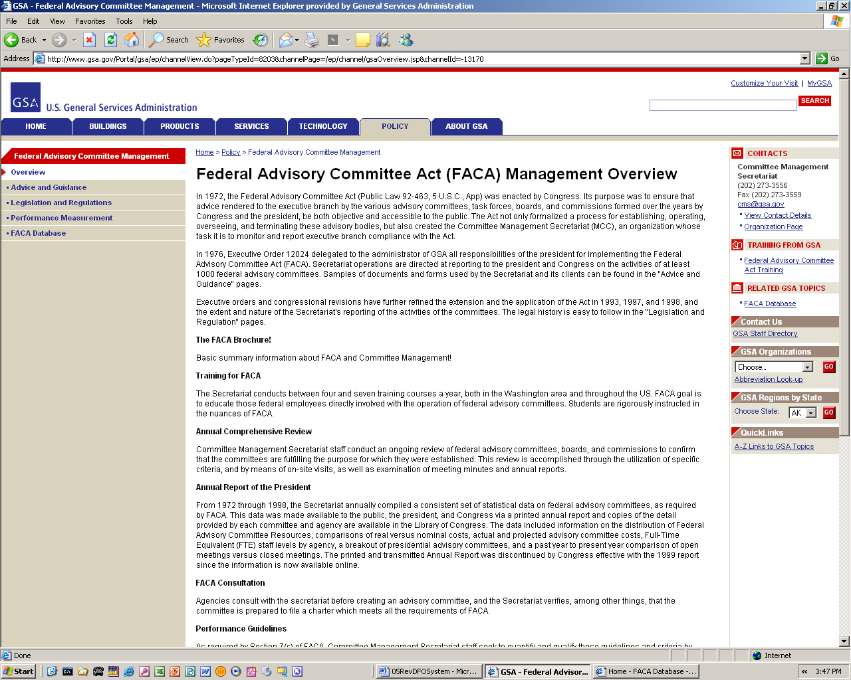
The GSA Portal website:
http://www.gsa.gov/
committeemanagement is the launching point for the Committee Management Secretariat’s Home Page on the GSA Portal. This mini-portal on the GSA agency portal is a comprehensive listing of documents examining the advisory committee process, practices, history, case law, advice and training.

The Annual Report of the President on Federal Advisory Committees - 1972-1998 is a link to an online set of the reports prepared by the Committee Management Secretariat yearly from 1972 through 1998 and sent to the Congress over the President’s signature reporting the status of Federal Advisory Committees. While the printed report was discontinued in 1999, the FACADatabase system continues to collect an expanded dataset for the Annual Comprehensive Review.
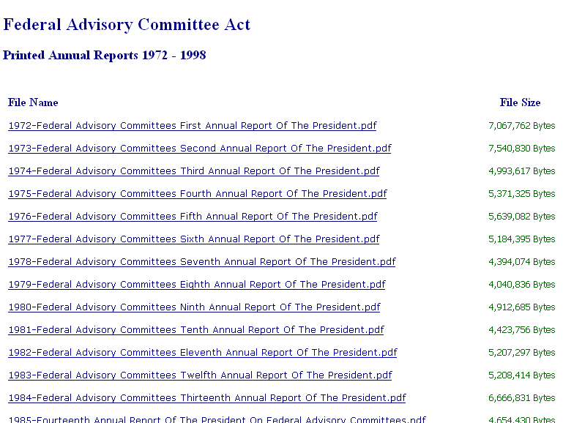

Case Digest Search is a link to an on-line, searchable compilation of the case law concerned with FACA from 1972 through May, 2004.

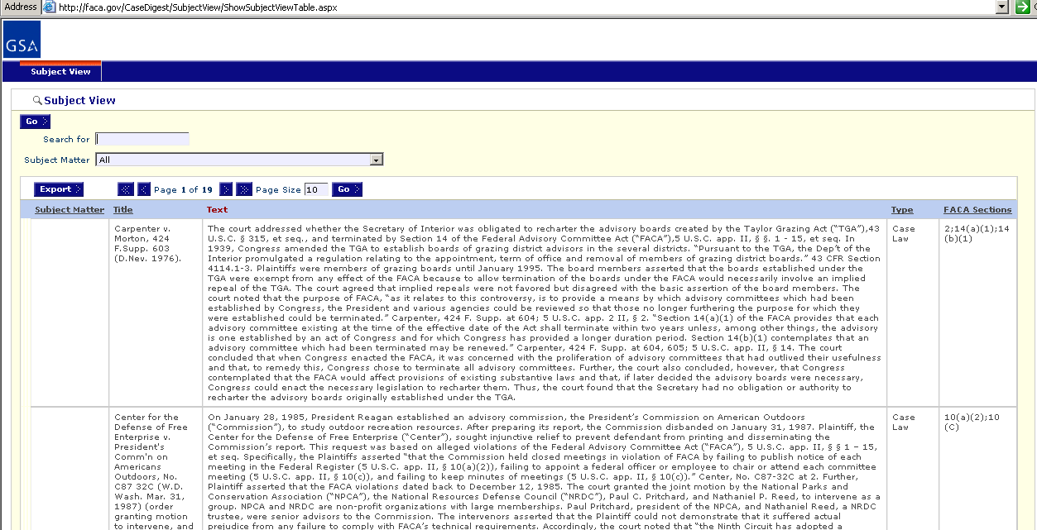
Logging onto GFO Data Maintenance Activities

Logon allows GFOs who are responsible for the committee data and who have editing rights to log on to the current year and view and update the management data. DFOs can update their committees, GFOs can update the committees in their group, CMOs can update all of their agency’s committees, and the Committee Management Secretariat’s staff can update all the agencies’ data. Unless the GFO wants to add or edit some specific committee data or limit the display to just the committees for which they are responsible, there may be no need to log on. All of the information, searches, and most of the reports are available from the Public Access section, the difference being that the Public section is read-only.

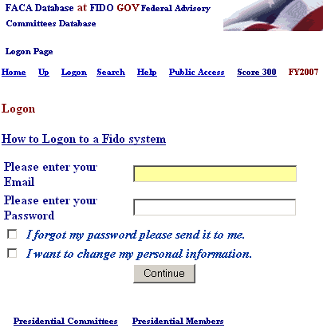
Clicking the Logon link displays the Logon page. The Logon page has ten hyperlinks, four data fields and one submit button. In addition to the links previously mentioned are Presidential Committees, and Presidential Members, which are reports designed for the White House Personnel Office. One of the links is an instructional online movie, How to Logon to a Fido system. The data fields are the LOGON Text Box, the PASSWORD Text Box, the “I forgot my password” Check Box, and the “I WANT TO CHANGE” Check Box. The submit button is labeled Continue.

To Logon, the GFO enters his/her username in the Logon: Text Box field (which has the label: Please enter your Email) and their password in the Password: Text Box field (which has the label: Please enter your password). When the Continue button is clicked, the program takes the GFO user to the Committee Menu page. The system design calls for all registered users to log on with their government e-mail address as the username.

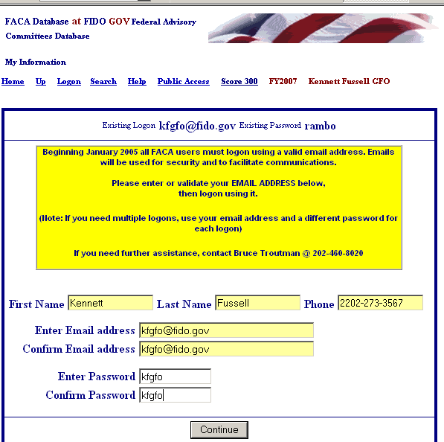
The GFO can change their user information any time they are logging in by checking the “I WANT TO CHANGE” Check Box before they click the Continue button. After the user has filled out the User Profile page, including their e-mail, than the OOPS Check box (otherwise known as the “I forgot my password, please send it to me” Check Box) will work.

Using the Logon Page shown above, if the user wants to receive an email with their password, they enter their LOGON (E-mail address), check the “I forgot my password, please send it to me” Check Box, and click the Continue button. The program will email their logon information to their registered “government” email address.
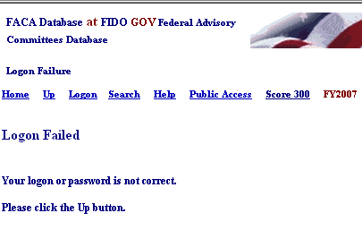
If the GFO receives a Logon Error, they should note the error message and contact their CMO to adjust their access rights. If you enter an incorrect Logon or Password, you receive the “Your logon or password is not correct” error. The FACA Database does not use a 3-attempts-and-you-are-locked-out approach to logons, so you can keep trying until you are either frustrated or your fingers bleed. We suspect that adding data to the system is seldom so urgent that you can’t wait for an email. Feel free to ask for your password to be sent to you by clicking the checkbox, especially if you logon infrequently. We all are beset with dozens of different logons and no one can keep all the combinations in their head.

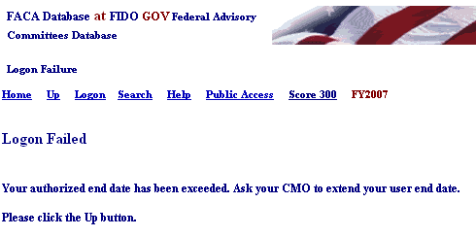
If the user’s dates for access have expired, you receive “Your authorized end date has been exceeded.” error. Most users are added with an expectation that they will be using the system for at least 5 years, but time does pass quickly, so don’t hesitate to let your CMO or Committee Management know that you need to have your access rights time frame extended.

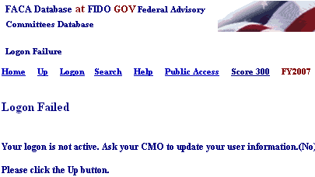
If your CMO has designated you as an “inactive” user, you see the “inactive logon” error when you attempt to logon. Committee Management Secretariat will switch users to an inactive status if the user has not logged in for more than a year. This situation can be easily changed by calling or emailing your CMO or the Secretariat.

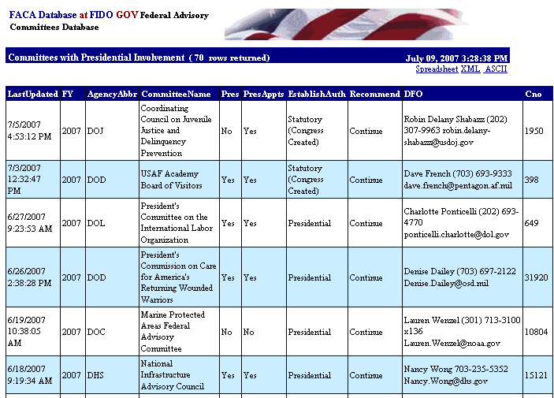
Clicking the Presidential Committees hyperlink displays basic committee information on committees that are either Presidential in type or established by the President. A committee is Presidential in type if it reports to the President even though it may have been established by Congressional Act. The committee listed in the third row to the right is an example of Presidential type.
Clicking the Presidential Members hyperlink displays a list of committee members appointed by the President that are in the current year’s member list (see above). These two hyperlinked reports are on the logon page at the request of the White House Personnel office. These reports, like all of the database’s reports for the current year, can only be useful and accurate if the data is kept up-to-date.
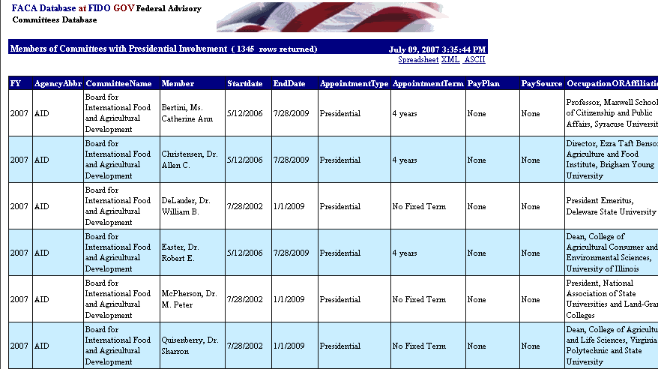

These presidential committee and member reports, like all the reports generated by the system, can be downloaded to the user’s computer for more direct use and customization via the Spreadsheet, XML, and ASCII hyperlinks. This is because none of the data kept in the FACADatabase is subject to privacy provisions, except for the committee members’ emails. Any public user may download all the data stored in the online system except for the committee members emails.

The GFO’s Committee List and Management Activities
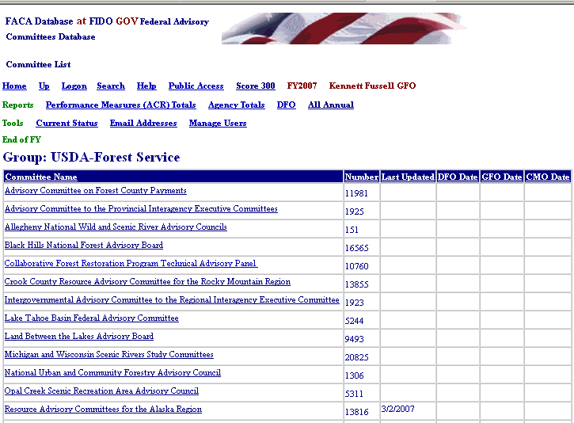
When the GFO logs on to the system, they proceed straight to the Committee List Page for their group. The Committee List page provides the GFO with access to any of their committees, and displays the navigation hyperlinks that activate most of their management activities in this web system. We will discuss the navigation hyperlinks first, and then the hyperlinks that access the individual committees.
The Committee List page currently displays seven additional hyperlinks in three groups. The new hyperlinks on this page are
For the Reports group:
- Performance Measure (ACR) Totals,
- Agency Totals,
- DFO Report, and
- All Annual Report,
For the Tools group:
- Current Status,
- Email Addresses, and
- Manage Users.
And for the End of FY group:
- No links are activated.

Performance Measures (ACR) Totals Report

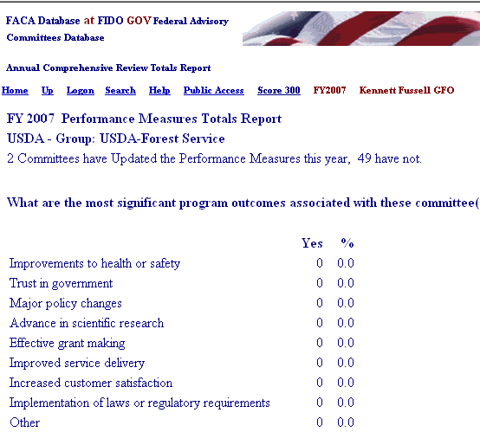
The Performance Measure Totals report link displays the Annual Comprehensive Review Totals page with the data displayed for all the committees in the group. These totals are for the categories of performance measures that are of interest to the agency, Congress, and the public during and after the reporting year. This data is carried forward for the committees from year to year, but the report begins with a count of committees updated for the current year. This data is not integrated with the rest of the committee report in this version of the system. The GFO should make sure that all of the committees in the group have updated the Performance Measures as part of the ACR verification process.

Agency Totals for the Group

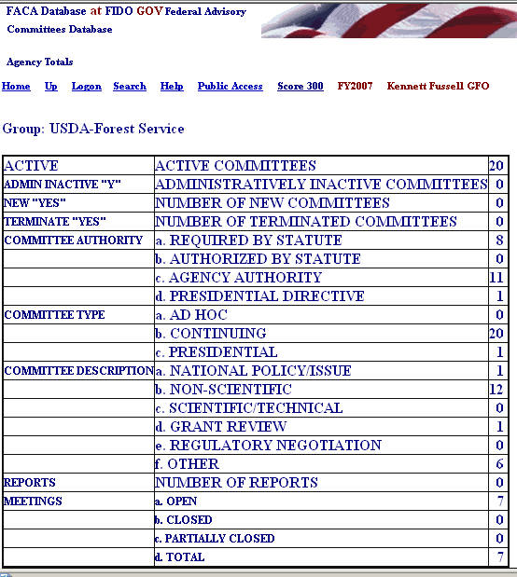
The Agency Totals hyperlink displays the Totals page for the group, which are totals of the collected data elements for the current year thus far. The Active and Inactive lines refer to committees for the group. The rest of the lines refer to the distribution of the committees in the group among the elements. New or terminated committees in the group, the distribution of committees by authority or function in the group, the number of meetings, reports, members, costs, etc., etc. The accuracy of the report at any point in time during the current year depends upon the frequency and timeliness of committee information data entry on the part of the DFOs, and that, to some extent, depends on the guidance provided by the GFO to the DFOs. Glancing at the totals from time to time will aid the GFO in knowing when to coach the DFOs to correct their data entry, i.e., while the total members serving shown below is probable, the Total FTE Years is not.

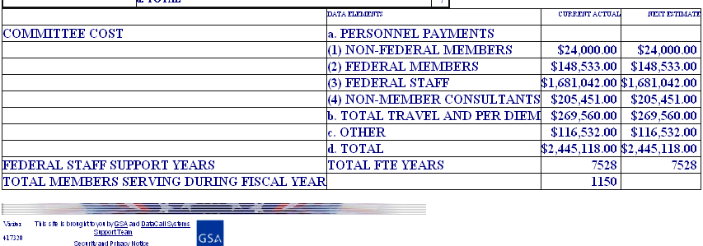

DFO Report

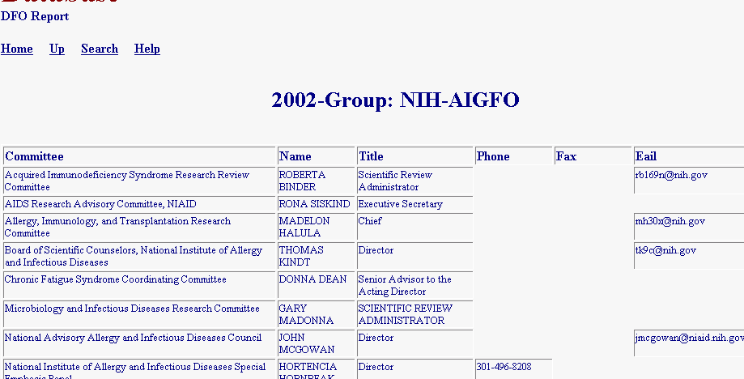
The DFO Report hyperlink displays the DFO Report page, a listing of the Committees and the DFOs’ contact information. Again, this information is only as useful as the DFOs’ timeliness in keeping their information current. The GFO generally gives the DFOs access to their committee data so that the DFOs can keep their information up to date. Of course, the structure allows the GFOs to do the data entry themselves.
All Annual Reports

The All Annual Reports hyperlink (which is really useful only after the end of the FY and all of the data is reported and verified) displays a single, continuous, scrollable, printer-friendly page of all the annual reports for all the committees in the group for that year. Depending upon the number of committees in the group, this page can take a while to load and display. This page can also be saved to a Word document and once in Word, the user can add page breaks and other formatting features to display the reports as formally as required. To return from this page to the Committee List page is an instance of when the GFO will have to use the browser Back button.

Current Status

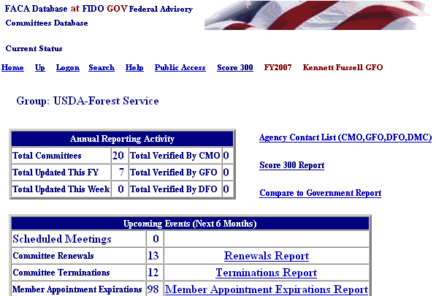
The Current Status link in the Tools group is an assortment of helpful, heads-up and on-guard reports for the GFO and other parts of the agency leadership.
Reports (signified by a hyperlink) are only generated if data is present that makes the report potentially relevant or suggests that a “possible” problem could exist.

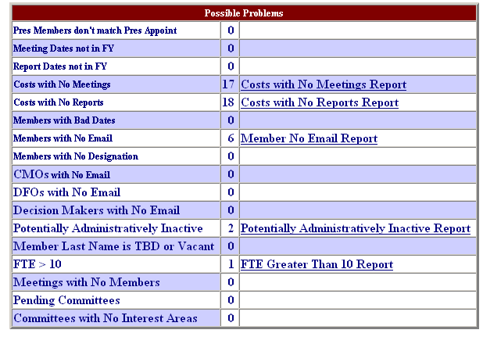
For instance, the General Info page has a Yes/No response field regarding whether any committee members are Presidential Appointments. The Members List page has an appointments field that indicates the source authority of the appointment. Is there a problem if the pages don’t agree? Usually! Could there be a reasonable explanation for the conflicting information? Possibly? In all cases, intelligence is to be applied. These report items are potential alerts, not flags that specific content is wrong. A more complete description of each separate report in the possible problems section exists below in this section.
The Current Status Page Management and Tracking Reports

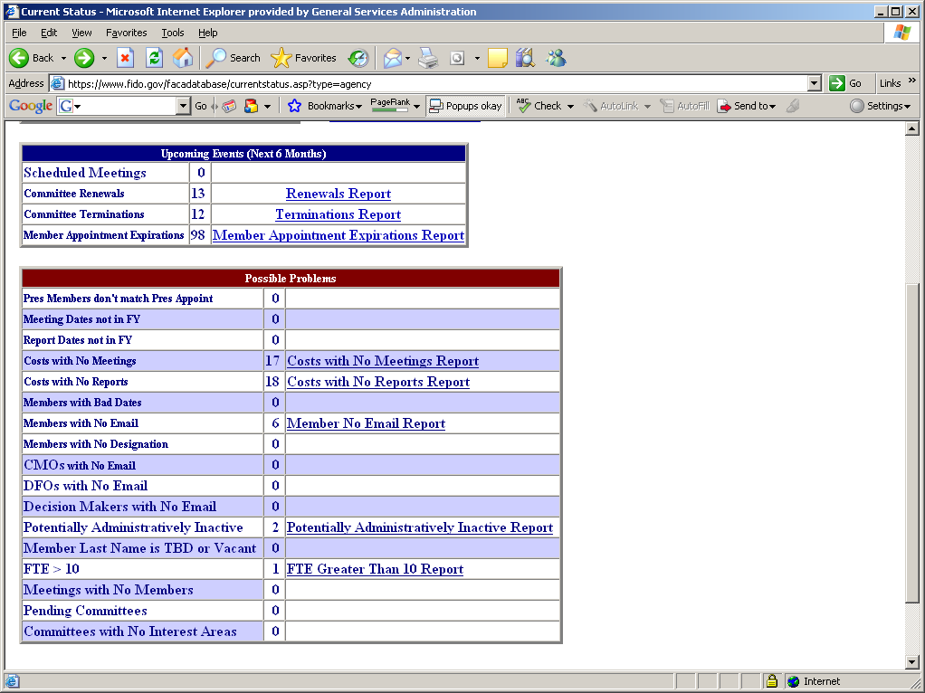
The Current Status page is a set of reports that should be helpful to the GFO and agency in managing and tracking the activities and administrative details of their advisory committees. The page is divided into two sections, Upcoming Events and Possible Problems. Upcoming Events (Next 6 Months) displays reports that are useful for planning and managing anticipated events, while Possible Problems displays report where discrepancies that “might be problems” exist in the data. I hope we all are aware that the entire system is an attempt to categorize and describe in consistent terms and a unified fashion almost 1000 distinct and uniquely functioning advisory committees. The term “possible” in the possible problems heading is a clue that intelligence should be applied in the analysis of these reports, and the term “problems” is often entirely the wrong word.

The Upcoming Events (Next 6 Months) Reports
The Upcoming Events section potentially displays four reports, one each for Future Meetings, Charter Renewals, Charter Terminations, and Member Appointments which are expiring. A report link will only appear when data exists to produce a useful report, so no links will display for empty reports. No links is good.
When the DFOs post committee meetings to the on-line system, the number of future posted meetings for the Fiscal Year being managed is displayed and a Meetings Report link shows up in the report column. If the DFOs post future meetings as soon as they are scheduled, the meetings for the next six months are displayed.
When committee charters are due for renewal in the next 6 months, the Renewals Report will display that committee on the list. The Renewals Report also displays any committees for which the data on the committee could be interpreted that the committee has been overlooked or is overdue for re-chartering. Committees can be removed from the Renewals Report by changing the data on the committee on the General Info page, the Agency Recommendations page, or the Consultation page.
By the same token, the Terminations Report displays any committees for which the data on the committee could be interpreted that the committee is a candidate for termination. Committees can be removed from the Terminations Report by changing the data on the committee on the General Info, the Agency Recommendations, or the Consultation pages as well.
The Member Appointment Expirations Report lists those members agency-wide whose recorded appointment end dates have either already elapsed or will elapse in the next six months.
A Meetings Report link and a Member Appointments Expiration Report link for their committee data are available to individual DFOs on the Current Status link for their committee on their Committee Menu page.
The Scheduled Meetings Count Results in the Meetings Report

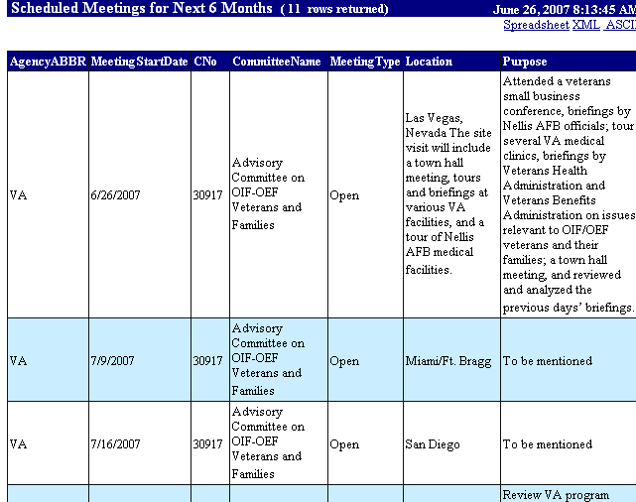
The helpfulness of being able to display a count of already posted future meetings and a resulting Meetings Report will differ from agency to agency. It is highly likely that the GFO already has an alert or tickler system to anticipate and plan for scheduled meetings and the associated meeting logistics, Federal Register Notices, etc. However, since, the displayed report rolls cumulatively up from the Committee (DFO) to the office (GFO) and agency (CMO) level, posting committee meetings like this in advance serves to keep the whole agency informed and involved. The meetings have to be recorded anyway at some point during the Fiscal Year, so why not post the information when the meetings are scheduled and use this feature profitably. Meeting records can always be edited further if the scheduled is rearranged or details change.

The Committee Renewals Count Results in the Renewals Report

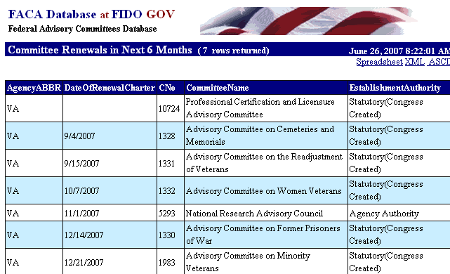
The Committee Renewals Report is an obvious tool for the GFO to use to anticipate what committees are overdue for review, what committees are up for review this month, and what committees are up for renewal in the near future. If a lot of committees show up on the report that should not be there, then the data recorded in the system for those committees is not useful or accurate and the GFO should review the data with their CMO and their DFOs.

The Committee Terminations Count Results in the Terminations Report

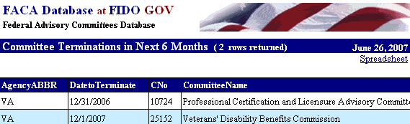
The Committee Terminations Report is an obvious tool for the GFO to use to anticipate what committees are up for termination. If committees show up on the report that should not be there, then the data recorded in the system for those committees is not useful or accurate and the GFO should review the data with their CMO and their DFOs.
The Member Appointment Expiration Report

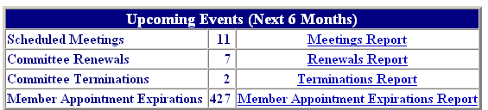
A significant number of DFOs from larger committees report that staying on top of member appointments verges on being a full-time job. CMOs from small agencies report the same thing. For the GFO, the Member Appointment Expiration Report is designed to display all the members in their group whose appointments have expired or which will expire in the next six months. How a tool like this fits into the agency process for vetting and appointing new members and re-appointing and replacing existing members will differ from agency to agency and even from committee to committee or group to group within the agency based on the establishment authority and agency precedent and process.

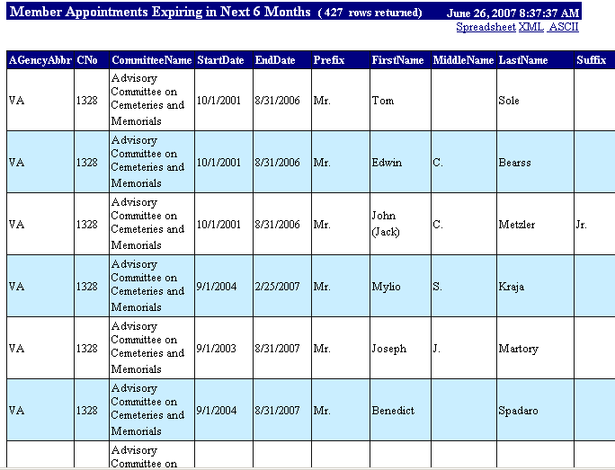
However, this report, like the Meeting Report above, displays at the committee, office, and agency level. This can facilitate the communication necessary to handle the process in an orderly and timely fashion without continuous data calls. Both of these reports, and, essentially, all the reports available and utilized by the system, are only as useful and accurate as the data from which they are generated. What this means and comes down to for the FACA community and the interested public is that everything works best, if, when data about the committee changes, it is updated in the on-line system.

The Possible Problems Reports

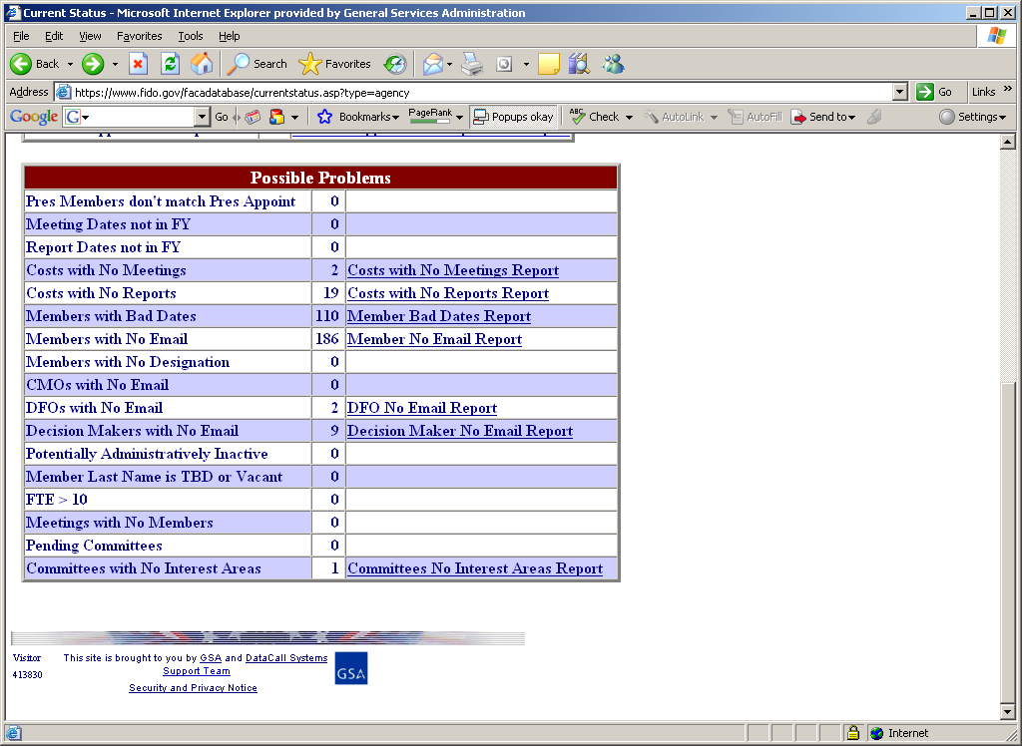
The Possible Problems reports set is a compilation of items identified over the years as the result of discrepancies in how the same committee data is treated differently in different places and at different times, or as areas of concern raised by users of committee data (agency leadership, congress, GAO, White House, public, etc.). These items have usually been resolved during the Annual Comprehensive Review (ACR) reconciliation process, if they were not resolved immediately upon discovery by data calls, investigation, analysis, and lengthy explanations. They are available here to be an ongoing tool to assist the GFO in tracking and managing the group’s data, and have proven an invaluable tool in completing the Annual Comprehensive Review (ACR). The reports have been usefully demonstrated to serve multiple purposes for multiple audiences, as you will see in the explanations below.
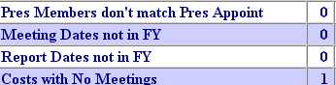
The first three reports,
Presidential Members don’t match Presidential Appointments,
Meeting Dates not in Fiscal Year, and
Report Dates not in Fiscal Year,
are usually the result of mistaken data entry based on a misunderstanding of what was required. For the Pres Members report, the General Information page has a question whether the committee utilizes members appointed by the President, and the Members page includes a question about appointment type (Presidential being one of the types of appointments). When this information, often entered by different people, is inconsistent, it needs to be resolved. This question was first posed by the White House personnel office.
The Meeting Dates and Report Dates reports occur when the user manages to add a meeting with dates that do not fall within the reporting year. You might wonder how this can happen if the meeting record's date fields have code to catch that kind of error. It’s a mystery. We speculate that some data is uploaded in batch files and the “bad” dates get by the screening, and some users are very creative and determined to put in precisely the date they want, even if it falls outside of the Fiscal Year.
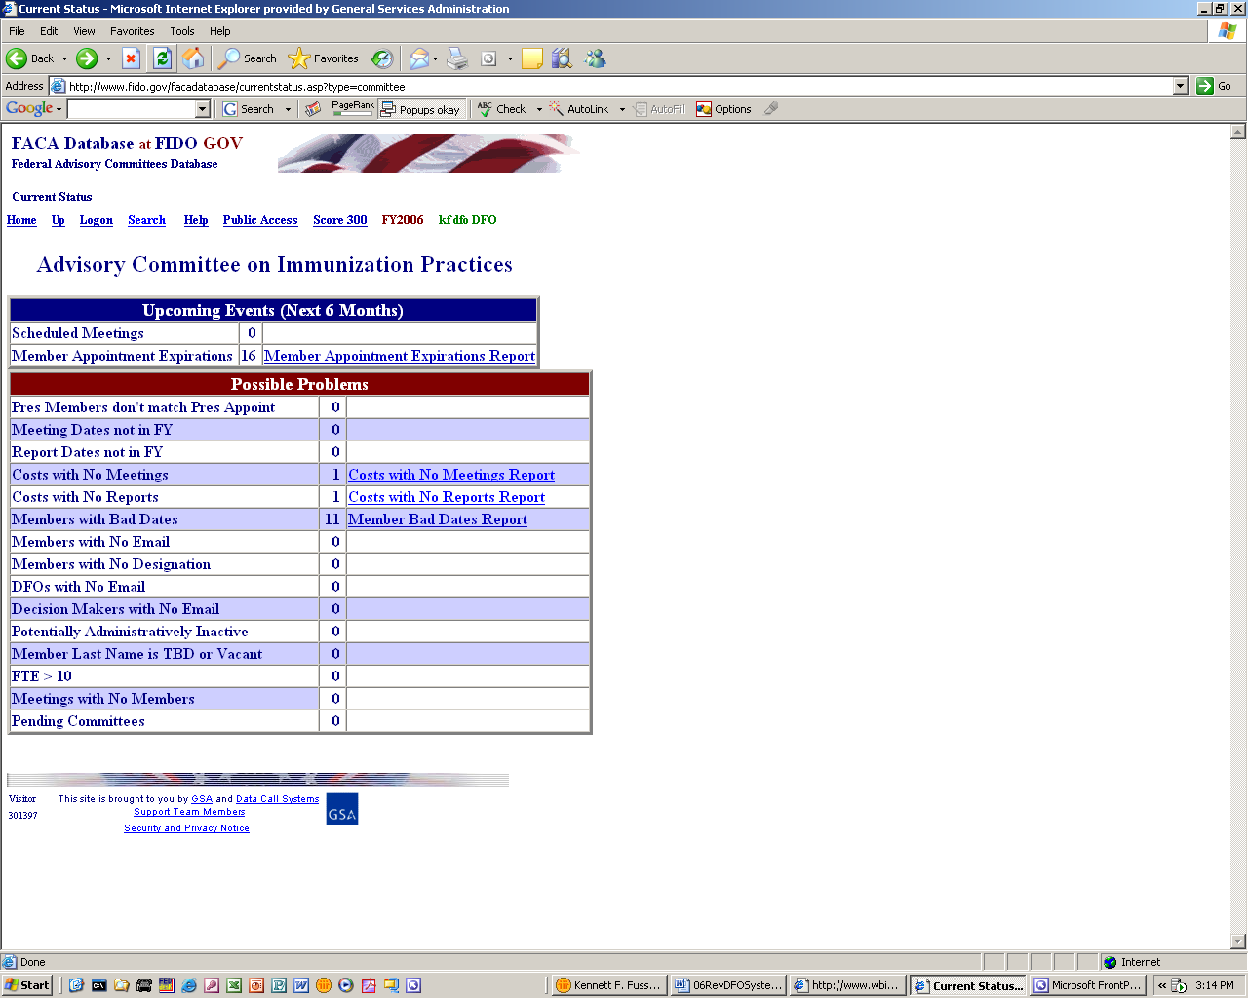
The next two reports,
Costs with No Meetings,
Costs with No Reports,
are in response to questions which are often asked about and just as often not very significant in the results shown. GFOs are familiar with many reasons why a committee may be reporting costs with no visible activity of any kind showing up in the on-line data. The most common reason is that meetings or reports have not been reported yet. The cost data is carried forward by the system from the previous reporting year while the meeting and report data is new and has to be added each year. It is also true that the cost versus visible activity ratio tends to be greater during the first year of a committee during setup and the terminating year when things are being wrapped up. This set of reports becomes more useful when the agency is reconciling its ACR data, and is a prime example for why some intelligence needs to be applied to report analysis.
Three reports on member data deal with appointment dates, email addresses, and Member Designations.
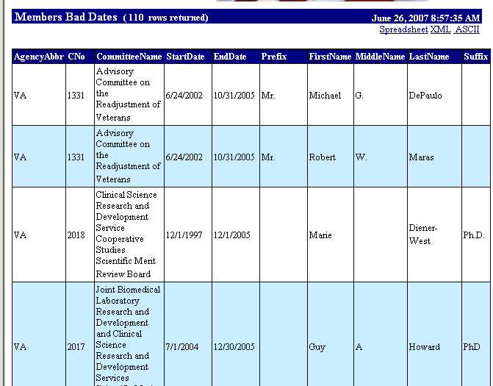
The Members with Bad Dates report might seem redundant of the Member Appointments Expiration Report, however the purpose is different since the Expiration report is an alert and the Bad Dates report is probably a real problem. The Bad Dates report indicates those members whose appointment dates fall outside of the current Fiscal Year, so we are no longer concerned with members whose appointments are due to expire. The Bad Dates report points to members whose appointments ended the previous fiscal year or whose appointment don’t start until the next fiscal year. This may be a non-issue for some CMOs and DFOs if their members can continue to serve until a replacement is appointed or if the CMO is completely disconnected from the agency appointment process. However, this can seriously affect the accuracy of the number of members serving on agency committees.
The Members with No Email report would only be a problem if the CMO, GFO, or the DFO thought it was a problem or the agency needed the email for Committee Management survey activity. Member emails do not display from the Public Access part of the on-line system and generally should only be reported with the Members knowledge and permission, and if it is agency policy to collect the emails.
The Members with No Designation report is another instance of a report that should not be necessary, since the program is coded so that a DFO or GFO or CMO should not be able to add a member without including the Member Designation. The Member Designation is a required field in the system and, by law, is part of the appointment process of every advisory committee member. Somehow, it still happens that a Member Designation field comes up blank, and this report is an alert to those concerned.
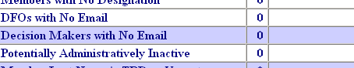
The next three reports are considered alerts to what can only be labeled as oversights. These reports are more useful as alert reports when the results for all the committees in the agency are rolled up into reports for the CMO, GFO, and other agency officials.
Regarding DFOs with No Email and Decision Makers with No Email, the online program creates email mailing lists for CMOs and GFOs and other agency officials with logon rights. The emails for the lists are collected from the DFO and Decision Maker Page forms, hence the usefulness of the DFOs with No Email and the Decision makers with No Email reports. The CMOs, GFOs, and/or other agency officials can know who is missing from the mailing list.
The Potentially Administratively Inactive report lists those committees which may be in a group of committees that no longer require ongoing attention and active DFO participation. The report exists so that the CMO and GFO can make sure that the committee’s records and reporting does not administratively slip through the cracks, and can move the committee to the agency’s Administratively Inactive group of committees. When a statutory committee has completed its work, it cannot often be easily terminated or removed from the agency’s committee inventory unless the statute that created the committee included language to terminate the committee. The DFO involved with the work of the committee will generally wrap up his or her responsibilities and move on to other tasks as assigned, but the committee and the responsibility to track and report the committee lingers on, sometimes for years or even decades.

The Member Last Name is TBD or Vacant Report

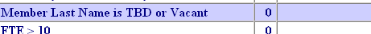
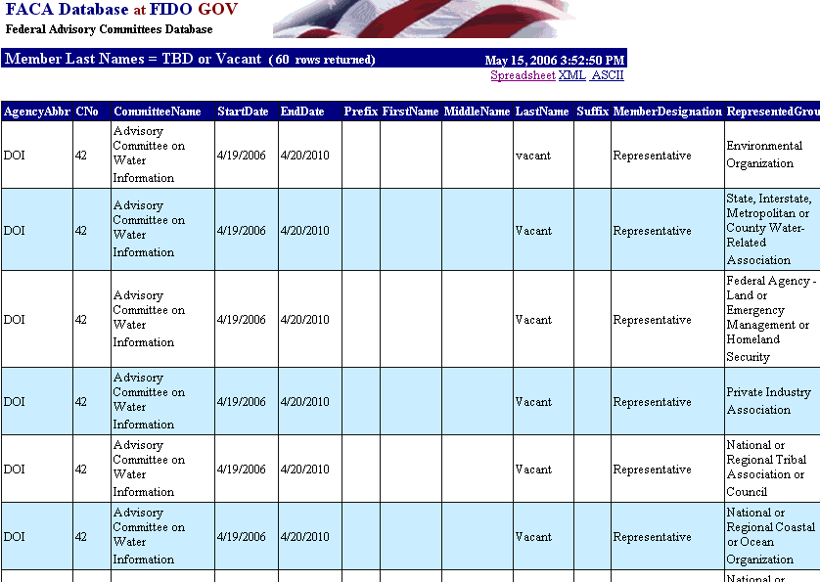
The Member Last Name is TBD or Vacant report is a special kind of possible problem report in that it serves multiple purposes. The agency can choose to use this report as a helpful “identification of need” tool in the committee member appointment management process. To do so, the DFO can add a blank member record to the committee member list with TBD or Vacant in the Last Name field. The DFO does this to indicate that a member’s appointment slot is available and a new member needs to be appointed.
When the GFO or CMO or other agency officials look at this report from a group or agency-wide basis, they will see a list of all the committees with potentially empty member slots needing new members to be appointed. Used this way, this report is a visible, accessible, communication link that allows the agency to stay abreast of, if not ahead of the member appointment process without duplication and multiple email exchanges. Best of all, this process is capable of being managed in real time.
While the TBD or Vacant report can be used this way to manage the “identification of need part” of the appointment process, we probably should not forget that the member who is resigning or whose appointment has expired is also part of the current committee member list. At the end of the reported year, the online system will be used to retain and count the members who actually served on the committees and not the empty slots that needed to be filled. When the Annual Comprehensive Review (ACR) is completed and the data verified by the DFO, the committee data will be rolled into a new fiscal year. The new year’s data will still include all the member slots that have a TBD or Vacant in the Last Name field. The data verified for the ACR for the year being closed will have the member records with TBD or Vacant in the Last Name field removed.
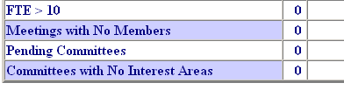
The last four reports in the possible problems list are designed to catch errors. Since a committee seldom has a support staff of greater than 10, the FTE > 10 report lets the DFO, GFO, CMO, or Committee Management know when someone may have tried to insert the total cost of the committee in the Federal Staff Support field.
The second report, Meetings with No Members, is seldom a problem for committees where the data is entered directly by the DFO or his or her designee. Every agency works a little differently in this area, and there are several agencies that provide the data for the online system in batch uploads. This report has proved helpful in catching missing data from such uploads.
The third report, the Pending Committees report is a problem for the CMO and GFO as the end of the FY approaches. This report shows the committees that are not yet live with authority to act, i.e., the charters have not been filed. While this report is most useful to the CMO on an agency-wide basis, it can also be important to the DFO and GFO working against a deadline and/or agency expectations.
The last report, Committees with No Interest Areas, identifies committees without any assigned interest areas. This could leave the committee out of the result set when a search is conducted.

While this list of reports could perhaps be larger, any new reports of this type will have to be added to a future version of the online system.

Emails Addresses

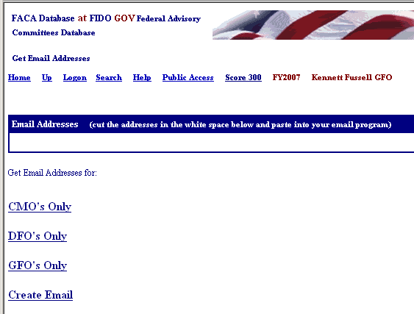
The Get Emails link displayed in the Tools group provides different combination of email addresses. These emails belong to the agency users of the online system. The emails are found in the user profiles and the DFO page data, the GFO page data, and the CMO page data kept in the online system. This information extends beyond the formal agency DFO, GFO, and CMO list to everyone with responsibility for data management from the agency in the system that has been given a login or otherwise added to the system list, including decision makers, supervisors, and administrative staff. We expect a contact list like this to become more and more useful, so it is best to urge everyone to keep his or her information up-to-date.
Manage Users
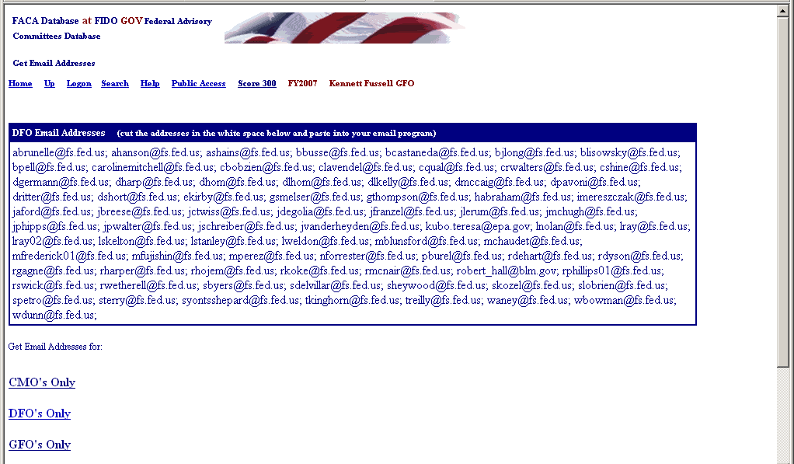
The Manage Users link displays the list of agency users and their access rights on the system. After the CMO gives a user GFO status on the system, the GFO can
- Add users at the DFO levels of use and assign them a committee,
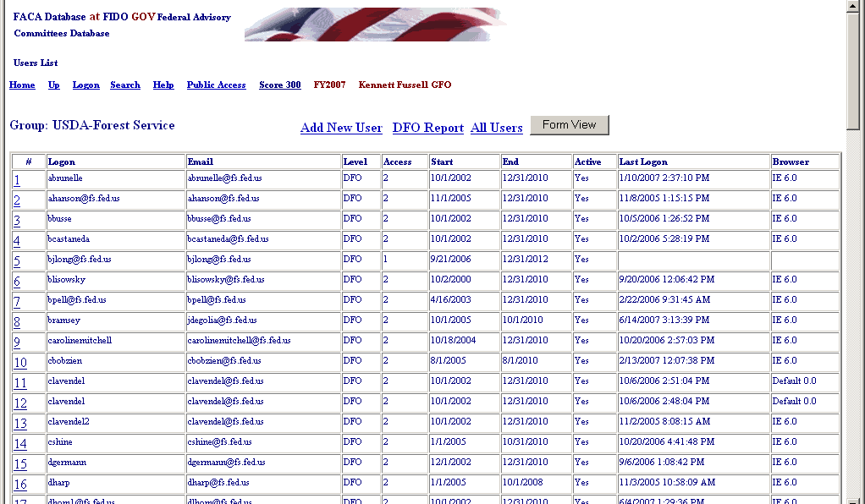
- Control whether users can edit the current year’s data,
- Limit when a user will have access to the system, and
- Look up the user’s password.

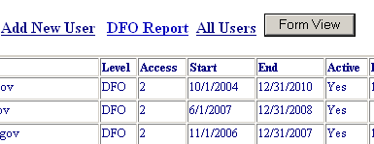
By clicking the hot link, which is the underlined number at the left of the row of user information (see the screenshot to the left), or by clicking the FormView Navigation Button (see the screenshot to the right), the GFO displays a user record to edit.

The Add New User link provides a form to add a new user. The DFO Report link displays all the user data in a list view. The All Users link displays all the users who have ever been added, including those who are no longer active users. This can be helpful if you want to return an inactive user to active status. The Form View Button displays the first record in the list in a form. The records are reviewed alphabetically. The Hot Link displays the record of the user identified in the Logon field.

Add New User

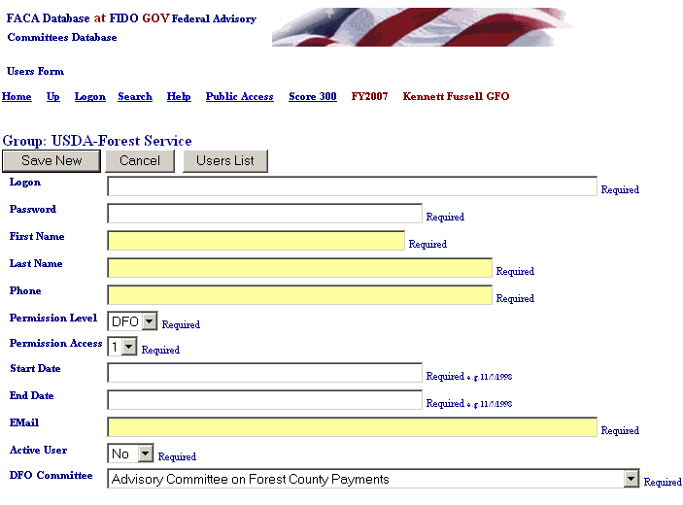
This is blank add user form. Directions for adding a new user and the rules and codes are described in the section below.

DFO Report

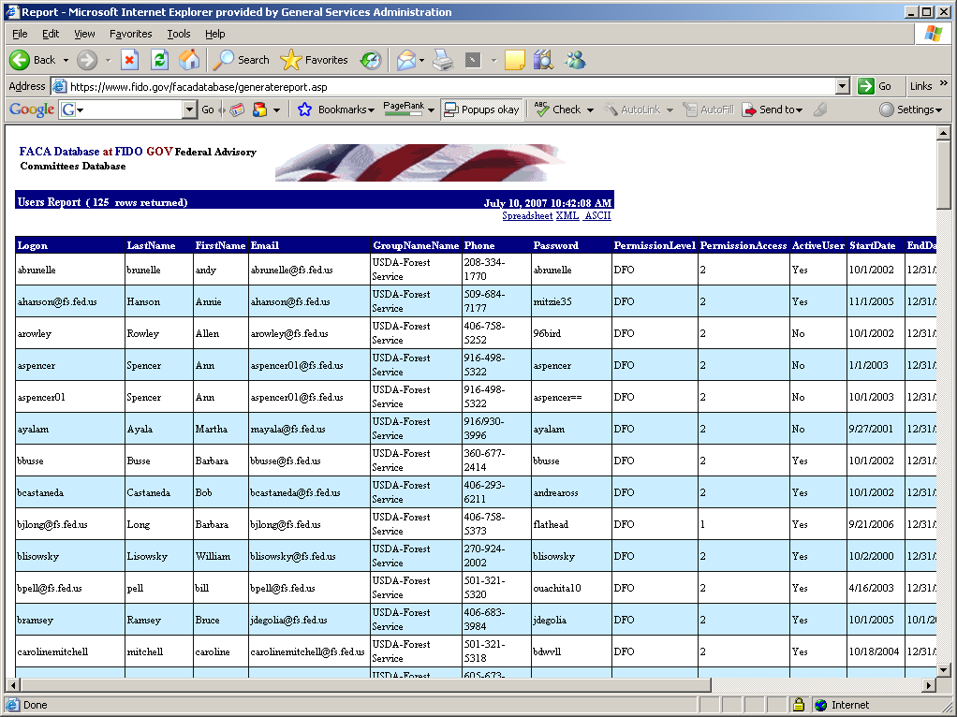
All Users

Note that the All Users List has an Active Users link so the display can be limited to just the active users. If you examine the Active column you will see the entry “No” for some of the users.
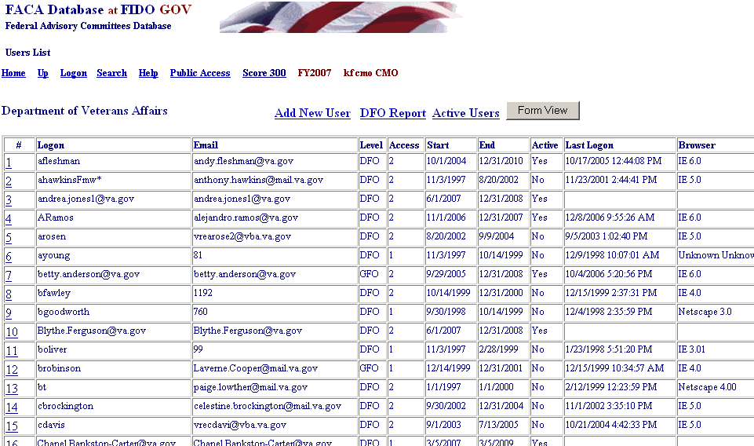

User Form Rules and Codes to Assign User Rights

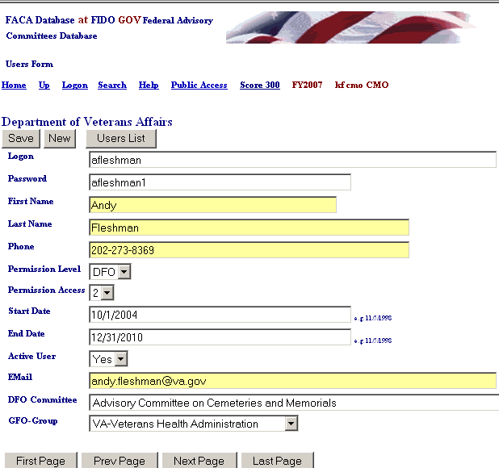
On the User Form the GFO will find buttons to Save an edited record, add a New user, and return to the User List, but the GFO will not find a button to delete a user. Once a user is added to the system, they are kept in the system forever so that there is an audit trail regarding who created or edited the data in this record of the system. The personal identification information is displayed in a profile form when the new user logs on. When adding a new user, the GFO should add complete data to all fields with a special focus on the logon, password and the user’s access rights. The DFO will have a later opportunity to complete and correct any contact-information-fields (First Name, Last Name, Phone) that are incorrect in the user profile form when they first logon.

The rules and codes regarding the user information and access rights (permission levels) follow.
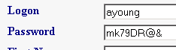
- The user’s Logon name and Password together form a unique key field that is not duplicated in the system. The username (Logon) should be in the form of the user’s government email address. The actual user should be identifiable and recognizable from the username.

- The Password can be any combination letters, numbers, symbols, characters, and case of up to 16 positions long. The password can be duplicated in the system with other users’ passwords. However, if the individual user has more than one login, each of the individual user’s passwords associated with each login must be unique. Passwords are generally a system’s weakest point of defense from unwanted intrusion, so, unfortunately, the best password is such a complicated combination of letters, numbers, characters, and symbols that you will never be able to remember it.

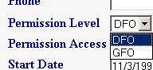
- The GFO can add users at the Permission Level of DFO. The DFO can only view and edit their single committee when logged on.

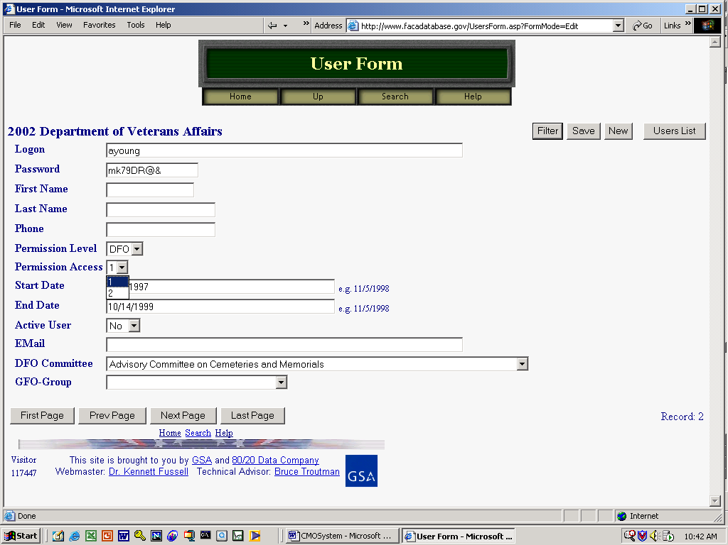
- Permission Access is either read-only: 1, or edit: 2. A user needs a Permission Access of 2 (EDIT) to make changes to the data and add new information.

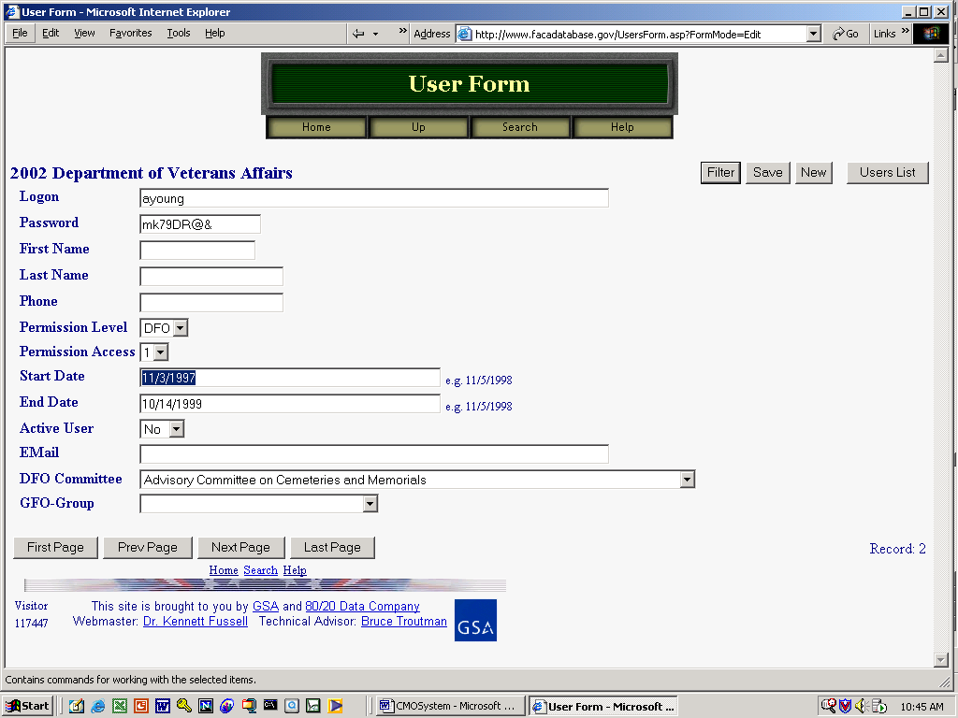
- The Start Date is the earliest date that a user can logon and the End Date is the last date that a user can logon.

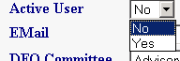
- The Active User can be set to “Yes” or “No”. This field is used to turn a user’s logon rights on or off without having to change all the other settings. A new user should be set to “Yes”. Committee Management Secretariat regularly switches the Active User setting to no for users who have not logged in for more than a couple of years.

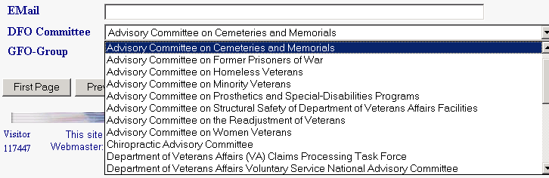
- The Committee for which the DFO user is responsible can be selected from the “DFO Committee” pull-down. The pull down list will display all the possible committees for the group. Of course, this only works if the CMO added the committee to the group when the committee was created in the system. To select the DFO’s committee, the GFO clicks on the correct committee.

The Save button save the data entry changes on the page when you are editing an existing user. The New button displays a blank data entry page for adding a new user when you are on the page for editing an existing user. The GFO returns to the full read-only User List page with the Users List button.

Saving New Users

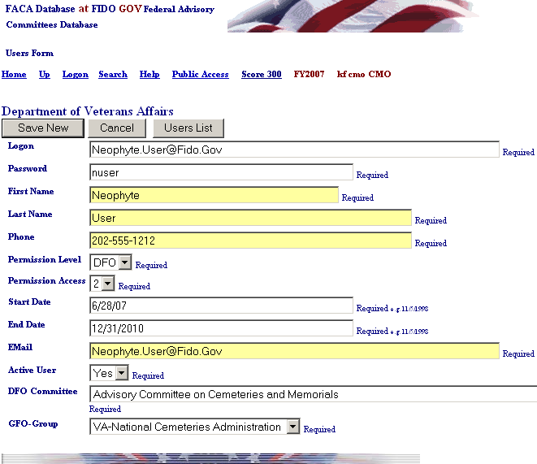
The GFO fills in all the contact information and applies the permissions and rules to create a new user, finally “saving” the information on the new user by clicking the Save New button. The GFO can abandon the new record at any time before the “SAVE” action by clicking the Cancel button. The system may overreact quite negatively if you attempt to create a duplicate user, so cover your eyes before you click the Save New button in doubtful situations.

Editing a Committee’s Data

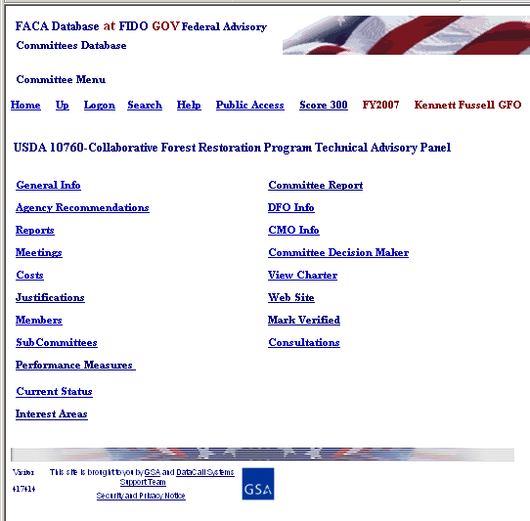
The GFO should check out the DFO System Manual for a thorough introduction to the process of editing the committee information.

The GFO has complete editing rights to all the committee data and all changes are made, meetings and reports and members are added through the Committee Menu page. The links below display the editable pages. The menu options include
- General Info,
- Recommendations.
- Reports,
- Meetings,
- Costs,
- Justifications,
- Members,
- Sub-Committees,
- Performance Measures,
- Current Status,
- Interest Areas,
- Committee Report,
- DFO Info,
- GFO Info,
- CMO Info,
- Committee Decision Maker,
- View Charter,
- Web Site (if the committee has one),
- Mark Verified, and
- Consultations.

The Rest of the Story

There are many other features and reports available to assist the GFO in the FACA Database online system. Most of the other features are found and described in the Public System part of the manual. However, all of the features, data, and reports are only as useful and accurate as the data entered and kept up-to-date, primarily by the DFOs or their designees. The DFOs, keeping the system up-to-date as frequently as possible, whenever the committee data changes, or even on a weekly basis, transforms the FACA database into a rare commodity in government, a useful, interagency data-sharing and management tool. The FACA Database online system has been available since 1997. It is a living system in the sense that it has grown in usefulness and functionality (and size) every year that it has existed. Some of the improvement is due to the improved technology of the Internet, and a little can be counted due to the increasing skill of the development team. However, most of the improvement is due to the feedback, patience, and willingness of the users to participate both in the development process and with on-line record keeping. The FACADatabase is truly a shared system that belongs to all of us.

