Biography 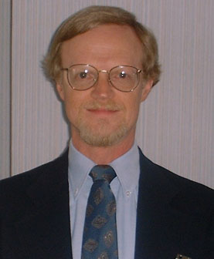

Mr. Russell G. Thomas

Russell Thomas is the Human Resources Director for the Mississippi Valley Division/Mississippi River Commission (MVD/MRC), U.S. Army Corps of Engineers. He has held this position since 1999. He also serves as the Human Resources Director for the U.S. Army Corps of Engineers Research and Development Center, with laboratories in Vicksburg, Alexandria, Va., Hanover, N.H., and Champaign, Ill.

He earned a bachelor’s degree in political science from the University of Washington in 1970, and a master’s degree in public and international affairs from George Washington University in 1971.

He first entered civil service in 1971 as a civilian personnel functional intern at Fort Hamilton, Brooklyn, N.Y. After serving as Chief, Technical Services, and Chief, Position and Pay Management, he moved to the Fort McPherson, Ga., Civilian Personnel Office as a classification specialist.

Mr. Thomas was assigned to the Kaiserslautern, Germany, Area Civilian Personnel office in 1976 as Chief of Technical Services. He moved to the Headquarters, U.S. Army Europe Civilian (HQ USAREUR) Personnel Division in 1978, and served in a variety of positions in United States employment policy and foreign national employment programs. From 1981 to 1987 he served as Chief of Compensation Management, for HQ USAREUR, overseeing the position classification program and the foreign national employment programs for the command. Mr. Thomas represented United States forces in negotiations with the German government and German unions through this period. In 1987 he was assigned as Personnel Director in Berlin, and managed the Berlin personnel programs through the fall of the Berlin Wall and its eventual closure. As Berlin closed, he was assigned to the European Civilian Personnel Operations Center as Chief, Information Services, serving there for 20 months during the initial establishment of that operation. In 1996, he was assigned to establish the Wuerzburg Civilian Personnel Advisory Center to serve the 98th Area Support Group from Wuerzburg, Germany.

His awards include two Commander's Awards for Civilian Service, two Superior Civilian Service Awards, and a Meritorious Civilian Service Award.

Mr. Thomas is a native of Waterloo, Iowa.

The Mississippi Valley Division (MVD) is responsible for Corps water resource engineering programs in a 370,000-square-mile area that includes portions of 12 states; its boundary extends from Canada to the Gulf of Mexico. District offices are headquartered in St. Paul, MN; Rock Island, IL; St. Louis, MO; Memphis, TN; Vicksburg, MS; and New Orleans, LA. The Presidentially appointed Mississippi River Commission (MRC) is responsible for the comprehensive Mississippi River and Tributaries flood control and navigation project and engineering work associated with the Mississippi River and its tributaries from Lake Itasca, MN, to the Head of Passes in Louisiana. July 2004

