

JTX User Guide
FEMA DFIRM Production Tools

(DFIRM Release 2.1.2)

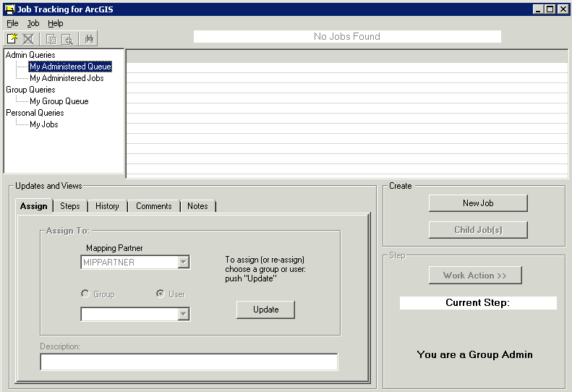

Table of Contents:

What is JTX? 4
JTX Overview 4
Quick Reference Guide 4
JTX Key Concepts 5
What are JTX Users/Groups? 5
JTX Jobs/Job Types 5
DFIRM Study (STDY) 5
Getting Started 8
User Request Process 8
Data Submission Process 8
Set Access Level 8
Tool Controls 9
JTX Toolbar 9
Create New Job 9
Cancel Job 10
Create Child Jobs 10
Reconcile and Post 12
Show Child Jobs 13
Find Job 13
JTX Menu 14
File 14
Job 15
Help 15
Job Query Window 15
Admin Queries 15
Group Queries 15
Personal Queries 16
Updates and Views Section 17
Assign Tab 17
Steps Tab 18
History Tab 18
Comments Tab 19
Notes Tab 19
Step Actions Section 20
Run Current Step 20
Mark Current Step Done 21
Uncheck Previous Step 21
Close Job 21
Create Job Section 21
Additional JTX Toolbars 21
Rendering/Symbology Toolbar 21
Rendering using VVT Symbology 22
PLTS Dangle and Pseudo Renderer 22
Default Renderer 22
Set Polygon Transparency Percentage 22
Load Additional Data Toolbar 22
DFIRM Layer Data Loader 23
DFIRM Reference Data Loader 23
Show DFIRM Adjacent Area 25
Show Only DFIRM Area 26
Contacts 27

What is JTX?
JTX, an ESRI application, is a workflow management application that follows a job throughout its entire lifecycle. It allows for the creation, management, and termination of jobs. JTX supports job tracking by maintaining a detailed job history table that will include user identification, task worked on, and date of work. Each job type has a standardized set of steps that the users must work through before the job can be considered complete. As the job progresses through the lifecycle, users are provided with data and tools to assist in the completion of the task. JTX also assists in the allocation of resources by managing users and user groups. Jobs may be assigned directly to a specific user or a user group. All DFIRM production tools will be accessible through a step in the JTX workflow.

JTX Overview
The JTX user guide contains useful information that will help guide you through using the tool. The key sections of this guide are:
- Quick user reference guide (p. 4)
- Key concepts and definitions (p. 5)
- Descriptions of tools and how to use them (p. 9)
- Support/contact information (p. 27)

Quick Reference Guide
The following is a quick reference guide to all of the components of JTX.
JTX Menu ----------------  JTX Toolbar -------------  Job Query Window ----  Displays all current jobs sorted by privilege (admin, group and personal)  Updates and Views Section -------------------  Allows users to assign jobs, view job steps, view job history, and add comments or notes | 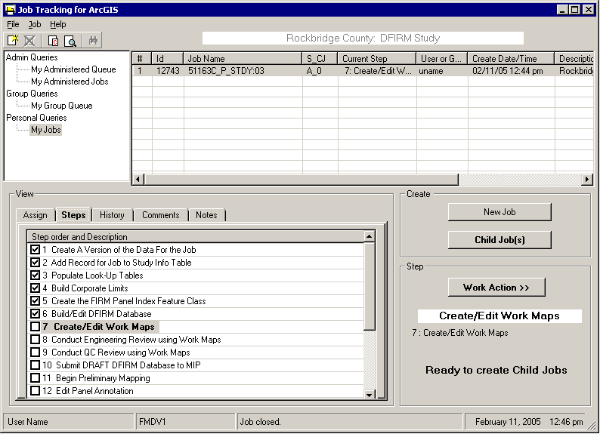 |  |  | JTX Job(s)  List of jobs in the selected queue  Create Job Section  Allows users to create new jobs  Step Actions Section  Displays current job step and status, and allows user to advance to next step of job
 | User | Message box | Date / time (EST)

JTX Key Concepts

What are JTX Users/Groups?
A JTX User is any person that has access to and will be working within the JTX environment. Each User must have his/her own user name set for job assignment and tracking purposes.
A JTX Group is a set of Users that share a common role and typically work in the same department (e.g. Engineering, QA/QC, Mapping, etc.). Groups are used for two reasons: to control privileges and to provide a queuing mechanism for jobs. There will be two Groups per department – one Admin and one Analyst, which will be given different permissions depending on their role in the workflow.
A Mapping Partner is a collection of Groups and Users that work for the same company (e.g. Baker, Watershed, etc.).
Admin Groups will be able to create jobs, assign jobs to any User or Group, and close jobs at the end of the workflow. Admins can also assign jobs to other Mapping Partners.
Analyst Groups will only be able to assign jobs within their Group or to their Admin. Analysts cannot create parent or child jobs.

JTX Jobs/Job Types
A job is a unit of work to be performed on a particular set of data by one or more people. A job type is a logical grouping of steps and layers required to perform a particular task, and it is also used to streamline the workflow.
One job type has been created for this implementation -- DFIRM Study.

DFIRM Study (STDY)
This job type includes any DFIRM Production work. Currently, the 42-step workflow extends through the submission of the preliminary DFIRM database to the MIP. As more tools are added to the environment, the workflow will be extended.
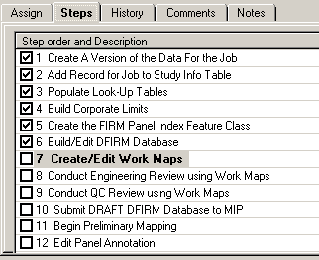 | Step 1 is completed automatically when a job is created.  The remaining steps may launch ArcMap and the appropriate tools or they may be procedural.
First 12 steps for a DFIRM Study Job
- Create a version of the data for the job: will be performed automatically, when a job is created [JTX]
- Add Record to Study_Info Table: will only have to be done once for the study. If record already exists, you won’t need to add it, but will have the chance to edit it [GeoPop]
- Populate Look-Up Tables: users will populate all required look-up tables to assist with database production, this task can be divided up and assigned to multiple users [GeoPop]
- Build Corporate Limits: will allow user to create the corporate limits, which is required for the creation of the FIRM Panel Index Feature Class. [GeoPop]
- Create the FIRM Panel Index Feature Class: will create 2000 scale panel layout for study, which the user will be able to edit as needed [GeoPop]
- Build/Edit DFIRM Database: allows user to populate database with required features, this can also be divided up into multiple jobs [GeoPop]
- Create/Edit Work Maps: allows user to create a workmap to check database population. [Work Map]
- Conduct Engineering Review using Work Maps: allows engineering staff to review work maps [Data ReViewer]
- Conduct QC Review using Work Maps: allows QC group to review work maps [Data ReViewer]
- Submit DRAFT DFIRM Database to MIP: DRAFT DFIRM Database will be submitted to the MIP
- Begin Preliminary Mapping: annotation will be generated for map creation [Label-EZ]
- Edit Panel Annotation: user will be able to edit automatically generated annotation, and add any missing elements [Map Production Pro, Label Edit, Annotation Tool]
- Conduct QC Review using Checkprints: QC will review checkprints with annotation [Data ReViewer]
- Conduct Engineering Review Using Checkprints: engineering will review checkprints with annotation [Data ReViewer]
- QC Review Engineering Comments: QC will review engineering comments on maps and annotation [Data ReViewer]
- Perform Corrections to Checkprints: analysts will make necessary changes, as outlined by engineering and QC [GeoPop, Label-EZ, Map Production Pro, Label Edit, Annotation Tool]
- Create Preliminary Maps: user will create draft preliminary maps [Map Production Pro]
- Create Preliminary Index: user will create draft preliminary index [DFIT]
- QA Preliminary Index: QA will review index [DFIT, Data ReViewer]
- Submit Preliminary DFIRM Database to MIP: draft preliminary submission of DFIRM database to MIP
- Independent QA of Preliminary: independent QA will review submission and provide comments
- Add Independent QA Comments (1): review comments and make changes to DFIRM database [GeoPop, Map Production Pro, Data ReViewer, LabelPanel, Label Edit, DFIRM Annotation]
- Create Final Prelim Checkprints: user will create final preliminary maps [Map Production Pro]
- Create Final Prelim Index: user will create final preliminary index [DFIT]
- QA Final Prelim Index: QA will review index [DFIT, Data ReViewer]
- Submit Final Prelim DFIRM Database to MIP: preliminary submission of DFIRM database to MIP [Database Exporter]
- Create Metadata for Preliminary DFIRM: create/edit metadata file for DFIRM [Metadata Builder]
- Prepare Preliminary Package: components of preliminary package are gathered
- Mail Preliminary Package: preliminary package is mailed
- Post-Preliminary DFIRM Processing – Receive Comments: receive and review comments from communities
- QC Review of the Engineering/Community Comments: QC review of community comments
- Incorporate Required Changes to DFIRM: incorporate community comments into DFIRM [GeoPop, Map Production Pro, Data ReViewer, LabelPanel, Label Edit, DFIRM Annotation]
- QC Review of GPO Checkprints: QC review checkprints [Map Production Pro, Data ReViewer]
- Engineering Review of GPO Checkprints: engineering review GPO checkprints [Map Production Pro, Data ReViewer]
- Submit GPO DFIRM Database to MIP for Independent QA: draft preliminary submission of DFIRM database to MIP [Database Exporter, Metadata Builder]
- Receive and Incorporate Comments from Independent QA: incorporate comments into DFIRM [GeoPop, Map Production Pro, Data ReViewer, LabelPanel, Label Edit, DFIRM Annotation]
- Prepare GPO Package: components of GPO package are gathered
- Perform QC Review of GPO Package: QC reviews GPO package
- Prepare Submission to Map Service Center: components of MSC deliverable are gathered
- QC Review of MSC Deliverables: QC review of MSC deliverable package
- Mail MSC Package: MSC deliverable package is sent
- Reconcile and Post Using JTX Toolbar to Capture Transactions: once job is complete, JTX admin will reconcile and post the job to the default database

Getting Started

User Request Process
Contractors who wish to use the environment must complete a login request form that can be found at: http://hazards.fema.gov/resources/dfirm.htm
Once the form is complete, it should be sent to the corresponding Regional Management Center (RMC) for the request to be processed.

Data Submission Process
If the contractor has any data they wish to use, it should be submitted to the following address for posting:
DFIRM Data
Attn: Anil Shrestha
3601 Eisenhower Avenue
Alexandria, VA 22304-6425
Please note that whenever possible, data should comply with Appendix L of the Guidelines and Specifications and should include a readme.txt file containing contact information. However, additional reference data can be included with the submission that has no Appendix L specifications (e.g. DRGs, topo data, ortho photos, other GIS data, etc.). All data that will be used for final FIRM production must be referenced in the projection.

Set Access Level
The first time you log on to Citrix and click on the DFIRM Tools icon, you will be prompted to set your file security level. In order for tools such as the PDF Exporter to function properly, you must allow the ICA application to have “Full Access” to your computer. You can select any of the reminder options.
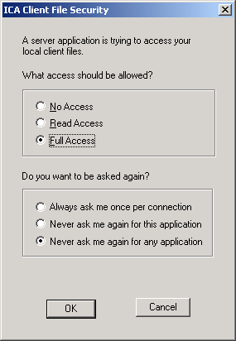 | Allow Full Access to your local files.  Select one of the prompt options available.

Tool Controls
Now that you are ready to start working in JTX, you’ll need to know how each of the menus and tools work.

JTX Toolbar
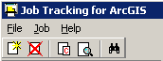

Create New Job
Opens Create Job dialog where user enters information for a new project. The dialog box is shown on the following page. Only users in Admin Groups can create a new job.
User selects Job Type, State, County, or Community from preset list, which appears in drop-down menu.  DFIRM ID is calculated automatically based on values entered in the “Describe Location” section of this dialog | 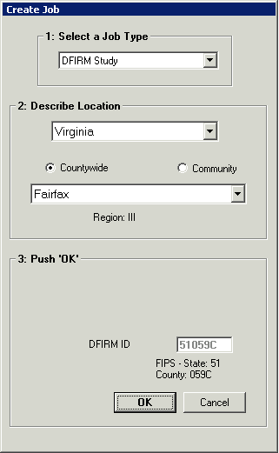 | Job Type:  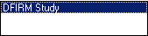  State:  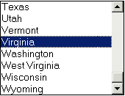  County List:  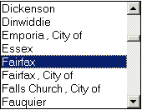  Community List:  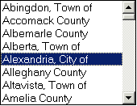

Cancel Job
Cancels selected job. This may be needed if an error is detected in the initial set-up of a job (e.g. Admin accidentally selects wrong job type, State, or county/community).
You can only cancel a job that is unassigned, regardless of privileges. Only Admins will be able to cancel a job, as they are the only users capable of creating jobs.

Create Child Jobs
Opens Create Child Jobs dialog, as seen on next page.
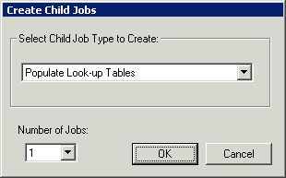
Use the drop-down list to prevent typos when entering the number of child jobs to create

Users in Admin Groups create Child jobs when a step within the Parent job can be split into multiple smaller jobs that can be assigned to different users. Whenever the Child Job(s) option is available, at least one child job must be created. This is a good way to allocate resources. For example, if you are at the Populate Look-up Tables stage and have two analysts available, you can create two child jobs so that both analysts can work on the task simultaneously populating their different tables, which increases efficiency.
Note: Any steps that involve data editing require the creation of at least one child job as a data protection measure.
Parent and Child jobs can be identified in the Job Name field in the queries window. Parent jobs will have a _P_, as seen in the first record in the image below, while a Child job will have a _C_, as seen in the second and third records of the table below.
Identify a Parent job (_P_) or Child job (_C_) in the Job Name field.

When a child job is created, it will have its own set of steps that reflect the steps needed to complete that child job. The first of these steps is completed automatically when a version of the data is created for the user to work on, as in the workflow steps for a child job seen below:
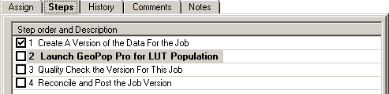

Reconcile and Post
Child jobs that involve editing work have a workflow step called “Reconcile and Post the Job Version” (step number 4 in the example on the previous page). If edits have been made to data in a child job, it is critical that this step be run. Child job versions are reconciled with one another to ensure that no conflicts exist. Versions are then posted back to the Parent version of the data.
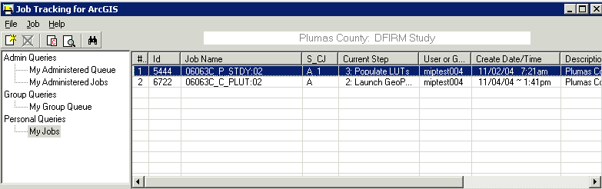
Make a note of the Job ID

- Make a note of the of the Parent job ID number, which is visible in the job record in JTX. This number is not related to the DFIRM ID.
- Make edits to data tables or layers using GeoPop Pro.
- Save edits.
- Run the Reconcile and Post step in the child job workflow. This step launches ArcMap.
- Use the ArcMap tools to reconcile and post data to the parent version. If you do not see the Versioning toolbar, as seen below, add it to your project under View / Toolbars.
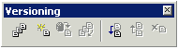
- Select the Reconcile button
- The following dialog appears to ask with which version of the data the edits should be reconciled. Select the Parent job by its job ID. Remember, the job ID is not related to the DFIRM ID.
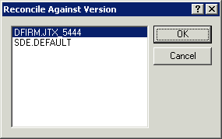
Reconcile to the Job ID for the job on which you are working

- Once the edits are reconciled with the parent version, post them using the Post button located on the Versioning toolbar.
- Exit ArcMap.
- Close the child job using the option from the Work Action >> button.
Note: The Parent job will not be able to advance to the next step until all child jobs are closed. Refer to page 17 of this document for more information.

Show Child Jobs
Will show all child jobs for the selected parent job.

Find Job
Will allow the user to search for a particular job according to certain parameters. Searches are made within a selected queue (in the example below, the search is being done on My Group Queue). Searches can be made based on job ID, job name, the number of a job’s current step, creation date, person or group to whom a job is assigned (‘Current User’), Region (enter a number 1 through 10), State, County, or Community.
The results of the Find operation will be returned in the dropdown list at the bottom of the dialog. Select one job or all of them. You will be returned to the JTX interface and will see the list of the job(s) that you select from the dropdown.

User selects search criteria  A complete or partial string can be added  Dropdown menu provides list of all job IDs | 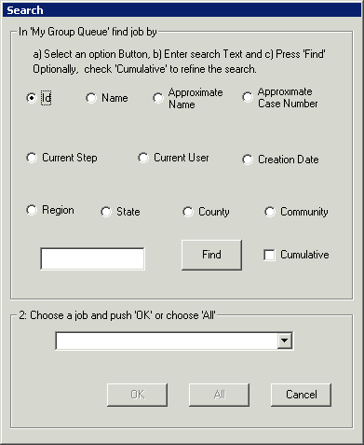

JTX Menu

File
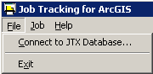
Connect to JTX Database: Allows user to set up different server configurations to allow work on a different geodatabase. This option shouldn’t be used since all FEMA work will be done on one server.

Job
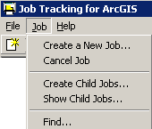
Note: All functions on this menu work the same as those previously defined on pages 6-8 of this user guide.

Help
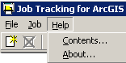
Contents… Opens the standard JTX help as created by ESRI. At this time it does not reflect any of the customizations made by the National Service Provider.

Job Query Window
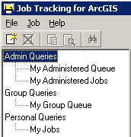 | Within the Job Query window there are three different sets of queries that you can run including  Admin Queries, Group Queries, and Personal Queries.

Admin Queries
This set of queries allows an administrator to see what jobs are queued for the group that they are in charge of (My Administered Queue) and what jobs have been assigned to particular people within their group (My Administered Jobs).

Group Queries
This query shows all jobs that are assigned to the group to which you belong.

Personal Queries
This query shows all jobs that are assigned to you.
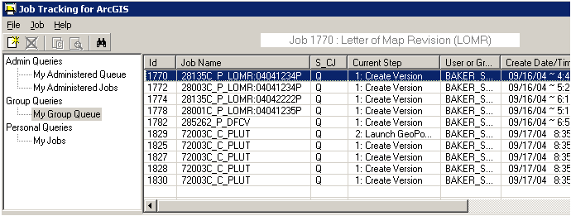
Regardless of which query section you choose to view, the same job information will be displayed as seen in the above image. Note that jobs can be sorted in ascending or descending order by clicking on a column header.
ID = the unique ID for that job
Job Name = name of the job, which tells the county/community, whether it is a parent job or a child job, what type of job it is, and job case number (for LOMR only)
Sample Job Name: 28135C_P_LOMR:04041234P
28135C is the community number
P means that it is a parent job
LOMR identifies the job type (other job types are STDY- DFIRM Study, DFCV – DFIRM Conversion)
:04041234P is the case number (LOMR only)
For Child Jobs, LOMR will change to reflect the current step of the child job (PLUT for Populating Look-Up Tables and COMP for Compilation tasks)
S_CJ = identifies whether a job is assigned to a specific person (Q = queued, A = assigned) and if any child jobs exist (child jobs will show up as A_2 where the number indicates how many child jobs have been created)
Current Step = identifies current step to be completed
User or Group = identifies who the job is assigned to
Create Date/Time = displays the date/time that the job was initiated
Description = describes the job by area and type (E.g. Arapahoe County in Colorado: DFIRM Study)

Updates and Views Section
This section is used to assign jobs, show the job steps, show the job history, and add comments or notes to the current job selected in your queries window.
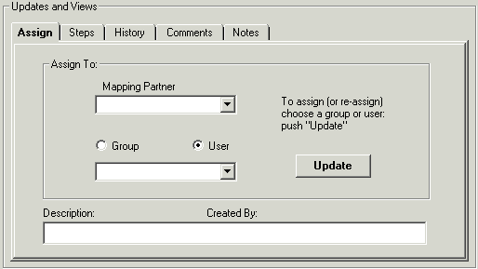

Assign Tab
This tab allows you to assign a job to another user, group or mapping partner, depending on your privileges.
When the user selects the category of who they want to assign the job to (mapping partner, group, or user), dropdown lists are provided for the user to choose from, as seen in the image below.
Once the appropriate party has been identified, the Update button is used to apply the selection to the job.
When a new parent or child job is assigned to a user, a version of the data will be created. Assigning the job from one user to another will not result in the creation of a new version.
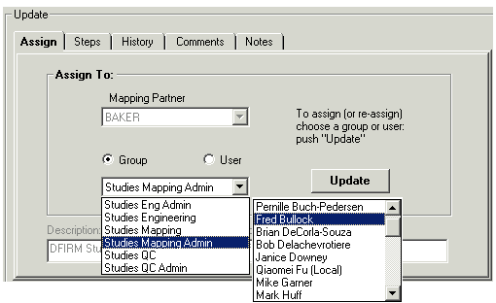
Groups and Users are sorted by Mapping Partner

Steps Tab
This tab shows users a list of all the required steps of their job, and identifies which steps have been completed, which step is the current step, and which steps need to be completed.
Check marks are used to identify completed steps.  Highlight identifies current step.  All other steps after current step need to be completed. | 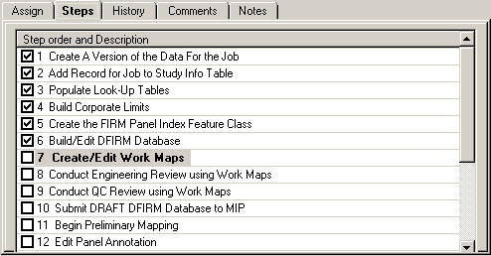

History Tab
This tab displays all user interaction with a job as seen in the image below. Each time a user interacts with a job, a time stamp, user name, and action description is automatically recorded in the JTX admin database.
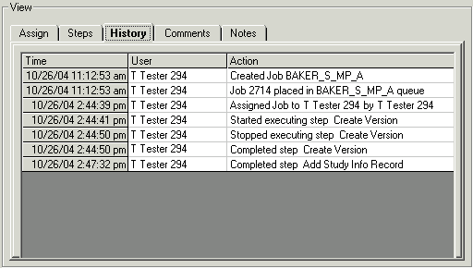

Comments Tab
This tab allows the user to add any additional time sensitive information that is not captured automatically and shown in the History tab. This supplemental information is maintained by JTX for the duration of the job. The user must type their comment into the comment box and press the Add button for the comment to be recorded.
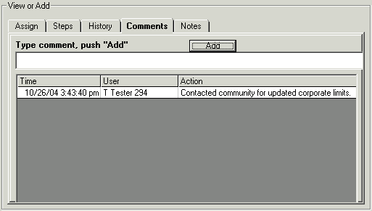

Notes Tab
This tab can be used to add general comments to the project that are not time sensitive. After the comment is entered, click on Update to commit the entry to the field.
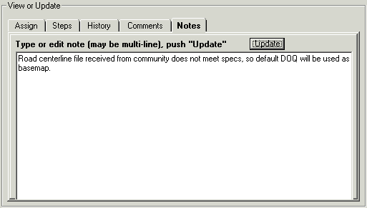

Step Actions Section
This tab is used to work on the current step of a job, or to advance a job to the next step. Within the tab, the name of the project, current step of the project, warnings, and the status of the job (step and child job information) are shown as seen below. Clicking on the Work Action >> button will open the menu seen below on the right.
Opens Work Action menu -------------  Describes what will happen when the current step is run. -----------------  Prompts user to run a step or perform another action. ----------------  Indicates when a step can be run or what needs to be done in order to run the step. ------------------------------ | 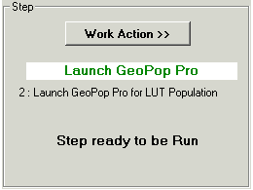 | Work Action Menu options:  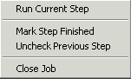

Run Current Step
Allows the user to work on the current step of the job. If the step is not procedural, an ArcMap session will be launched automatically and customized based on the requirements of the step. The ArcMap project will include the default DFIRM layers and any toolbars that will be needed to complete the step.

Mark Current Step Done
Allows the user to identify when a step is complete. Some steps will launch an ArcMap session for the user depending on the requirements of the task. When a user exits ArcMap the job is not automatically marked as complete since the user may need to continue work at a later date. For these steps, the user will need to use the Mark Current Step Done function to identify that the step is complete.

Uncheck Previous Step
This allows the user to return to the previous step in the workflow. This may be necessary if a member of the engineering department identifies a problem that a member of the mapping department must go back and correct.

Close Job
When the job is complete, this allows the user to close the job.

Create Job Section
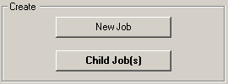 | Note:  All functions on this menu work the same as those previously defined on pages 8-9 of this user guide.

Additional JTX Toolbars
Outlined below are additional toolbars that will be added to ArcMap at given steps of a job.

Rendering/Symbology Toolbar
This toolbar is used to render feature classes with predefined symbols. This toolbar also acts as a quality control tool as it can identify errors in the attribution of feature classes.

Rendering using VVT Symbology
Renders all features using symbology based on the Valid Value Tables (VVTs). If the VVTs identify a feature as an error (doesn’t pass valid value checks), it is symbolized differently than the valid features.

PLTS Dangle and Pseudo Renderer
This tool renders line feature classes to show dangle, pseudo, and regular nodes.

Default Renderer
This renders all the layers using the default unique value renderer with random symbols.

Set Polygon Transparency Percentage
Allows users to set transparency on polygon features.

Load Additional Data Toolbar
The tools on the Load Additional Data Toolbar allow users to add data to their ArcMap session that is not added automatically as part of the standard DFIRM layers. Data that a user may wish to add includes raster catalogs of DOQs/Quads, contour lines, effective panel layout schemes, and any of the enhanced SDE feature classes.
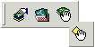
 | DFIRM Layer Data Loader | Adds additional layers and tables from the SDE geodatabase
 | DFIRM Reference Data Loader | Adds reference data to the map view
 | Show DFIRM Adjacent Area | View adjacent DFIRMs
 | Show Only DFIRM Area | Remove view of adjacent DFIRMs

DFIRM Layer Data Loader
Available Data Layers: list of any features that are part of the SDE geodatabase that can be added  Select features form the Available Data Layers box and hit the add arrow to add it to the list of features to be added to ArcMap | 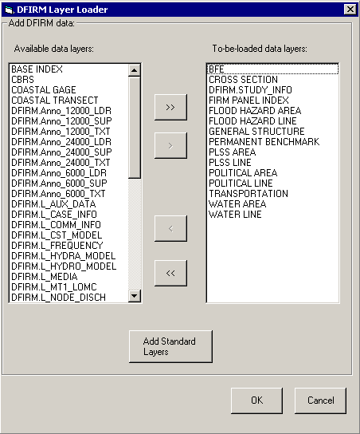 | To-be-loaded data layers: list of all features that will be added to ArcMap  Will add all standard layers to ArcMap (done by default)

DFIRM Reference Data Loader
Used to add any additional reference data that does not reside in the SDE geodatabase. This includes: raster catalogs (DOQs or USGS Quads), topo (contour lines), and effective map layouts.
Select type of reference data to load  Any files of the selected type will be displayed in this box for the user to select from  Adds selected data to ArcMap session | 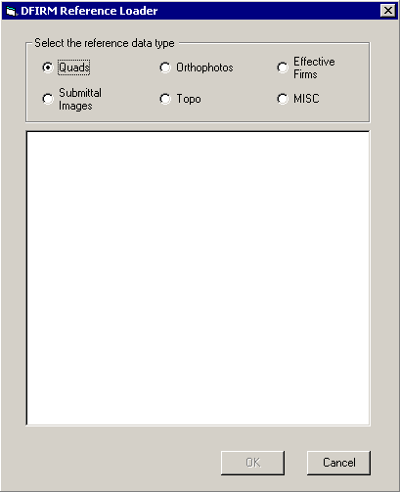

If the user selects the “Topo” or “MISC” radio button, then they will receive the following message:

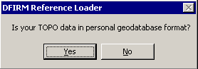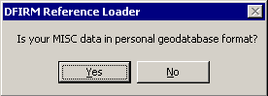

If the user selects “Yes”, then the dialog changes to the following, where the user can pick the personal geodatabase and then will be able to choose the feature classes from that geodatabase:
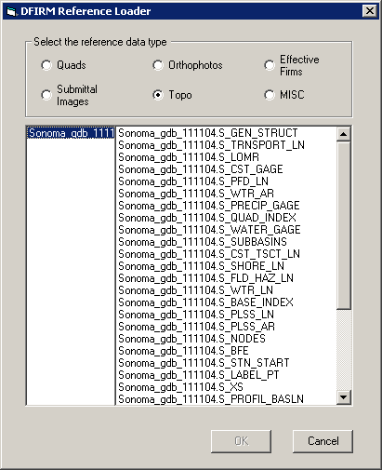

Show DFIRM Adjacent Area
Click on this button to show data for adjacent areas. If data for adjacent areas is loaded into the database, it will be shown. You will not have permission to edit any data in an adjacent area; it is only shown for your reference. Once you select the button, its icon will change to that of the Show Only DFIRM Area tool.
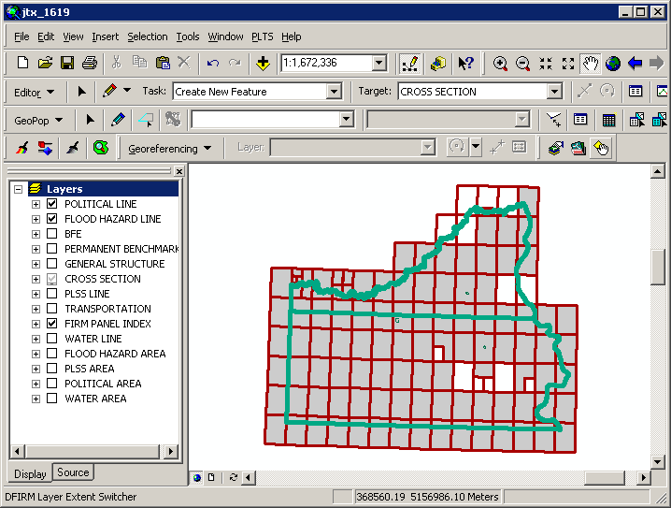

Show Only DFIRM Area
Click on this button to remove data showing for adjacent areas. Once you select the button, adjacent data will disappear and the button icon will change to that of the Show DFIRM Adjacent Area tool (see above).
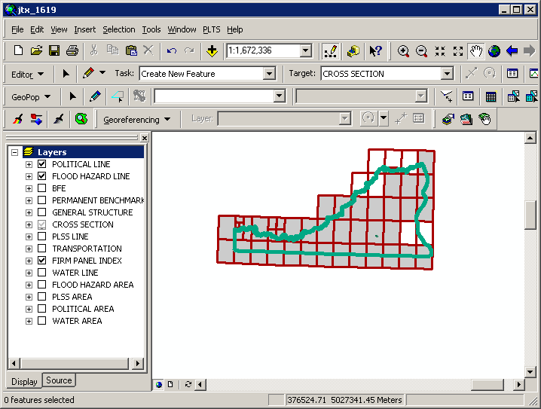

Trouble - Shooting
Problem: I see the following error message when I try to uncheck the previous step.
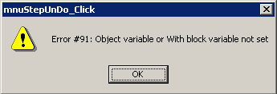
Solution: Users cannot uncheck a step at which a version is created. If you are working in a child job and want to go back to the previous parent step, you must mark all of the steps in the child job complete and close the child job. Once you are back in a parent job, you can uncheck the previous step(s) until you are at the step you need to be.

Contacts
If you need assistance with this tool, please contact the representative at your local RMC.

