

GeoPop Pro Tool

User Guide

FEMA DFIRM Production Tools

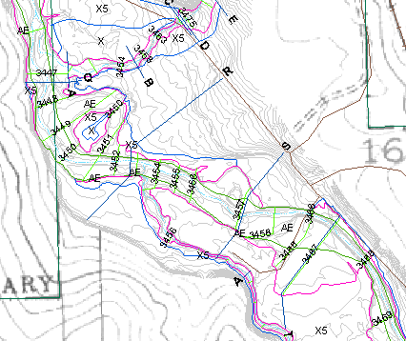

Table of Contents:

What is GeoPop Pro? 4
GeoPop Pro Overview 4
What can you do with the GeoPop Pro Tool? 5
Quick Reference Guide 6
Editing in the JTX Environment 7
Tool Controls 7
GeoPop Pro Menu 7
Create Image Catalog 8
Panel Index Generator 10
Base and Quad Index Generator 10
Validate Features 12
Snapping 14
Dangle 15
Options 16
Edit 16
Create New Feature 18
Trace 19
Construct Features 20
Target Layer 21
Feature Type 22
Snap Tolerance 23
Attributes 23
Add New Row 24
Attribute Selected Features 25
Attribute All Selected Features 26
Panel Divider 27
Panel Merger 29
Load Additional Data Toolbar 32
DFIRM Layer Data Loader 32
DFIRM Reference Data Loader 33
Show DFIRM Adjacent Area 34
Show Only DFIRM Area 35
Trouble - Shooting 36
Contacts 38

What is GeoPop Pro?
The Federal Emergency Management Agency’s (FEMA) April 2003 Appendix L: Guidelines and Specifications for Flood Hazard Partners (hereon after referred to as FEMA’s database specifications) includes the specifications for both draft and delivered DFIRM data. The Geodatabase Population (GeoPop Pro) Tool is a user-friendly application designed to run within ArcMap that allows you to easily capture and edit data that meets FEMA’s draft DFIRM database specifications.
With this application, you can easily edit geodatabases with feature classes, domains, and business tables that are compliant with FEMA’s database specifications. An advantage of this application is that it prompts you to attribute features as they are digitized. Another advantage is that the dropdown options on the attribute forms are read directly from the domain tables and look-up business tables.
The design of this application consists of a toolbar that is accessible through ArcMap. Each tool on the toolbar helps to simplify data capture. Many tools are similar to existing ArcMap tools for easy recognition: however, they have different functionality. For instance, the GeoPop Pro Create New Feature tool allows you to attribute each feature as it is created. There are also tools included for convenience that have not been modified, such as the Snap Tolerance tool.
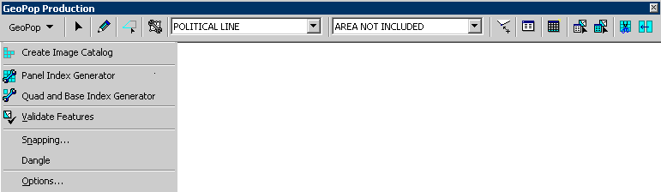

GeoPop Pro Overview
The GeoPop Pro user guide contains information that will help guide you in the use of the tool. The key sections of this guide are:
- Quick user reference guide (p. 6)
- Descriptions of tools and how to use them (p. 7)
- Trouble-shooting section containing common errors and their solutions (p. 36)

What can you do with the GeoPop Pro Tool?

You can attribute features as you digitize by using the Create New Feature tool. |  |  |  | You can validate attributes of selected features using the Validate Features tool.
You can attribute a selected set of features individually using the Attribute Selected Features tool, or you can attribute all of the selected features the same way using the Attribute All Selected Features tool. |  | 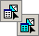 |  | You can set the snapping tolerance using the Snap Tolerance tool.
You can add a record to one of the look-up tables using the Add New Row tool. |  |  |  | You can merge the FIRM Panel Index panels using the Panel Merger tool.
You can create new features using existing features in the same layer with the Trace tool. |  | 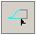 |  | You can split the FIRM Panel Index panels into quarters using the Panel Divider tool.
You can create new features based on the shape of the features in another layer using the Construct Features tool. |  | 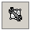 |  | You can view the attributes of selected features using the Attributes tool. |  | 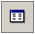
You can generate panels for the FIRM Panel Index (S_FIRM_Pan) using the Panel Index Generator tool. |  |  |  | You can create raster catalogs using the Create Image Catalog tool. This creates a raster catalog from all the images located in a folder.
You can select the type of feature to sketch using the Feature Type drop down tool. | 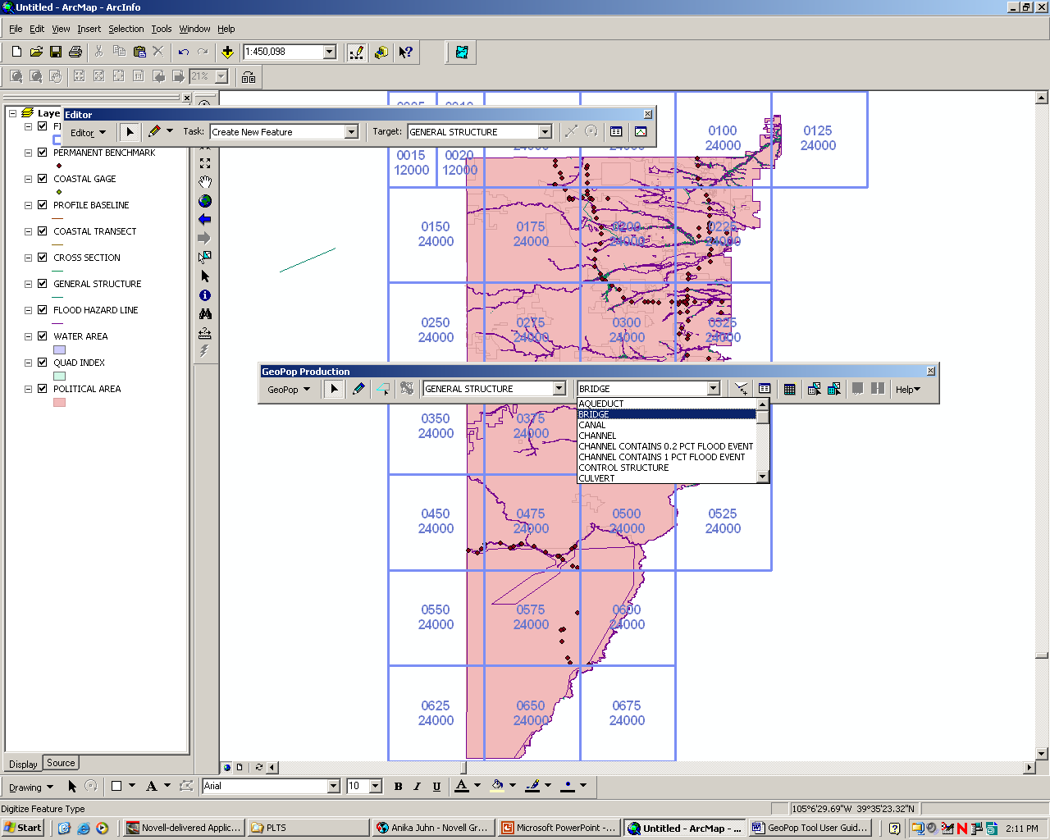 |  |  |  | Select the feature layer to edit using the Target Layer drop down tool. This will also set the target layer as the only selectable layer.

Quick Reference Guide
The following is a quick reference guide to all the tools available in the GeoPop Pro Tool. In addition, positioning your cursor over a button on the toolbar will display its name.
 | Edit | Edits features
 | Create New Feature | Adds points to sketch
 | Trace | Trace features
 | Target Layer | Identifies which map layer to store features
 | Feature Type | Identifies the type of feature to digitize
 | Construct Features | Creates features based on selected features
 | Create Image Catalog | Creates catalog
 | Panel Index Generator | Generates panels for FIRM Panel Index
 | Validate Features | Validates features
 | Snapping | Shows snapping environment window
 | Dangle | Shows dangle window
 | Options | Modify the snapping environment
 | Attributes | Shows attribute properties
 | Add New Row | Edits tables
 | Attribute All Selected Features | Attributes all selected features
 | Attribute Selected Features | Attributes selected features individually
 | Snap Tolerance | Sets snap tolerance
 | Panel Merger | Merges Selected Panels
 | Panel Divider | Splits Selected Panel
 | About | Displays program information

Editing in the JTX Environment
Many of the tools available in GeoPop require that you start an editing session. When you start an editing session, you may see the following dialog:
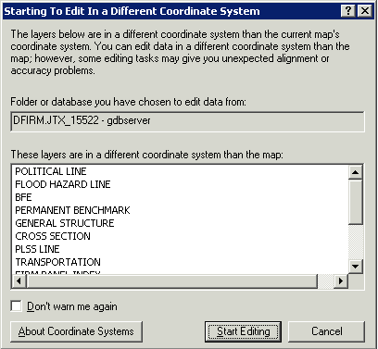
The dialog box warns you that the version of the data that you are planning to edit is stored in a different projection than that which it is displayed in the ArcMap project. The ArcMap session in which you are working projects the data based on the entry made in the STUDY_INFO table and the data is stored in geographic. Click on Start Editing to accept the warning.

Tool Controls
This section describes the functionality of each of the tools on the GeoPop Pro toolbar.

GeoPop Pro Menu
This button opens the drop down menu containing menu items that allow you to validate features and to set snapping and editing options.
From the GeoPop Pro toolbar, click GeoPop Pro menu to display the menu items.

Create Image Catalog
This tool creates an image catalog from the images located in a directory. To display the catalog, the layer must first be added using the DFIRM Reference Data Loader button.
- Click on the Create Image Catalog button. Choose to create an Ortho Catalog, Quad Catalog, or both by checking the boxes in the dialog shown below.
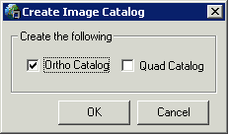
- Select the name of the project that contains the images for which you want to create a catalog, as shown below.
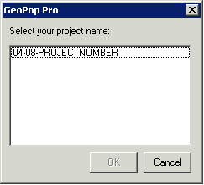
- Once you select the project number, click OK. This will create a new catalog, if one does not already exist for the county on which you are working. If a catalog already exists, you will be notified.
- Load the image catalog using the DFIRM Reference Data Loader (page 31). When you select the icon, the following dialog will appear. Select the project name.
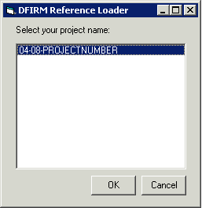
- Click OK
- The DFIRM Reference Data Loader dialog will appear. Use the radio buttons to select the type of reference data you would like to load. If you created a quad or orthophoto image catalog, select the appropriate option and then select the catalog to be added to your ArcMap session.
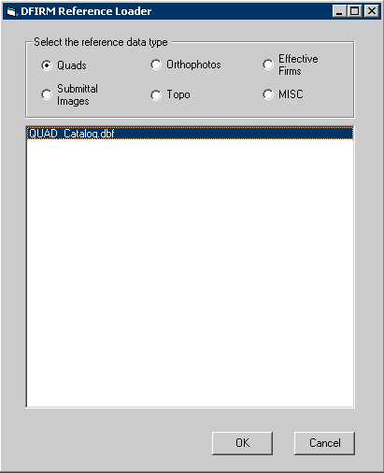

Panel Index Generator
Generates FIRM Panel Index (S_FIRM_Pan) panel areas based on the extent of the Political Area (S_Pol_Ar). When you use the Panel Index Generator tool, certain fields such as panel number and scale will be automatically calculated for you. This tool requires that the Political Area (S_Pol_Ar) data layer is created and populated in advance. The panels created are limited to the extent of the Political Area.
- Click Panel Index Generator.
The tool will now begin the process of generating FIRM Panel Index (S_FIRM_Pan) panel areas. The following window will appear. It may take a few moments to complete. This window will disappear when the process has completed.
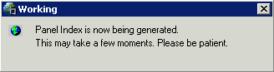
Generating S_FIRM_Pan and S_Quad_Index using the Panel Index Generator

Note: It is important that you attribute the FIRM Panel features after generating them. While some attributes are calculated automatically upon creation, there are others that the user will have to enter for additional DFIRM tools to function.

If any features already exist in the FIRM Panel Index (S_FIRM_Pan), the following error message will appear. You must remove any existing features before re-running the tool.
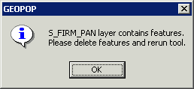

Base and Quad Index Generator
Generates Base Index (S_BASE_INDEX) and Quad Index (S_QUAD_INDEX) based on your study data. For Base Index, the tool looks to the appropriate folder which contains the base images used for the study. Any image that resides in that folder is added to the Base Index. For Quad Index, the tool uses the Political Area features to select the appropriate panels from a nationwide shapefile of USGS 7.5 minute Quads. During this process, the user is prompted to set attribute information for the features being created, as outlined below.
      - On the GeoPop toolbar menu, select the Base and Quad Index Generator tool.
      - The tool will begin to process Quad Index, indicated by the following status box.
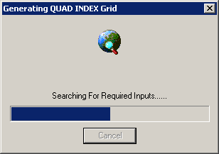

      - The user is then prompted with the Quad Index Source Selection dialog, where they need to select the appropriate source citation from the list provided.
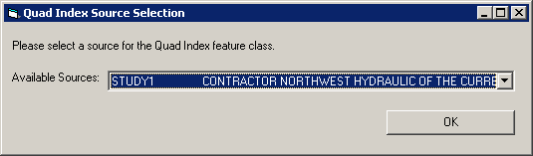
Note: The Available Sources dropdown menu is populated by L_SOURCE_CIT. If the source that you need is not present in the list, then you will have to go back and use GeoPop to add and additional source to L_SOURCE_CIT.

      - When the user hits OK on that dialog, they will see that the tool starts generating the Base Index.
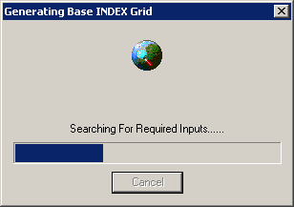

      - Next, the user is prompted with the Populate Base Index Attributes dialog. Here the user has an option – they can either attribute the images one by one (Current Record), or can apply attributes to all records. Note that if the user chooses to attribute the current record, the tool will loop through all records.
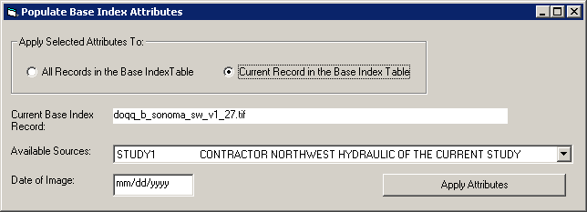
Note: The Available Sources dropdown menu is populated by L_SOURCE_CIT. If the source that you need is not present in the list, then you will have to go back and use GeoPop to add and additional source to L_SOURCE_CIT.

      - Once the user has set the attributes, the click on Apply Attributes to complete the process.

Validate Features

Applies validation rules to selected features in a geodatabase and flags those features with invalid attributes.
- Begin an edit session, from the Editor toolbar, click on the Editor dropdown list and click Start Editing.
- Select the features you want to validate using the Edit tool.
- Click on the GeoPop Pro menu and select Validate Features.
If your selection contains any invalid features, a message box will appear with the number of invalid features. Only those features that are invalid will remain selected, as seen in the following image:
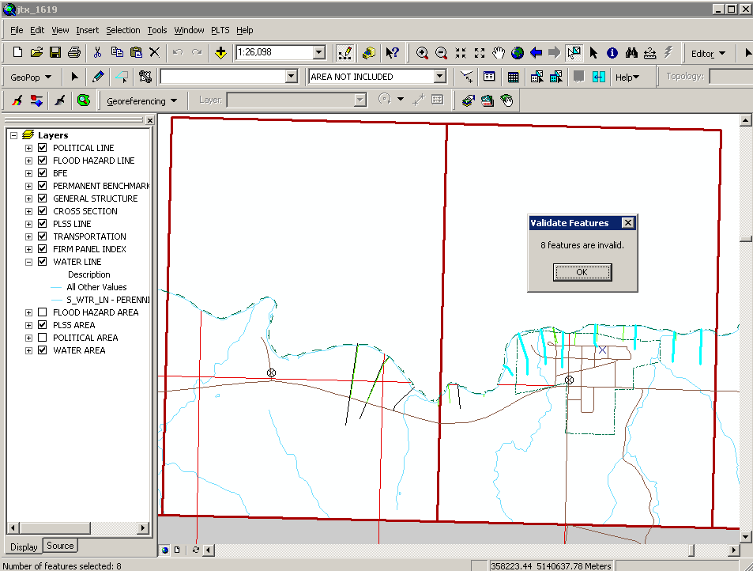
- Click OK.
- Click on one of the invalid features.
- Repeat step 3.
A message box appears telling you why the feature is invalid.
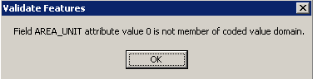
- Click the Attributes button to view the attributes of the invalid features.
- Click on the values that are invalid and make the necessary modifications.
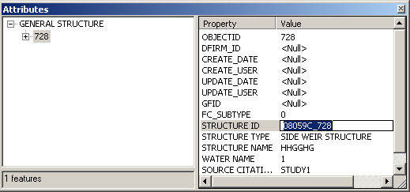
Attributes window seen in ArcMap

- Close the attributes window.
- Repeat steps 6 – 9 for the remaining features.
- Repeat steps 2 and 3. You should see a message box informing you that all the features are valid
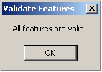
Validate Selection results window seen in ArcMap

Snapping
Opens and closes the Snapping Environment window. Snapping allows the user to designate if the edited feature will connect to the vertex, edge, or end of another feature. The user may also elect whether the feature being edited is able to snap to its own edge or vertex. The order of the feature layers defines the priority of the snapping. By dragging layers up and down in the Table of Contents, the snapping priority will change. Note that when the Snapping Environment window is closed, the snap-related properties are still active; the user must unselect the relative checkboxes to discontinue snapping.
- From the GeoPop Pro toolbar, click GeoPop Pro menu and click Snapping.
- The Snapping Environment window will appear.
- Check the properties you wish to set.
The snapping properties are effective as soon as they are checked or unchecked.
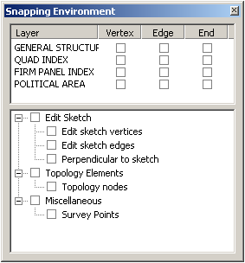
Snapping environment window seen in ArcMap

Dangle
Opens and closes the Dangle environment window. This tool allows the user to display dangle-related errors. If the selected polyline features are not connected to the vertex, edge, or end of another polyline feature, the node is highlighted. The user may choose to display errors for the target layer, which must have a polyline geometry type, or may choose to display errors in all selectable polyline geometry types. Note that when the Dangle Window is closed, the dangle-related properties are still active; the user must unselect the relative checkboxes to no longer display the dangle nodes.
- From the GeoPop Pro toolbar, click the GeoPop Pro menu and click Dangle. The Dangle Window will appear:
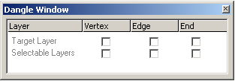
- Check the properties you wish to set. The dangle properties are effective as soon as they are checked or unchecked.
Note: This tool is especially useful for snapping flood zone lines together and for snapping BFEs to the 100-year flood zone.

Options
Displays the options for the ArcMap editing environment. Most of the time, you will only use the options that appear under the General tab.
- From the GeoPop Pro toolbar, click GeoPop Pro menu and click Options. The Editing Options window will appear.
- Set the editing options and click OK.
It is recommended to set the units of snapping tolerance to map units.
The editing properties are effective immediately.
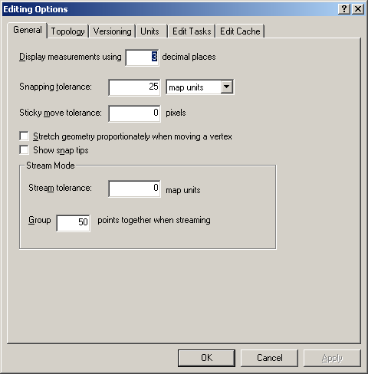
Editing Options dialog window

Edit
Selects geographic features for the purpose of editing. You can click on a feature to select it or drag a box to select many features.
- Begin an edit session. From the Editor toolbar, click on the Editor dropdown list and click Start Editing.
- Click the Edit tool
- Move the pointer over a feature and click the mouse. The feature should be highlighted.
- Hold the Shift key down while you click to select multiple features. You can also click and drag a box to select multiple features.
- Hold the space bar key down while you click to select a subset of features that are already selected
- Click on the vertices to modify them. Delete those selected or add new ones using the Sketch context menu. To view the Sketch context menu, right-click while holding the mouse over the feature.
  - To modify the vertices of a feature:
Double-click on the feature with the Edit tool. Make sure that the task in the Current Task dropdown list is Modify Feature.
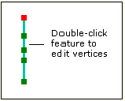
Modifying vertices of a feature in ArcMap
  - Use the Set Selectable Layers dialog box to limit feature selection to the layers of interest. The features in the layers chosen are selectable immediately.
    - From the Main menu, click Selection.
    - Click Set Selectable Layers.
    - Choose the layers you want to select.
    - Click Close.
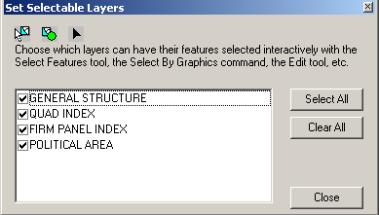
Set Selectable Layers window seen in ArcMap

Create New Feature
Adds points, vertices, and segments to the sketch. You can create three types of features: points, lines, and polygons.
- Begin an edit session. From the Editor toolbar, click on the Editor dropdown list and click Start Editing.
- Make sure that the current task listed in the task dropdown list on the Editor toolbar is Create New Feature.
- Set a target layer in the Target Layer dropdown on the GeoPop Pro toolbar.
- If the Feature Type tool is enabled, set the feature type to digitize.
- From the GeoPop Pro toolbar, click Create New Feature.
- Click on the map to sketch a new feature.
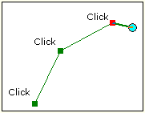
Creating new features in ArcMap

TIP: Use snapping to ensure connectivity.

- Double-click to finish the sketch.
- Once a new feature has been created the attribute window will appear.
The dropdown lists contain the coded value descriptions for the related fields, which are populated from the tables inside the geodatabase. Changes to the tables in the geodatabase will affect the list that appears in the dropdown.
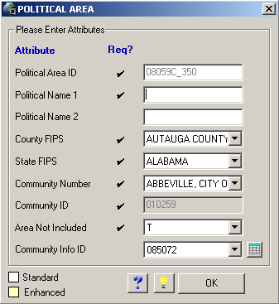 | NOTES:  Standard attributes are displayed with white field backgrounds. Enhanced attributes have yellow field backgrounds.  Checkmarks in the “Required” column indicate those fields that must be populated.
Attribute feature window seen in ArcMap. Note: Attribute dialogs will vary depending on target layer

- Click the Flash Feature button to highlight the new feature.
- Attribute the new feature by typing in new values in the fields and selecting from the options in the dropdown lists.
- Click OK.

Trace
Creates segments by tracing over the segments of selected features.
- Switch to Data View from Layout View.
- Begin an edit session. From the Editor toolbar, click on the Editor dropdown list and click Start Editing.
- Select features you want to trace using the Edit tool.
- Click the Trace tool.
- Click on the map to start tracing.
- Move the cursor over what you want to trace.
You can move the mouse in the reverse direction to remove unwanted segments or press the Esc key to cancel the trace.
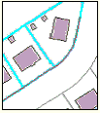
Tracing features in ArcMap. No offset is used in this example.

- Click on the map to stop tracing.
- Double-click to display the attribute dialog window.
- Click the Flash Feature button to highlight the new feature.
- Attribute the new feature by typing in new values in the fields and selecting from the dropdowns.
- Click OK.

Construct Features
Constructs features based on the shape of selected features. You can select features from one or more layers to create features in the target layer. You can choose to select lines or polygons to create lines or polygons depending on the geometry of the target layer. This command is disabled if you have an ArcView license.
- Begin an edit session. From the Editor toolbar, click on the Editor dropdown list and click Start Editing.
- Select the features with the geometry from which you would like to construct features. This command is disabled if you do not have any features selected.
- Set the target layer in the Target Layer box.
Target Layer

- Click the Construct Features command.
- The Construct Features window will appear.
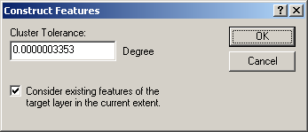
Setting the cluster tolerance for Construct Features command in ArcMap

- The cluster tolerance is the minimum distance between vertices of features that are not coincident. Vertices that fall within the cluster tolerance are defined as coincident and snapped together (ESRI help).
- The default value for the cluster tolerance is 3.353 X 10^{–7} degrees. You can modify this tolerance. Select OK to set the cluster tolerance.
- The new feature is created in the target layer.

Target Layer
Sets the map layer that contains the features you want to edit or store new features to. In setting the target layer, the Feature Type dropdown is enabled/disabled based on whether the target layer has multiple feature types that can be digitized.
- Begin an edit session. From the Editor toolbar, click on the Editor dropdown list and click Start Editing.
The Target Layer window should be active.
Target Layer

- Click on a layer in the Target Layer dropdown list to select it.
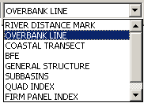
Setting the target layer in ArcMap

Feature Type
Specifies the feature type that will be digitized. This tool is only enabled when the current edit layer is either: Flood Hazard Line (S_Fld_Haz_Ln), General Structure (S_Gen_Struct), PLSS Line (S_PLSS_Ln), Political Line (S_Pol_Ln), Transportation (S_Trnsport_Ln), or Water Line (S_Wtr_Ln). The tool will not be enabled if any other layer is currently being edited.
- Begin an edit session. From the Editor toolbar, click on the Editor dropdown list and click Start Editing.
- The Target Layer tool should be active.
- Click a layer in the Target Layer dropdown list.
- If the layer listed in the Target Layer dropdown list has multiple feature types, the Feature Type dropdown will be enabled/disabled.
- Select a feature type and using the Create New Feature tool, begin adding new features.
Target Layer | Feature Type
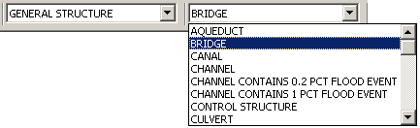
Setting Feature Type command in ArcMap

You will notice that the feature type selected is reflected in the attribute feature dialog window. The feature type can be modified before the attributes are applied to the feature.
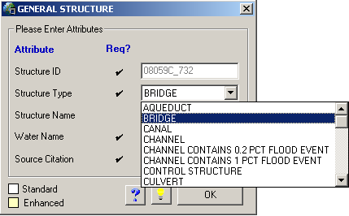 | NOTES:  Standard attributes are displayed with white field backgrounds. Enhanced attributes have yellow field backgrounds.  Checkmarks in the “Required” column indicate those fields that must be populated.
Attribute feature window for the General Structures layer

Snap Tolerance
Sets the tolerance value applied to all snap agents.
- Begin an edit session. From the Editor toolbar, click on the Editor dropdown list and click Start Editing.
- Click on the Snap Tolerance tool.
- Click on the map.
- Drag an expanding circle on the map to set the tolerance value.
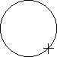

- Press the T key to see the tolerance value when editing.
The tolerance units and value can also be set in the Options window.

Attributes
Allows attributes of selected features to be viewed and modified. This tool is useful for viewing data and making edits. To have more control over attribute editing and to take advantage of intuitive dropdown options for fields with domains and look-up tables, it is recommended that you use either the Attribute Selected Features (page 24) or the Attribute All Selected Features (page 25) tool.
- Begin an edit session. From the Editor toolbar, click on the Editor dropdown list and click Start Editing.
- Select the features whose attributes you want to view with the Edit tool.
- Click the Attributes tool.
- The Attributes window will appear.
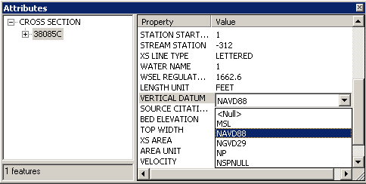
Attributes window

- Select values for editing. Dropdown options will be shown for those attributes with domains, as seen in the above image.

Add New Row
Adds new records to the tables. Currently, this tool works for the non-feature attribute tables (L_) and Study_Info.
- Begin an edit session. From the Editor toolbar, click on the Editor dropdown list and click Start Editing.
- Click the Source tab on the bottom of the table of contents.
- Select a table in the table of contents that has been added to ArcMap, or add a table using the DFIRM Layer Data Loader tool.
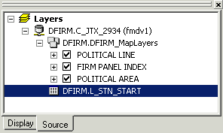
Table of contents frame in ArcMap

- Click Add New Row tool.
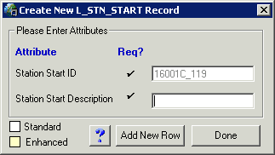 | NOTES:  Standard attributes are displayed with white field backgrounds. Enhanced attributes have yellow field backgrounds.  Checkmarks in the “Required” column indicate those fields that must be populated.
Add New Row attribute window

- Type in the attribute values in the fields.
- Repeat steps 4 & 5 until completed.
- Click Done when finished.
Note: To view the tables listed in the table of contents, click on the Source tab located at the bottom left of the viewer window.

Attribute Selected Features
Attributes selected features using the attribute dialog windows.
- Begin an edit session. From the Editor toolbar, click on the Editor dropdown list and click Start Editing.
- Click a layer in the Target Layer dropdown list.
- Select features you want to attribute using the Edit tool.
- Click the Attribute Selected Features tool.
The feature attribute window will appear.
The attribute window displays the current attributes of the feature. If the feature does not have any attributes, default attributes will be shown.
- Click the Flash Feature button to highlight the new feature.
- Attribute the feature by typing in new values in the fields and selecting from the dropdowns.
- Click OK.
- Steps 5 - 7 will be repeated for every selected feature.

Attribute All Selected Features
Attributes all selected features using dialog windows. All selected features will be attributed with the same values.
- Begin an edit session. From the Editor toolbar, click on the Editor dropdown list and click Start Editing.
- Click a layer in the Target Layer dropdown list.
- Select features you want to attribute using the Edit tool.
- Click the Attribute All Selected Features tool. The feature attribute window will appear.
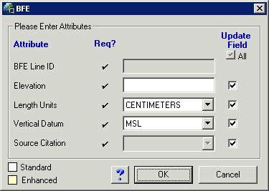
- Check the box next to the fields you want to modify. Click the to select/unselect all the checkboxes.
- Attribute the features by typing in new values in the fields and selecting from the dropdowns.
- Click OK.
Note: Attribute All Selected Features will apply the same attributes to all of the selected features. Attribute Selected Features permits you to apply unique attributes to features, even if you select more than one at a time. Also note that your edits will be saved automatically. You will not be prompted to “Save Edits” when you stop editing.

Panel Divider
Panel Divider enables you to divide a FIRM Panel Index (S_FIRM_Pan) panel into quarters. You can split a 1:24,000 scale panel into four 1:12,000 panels, or you can split a 1:12000 panel into four 1:6,000 panels. The scales mentioned are those displayed in ArcMap. The scale shown on panel layouts will be displayed in feet. The tool also automatically calculates the new panel numbers, scales, and corner coordinates.
- Switch from Layout View to Data View.
- Begin an edit session. From the Editor toolbar, click on the Editor dropdown list and click Start Editing.
- Select the FIRM Panel Index (S_FIRM_Pan) layer in the Target Layer dropdown list.
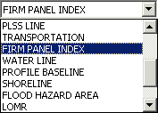
Note: If you want to turn on labels for this process, you need to right-click on “FIRM PANEL INDEX” in the table of contents. Next, select “Properties…”, then select the “Label” Tab. Then, check the “Label features in this layer” box and select the “Expression” tab. In the “Expression” window, type [PANEL] & vbnewline & [SCALE]. This will label each FIRM Panel with the panel number and scale as seen in the images below.

- Select the panel to split using either the Edit tool or the Select Features tool .
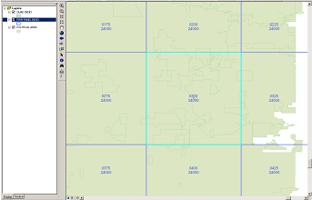 | Each panel shows the Panel ID number above the Panel Scale (in inches)
Selecting features to split using the Panel Divider tool in ArcMap

- Click the Panel Divider tool .
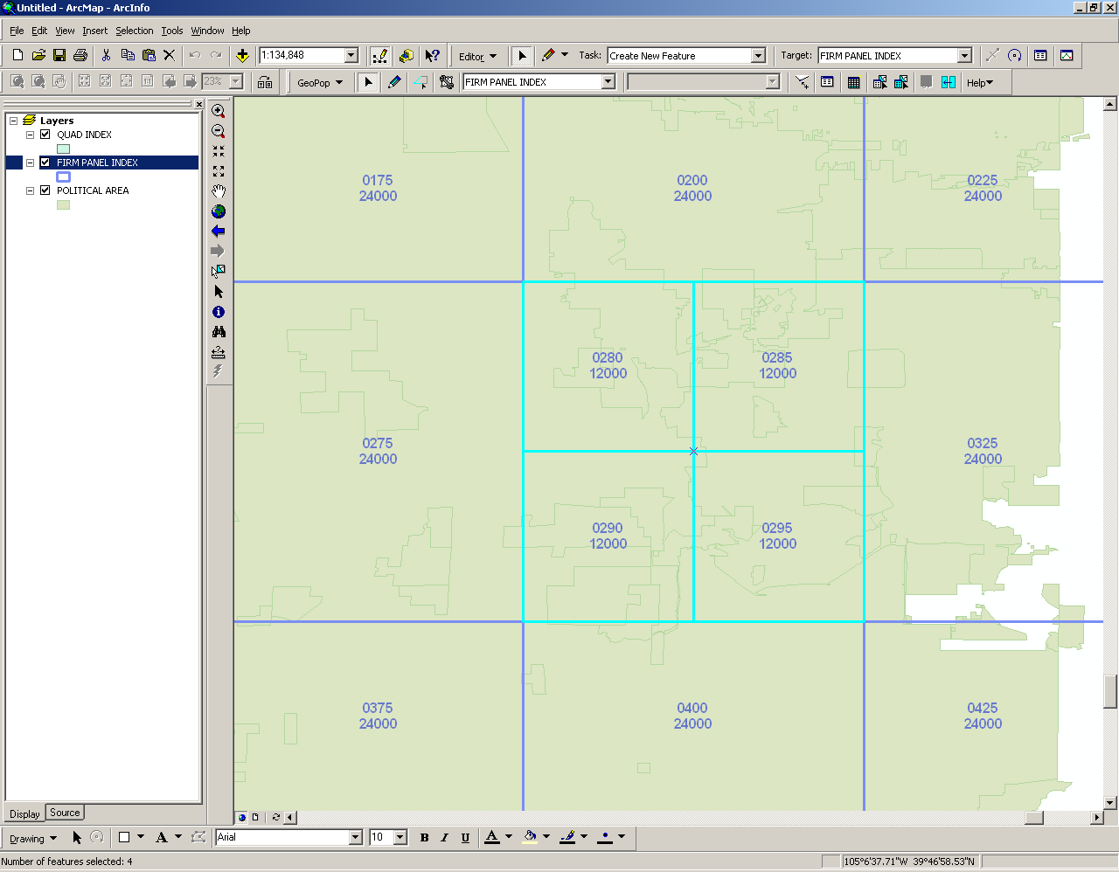 | Each panel shows the Panel ID number above the Panel Scale (in inches)
The results of the Panel Divider command

You should see the panels divided into quarters with the panels and scale correctly attributed.
Note: It is critical that you validate the topology after each use of the Panel Divider. If you do not validate after each edit, there will be errors in the topology (gaps and slivers) and resulting error messages will follow.

- Validate the topology of the FIRM Panel Layout (S_FIRM_PAN). This will ensure that there will be no gaps or slivers in the panel layout.
  - Start an editing session, if you are not already in one.
  - Check your table of contents for the Topology Rules layer. If you do not see it, add the layer with the DFIRM Layer Data Loader (see p. 31). Click on the DFIRM Layer Data Loader icon and select the Add Standard Layers button.
  - Zoom out to the full extent of your data
  - Select the FIRM_PAN_TOPOLOGY from the dropdown target list in the Topology toolbar. If you do not see the Topology toolbar below, add it to your project from View / Toolbars.
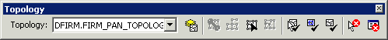
Validate Topology in Current Extent
- Run the Validate Topology in Current Extent tool, located on the Topology toolbar. The following status box will appear:
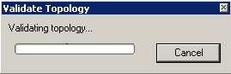
Validating Topology status box

- Click Save Edits to preserve any changes.
NOTE: The Panel Divider tool will not allow you to create panels smaller than 6,000-scale. You will see the following window if you attempt to divide a 6,000-scale panel.

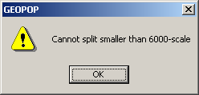
Error message shown when trying to split panels smaller than 6000-scale

Panel Merger
The Panel Merger tool enables you to merge two or more selected FIRM Panel Index (S_FIRM_Pan) panels to create custom panels. The tool automatically calculates the new panel number and scale. It also checks to make sure duplicate panels are not created in the merging operation. For example, if a 24,000-scale panel exists, it will not create another.
The Panel Merger tool allows you to merge multiple panels within the extent of a 1:24,000 scale panel into one panel. However, it will not allow you to merge panels across 24,000-scale panels, nor will it merge 6,000-scale panels across 12,000-scale panels.
- Switch from Layout View to Data View.
- Begin an edit session. From the Editor toolbar, click on the Editor dropdown list and click Start Editing.
- Select the FIRM Panel Index (S_FIRM_Pan) layer in the Target Layer dropdown list.
- Select the panels to merge using either the Edit tool or the Select Features tool .
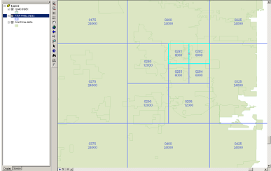
Merging panels using the Panel Merger command in ArcMap

- Click the Panel Merger tool. The following message box will appear:
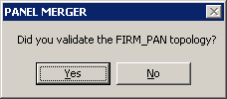
Confirm that you have validated the topology

If you select Yes, then the panels will merge. However if you select No, the tool will not merge the panels, giving you the chance to properly validate your features. You should see the panels merged and scale correctly attributed.
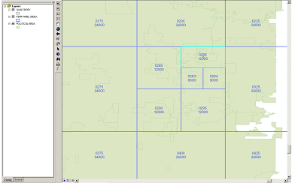
The results of the Panel Merger command

- Validate the topology of the FIRM Panel Layout (S_FIRM_PAN). This will ensure that there will be no gaps or slivers in the panel layout.
  - Start an editing session, if you are not already in one.
  - Check your table of contents for the Topology Rules layer. If you do not see it, add the layer with the DFIRM Layer Data Loader (see p. 31). Click on the DFIRM Layer Data Loader icon and select the Add Standard Layers button.
  - Zoom out to the full extent of your data.
  - Select the FIRM_PAN_TOPOLOGY from the dropdown target list in the Topology toolbar. If you do not see the Topology toolbar below, add it to your project from View / Toolbars.
Validate Topology in Current Extent

- Run the Validate Topology in Current Extent tool, located on the Topology toolbar. The following status box will appear:
Validating Topology status box

- Click Save Edits to preserve any changes.

Load Additional Data Toolbar
The tools on the Load Additional Data Toolbar allow users to add data to their ArcMap session that is not added automatically as part of the standard DFIRM layers. Data that a user may wish to add includes raster catalogs of DOQs/Quads, contour lines, effective panel layout schemes, and any of the enhanced SDE feature classes.
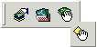
 | DFIRM Layer Data Loader | Adds additional layers and tables from the SDE geodatabase
 | DFIRM Reference Data Loader | Adds reference data to the map view
 | Show DFIRM Adjacent Area | View adjacent DFIRMs
 | Show Only DFIRM Area | Remove view of adjacent DFIRMs

DFIRM Layer Data Loader
Available Data Layers: list of features that are part of the SDE geodatabase that can be added.  Select features from the Available Data Layers box and hit the add arrow to add it to the list of features to be added to ArcMap. | 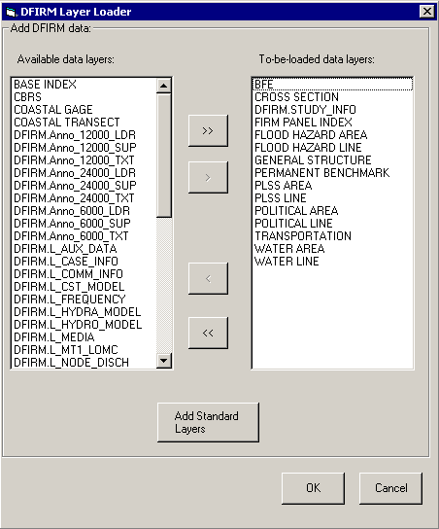 | To-be-loaded data layers: list of all features that will be added to ArcMap.  Will add all standard layers to ArcMap (done by default).

DFIRM Reference Data Loader
Used to add any additional reference data that does not reside in the SDE geodatabase. This includes: raster catalogs (DOQs or USGS Quads), topo (contour lines), and effective map layouts.
Select type of reference data to load:  Any files of the selected type will be displayed in this box for the user to select from.  Adds selected data to ArcMap session | 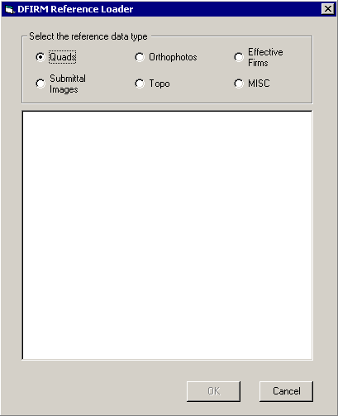

If the user selects the “Topo” or “MISC” radio button, then they will receive the following message:
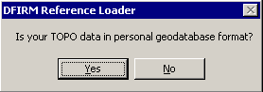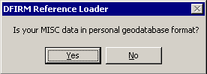
If the user selects “Yes”, then the dialog changes to the following, where the user can pick the personal geodatabase and then will be able to choose the feature classes from that geodatabase:
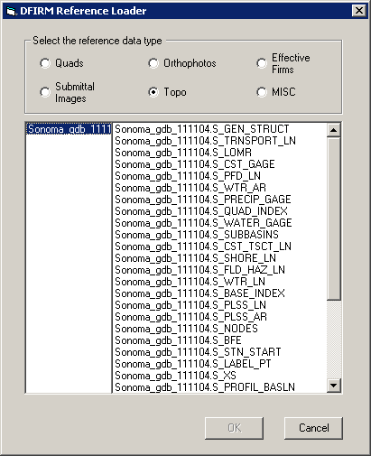

Show DFIRM Adjacent Area
Click on this button to show data for adjacent areas. If data for adjacent areas is loaded into the database, it will be shown. You will not have permission to edit any data in an adjacent area; it is only shown for your reference. Once you select the button, its icon will change to that of the Show Only DFIRM Area tool.
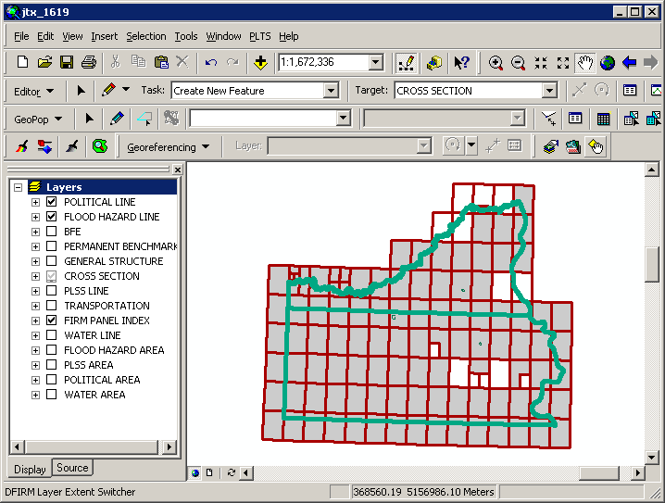

Show Only DFIRM Area
Click on this button to remove data showing for adjacent areas. Once you select the button, adjacent data will disappear and the button icon will change to that of the Show DFIRM Adjacent Area tool (see above).
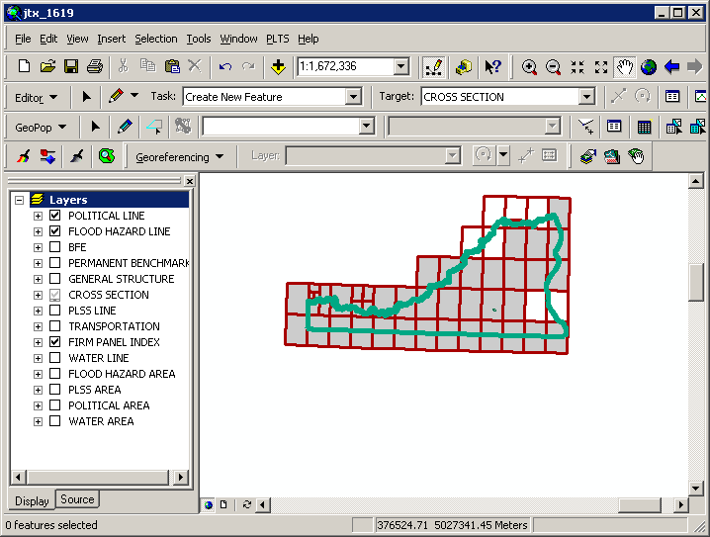

Trouble - Shooting
Problem: Feature Type tool is enabled and not displaying any line types.
Solution: Make sure that you use the Target Layer dropdown item on the GeoPop Pro toolbar when you start an edit session.

Problem: Attribute dialog boxes do not appear after a new sketch has been created.
Solution: Make sure that you double-click to finish creating a new sketch.

Problem: The Panel Index Generator doesn’t work.
Solution: Verify that the corporate limits or political layer (S_Pol_Ar) is loaded. If it does not appear in the table of contents, add it to your project using the DFIRM Layer Data Loader.

Problem: When splitting and merging panels, a panel will not merge properly.
Solution: Try performing the splitting and merging of panels in a different order. For instance, if you wanted to make the panel layout shown in the diagram below, there are several ways you could create it. You could do the panel splitting work first and then the merging. Alternatively, you could split the large panel, merge three of the resulting panels and then repeat the process with the fourth panel.
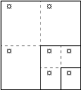

Problem: The following error message appears:
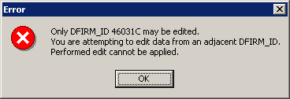
Solution: You are restricted to editing data that has the same DFIRM ID as the job on which you are working. When you click on OK to accept the message, your editing session will be terminated automatically.

Problem: I cannot add a feature to a feature class that is visible (there is a black checkmark in the box next to the name). I have made sure that the layer is selectable.
Solution: Some layers have scale dependencies set on them to prevent the addition of features if the scale of the map is too small. Zoom in to a larger scale, such as 1:3000, and try to add the feature with the GeoPop tools.

Problem: I digitized several features, but when I open the attribute table, many of the fields are “<NULL>”.
Solution: Make sure that you are using the tools on the GeoPop toolbar, and not the tools on the Editor toolbar. Also, be sure to wait for the attribute dialog box to open after each feature you create. This will ensure you are attributing all features correctly.

Contacts
If you need assistance with this tool, please contact the representative at your local RMC.

