

Work Map Pro Tool
User Guide

FEMA DFIRM Production Tools

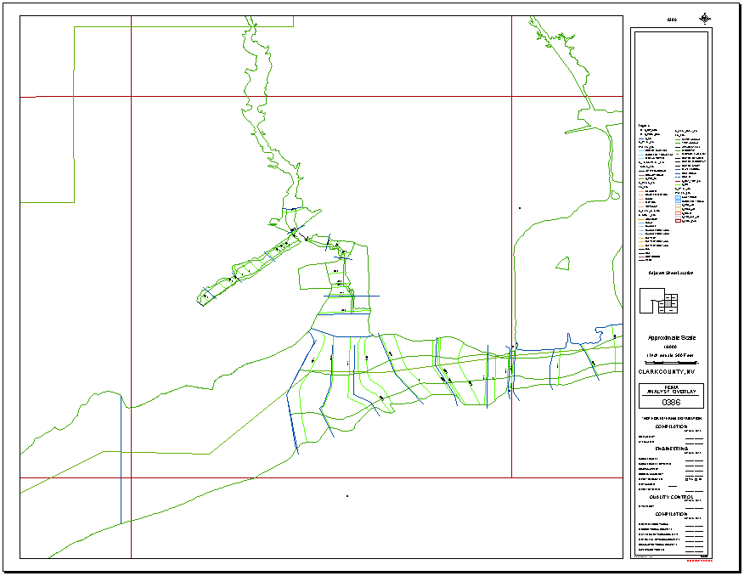

Table of Contents:

What is Work Map Pro? 3
Work Map Pro Overview 3
What can you do with the Work Map Pro Tool? 4
Quick Reference Guide 4
Getting Started 5
Create Work Maps 5
Tool Controls 7
Create Image Catalog 7
Print 9
Preview 10
Remove Graphics 13
Select All Printable Panels 13
Clear Selection 13
PDF Export Toolbar 13
PDF Export 14
Load Additional Data Toolbar 16
DFIRM Layer Data Loader 16
DFIRM Reference Data Loader 17
Show DFIRM Adjacent Area 18
Show Only DFIRM Area 19
Trouble – Shooting 20
Contacts 21

What is Work Map Pro?
Work Map Pro Tool is a user-friendly application designed to run within ArcMap. With this application, you can effortlessly create work maps. An advantage of this application is that you can preview your plots before printing. Another advantage is that you can batch print plots for multiple panels.
The design of this application consists of a window with tools and menu options that are easily accessible in ArcMap. Each tool serves to simplify the creation of work maps. Many tools appear similar to existing ArcMap tools for easy recognition. For instance, the Print tool creates a PDF file of selected panel(s).
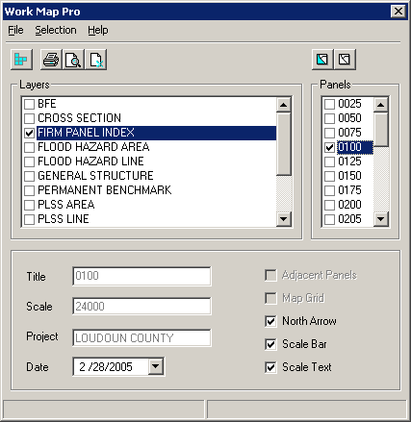

Work Map Pro Overview
The Work Map Pro user guide contains useful information that will help guide you in the use of the tool. The key sections of this guide are:
- Quick user reference guide (p. 4)
- Descriptions of tools and how to use them (p. 7)
- Trouble-shooting section containing common errors and their solutions (p. 20)
- Support/contact information (p. 21)

What can you do with the Work Map Pro Tool?

You can create a preview of the work map for a selected panel using the Preview tool. |  |  | You can print a work map to PDF for an individual panel or multiple panels using the Print tool.
You can remove all the graphics using the Remove Graphics tool. |  |  | You can select all the printable panels using the Select All Printable Panels tool.
You can create raster catalogs using the Create Image Catalog tool. This creates a raster catalog from all the images located in a directory. The output is stored in the directory where the images are located. |  |  | You can deselect all of the panels you have selected for printing using the Clear Selection tool.

Quick Reference Guide
The following is a quick reference guide to all the tools available on the Work Map Pro Tool. In addition, positioning your cursor over the tool will display the name of the tool.
Work Map Pro toolbar  Layers window:  Lists the loaded layers and currently selected layer  Lists currently selected panel information, including title, scale, project, and current date |  | Panels window:  Lists panels available for currently selected layer  Map elements to be added to the plot, including adjacent panels, map grid, north arrow, scale bar, and scale text

 | Create Image Catalog | Makes a catalog of raster data
 | Print | Prints map document to PDF
 | Preview | Creates preview of panel selected for printing
 | Remove Graphics | Removes all graphics
 | Select All Printable Panels | Selects all panels that can be printed
 | Clear Selection | Clears selected panels

Getting Started
It is important that a few key tasks have been completed prior to creating work maps using Work Map Pro. There are specific components of the DFIRM database that must be completed prior to using this tool. They are:
- The Study Info Table must be populated.
- There must be a panel index or effective panel index in order to create a work map. The panel index can be created using the Panel Index Generator (see the GeoPop Pro user documentation) or it can be generated using your own methods.

Create Work Maps
This section describes how to create a work map using the Work Map Pro toolbar.
Note: If you wish to label the features, this can be done by right-clicking on the feature class in the table of contents and selecting Label. Predefined labels have been set for you. If you wish to modify these, then right-click on the feature class in the table of contents and select Properties, from which you can advance to the Labels tab and alter the labels.

- Select the layer that contains the panel information. The application will list all of the panels in the layer. If panels are not found, the panel list will be empty.
Panel Number (Title) and scale for the selected panel. |  | Check elements you want to have on the work map(s) for the panel(s) you have selected.

- Select the panel for which you would like to create a work map.
You will notice that the information for the title and scale will change as you select panels. These fields show the information for the currently selected panel. You can modify the information by clicking the fields and replacing the existing information.
Note: If multiple panels have been selected, changes made to the title and scale will be applied only to the first selected panel. Subsequent panels selected will have the original panel information.

You can also use the Select All Printable Panels button to have the application select all the panels that are printed.
You can also change the map elements that appear on the work map, such as adjacent panel information, map grid, and north arrow. Check the elements you would like to include. Note that these changes will be applied to all of the selected panels.
- You can use the Preview button to view the panel selected.
- Use the Print button to generate an EPS (encapsulated postscript) file. This file will be processed into a PDF file.
Note: The print properties have been set to create a PDF file in landscape format, 44 inches by 34 inches (ANSI E). The PDF file can be downloaded for printing.
The Preview and the Print output should look like the following:

Tool Controls
This section describes the functionality of each of the tools in the Work Map Pro toolset.
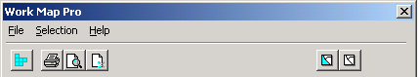

Create Image Catalog
Creates an image catalog from the images located in a directory. To display the catalog, the layer must first be added using the DFIRM Reference Data Loader button.
- Click on the Create Image Catalog button. Choose to create an Ortho Catalog, Quad Catalog, or both by checking the boxes in the dialog shown below.
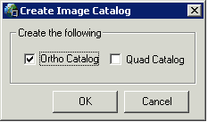
Select the name of the project that contains the images for which you want to create a catalog, as shown below.
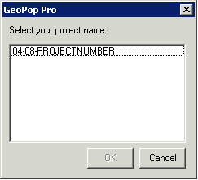
- Once you select the project number, click OK. This will create a new catalog if one does not already exist for the county on which you are working. If a catalog already exists, you will be notified.
- Load the image catalog using the DFIRM Reference Data Loader (page 17). When you select the icon, the following dialog will appear. Select the project name.
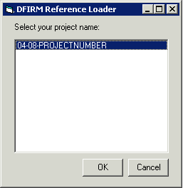
- Click OK
- The DFIRM Reference Data Loader dialog will appear. Use the radio buttons to select the type of reference data you would like to load. If you created a quad or orthophoto image catalog, select the appropriate option and then select the catalog to be added to your ArcMap session.
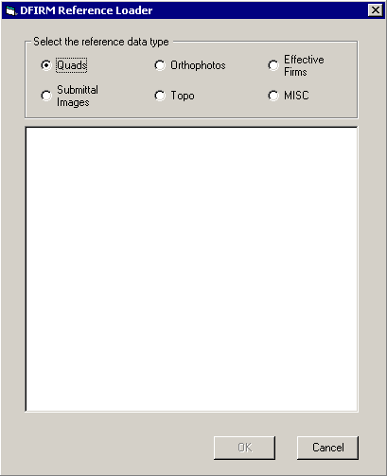

Print
Generates a PDF file of the selected panel with the selected layout elements. If multiple panels have been selected, the tool will batch print all the selected panels. At least one panel must be selected.
- From the Work Map Pro window, select the panel(s) of interest.
- Click Print.
- A PDF file will be created using the following naming convention:
W(CID)_(Panel#).pdf = W06063C_0225.pdf

Preview
Creates a preview of the work map in the layout view. If multiple panels have been selected, the tool will create a preview of the current selected panel
- From the Work Map Pro window, select panel(s).
- Click Preview.
- To preview another panel:
  - Click Remove Graphics.
  - Select another panel.
  - Click Preview.
- After you Preview your work map, you may notice that the legend information extends past the margin of the page. Leave the Work Map Pro dialog window open and correct the legend display properties.
- Use the Select Elements tool (the black arrow) to select the legend.
- Right click on the selection and select Properties from the options that appear.
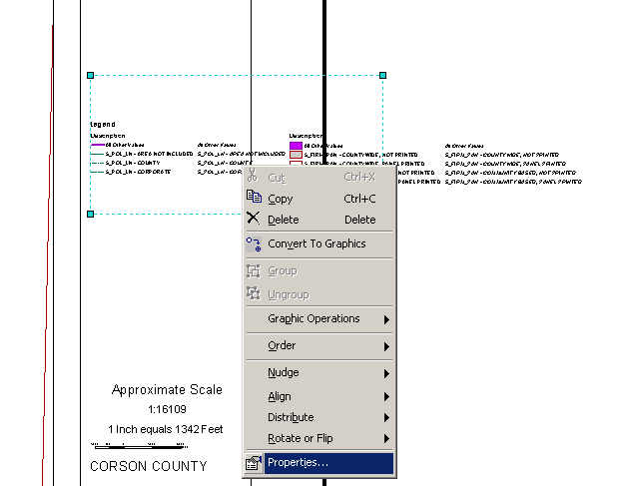
- The Map Graphic Properties dialog box will appear which will allow you to set the options for the Legend.
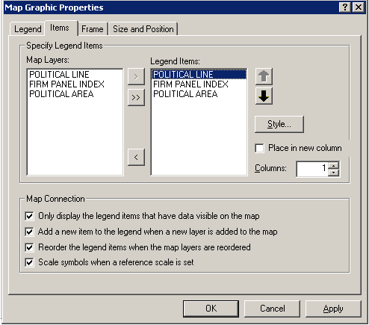

- Click on the Items tab.
- Select the first layer name in the Legend Items column.
- Click on the Style button to change the style of the layer display in the legend.
- The Legend Item Selector dialog will appear.
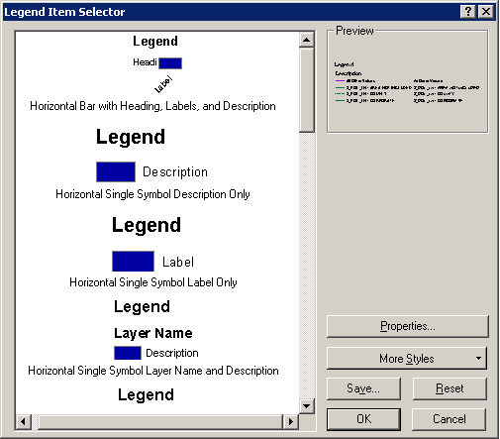
- Scroll down the legend styles to find the type that will stack the legend elements for the selected layer (Horizontal with Layer Name, Heading and Label). You will see the legend style change in the Preview section of the Legend Item Selector dialog box.
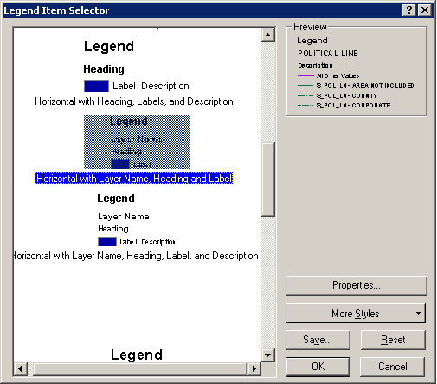
- Click on OK to apply the setting to the selected layer.
- Repeat the process for each layer that appears in the Legend Items window.
- Once you have changed the styles for each layer, click OK to apply the settings to the work map layout.
- Since you have left the Work Map Pro dialog window open, you can now print the selected panel to PDF. Your settings will not be saved if you preview a new panel.
Note: Do not preview the panel you just modified as it will cause a re-draw and your style changes will be lost.

Remove Graphics
Removes all graphics from the layout. From the Work Map Pro window, click Remove Graphics.

Select All Printable Panels
Selects all printable panels. When a panel is selected, the details such as title, scale, and project are displayed in the bottom half of the Work Map Pro window.
From the Work Map Pro window, click Select All Printable Panels.

Clear Selection
Clears all panel selections.
From the Work Map Pro window, click Clear Selection.

PDF Export Toolbar
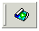
Once you have printed your selected panels to PDF, you can retrieve them and save them to a local drive or server using the PDF Export Tool. You can print the PDF work maps to your local plotter, share them electronically, or store them in an archive.

PDF Export
Allows users to download single or multiple PDF files. Use this tool after printing panels to PDF using Work Map Pro’s Print button.
- Click on the PDF Export button.
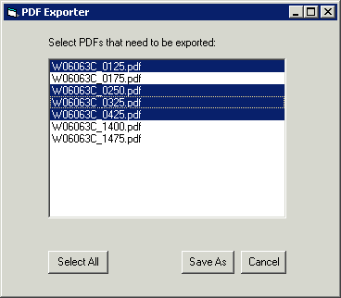

- Select the PDF file(s) of interest and click Save As. Hold down the Ctrl key to make multiple selections.
You may see a dialog box like the one on the following page asking you what access should be allowed to your local files. Select the settings you would like to allow, choose your options to be reminded, then click OK.
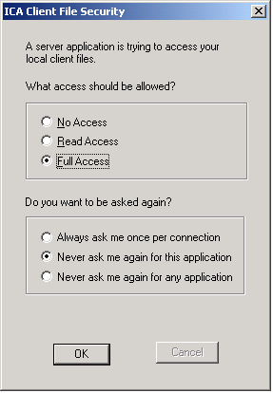
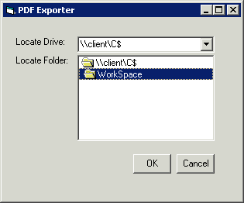
- Navigate to the location on your local drive where you wish to save the files and click OK.

Load Additional Data Toolbar
The tools on the Load Additional Data Toolbar allow users to add data to their ArcMap session that is not added automatically as part of the standard DFIRM layers. Data that a user may wish to add includes raster catalogs of DOQs/Quads, contour lines, effective panel layout schemes, and any of the enhanced SDE feature classes.
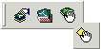
 | DFIRM Layer Data Loader | Adds additional layers and tables from the SDE geodatabase
 | DFIRM Reference Data Loader | Adds reference data to the map view
 | Show DFIRM Adjacent Area | View adjacent DFIRMs
 | Show Only DFIRM Area | Remove view of adjacent DFIRMs

DFIRM Layer Data Loader
Available Data Layers: list of any features that are part of the SDE geodatabase that can be added.  Select features from the Available Data Layers box and hit the add arrow to add them to the list of features to be added to ArcMap. | 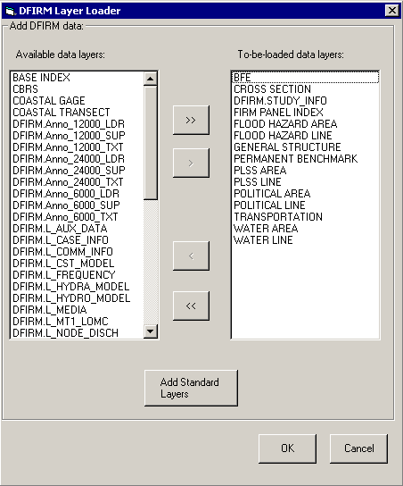 | To-be-loaded data layers: list of all features that will be added to ArcMap.  Will add all standard layers to ArcMap (done by default).

DFIRM Reference Data Loader
Used to add any additional reference data that does not reside in the SDE geodatabase. This includes: raster catalogs (DOQs or USGS Quads), topo (contour lines), and effective map layouts.
Select type of reference data to load:

Any files of the selected type will be displayed in this box for the user to select from.

Adds selected data to ArcMap session.

If the user selects the “Topo” or “MISC” radio button, then they will receive the following message:

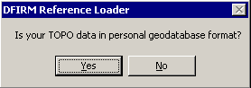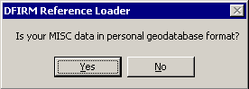

If the user selects “Yes”, then the dialog changes to the following, where the user can pick the personal geodatabase and then will be able to choose the feature classes from that geodatabase:
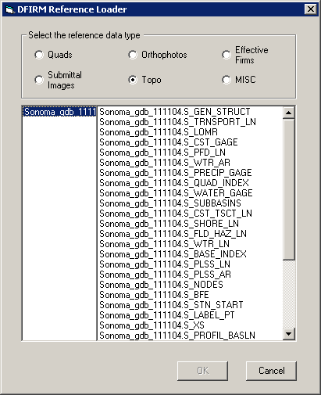

Show DFIRM Adjacent Area
Click on this button to show data for adjacent areas. If data for adjacent areas is loaded into the database, it will be shown. You will not have permission to edit any data in an adjacent area; it is only shown for your reference. Once you select the button, its icon will change to that of the Show Only DFIRM Area tool.
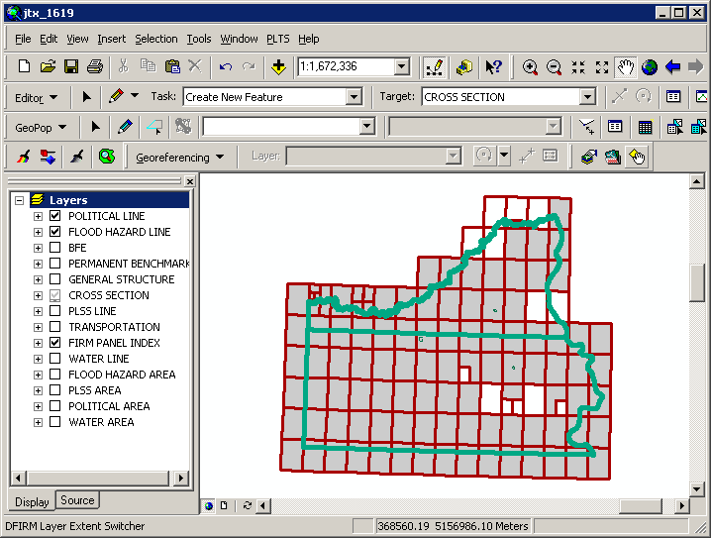

Show Only DFIRM Area
Click on this button to remove data showing for adjacent areas. Once you select the button, adjacent data will disappear and the button icon will change to that of the Show DFIRM Adjacent Area tool (see above).
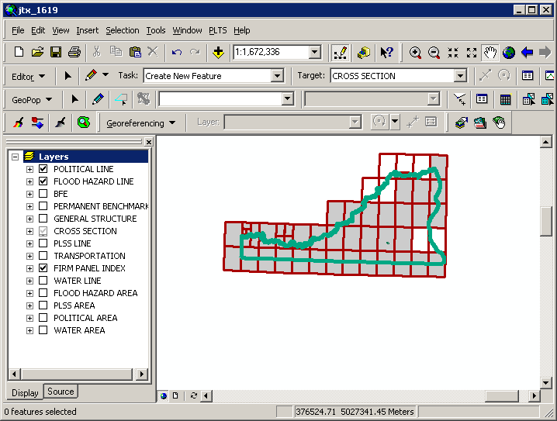

Trouble – Shooting

Problem: The text in the panel layout is too large and extends past the bounding box.
Solution: Check the units of your page size under Page Setup. The measurements should be in inches, not centimeters or points.

Problem: The panel that is generated when I create the layout is not the same panel that I have checked off in the panel box.
Solution: In the panel selection box, those panels that are checked will be printed, but the panel that is selected (highlighted in blue) will appear in the generated layout.
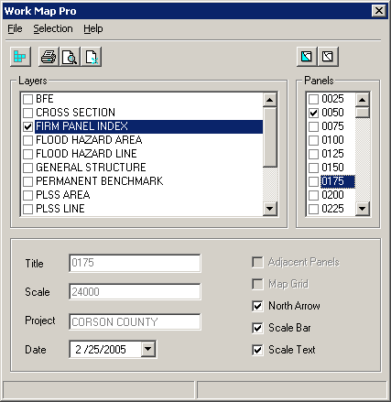 | Checked panels will be printed to PDF.  Highlighted panel will appear in generated layout.

Contacts
If you need assistance with this tool, please contact the representative at your local RMC.

