

Digital FIRM INDEX Tool (DFIT) Pro

User Guide

FEMA DFIRM Production Tools
Version 2.0

Table of Contents

What is Digital FIRM INDEX Tool (DFIT) Pro? 1
Quick Reference Guide 2
Tool Controls 3
Generate INDEX Layout 3
Page Size 9
Page Orientation 10
INDEX Page & Suffix 10
INDEX Locator Diagram 12
Title Block Logo 14
Effective / Revised Date 14
Inset Maps 15
This Area Notes 16
Export to PDF 17
Export to Images 18
Clear Layout 19
Generate FIRM Panel Dates Table 19
Generate Listing of Communities Table 20
Add Logo 20
Symbolize Multi-Page Panels 21
Update Multi-Page Panels 22
Auto Label 23
Save INDEX MXD 24
Load INDEX MXD 25
PDF Export Toolbar 26
PDF Export 26
PLTS Symbology and QA Toolbar 28
Render using VVT Symbology 28
PLTS Dangle and Pseudo Renderer 29
Default Render 29
Set Polygon Transparency Percentage 29
DFIRM Layer Loader Toolbar 30
DFIRM Layer Data Loader 31
DFIRM Reference Data Loader 32
Show DFIRM Adjacent Area 36
Show Only DFIRM Area 37
Zoom to DFIRM ID 38
Suspend Drawing 38
DFIRM Export to PGDB 40
Troubleshooting 43
Contacts 46
Appendix A – Fields Required for Rendering 47

What is Digital FIRM INDEX Tool (DFIT) Pro?
Digital FIRM INDEX Tool (DFIT) Pro is a tool that automates the production of the FIRM panel INDEX map. There are several options that are available that allow you to customize the layout according to the characteristics of the INDEX, as well as create inset maps and/or multiple page INDEX sheets. The panel INDEX map elements meet FEMA’s standards, which are described in FEMA’s Guidelines and Specifications for Flood Hazard Mapping Partners Appendix K: Format and Specifications for Flood Insurance Rate Maps (hereby referred to as Appendix K).
The Title Block, Listing of Communities tables, Map Repository address list, FIRM Panel Dates table, Base Map note, Elevation Datum note, Panel Not Printed (PNP) description list, and CBRS/OPA note are generated automatically, based on information in the study’s look-up tables and feature classes. Also, the standardized Note to Users and Map Dates notes are produced. In addition, the panel number and suffix, panel effective dates, and political areas are automatically labeled.
Moreover, DFIT Pro will enable you to easily export the INDEX map(s) to the file format required for finalized data deliverable submissions to FEMA.

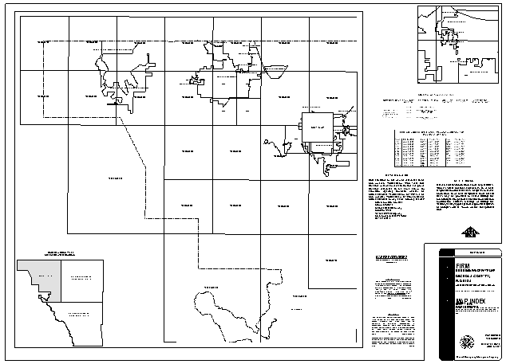

Quick Reference Guide
The following is a quick reference guide to all of the components of DFIT Pro. You can prepare the FIRM INDEX map for printing via the Generate INDEX Layout dialog. Additionally, you can export INDEX map layouts to image formats.

Generate INDEX Layout Dialog
Select the page size for your INDEX map.  Select the page orientation.  Indicate whether the INDEX will be single page or multi-page, and identify the suffix and, if applicable, the page number  If you have a multi-page INDEX, select the maximum number of sheets for the INDEX Locator Diagram. | 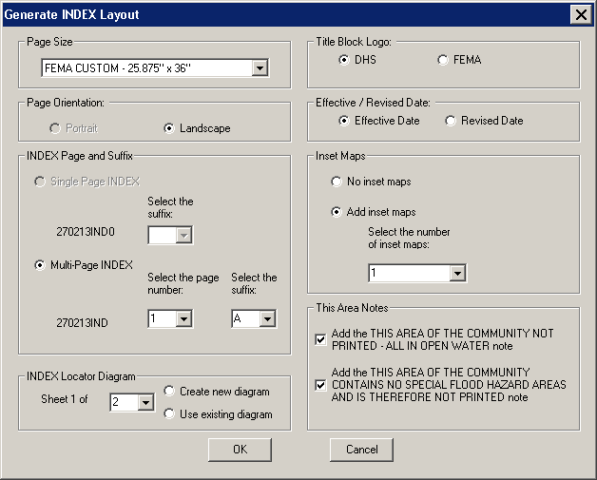 | Choose the logo style.  Choose the date title.  If applicable, add inset map(s) to your INDEX map layout.  If applicable, select the necessary ‘This Area Notes’.

 | Generate INDEX Layout | Creates FIRM Panel INDEX map.
 | Export to PDF | Prints the INDEX map to .pdf format.
 | Export to Images | Exports the INDEX map to .eps and .tif format.
 | Clear Layout | Clears the graphics in the layout view.
 | Generate FIRM Panel Dates Table | Generates the FIRM panel map dates table without regenerating the INDEX layout.
 | Generate Listing of Communities Table | Generates the Listing of Communities table without regenerating the INDEX layout.
 | Add Logo | Adds supplementary logo(s) into the INDEX layout.
 | Symbolize Multi-Page Panels | Returns to the INDEX panel symbology created by the Generate INDEX Layout tool after running the Render Using VVT Symbology tool.
 | Update Multi-Page Panels | Updates the multi-page INDEX sheet after editing panels on the individual sheet.
 | Auto Label | Automatically labels the water line, water area, and transportation features.
 | Save INDEX MXD | Saves an INDEX map layout.
 | Load INDEX MXD | Opens a previously saved INDEX map layout in ArcMap.

Tool Controls
Now that you are ready to produce your INDEX map, you will need to know how to create the layout with DFIT Pro and then export your layout to the required image file format.

Generate INDEX Layout
The Generate INDEX Layout tool enables you to customize your INDEX layout map for your study, according to the options chosen in the Generate INDEX Layout dialog. The layout will be generated in the Layout view. All INDEX map elements adhere to Appendix K specifications.
Note: Before creating a layout, run the Render using VVT Symbology tool with the DFIRMINDEX option on the PLTS Symbology and QA toolbar.
This tool will automatically create the following INDEX map elements applicable to your study: Title Block, Listing of Communities tables, Map Repository address list, FIRM Panel Dates table, Base Map note, Elevation Datum note, Note to User, Panel Not Printed (PNP) description list, and CBRS/OPA note. In addition, the panel number and suffix, panel effective dates, and political areas are automatically labeled in the map. Each political area polygon will be labeled (e.g., if there are 3 polygons for the City of Springfield, the label will appear 3 times on the layout).
Note: Political areas where the Area Not Included (ANI_TF) value equals “T” will be labeled in the map with the community name and the note “AREA NOT INCLUDED”.
Note: Tables, lists, inset maps, and/or the INDEX Locator Diagram might be stacked on top of each other when the Generate INDEX Layout tool is run. Select one element (e.g., Listing of Communities table) at a time and space them around your layout to ensure that all of your necessary INDEX map elements have been created.

Title Block
The Title Block is generated from data in the FIRM Panel Index (S_FIRM_Pan) data layer, Study_Info table, and input from the Generate INDEX Layout dialog. Multi-page INDEX sheet maps will be labeled as “SHEET X of Y” in the Title Block, where X is the current sheet and Y is the total number of sheets.
Example of the Title Block for a single page INDEX | Example of the Title Block for a multi-page INDEX

Listing of Communities table
The Listing of Communities table is generated from data in the FIRM Panel Index (S_FIRM_Pan) data layer, Political Area (S_Pol_Ar) data layer, and the Community Info (L_Comm_Info) look-up table. The Listing of Communities table is automatically created for all countywide studies; single-jurisdiction studies do not require this table, therefore it is not created.
Any community that is not floodprone will be footnoted in the Listing of Communities table as “†Non-floodprone”. This information is derived from the NSP-created field Floodprone (FLOODPRONE) in the Community Info (L_Comm_Info) look-up table. This field must be populated with “T” or “F”.
Communities that will only receive an updated INDEX (i.e., not updated panel maps because no revisions occur within the panels) will be footnoted in the Listing of Communities table as “*Includes Most Recent Map Index”. When the community does not have any panel revisions, there will not be a date in the “MOST RECENT FIRM PANEL DATE” column in the table. This information is taken from the NSP-created field Revisions (REVISIONS) in the Community Info (L_Comm_Info) look-up table. This field must be populated with “T” or “F”.
Panels that are not printed will be footnoted in the Listing of Communities table as “°Panel Not Printed”. This information is taken from the Panel Type (PANEL_TYP) field in the FIRM Panel Index (S_FIRM_Pan) data layer.
The Listing of Communities table is created via Crystal Reports and is, therefore, an image. You cannot edit the text in the image. Additionally, Crystal Reports creates a whole page for the image; if your table is smaller than a page, the image will contain both the table and white space representing the length of the page (i.e., the image is not clipped to the table extents). On the layout, you should use the Draw toolbar (e.g., the Order tools) to arrange your elements effectively.
Example of the Listing of Communities table

In addition to the Listing of Communities table graphic, its related Note to User graphic note will automatically be generated for all countywide studies.
Note to User to accompany the Listing of Communities table

Map Repository Address list
The Map Repository Address list is created from the information that is populated in the Community Info (L_Comm_Info) look-up table. You must have one record in the table for every applicable community included in your study. An applicable community is any community which is included in the study (i.e., is not an Area Not Included) and has a valid CID value (i.e., a value other than “FED”, “ST”, or “OTHR”). Any community in the Community Info (L_Comm_Info) look-up table which is identified as not being floodprone in the field Floodprone (FLOODPRONE) will not be listed in the Map Repository Address list. If the community is not floodprone, they will not be receiving any flood maps.
Example of a Countywide Map Repository Address list | Example of a Single Jurisdiction Map Repository Address list

FIRM Panel Dates table
The FIRM Panel Dates table is based on the information in the Panel Number (PANEL) and Effective Date (EFF_DATE) field in the FIRM Panel Index (S_FIRM_Pan) data layer. Panels that have null values or are populated with “99990909” for the effective date will be identified as “<Null>” in the table. For multi-page INDEX maps, the FIRM Panel Date table will only list those panels that are displayed on that particular sheet.
The FIRM Panel Dates table is created via Crystal Reports and is, therefore, an image. You cannot edit the text in the image. Crystal Reports creates a whole page for the image; if your table is smaller than a page, the image will contain both the table and white space representing the length of the page (i.e., the image is not clipped to the table extents). On the layout, you should use the Draw toolbar (e.g., the Order tools) to arrange your elements effectively.
Example of the FIRM Panel Dates table

Base Map Note
The Base Map note is created from the Base Map Note option in the Map Production Pro dialog. Refer to the Map Production Pro User Guide, FEMA DFIRM Production Tools for more information as how to populate and generate the Base Map note.

Elevation Datum
The dynamic information in the Elevation Datum note is taken from the Vertical Datum (V_DATUM) field in the Study_Info table.
Example Elevation Datum note

Note to Users
The Note to Users is standardized text, and it does not require any input from the spatial layers, look-up tables, or the Generate INDEX Layout dialog. The note is generated each time a layout is created with the Generate INDEX Layout tool. However, the Note to Users in the INDEX map should only be included on preliminary INDEX maps or on INDEX maps where only one panel is being printed. You will have to manually delete the Note to Users text when it is not applicable.

Note to Users in the INDEX map.

PNP Description list
The Panel Not Printed (PNP) description list is derived from the PNP Reason (L_PNP_Reason) look-up table and the FIRM Panel INDEX (S_FIRM_Pan) data layer. The PNP Reason look-up table is populated early in the workflow to assist you with populating the Panel Not Printed Reason (PNP_REASON) field for each appropriate panel via GeoPop Pro. Do not populate a null record (e.g., NSPNULL, an empty space such as “ ”) in the PNP Reason look-up table, as the Panel Not Printed Reason (PNP_REASON) field is only applicable when the Panel Type (PANEL_TYP) field for a particular panel indicates that the panel is not printed. The panel number label(s) in the INDEX map will be footnoted when the panel is not printed. Detailed and revised panels will always be printed panels.
Note: Panels that are not printed will not be labeled with the effective date in the map.
Example of footnoted panel number label in INDEX | Example of Panel Not Printed (PNP) description list

CBRS/OPA note
The CBRS/OPA note will be generated if features exist in the Coastal Barrier Resource System (CBRS) (S_CBRS) data layer. All panels in which a CBRS feature(s) occurs will be identified in the note; however, any panel in the note that is not printed will be footnoted as “Panel Note Printed”.
Example CBRS note

Note: You should not edit any of the text in the tables, lists, and/or notes. You must edit the appropriate values in the necessary tables and re-run the Generate INDEX Layout tool. If only the Listing of Communities table or the FIRM Panel Dates table need to be corrected, run the Generate Listing of Communities Table tool or the Generate FIRM Panel Dates Table tool after resolving the error(s) in the table(s). However, if necessary, you may edit the graphic notes manually. To do so, you should double-click on the note to prompt the graphic properties. If the graphic is composed of a group of graphics, you will need to ungroup the graphic before editing.

Map Number note
The label “MAP NUMBER” will be created when the INDEX is generated. You will need to position the label “MAP NUMBER” to the left or right of top row of panels and draw an arrow via the New Line tool on the Draw toolbar from the label to the nearest panel number. Right-click the line and select Properties to select the appropriate arrowhead from the symbol list.
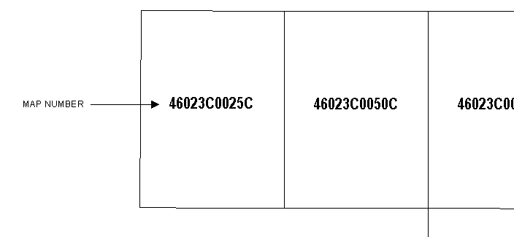
Example placement of the Map Number note

Note: The label “MAP NUMBER” will be generated regardless if you are creating a single page INDEX or part of a multi-page INDEX. You should include the label on all map sheets.

Page Size
Select the appropriate page size for your FIRM panel INDEX map. The two page sizes are ANSI A (8.5” x 11”) and FEMA Custom (25.875” x 36”).
Note: Only community-based studies are allowed to create INDEX maps on an ANSI A (8.5” x 11”) page size. Additionally, INDEX maps on an ANSI A page size must be a single page layout. The FEMA Custom (25.875” x 36”) page size can be used for single page INDEX layouts or multi-page INDEX layouts.

Page Orientation
Select the portrait or landscape page orientation for your FIRM panel INDEX map. The portrait orientation is only available for the ANSI A (8.5” x 11”) page size.

INDEX Page & Suffix
Choose to create a single page INDEX map or a multiple page INDEX map. If your study does not legibly fit on a single page, either because of it being a large area or an elongated area, a multi-page INDEX map is appropriate; otherwise, create a single page map layout.
If you choose to generate a single page INDEX map, your entire INDEX map features and all tables required by Appendix K will be displayed on one page. In the Generate INDEX Layout dialog you will have to select the INDEX map suffix letter. Since there is only one page comprising your INDEX map, the map page number will be automatically set to zero. In other words, a single page INDEX map would follow the naming convention: <DFIRM ID>IND0<suffix> (e.g., 21131CIND0B, 306307IND0A).
If you choose to generate a multi-page INDEX map, your INDEX map features and all tables required by Appendix K may span up to four pages. In the Generate INDEX Layout dialog select the page number and suffix for the particular page of the INDEX map you are creating. Each page in a multi-page INDEX map must be generated separately. In other words, if you have a three-page INDEX map, you must enter the number “1” for the page number, complete all other necessary information in the Generate INDEX Layout dialog, and generate the INDEX map for the first page. You’ll then repeat this process two more times, in order to fully create your three-page INDEX map. Based on the information you enter in the dialog, a multiple page INDEX map would follow the naming convention: <DFIRM ID>IND<page number><suffix> (e.g., 18167CIND2E, 400483IND4A).

Note: Upon layout creation the Listing of Communities table (if the study is countywide), Map Repository table, Base Map Note, and the Panel Not Printed Notes will appear on the panel. If the information is not appropriate for that particular page of a multi-page INDEX map, you will have to manually delete the tables and reference notes that are not relevant. Additionally, reference notes will be created on every INDEX map page for the Listing of Communities table and the Map Repository table (e.g., See Sheet X of Y for MAP REPOSITORY LISTING). If the map page number in the reference note (i.e., X) is incorrect, you will have to manually edit the page number.

Note: The Panels Printed list in the Title Block will only include those panels which are shown on that particular INDEX map page.

INDEX Locator Diagram
Create or revise an INDEX Locator Diagram for multi-page INDEX map layouts. This diagram will be added to each page of the INDEX map, and it will indicate which portion of the complete study is represented on that page of the INDEX. There will be a separate data frame, named Index Locator Diagram, loaded into your Table of Contents, and it will contain the Index Locator Diagram (DFIT_INDXLOCDIAGRAM) data layer.

The NSP-created field Index Sheet (INDEXSHEET) in the FIRM Panel Index (S_FIRM_Pan) data layer must be populated with the page number that the panel will appear on in the INDEX map. A multi-page INDEX map can be composed of up to four pages. Therefore, the valid values for the Index Sheet (INDEXSHEET) field are 2, 3, and 4.

Note: The field Index Sheet must be populated for both single page and multi-page INDEX layouts. If you are creating a single page index, you must populate this field with “0” as the page number.
The portion of the political area included on the map page will be displayed in gray with the reference note “SHEET X of Y” in the INDEX Locator Diagram. Portions of the political area that fall on another INDEX map sheet(s) will be displayed in white with the reference note “THIS AREA SHOWN ON INDEX SHEET X OF Y”. The INDEX Locator Diagram will be given the title “<county or community name>, <state abbreviation> (first line) followed by the text “INDEX LOCATOR DIAGRAM” (second line). Specifically, the <county or community name> value is a concatenation of Study_Info’s Study Prefix (STUDY_PRE) and Study Name (STUDY_NM) attribute values. The <state abbreviation> value is an abbreviation of Study_Info’s State Name (STATE_NM) attribute value. You should manually move the graphic title to the desired location.

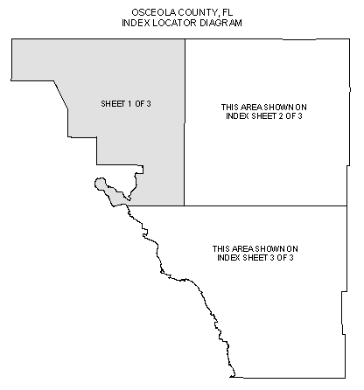
Example of an INDEX Locator Diagram for a multi-page INDEX sheet

Each page in a multi-page INDEX map must be generated separately. In other words, if you have a three-page INDEX map, for “Sheet 1 of” you must enter the number “1” for the page, complete all other necessary information in the Generate INDEX Layout dialog, and generate the INDEX map for the first page. You’ll then repeat this process two more times, in order to fully create your three-page INDEX map, with an INDEX Locator Diagram on each page.

Note: The INDEX Locator Diagram option is not available for single page INDEX maps.

Title Block Logo
Choose which logo (i.e., DHS, FEMA) is appropriate to display in the title block. To determine which logo is correct for your project, use the following guidelines:
- If this is a new DFIRM study, use the DHS logo.
- If this entire DFIRM study is being republished, use the DHS logo.
- If only part of the DFIRM study is being republished, use the logo on the effective FIRM.

Effective / Revised Date
Select a date format for your layout (i.e., Effective Date, Revised Date). The date will be generated from the most recent value in the Effective Date (EFF_DATE) field in the FIRM Panel Index (S_FIRM_Pan) data layer.

Note: If your effective date has not yet been established, then enter the value ‘99990909’ in the Effective Date field (EFF_DATE) in the FIRM Panel Index layer (S_FIRM_Pan). This value acts as a null value and will not be displayed in the layout.

Inset Maps
Create up to five inset map(s) in your layout for the congested areas on your INDEX map. A new data frame is added to the Table of Contents for each inset map that will be added to your INDEX layout. The data frame(s) are named “Insert Map X”, where X indicates the number for that particular inset map (e.g., Inset Map 3). Each of the inset map data frames contain the exact duplication of the data layers that were in the Table of Contents at the time the INDEX layout was generated. Additionally, the inset map will be labeled just as the Layer data frame has been labeled.

You will have to zoom to the appropriate scale and extents within the inset map for displaying the data. You can increase the size of the inset map data frame, if necessary. The title(s) for the inset map(s) will automatically be created (e.g., INSET MAP 2), but you will have to manually position the title above or below the data frame, as appropriate.

Additionally, you will have to manually create and place the extent rectangle(s) in the Layer data frame (i.e., main INDEX map) to indicate which area(s) of your map the inset(s) represents. This extent rectangle graphic(s) should be a solid white box(es), drawn and symbolized with the Draw toolbar tools. Reference notes for the inset map(s) will automatically be created (e.g., See INSET MAP 2); however, you will have to manually place them on top of the appropriate extent rectangle graphic in the Layers data frame.

Note: If only one inset map is created, the data frame will be titled “INSET MAP” and the inset reference note will be “See INSET MAP”.

Note: To align your inset map borders with the INDEX map border, you can use the Draw toolbar tools, the Graphics toolbar tools, and/or the Snapping to ruler, margins, and/or grid functions by right-clicking in the layout view.

This Area Notes
Add notes to the layout, where appropriate, to indicate why specific areas of panels are not printed (i.e., All in open water or No Special Flood Hazard Areas). The generated note(s) will adhere to Appendix K specifications.

This Area Note for ‘All in Open Water’ | This Area Note for ‘No Special Flood Hazard Areas’

Note: This option is only enabled for DFIRM panel INDEX maps created on a FEMA Custom (25.875” x 36”) page size.

Export to PDF
The Export to PDF tool prints the displayed INDEX layout to .pdf format. The layout will be saved according to the following naming convention:
<DFIRM ID>_IND<map page number><suffix>.pdf
(e.g., 06063C_IND2B.pdf, 218193_IND0A.pdf)

- Click the Export to PDF button to open the Project Selection dialog.
- Select the project name (i.e., FEMA Case Number) and click OK.
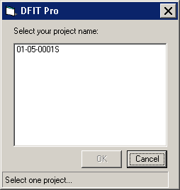
Project selection dialog

- Enter the page number and suffix for your INDEX map layout, if prompted. If your INDEX is a single page, then the page number will be 0.
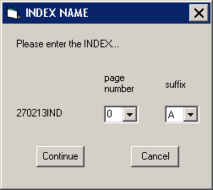
INDEX page number and suffix dialog

- Click Continue to print your INDEX map layout to .pdf format.

The printed .pdfs are stored in the following folder structure on the MIP: J:\FEMA\<region>\<state>\<county>\<county or community>\<FEMA Case Number>\ Mapping\MappingOutputs\PDF.

Note: Use the PDF Export tool to download the .pdf from the MIP directory structure to your local drive for printing and/or archiving.

Export to Images
The Export to Images tool exports FIRM panel INDEX map layouts to 400 dpi images. The map layout(s) are exported to .eps and .tif formats.
- Click the Export to Images button to open the Project Selection dialog.
- Select the project name (i.e., FEMA Case Number) and click OK.
Project selection dialog

- Enter the page number and suffix for your INDEX map layout, if prompted. If your INDEX is a single page, then the page number will be 0.
INDEX page number and suffix dialog

- Click Continue to export your INDEX map layout to .eps and .tif formats.

The .eps, and .tif image files are stored in the following folder structure on the MIP: K:\<region>\<state>\<county>\<county or community>\<FEMA Case Number>\ Mapping\Final_DFIRM_DB\RFIRM.

Note: The following is a universal approach to printing .eps files directly to a printer/plotter.
- Go to the DOS Prompt (cmd.exe) via Start Menu > Run > Type “cmd” into the Open: dialog.
- Change the directory to be your local directory to where the .eps file was copied via Citrix Windows Explorer.
- Enter the following command “{local directory path}>copy {local directory path with .eps file name and extension} {printer location including the server path}”

For example, the image 170338IND0B.eps was copied to the local D drive into the folder BradleyCity_IL, and it needs to be printed to the plotter named ‘1055A’. The following commands in the DOS prompt application will accomplish this task.

C:\>cd D:\DFIRM\BradleyCity_IL
D:\DFIRM\BradleyCity_IL>copy D:\DFIRM\BradleyCity_IL\170338IND0B.eps \\Server08\1055A

Clear Layout
The Clear Layout tool removes all graphics and all added data frames from the current INDEX map layout; the Layers data frame will persist. The labels on the layers FIRM Panel Index (S_FIRM_Pan), Political Area (S_Pol_Ar), Water Line (S_Wtr_Ln), Water Area (S_Wtr_Ar), and Transportation (S_Trnsport_Ln) will also be removed.

Generate FIRM Panel Dates Table
The Generate FIRM Panel Dates Table tool regenerates the FIRM Panel Dates table without having to recreate the INDEX map layout via the Generate INDEX Layout tool. For single page INDEX maps the FIRM Panel Dates table will include all panels for your study. Whereas, for multi-page INDEX maps the FIRM Panel Dates table will include only dates for those panels that are displayed on that particular map page.

The FIRM Panel Dates table is created via Crystal Reports and is, therefore, an image. You may not edit the text in the image. Crystal Reports creates a whole page for the image; if your table is smaller than a page, the image will contain both the table and white space representing the length of the page (i.e., the image is not clipped to the table extents). On the layout, you should use the Draw toolbar (e.g., the Order tools) to arrange your elements effectively.

Note: The Generate FIRM Panel Dates Table tool does not replace the current FIRM Panel Date table; rather it creates a new table image, and you will have to manually delete the old table image. Therefore, if you click the Generate FIRM Panel Dates Table button 11 times, you will have 12 instances of the table – one created via the Generate INDEX Layout tool and 11 created via the Generate FIRM Panel Dates Table tool.

Generate Listing of Communities Table
The Generate Listing of Communities Table tool regenerates the Listing of Communities table, for countywide studies, without having to recreate the INDEX map layout via the Generate INDEX Layout tool.

The Listing of Communities table is created via Crystal Reports and is, therefore, an image. You may not edit the text in the image. Crystal Reports creates a whole page for the image; if your table is smaller than a page, the image will contain both the table and white space representing the length of the page (i.e., the image is not clipped to the table extents). On the layout, you should use the Draw toolbar (e.g., the Order tools) to arrange your elements effectively.

Note: The Listings of Communities table is not created for community-based studies.

Note: The Generate Listing of Communities Table tool does not replace the current Listing of Communities table; rather it creates a new table image, and you will have to manually delete the old table image. Therefore, if you click the Generate Listing of Communities Table button 11 times, you will have 12 instances of the table – one created via the Generate INDEX Layout tool and 11 created via the Generate Listing of Communities Table tool.

Add Logo
The Add Logo tool allows the user to add any additional logo(s) to the INDEX map layout. The logo(s) must be located in the J:\FEMA\<region>\<state>\<county>\<county or community>\<FEMA Case Number>\Mapping\MISC, and it must be in .bmp, .jpg, .emf, or .tif file format.

- Click the Add Logo button to open the Project Selection dialog.
- Select the project name (i.e., FEMA Case Number) and click OK.
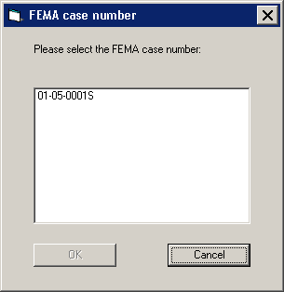
Project selection dialog

- Select the appropriate logo(s) in the dialog.
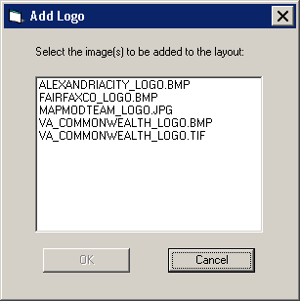
Add Logo dialog

- Click OK to add the images to the INDEX map layout as graphics. You will need to manually move and/or resize the additional logo(s) as necessary.

Note: The Add Logos tool does not currently support compressed .tif images.

Symbolize Multi-Page Panels
The Symbolize Multi-Page Panels tool allows you to symbolize the FIRM Panel Index (S_FIRM_Pan) data layer in a multi-page INDEX layout, so that only the panels on that map page are visible (i.e., displayed with a black outline and hollow fill).

Running the Render using VVT Symbology tool on the PLTS Symbology and QA toolbar after generating the INDEX map layout will cause all panels to be displayed, despite whether or not the panels are included on that particular map page. Running the Symbolize Multi-Page Panels tool will symbolize just the FIRM Panel Index (S_FIRM_Pan) features; all other data layers will remain symbolized as they currently are.
Note: Run the Render using VVT Symbology tool with the DFIRMINDEX option prior to generating the INDEX map layout. The Generate INDEX Layout tool will automatically symbolize your panels properly, according to which panels are displayed on that particular map page.
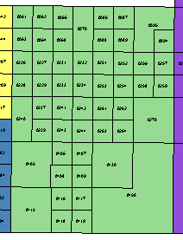 |  | 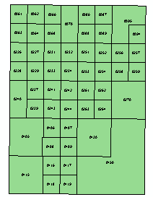
Graphical depiction of running the Render using VVT Symbology tool after running the Generate INDEX Layout tool for sheet 3. Notice that the neighboring panels for the other INDEX sheets are displayed. | Graphical depiction of the FIRM Panel Index features. Each color represents a different INDEX sheet in a multi-page sheet INDEX. | Graphical depiction of running the Symbolize Multi-Page Panels tool after running the Render using VVT Symbology tool on generated sheet 3. Notice that the neighboring panels for the other INDEX sheets are not displayed.

Update Multi-Page Panels
The Update Multi-Page Panels tool allows you to update the map layout in a multi-page INDEX when changes are made to the INDEX Sheet (INDEXSHEET) field in the FIRM Panel Index (S_FIRM_Pan) data layer. For instance, you initially populated your INDEXSHEET field with the values “1” and “2”. After creating INDEX sheet 2 with the Generate INDEX Layout tool, you realize that your study would best be shown on three sheets. So, you modify the values in the Index Sheet (INDEXSHEET) field in the FIRM Panel Index (S_FIRM_Pan) to be “1”, “2”, and “3”. You can then click the Update Multi-Page Panels tool to update the appropriate pieces of the existing sheet 2. This tool prevents you from having to recreate the entire INDEX sheet with the Generate INDEX Layout tool when the panels on that sheet have changed.

The Update Multi-Page Panels tool will regenerate the Panels Printed section in the Title Block, recreate the FIRM Panel Dates table, regenerate INDEX Locator Diagram, and automatically symbolize the FIRM Panel Index (S_FIRM_Pan) data layer, based on the panels which are displayed on that map page. The changes that you made to the arrangement of the layout elements (e.g., moving and aligning the Map Repository Address list) will be preserved.

Note: The Update Multi-Page Panels tool does not replace the current FIRM Panel Date table; rather it creates a new table image, and you will have to manually delete the old table image. Therefore, if you click the Update Multi-Page Panels button 11 times, you will have 12 instances of the table – one created via the Generate INDEX Layout tool and 11 created via the Update Multi-Page Panels tool.
The Generate INDEX Layout tool stores your INDEX sheet name in memory. If the Update Multi-Page Panels tool is unable to locate the sheet name because you, for instance, have closed ArcMap since generating the sheet or have loaded a previously created sheet, the tool will prompt you to supply the page number and suffix of your current INDEX map layout. Once you select the values and click OK, your INDEX sheet name will be stored in memory for that ArcMap session.

Note: If you enter an erroneous page number or suffix when prompted, you will not be able to correct your mistake since now the name is stored in memory, and you will not be prompted again to supply it. To correct this, you will need to close ArcMap and re-launch it to clear the INDEX sheet name from memory.

Auto Label
The Auto Label tool automatically labels the features in the Water Line (S_Wtr_Ln), Water Area (S_Wtr_Ar), and Transportation (S_Trnsport_Ln) data layers, based on a true value in the Shown on INDEX (SHOWN_INDX) field in each of these data layers. The Auto Label tool will label features in the Layers data frame as well as any existing inset map data frames.
Water features will be labeled with the value in the Water Name (WTR_NM) field. If “NP” or “UNKNOWN” is the value in the Water Name (WTR_NM) field in either the Water Line (S_Wtr_Ln) or Water Area (S_Wtr_Ar) data layer, the water feature will not be labeled.
Transportation features, excluding railroads, will be labeled with the concatenation of the following fields: Prefix (PREFIX), Feature Name 1 (FEAT_NM1), Suffix (SUFFIX), and Name Type (NM_TYP). If any of these fields are populated with a null or “NP” value, the field value will be omitted from the concatenation. Road shields will be created for any features where the Name Type (NM_TYP) value is “COUNTY HIGHWAY”, “STATE HIGHWAY”, or “INTERSTATE HIGHWAY”. Also, if the name type equals “HIGHWAY” and the field Feature Name 1 (FEAT_NM1) contains “ST”, “CO”, or “I”, a road shield will be created for the feature; otherwise the feature will be labeled according to the field concatenation.
Note: Each label name (e.g., Potomac River), excluding railroads, will be generated only once per INDEX map page.

Note: When Name Type (NM_TYP) equals “HIGHWAY” and Feature Name 1 (FEAT_NM1) contains “I”, “ST”, or “CO” and a letter (e.g., “CO K” for county highway K), the feature will be labeled as “CO K HIGHWAY”. To properly label lettered highways with a shield, the Feature Name 1 (FEAT_NM1) value should be only the lettered portion (e.g., “K”) of the highway name and the Name Type (NM_TYP) value should be specific to the highway type (e.g., “COUNTY HIGHWAY”).
If the Transportation Feature Type (TRANS_TYP) value equals “railroad”, then the feature will be labeled as “RAILROAD”. Unlike the road transportation features, every railroad transportation feature will be labeled.
Note: If you need to alter the generated labels, you should change the Label options in the Layer Properties dialog.

Note: The Auto Label tool does not replace the current transportation and water labels; rather it creates new labels, and you will have to manually delete the old labels. Therefore, if you click the Auto Label button three times, you will have three instances of the labels.

Save INDEX MXD
The Save INDEX MXD tool saves the current MXD to the SDE database. The MXD will be associated with the parent job, so it will be preserved throughout the JTX workflow lifecycle.
The MXD will be named according to the INDEX map name (e.g., 06037CIND2B.mxd, 170238IND0A.mxd). Therefore, only one MXD can exist at a time for a particular INDEX map sheet. You will be prompted with the option to overwrite the current MXD, if an ArcMap session already exists for that particular INDEX map.
Note: When the Save INDEX MXD tool is applied, the INDEX MXD is saved with a reference to the Parent Job version. This is essential so that when you return to the INDEX for post-preliminary processing, you may access your data. Whereas, if the Save INDEX MXD tool saved the MXD with a reference to a Child Job version, when you returned to the INDEX MXD in the future, there would be unrecoverable broken data links in the MXD since the Child Job version no longer exists. Therefore, DFIT Pro is designed to be used within a Parent Job step. Create the INDEX map layout in a Child Job with caution. If you edit the data, you must reconcile and post your data so that it is reflected in your Parent Job version and, therefore, in the saved MXD.

Note: When you exit ArcMap you will be prompted to save your saved MXD again before you close the application. This is in case you made any changes to the INDEX MXD since you saved it.

Load INDEX MXD
The Load INDEX MXD tool opens a saved INDEX map MXD. Only INDEX maps previously saved via the Save INDEX MXD tool, for your specific parent job, can be opened.
- Click the Load INDEX MXD button to open the INDEX MXD Names dialog.
- Select the INDEX MXD you want to open and click OK.
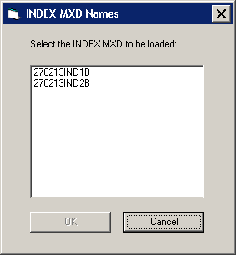
INDEX MXD Names dialog

- The selected INDEX MXD will open.
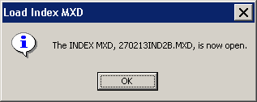
- You will be prompted to save the current ArcMap session, before working in the opened INDEX MXD. Click Yes to save your ArcMap session for the next time that ArcMap is launched from JTX; whereas click No to discard all of your ArcMap settings (e.g., DFIRMINDEX symbology).
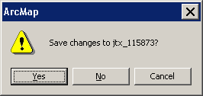

Note: To return to the ArcMap session or MXD that is associated with the current JTX workflow step, you must close ArcMap and relaunch ArcMap from JTX.

Note: When you exit ArcMap you will be prompted to save your opened INDEX MXD before you close the application. This is in case you made any changes to the INDEX MXD since you opened or saved it.

PDF Export Toolbar
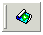
The PDF Export toolbar has one tool that enables you to export existing .pdf file(s) to your local drive(s).

PDF Export
The PDF Export tool exports a .pdf file(s) to your local drive(s). Once panels have been printed to .pdf format via the Export to PDF tool on the DFIT Pro toolbar, they can be retrieved and saved to a local drive using the PDF Export tool. Then, once the files have been saved locally, print the .pdf files to a local plotter, share them electronically, and/or store them in an archive.
Note: You are not able to directly print in the Citrix environment. You must export any maps that you want to print/plot.
- Click the PDF Export button to open the Project Selection dialog.
- Select the project name (i.e., FEMA Case Number).
Project Selection dialog
- Highlight the .pdf file(s) to be exported to a local drive. To export all of the files, click the Select All button; all files will highlight in the dialog.
PDF Selection dialog
- Click the Save As button.
- Browse to the desired folder on the local drive.
Browse dialog for local folders
Note: New folders cannot be created in the Browse dialog; use the dialog to navigate to existing folders. Any new folders must be created using Windows Explorer on your local machine, prior to clicking the PDF Export button.

Note: Do not attempt to save .pdf files to a local software system folder (e.g., Drivers). This may lead to a permissions error, and the files will not be exported.
- Click the OK button to export all of the selected .pdf files to a local folder. The Browse dialog will close without prompting a completion message.

PLTS Symbology and QA Toolbar
The PLTS Symbology and QA toolbar enables visual display and assessment of feature classes. The primary function for this toolbar though is to render the DFIRM feature classes with predefined symbols. The Render using VVT Symbology button is the only DFIRM-customized function on this toolbar.
The toolbar is available within ArcMap, and it will be automatically loaded at each executable step when appropriate. Otherwise, it can be manually added in ArcMap by clicking View menu > Toolbars > PLTS Symbology and QA.

Render using VVT Symbology
The Render using VVT Symbology tool renders all of the loaded DFIRM data according to the specifications in Appendix K, based upon the DFIRM type (i.e., vector, raster) or step of DFIRM production on which you are working. This symbology is dictated by the customized Valid Value Tables (VVTs), and valid attribute combinations for each feature can be verified by running Batch Validate on the GIS Data ReViewer toolbar. Refer to GIS Data ReViewer User Guide, FEMA DFIRM Production Tools for further details as to how to use Batch Validate.
There are slightly different symbols for vector-based DFIRMs, raster-based DFIRMs, and Index Maps; therefore, there is a customized style to accommodate each type of map. Additionally, there is a colorful symbol set for Workmaps to help easily distinguish between features when digitizing, attributing, and/or QCing.
Note: Features that are displayed as bright pink indicate that the necessary attribute fields do not have a valid combination of values required for symbology. Essentially, the feature has been attributed incorrectly (e.g., NULL versus NSPNULL). On the other hand, a feature that is displayed as bright purple indicates that the feature has not been entirely attributed. A required field(s) has not been populated. Resolve the attribute error(s), and rerun the Render using VVT Symbology tool to verify that all bright pink and/or purple symbology has disappeared.

Note: When using the Render using VVT Symbology tool, the symbology is rendered for all data, existing in the job version, which is within the data view extents. Therefore, if there is effective data within the data frame, despite whether or not it is visible, the data features will be symbolized. You can display neighboring effective data using the Show DFIRM Adjacent Data button on the DFIRM Layer Loader toolbar. If you see a QC error in the Table of Contents, run the VVT validation checks in Batch Validate to verify whether or not the error(s) is in your dataset. Remember, you are only to edit your dataset, not the neighboring datasets, despite any errors you may find in the neighboring effective data.

PLTS Dangle and Pseudo Renderer
The PLTS Dangle and Pseudo Renderer tool renders line feature classes to show dangle, pseudo, and regular nodes. You will be able to select which layers and which node types you want to render. The tool will create a group layer named ‘NODES’. New feature layers that identify the dangles, pseudonodes, and/or nodes will be placed in that group layer. This tool has no DFIRM customizations.

Default Render
The Default Render tool has been disabled, as it assigns every feature class one random distinct symbol.

Set Polygon Transparency Percentage
The Set Polygon Transparency Percentage tool enables you to set the same transparency on all polygon features. This tool will not let you differentiate between polygon feature classes, rather assignment of individual transparency values must be done through each layer’s properties. This tool has no DFIRM customizations.

Note: If you manually change any feature’s symbology through the Layer Properties dialog, you will have to rerun the Render using VVT Symbology tool to reset the symbology to be Appendix K- compliant.

DFIRM Layer Loader Toolbar
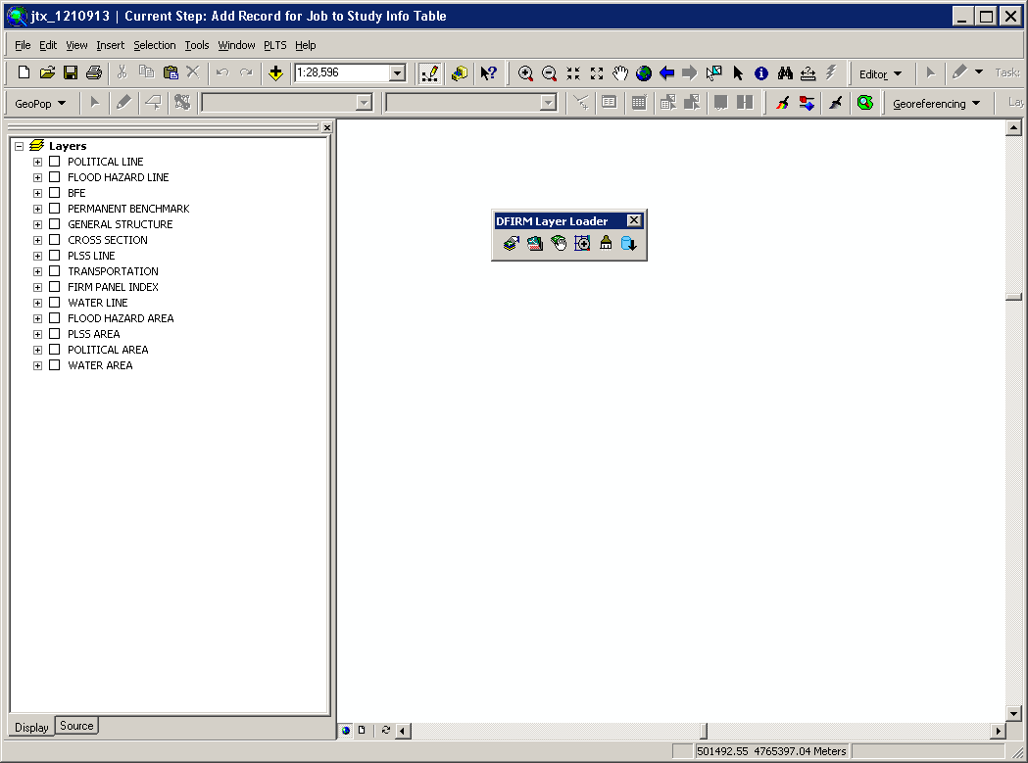
The tools on the DFIRM Layer Loader Toolbar allow you to add data to the current ArcMap session that is not added automatically as part of the standard DFIRM layers for a particular step. Such data may include, but are not limited to, raster catalogs of orthophotos/Quads, contour lines, effective panel layout schemes, Appendix L non-compliant data, and any of the enhanced SDE feature classes.
 | DFIRM Layer Data Loader | Adds additional layers and/or look-up tables from the SDE geodatabase
 | DFIRM Reference Data Loader | Adds reference data to the map view
 | Show DFIRM Adjacent Area | View adjacent effective DFIRMs
 | Show Only DFIRM Area | Remove view of adjacent effective DFIRMs
 | Zoom to DFIRM ID | Zooms to the extents of the DFIRM
 | Suspend Drawing | Pauses the data drawing process
 | DFIRM Export to PGDB | Exports the feature classes and look-up tables from the SDE geodatabase into a personal geodatabase.

DFIRM Layer Data Loader
The DFIRM Layer Data Loader tool adds feature classes and/or look-up tables from the SDE geodatabase. Additionally, all topology rules are added into the ArcMap session when the tool is launched and the OK button is clicked, even if no additional feature classes and/or look-up tables are selected to be added.
The Available data layers: list displays all feature classes and look-up tables in the SDE geodatabase that can be added to the ArcMap session. A feature class or table does not have to contain records for the current DFIRM in order to appear in the list (e.g., Coastal Transect), all feature classes and look-up tables in the SDE geodatabase are available to add. Highlight the feature class(es) and/or look-up table(s) from the Available data layers: list, and use the Forward Arrow button to transfer your selection into the To-be-loaded data layers: list. The Add Standard Layers button will automatically move all of the features classes that are in a Standard DFIRM database, as dictated by Appendix L: Guidance for Preparing Draft Digital Data and DFIRM Database, to the To-be-loaded data layers: list. If you decide not to add a feature class or look-up table, highlight the item and use the Backwards Arrow button to remove it from the To-be-loaded data layers: list. Click OK to add all of the items in the To-be-loaded data layers: list into the ArcMap session.
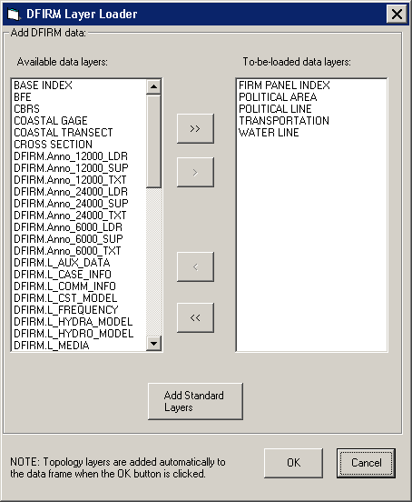

DFIRM Reference Data Loader
The DFIRM Reference Data Loader tool adds data not residing in the SDE geodatabase to be used for reference. This reference data includes, but is not limited to, raster catalogs (Orthophotos or USGS Quads), topographic maps, shapefiles, geodatabases, coverages, and effective DFIRM maps.
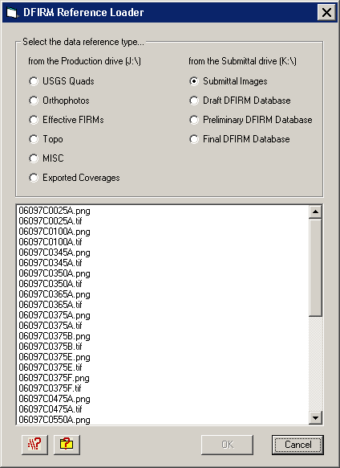

Each radio button accesses a different folder in the directory. The following list maps the directory path for each radio button, so you will know to which folders to upload your reference data. Additionally, this chart can be accessed from within the DFIRM Reference Data Loader dialog via the Folder Pathway Help button .

Radio Button | Folder Path
USGS Quads | J:\<region>\<state>\<county>\<community/county>\<Case #>\Mapping\Raster\Quad
Orthophotos | J:\<region>\<state>\<county>\<community/county>\Ortho
Effective FIRMs | J:\<region>\<state>\<county>\<community/county>\<Case #>\Mapping\Raster\EF_FIRMS
Topo | J:\<region>\<state>\<county>\<community/county>\<Case #>\Mapping\Topo
MISC | J:\<region>\<state>\<county>\<community/county>\<Case #>\Mapping\Misc
Exported Coverages | J:\<region>\<state>\<county>\<community/county>\<Case #>\Mapping\Cov
Submittal Images | K:\<region>\<state>\<county>\<community/county>\<Case#>\Mapping\Final_DFIRM_DB\RFIRM
Draft DFIRM Database | K:\<region>\<state>\<county>\<community/county>\<Case #>\Mapping\Draft_DFIRM_DB
Preliminary DFIRM Database | K:\<region>\<state>\<county>\<community/county>\<Case #>\Mapping\Preliminary_DFIRM_DB
Final DFIRM Database | K:\<region>\<state>\<county>\<community/county>\<Case #>\Mapping\Final_DFIRM_DB

This following chart lists the data format types that can be accessed via each radio button in the DFIRM Reference Data Loader. Additionally, this chart can be accessed from within the DFIRM Reference Data Loader dialog via the File Format Help button .

USGS Quad | Submittal Images | Ortho-photos | Topo | Effective FIRMs | MISC | Exported Coverage | Draft DFIRM DB | Prelim DFIRM DB | Final DFIRM DB
TIFF (*.tif) | ●* | ● | ●* |  | ● | ●
MrSID (*.sid) | ●* |  | ●* |  |  | ●
JPEG (*.jpg) | ●* |  | ●* |  |  | ●
ESRI BIL (*.bil) | ●* |  | ●* |  |  | ●
Windows Bitmap (*.bmp) |  |  |  |  |  | ●
PNG (*.png) |  | ●† |  |  | ●† | ●†
CAD (*.dgn) |  |  |  | ● |  | ●
DBF (*.dbf) | ●* |  | ●* | ● |  | ● |  | ● | ● | ●
PGDB (feature classes & tables) (*.gdb) |  |  |  | ● |  | ●
ESRI Coverages (spatial & tabular) (<coverage>) |  |  |  | ● |  | ● | ●
Shapefile (*.shp) |  |  |  | ● |  | ● |  | ● | ● | ●

Reference data file formats which can be accessed via each radio button
* Accesses an image catalog(s) created from USGS Quads or Orthophotos
† Due to ArcMap 8.3 software limitations, only files with 300 dpi or less are readable

Select the radio button for the appropriate data type (e.g., USGS Quads, Effective FIRMs). All data files in accessible format which are stored in the associated folder will be listed in the dialog window. Highlight one or more reference files, and click OK.
If you select the Topo or MISC radio button, then one of the following dialogs will appear.
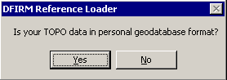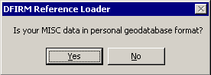
Click No to display all data files in the relevant folder that are not in a personal geodatabase. Click Yes to change the dialog to enable selection of a personal geodatabase in the associated folder and then to load a data layer(s) stored within the personal geodatabase.
Note: If you erroneously click the No button when you meant to choose the Yes button (or vice versa), right-click on the radio button, and the personal geodatabase dialog will reappear.
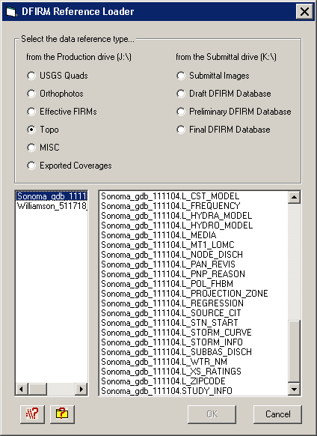
Dialog for personal geodatabases in the Topo or MISC folder

The USGS Quad and the Orthophotos radio buttons only access the image catalog(s) created for the image files stored in the respective folders. The preferred image file formats to create image catalogs are TIFF (.tif), MrSID (.sid), and PNG (.png). To create an image catalog, use the Create Image Catalog tool on the GeoPop Pro dropdown menu. Refer to GeoPop Pro User Guide, FEMA DFIRM Production Tools for detailed instructions on using the Create Image Catalog tool.

Note: The DFIRM Layer Data Loader and the DFIRM Reference Data Loader are the only means to add data into your ArcMap session. The ESRI tool Add Data has been disabled, as this is not the correct way to access the Citrix directory structure and/or the SDE geodatabase.

Show DFIRM Adjacent Area
The Show DFIRM Adjacent Area tool shows effective DFIRM/DEFAULT data loaded into the SDE geodatabase, which is adjacent to your study area. Only effective data that has been loaded into DEFAULT will appear when the Show DFIRM Adjacent Area button is clicked.
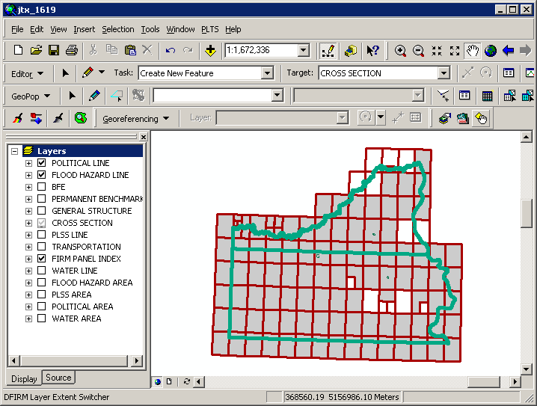
The northern political area is the actual study area, whereas the southern political area is the adjacent effective DFIRM area.

Note: You should not attempt to edit any data in an adjacent area to your study; the data is effective and is only being shown for your reference.
Once the Show DFIRM Adjacent Area button has been selected, its icon will change to that of the Show Only DFIRM Area tool.

Show Only DFIRM Area
The Show Only DFIRM Area tool removes the reference display of effective DFIRM/DEFAULT data loaded into the SDE geodatabase, which is adjacent to your study area.
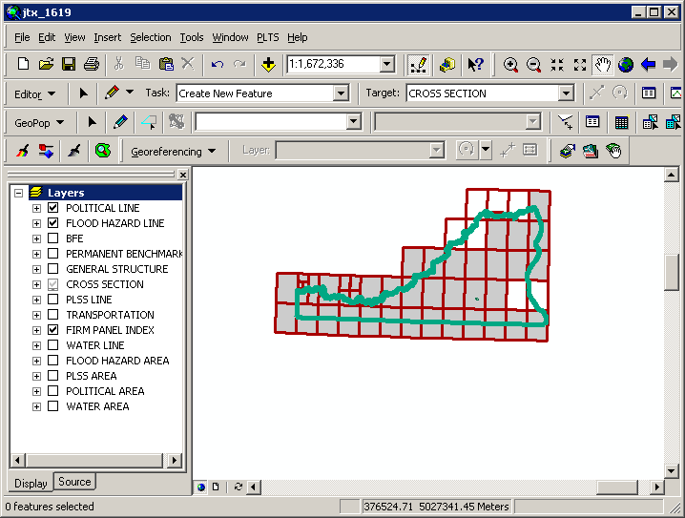
The adjacent effective DFIRM data, south of the actual study, is no longer displayed.

Once the Show Only DFIRM Area button has been selected, the reference data for the adjacent area(s) will no longer be displayed, and the button’s icon will change to that of the Show DFIRM Adjacent Area tool.

Zoom to DFIRM ID
The Zoom to DFIRM ID tool replaces the functionality in ArcMap that allows you to zoom to a layer or to the dataset’s full extent. Without disabling these functions, you would zoom to the extent of the entire SDE geodatabase (Continental US and its territories) as opposed to the extent of your DFIRM study. If the FIRM Panel Index (S_FIRM_Pan) layer is loaded into the ArcMap session and is populated, the tool will zoom to the extent of this layer. If the FIRM Panel Index layer is not loaded or not populated, then the tool zooms to the extent of the Political Line (S_Pol_Ln) layer. If neither of these data layers is loaded or populated in your ArcMap session, you will be prompted to select a data layer.
Select a data layer loaded into your Table of Contents on which to zoom.

Suspend Drawing
The Suspend Drawing tool temporarily “freezes” and “unfreezes” the process of displaying data in a session. This ESRI tool allows you to perform several functions in a sequence without having to wait for a lengthy drawing of all the map layers (both feature classes and raster images). Discretionary use of the Suspend Drawing tool will save considerable time during the annotation process, because the layers will not have to redraw after every single step, such as selecting a label, duplicating a label, stacking a label, making a label horizontal, etc.
- Start an editing session (i.e., Editor Toolbar > Editor > Start Editing).
- Make selectable only the DFIRM.Anno_<your scale>_TXT layer and DFIRM.Anno_<your scale>_LDR layer (i.e., Standard Toolbar > Selection menu > Set Selectable Layers).
Note: The leader lines need to be selectable only if you are moving your annotation and leader line features together to a new location. Do not attempt to resize your leader line features, rather delete them and recreate them.

- Allow ArcMap to completely draw all the features, raster images, and labels in your extent.
- Click the Suspend Drawing button . The icon will change when the data drawing has been suspended .
- Select the desired annotation features, using the Edit tool on the Editor toolbar. Exercise caution when selecting multiple annotation features in crowded areas, so as to select only those labels that you want.
Note: Multiple labels may be selected simultaneously, but they will keep the same relative distances from each other when they are moved to a new location.

When selecting labels, the regular cyan selection boxes will not be displayed. Instead, you will use gray outline boxes and crosshairs to drag and drop the labels.
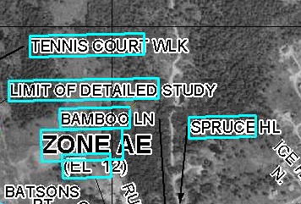 | 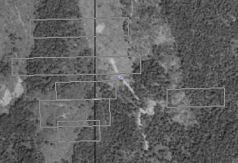
Normal selection for annotation features | Selection for annotation features when Suspend Drawing is engaged.
Note: Do not pan or zoom while the Suspend Drawing tool is active (i.e., icon displays a red X), this will result in a blank screen. If you need to pan or zoom, uncheck the Suspend Drawing tool (i.e., the icon display as a paintbrush without the red X), refresh, and start the procedure again.

- Drag the selected label(s) using the gray outline boxes and the crosshairs as guides, and drop the annotation features where desired.
Note: The changes that you make to the annotation or other features will not be seen on the map until the Suspend Drawing tool is deactivated and the map refreshes. Several different functions (e.g., Stack Labels, Make Labels Horizontal, Suppress Labels) can be executed sequentially on one individual label at a time before deactivating the tool.
- Click the Suspend Drawing button when you are finished with your edits. The icon will change back to be just the paintbrush (i.e., the red X will disappear) .
- Refresh your ArcMap session if necessary in order to see the new placement of all the labels.

DFIRM Export to PGDB
The DFIRM Export to PGDB tool exports all of your study’s spatial layers, look-up tables, and annotation from the SDE geodatabase into a personal geodatabase. The personal geodatabase is created from a template and will, therefore, contain all layers/tables in the SDE geodatabase. Only those layers/tables which are populated for your study will be populated in the personal geodatabase. For instance, if you have Water Line (S_Wtr_Ln) features, the features will be exported to the personal geodatabase. If you do not have Water Gage (S_Water_Gage) features for your study, the layer will exist in the personal geodatabase but will not contain any records. The personal geodatabase possesses the same schema (e.g., area extent, precision, field names, field definitions, domain tables) as the SDE geodatabase.
Note: The personal geodatabase does not contain topology rules. If these are desired, you will need to establish them yourself. For reference, the SDE geodatabase contains the following topology rules:
Topology Filename | Spatial Layer | Topology Rule | Parameter
BFE_XS | S_BFE | Must not self-intersect
BFE_XS | S_BFE | Must not self-overlap
BFE_XS | S_BFE | Must be single part
BFE_XS | S_BFE | Must not overlap with | S_XS
CST_TSCT_LN | S_Cst_Tsct_Ln | Must not self-intersect
CST_TSCT_LN | S_Cst_Tsct_Ln | Must be single part
CST_TSCT_LN | S_Cst_Tsct_Ln | Must not self-overlap
FLD_HAZ | S_Fld_Haz_Ar | Boundary must be covered by | S_Fld_Haz_Ln
FLD_HAZ | S_Fld_Haz_Ar | Must not have gaps
FLD_HAZ | S_Fld_Haz_Ln | Must be covered by boundary of | S_Fld_Haz_Ar
FLD_HAZ | S_Fld_Haz_Ln | Must not have dangles
FLD_HAZ | S_Fld_Haz_Ln | Must not self-intersect
FLD_HAZ | S_Fld_Haz_Ln | Must not self-overlap
FLD_HAZ | S_Fld_Haz_Ln | Must be single part
FIRM_PAN | S_FIRM_Pan | Must not have gaps
FIRM_PAN | S_FIRM_Pan | Must not overlap
GEN_STRUCT | S_Gen_Struct | Must not self-overlap
GEN_STRUCT | S_Gen_Struct | Must not self-intersect
GEN_STRUCT | S_Gen_Struct | Must be single part
OVRBNK_LN | S_Ovrbnk_Ln | Must not self-overlap
OVRBNK_LN | S_Ovrbnk_Ln | Must not self-intersect
PFD_LN | S_PFD_Ln | Must not self-overlap
PFD_LN | S_PFD_Ln | Must not self-intersect
POL | S_Pol_Ar | Must not have gaps
POL | S_Pol_Ar | Boundary must be covered by | S_Pol_Ln
POL | S_Pol_Ln | Must be covered by boundary of | S_Pol_Ar
POL | S_Pol_Ln | Must not self-overlap
POL | S_Pol_Ln | Must not self-intersect
POL | S_Pol_Ln | Must not have dangles
PLSS_LN | S_PLSS_Ln | Must not have dangles
PROFIL_BASLN | S_Profil_Basln | Must not self-overlap
PROFIL_BASLN | S_Profil_Basln | Must not self-intersect
Topology Filename | Spatial Layer | Topology Rule | Parameter
BFE_XS | S_XS | Must not self-intersect
BFE_XS | S_XS | Must not self-overlap
BFE_XS | S_XS | Must be single part

The personal geodatabase may be used as a personal archive/back-up copy of your study. In addition, the personal geodatabase may be used for local editing. Once the local editing has been completed, you may easily upload the data yourself by adding the data as reference data and copying and pasting the features into the correct layer.
Note: Stand-alone GeoPop may not be used to edit the personal geodatabase created by DFIRM Export to PGDB.
The *_TXT, *_SUP, and *_LDR annotation features for the three panel scales are exported to the personal geodatabase. However, the only way to upload personal geodatabase annotation to the SDE geodatabase is by manually copying and pasting the features into the appropriate annotation feature class. ESRI does not allow for annotation features to be loaded into an existing annotation feature class via ArcMap or ArcCatalog data load tools.
When Label-EZ creates annotation, it creates records in internal tables which track the spatial feature OID associated with each piece of annotation. These internal Label-EZ tables are not exported to the personal geodatabase. When you upload annotation from a personal geodatabase to the SDE geodatabase, the OID of the annotation features is automatically generated. There may now be a discrepancy between the new annotation OID and the data stored in the internal Label-EZ tables. Some of the tools (i.e., Reposition Label, Flip Label, Highlight Label, Restore Suppressed Label, Draw New Leader) on the Label-Edit toolbar consult the internal Label-EZ tables. If the link in the internal table is broken, these Label-Edit tools will not function correctly and should not be used. The following are suggestions on how to work around these tools:
- Reposition Label – No work-around. To move the label without splining, you should use the Select Elements tool on the Tools toolbar.
- Flip Label – Use the Rotate tool on the Draw toolbar to angle the label appropriately (select the feature with the Select Elements tool first).
- Highlight Label – No work-around.
- Restore Suppressed Label – You may copy the annotation feature from the *_SUP layer and paste it into the *_TXT layer. You should then delete the annotation feature from the *_SUP layer.
- Draw New Leader – Create a leader line via the leader tools on the DFIRM Annotation Tool toolbar.

Note: Although the DFIRM Export to PGDB tool exports annotation features, we insist that you upload the features back to the SDE geodatabase with caution. This process is not recommended due to issues with Label-Edit and ESRI upload processes.
- Click the DFIRM Export to PGDB button to open the Project Selection dialog.
- Select the project name (i.e., FEMA Case Number).
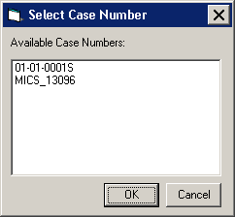
Project selection dialog
- Click OK to begin running the export process. Three separate progress bars (i.e., exporting feature classes, exporting domain and look-up tables, and exporting annotation) will be displayed in the lower right-hand corner of the ArcMap window. These progress bars will disappear when the process is complete.
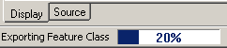 | 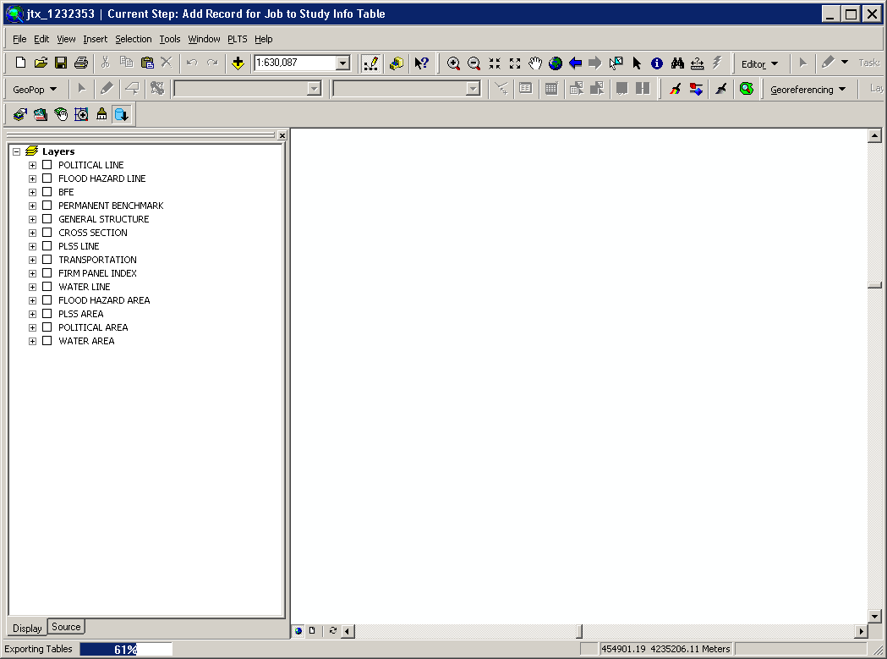 | 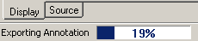

The personal geodatabase will be named according to the following naming convention:
<DFIRM ID>_<JTX Job ID>_<date exported, in the format yyyymmdd>.mdb
(e.g., 24015C_1022734_20060919.mdb, 060358_1143930_20061002.mdb)
Note: If the personal geodatabase already exists, you will be prompted to replace it.
The personal geodatabase is stored in the following folder structure on the MIP: J:\<region>\<state>\<county>\<county or community>\<FEMA Case Number>\Mapping\MISC.

Troubleshooting

Problem: What are the four date fields in the L_Comm_Info table, and how do I populate them?
Solution: The Initial Identification Date for the Community (IN_ID_DAT) value is the date that the community was first identified as a flood-prone area and is a candidate for the program. This date appears on current effective maps.
The Initial Date of the NFIP map Published by FEMA for the Community (IN_NFIP_DAT) value is obtainable from the FIRM; the date is related to the Flood Hazard Boundary Map Revisions and Flood Insurance Rate Map Effective listing on the FIRM Legend. This is essentially the date of the first FEMA map. If the FHBM is the first FEMA map, for instance, then its effective date is placed here. If a currently effective FIRM is the first FEMA map then that date should go here. If this FIRM in-progress is the first FEMA map, then its effective date (when it’s known) should be listed here. If there is no FHBM or effective FIRM date and the soon-to-be-effective FIRM date is not yet known, the value should be 88880808.
The Initial Date FIRM was Created (IN_FRM_DAT) value is also on the FIRM. This value is the date that is listed under the Flood Insurance Rate Map Effective heading. So if there is no FHBM date, then IN_NFIP_DAT and IN_FRM_DAT will hold the same value. If this is a first time FIRM, this value would be 88880808 during the preliminary period and would be replaced with the valid effective date when the map is finalized.
The Most Recent Panel Date (RECENT_DAT) is the effective date of the FIRM in-progress. During the preliminary stage, this value would be 99990909. Once the preliminary period is over and the effective date has been established, 99990909 would be replaced with the valid effective date.

Problem: After I ran the Generate INDEX Layout tool, I added more data layers via the DFIRM Layer Data Loader tool. All of my data in the Layers data frame disappears in my map layout.
Solution: If you need to add additional data to your INDEX map after creating a layout via the Generate INDEX Layout tool, make sure you are in the Data view when you use the DFIRM Layer Data Loader tool. Otherwise, if you add data in the Layout view after using the Generate INDEX Layout tool, you will have to click the Go Back to Previous Extent tool on the Tools toolbar to refresh the map layout.

Problem: This message appeared when I tried to generate my INDEX map layout.
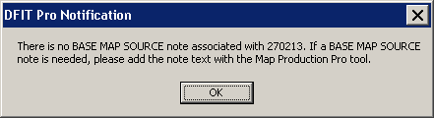
Solution: To add a base map note to an INDEX map, you need to populate the base map note in the Map Production Pro dialog accessible via the Map Production Pro tool. Refer to the Map Production Pro User Guide, FEMA DFIRM Production Tools for more information.

Problem: I cannot select the labels or features for editing within my INDEX layout.
Solution: To be able to select the labels within your Layers data frame while in the Layout view, you need to select the data frame by right-clicking Layers in the Table of Contents and selecting Activate from the dropdown list. When the Layers data frame is selected (i.e., cyan dotted line), right-click within the data frame, click the Order option menu, and select Bring to Front. Then, double-click the Layers data frame to focus the active frame; the frame will be outlined with a thick gray hashing when it is focused. Now you will be able to select the labels or features and edit them as necessary.

Problem: When I attempt to start an editing session, this error message appears.
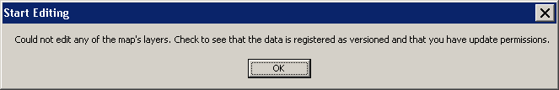
Solution: This message appears when you are attempting to edit a data frame other than the Layers data frame. To starting editing the Layers data frame, right-click the “Layers” data frame name in the Table of Contents and select Activate. Once the Layers data frame is active (i.e., the data frame name in the Table of Contents is bold), you will be able to start an editing session.

Problem: I was using the PDF Export tool, and this error message appeared after I selected a local drive to which to export my .pdf files.
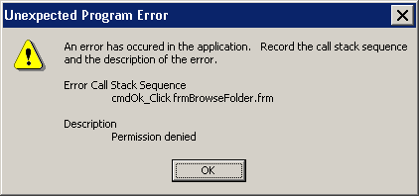
Call Stack Error – Permission denied
Solution: The file security for Citrix (i.e., ICA Application) is not set to “Full Access”; therefore, you cannot write to any of your local drives. To change this setting, right-click the ICA icon in the lower right-hand corner of the Taskbar on your computer screen. Click Open Connection Center. This will bring up the Program Manager Connection Center dialog for Citrix. Click on the File Security button. The ICA File Security dialog will appear. Change the settings as needed and click OK.

Problem: In the PDF of my map layout, there is an inconsistent shadow around the words “National Flood Insurance Program” in the Title Block.
Solution: The shadow is a result of the printing to .pdf format process; the error will only exist on PDF-based images. Since PDFs are not official submitted images to FEMA, this will not cause any errors in your DFIRM database deliverable submissions. When your map layout is exported to .eps, .tif, and .png formats, the shadowing effect will not occur. Also, if you look at the layout in ArcMap, you will not see this shadowing issue onscreen.

Problem: In the PDF of my map layout, the Panel Not Printed footnote symbol is overlapping the map number.
Solution: The text overlap is a result of the printing to .pdf format process; the error will only exist on PDF-based images. Since PDFs are not official submitted images to FEMA, this will not cause any errors in your DFIRM database deliverable submissions. When your map layout is exported to .eps and .tif formats, the footnote symbol will be properly placed before the map number. Also, if you look at the layout in ArcMap, you will not see the footnote overlapping the map number onscreen.

Contacts
If you need assistance with this tool, please contact the representative at your local RMC.

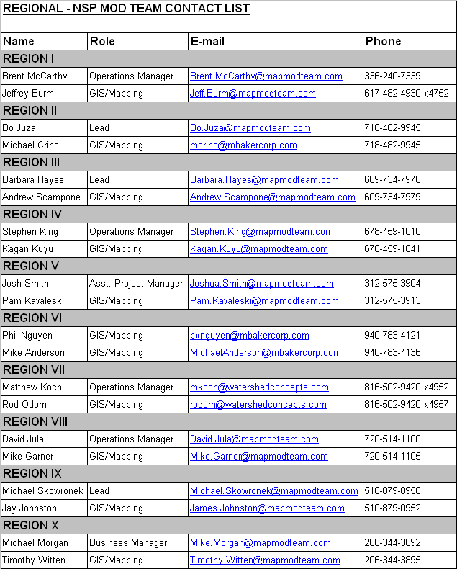

Appendix A – Fields Required for Rendering

The following fields in the specified feature classes must be populated in order to successfully symbolize the individual features via the Render using VVT Symbology tool on the PLTS Symbology and QA toolbar. The combination of attribute values in the specified fields will dictate the symbology for each feature. The value for the field Feature Class Subtype (FC_SUBTYPE) is computer-generated and must always be populated with 0 for all feature classes; there are no subtypes used within the DFIRM Tools database.

Raster Base Map Tile Index (S_Base_Index)
Feature Class Subtype (FC_SUBTYPE) – must equal 0

Base Flood Elevation (S_BFE)
Feature Class Subtype (FC_SUBTYPE) – must equal 0

Coastal Barrier Resource System (S_CBRS)
Feature Class Subtype (FC_SUBTYPE) – must equal 0
CBRS Type (CBRS_TYP) – domain value; can be NSPNULL
CBRS True/False (CBRS_TF) – domain value

Coastal Gage (S_Cst_Gage)
Feature Class Subtype (FC_SUBTYPE) – must equal 0

Coastal Transect Line (S_Cst_Tsct_Ln)
Feature Class Subtype (FC_SUBTYPE) – must equal 0
Shown on FIRM (SHOWN_FIRM) – NSP-created field; domain value

FIRM Panel Index (S_FIRM_Pan)
Feature Class Subtype (FC_SUBTYPE) – must equal 0
Panel Type (PANEL_TYP) – domain value

Flood Hazard Area (S_Fld_Haz_Ar)
Feature Class Subtype (FC_SUBTYPE) – must equal 0
Flood Zone (FLD_ZONE) – domain value
Floodway Type (FLOODWAY) – domain value; can be NSPNULL
AR Revert Zone (AR_REVERT) – domain value; can be NSPNULL

Flood Hazard Line (S_Fld_Haz_Ln)
Feature Class Subtype (FC_SUBTYPE) – must equal 0
Line Type (LN_TYP) – domain value
Is Gutter (GUTTER) – NSP-created field; domain value

General Structures (S_Gen_Struct)
Feature Class Subtype (FC_SUBTYPE) – must equal 0
Structure Type (STRUCT_TYP)

LOMR Areas (S_LOMR)
Feature Class Subtype (FC_SUBTYPE) – must equal 0
LOMR Boundary Lines (S_LOMR_Ln)
Feature Class Subtype (FC_SUBTYPE) – must equal 0
Shown on LOMR (SHOWN_LOMR) – NSP-created field; domain value

Overbank Flow Lines (S_Ovrbnkln)
Feature Class Subtype (FC_SUBTYPE) – must equal 0

Permanent Benchmarks (S_Perm_Bmk)
Feature Class Subtype (FC_SUBTYPE) – must equal 0

Primary Frontal Dunes (S_PFD_Ln)
Feature Class Subtype (FC_SUBTYPE) – must equal 0

PLSS Areas (S_PLSS_Ar)
Feature Class Subtype (FC_SUBTYPE) – must equal 0

PLSS Lines (S_PLSS_Ln)
Feature Class Subtype (FC_SUBTYPE) – must equal 0
Shown on FIRM (SHOWN_FIRM) – NSP-created field; domain value

Political Areas (S_Pol_Ar)
Feature Class Subtype (FC_SUBTYPE) – must equal 0

Political Lines (S_Pol_Ln)
Feature Class Subtype (FC_SUBTYPE) – must equal 0
Line Type (LN_TYP) – domain value

Precipitation Gages (S_Precip_Gage)
Feature Class Subtype (FC_SUBTYPE) – must equal 0

Profile Baselines (S_Profil_Basln)
Feature Class Subtype (FC_SUBTYPE) – must equal 0
Shown on FIRM (SHOWN_FIRM) – NSP-created field; domain value

USGS Quadrangles (S_Quad_Index)
Feature Class Subtype (FC_SUBTYPE) – must equal 0

River Distance Marks (S_Riv_Mrk)
Feature Class Subtype (FC_SUBTYPE) – must equal 0

Shorelines (S_Shore_Ln)
Feature Class Subtype (FC_SUBTYPE) – must equal 0

Transportation Lines (S_Trnsport_Ln)
Feature Class Subtype (FC_SUBTYPE) – must equal 0
Transportation Type (TRANS_TYP) – domain value
Shown on FIRM (SHOWN_FIRM) – NSP-created field; domain value
Shown on INDEX (SHOWN_INDX) – NSP-created field; domain value

Water Gages (S_Water_Gage)
Feature Class Subtype (FC_SUBTYPE) – must equal 0

Surface Water Areas (S_Wtr_Ar)
Feature Class Subtype (FC_SUBTYPE) – must equal 0

Surface Water Lines (S_Wtr_Ln)
Feature Class Subtype (FC_SUBTYPE) – must equal 0
Water Type (WATER_TYP) – domain value
Shown on INDEX (SHOWN_INDX) – NSP-created field; domain value

Cross Sections (S_XS)
Feature Class Subtype (FC_SUBTYPE) – must equal 0
Cross Section Line Type (XS_LN_TYP) – domain value

