DFIRM Annotation Tool

User Guide

FEMA DFIRM Production Tools

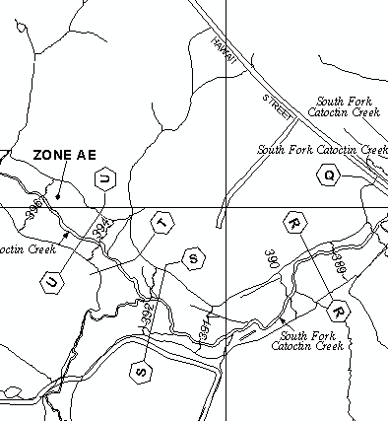

Table of Contents:

What is the DFIRM Annotation Tool? 3
DFIRM Annotation Tool Overview 3
What can you do with the DFIRM Annotation Tool? 4
Quick Reference Guide 5
Tool Controls 6
Symbol Manager 6
Line Leader 7
Dot Leader 8
Arrow Leader 9
Vector Gutter 10
DOQQ Line Leader 11
DOQQ Dot Leader 12
DOQQ Arrow Leader 13
DOQQ Vector Gutter 14
Interstate Highway 14
US Highway 14
State Highway 15
County Highway 15
Hold Out Interstate Highway 15
Hold Out US Highway 16
Hold Out State Highway 16
Hold Out County Highway 16
Trouble - Shooting 17
Contacts 18
Appendix A: FEMA Symbol Sets 19

What is the DFIRM Annotation Tool?
The DFIRM Annotation tool allows the user to add leader lines, highway shields, and other notes on DFIRM maps that are not automatically generated in the batch annotation done with Label Panel. Annotation and leaders can be added for maps with vector or DOQQ bases. The tool creates annotation that meets FEMA’s Guidelines and Specifications for Flood Hazard Mapping Partners Appendix K: Format and Specifications for Flood Insurance Rate Maps and Appendix L: Guidance for Preparing Draft Digital Data and DFIRM Database.
The text, leaders, and other graphics you create with this set of tools are features that are added to the annotation feature class associated with the job. This annotation is stored in the annotation feature classes that hold the Label Panel output. If text is added to a panel, using the DFIRM Annotation tool, the annotation will be “fixed” and will not be overwritten if Label Panel is re-run. Just as leaders generated with the Label Panel tool are re-created each time Label Panel is run, the leaders created with the DFIRM Annotation tool will need to be re-created manually if the panel is re-annotated with Label Panel.
The features available in this tool should only be used after a panel layout has been previewed with Map Production Pro. Once the panel has drawn, the user must switch from Layout View to Data View to begin using the DFIRM Annotation tools.
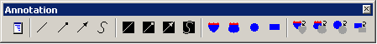
The DFIRM Annotation Toolbar

DFIRM Annotation Tool Overview
This user guide contains useful information that will help guide you in the use of the tool. The key sections of this guide are:
- Quick user reference guide (p. 5)
- Descriptions of tools and how to use them (p. 6)
- Trouble-shooting section containing common errors and their solutions (p. 17)
- Contact information (p. 18)

What can you do with the DFIRM Annotation Tool?

Use the Symbol Manager to add additional text to the map, according to the type of base used. |  |  | If the interstate highway shield runs over a line, use the Interstate Highway Hold Out to hide the underlying line.
Use the Line Leader tool to add a leader for a line feature. |  |  | Add an Interstate Highway shield with a hollow fill.
Add a cartographic gutter to the map with the Vector Gutter tool. |  |  | Use the DOQQ Line Leader tool to add a heavy leader for a line feature.

Quick Reference Guide
The following is a quick reference guide to all the tools available on the DFIRM Annotation toolbar. In addition, positioning your cursor over a button on the toolbar will display its name.
 | Symbol Manager | Allows user to specify annotation to be added
 | Line Leader | Creates a simple leader line
 | Dot Leader | Creates a leader line with a dot at the terminal end
 | Arrow Leader | Creates a line with an arrow at the terminal end
 | Vector Gutter | Allows user to add a cartographic gutter (symbolized by a white line)
 | Line Leader for DOQQ | Creates a simple leader line for a DOQQ base
 | Dot Leader for DOQQ | Creates a leader line with a dot at the terminal end for a DOQQ base
 | Arrow Leader for DOQQ | Creates a line with an arrow at the terminal end for a DOQQ base
 | Vector Gutter for DOQQ | Allows user to add a cartographic gutter (symbolized by a white line) for a DOQQ base
 | Interstate Highway | Creates an interstate highway label with a hollow background
 | US Highway | Creates a US highway label with a hollow background
 | State Highway | Creates a state highway label with a hollow background
 | County Highway | Creates a county highway label with a hollow background
 | Hold Out Interstate Highway | Creates an interstate highway label with a solid background
 | Hold Out US Highway | Creates a US highway label with a solid background
 | Hold Out State Highway | Creates a state highway with a solid background
 | Hold Out County Highway | Creates a county highway with a solid background

Tool Controls
This section describes the functionality of each of the tools on the DFIRM Annotation toolbar.

Symbol Manager
Use the Symbol Manager to specify which annotation should be added to your FIRM. Refer to Appendix A in this document for a complete list of the annotation that can be added using this tool.
- Switch to Data View, if you are in Layout View.
- Click on the Symbol Manager tool and the following dialog will appear:
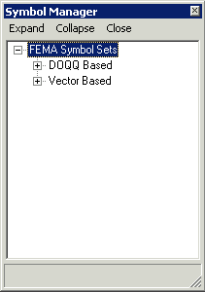
Symbol Manager dialog window

- Expand the symbol set for the FIRM map base by clicking on the symbol.
- Expand the selections available until you locate the symbol or text that you would like to add to the FIRM. Refer to Appendix A for the expanded list of options. The options are the same for the vector-based and DOQQ-based maps.
- Select the annotation you want to add by highlighting it in the Symbol Manager window.
- Click once on the map at the location where the annotation or text should be added. It may take a few moments for the feature to be created.
- Depending on the symbol you selected, you may be prompted for additional information, including text, dates and feature type. As was noted in the introduction section, these tools do not reference the attributes of the features shown. For instance, if you want to add Township and Range information for an area, you would need to manually enter the number in a dialog such as the one below.
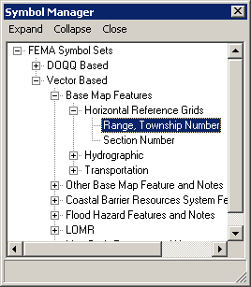
Range, Township Number in the Symbol Manager dialog window

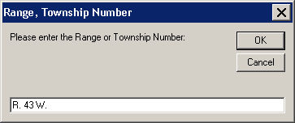
Range, Township Number dialog window

- Close the Symbol Manager if you are finished adding text or symbols. Leave the window open if you want to add more annotation.

Line Leader
Add a leader to an existing piece of annotation. The leader style cannot be modified.
- Switch to Data View, if you are in Layout View.
- Select the Line Leader tool.
- Click near the annotation you would like to leader, and the following dialog will appear.
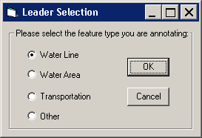
Leader Selection dialog window

- Select the type of leader you would like to create.
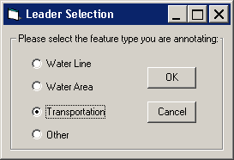
Leader Selection dialog window with Transportation feature type selected.

Note: It is important to make an accurate leader type selection, as this information is used in the conversion of the annotation layer to the S_Label_Ld layer. The S_Label_Ld layer is required, according to specifications in FEMA’s Appendix L.
- Click OK to continue.
- Click on the map at each point where you want to add a vertex to the leader.
- Double click the feature to end the leader.

Dot Leader
Add a leader with a dot ending to an existing piece of annotation. The leader style cannot be modified.
- Switch to Data View, if you are in Layout View.
- Select the Dot Leader tool.
- Click near the annotation you would like to leader, and the following dialog will appear.
Leader Selection dialog window

- Select the type of leader you would like to create.
Leader Selection dialog window with Transportation feature type selected.

Note: It is important to make an accurate leader type selection, as this information is used in the conversion of the annotation layer to the S_Label_Ld layer. The S_Label_Ld layer is required, according to specifications in FEMA’s Appendix L.
- Click OK to continue.
- Click on the map at each point where you want to add a vertex to the leader.
- Double click the feature to end the leader.

Arrow Leader
Add a leader with an arrowhead end to an existing piece of annotation. The leader style cannot be modified.
- Switch to Data View, if you are in Layout View.
- Select the Arrow Leader tool.
- Click near the annotation you would like to leader, and the following dialog will appear.
Leader Selection dialog window

- Select the type of leader you would like to create.
Leader Selection dialog window with Transportation feature type selected.

Note: It is important to make an accurate leader type selection, as this information is used in the conversion of the annotation layer to the S_Label_Ld layer. The S_Label_Ld layer is required, according to specifications in FEMA’s Appendix L.
- Click OK to continue.
- Click on the map at each point where you want to add a vertex to the leader.
- Double click the feature to end the leader.

Vector Gutter
A vector or cartographic gutter is used to denote a boundary between flood hazard zones, for example between an A and an AE zone. This symbol style cannot be modified.
- Switch to Data View, if you are in Layout View.
- Select the Vector Gutter tool.
- Click on the map at each point where you want to add a vertex to the gutter.
- Double click to end the line.

DOQQ Line Leader
This tool will add a leader to the map with a heavy line weight so that it is more visible on an orthophoto base-map. The line style cannot be modified.
- Switch to Data View, if you are in Layout View.
- Select the DOQQ Line Leader tool.
- Click near the annotation you would like to leader, and the following dialog will appear.
Leader Selection dialog window

- Select the type of leader you would like to create.
Leader Selection dialog window with Transportation feature type selected.

Note: It is important to make an accurate leader type selection, as this information is used in the conversion of the annotation layer to the S_Label_Ld layer. The S_Label_Ld layer is required, according to specifications in FEMA’s Appendix L.
- Click OK to continue.
- Click on the map at each point where you want to add a vertex to the leader.
- Double click the feature to end the leader.

DOQQ Dot Leader
This tool will add a leader with a dot or meatball end with a heavy line weight. It will be more visible on an orthophoto base map. The line style cannot be modified.
- Switch to Data View, if you are in Layout View.
- Select the DOQQ Dot Leader tool.
- Click near the annotation you would like to leader, and the following dialog will appear.
Leader Selection dialog window

- Select the type of leader you would like to create.
Leader Selection dialog window with Transportation feature type selected.

Note: It is important to make an accurate leader type selection, as this information is used in the conversion of the annotation layer to the S_Label_Ld layer. The S_Label_Ld layer is required, according to specifications in FEMA’s Appendix L.
- Click OK to continue.
- Click on the map at each point where you want to add a vertex to the leader.
- Double click the feature to end the leader.

DOQQ Arrow Leader
This tool will add a leader with an arrow head end with a heavy line weight. The line will be more visible on an orthophoto base map. The line style cannot be modified.
- Switch to Data View, if you are in Layout View.
- Select the DOQQ Arrow Leader tool.
- Click near the annotation you would like to leader, and the following dialog will appear.
Leader Selection dialog window

- Select the type of leader you would like to create.
Leader Selection dialog window with Transportation feature type selected.

Note: It is important to make an accurate leader type selection, as this information is used in the conversion of the annotation layer to the S_Label_Ld layer. The S_Label_Ld layer is required, according to specifications in FEMA’s Appendix L.
- Click OK to continue.
- Click on the map at each point where you want to add a vertex to the leader.
- Double click the feature to end the leader.

DOQQ Vector Gutter
A vector or cartographic gutter is used to denote a boundary between flood hazard zones, for example between an A and an AE zone. This symbol style has a heavy line weight so that it is visible on an orthophoto base map. This symbol style cannot be modified.
- Switch to Data View, if you are in Layout View.
- Select the DOQQ Vector Gutter tool.
- Click on the map at each point where you want to add a vertex to the gutter.
- Double click to end the line.

Interstate Highway
The tool adds an interstate highway shield with a hollow fill to the map.
- Switch to Data View, if you are in Layout View.
- Click on the Interstate Highway tool.
- Click on the map at the location where you want to add the shield.
- At the prompt, enter the highway name (e.g., 195 or 81)
- Click OK to apply the name to the shield.

US Highway
The tool adds a US highway shield with a hollow fill to the map.
- Switch to Data View, if you are in Layout View.
- Click on the US Highway tool.
- Click on the map at the location where you want to add the shield.
- At the prompt, enter the highway name (e.g., 101, 1, 1A)
- Click OK to apply the name to the shield.

State Highway
The tool adds a State highway shield with a hollow fill to the map.
- Switch to Data View, if you are in Layout View.
- Click on the State Highway tool.
- Click on the map at the location where you want to add the shield.
- At the prompt, enter the highway name (e.g., 121 or A23)
- Click OK to apply the name to the shield.

County Highway
The tool adds a county highway shield with a hollow fill to the map.
- Switch to Data View, if you are in Layout View.
- Click on the County Highway tool.
- Click on the map at the location where you want to add the shield.
- At the prompt, enter the highway name (e.g., P30, 336, 22A)
- Click OK to apply the name to the shield.

Hold Out Interstate Highway
The tool adds an interstate highway shield with a solid white fill to the map.
- Switch to Data View, if you are in Layout View.
- Click on the Hold Out Interstate Highway tool.
- Click on the map at the location where you want to add the shield.
- At the prompt, enter the highway name (e.g., 195 or 81)
- Click OK to apply the name to the shield.

Hold Out US Highway
The tool adds a US highway shield with a solid white fill to the map.
- Switch to Data View, if you are in Layout View.
- Click on the Hold Out US Highway tool.
- Click on the map at the location where you want to add the shield.
- At the prompt, enter the highway name (e.g., 101, 1, 1A)
- Click OK to apply the name to the shield.

Hold Out State Highway
The tool adds a State highway shield with a solid white fill to the map.
- Switch to Data View, if you are in Layout View.
- Click on the Hold Out State Highway tool.
- Click on the map at the location where you want to add the shield.
- At the prompt, enter the highway name (e.g., 121 or A23)
- Click OK to apply the name to the shield.

Hold Out County Highway
The tool adds a county highway shield with a solid white fill to the map.
- Switch to Data View, if you are in Layout View.
- Click on the Hold Out County Highway tool.
- Click on the map at the location where you want to add the shield.
- At the prompt, enter the highway name (e.g., P30, 336, 22A)
- Click OK to apply the name to the shield.

Trouble - Shooting
Problem: You receive an error message that the data is not in a projection.
Solution: You must use the DFIRM Layer Data Loader to add the STUDY_INFO table to the project. Use GeoPop Pro to populate the table with the correct projection information.

Problem: The following error message appears when you try to use a tool.
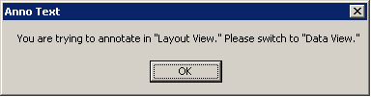
Solution: Switch to the specified view.

Problem: The following error message appears when you try to use a tool.
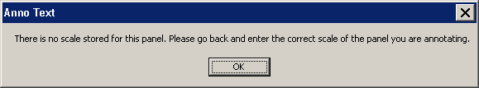
Solution: The SCALE attribute is not populated correctly in the FIRM INDEX layer (S_Fld_Haz_Ar). Use GeoPop Pro to populate the table with the correct scale information.

Contacts
If you need assistance with this tool, please contact the representative at your local RMC.

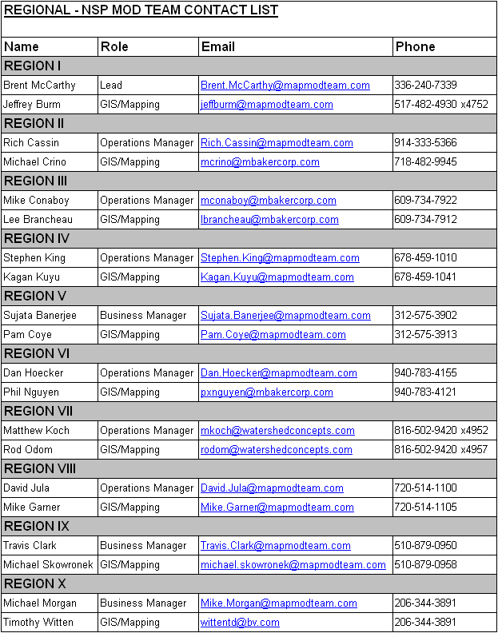

Appendix A: FEMA Symbol Sets
When you open the Symbol Manager, the annotation below is available to you, for both Vector and DOQQ-based FIRMs.

DOQQ Based – Has the same options available as for vector-based maps, shown below.
Vector Based
Base Map Features
Horizontal Reference Grids
Range, Township Number
Section Number
Hydrographic
Name of River, Stream, or Other Hydrographic Feature (Small)
Name of River, Stream, or Other Hydrographic Feature (Medium)
Name of River, Stream, or Other Hydrographic Feature (Large)
Unnamed Stream, Unnamed Tributary
Wash or Glacier and Name
Intracoastal Waterway Label
Canal Label
Cranberry Bog Label
Ditch Label
Glacier Label
Marsh Label
Pond Label
Swamp Label
Wash Label
Transportation
Street, Road, Avenue
Private Road Label
Unimproved Road Label
Unnamed Road Label
Road or Railroad Bridge
Footbridge Label
Tunnel Label
Railroad
Abandoned Railroad Label CAPS
Abandoned Railroad Label CLC
Dismantled Railroad Label CAPS
Dismantled Railroad Label CLC
Old Railroad Grade Label CAPS
Old Railroad Grade Label CLC
Ferry Label
Airport / Airfield Name (Small)
Airport / Airfield Name (Medium)
Airport / Airfield Name (Large)
Airfield Label
Landing Strip Label
Other Base Map Feature and Notes
Name of Large Island (Small)
Name of Large Island (Medium)
Name of Large Island (Large)
Name of Small Island (Small) CAPS
Name of Small Island (Small) CLC
Name of Small Island (Large) CAPS
Name of Small Island (Large) CLC
Name of Point, Cape, Neck (Small) CAPS
Name of Point, Cape, Neck (Small) CLC
Name of Point, Cape, Neck (Medium) CAPS
Name of Point, Cape, Neck (Medium) CLC
Name of Point, Cape, Neck (Large) CAPS
Name of Point, Cape, Neck (Large) CLC
Name of Gulch, Canyon, Draw (Small) CAPS
Name of Gulch, Canyon, Draw (Small) CLC
Name of Gulch, Canyon, Draw (Large) CAPS
Name of Gulch, Canyon, Draw (Large) CLC
Corporate Limits Coincident With Shoreline Label
This Area Shown Label
Significant Outlined Landmark
Coastal Barrier Resources System Features and Notes
Flood Insurance Not Available for Structures after Oct 1, 1983 Label
Flood Insurance Not Available for New Construction Label
Flood Insurance Not Available for Structures (Insert date) Label
Coastal Barrier Identified Label
Otherwise Protected Area Identified Label
This Area Contained Within CBRS Label
Comments or Concerns Regarding CBRS Label
Flood Hazard Features and Notes
Flooding Effects From (source name) Label
Floodway in This Area Too Narrow Label
Floodway Contained in Channel Label
Floodway Contained in Culvert Label
This Area Protected From 1% Annual Chance Flood Label
This Area Includes Areas Protected from 1% Annual Chance Flood Label
Coastal Base Flood Elevations Apply Only Landward Label
Flood Hazard Information Not Shown Label
Flood Hazard Information is Shown Within Label
Flood Insurance Information on This Map Label
LOMR
Revised Area Label (Small)
Revised Area Label (Medium)
Revised Area Label (Large)
Area Revised by LOMR Dated Label (Small)
Area Revised by LOMR Dated Label (Medium)
Area Revised by LOMR Dated Label (Large)
Map Body Features and Notes
Clarify Coincident With Features
Profile Base Line Label

