

DFIRM Metadata Builder Tool

User Guide

FEMA DFIRM Production Tools

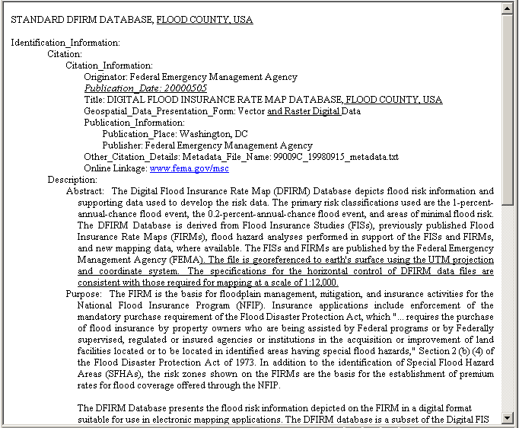

Table of Contents:
What is the DFIRM Metadata Builder? 3
DFIRM Metadata Builder Overview 3
Quick Reference Guide 3
Tool Controls 4
DFIRM Metadata Builder Toolbar 4
Build DFIRM metadata file 4
View DFIRM metadata file 7
Add Source to DFIRM metadata file 8
Edit Source in DFIRM metadata file 9
Trouble – Shooting 11
Contacts 16

What is the DFIRM Metadata Builder?
The DFIRM Metadata Builder simplifies the creation of the database metadata document. A metadata file is generated to meet FGDC Content Standards for Digital Geospatial Metadata. The content of the file is based upon the template in FEMA’s Guidelines and Specifications for Flood Hazard Mapping Partners, Appendix L: Guidance for Preparing Draft Digital Data and DFIRM Database and records in the Source Citation lookup table (L_SOURCE_CIT). The metadata document generated is saved to the K: drive within the Document folder, located in Submissions folder for the project.
DFIRM Metadata Builder toolbar

DFIRM Metadata Builder Overview
The DFIRM Metadata Builder user guide contains useful information that will help guide you through using the tool. The key sections of this guide are:
- Quick user reference guide (p. 3)
- Descriptions of tools and how to use them (p. 4)
- Support/contact information (p. 16)

Quick Reference Guide
The following is a quick reference guide to all of the components of DFIRM Metadata Builder. All data is required to have a complete metadata file, so you will need to know how to generate and populate a metadata file to meet FGDC standards.
 | Build DFIRM metadata file | Initialize a new metadata file
 | View DFIRM metadata file | View a metadata file
 | Add Source to DFIRM metadata file | Add a new source to an existing metadata file
 | Edit Source in DFIRM metadata file | Edit source information in an existing metadata file

Tool Controls

DFIRM Metadata Builder Toolbar

Build DFIRM metadata file
This tool generates and populates the metadata file based upon the source citations listed in the Source Citation lookup table (L_SOURCE_CIT).
- Click on the Build DFIRM Metadata file button. The project selection dialog will appear.
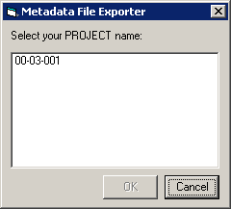
Project selection dialog

- In the Metadata File Exporter dialog, select the project name.
- If a metadata file exists for the project, a message box will appear to inform you and ask if the existing file should be overwritten.
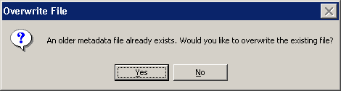
Confirm overwrite dialog
NOTE: If the user clicks ‘No’, the metadata tool will terminate. Only one metadata file can exist per DFIRM study.

- The Keyword Selection dialog will appear. Make the appropriate selections, if applicable, and click OK.
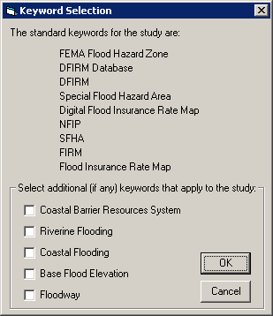 | The standard keywords for DFIRM databases are listed, for your reference.  Click on the checkboxes to select additional keywords.  Click OK to apply the selections.
Keyword Selection dialog

- Select the source citation template that is appropriate for the source listed. The Source Citation Selection dialog will appear for each record in the Source Citation table.
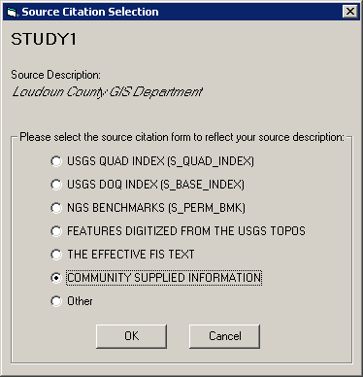 | Source Citation name from the Source Citation table  Source description from the Source Citation table  Select the source citation template that is appropriate for the source listed at the top of the dialog.
Source Citation template dialog

- A series of dialog boxes will appear prompting the user for additional information. The information required depends upon the source citation template selected, and it is summarized in the table below.
USGS Quad Index | USGS DOQ Index | NGS Benchmarks | Digitized Features, USGS Topos | Effective FIS Text | Community-Supplied Information | Other
Originator |  |  |  |  |  | ● | ●
Publication Date |  | ● |  | ● | ● | ● | ●
Title |  |  |  |  |  | ● | ●
Geospatial Data Presentation Form |  |  |  |  |  | ● | ●
Publication Place |  |  |  |  |  | ● | ●
Publisher |  |  |  |  | ● | ● | ●
Other Citation Details |  |  |  |  | ● | ● | ●
Source Scale Denominator |  |  |  |  |  | ● | ●
Type of Source Media |  |  |  |  |  | ● | ●
Calendar Date |  |  |  |  | ● | ● | ●
Source Currentness Reference |  |  |  |  |  |  | ●
Source Contribution |  |  |  |  | ● | ● | ●
Features Digitized |  |  |  | ●
Altitude Resolution (feet) | ● | ● | ● | ● | ● | ● | ●

Required information for each source citation

- Regardless of the source citation template chosen, the user is prompted to provide the altitude resolution in feet for the vertical coordinate system.
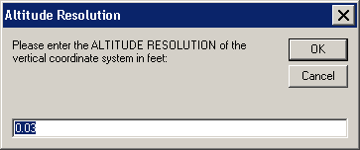
Altitude Resolution dialog. The default value is 0.03 feet.

NOTE: If the user clicks a ‘Cancel’ button on any of the dialog boxes presented, the metadata creation process will terminate. No metadata file will be generated.
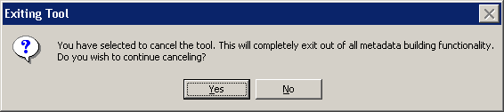
Confirm exiting metadata tool dialog

View DFIRM metadata file
This tool views the metadata file created for the data.
- Clicking on the View DFIRM metadata file button will prompt the user to select the current project, unless the project has already been chosen in Steps 1 or 2 within this session.
- If you have not already selected the project on which you are working, the Metadata File Exporter dialog will appear.
Project selection dialog

- The created metadata file will be displayed in a window. This file has been saved on the K: drive within the Document folder, located in Submissions folder for the project.
NOTE: Only the source citations can be edited (See the section Edit Source in DFIRM metadata file for additional instruction.) The entire metadata file must be recreated and the previous file overwritten to revise the keywords and/or the altitude resolution value in the metadata.
- To save a copy of the metadata file locally, select all the text (Ctrl+A), and copy and paste it into a Word or text file document. Then, save this file locally.

Add Source to DFIRM metadata file
This tool evaluates the entries in the Source Citation lookup table (L_SOURCE_CIT) and compares the records to the sources that have been entered in the existing metadata document. If there are sources in the lookup table that do not appear in the metadata file, the user will be prompted to add information for the “new” records.
- Click on the Add Source to DFIRM metadata file button.
- If you have not already selected the project on which you are working, the Metadata File Exporter dialog will appear.
Project selection dialog

- The user is prompted to select a source citation template that would be appropriate for the new source citation listed. This selection dialog will appear and is required for every record recently added to the Source Citation lookup table (L_SOURCE_CIT).
Source Citation template dialog
NOTE: If the user clicks a ‘Cancel’ button on any of the dialog boxes presented, the metadata source addition process will terminate. No additional source(s) will be populated in the existing metadata file.
Confirm exiting metadata tool dialog

Edit Source in DFIRM metadata file
This tool allows the user to edit the information that they entered for each of the source citations referenced in the current metadata file.
- Click on the Edit Source in DFIRM metadata file button.
- If you have not already selected the project on which you are working, the Metadata File Exporter dialog will appear.
Project selection dialog

- The user is prompted to select the source citation that they wish to edit from the drop-down list. All of the editable sources in the current metadata file will be listed.
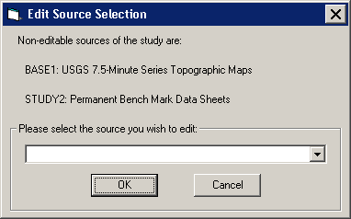
Edit Source Selection dialog

NOTE: The source citations that reference USGS Quad Index and NGS Benchmarks are not editable because the user does not enter any additional information into templates for these citations.
- The appropriate template for the selected source will appear with the current data populated in the text boxes. Edit the incorrect text, and click OK. The revised source information will be saved in the metadata file.
- To edit another source, click the Edit Source in DFIRM metadata file button and select another source from the list.
NOTE: Only one source can be edited and saved at a time. However, sources can be edited multiple times, as necessary.
- To view the revised metadata file, click the View DFIRM Metadata file button.

Trouble – Shooting

Problem: One or both of the following error messages appeared when I tried to build a metadata file.
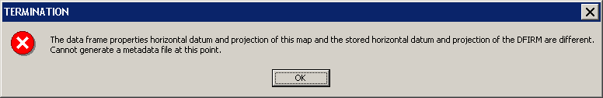
Termination message – Data frame projection information does not match Study_Info table projection information.
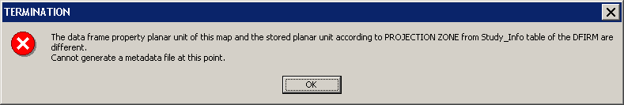
Termination message – Data frame units do not match Study_Info table projection information.
Solution: The value for the field PROJECTION ZONE in the Study_Info table has been changed while you were in the current ArcMap session. Close ArcMap and do not save the .mxd. Relaunch the step in JTX. When ArcMap opens, the data frame projection and datum will be set to the values within your Study_Info table. You should now be able to build your metadata file successfully.

Problem: The following error message appeared when I tried to build a metadata file.
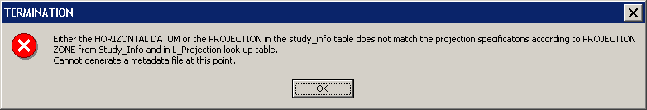
Termination message – Datum, projection, and projection zone information within Study_Info table do not match.
Solution: The horizontal datum and/or projection in the Study_Info table do not match the projection information designated by the domain value in the PROJECTION ZONE field. To synchronize all of the projection information in the Study_Info table, use the DFIRM Layer Data Loader tool to add the Study_Info table to your project. Enter an editing session, select the record in the Study_Info table, and use the Attribute Selected Features tool on the GeoPop toolbar to edit the Datum, Projection, and Projection Zone values in the Study_Info table to match. Once you have saved the edits to the table, stop editing, and start creating your metadata file again.

Problem: The following error message appeared when I tried to build a metadata file.
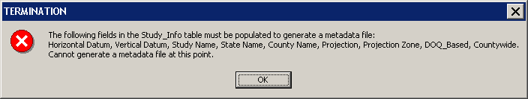
Termination message – Certain fields in the Study_Info table must be populated to generate a metadata file.
Solution: The metadata tool obtains certain information from the Study_Info table, therefore, specific fields must be populated in order to create a metadata file. To populate any of the fields listed in the error message, use the DFIRM Layer Data Loader tool to add the Study_Info table to your project. Enter an editing session, select the record in the Study_Info table, and use the Attribute Selected Features tool on the GeoPop toolbar to edit the necessary values in the Study_Info table. Once you have saved the edits to the table, stop editing, and start creating your metadata file again.

Problem: The following dialog box appeared when I tried to build a metadata file.
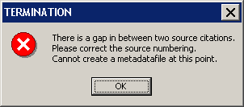
Termination message – Source citations are not sequential.
Solution: As sources are created with the GeoPop tools, the source citation IDs are incremented sequentially when more than one record is added for a source type (i.e., Study1, Study2, Base1, Base2). However, if the user deletes a record in a sequential sequence, the Metadata Tool will not allow the user to generate a metadata file. The user needs to manually edit the source citation IDs to ensure that all the source types are numbered sequentially with no omitted numbers.

Problem: The following dialog box appeared while I was creating a new metadata file.
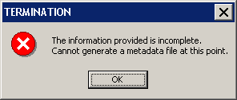
Termination message – Information is incomplete.
Solution: If the user exits out of any of the dialogs that appear to collect the required information, the metadata creation process is terminated after the user confirms cancellation of the tool, and the message box above will appear. You must re-start the metadata building process.

Problem: The following dialog appeared when I tried use the USGS Quad Index or NGS Benchmark template for the second time.
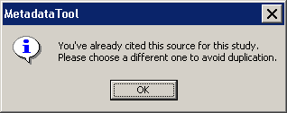
Information dialog – Source duplication.
Solution: Each DFIRM study should only have one USGS Quad Index citation and one NGS Benchmark citation.

Problem: The following dialog box appeared when I tried to add a new source to an existing metadata file.
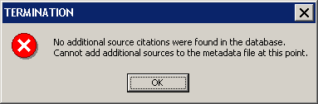
Termination message – No additional sources found.
Solution: Unless you have added a new record to the Source Citation table (L_SOURCE_CIT), you cannot add a new reference in the metadata file. Use the DFIRM Layer Data Loader tool to add the Source Citation table to your project. Enter an editing session and use the Add New Row tool on the GeoPop toolbar to add a new record to the Source Citation table. Once you have saved the edits to the table, you can stop editing and use the Add Source button on the DFIRM Metadata Builder toolbar to add a new source to the metadata file.

Problem: The following dialog box appeared when I tried to add a new source to an existing metadata file.
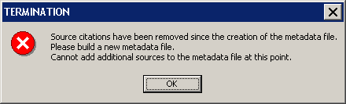
Termination message – Sources have been removed.
Solution: Once a metadata file is created, sources cannot be removed from the Source Citation lookup table (L_SOURCE_CIT). Removing sources from the lookup table does not remove the associated information in the existing metadata file. If sources are deleted, a new metadata file must be created, overwriting the existing metadata file.

Problem: In the metadata file the publication date and calendar date are listed as ‘prelim’, and the metadata is for an effective study, not a preliminary study.
Solution: If the field EFF_DATE in FIRM Panel Index (S_FIRM_PAN) is blank, then the effective date in the metadata will be populated with ‘prelim’. Populate the field in the FIRM Panel Index attribute table with the appropriate effective date, and recreate the metadata file.

Problem: The following dialog box appeared when I tried to edit a source in the existing metadata file.
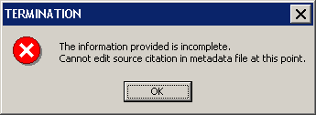
Termination message – Information is incomplete.
Solution: If the user exits out of the dialog to select an editable source, the metadata editing process is terminated after the user confirms cancellation of the tool, and the message box above will appear. You must re-start the metadata editing process to edit the existing source citation information.

Problem: The following dialog box appeared when I tried to edit a source in the existing metadata file.
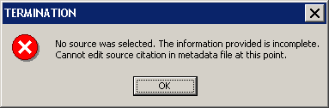
Termination message - No source was selected.
Solution: When the Edit Source Selection dialog appears, the drop-down window is blank, and the user need to hit the down arrow button to view the list of their source. However, if the user hits “OK”, the error message will appear because no actual source was chosen for editing. You must re-start the metadata editing process to edit the existing source citation information.

Problem: I want to edit the Keywords and/or the Altitude Resolution value in the current metadata file.
Solution: Only the information for individual sources is editable. To change the keywords or altitude resolution in the metadata file, a new metadata file must be created, which overwrites the existing metadata file.

Contacts
If you need assistance with this tool, please contact the representative at your local RMC.

