

JTX User Guide
FEMA DFIRM Production Tools
Version 2.0

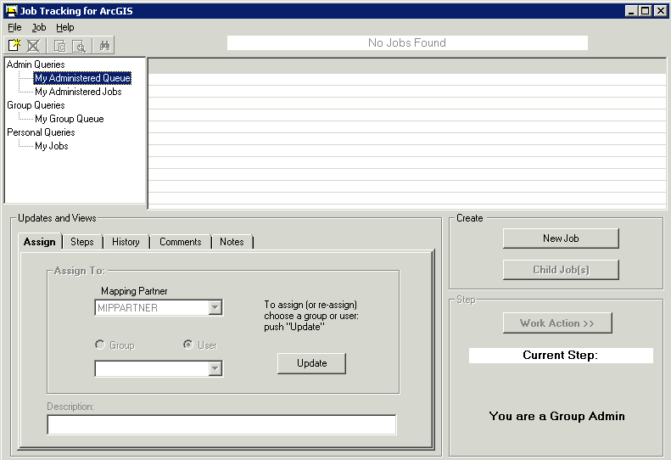

Table of Contents:

What is JTX? 1
Quick Reference Guide 1
JTX Key Concepts 2
What are JTX Users/Groups? 2
JTX Jobs/Job Types 3
DFIRM Study (P_STDY) 3
DFIRM Study Workflow Steps 4
Letter of Map Revision (LOMR) 7
LOMR Workflow Steps 7
Getting Started 8
User Request Process 8
Data Submission Process 9
Set Access Level 9
JTX Tool Controls 10
JTX Toolbar 10
Create New Job 10
Cancel Job 11
Create Child Jobs 12
Show Child Jobs 13
Find Job 13
JTX Menu 14
File Menu 14
Job Menu 15
Help Menu 16
Job Query Window 16
Admin Queries 16
Group Queries 17
Personal Queries 17
Jobs Listing Window 17
ID 17
Job Name 17
S_CJ 18
Current Step 18
User or Group 18
Create Date/Time 19
Description 19
Updates and Views Section 19
Assign Tab 20
Steps Tab 21
History Tab 22
Comments Tab 23
Notes Tab 24
Step Actions Section 25
Run Current Step 25
Mark Step Finished 25
Uncheck Previous Step 26
Close Job 26
Create Job Section 26
Reconcile and Post 27
PLTS Symbology and QA Toolbar 29
Render using VVT Symbology 29
PLTS Dangle and Pseudo Renderer 30
Default Render 30
Set Polygon Transparency Percentage 30
DFIRM Layer Loader Toolbar 31
DFIRM Layer Data Loader 32
DFIRM Reference Data Loader 33
Show DFIRM Adjacent Area 36
Show Only DFIRM Area 37
Zoom to DFIRM ID 38
Suspend Drawing 38
Troubleshooting 40
Contacts 43
Appendix A – DFIRM Study Detailed Step Descriptions 44
Appendix B – LOMR Detailed Step Descriptions 50

What is JTX?
JTX, a DFIRM Tools-customized ESRI application, is a workflow management application that follows a job throughout its entire lifecycle. It allows for the creation, management, and termination of jobs. JTX supports job tracking by maintaining a detailed job history table that will include user identification, task worked on, and date of work. Each job type has a standardized set of steps that you must work through before the job can be considered complete. As the job progresses through the lifecycle, you are provided with data and tools to assist in the completion of the task. JTX also assists in the allocation of resources by managing users and user groups. Jobs may be assigned directly to a specific user or a user group. All DFIRM production tools will be accessible through executable steps in the JTX workflow.

Quick Reference Guide
The following is a quick reference guide to all of the components of JTX.
JTX Menu ---------------  JTX Toolbar ------------  Job Query Window ----  Displays all current jobs sorted by privilege (admin, group, and personal)  Updates and Views Section ------------------  Allows you to assign jobs, view job steps, view job history, and add comments or notes | 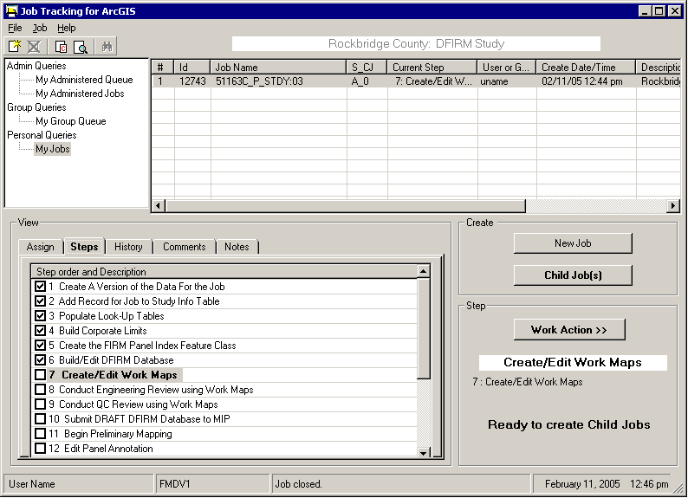 |  |  | JTX Job(s)  List of jobs in the selected queue  Create Job Section  Allows you to create new jobs  Step Actions Section  Displays current job step and status, and allows you to advance to next step of job
 | User | Message box | Date / time (EST)

JTX Key Concepts

What are JTX Users/Groups?
A JTX User is any person that has access to and will be working within the JTX environment. Each user must have his/her own user name setup for job assignment and tracking purposes. Every user must fall into a defined DFIRM Tools group. A user may be part of only one group.
A JTX Group is a set of users that share a common role and typically work in the same department (e.g. Engineering, QA/QC, Mapping, etc.). Groups are used for two reasons: to control privileges and to provide a queuing mechanism for jobs. Each group type (e.g., Mapping) may have a corresponding Administrator group and a corresponding Analyst group (e.g., Mapping Administrator group, Mapping Analyst group). There must be an Administrator group for every group type, but the Analyst group can be omitted for a specific group type. Both the Administrator and Analyst groups can have as few as one person.
Administrators have the following privileges – creating a job (i.e., parent or child jobs), closing child jobs, and assigning a job to any user (i.e., Administrator or Analyst) or any group (i.e., their own group or any other group either within or outside of their Mapping Partner).
Note: These Administrators are Group Administrators; they should not be confused with JTX Administrators who manage and maintain the DFIRM Tools suite. However, in the documentation, training, and MIPHelp communications, Group Administrators will be referred to as just ‘Administrators’; whereas JTX Administrators will always be referred to as ‘JTX Administrators’.
Analysts’ privileges are limited to assigning a job to their Administrator’s group or their own Analyst group. Analysts cannot create parent or child jobs. Analysts may close child jobs.
Note: DFIRM Tools group types/groups do not have any association with WISE groups and/or privileges. WISE groups and DFIRM Tools groups are entirely separate and interact with two different sets of software.
A Mapping Partner is a collection of Groups and Users that work for the same company (e.g., Baker, Watershed Concepts). Companies must be designated as individual Mapping Partners. If more than one company will be working with a particular study, each of those companies still need to be their own Mapping Partner with their own set of groups. Defining each company as a Mapping Partner does not restrict a Mapping Partner’s access to a job. An administrator user may assign a job to group/user within a different Mapping Partner. In this way, Mapping Partners may work together on a study.
Group types may be used to assist the Mapping Partner with user organization. Users that perform similar tasks can be given a unique classification via a group type. For example, the Mapping Partner Floodville CTP utilizes three group types: Mapping, Engineering, and QC. Each of these group types has an administrator and analyst group. Therefore, Floodville has the following groups: Mapping Administrator, Mapping Analyst, Engineering Administrator, Engineering Analyst, QC Administrator, and QC Analyst.
Floodville CTP will utilize these groups to move a job effectively through the workflow. Specifically, for internal use Floodville has assigned workflow steps as belonging to particular group types. As the job moves through the workflow, the job will be reassigned to the appropriate groups/users based on this step designation. For instance, once the mapping database creation step is completed, the data must be evaluated for correctness. Therefore, a Mapping Administrator would reassign the job to a QC Administrator group/user, so that the data evaluation may be performed by the QC team.
Another way to organize users is by location (of the user, not the study). The Mapping Partner FloodFolks, for instance, has offices in the Northwest, Northeast, and South. Users between offices have little interaction. FloodFolks, therefore, has decided to set up three group types: NE, NW, and S. The group types NE and NW both have a significant number of users, so they will set up both analyst and administrator groups. The S office, however, has only two employees both whom perform the same functions, so they decide to set up only an administrator group. Thus, FloodFolks has the following groups established: NE Administrator, NE Analyst, NW Administrator, NW Analyst, and S Administrator. FloodFolks will use their groups to help keep their work assigned to specific offices.
Groups may be simple or more complex depending upon the Mapping Partner’s needs. For example, a large company may chose to declare groups according to both the group function and the group location. A configuration based on that organization could have the following groups, for instance: NE Mapping Administrator, NE Mapping Analyst, NW Mapping Administrator, NW Mapping Analyst, etc. A small company may choose to have just a single Administrator group and a single Analyst group. Group types are flexible enough to accommodate all Mapping Partners.
With that being said, the Mapping Partner would benefit by giving some thought as to how their groups should be setup. Once jobs are created, it is difficult to alter a Mapping Partner’s existing groups (although, it is not difficult to add additional groups for new users).
However, it needs to be clear that group types beyond simply an Administrator group and an Analyst group exist solely for the Mapping Partner’s organizational purposes. All Administrator groups have the same JTX software privileges, and all Analyst groups have the same JTX software privileges. Jobs are categorized according to this basic grouping. Administrators have the advantage of reviewing those jobs associated with their administered group queue. For instance, a Floodville CTP Mapping Administrator will be able to see all jobs assigned to the Floodville Mapping Administrator group/users and the Floodville Mapping Analyst group/users. This queue allows the administrator to manage his/her studies more easily.
Note: JTX privileges do not affect ESRI ArcMap functionality. Administrators and Analysts have access to the same toolbars and tools, and both Administrators and Analysts can perform the same tasks/functions within ArcMap.

JTX Jobs/Job Types
A job is a unit of work to be performed on a particular set of data by one or more people. A job type is a logical grouping of steps and layers required to perform a particular task, and it is also used to streamline the workflow. Two job types exist within JTX – DFIRM Study (P_STDY) and Letter of Map Revision (LOMR).

DFIRM Study (P_STDY)
This job type includes any DFIRM Production work. The 42-step workflow extends through the submission of the final DFIRM database deliverable to the MIP. Steps are either executable or procedural. Executable steps launch ArcMap and load the appropriate toolbars. These steps designate user interaction within DFIRM Tools. Procedural steps do not require any action within the DFIRM Tools environment and are only there to track that an action has occurred.

DFIRM Study Workflow Steps
The following list is the description of each chronological step within the DFIRM Study workflow. Steps are identified as being executable or procedural. The toolbars that are launched in ArcMap for that step are identified in the brackets. Refer to Appendix A in this user guide for a detailed description of each step.
- Create a version of the data for the job - Performed automatically when a job is created. This is a procedural step. [JTX]
- Add Record to Study_Info Table - Create or edit the one record in the Study_Info table. This is an executable step. [GeoPop Pro]
- Populate Look-Up Tables - Populate all required lookup tables to assist with database production. This is an executable step and requires the creation of a child job(s). [GeoPop Pro]
- Build Corporate Limits - Create the corporate limits, which are required for the creation of the FIRM Panel Index Feature Class. This is an executable step. [GeoPop Pro]
- Create the FIRM Panel Index Feature Class - Create a 2000-scale panel layout for the study, which can be edited as needed. This is an executable step. [GeoPop Pro]
- Build/Edit DFIRM Database - Populate the database with all of the required features and attributes. This is an executable step and requires the creation of a child job(s). [GeoPop Pro]
- Create/Edit Work Maps - Create a work map to visually check the database population. This is an executable step and requires the creation of a child job(s). [Work Map Pro]
- Conduct Engineering Review using Work Map - Engineering reviews work maps. This is an executable step and requires the creation of a child job(s). [GIS Data ReViewer]
- Conduct QC Review using Work Maps - QC reviews the work maps. This is an executable step and requires the creation of a child job(s). [GIS Data ReViewer]
- Submit DRAFT DFIRM Database to MIP - Submit Draft DFIRM Database to the MIP. This is an executable step. [DFIRM Metadata Builder, Database Exporter]
- Begin Preliminary Mapping - Generate annotation for map creation. This is an executable step. [LabelPanel]
- Edit Panel Annotation - Edit generated annotation, and add any missing elements. This is an executable step and requires the creation of a child job(s). [Map Production Pro, Label-Edit, DFIRM Annotation Tool]
- Conduct QC Review using Checkprints – QC reviews the checkprints with annotation. This is an executable step and requires the creation of a child job(s). [Map Production Pro, GIS Data ReViewer]
- Conduct Engineering Review Using Checkprints - Engineering reviews checkprints with annotation. This is an executable step and requires the creation of a child job(s). [Map Production Pro, GIS Data ReViewer]
- QC Review Engineering Comments - QC reviews the engineering comments on the checkprints and annotation. This is an executable step and requires the creation of a child job(s). [Map Production Pro, GIS Data ReViewer]
- Perform Corrections to Checkprints - Make the necessary edits, as outlined by engineering and QC. This is an executable step and requires the creation of a child job(s). [GeoPop Pro, LabelPanel, Map Production Pro, Label-Edit, DFIRM Annotation Tool]
- Create Preliminary Maps - Create the preliminary maps. This is an executable step and requires the creation of a child job(s). [Map Production Pro]
- Create Preliminary Index - Create the preliminary index. This is an executable step. [DFIT]
- QA Preliminary Index - QA reviews the index. This is an executable step. [DFIT, GIS Data ReViewer]
- Submit Preliminary DFIRM Database to MIP - Submit Preliminary DFIRM Database to the MIP. This is an executable step. [DFIRM Metadata Builder, Database Exporter]
- Independent QA of Preliminary - Independent QA will review submission and provide comments. This is a procedural step.
- Add Independent QA Comments (1) - Review comments and edit the versioned DFIRM database. This is an executable step and requires the creation of a child job(s). [GeoPop Pro, Map Production Pro, GIS Data ReViewer, LabelPanel, Label-Edit, DFIRM Annotation Tool]
- Create Final Prelim Checkprints - Create the final preliminary maps. This is an executable step and requires the creation of a child job(s). [Map Production Pro]
- Create Final Prelim Index - Create the final preliminary index. This is an executable step. [DFIT]
- QA Final Prelim Index - QA reviews the index. This is an executable step. [DFIT, GIS Data ReViewer]
- Submit Final Prelim DFIRM Database to MIP - Submit final Preliminary DFIRM Database to the MIP. This is an executable step. [Database Exporter]
- Create Metadata for Preliminary DFIRM - Create or edit the metadata file for the DFIRM study. This is an executable step. [DFIRM Metadata Builder]
- Prepare Preliminary Package - Gather the components of the preliminary package. This is a procedural step and requires the creation of a child job(s).
- Mail Preliminary Package - Mail the preliminary package. This is a procedural step.
- Post-Preliminary DFIRM Processing – Receive Comments - Receive and review the comments from the communities. This is a procedural step.
- QC Review of the Engineering/Community Comments - QC reviews the community comments that need to be incorporated. This is a procedural step.
- Incorporate Required Changes to DFIRM - Incorporate community comments into the DFIRM maps. This is an executable step and requires the creation of a child job(s). [GeoPop Pro, Map Production Pro, GIS Data ReViewer, LabelPanel, Label-Edit, DFIRM Annotation Tool]
- QC Review of GPO Checkprints - QC reviews the GPO checkprints with annotation. This is an executable step and requires the creation of a child job(s). [Map Production Pro, GIS Data ReViewer]
Note: The abbreviation GPO stands for Government Printing Office. This term represents the final product which is delivered to the MSC.
- Engineering Review of GPO Checkprints - Engineering reviews the GPO checkprints with annotation. This is an executable step and requires the creation of a child job(s). [Map Production Pro, GIS Data ReViewer]
- Submit GPO DFIRM Database to MIP for Independent QA - Submit Final DFIRM Database to the MIP. This is an executable step. [Database Exporter, Metadata Builder]
- Receive and Incorporate Comments from Independent QA - Incorporate Independent QA comments into the DFIRM maps. This is an executable step and requires the creation of a child job(s). [GeoPop Pro, Map Production Pro, GIS Data ReViewer, LabelPanel, Label-Edit, DFIRM Annotation Tool]
- Prepare GPO Package - Prepare all of the components of GPO package. This is a procedural step.
- Perform QC Review of GPO Package - QC reviews the GPO package. This is a procedural step, which will be performed by the NSP.
- Prepare Submission to Map Service Center - Prepare all of the components for MSC deliverable. This is a procedural step, which will be performed by the NSP.
- QC Review of MSC Deliverables - QC reviews the MSC submission package. This is a procedural step, which will be performed by the NSP.
- Mail MSC Package - Mail the MSC deliverable package. This is a procedural step, which will be performed by the NSP.
- Reconcile and Post Using JTX Toolbar to Capture Transactions – Automatically assigns the job to the JTX Administrator; the JTX Administrator will post the job to the default SDE database. This is an executable step. [JTX]

Letter of Map Revision (LOMR)
This job type includes any DFIRM LOMR Production work. The 22-step workflow extends through the LOMR going effective. Steps are either executable or procedural. Executable steps launch ArcMap and load the appropriate toolbars. These steps require user interaction within DFIRM Tools. Procedural steps do not require any action within the DFIRM Tools environment and are only there to track that an action has occurred.

LOMR Workflow Steps
The following list is the description of each chronological step within the LOMR workflow. Steps are identified as being executable or procedural. The toolbars that are launched in ArcMap for that step are identified in the brackets. Refer to Appendix B in this user guide for a detail description of each step.
- Create a version of the data for the job - Performed automatically when a job is created. This is a procedural step. [JTX]
- Pull Data From the MIP Engineering Review – Access and download data on the MIP for the initial engineering review. This is procedural step.
- Initial Data Review – Inventory the submitted data and information for the revision request. This is an engineering procedural step.
- Pull Mapping Data From MIP – Access and download spatial data on the MIP for the initial engineering review and LOMR attachment creation. This is a procedural step.
- Prepare Data and Execute Data Load – Collect of all the data needed for the mapping project and submit it to DFIRM Data Depot. This is a procedural step.
- Populate Look-up Tables - Populate all required lookup tables to assist with database production. This is an executable step and requires the creation of a child job(s). [GeoPop Pro]
- Create Work Map of Current Effective Data - Create a work map for the engineering staff to visually check the effective data. This is an executable step and requires the creation of a child job(s). [Work Map Pro]
- Digitize the Boundary of the Revised Area – Create and attribute the LOMR box for the LOMR feature class (S_LOMR). This is an executable step. [GeoPop Pro]
- Integrate LOMR Data with Effective Data – LOMR analysts make the necessary changes to the feature classes, per the new LOMR. This is an executable step. [GeoPop Pro]
- Create Annotation for LOMR – Generate annotation for the LOMR map attachment(s). This is an executable step. [LabelPanel]
- Create Plot for Engineering Review – Create the LOMR map attachment(s). This is an executable step and requires the creation of a child job(s). [Map Production Pro]
- Conduct Engineering Review – Engineering staff reviews the LOMR map attachment(s). This is an executable step and requires the creation of a child job(s). [Map Production Pro, GIS Data ReViewer]
- Draft LOMR Letter and Engineering Attachments – Draft the LOMR letter and all applicable engineering attachments. This is a procedural step.
- Incorporate Engineering Edits into Version – LOMR analysts make the necessary changes to the database and LOMR map attachment(s), based on the engineering comments. This is an executable step and requires the creation of a child job(s). [GeoPop Pro, LabelPanel, Label-Edit, DFIRM Annotation Tool, GIS Data ReViewer]
- Create Work Map or Draft LOMR – Create the LOMR map attachment(s). This is an executable step and requires the creation of a child job(s). [Map Production Pro]
- Review of LOMR Map by Engineering – Engineering staff reviews the LOMR map attachment(s). This is an executable step and requires the creation of a child job(s). [Map Production Pro, GIS Data ReViewer]
- Review of LOMR by QC Group – QC staff reviews the LOMR map attachment(s). This is an executable step and requires the creation of a child job(s). [Map Production Pro, GIS Data ReViewer]
- Create Final LOMR Map - Create the final LOMR map attachment(s). This is an executable step and requires the creation of a child job(s). [Map Production Pro]
- Submit Preliminary LOMR Database to MIP - Submit Preliminary DFIRM Database to the MIP. This is an executable step. [DFIRM Metadata Builder, Database Exporter]
- Create Final Letter and Engineering Attachments – Print the final LOMR letter(s) and engineering attachments. This is a procedural step.
- Receive Approval from FEMA – Date-stamp the issue date and effective date on the LOMRs and distribute the LOMR package to the appropriate individuals. This is a procedural step.
- LOMR has Reached Effective Date – LOMR package becomes effective information. This is a procedural step.
- Reconcile and Post Using JTX Toolbar to Capture Transactions – Automatically assigns the job to the JTX Administrator; the JTX Administrator will post the job to the default SDE database. This is an executable step. [JTX]

Getting Started

User Request Process
Mapping Partners who wish to use the environment must complete a Citrix/DFIRM Tools user registration form. Once the form is complete, it should be sent to the corresponding Regional Management Center (RMC) for the request to be processed.

Data Submission Process
If the Mapping Partner has any spatial data that they wish to use, it should be submitted to the following address for upload into SDE:
DFIRM Data Depot
3601 Eisenhower Avenue
Alexandria, VA 22304-6425
Please note that whenever possible, data should comply with Appendix L: Guidance for Preparing Draft Digital Data and DFIRM Database of the Guidelines and Specifications for Flood Hazard Mapping Partners. However, additional reference data can be included with the submission that does not have Appendix L specifications (e.g., DRGs, topographic data, orthophotos, other GIS data). All data that will be used for final FIRM production must be in the same projection as the final FIRM. The submission must also include a readme.txt file containing FEMA Case Number, study location (i.e., region, state, county, and community), and contact information (i.e., name, e-mail, and phone number of contact person).
The SDE Administrator will upload your data, create a new job, and assign it to the contact person for the data submittal. The contact person will receive notification that a new job has been assigned to him/her. Only this job (i.e., versioned dataset) will contain the data that was uploaded. If a user creates a new job for the same location, the user will not be able to see the data that had been submitted.

Set Access Level
The first time you log into the Citrix environment and click on the DFIRM Tools icon, you will be prompted to set your file security level. In order for tools such as the PDF Exporter to function properly, you must allow the ICA application to have “Full Access” to your computer. You may select any of the prompt options.
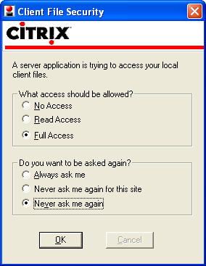 | Allow Full Access to your local files.  Select one of the prompt options available.

Note: If you do not choose “Full Access” initially, you can change this setting by right-clicking the ICA icon in the lower right-hand corner of the Taskbar on your computer screen. Click Open Connection Center. This will bring up the Program Manager Connection Center dialog for Citrix. Click on the File Security button. The ICA File Security dialog will appear. Change the settings as needed and click OK.

JTX Tool Controls
Now that you are ready to start working in JTX, you will need to know how each of the menus and tools work.

JTX Toolbar
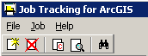

Create New Job
The Create New Job tool opens the Create Job dialog where an Administrator enters information for a new project. Only users in Administrator Groups can create a new job.
Select Job Type, State, and County or Community from the preset list, which appears in dropdown menus.  DFIRM ID is calculated automatically based upon the values selected in the “Describe Location” section of this dialog. | 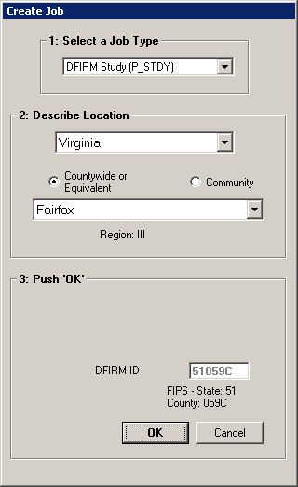 | Job Type:  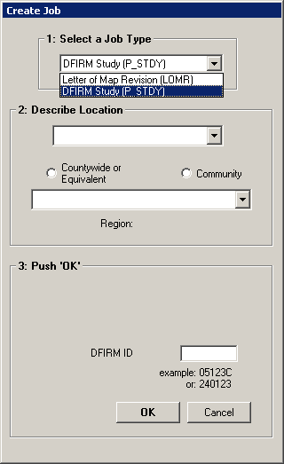  State:  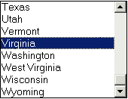  County List:  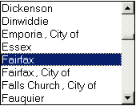  Community List:  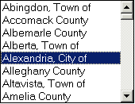
DFIRM Study (P_STDY) Create Job dialog

Select Job Type, State, and County or Community from the preset list, which appears in dropdown menus.  Enter the 8-character FEMA Case Number.  DFIRM ID is calculated automatically based upon the values selected in the “Describe Location” section of this dialog. | 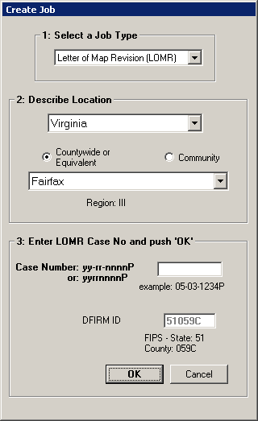 | Job Type:  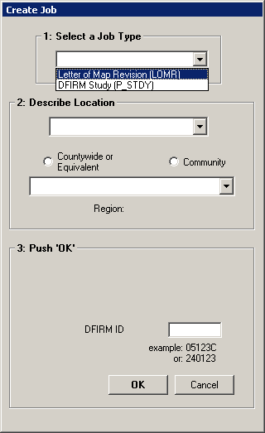  State:  County List:  Community List:
Letter of Map Revision (LOMR) Create Job dialog

Cancel Job
The Cancel Job tool cancels the selected job before it has been assigned.
You may need to cancel a job if the initial creation of a job is in error (i.e., selected wrong job type or location). Also, you can cancel child jobs if too many are created. Only Administrators are able to cancel a job, as they are the only users capable of creating jobs. However, despite privileges, once a job has been assigned it cannot be cancelled.

Create Child Jobs
The Create Child Jobs tool opens the Create Child Jobs dialog when a parent job requiring child jobs is selected.
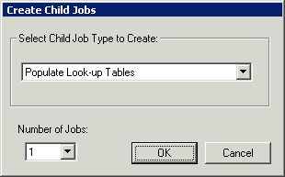
The child job type is already set in the dialog based upon the parent job step.

Note: JTX will only allow you to create 15 child jobs at a time. If you need additional child jobs, simply click on the Create Child Job button for a second time.
Child jobs must be created when a step within the Parent job can be split into multiple smaller jobs and assigned to different users. Whenever the Child Job(s) button is active, an Administrator must create at least one child job. This is a good way to allocate resources. For example, if the job is on the Populate Look-up Tables task and you have two Analysts available, then you can create two child jobs, so that both Analysts can simultaneously populate different look-up tables. This increases efficiency within the task by utilizing your personnel resources to the fullest extent.
Note: Any steps that involve data editing require the creation of at least one child job as a data protection measure.
Parent and child jobs can be identified in the Job Name field in the Jobs Listing Window. Parent jobs will have a _P_ after the DFIRM ID, as seen in the first record; whereas a Child job will have a _C_ after the DFIRM ID, as seen in the second and third records.
Identifies a Parent job (_P_) or Child job (_C_) in the Job Name field.

When a child job is created, it will have its own set of steps that reflect the steps needed to complete that child job. Clicking the Steps tab in the child job will display only the steps required in that particular child job. The first step in all child job is completed automatically when the child job is created (i.e., a version of the data in the parent step is created). Further information regarding JTX workflow steps for either the DFIRM Study or LOMR job types is provided in the Steps Tab section of this user guide.
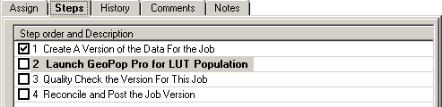
Steps in a child job for the parent step Populate Look-up Tables.

Show Child Jobs
The Show Child Jobs tool displays all open child jobs for the selected parent job.
If you ever need to track your child jobs regardless of whom they are assigned to, highlight the parent job and click the Show Child Jobs button on the JTX toolbar. This will display all of the open child jobs associated with the highlighted parent job. You will be able to see who the jobs are assigned to and when they were created. From this listing, you can highlight any of the child jobs (even those assigned outside of your group) and close the job by going through the steps and marking them finished. You can even highlight a child job and run the current step, if desired.
Note: Reassigning a job should not be attempted without first communicating with the current owner of the job. You risk corrupting the child job and its data, if two users attempt to access the same job at the same time.

Find Job
The Find Job tool allows you to search for a particular job according to certain parameters.
Searches are made within a selected queue; in the example below, the search is being done on ‘My Group Queue’. Searches can be based upon one criteria: Job ID, job name, current step number in the workflow, creation date, person/group to whom a job is assigned (‘Current User’), Region (enter a number 1 through 10), State, County, or Community. To search on multiple criteria, click the Cumulative button.
The results of the Find operation will be returned in the dropdown list at the bottom of the dialog. Select one job or all of them. You will be returned to the JTX interface, and the list of job(s) that you selected from the dropdown will be displayed in the Jobs Listing Window.
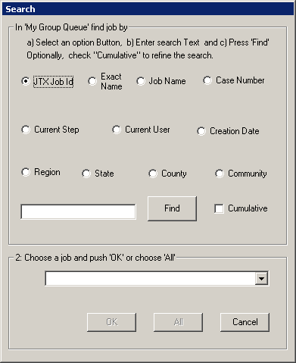 | Select search criteria  A complete or partial text search can be performed.  Dropdown menu provides list of all Job IDs

JTX Menu

File Menu
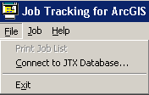

Print Job List
The Print Job List option will always be inactive. This functionality is reserved for JTX Administrators.

Connect to JTX Database…
The Connect to JTX Database… option allows you to set up different server configurations to work on a different geodatabases. Though this menu item is active, the server (GDBSERVER) dedicated to DFIRM Tools data is the only option in the dropdown list.

Exit
The Exit option ends JTX and exits the DFIRM Tools suite.

Job Menu

Create a New Job…
The Create a New Job… option opens the Create Job dialog where an Administrator enters information for a new project. Only users in Administrator Groups can create a new job.

Cancel Job
The Cancel Job option cancels the selected job before it has been assigned.

Kill Job
The Kill Job option deletes a job after it has been assigned. This menu item will always be inactive, as only a JTX Administrator has the ability to kill jobs. If you need to delete an assigned job, contact MIPHelp at MIPHelp@mapmodteam.com or 1-877-FEMA-MAP (option 2).

Create Child Jobs…
The Create Child Jobs… option opens the Create Child Jobs dialog when a parent job requiring child jobs is selected.

Show Child Jobs…
The Show Child Jobs… option displays all open child jobs for the selected parent job.

Find…
The Find… option allows you to search for a particular job according to certain parameters.
Note: All items on the Job Menu, except Kill Job, function the same as previously defined in the JTX Toolbar section of this user guide. Selecting items on the Job Menu is just a different way of navigating to the same operations.

Help Menu
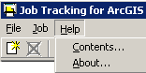

Contacts…
The Contents… option opens the standard JTX help as created by ESRI. The help does not reflect any of the customizations made by the National Service Provider.

About…
The About… option certifies the DFIRM Tools suite as a FEMA product.

Job Query Window
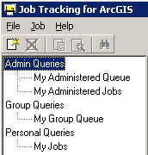 | Within the Job Query window there are three different sets of queries that you can run -  Admin Queries, Group Queries, and Personal Queries.  Note: Analysts will only see the Group Queries and Personal Queries.

Admin Queries
This set of queries enables an Administrator to manage and monitor jobs that are assigned to the users or groups of which he/she is in charge. There are two query options in the Admin Queries – My Administered Queue and My Administered Jobs.

My Administered Queue
This query will display all of the jobs that have been assigned to the Analyst group associated with your Administrator group. For instance, if you are in the NE Administrator [FloodFolks] group, then you would be able to view all of the jobs assigned to the NE Analyst [FloodFolks] group.

My Administered Jobs
This query will display all of the jobs that have been assigned to actual users in the Analyst group associated with your Administrator group. For instance, if you are in the NE Administrator [FloodFolks] group, then you would be able to see all of the jobs assigned to the users (e.g., John Smith, Sally Martin) within the NE Analyst [FloodFolks] group.
Note: Despite your privileges you will not be able to see jobs assigned to other Mapping Partners or other Administrators within your group, even if you are sharing the same job. As an Administrator you are not directly responsible for other Mapping Partners or other Administrators or Administrator Groups within your own Mapping Partner. Thereby, the Admin Queries will not display a job(s) shared amongst these groups/users. To facilitate sharing jobs between other Administrators within your group, assign the job(s) to your group rather than individual Administrators. The job(s) will then always be found in the My Group Queue, and anyone in the group can launch/work in the job(s) assigned to the group. Sharing jobs between other Mapping Partners requires more communication outside of the DFIRM Tools suite. To move a job(s) between Mapping Partners, assign the job(s) to the appropriate Administrator Group within the other Mapping Partner. This job will then disappear from all of your queries but will be visible within the other Mapping Partners My Group Queue. When the other Mapping Partner has completed their work, they should assign the job back to your Administrator Group. The reassigned job will then be displayed in your My Group Queue.

Group Queries
This query shows all jobs that are assigned to the Group to which you belong (e.g., Engineering Analyst [Floodville CTP], NE Administrator [FloodFolks]). Jobs assigned to users in your group will not be displayed in this queue. Both Administrators and Analysts can run Group Queries, and the only query option is My Group Queue.

Personal Queries
This query shows all jobs that are assigned to you. Both Administrators and Analysts can run Personal Queries, and the only query option is My Jobs.

Jobs Listing Window
Regardless of which query section you choose to view, the same job information for all jobs will be displayed in the Jobs Listing Window.

ID
The numeric value in the ID column is the unique identifier for that JTX job. This identifier is called the JTX Job ID. Use the JTX Job ID to reference your job in MIPHelp tickets.

Job Name
The value in the Job Name field is the title of the job, which is assigned automatically when the job is created. The Job Name indicates the DFIRM ID, whether it is a parent job or a child job, what type of job it is, and the FEMA case number (for LOMR jobs only).
Sample Job Name: 200351_P_LOMR:06-07-2143P
200351 is the DFIRM ID. The six-digit number indicates that is it a community-based study, whereas a five-digit number with ‘C’ would indicate a countywide study.
P signifies that it is a parent job; whereas a ‘C’ would signify a child job.
LOMR identifies the job type as being a Letter of Map Revision (LOMR) job; whereas ‘STDY’ would identify the job as being a DFIRM Study job. However, for child jobs, the job type (e.g., LOMR) will change to an abbreviation of the current step in the child job (e.g., PLUT for Populating Look-Up Tables, QRVW for Conduct QC Review using Work Maps).
06-07-2143P is the FEMA case number. The FEMA Case Number is only used for LOMR jobs, and it can also be entered without any dashes (i.e., 06072143P).

S_CJ
The value in the S_CJ (Status of Current Job) column indicates the status of job assignment and how many child jobs are associated with that parent step, if applicable. The value A means the job has been assigned to a specific person; whereas Q means the job has been queued (i.e., it is in a group’s queue). The value C indicates that the job has been completed; this is the status value when a child job has been completed but not yet closed. If the job is a parent job and currently at a step that requires child jobs, then a number will follow A or Q, indicating how many child jobs have been created. For example, A_4 would mean that the parent job has been assigned to a user and four child jobs have been created. As child jobs are completed and closed, the number will decrease (e.g., A_3, A_2). When all child jobs have been closed, the status value will then change to A_4C, indicating that four child jobs were created and closed.
Note: The value in the S_CJ field will be A_0 when an assigned parent job has advanced to a step that requires child jobs, but no child jobs have been created. When steps require child jobs, at least one child job must be created and completed before the parent job can advance in the JTX workflow.

Current Step
The number and text in the Current Step field defines the current step to be completed in the JTX workflow. Child jobs have their own list of steps, and these step numbers and text will reflect the step in the child job’s workflow versus the parent job’s current step.
When all steps have been completed in the child job’s workflow, the value in the Current Step field will be ***Job Complete***. The child job can then be closed, as the parent job cannot advance in the workflow until all associated child jobs are closed; complete child jobs will still prevent the parent job from advancing.

User or Group
The value in the User or Group field identifies to whom the job is assigned. Individual users or groups are valid values for this field. Users will be in lower case, whereas groups will be in all capital letters.

Create Date/Time
The value in the Create Date/Time column identifies the date and timestamp in Eastern Standard Time that the job was initiated. This value is automatically generated when the job is created.

Description
The value in the Description column describes the job’s location and job type (e.g., Jackson, City of, Minnesota: DFIRM Study). The information is created based upon the details that you entered into the Create Job dialog.
Note: Jobs can be sorted in ascending or descending order within a field by clicking on a column heading within the Jobs Listing Windows.

Updates and Views Section
This section is used to assign jobs, show the job steps, show the job history, and add comments or notes to the current job selected in your Jobs Listing Window. When a job is highlighted in the Jobs Listing Window, the description, creator, and current assignment of the job is listed in the Updates and Views section of the JTX interface.
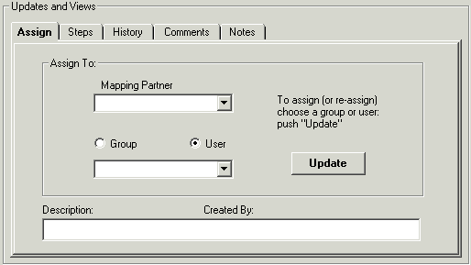

Assign Tab
The Assign tab allows you to assign a job to another User, Group, or Mapping Partner, depending upon your privileges. Administrators will be able to assign jobs to any user or group both within and outside of their own Mapping Partner. Analysts will only be able to assign a job to any user within their group (e.g., Bob Smith) or to their Analyst and Administrator groups (i.e., NE Analyst [FloodFolks], NE Administrator [FloodFolks]).
Groups and Users are sorted by Mapping Partner.

The Mapping Partner dropdown list displays all of the registered Mapping Partners for DFIRM Tools usage. The Mapping Partner selected will affect which users and groups are populated in the second dropdown list. However, the Mapping Partner dropdown menu will be inactive for Analysts, as they cannot assign jobs to other Mapping Partners.
Click either the Group or User radio button to indicate which category should be populated in the dropdown list. Select the user or group from the dropdown list for the job assignment. Click the Update button to apply the selection to the job. There is no limit to how many times a job can be reassigned, even within the same task.
Note: When a new parent or child job is created and assigned to a user/group, a version of the data will be created. However, assigning an existing job from one user/group to another will not result in the creation of a new version.

Steps Tab
The Steps tab displays a list of all of the required steps for your job. The job types DFIRM Study and LOMR each have different required steps, though the same tools in the DFIRM Tools suite are used to complete both JTX workflows.
Check marks are used to identify completed steps.

The highlighted task is the current step in the JTX workflow.

All of the other steps after the current step need to be completed.

The current step in the JTX workflow is highlighted in the Step Order and Description list. As steps are marked finished, the step is automatically checked as being completed. The step list for a parent job will not display the steps required in the child jobs. All steps in the child job must be checked as being completed before the child job can be closed. The associated parent step cannot be checked until all of the created child jobs are closed.
The Steps tab is a view of the steps, and it is not directly interactive. You cannot click on the step to which you want to advance. You must advance through the workflow by marking steps finished or unchecking previous steps to backtrack in the workflow.
Note: Steps must be completed in a linear fashion. In other words, step 3 cannot be completed before step 2 is completed which cannot be started before step 1. Therefore, you cannot have one Analyst digitizing the Eastern portion of your study, while another Analyst creates Work Maps for the Western portion of your study which has already been digitized. The steps build upon each other to ensure a streamlined DFIRM creation process.

History Tab
The History tab displays all of the user interaction in JTX with a job. Each time any user interacts with a job, the timestamp, username, step number, and description of the user’s action are automatically recorded in the job’s history.
The History tab is a view of the recorded JTX action history, and it is not directly interactive. That is to say, you cannot manually enter any information into the history. Also, user interaction outside of JTX (i.e., ArcMap) is not recorded in the history. For example, the History tab will show when and who launched ArcMap for step 4 (Build Corporate Limits). However, it will not record what features that user created and/or edited in ArcMap.
The JTX actions performed within a child job are not recorded in the associated parent job’s history. Creating child jobs is the first action taken for any parent job requiring child jobs, therefore, the parent job’s history will only indicate when and which child job was closed. You will need to click the Show Child Jobs button to find all associated child jobs.
Excerpt from a child job’s history

The child job history will indicated with which parent job it is associated. Once the child job has been closed, the history information for the child job is no longer accessible.

Comments Tab
The Comments tab enables you to add any additional permanent information that is not automatically captured in the job’s history. Also, information that is time-sensitive should be recorded under the Comments tab, as the timestamp and username of the submitter will be documented. Comment information is accessible for the duration of the job.
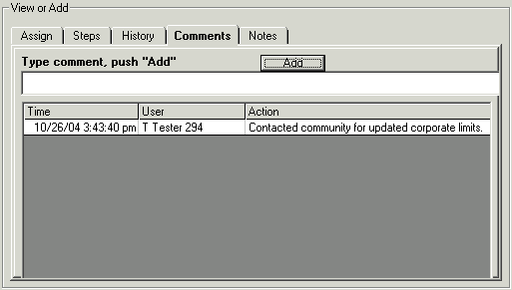
Type the comment into the text box, and click the Add button to commit the information. Comments cannot be deleted once they have been added; they survive the lifetime of the job. Essentially, think of the Comments tab as a message board, whereas the Notes tab can be equated to a dry erase board.
The comments added within a child job are not recorded in the associated parent job’s comments. Once the child job has been closed, the comment information for the child job is no longer accessible.

Notes Tab
The Notes tab enables you to post any general comments to the job. Time-sensitive information should not be recorded under the Notes tab, as timestamp and username details are not documented.
Type the note into the text box, and click the Update button to commit the information. Notes are always editable, regardless of who entered the note. The Notes tab is a good place for entering information when a job is going to be assigned to another user, especially mid-task. After the note is no longer useful, it can be deleted (e.g., “Going on vacation for 2 weeks, please create and manage 4 child jobs to digitize/attribute features.”). Essentially, think of the Notes tab as a dry erase board, whereas the Comments tab is similar to a message board.
The notes added within a child job are not recorded in the associated parent job’s notes. Once the child job has been closed, the note information for the child job is no longer accessible.

Step Actions Section
The Step Actions section allows you to launch ArcMap for the current executable step or move forward and backwards in the JTX workflow. Within this section, the current step of the project, warnings, and the job status (step and child job information) are displayed.
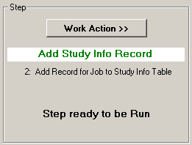 | The Work Action >> button opens the Work Action menu.  Description and status of current step. Green steps will launch ArcMap.  Prompts to run a step or perform another action. Warnings will be issued, if necessary (e.g., Job has not been assigned). | 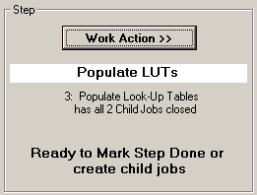
Examples of the Step Actions section
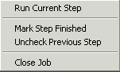
Work Action menu prompted by the Work Action >> button.

Run Current Step
The Run Current Step option launches ArcMap to work on the current step of the job. The ArcMap session will be customized with the appropriate toolbars and DFIRM feature classes required to complete the step. However, you will be able to add toolbars, additional DFIRM layers, and reference data in every ArcMap session, regardless of the step.
If the step is a parent step associated with child jobs or a procedural step, then Run Current Step will not be active. Parent jobs require the creation of a child job(s), and therefore, ArcMap is not employed by the parent job. The option though will be active in the child job steps for all executable parent steps. Procedural steps require work to be completed outside of the DFIRM Tools suite (e.g., Mail Preliminary Package); obviously, ArcMap will not be launched for these steps.

Mark Step Finished
The Mark Step Finished option marks steps as being completed, thereby, allows you to advance to the next step in the JTX workflow. Executable steps will not advance automatically in the workflow when the ArcMap session is closed, since you may need to continue the work at a later time. Therefore, you will have to click on Mark Step Finished to designate the step as being complete. Additionally, the work for procedural steps is done outside of the DFIRM Tools suite (i.e., ArcMap), and again, you will have to manually identify when the step has been accomplished.

Uncheck Previous Step
The Uncheck Previous Step option returns to the previous step in the workflow, unchecking the completed step. Steps that involve data/map production and Engineering/QC review can be cyclic, and thereby, the workflow might have to be backtracked if errors are identified. For instance, it may be necessary to uncheck previous step(s) if Engineering discovers a problem during the Work Map Review step (i.e., Step 9 in the P_STDY workflow) that Mapping must return to and remedy (i.e., Step 6). You can uncheck all of the steps after Step 1 (Create Version of the Data for the Job), and you are not limited as to how many steps you can backtrack in one sitting.
Note: In child jobs, once the last step has been marked as complete by an Analyst, you are unable to uncheck the step. Be sure to mark the last step of every child job complete with care.

Note: The JTX workflow is simply a workflow of chronological steps to complete a process. It does not control nor change your actual data. When you save your data edits in ArcMap, you are committing them to the database; stepping back in steps does not change the fact that you have saved your data. However, keep in mind that the linear workflow has been designed to make sure that certain tasks are completed first, so other steps work smoothly and without errors (e.g., attribute/batch validate feature values prior to annotating features).

Close Job
The Close Job option closes and deletes a child job when all steps in the child job’s workflow have been completed. The option Close Job will not be activated until all steps in the workflow have been checked.
Note: You will not be able to close parent jobs. At Step 42 in the P_STDY workflow and Step 23 in the LOMR workflow, the job will automatically be reassigned to the JTX Administrator’s group. At this time, your versioned database will be reconciled and posted with master SDE database, and then your job will be closed by the JTX Administrator.

Create Job Section
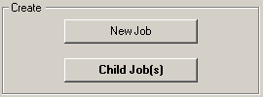

New Job
The New Job button opens the Create Job dialog where an Administrator enters information for a new project. Only users in Administrator Groups can create a new job.

Child Job(s)
The Child Job(s) button opens the Create Child Jobs dialog when a parent job requiring child jobs is selected.

Reconcile and Post
All child jobs that involve editing work have a JTX workflow step called “Reconcile and Post the Job Version”. This is a critical step to run, if edits have been made to the data in a child job. All of the edits will be lost if this step is marked completed without actually having executed the step.
Within ArcMap child job versions are reconciled with the parent to ensure that no conflicts in the data exist. Conflicts could develop if two users are editing the same features for the same feature class in the same area (e.g., the same flood hazard area feature is attributed with different zones by two different users). The second user that reconciles with the parent job will have to choose which of the features in conflict he/she wish to keep.
When all conflicts have been resolved, the child job version of the data is then posted back to the parent job version of the data within ArcMap. Once the edits are posted to the parent, the child job can be closed, as the edits are now retained in the parent job. Additionally, as child jobs are posted to the parent job, the open child jobs will be able to see the closed child jobs’ edits in their child job version by reconciling with the parent job within ArcMap. This will pull all of the changes in the parent job down into the reconciled child job.
Note: If you reconcile and post your data and then backtrack in the child job’s workflow for additional editing, you will have to reconcile and post any new edits to the parent job again. There is no limit to the amount of times that a child job can be reconciled and posted to the parent job.

Example of the Reconcile and Post step in the “Populate Look-up Tables” child job. | Example of the Reconcile and Post step in the “Edit Panel Annotation” child job.

- Run the “Reconcile and Post the Job Version” step in the child job workflow. This will launch ArcMap.
- Start an editing session (i.e., Editor Toolbar > Editor > Start Editing).
- Use the ESRI Versioning Toolbar to reconcile and post the child job data to the parent job version of the data.
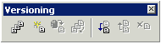
Note: Excluding the Reconcile and Post buttons, all other buttons on the ESRI Versioning toolbar have been disabled.
- Click the Reconcile button .
- The following dialog appears to confirm that you want to reconcile the child job with the parent job. Click the Yes button to confirm reconciling the data, or click the No button to exit the reconciling process.
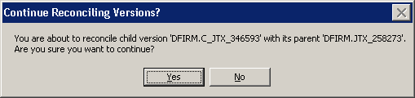
- Once the edits have been reconciled with the parent version, the Post button will activate and the mouse-over will change to “Post to DFIRM.JTX_<JTX JOB ID>”. Click the Post button to commit the child job edits to the parent job.
Note: The Post button will not be active until the data has been reconciled with the parent job. This ensures that all data conflicts between that child job and the parent job are resolved before posting the new edits to the parent job.
- Stop the editing session (i.e., Editor Toolbar > Editor > Stop Editing).
- Exit ArcMap and do not save changes to the .mxd.
- When JTX reappears, click on the Work Action >> button, and select Mark Step Finished.
- Close the child job by clicking the Work Action >> button, and selecting Close Job. ClickYes to confirm closing the child job, or click No to cancel the process.
Note: After posting your child job and before closing it, consider creating a new child job from the posted parent to verify that all child job edits have been posted successfully. If it seems that your edits have not been posted correctly, repost your child job. Only after all edits have been verified in your new child job should you close your previous child job. Once a child job has been closed, it cannot be recovered. All of your edits will be lost if the child was not posted and reconciled before it was closed. MIPHelp will not be able recover this edited data.

Note: Multiple users should never reconcile and post different child jobs at the same time. This process should always be sequential.

Note: For additional information regarding Reconcile and Post functionality, please refer to ESRI’s support documentation, including Editing a Version, Editing and Conflict Resolution, Versioning Scenarios, Reconcile Version (Data Management), and Post Version (Data Management).

PLTS Symbology and QA Toolbar
The PLTS Symbology and QA toolbar enables visual display and assessment of feature classes. The primary function for this toolbar though is to render the DFIRM feature classes with predefined symbols. The Render using VVT Symbology button is the only DFIRM-customized function on this toolbar.
The toolbar is available within ArcMap, and it will be automatically loaded at each executable step when appropriate. Otherwise, it can be manually added in ArcMap by clicking View menu > Toolbars > PLTS Symbology and QA.

Render using VVT Symbology
The Render using VVT Symbology tool renders all of the loaded DFIRM data according the specifications in Appendix K, based upon the DFIRM type (i.e., vector, raster) or step of DFIRM production on which you are working. This symbology is dictated by the customized Valid Value Tables (VVTs), and valid attribute combinations for each feature can be verified by running Batch Validate on the GIS Data ReViewer toolbar. Refer to GIS Data ReViewer User Guide, FEMA DFIRM Production Tools for further details as to how to use Batch Validate.
There are slightly different symbols for vector-based DFIRMs, raster-based DFIRMs, and Index Maps; therefore, there is a customized style to accommodate each type of map. Additionally, there is a colorful symbol set for Workmaps to help easily distinguish between features when digitizing, attributing, and/or QCing.
Note: Features that are displayed as bright pink indicate that the necessary attribute fields do not have a valid combination of values required for symbology. Essentially, the feature has been attributed incorrectly (e.g., NULL versus NSPNULL). On the other hand, a feature that is displayed as bright purple indicates that the feature has not been entirely attributed. A required field(s) has not been populated. Resolve the attribute error(s), and rerun the Render using VVT Symbology tool to verify that all bright pink and/or purple symbology has disappeared.

Note: When using the Render using VVT Symbology tool, the symbology is rendered for all data, existing in the job version, which is within the data view extents. Therefore, if there is effective data within the data frame, despite whether or not it is visible, the data features will be symbolized. You can display neighboring effective data using the Show DFIRM Adjacent Data button on the DFIRM Layer Loader toolbar. If you see a QC error in the Table of Contents, run the VVT validation checks in Batch Validate to verify whether or not the error(s) is in your dataset. Remember, you are only to edit your dataset, not the neighboring datasets, despite any errors you may find in the neighboring effective data.

PLTS Dangle and Pseudo Renderer
The PLTS Dangle and Pseudo Renderer tool renders line feature classes to show dangle, pseudo, and regular nodes. You will be able to select which layers and which node types you want to render. The tool will create a group layer named ‘NODES’. New feature layers that identify the dangles, pseudonodes, and/or nodes will be placed in that group layer. This tool has no DFIRM customizations.

Default Render
The Default Render tool has been disabled, as it assigns every feature class one random distinct symbol.

Set Polygon Transparency Percentage
The Set Polygon Transparency Percentage tool enables you to set the same transparency on all polygon features. This tool will not let you differentiate between polygon feature classes, rather assignment of individual transparency values must be done through each layer’s properties. This tool has no DFIRM customizations.

Note: If you manually change any feature’s symbology through the Layer Properties dialog, you will have to rerun the Render using VVT Symbology tool to reset the symbology to be Appendix K: Format and Specification for Flood Insurance Rate Maps compliant.

DFIRM Layer Loader Toolbar
The tools on the DFIRM Layer Loader Toolbar allow you to add data to the current ArcMap session that is not added automatically as part of the standard DFIRM layers for a particular step. Such data may include, but are not limited to, raster catalogs of DOQs/Quads, contour lines, effective panel layout schemes, Appendix L non-compliant data, and any of the enhanced SDE feature classes.
 | DFIRM Layer Data Loader | Adds additional layers and/or look-up tables from the SDE geodatabase
 | DFIRM Reference Data Loader | Adds reference data to the map view
 | Show DFIRM Adjacent Area | View adjacent effective DFIRMs
 | Show Only DFIRM Area | Remove view of adjacent effective DFIRMs
 | Zoom to DFIRM ID | Zooms to the extents of the DFIRM
 | Suspend Drawing | Pauses the data drawing process

DFIRM Layer Data Loader
The DFIRM Layer Data Loader tool adds feature classes and/or look-up tables from the SDE geodatabase. Additionally, all topology rules are added into the ArcMap session when the tool is launched and the OK button is clicked, even if no additional feature classes and/or look-up tables are selected to be added.
The Available data layers: list displays all feature classes and look-up tables in the SDE geodatabase that can be added to the ArcMap session. A feature class or table does not have to contain records for the current DFIRM in order to appear in the list (e.g., Coastal Transect), all feature classes and look-up tables in the SDE geodatabase are available to add. Highlight the feature class(es) and/or look-up table(s) from the Available data layers: list, and use the Forward Arrow button to transfer your selection into the To-be-loaded data layers: list. The Add Standard Layers button will automatically move all of the features classes that are in a Standard DFIRM database, as dictated by Appendix L: Guidance for Preparing Draft Digital Data and DFIRM Database, to the To-be-loaded data layers: list. If you decide not to add a feature class or look-up table, highlight the item and use the Backwards Arrow button to remove it from the To-be-loaded data layers list. Click OK to add all of the items in the To-be-loaded data layers: list into the ArcMap session.
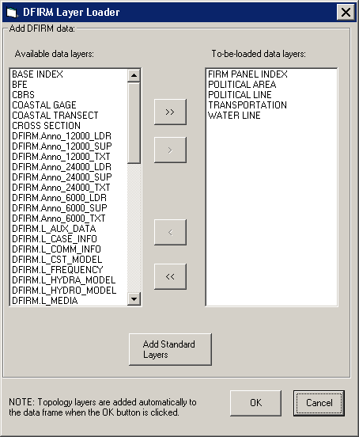

DFIRM Reference Data Loader
The DFIRM Reference Data Loader tool adds data not residing in the SDE geodatabase to be used for reference. This reference data includes, but is not limited to, raster catalogs (DOQs or USGS Quads), topographic maps, non-Appendix L compliant shapefiles, and effective DFIRM maps.
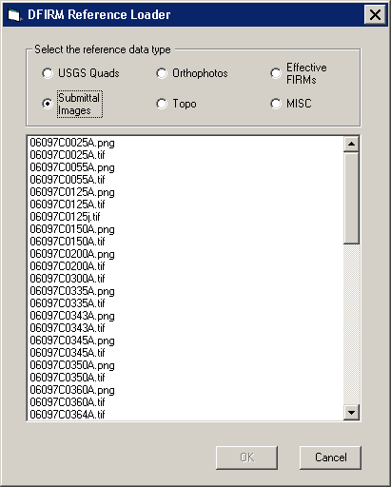

Each radio button accesses a different folder in the directory. The following list maps the directory path for each radio button, so you will know to which folders to upload your reference data.
Radio Button | Folder Path
USGS Quads | J:\<region>\<state>\<county>\<community/county>\<Case #>\Mapping\Raster\Quad
Submittal Images | K:\<region>\<state>\<county>\<community/county>\<Case #>\Mapping\Final_DFIRM_DB\ RFIRM
Orthophotos | J:\<region>\<state>\<county>\<community/county>\Ortho
Topo | J:\<region>\<state>\<county>\<community/county>\<Case #>\Mapping\Topo
Effective FIRMs | J:\<region>\<state>\<county>\<community/county>\<Case #>\Mapping\Raster\EF_FIRMS
MISC | J:\<region>\<state>\<county>\<community/county>\<Case #>\Mapping\Misc

USGS Quad | Submittal  Images | Orthophotos | Topo | Effective FIRMs | MISC
TIFF (*.tif) | ●* | ● | ●* |  | ● | ●
MrSID (*.sid) | ●* |  | ●* |  |  | ●
JPEG (*.jpg) | ●* |  | ●* |  |  | ●
ESRI BIL (*.bil) | ●* |  | ●* |  |  | ●
Windows Bitmap (*.bmp) |  |  |  |  |  | ●
PNG (*.png) |  | ●† |  |  | ●† | ●†
CAD (*.dgn) |  |  |  | ● |  | ●
DBF (*.dbf) | ●* |  | ●* | ● |  | ●
PGDB (feature classes & tables) (*.gdb) |  |  |  | ● |  | ●
ESRI Coverages (spatial & tabular) (<coverage>) |  |  |  | ● |  | ●
Shapefile (*.shp) |  |  |  | ● |  | ●

Reference data file formats which can be accessed via each radio button
* Accesses an image catalog(s) created from USGS Quads or Orthophotos
† Due to ArcMap 8.3 software limitations, only files with 300 dpi or less are readable

Select the radio button for the appropriate data type (e.g., USGS Quads, Effective FIRMs). All data files in accessible format which are stored in the associated folder will be listed in the dialog window. Highlight one or more reference files, and click OK.
If you select the Topo or MISC radio button, then one of the following dialogs will appear.
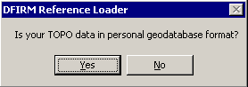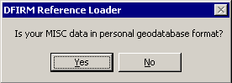
Click No to display all data files in the relevant folder that are not in a personal geodatabase. ClickYes to change the dialog to enable selection of a personal geodatabase in the associated folder and then to load a data layer(s) stored within the personal geodatabase.
Note: If you erroneously click the No button when you meant to choose the Yes button (or vice versa), right-click on the radio button, and the personal geodatabase dialog will reappear.
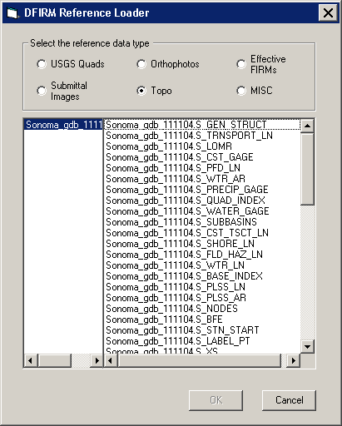
Dialog for personal geodatabases in the Topo or MISC folder

The USGS Quad and the Orthophotos radio buttons only access the image catalog(s) created for the image files stored in the respective folders. The preferred image file formats to create image catalogs are TIFF (.tif), MrSID (.sid), and PNG (.png). To create an image catalog, use the Create Image Catalog tool on the GeoPop Pro dropdown menu. Refer to GeoPop Pro User Guide, FEMA DFIRM Production Tools for detailed instructions on using the Create Image Catalog tool.

Note: The DFIRM Data Layer Loader and the DFIRM Reference Data Loader are the only means to add data into your ArcMap session. The ESRI tool Add Data has been disabled, as this is not the correct way to access the Citrix directory structure and/or the SDE geodatabase.

Show DFIRM Adjacent Area
The Show DFIRM Adjacent Area tool shows effective DFIRM/DEFAULT data loaded into the SDE geodatabase, which is adjacent to your study area. Only effective data that has been loaded into DEFAULT will appear when the Show DFIRM Adjacent Area button is clicked.
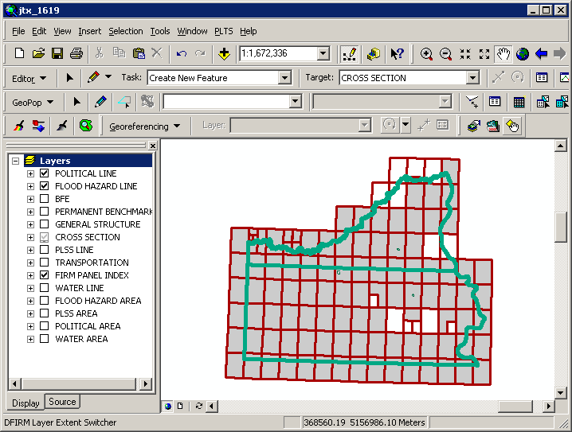
The northern political area is the actual study area, whereas the southern political area is the adjacent effective DFIRM area.

Note: You should not attempt to edit any data in an adjacent area to your study; the data is effective and is only being shown for your reference.
Once the Show DFIRM Adjacent Area button has been selected, its icon will change to that of the Show Only DFIRM Area tool.

Show Only DFIRM Area
The Show Only DFIRM Area tool removes the reference display of effective DFIRM/DEFAULT data loaded into the SDE geodatabase, which is adjacent to your study area.
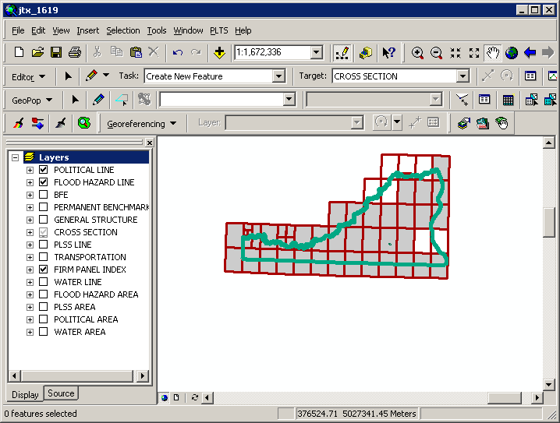
The adjacent effective DFIRM data, south of the actual study, is no longer displayed.

Once the Show Only DFIRM Area button has been selected, the reference data for the adjacent area(s) will no longer be displayed, and the button’s icon will change to that of the Show DFIRM Adjacent Area tool.

Zoom to DFIRM ID
The Zoom to DFIRM ID tool replaces the functionality in ArcMap that allows you to zoom to a layer or to the dataset’s full extent. Without disabling these functions, you would zoom to the extent of the entire SDE geodatabase (Continental US and its territories) as opposed to the extent of your DFIRM study. If the FIRM Panel Index (S_FIRM_Pan) layer is loaded into the ArcMap session and it is populated, the tool will zoom to the extent of this layer. If the FIRM Panel Index layer is not loaded or not populated, then the tool zooms to the extent of the Political Line (S_Pol_Ln) layer. If neither of these data layers is loaded or populated in your ArcMap session, you will be prompted to select a data layer.
Select a data layer loaded into your Table of Contents on which to zoom.

Suspend Drawing
The Suspend Drawing tool temporarily “freezes” and “unfreezes” the process of displaying data in a session. This ESRI tool allows you to perform several functions in a sequence without having to wait for a lengthy drawing of all the map layers (both feature classes and raster images). Discretionary use of the Suspend Drawing tool will save considerable time during the annotation process, because the layers will not have to redraw after every single step, such as selecting a label, duplicating a label, stacking a label, making a label horizontal, etc.
- Start an editing session (i.e., Editor Toolbar > Editor > Start Editing).
- Make selectable only the DFIRM.Anno_<your scale>_TXT layer and DFIRM.Anno_<your scale>_LDR layer (i.e., Standard Toolbar > Selection menu > Set Selectable Layers).
Note: The leader lines need to be selectable only if you are moving your annotation and leader line features together to a new location. Do not attempt to resize your leader line features, rather delete them and recreate them.

- Allow ArcMap to completely draw all the features, raster images, and labels in your extent.
- Click the Suspend Drawing button . The icon will change when the data drawing has been suspended .
- Select the desired annotation features, using the Edit tool on the Editor toolbar. Exercise caution when selecting multiple annotation features in crowded areas, so as to select only those labels that you want.
Note: Multiple labels may be selected simultaneously, but they will keep the same relative distances from each other when they are moved to a new location.

When selecting labels, the regular cyan selection boxes will not be displayed. Instead, you will use gray outline boxes and crosshairs to drag and drop the labels.
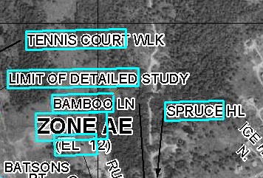 | 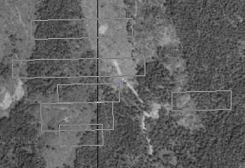
Normal selection for annotation features | Selection for annotation features when Suspend Drawing is engaged.
Note: Do not pan or zoom while the Suspend Drawing tool is active (i.e., icon displays a red X), this will result in a blank screen. If you need to pan or zoom, uncheck the Suspend Drawing tool (i.e., the icon display as a paintbrush without the red X), refresh, and start the procedure again.

- Drag the selected label(s) using the gray outline boxes and the crosshairs as guides, and drop the annotation features where desired.
Note: The changes that you make to the annotation or other features will not be seen on the map until the Suspend Drawing tool is deactivated and the map refreshes. Several different functions (e.g., Stack Labels, Make Labels Horizontal, Suppress Labels) can be executed sequentially on one individual label at a time before deactivating the tool.
- Click the Suspend Drawing button when you are finished with your edits. The icon will change back to be just the paintbrush (i.e., the red X will disappear) .
- Refresh your ArcMap session if necessary in order to see the new placement of all the labels.

Troubleshooting

Problem: The following error message appears when I try to uncheck the previous step.
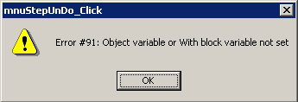
Solution: You cannot uncheck a step at which a version is created (i.e., Step 1). If you are working in a child job and want to go back to the previous parent step, you must mark all of the steps in the child job complete and close the child job. Once you are back in a parent job, you can uncheck the previous step(s) until you are at the step you need to be.

Problem: The following message appears when I try to find a job by the Job ID.
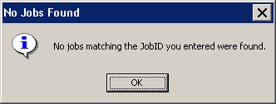
Solution: If a job cannot be found, then either you typed an incorrect Job ID or the job has been closed. Once any job, parent or child, has been closed, it will no longer be available in JTX and you will not be able to find it in the Jobs Listing Window.

Problem: I would like multiple users to work simultaneously on a single job. I’ve assigned the job to the group, but still JTX only allows one user to work on the job at time.
Solution: Assigning a job to a group, simply allows anyone within that group to see and assign the job to themselves. This type of assignment will not allow everyone in the group to work on the step at the same time. For every one job (parent or child) only one person can be working on it at a time.

Problem: How do I keep ArcMap open while I create more child jobs in JTX?
Solution: Due to ESRI software limitations, JTX and ArcMap cannot be open at the same time. JTX will close once ArcMap is launched, and ArcMap must be closed before JTX reopens. As a Group Administrator, try to anticipate your Analysts’ needs. For instance, you are an Administrator, and you have two Analysts working on editing annotation in child jobs. To avoid disrupting your work within the ArcMap session, at the beginning of the task you create four child jobs. Assign one child job directly to each of your two Analysts, and assign the other two child jobs to the Analyst group queue. When an Analyst needs a new child job to continue working, he/she can retrieve one of the child jobs from the Analyst group queue and assign it to himself/herself. In this way, the Analyst may continue to work, and the Administrator’s work is not interrupted.

Problem: When ArcMap opens, I see a warning message similar to this.
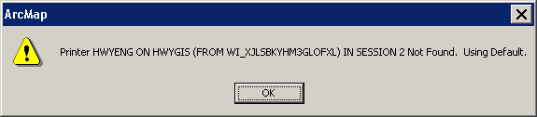
Solution: This is a warning message alerting you that the previous default printer cannot be found. Therefore, ArcMap will save the information regarding your default printer. Anytime ArcMap opens, it will look for the printer information, which it has retained, from the previous user. However, since you cannot print directly from Citrix/JTX, simply click OK and continue working as normal.

Problem: My parent job will not advance to the next step in the JTX workflow.

Solution: Parent jobs will not be able to advance in the JTX workflow until all child jobs have been closed. Highlight the parent job in the Jobs Listing Window. If the parent job has a numeric value without a ‘C’ (e.g., A_2) in the S_CJ field, then there are still open child jobs. Click the Show Child Jobs button. The open child jobs associated with the parent job will be displayed in the Jobs Listing Window. Close all the remaining child jobs, after completing any necessary editing. Once all of the child jobs have been closed, the value in the S_CJ field should end with ‘C’ (e.g., A_2C), indicating that all of the created child jobs have been closed. You should now be able to advance the parent job to the next step in the JTX workflow.

Problem: I erroneously created and assigned too many child jobs. Is there a way to close all of the extra child jobs at once?

Solution: There is no shortcut to closing child jobs. You will have to step-through each of their workflows, meaning that you will have to mark each step finished in each of the child jobs separately.

Problem: After reconciling my child job with the parent job, I did not resolve all of my conflicts before I saved my edits and closed ArcMap. The next time I opened my child job and reconciled, I received no conflict errors.

Solution: If data conflicts occur after reconciling your child job with the parent job, you must resolve all conflicts before saving edits in your child job’s editing session. If you save your edits without addressing all of the conflicts, you are tacitly accepting that all unresolved conflicts should appear as they do in the parent job. If you cannot assess all conflicts in a single editing session at that moment, you can undo your reconcile process by stopping your editing session without saving edits.

Problem: The following message appears when I try to Mark Step Finished for step 41 in the DFIRM Study workflow or for step 22 in the LOMR workflow.
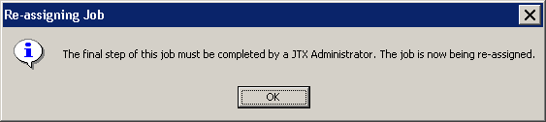

Solution: Step 42 in the DFIRM Study and step 23 in the LOMR workflow must be completed by a JTX Administrator. In these steps the effective study or LOMR is reconciled and posted to DEFAULT in the SDE database. Therefore, since these steps require SDE maintenance, a JTX Administrator will complete the final step before closing the job.

Problem: I have a Flood Hazard Line (S_FLD_HAZ_LN) feature that represents both a ‘Limit of Detailed Study’ and a ‘Zone Break’, how should I attribute the Flood Line Type, so that the feature is symbolized correctly?

Solution: A Flood Hazard line feature should be attributed with the field Line Type equal to ‘Limit of Detailed Study’ and the field Gutter equal to ‘T’. The line should be symbolized as a white line on a raster-based map. The line feature will be symbolized correctly, based upon the combination of the values in the fields Line Type and Gutter, once the Render using VVT Symbology tool is run.
Contacts
If you need assistance with this tool, please contact the representative at your local RMC.

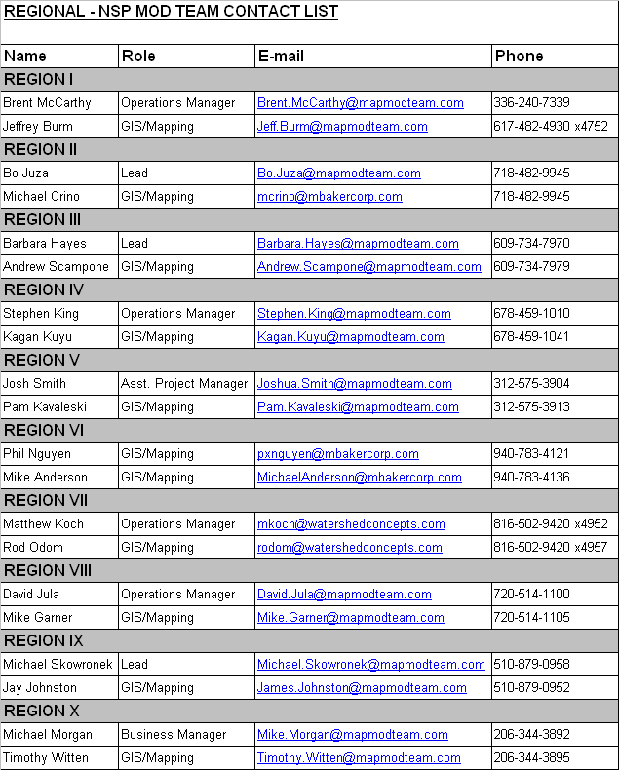

Appendix A – DFIRM Study Detailed Step Descriptions
[E] indicates an executable step, and [P] indicates a procedural step.

- Create a version of the data for the job: [P] This step will be performed automatically when a job is created in JTX and assigned to a user. A version is created to maintain data integrity.
- Add Record to Study_Info Table: [E] This step allows the user to create or edit the Study_Info record for their project using GeoPop Pro. This table contains details about the study, including study name, datum and projection information. There will only be one Study_Info record per study. Populating this information is critical, as subsequent tools depend on this information.
- Populate Look-Up Tables: [E] This step allows users to populate all required look-up tables using GeoPop Pro, thus assisting with database production. Although there are many look-up tables, the most commonly used tables are Community Info (L_Comm_Info) which contains community specific map repository and map history information, Station Start (L_Stn_Start) which contains information about the station starting locations defined on the profiles, Source Citation (L_Source_Cit) which contains metadata information, and Water Names (L_Wtr_Nm) which contains a list of all water feature names. Determining which tables need to be populated will depend on the study. Child jobs are created in the step to allow for further versioning control and to assign this task to multiple users. At this step users will also have the opportunity to use GIS Data ReViewer to validate the information they have entered.
- Build Corporate Limits: [E] This step allows users to create corporate limits features using GeoPop Pro. These boundaries may be provided by communities in some instances; however, there will be situations where corporate limits will need to be captured off of effective maps or USGS Quads. Users will start by capturing the line features; area features can be created from these line features. The user will be required to populate both the line and area features with important attribute information, such as line type and community name and number. It is important that the political boundaries are established and attributed early in the job, as subsequent tools (Panel Index Generator for example) will depend on these features.
- Create the FIRM Panel Index Feature Class: [E] This step will allow the user to create a 24000-meter scale panel layout for their study using the Panel Index Generator feature of GeoPop Pro. Once the initial layout is created, the user will be able to edit the features to create 12000- and 6000-meter scale panels, using Panel Divider and Panel Merger. As the user edits the panels, the panel number and scale are calculated automatically, as are the corner coordinates. This feature is a huge time saver – previously it could take an analyst a day to complete the panel index, now it can be done in half an hour. The user must complete the population of the features with the GeoPop Pro attribute tools.
- Build/Edit DFIRM Database: [E] This step allows users to populate their database with all of the required features and attributes using GeoPop Pro. This step has the potential to be the most time consuming, depending on the number of features that a user is required to capture off georeferenced effective maps. As the user creates features, he is prompted with attribution dialog boxes, which make the attribution of the database much more user friendly. These boxes identify which attribute fields are required, which fields are part of the enhanced database, and offers guidance to assist the users with attribution. Child jobs are created in the step to allow for further versioning control, and to assign this task to multiple users. At this step users will also have the opportunity to use GIS Data ReViewer to validate the information they have created/entered.
- Create/Edit Work Maps: [E] This step allows the user to create work maps using Work Map Pro. Work maps help the user to visually check database population. Child jobs are created in the step to allow for further versioning control and to assign this task to multiple users. Users will also have the option to download the work maps to their local hard drive using the PDF Export Tool. Once the work maps have been downloaded, the user can print the work maps for review.
- Conduct Engineering Review using Work Maps: [E] This step allows engineering staff to review work maps created by Work Map Pro. Users will be able to make comments on the digital work maps using GIS Data ReViewer. Child jobs are created in the step to allow for further versioning control and to assign this task to multiple users.
- Conduct QC Review: [E] This step allows quality control staff to review work maps created by Work Map Pro. Users will be able to make comments on the digital work maps using GIS Data ReViewer. Child jobs are created in the step to allow for further versioning control and to assign this task to multiple users.
- Submit DRAFT DFIRM Database to MIP: [E] This step allows users to prepare and submit their DRAFT DFIRM Database to the MIP using the Submit Draft Data option of the Database Exporter Tool. At this step the user will also be able to create the metadata file using the DFIRM Metadata Builder. Upon submission to the MIP, the data will also be automatically reviewed for Appendix L compliance.
- Begin Preliminary Mapping: [E] This step allows users to generate annotation for their DFIRM, using Label Panel. The user will be prompted to select the panel(s) for which they want to generate annotation. If multiple panels are selected, the panels will be annotated in a batch process. This auto generation is completely dependent on the attribute values that the user has populated for each layer. Any incorrect labels are an indication of an incorrect attribute in the database. To amend a wrong attribute, the user should use GeoPop Pro to correctly populate the feature. The annotation is stored in a set of scale dependent feature classes. Depending on the complexity of the panels, this may be a step that the user will run overnight.
- Edit Panel Annotation: [E] This step allows the user to generate a map panel using Map Production Pro. Once the map panel is created, the user may edit the automatically generated annotation using Label-Edit, and add any missing elements using DFIRM Annotation Tool. Missing elements may include road shields, graphic gutters and special notes that appear on a map that are not attribute driven. Child jobs are created in the step to allow for further versioning control and to assign this task to multiple users.
- Conduct QC Review: [E] This step allows quality control staff to review checkprints with annotation created by Map Production Pro. Users will be able to make comments on the digital panels using GIS Data ReViewer. Child jobs are created in the step to allow for further versioning control and to assign this task to multiple users.
- Conduct Engineering Review Using Checkprints: [E] This step allows engineering staff to review checkprints with annotation created by Map Production Pro. Users will be able to make comments on the digital panels using GIS Data ReViewer. Engineers will also have the opportunity to address any issue identified by the quality control staff. Child jobs are created in the step to allow for further versioning control and to assign this task to multiple users.
- QC Review Engineering Comments: [E] This step allows the quality control staff to review the comments made by the engineering staff, using Map production Pro and GIS Data ReViewer. Child jobs are created in the step to allow for further versioning control and to assign this task to multiple users.
- Perform Corrections to Checkprints: [E] This step allows the GIS analysts to make necessary changes to the database, as outlined by engineering and QC comments. Depending on the nature of the comments, this could involve using GeoPop (attribution or feature changes), Label Panel (to regenerate annotation after feature/attribute changes), Label-Edit and DFIRM Annotation Tool (to edit newly generated annotation). Child jobs are created in the step to allow for further versioning control and to assign this task to multiple users.
- Create Preliminary Maps: [E] This step allows the user to create preliminary FIRM panels using Map Production Pro. This tool ensures that the map panels are in compliance with Appendix K of the Guidelines and Specifications. These map panels can be exported to PDFs, which can be downloaded to the user’s local hard drive, using the PDF Export tool. Child jobs are created in the step to allow for further versioning control and to assign this task to multiple users.
- Create Preliminary Index: [E] This step allows the user to create a preliminary FIRM index using DFIT (Digital FIRM Index Tool). Five standard index layers will be loaded (political areas, political lines, transportation, FIRM panel index and water lines). Political area and FIRM panel labels will be automatically generated. This tool creates all the components needed for an index (community listing, map repository list, datum/projection note, etc.); however it is the user’s responsibility to resize and place these elements accordingly within the index frame. Once the index is complete, it can be exported to a PDF, which can be downloaded to the user’s local hard drive, using the PDF Export tool.
- QA Preliminary Index: [E] This step allows the QC staff to review the digital index created by DFIT and make comments/changes using GIS Data ReViewer.
- Submit Preliminary DFIRM Database to MIP: [E] This step allows users to prepare and submit their preliminary DFIRM Database to the MIP using the Submit Preliminary Data option of the Database Exporter Tool. At this step the user will also be able to edit the metadata file using the DFIRM Metadata Builder. Upon submission to the MIP, the data will also be automatically reviewed for Appendix L compliance.
- Independent QA of Preliminary: [P] This step will be performed by the independent QA team that will review the submitted database. Comments will be returned to the user.
- Add Independent QA Comments (1): [E] This step allows the GIS analysts to make necessary changes to the database, as outlined by the independent QA team. Depending on the nature of the comments, this could involve using GeoPop (attribution or feature changes), Label Panel (to regenerate annotation after feature/attribute changes), Label-Edit and DFIRM Annotation Tool (to edit newly generated annotation). Child jobs are created in the step to allow for further versioning control and to assign this task to multiple users.
- Create Final Prelim Checkprints: [E] This step allows the user to create final preliminary FIRM panels using Map Production Pro. This tool ensures that the map panels are in compliance with Appendix K of the Guidelines and Specifications. These map panels can be exported to PDFs, which can be downloaded to the user’s local hard drive, using the PDF Export tool. Child jobs are created in the step to allow for further versioning control and to assign this task to multiple users.
- Create Final Prelim Index: [E] This step allows the user to create their final preliminary FIRM index using DFIT (Digital FIRM Index Tool). Five standard index layers will be loaded (political areas, political lines, transportation, FIRM panel index and water lines). Political area and FIRM panel labels will be automatically generated. This tool creates all the components needed for an index (community listing, map repository list, datum/projection note, etc.); however it is the user’s responsibility to resize and place these elements accordingly within the index frame. Once the index is complete, it can be exported to a PDF, which can be downloaded to the user’s local hard drive, using the PDF Export tool.
- QC Final Prelim Index:[E] This step allows the QC staff to review the digital index created by DFIT and make comments/changes using GIS Data ReViewer.
- Submit Final Prelim DFIRM Database to MIP: [E] This step allows users to prepare and submit their final preliminary DFIRM Database to the MIP using the Submit Preliminary Data option of the Database Exporter Tool. Upon submission to the MIP, the data will also be automatically reviewed for Appendix L compliance.
- Create Metadata for Preliminary DFIRM: [E] This step allows the user to edit the metadata file using the DFIRM Metadata Builder. The metadata file will be Appendix L compliant.
- Prepare Preliminary Package: [P] This step allows the user to prepare the components of the preliminary package that will be mailed out to the community. These components include: copies of the FIRM panels, copies of the FIS text, preliminary SOMA (Summary of Map Actions list) and preliminary submission letters.
- Mail Preliminary Package: [P] This step allows the user to mail the preliminary package to the community and the region.
- Post-Preliminary DFIRM Processing – Receive Comments: [P] This step allows the engineering staff to receive and review any comments from the communities. Comments may be on the FIRM maps or in the FIS. The engineering staff will decide which comments will be incorporated. This may involve extra communication with the community.
- QC Review of the Engineering/Community Comments: [P] This step allows the QC staff to review the comments from the communities that the engineering staff has identified as comments which need to be incorporated.
- Incorporate Required Changes to DFIRM: [E] This step allows the GIS analysts to incorporate community comments into the database, as outlined by engineering and QC review comments. Depending on the nature of the changes, this could involve using GeoPop Pro (attribution or feature changes), Label Panel (to regenerate annotation after feature/attribute changes), Label-Edit and DFIRM Annotation Tool (to edit newly generated annotation). Child jobs are created in the step to allow for further versioning control and to assign this task to multiple users. When the analyst has finished editing, he will create a new set of checkprints for review.
- QC Review of GPO Checkprints: [E] This step allows the QC staff to review GPO checkprints with annotation created by Map Production Pro. Users will be able to make comments on the digital panels using GIS Data ReViewer. Engineers will also have the opportunity to address any issue identified by the quality control staff. Child jobs are created in the step to allow for further versioning control and to assign this task to multiple users.
- Engineering Review of GPO Checkprints: [E] This step allows engineering staff to review GPO checkprints with annotation created by Map Production Pro. Users will be able to make comments on the digital panels using GIS Data ReViewer. Engineers will also have the opportunity to address any issue identified by the quality control staff. Child jobs are created in the step to allow for further versioning control and to assign this task to multiple users.
- Submit GPO DFIRM Database to MIP for Independent QA: [E] This step allows users to prepare and submit their final DFIRM Database to the MIP using the Submit Final Data option of the Database Exporter Tool. At this step the user will also be able to edit the metadata file using the DFIRM Metadata Builder. Upon submission to the MIP, the data will also be automatically reviewed for Appendix L compliance.
- Receive and Incorporate Comments from Independent QA: [E] This step allows the GIS analysts to make necessary changes to the database, as outlined by the independent QA team. Depending on the nature of the comments, this could involve using GeoPop Pro (attribution or feature changes), Label Panel (to regenerate annotation after feature/attribute changes), Label-Edit and DFIRM Annotation Tool (to edit newly generated annotation). Child jobs are created in the step to allow for further versioning control and to assign this task to multiple users.
- Prepare GPO Package: [P] This step allows the user to prepare the components of the GPO package that will be mailed out to the community. These components include: 2 copies of the final FIRM panels, FIRM panel negatives, final FIS report, FIS cover negative, FIS profile negatives, CD with DFIRM data, and completed GPO processing forms.
- Perform QC Review of GPO Package: [P] This step allows the QC staff to review the GPO package which ensures that all components have been prepared. This step will be performed by the NSP.
- Prepare Submission to Map Service Center: [P] This step allows the user to prepare the submission for the Map Service Center. These components include: the Print Requisition form, the Print Processing worksheet, the CMAL (Community Mapping Actions List), the Community Letter, the negatives (for map panels, FIS cover and FIS profiles), Bluelines, the DFIRM Database on CD, the DOQs (if applicable), the digital map panels (TIF/PNG and associated world files), the digital FIS (PDF), and the GeoIndex Update. This step will be performed by the NSP.
- QC Review of MSC Deliverables: [P] This step allows the QC staff to review the Map Service Center submission package, ensuring all components have been prepared. This step will be performed by the NSP.
- Mail MSC Package: [P] This step allows the user to submit the completed MSC package to the Map Service Center. This step will be performed by the NSP.
- Reconcile and Post Using JTX Toolbar to Capture Transactions: [E] This step allows the user to assign their job to the JTX Administrator so that the data can be posted to the DEFAULT database on the effective date.

Appendix B – LOMR Detailed Step Descriptions
[E] indicates an executable step, and [P] indicates a procedural step.

- Create a Version of the Data For the Job: [P] This step will be performed automatically when a job is created in JTX and assigned to a user. A version is created to maintain data integrity.
- Pull Data From the MIP for Engineering Review: [P] This step allows the user to access and download any data that has been submitted to the MIP that is needed for the initial engineering review.
- Initial Data Review: [P] This step allows the engineering staff to inventory the submitted data/information and work to acquire a general understanding of the revision request. The engineering staff will determine if all necessary data/information for such a request has been submitted, and if so, they can continue onto the detailed review.
- Pull Mapping Data From MIP: [P] This step allows users to access and download any submitted spatial data that is needed for the initial engineering review and LOMR attachment creation.
- Prepare Data and Execute Data Load: [P] This step allows the user to collect all data needed for the mapping project. The data will be submitted to DFIRM Data Depot so that it can be loaded into the database and the appropriate folders for the project.
- Populate Look-Up Tables: [E] This step allows users to populate all required look-up tables using GeoPop Pro, thus assisting with database production. Although there are many look-up tables, the most commonly used tables are Station Start (L_Stn_Start) which contains information about the station starting locations defined on the profiles and Water Names (L_Wtr_Nm) which contains a list of all water feature names. Determining which tables need to be populated will depend on the study. Child jobs are created in the step to allow for further versioning control and to assign this task to multiple users. At this step users will also have the opportunity to use GIS Data ReViewer to validate the information they have entered.
- Create Work Map of Current Effective Data: [E] This step allows the user to create work maps using Work Map Pro. This tool will allow LOMR analysts to create a work map of the effective data for the engineering staff to use in their review/QC. Users will also have the option to download the work maps to their local hard drive using the PDF Export Tool. Once the work maps have been downloaded, the user can print the work maps for review.
- Digitize the Boundary of the Revised Area: [E] This step allows users to create and attribute the LOMR box needed for the LOMR (S_LOMR) feature class using GeoPop Pro. Users will start by capturing the line features; area features can be created from these line features. The user will be required to populate both the line and area features with important attribute information.
- Integrate LOMR Data with Effective Data: [E] This step allows the LOMR analysts to make necessary changes to the database, as per the new LOMR. Depending on the nature of the comments, this could involve using GeoPop Pro for attribution or feature changes.
- Create Annotation for LOMR: [E] This step allows users to generate annotation for their LOMR using LabelPanel. The user will be prompted to select the panel(s) for which he/she wants to generate annotation. If multiple panels are selected, the panels will be annotated in a batch process. This auto generation is completely dependent upon the attribute values that the user has populated for each layer. Any incorrect labels are an indication of an incorrect attribute in the database. To correct an attribute, the user should use GeoPop Pro. The annotation is stored in a set of scale dependent feature classes.
- Create Plot for Engineering Review: [E] This step allows the user to generate a LOMR attachment using Map Production Pro. Users will also have the option to download the LOMR attachment to their local hard drive using the PDF Export Tool. Once the LOMR attachments have been downloaded, the user can print them for review.
- Conduct Engineering Review: [E] This step allows engineering staff to review LOMR attachments. Users will be able to make comments on the digital panels using GIS Data ReViewer. Child jobs are created in the step to allow for further versioning control and to assign this task to multiple users.
- Draft LOMR Letter and Engineering Attachments: [P] This step allows the LOMR letter and all applicable engineering attachments to be drafted, once the engineering staff has finished a detailed review of the revision request and ensured that the submitted data is technically accurate, consistent with standard engineering practice and FEMA standards, and sufficient to warrant a revision. These engineering attachments include, but are not limited to, flood profiles, floodway data tables, summary of discharge tables, and summary of stillwater elevation tables.
- Incorporate Engineering Edits into Version: [E] This step allows the LOMR analysts to make necessary changes to the database, based on comments from the engineering staff. Depending on the nature of the comments, this could involve using GeoPop Pro for attribution or feature changes, LabelPanel to regenerate annotation after feature/attribute changes, and Label-Edit and DFIRM Annotation Tool to edit newly generated annotation.
- Create Work Map or Draft LOMR: [E] This step allows the user to generate a LOMR attachment using Map Production Pro. Child jobs are created in the step to allow for further versioning control and to assign this task to multiple users.
- Review of LOMR Map by Engineering: [E] This step allows engineering staff to review LOMR map attachments. Users will be able to make comments on the digital panels using GIS Data ReViewer. Child jobs are created in the step to allow for further versioning control and to assign this task to multiple users.
- Review of LOMR by QC Group: [E] This step allows the quality control staff to review the comments made by the engineering staff, using Map Production Pro and GIS Data ReViewer. Child jobs are created in the step to allow for further versioning control and to assign this task to multiple users.
- Create Final LOMR Map: [E] This step allows the user to create the final LOMR map attachment using Map Production Pro. This tool ensures that the map panels are in compliance with Appendix K of the Guidelines and Specifications. These map panels can be exported to PDFs, which can be downloaded to the user’s local hard drive using the PDF Export tool. Child jobs are created in the step to allow for further versioning control and to assign this task to multiple users.
- Submit Preliminary LOMR Database to MIP: [E] This step allows users to prepare and submit their preliminary DFIRM Database to the MIP using the Submit Preliminary Data option of the Database Exporter Tool. At this step the user will also be able to edit the metadata file using the DFIRM Metadata Builder. Upon submission to the MIP, the data will also be automatically reviewed for Appendix L compliance.
- Create Final Letter and Engineering Attachments: [P] Once the draft LOMR letter(s) and engineering attachments have been reviewed and edited by the publications group and QC group, respectively, these items are ready for final printing. A package that includes the final letter, engineering attachments, final LOMR map, and case documents will be submitted to FEMA for the LOMR review and approval.
- Receive Approval From FEMA: [P] Once the LOMR has been approved by FEMA, the letter will be date-stamped with both issue (FEMA approval date) and effective dates (these dates may or may not be the same). In addition, the LOMR map and all engineering attachments will be date-stamped as of the effective date. Finally, the LOMR package will be issued/mailed to the appropriate individuals.
- LOMR has Reached Effective Date: [P] The LOMR will either become effective as of the date of issuance (same day as effective date) or effective after the necessary appeal or compliance period. If there is an appeal or compliance period required for the LOMR and the effective date has been reached, 116 letter must be drafted to remind the community that the LOMR has become effective. Once the LOMR has reached the effective date as determined by FEMA’s approval, the LOMR package becomes effective information.
- Reconcile and Post Using the JTX Toolbar to Capture Transactions: [E] This step allows the user to assign their job to the JTX Administrator so that the data can be posted to the DEFAULT database on the effective date.

