

Digital FIRM Index Tool (DFIT)

User Guide

FEMA DFIRM Production Tools

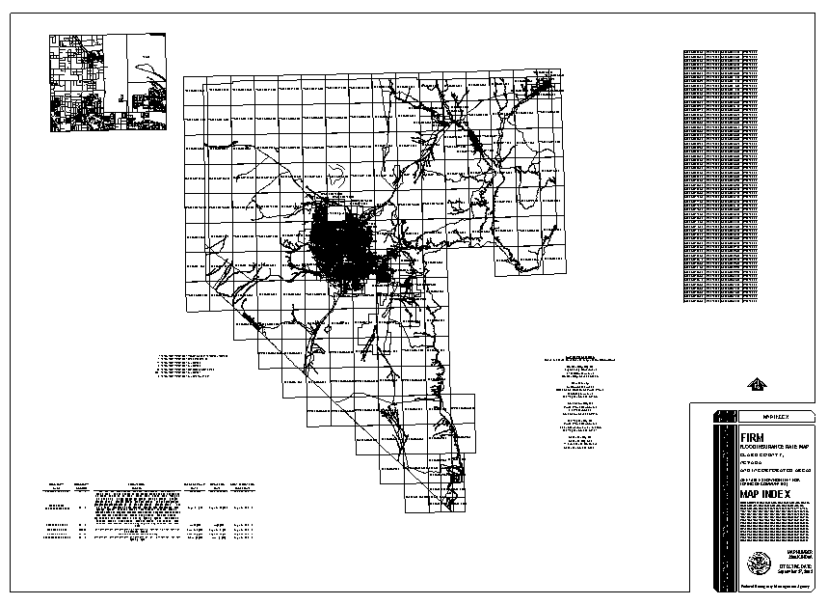

Table of Contents:

What is the Digital FIRM Index Tool (DFIT)? 3
DFIT Overview 3
Tool Controls 4
DFIT Toolbar 4
DFIT Tools 4
Digital FIRM Index Tool (DFIT) 4
Save to PDF 5
Clear Graphics 6
PDF Export Toolbar 6
PDF Export 6
Trouble – Shooting 7
Contacts 8

What is the Digital FIRM Index Tool (DFIT)?
DFIT is a tool that automates production of the FIRM panel index map. There are several options that are available to users, allowing for the customization of the layout according to the characteristics of the index. The panel index map elements meet FEMA’s standards, which are described in FEMA’s April 2003 Guidelines and Specifications for Flood Hazard Mapping Partners Appendix K: Format and Specifications for Flood Insurance Rate Maps.
The title block, map repository addresses, and PNP description list are generated automatically, based on information included in look-up tables and feature classes. In addition, the features shown on the map are labeled.
FIRM Panel Index map

DFIT Overview
The DFIT user guide contains useful information that will help guide you through using the tool. The key sections of this guide are:
- Quick user reference guide (p. 4)
- Descriptions of tools and how to use them (p. 4)
- Support/contact information (p. 8)
Quick Reference Guide
The following is a quick reference guide to all of the components of the Digital FIRM Index Tool (DFIT). You can use the tool to prepare a panel index map for printing.
Choose the printed page size -------------------------  Select the orientation of the page -------------------  Specify which logo should appear in the title block ------------------------ | 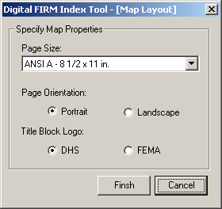

Tool Controls
Now that you are ready to print the FIRM panel index map, you can prepare the layout and produce a PDF using DFIT.

DFIT Toolbar
 | Digital FIRM Index Tool | Prepares the FIRM panel index map for printing.
 | Save to PDF | Prints the FIRM panel index map to PDF.
 | Clear Graphics | Clears the graphics from the layout view.

DFIT Tools

Digital FIRM Index Tool (DFIT)
View the DFIRM panel index map and modify the elements on the layout.
- Click on the DFIT tool.
- Specify the properties of the FIRM panel index map layout.
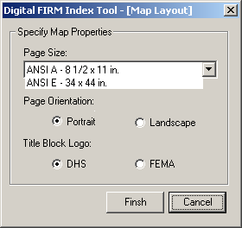
Digital FIRM Index Tool dialog window
  - Choose either ANSI A (8 ½ X 11 inches) or ANSI E (34 X 44 inches) for your panel index map.
  - Choose the page orientation. Note that if you choose ANSI E as your page size, you will be able to print only in landscape orientation.
  - Choose to display the DHS or FEMA logo in the Title Block.
    - If the entire DFIRM is being republished, use the DHS logo
    - If part of the DFIRM is being republished, use the same logo on the new map that appears on the old map.
    - If this is a new DFIRM, use the DHS logo.
- Click Finish and you will see the index generated in layout view, with all required elements.
- Modify the layout and text placement, as needed. You can move and resize text blocks as well as the panel index map. Note that you cannot edit the text in the text blocks.
- If you need to modify the placement or font size of labels in the panel index map, go into data view and make the necessary changes.

Save to PDF
Once you are satisfied with the arrangement of the layout elements, print your FIRM panel index map to PDF using the Save to PDF tool. The PDF generated will have the following naming convention:
- Click on the Save to PDF tool.
- The following dialog will open, prompting you to select the project number:
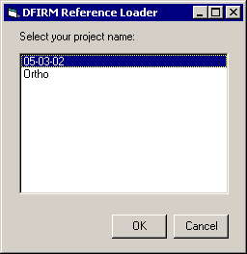
DFIRM Reference Loader dialog window
- Use the PDF Export tool to download the PDF to your local drive for printing or archiving. The INDEX will have the following name:
(CID)_IND0Apdf = 06063C_IND0A.pdf

Clear Graphics
After previewing an index, you can remove the graphics of the index. This will be necessary if you need to regenerate the index.

PDF Export Toolbar

Once you have printed your selected panels to PDF, you can retrieve them and save them to a local drive or server using the PDF Export Tool. You can print the PDF work maps to your local plotter, share them electronically, or store them in an archive.

PDF Export
Allows users to download single or multiple PDF files. Use this tool after printing panels to PDF using DFIT’s Save to PDF feature.

Trouble – Shooting

Problem: The following message box appears after running DFIT:
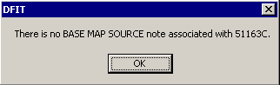
"There is no BASE MAP SOURCE note associate with 51163C" sample error message

Solution: Run Map Production Pro and enter a Base Map Note in the appropriate section Refer to page 9 of the Map Production Pro user guide.

Contacts
If you need assistance with this tool, please contact the representative at your local RMC.

