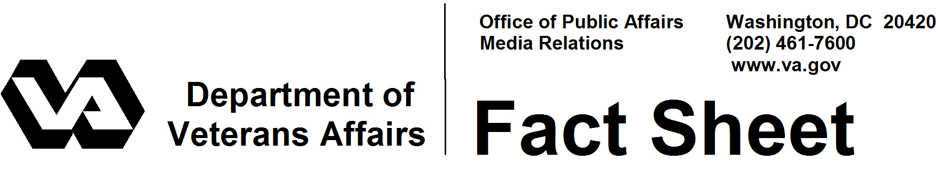
March 2008

VA Business Programs for Veterans
Self-employment presents opportunities and challenges to potential entrepreneurs. Veterans are no exception. The federal government supports veterans’ efforts to own their own businesses. VA has a special mission to act as an advocate in commercial and federal markets and ensure the Department meets certain goals in purchasing from veteran-owned small businesses. VA uses outreach and offers one-on-one coaching to carry out this mission.

An estimated 3 million American veterans own their own businesses. Most could benefit from VA’s enterprising veteran support services.

Services
VA offers:
- A toll-free call center (1-866-584-2344), where veterans, military personnel or their family members can talk one-on-one with a business coach about how to start or expand a business;
- Information on business management, financing and marketing, as well as small-business conferences and business training opportunities;
- Information about legislation affecting veteran-owned business, including existing laws that require federal agencies to increase business opportunities for veterans by setting aside a certain portion of their purchasing dollars for veterans and service-disabled veterans;
- Inclusion in a veterans business database for exposure to both commercial and government business, plus recognition as a verified veteran-owned or service-disabled veteran-owned small business.

A Web site – www.VetBiz.gov – has information on starting a business and entering the federal marketplace. This site is linked to Vendor Information Pages (VIP), a free, online database of veteran business owners. The VIP is used by federal procurement employees and federal contractors to locate veteran-owned and service-disabled veteran-owned small businesses. Another database lists local, state and national sources of assistance for businesses.

VA also operates a call center that responded to nearly 57,000 contacts in 2007 from business owners, prospective owners, federal procurement officers and others inquiring about services available to veterans and general information. More than 20,000 of those contacts were from first-time callers seeking business advice.

- More -
Veterans in Business 2/2/2

Outreach
The staff of VA’s Center for Veterans Enterprise participates in small-business conferences to inform veterans about how to maximize business opportunities with VA, other federal agencies and large corporations. In an annual awards program, VA recognizes “Champions of Veterans’ Enterprise” – organizations and individuals who lead in doing business with veteran-owned small businesses. Included in the program is the Center’s highest honor, the “Enterprising Veteran” award, given to a high-performing veteran entrepreneur.

VA partners with business specialists at the Small Business Administration, the Association of Small Business Development Centers, Veterans Business Outreach Centers, The Veterans Corporation and the Association of Procurement Technical Assistance Centers to expand services for veterans. Another partner, the International Franchise Association, has more than 250 franchisor members who offer discounts to veterans wishing to purchase a franchise through the VetFran program. Since 2002, more than 1,000 veterans used it to become franchise owners.

The Law
The Veterans Entrepreneurship and Small Business Development Act of 1999 set a spending requirement for federal agencies: at least 3 percent of prime-contract funds spent with service-disabled veteran-owned small businesses. VA’s objectives are to help other federal agencies reach that required procurement target. In addition, VA has a self-imposed 7 percent target for purchasing from service-disabled veteran-owned small businesses and a 10 percent target for veteran-owned businesses.

A law passed in 2006, which applies only to VA, requires the department to give first consideration to service-disabled veteran owners in new small business opportunities. It also permits non-competitive purchasing, up to $5 million, in some instances.

Where to find veteran-owned businesses
Veterans register their businesses in the VIP database at www.vetbiz.gov. There is no charge for this service. Federal contracting employees and prime contractors use the database to locate veteran-owned businesses.

What is a veteran-owned business?
A veteran-owned business is maintained by a veteran who has 51 percent of the ownership and control of the enterprise. A veteran is a person who served on active duty with the U.S. Army, Air Force, Navy, Marines or Coast Guard and was released under conditions other than dishonorable. People who were called to active duty, as well as reservists or National Guardsmen who retired or were injured while in training status, also qualify as veterans.

- More -
Veterans in Business 3/3/3

What is a service-disabled veteran-owned business?
A service-disabled veteran-owned business must meet the same requirements as a veteran-owned business, plus the veteran or veterans owning the controlling interest must have a VA-rated service-connected disability. If a veteran is severely disabled, the day-to-day management of the business may be performed by a spouse or personal caregiver.

# # #

