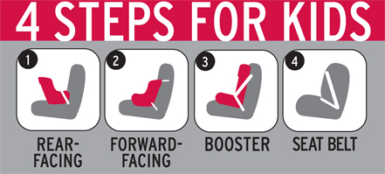
CPS Week Planner
FACT SHEET

Overview: All 50 States, the District of Columbia, and Puerto Rico have laws requiring that children be restrained in motor vehicles. Child safety seats and booster seats save lives. They offer the best protection for children in the event of a crash. During the past 30 years, approximately 8,325 children’s lives have been saved by the use of child restraints, according to the National Highway Traffic Safety Administration.

Mission: National Child Passenger Safety Week (September 21-27) is an annual campaign to bring public attention to the importance of properly securing all children in appropriate child safety seats, booster seats, or seat belts – every trip, every time. The campaign kicks off on September 20, 2008, with “Seat Check Saturday” inspection events nationwide. Across the country, English-speaking and Spanish-speaking child passenger safety certified technicians will provide free on-site child safety seat inspections to help parents and caregivers make sure their vehicle’s child safety seats are appropriately sized and properly installed.

History & Timeline

1971: NHTSA adopts the first Federal standard for child restraint systems, called FMVSS 213. The standard required that a seat belt be used to secure a forward-facing car seat into the vehicle. In addition, it mandated that a forward-facing seat come equipped with a harness to hold the child in place.
1979: Tennessee is first State to pass a child passenger safety law, requiring parents to put their infants and young children in child restraint systems that met the Federal standard. Legislative effort begins in other States.
1980: Additional stringent Federal standards for child restraint systems became effective on January 1, 1980 (FMVSS 213-80).
1984: The first Presidential Proclamation is issued by President Ronald Reagan on child passenger protection, titled “National Child Passenger Safety Awareness Day, 1984.” This marked the birth of what is now known as Child Passenger Safety Week.
1985: All States, the District of Columbia, and Puerto Rico have enacted child passenger safety laws.
1995: NHTSA calls for the establishment of a Blue Ribbon Panel to resolve child restraint and vehicle compatibility issues. The panel calls for the development of a universal anchorage system for child restraints that does not rely on seat belts.
1997: NHTSA develops a standardized Child Passenger Safety curriculum. The Child Passenger Safety Technician Certification program begins.
2002: In September 2002 final implementation of a universal anchorage system for new child restraints called Lower Anchors and Tethers for Children (LATCH) goes into effect. This new system has both vehicle and child restraint requirements.
2007: Observance of Child Passenger Safety Week moves to September in order to increase opportunities for communities to conduct seat check events without the threat of inclement weather (it had formerly been held in February). Communities kick off Child Passenger Safety Week by hosting the first “Seat Check Saturday” inspection events nationwide.
2008: By this time more than 30,000 CPS technicians have been certified.

