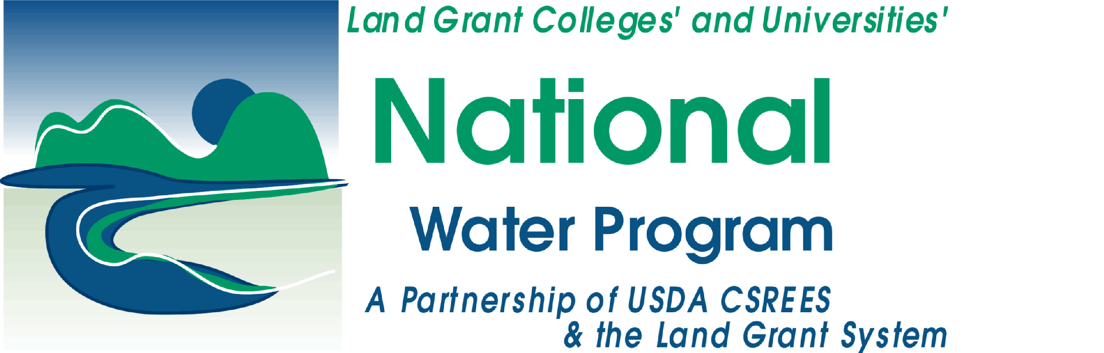
National Water Program
Liaison Standing Leadership Team

Call Notes -- DRAFT
March 13, 2008

Attendees

Daphne Pee (R3) – (301) 405-8569
Susan Brown (R7) – (828)-883-2340
Lloyd Walker (R8) – (970) 491-6328
Christine French (R9) – (951) 827-4327
Jan Seago (R10) – (206) 553-0038

Agenda items
- Roundtable discussion of re-competition process, concerns, questions
- Report on the Marketing/Communications Workshop held at the National Water Conference
- Presentation on R10's climate change initiative

Re-submission Process → Changes, concerns, questions
- Shared our experiences in pulling together our proposals, the changes our program are making to improve our performance and evaluation, and our concerns/questions related to re-structuring and re-competing.

Workshop Update (Daphne)
- Overall, the workshop was well attended and the evaluations show increases in knowledge. A two-page summary is being written up. From the written comments, it seems like there is more need for training in social marketing and communications.
- Next conference call should discuss where we go from here
  - Should we move on to other topics (funding, program management, evaluation)? Continue on communications track and cover a little more ground?
  - How should we continue planning these workshops?
    - After coordinating two workshops, it seems like Liaisons are best suited for identifying a problem, finding a specialist to develop a workshop, and providing assistance to identify case studies, adapt content to audience needs, etc.
- Depending on discussion, Lloyd can bring ideas for greater discussion by the CSL

Region 10 Climate Change Initiative
- EPA Region 10 has just started an effort to evaluate EPA’s role in climate change. They are at a very preliminary stage, and are seeking recommendations on what the EPA’s roles and responsibilities should be. They have not started evaluating funds, programming, FTEs, etc.
- A meeting is planned for Monday, March 24 to further develop the initiative.
Upcoming Conference Call Dates:
- May 8 - guest: Jennifer Kushner
- July 10
- Sept. 11
- Nov. 13

All times are 11:30 - 1:00 (Pacific) / 2:30 - 4:00 (Eastern).

Report from Regions:

Region 10
Activities/Priority Issues:
- WSU Puget Sound Counties (12 counties) are involved with the Puget Sound Partnership (PSP) that has around $30M in funding. The 12 county offices have formed an Education, Communication, and Outreach Network (ECOnet) to put together a comprehensive approach to education around the Puget Sound that saves on redundancy and more importantly competitiveness when applying for funding from the PSP.
- Three new publications have been developed by South Sound WSU faculty and staff to be used in educational opportunities with home owners, “Living on the Shore: A Resident’s Guide to Creating and Maintaining a Sound Landscape, a Rain Garden Manual for the soils in the Sound Counties, and a LID/Stormwater Management Guide. The LID manual has been accepted by the WA State Department of Ecology as a guide for all of Western Washington.
- The Water Resource Management Task Force has been assembled by the Dean of CAHRNS to assess education needs around the State.
- Alaska Extension has received grants for State-wide Septic and Well Education and more grant funds are being pursued.

Opportunity for multi-regional collaboration and/or elevation to national level:
- The Liaison has been asked to produce a video conference with the Office of Environmental Assessment at Region 10 to track the research being done around the country on Air Quality and Climate Change. Regions 1, 3, 4, 5, 9, and 10 have researchers who will interviewed for the program that will air sometime late summer or early fall 2008.Many of the Universities are LGUs.

