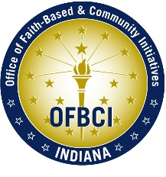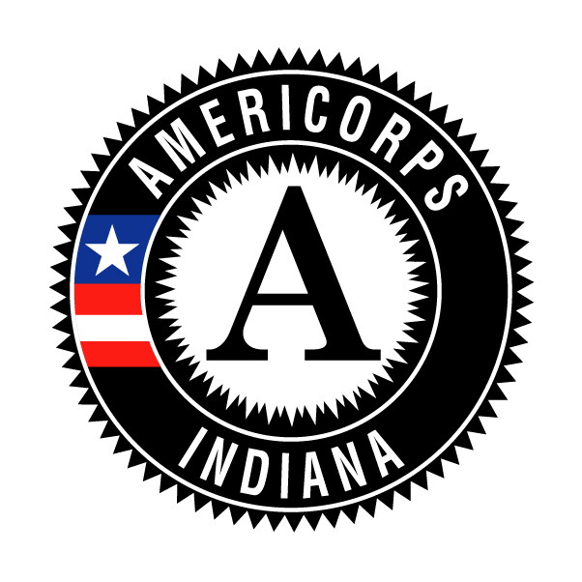
Indiana AmeriCorps New Program Start-Up Guide:
Benchmarks & Deliverables

Note: This document serves as a supplemental guide to use in developing your Indiana AmeriCorps program. It does not replace any of the requirements set forth by the AmeriCorps rules, provisions, and guidelines.

Explanation of Terms USED IN THIS DOCUMENT:

AmeriCorps Provisions (http://www.americorps.org/for_organizations/manage/index.asp#provisions)
- AmeriCorps program requirements that are binding on all grantees.

C.F.R. (http://www.americorps.org/for_organizations/manage/index.asp#provisions)
- The federal Code of Regulations (C.F.R. aka “Regulations) which codifies the general and permanent rules published in the Federal Register.

CNCS Blueprint (http://www.nationalserviceresources.org/resources/online_pubs/americorps/startup_guide.php)
- The Corporation for National and Community Service’s in-depth guide to help prospective AmeriCorps program applicants, start-up programs lacking AmeriCorps experience, existing AmeriCorps programs, and new AmeriCorps staff to understand the multiple facets of a successful AmeriCorps program.

OMB Circulars (http://www.whitehouse.gov/omb/circulars/)
- Instructions or information issued by the White House Office of Budget and Management that relate to procurement, financial management, information, and regulatory policies.

Project STAR (http://www.projectstar.org/star/index.htm)
- The Corporation for National and Community-sponsored technical assistance provider in performance measurement and evaluation.

WBRS (http://wbrs.net)
- AmeriCorps’ Web-Based Reporting System.

START-UP ACTIVITY | BENCHMARKS & DELIVERABLES | RESOURCES TO ASSIST
PRE-AWARD PREPARATION - AUGUST

AmeriCorps Information  - Subscribe to AmeriCorps List Serv (Aclist) | N/A | - AmeriCorps List Serv
AmeriCorps Regulations and Provisions  - Read and be familiar with the most current AmeriCorps Regulations & Provisions  - Read and be familiar with applicable OMB Circulars (which may include A-110, A-21, A-133, A-87, A-102, A-122)  - Read and be familiar with C.F.R. (45 C.F.R. 2520.5-2050.65; 2521.5-2521.95; 2522.10-2522.950) | N/A | - AmeriCorps Website  - AmeriCorps Statutes and Regulations  This provides links to all requirements!  - AmeriCorps Provisions  - OMB Circulars  - CNCS Blueprint: General AmeriCorps info p.10-36, 252-264  - CNCS Blueprint: Finance and Grants Management p. 114-134
Indiana and Corporation for National and Community Service (CNCS) Resources  - Review and become familiar with the Office of Faith-Based and Community Initiatives (OFBCI) website  - Review and become familiar with available program management resources | N/A | - OFBCI  - CNCS Resource Center  - CNCS Forms Library  - CNCS Blueprint  - Becoming a Better Supervisor
MONTH 1 - SEPTEMBER

Program Administration/Organizational Issues  - Finalize position descriptions for program-related staff  - Hire program staff  - Train and orient program staff to agency, community, and program  - Determine the primary programmatic and fiscal contacts and WBRS user access roles  - Develop and implement parent organization orientation to AmeriCorps  - Set up schedule of due dates for OFBCI required reports (both fiscal and program)  - Determine reporting requirements for organization, members, and host sites*  - Develop a document retention policy and procedure* | Program staff selected and in place  Documentation of training provided to parent  organization on AmeriCorps program and role  of members in the organization  Reporting requirements  List of program contacts  Established document retention policy and  procedure | - CNCS Blueprint: Program Development and Management p.36-70  - Staff Screening Toolkit  - WBRS  - OFBCI Calendar of Events
Host Sites  - Identify host sites, if applicable | List of host sites including host site supervisor,  contact information, and number and status of  future members | - CNCS Blueprint: Community and Site Partnerships p.71-96
Member/Program Management  - Ensure you have liability insurance that covers your members  - Ensure you have an Family and Medical Leave Act of 1993 (FMLA) policy that applies to members, if applicable*  - Ensure you have Workers’ Compensation for members  - Select health care provider for members  - Order and purchase office supplies, member gear, and AmeriCorps handbooks | Documentation of liability insurance, FMLA  policy, Workers’ Compensation  Health insurance plan for members  Supplies and materials received | - CNCS Blueprint: 0-3 Months: Finance and Grants Management p. 186-198  - National Service Catalog
Program Outcomes and Evaluation  - Revise performance measures  - Develop outcome data tracking systems/mechanisms  - Revise performance measures, if necessary  - Implement evaluation mechanism, if applicable | Complete Project STAR webinars #1-5  Complete Project STAR webinars #6-8  Complete WBRS Tutorials  Performance measures approved by OFBCI  Data collection plan completed  Data collection system  Data measurement tools | - CNCS Blueprint: 0-3 Months: Finance and Grants Management p. 186-198  - Project STAR  - WBRS
Member Recruitment  - Order free CNCS recruitment materials  - Develop recruitment plan  - Research possible outlets for recruitment  - Identify minimum requirements for members  - Develop a program boilerplate for press releases and public service announcements (PSAs)  - Develop recruitment materials (flyers, newspaper ads, PSAs, press releases, etc.)  - Develop member position descriptions  - Review the non-displacement clause in the provisions to ensure compliance  - Develop interview questions and procedures | Member position description  Recruitment plan  Eligibility checklist/minimum qualifications  Recruitment materials have AmeriCorps logo  and required non-discrimination language  List of applicants | - CNCS Media Kit  - CNCS Graphics Standards  - Materials Order Form  - CNCS Blueprint: 0-3 Months: Member Development and Support p. 97-113  - Member Recruitment Resources
Financial Management  - Develop an effective and efficient accounting system  - Develop written accounting practices, policies, and procedures  - Develop a separate accounting system dedicated solely to the AmeriCorps grant  - Develop internal controls to safeguard assets  - Develop a cost allocation plan for expenses of staff members to be charged to program expenses  - Develop plan to ensure proper matching requirements are met | Ability to distinguish grant from non-grant  expenses  Costs are identified by budget category  Direct and indirect costs are  differentiated  In-kind contributions recorded as both  revenues and expenses  Statements are easily attainable  Written accounting manual including accounts  payable, accounts receivable, travel expenses,  supplies and other expenses, etc.  Separate accounting system including separate  accounts, ledger, trial balance, financial  statements  Internal controls regarding receipt of funds,  managing disbursements, and managing  check writing  Plan to secure match | - OMB Circulars  - AmeriCorps Statutes and Regulations  (CFR 2541.200-2541.26)  - Cost Allocation Plan Model
Inclusion  - Develop a reasonable accommodation policy and ensure it is integrated into your member recruitment and management policies and procedures* | Reasonable accommodation policy for members  Process for members to request  accommodation  Non-discrimination language included on  program materials as required | - Civil Rights/Equal Opportunity Requirements  - National Service Inclusion Project  - Indiana Institute on Disability and Community

START-UP ACTIVITY | BENCHMARKS & DELIVERABLES | RESOURCES TO ASSIST
MONTH 2 - OCTOBER

Host Sites  - Develop Host Site Agreements/Memorandums of Understanding  - Develop orientation agenda and schedule for host sites/host site supervisors  - Develop training plans for host sites for the program year  - Develop a host site monitoring process and schedule*  - Establish site data collection reporting requirements and schedule | Host Site Agreement(s) including:  Site roles and responsibilities  Supervisory Responsibilities  Member activities – allowable & prohibited  References to C.F.R., Provisions, and  applicable OMB Circulars  Match and financial information  Reporting requirements  Terms of participation and release from  partnership  Agenda for host site orientation, including  review of policies, prohibited activities, service  descriptions and reporting procedures, and in-  kind match documentation (if applicable)  Ongoing training plan for host sites  Host Site monitoring plan, including:  Ensure members receive orientation  Ensure members receive adequate  supervision  Host Site monitoring tool  Host Site monitoring schedule | - CNCS Blueprint: Community and Site Partnerships p.71-96  - CNCS Blueprint: 4-6 Months Community and Site Partnerships p.206-224  - Project Star: Data Collection
Member Recruitment & Selection  - Post information about your program on the AmeriCorps Recruitment and Placement System (AC*RPS)  - Conduct outreach presentations to promote program and recruit members at schools, youth centers, churches, volunteer centers, other nonprofits, etc.  - Set up and begin interviews with program staff and host site, if applicable.  - Establish system for conducting criminal background checks* | Verify program is registered on AC*RPS  Criminal background check policy, including  Indiana and any other states in which member  resided | - Member Recruitment Resources (AC*RPS)  - CNCS Blueprint: 0-3 Months: Member Development and Support p. 97-112; p. 171-180  - Indiana State Police Limited Criminal History Search  - Criminal Background Checks by State (BackgroundFerret.com)
Financial Management  - Develop a system to track in-kind services and donations  - Develop a system to track cash match  - Develop a system and schedule for the disbursement of member living allowance | Systems in place to track match  System in place to distribute member living  allowance | - OMB Circulars  - AmeriCorps Statutes and Regulations  (CFR 2541.200-2541.240)
Volunteer Management  - Develop volunteer engagement plan for program  - Work with host site(s) as needed  - Write job descriptions for volunteers  - Work with host site(s) as needed | Volunteer position descriptions  Volunteer recruitment plan  Volunteer screening policy  Volunteer tracking system | - CNCS Blueprint: Framing the Program p.135-45
Member/Program Management  - Develop member forms  - Develop member file management process*  - Develop child care enrollment/waiver process*  - Develop program outreach materials | Member Application  Member Service Contract*  Grievance Procedure*  Publicity Release Form*  Time sheets  Health and child care enrollment/waiver forms  Member handbook  Mid-term member evaluation form (if  applicable)  End-of-term member evaluation form  Loan Forbearance forms and information  available  Member file checklist | - CNCS Blueprint: 0-3 Months: Finance and Grants Management p. 186-198  - CNCS Forms Library  - OFBCI Sample Forms  - WBRS Forms  - AmeriCorps Child Care Provider (NACCRRA)
Member Training Plan  - Read Starting Strong: a Guide to Pre-Service Training and other resource materials on training  - Assess needs for member orientation by talking to former members, site supervisors, OFBCI, and other national service programs  - Brainstorm training topics and formulate goals for orientation  - Plan and design member orientation  - Develop member orientation  - Begin planning program year long member training | Orientation agenda  Year-long member training plan | - CNCS Blueprint: 0-3 Months: Member Development and Support p. 97-113  - National Service Resource Center (sample planning and calendar)  - A Guide to Pre-Service Training  - Sample Forms
MONTH 3 - NOVEMBER

Member Selection  - Begin member interview process  - Once members have been selected, send welcome letter and request eligibility documentation needed for member files  - Begin reference and criminal background checks | Members selected  Documentation of completion of reference and  criminal background checks | - CNCS Blueprint: 0-3 Months: Member Development and Support p. 97-113  - Indiana State Police Limited Criminal History Search  - Criminal Background Checks by State (BackgroundFerret.com)
Host Sites  - Conduct Host Site Supervisor Orientation  - Ensure all host site agreements completed and signed  - Ensure each service site plans an orientation for members  - Revise and finalize data collection/program evaluation instruments; implement performance measurement tracking systems  - Develop formal site visit/monitoring instruments | Completed and signed host site agreements  Completed sign-in sheets for host site  orientation | - CNCS Blueprint: 4-6 Months Community and Site Partnerships p.206-224  - Project Star: Data Collection
Member/Program Management  - Begin entering members into WBRS  - Post drug free workplace statement  - Limit file access to relevant program staff  - Implement member file process  - Send welcome letter to new members | Copy of OFBCI contract, provisions, grant,  approved budget, resource material  Complete member files  Program calendar – reporting deadlines,  member events, monitoring schedule, site  visits, important program dates for members  and program staff | - WBRS  - Sample Member File Checklist
Member Training  - Conduct pre-service orientation and member swearing-in  - Finalize member calendar for the year | Agenda and completed sign-in sheets  Member calendar, including:  Member swearing-in date, time, location  Dates for meetings, trainings, service  projects, national service holidays,  celebration, and reflection  Administer AmeriCorps Pledge | - CNCS Blueprint: 0-3 Months: Member Development and Support p. 97-113  - The AmeriCorps Pledge
*Items to have in program’s policy and procedure manual.

