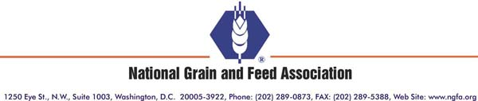

Testimony of the
National Grain and Feed Association
to the
Subcommittee on General Farm Commodities and Risk Management
Committee on Agriculture
U.S. House of Representatives

May 15, 2008

Thank you, Mr. Chairman, and Mr. Moran, for calling today’s hearing to examine activity in agricultural futures markets, and impacts of market fundamentals and investment capital. The National Grain and Feed Association (NGFA) appreciates the opportunity to provide input on this very important subject.

I am Rod Clark, Vice President of CGB/Diversified Services in Mt. Vernon, Ind. Diversified Services is the farm services and risk management division of CGB, which originates and markets grain and oilseeds for export and domestic channels. CGB has an extensive network of over 60 grain elevators and terminals which utilize various modes of transportation. We have been helping farmers manage their two most significant risks – price and yield – for years. At Diversified Services, our grain marketing experts work with farmers to develop disciplined and localized marketing plans and our crop insurance specialists understand the benefit of tying that marketing plan to a sound yield assurance program.

I appear today representing the National Grain and Feed Association. I serve as Chairman of the NGFA’s Risk Management Committee, which works to ensure the continuation of efficient, viable and sound agricultural commodity cash and futures markets. The NGFA is comprised of about 900 companies nationwide, including grain elevators, feed manufacturers, oilseed processors, flour mills, biofuels producers and marketers and many other related commercial businesses.

Convergence and Basis Issues

The NGFA’s member firms have relied for years on U.S. agricultural futures markets to hedge their price and inventory risk, and to aid them in assisting producers to market their commodities and manage risk. As first-purchasers of grains and oilseeds from producers, these firms rely on well-functioning futures markets for price discovery and risk management. One of the bedrock fundamentals on which hedging strategies are predicated is consistent and reliable convergence between cash and futures prices during the delivery period.

Today, that previously reliable relationship between cash and futures has deteriorated to a point where many commercial grain hedgers are questioning the effectiveness of hedging using exchange-traded futures. Genuine convergence occurs less often and only for short periods of time. The band, or range, of convergence has widened due to several factors, including: 1) higher and more volatile transportation costs; 2) demand for storage created by biofuels growth; and 3) the futures market running ahead of cash values due to the infusion of passively managed, long-only investment capital. The following charts illustrate that basis has become more volatile and “weaker” than demonstrated historically – corn, to some extent, and soybeans and wheat more dramatically – thus, convergence has deteriorated:

Ottawa, IL Corn Basis
Source: Advance Trading Inc.

Source: Advance Trading Inc.

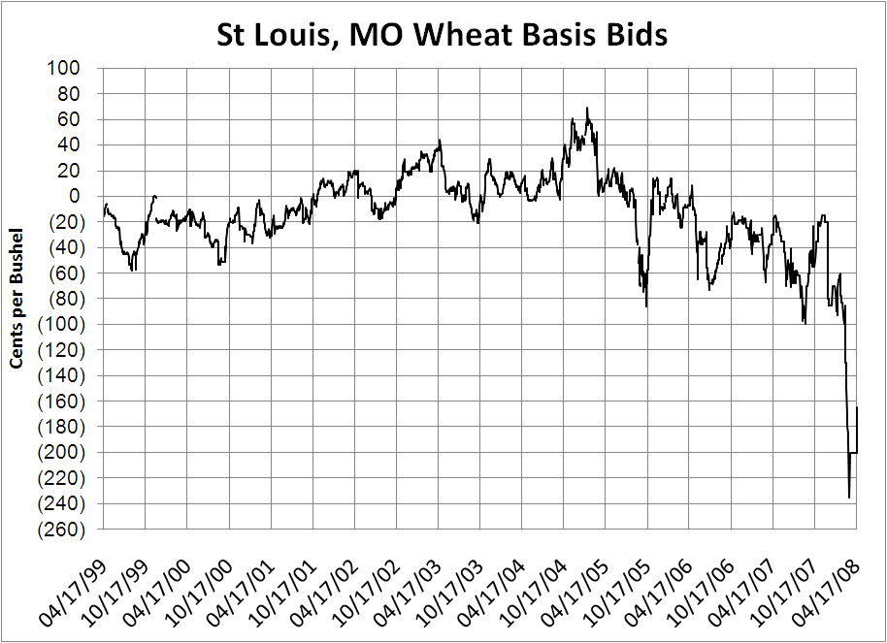
Source: Advance Trading Inc.
Note: This chart represents river values in the St. Louis area; wheat mills in the St. Louis area are
paying higher values (e.g., +5 Chicago on one recent day) for appropriate-quality wheat.

This lack of convergence – or “divergence” as some are calling it – is evident in wider basis levels between cash and futures. Cash bids to producers at any given location and time still reflect the true value of commodities, but rapid advances in futures price levels have widened basis to levels not historically expected. This wider basis can sometimes make commodity prices appear “too cheap” at the local grain elevator.

As mentioned above, many factors are at work to influence price levels and basis: transportation and fuel costs; changes in supply/demand fundamentals; carry-over inventory levels; farmer selling; storage rates; and more. Changes in any of these factors can result in significant changes to basis levels, and today we are seeing many changes occurring simultaneously. However, we believe that one new factor – the entry of large amounts of long-only, passively-managed investment capital like index and pension funds into agricultural futures markets – is causing a disruption in markets and resulting in futures prices no longer reflecting true supply/demand fundamentals.

Financial Liquidity Issues

Decreased hedging efficiency due to deteriorating convergence and unpredictable basis patterns are not the only concerns for commercial grain hedgers today. As a result of significantly higher futures prices, driven in part by investment capital, elevators that purchase cash grain from farmers for deferred delivery have been hit with extremely large margin calls on their hedge accounts.

Long-only, passively-managed investment funds account for a significant share of open interest in the CBOT grains and oilseeds contracts. These passively-managed, long-only contracts are not for sale at any price for extended periods of time, resulting in elevated prices not reflective of demand, increased speculative interest in the market, increased volatility, and pressure on banking resources to fund margins.

The following charts show the increased volatility for corn, soybean and wheat futures in recent months:

Source: CME Group
Source: CME Group

Source: CME Group

To finance inventory purchases and make margin calls, commercial grain hedgers’ borrowing needs today are several times normal levels. Elevators have reached their borrowing limits and some lenders have reached the limit of amounts they can lend to the commercial grain sector. Additional futures price advances – due to supply/demand shocks, bad weather, or ever-larger amounts of investment capital – could lead to severe financial stress. Even today, some elevators lack the capital to finance additional hedges, so they have been forced to restrict or eliminate deferred purchase bids to producers. If the situation continues, producers who lack access to cash forward contracts they have come to expect will increasingly be frustrated when attempting to optimize their marketing opportunities at a time when cash prices are very attractive.

To sum up and quantify the impact of investment capital on agricultural futures markets, we have analyzed the Commodity Futures Trading Commission’s (CFTC) Commitment of Traders (COT) report. This particular analysis uses data from the COT report dated April 8, 2008. For this analysis, we have excluded the non-commercial spread positions, which tend to overstate the open interest that is available for purchase or sale. This analysis demonstrates the significant share of open interest held by “Index” traders: 30% of net open interest in corn, 34% in soybeans, and an amazing 50% in wheat. These very large, long-only positions represent a large share of grains and oilseeds volume that is taken off the market for long periods of time and is not for sale at any price!

There is a perception that higher volume leads to increased liquidity. However, such a large share of open interest owned by passive participants actually results in reduced liquidity and higher volatility. In addition to the changes in liquidity and volatility, we believe long-only, passively-managed investment has a significant impact on futures prices and on the process of convergence.

Moratorium on Hedge Exemptions

For the reasons detailed above, the NGFA opposed proposals by the Commodity Futures Trading Commission (CFTC) late last year to increase federal speculative position limits and to create a new hedge exemption for index and pension funds. Today, we believe action by the CFTC is urgently needed to allow agricultural markets to “take a break” and adjust before additional large amounts of investment capital find their way into agricultural futures. At the CFTC’s Agricultural Futures Roundtable on April 22, we shared with the Commission our belief that investment capital is having a significant impact in agricultural futures markets.

Consequently, the NGFA has petitioned the CFTC for a moratorium on all hedge exemptions for long-only, passively-managed investment capital entering agricultural futures markets. For the two funds already approved by CFTC for hedge exemptions, the NGFA has asked the Commission not to expand their hedge exemptions beyond levels already approved by the Commission. The NGFA also has recommended that long-only, passively-managed investment capital participate in futures on a dollar-for-dollar, unleveraged basis – that is, that a participant’s positions in agricultural futures contracts should be backed by an identical amount of investor funds held in an account by the fund.

Commitments of Traders Report

Early last year, the CFTC began publication of a supplemental COT report with a new “Index” category to report investment capital. The NGFA’s member companies were extremely pleased with that new category, believing that transparency in the marketplace is of benefit to all participants. In particular, the new “Index” category was helpful in assisting commercial grain hedgers to develop their risk management strategies based on supply/demand fundamentals, rather than on speculative investment capital.

We believe that today’s market environment calls for a re-examination of the CoT report. While some suggest that investment capital’s share of open interest in agricultural futures contracts has not increased in recent years, we are skeptical of that claim. We suspect that some activity that rightly belongs in the “Index” category could now be showing up in other CoT report categories. For that reason, we have requested that the CFTC analyze in detail the reporting it receives from market participants to determine if all long-only investment capital is reflected in the “Index” category. Additionally, we have asked CFTC to fully and clearly define futures market activity reported in each existing category of the report; and consider whether any additional detail/categories added to the report would provide additional clarity for market participants.

Summary

Ultimately, the solution to recent market upheaval may simply be time. In time, the market may respond to new realities. The market likely will create new ways to deploy capital in agriculture. In time, industry may expand storage, and the CME Group may implement enhancements to their contracts. Without a doubt, market participants will create new products for risk management that reflect the broad changes in the agricultural landscape – transportation, biofuels, major acreage shifts, to name a few. The NGFA will continue its work to identify additional potential responses to assist commercial grain hedgers dealing with the volatility and financial stresses of today’s markets, whether they be changes to futures contracts, regulatory action or some other course.

In the shorter term, there are real disconnects and real stresses, in particular on the commercial grain hedging sector. We believe these stresses call for action along the lines outlined above that will help build a bridge to new market realities. Failing to do so could have serious consequences for all sectors of agriculture, including producers and the elevators who work with them to facilitate efficient marketing and risk management for the grain sector.

Again, Mr. Chairman, the NGFA deeply appreciates the opportunity to share our thoughts with the subcommittee. I would be happy to respond to any questions.

