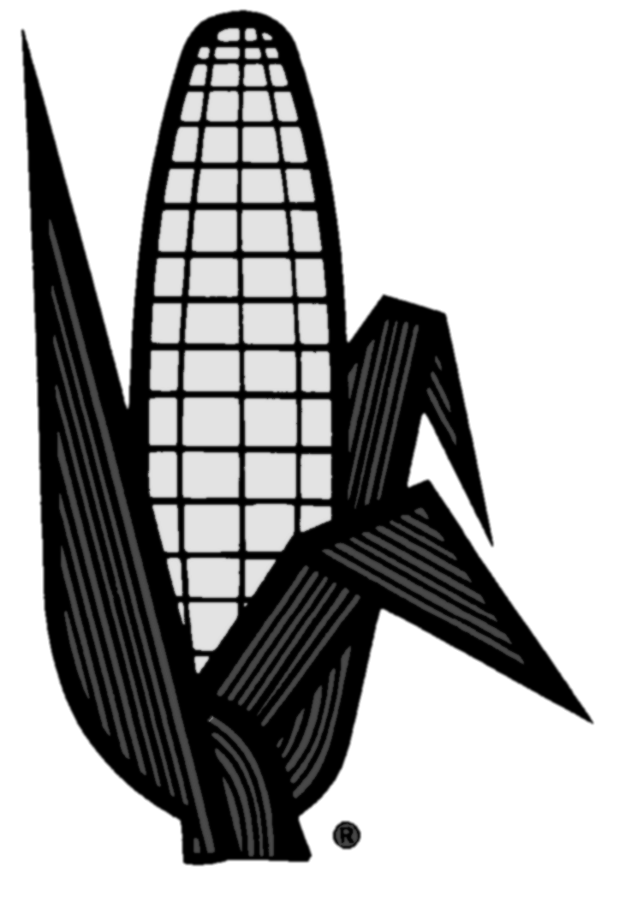
Corn Growers
National
Association
www.ncga.com

Testimony

of

Garry Niemeyer
National Corn Growers Association

Before the

U.S. House Agriculture Subcommittee
on

General Farm Commodities and Risk Management

Longworth House Office Building

Room 1300

Washington, DC

May 15, 2008

Good morning, I am Garry Niemeyer and I am a corn and soybean farmer in central Illinois. I am here today representing the National Corn Growers Association (NCGA). NCGA represents the interests of over 32,000 corn farmers throughout the U.S.

For over 100 years, the commodity exchanges have played the two valuable roles critically important to farmers; price discovery and risk management. Over the last several months, though, we have witnessed a lack of convergence between cash and futures markets as the futures contract expires. While the corn market has experienced significant lack of convergence, it is nothing compared to what has occurred in the wheat pits.

Without market convergence the futures markets are not fulfilling the role of price discovery. It leads many to question whether market fundamentals still underpin current grain prices. Economic theory suggests convergence is not really a point at zero, but a band of plus or minus a few cents either side of zero, varying based on current supply and demand factors. Further, it is natural to assume that the increased risk inherit in the grain markets would cause the “band of convergence” to expand from historical norms, but is 35 to 50 cents a real true measure of this risk? If the constant media barrage about scarcity is to be believed, you would certainly think the cash grain markets would converge closer to zero rather than spreading dramatically.

Moreover, a weakening of price discovery is rippling into the farm credit system, resulting in banks having difficulty in collateralizing loans to elevators and farmers, alike. It is this tightening in the agriculture credit markets that is setting the stage for a more serious problem.

It is our position that the lack of convergence is a symptom, not the disease. For a number of reasons, some of which I will detail later, grain markets are not performing with the efficiency in past years and this places farmers directly in the path of an economic storm.

Please do not misconstrue this point. Corn Growers are not upset about higher corn and grain prices. Our concern is that the current prices quoted may not be fundamentally supported. This is leading people to speculate that we may be witnessing the development of a “commodity bubble.” As this bubble has inflated, it has resulted in hardships for the elevator industry and has been devastating to our livestock customers. The sharp rise in prices has also impaired many growers’ ability to do price risk management.

To those who want to blame biofuels for today’s grain prices, I will simply state a close examination of the facts and market trends would indicate that such claims are difficult to substantiate. In the 2005-06 marketing year when the first Renewable Fuels Standard was approved by Congress, average farm-gate price for corn was $2.00 per bushel On May 9, 2008, USDA released its revised estimate for this marketing year’s corn price at $4.10 - $4.40. So what has changed? The simple sound bite is to point to ethanol and say “we’ve increased the demand for corn driving up the price”. During the last 3 years, corn for ethanol has increased from 1.6 billion bushels to a projected 3 billion, a 1.4 billion bushel increase in demand. What frequently gets overlooked is that over this same time period production has risen from 11.1 billion to 13.1 billion bushels over this time. This raises the question how a 2 billion increase in usage offset by a 2 billion bushel increase in production provides the necessary fundamental underpinning for a more than doubling of the corn price. Now contrast this estimated $4.25 corn price received to the May 12, 2008 closing price on the Chicago Board of Trade (CBOT) for July futures, $6.14 ¾. Although an imperfect comparison, it illustrates there is a significant difference between the prices farmers are receiving and the futures market.

The real damage to the elevator industry hit home in early March when many elevators took major hits on margin calls. Several leading grain companies’ initial response was to suspend forward contracting. While the suspension was short lived, severe restrictions were placed on new contracts once forward contracting was re-established. These restrictions on new grain contracts are the most troubling. Each of the large grain companies have instituted limits on writing new grain contracts. One company will not forward contract grain more than 60 days out. Two others will not contract grain more than 12 months in the future. Naturally, this has permeated down to the country elevator level. One of my local elevators will not contract for grain this fall and I assure you this is not a central Illinois phenomenon, but it is occurring across the country. As a farmer, how am I supposed to manage price risk, if my elevator will not contract grain? I am not talking about locking in prices 2 and 3 years into the future. But, how do I manage risks for the corn crop I would be planting today if it had not rained Tuesday?

Over the last several years, farmers have grown accustomed to the elevator industry’s willingness to carry the futures market risk for us. It has been quite common for us to do Hedge to Arrive contracts with the local elevator. The elevator would take the offsetting positions on the CBOT and absorb any margin risks. Of course, some of this risk would eventually be bid into the basis. During periods of little volatility, though, this risk premium was not that great. In return for carrying that risk, elevators were also able to lock in volume. Elevators make their profits in handling bushels. But, it is the more recent wild volatility and subsequent margin calls that have led to the restrictions on contracts. For example, one of the larger grain companies that re-established contracting for 12 months forward has implemented a 15¢ per bushel fee to write a HTA. It is worth noting that new fee is 15¢ in addition to what ever the basis might be when I am ready to deliver the grain.

Although farmers have always had the ability to do their own risk management on the exchanges, it is estimated that less than 10 percent of farmers actually do this themselves. Perhaps we have been spoiled because the elevators were willing to provide this service. Now, we will have to absorb the cost and risks of the futures market. In today’s market conditions, these costs and risks are not insignificant. Let me give you a very simplistic example of how this might impact a grower. Last year, I produced about 360,000 bushels of corn. If I did a simple short hedge on this grain (sell futures contracts to protect against falling prices), I would need to sell 72 contracts (5,000 bushels per contract). Let’s assume I did all of that on September 4, 2007 (when the grain was harvested) for delivery in May. On that day, May corn futures closed at $3.79/bushel. The typical margin, maintenance margin, and commission would have cost me between $110,000 and $150,000, which is money up front I send to Chicago. On May 1, 2008, May corn closed at $6.05 a bushel, an increase of $2.26/bushel. Since I had a short position (lose money if the price goes up), I would have lost $2.26 per contract. To maintain my maintenance margin, I would have been required to lay out an additional $750,000. Technically, I would have made this money back on the increased cash price of my physical corn, assuming the cash and futures prices tracked perfectly and did not diverge. Still, I would have had to finance and pay interest on this $813,000 until I could sell the cash corn. In the end, I would have stayed even at around the cash price on September 4th. Keep in mind this does nothing to protect me against basis risk.

Given the higher current prices on the exchanges, margin requirements have more than doubled since the end of 2007. In December 2007, for example, the margin on a corn contract was $1,080 and the maintenance margin was $800 (covers a 16¢ move against my position). Today, that same contract has a margin of $2,050 and the maintenance margin is $1,500. Once again, that is money I have to spend up front on each contract.

Another alternative is to use the options market and buy a put. While the options market does not carry margin risks, the premium associated with that put is cash paid up front regardless of whether or not I exercise the option. Last September when the futures price for May was $3.79, there were no strike prices comparable to today’s prices. The increased market volatility has dramatically increased premiums, especially for crops well into the future. For another example, let us assume I wanted to buy a put today for May 2009 contracts. These 72 puts would cost approximately 237,600 in premium and commissions. As I mentioned, this is money that is gone regardless of whether or not I exercise the puts. The question is what corn prices have I guaranteed for $237,000? $5.07/bushel. (May 2009 Corn Futures $6.58, Option with $6.10 strike price has a 65¢ premium reducing the Option price to $5.45. The one elevator offering a bid for May 2009 has a 38¢ basis which equal $5.07/bushel, assuming that basis does not erode).

The unwillingness of commercial players in the market to offer forward cash prices has effectively transferred the market risk onto producers and producers still do not have a means to offset the basis risk. A very real danger is a significant number of growers will forgo price risk management out of hope that prices will continue to rise. However, such a strategy will prove devastating if a significant downturn in corn prices occurs.

NCGA is not blaming the elevator industry for this recent phenomenon. The elevators are businesses that must be able to recoup losses and manage price risk. So, they spread basis to cover losses and build in additional risk principles; initiate fees on Hedge to Arrive contracts (HTA) or book the basis contracts; or they just forego future risk by not offering forward contracts. In the end, these actions transfer the risk back onto growers. The main risk elevators retain is the inability to lock in bushels.

What could happen if the “commodity bubble” pops? I can best illustrate this with an example. During the last several years, we have seen a tremendous increase in input costs. Fertilizer prices have more than doubled in the last two years. Likewise, diesel prices are skyrocketing. I like to consider myself a good manager, so, I try to forward price half of my expected grain production to at least cover my input costs. Last fall, I purchased my fertilizer for this year’s crop. Anhydrous Ammonia was $512/ton, Diammonium Phosphate (DAP) was $476/ton and Potash was $287/ton. Since then, we have seen an explosion in prices and concerns about availability next year. In March, my fertilizer dealer asked me to lock in my fertilizer for the crop I will plant in 2009. The prices for Anhydrous, DAP, and Potash were then $780, $950, and $625/ton, respectively. Coincidentally, between March and May, those prices have continued to increase to $830, $1,150 and $725. The trend is clearly pointing to even higher prices by this fall. Once again, I typically manage the risk of fertilizer prices by forward contracting a portion of my grain. However, no elevators are offering bids for new crop 2009 corn. My options are simple and unpleasant. I can borrow money to buy the fertilizer now, and remain completely exposed to a down turn in corn prices, or wait and remain completely exposed to the price of fertilizer continuing to rise. I am left to hope that should a downturn in grain prices occur, fertilizer prices would drop proportionally with grain prices, a very unlikely outcome.

As I have mentioned several times, NCGA’s concern is the development of a commodity bubble and now hoping that the bubble doesn’t burst. This bubble was not caused by ethanol. Instead, it has been caused by a dramatic increase in non-traditional investors in all commodities, not just corn, specifically, index and hedge funds and swap dealers. Commodities have traditionally been a prudent investment during periods of economic uncertainty. With huge influxes of outside money indicating these investors are returning it is no coincidence the recent run up in commodity prices coincides with the downturn in the stock market.

More importantly, we are concerned with the general investment pattern of the Index Funds that have inflated the bubble. These funds take huge net long positions (buy futures) which given the volume of purchases naturally drives prices higher. Their claim of being “Passive Longs” is partially true. They are not playing both sides of the market, only betting that the price will go up. The funds claim they are not responsible for the divergence between cash and futures because of the roll out of their long positions approximately a month before contract expirations. The latter part of this statement is true. However, one theory about the lack of convergence is the funds have driven a large enough wedge between the two markets when they complete their rolls and that it would take a significant fundamental signal to drive cash and futures together. The likelihood of this happening in a month’s time, particularly when the crop is not exposed to a production event, is slight.

The commodity exchanges’ strength has always been liquidity, openness, and fair and transparent rules. Unfortunately, we have seen erosion in market efficiency. The challenge is to restore efficiency in price discovery and risk management without jeopardizing market openness and liquidity. In light of that goal, NCGA would like to submit the following possible solutions for consideration:

First, to address the current lack of convergence in between Cash and Futures markets:
Simply to fix convergence in the market, we must fix delivery. The problem, there are no easy solutions to this task. Here are a few recommendations; we put forward to the CME Group.

1) Investigate the development of a method to allow farmers or small elevators that have taken a short position to actually deliver against that futures contract. Currently farmers cannot make delivery against these positions. Farmers can only sell futures and deliver against shipping certificates, provided the owner of that certificate plans to make delivery and go to load out. If the delivery stations realized that a farmer or an elevator could call a clearinghouse and set up delivery, it would cause the commercials to drive the futures down at contract expiration to the cash price. A possible hybrid would be to restrict farmer delivery to only a few points with a 1 or 2 day delivery option.

2) Investigate implementing a forced Load Out plan whereby some set percentage of contracts has to go to delivery. During the investigation, consideration must be given to how these Load Outs would be distributed, and what impact this may have on liquidity if the non-commercials are prematurely driven out of the market prior to contract expiration.
3) Investigate increasing the number of shipping stations. By our count, there are currently 28 shipping stations approved as “regular” for corn delivery through June 30, 2008. These stations are limited to 9 firms. Of these 9 firms, only 2 are truly sellers. In other words, they can write a shipping certificate, but since they cannot use the grain internally (processing or through their own export facilities) they must sell the grain, and therefore, may be more inclined to make delivery against a diverged market. We believe balancing or at least increasing the number of sellers that can write shipping certificates may help to re-establish convergence. For example, there are a number of large ethanol plants operating or being built in proximity to the Illinois River. Some of these will have docks that can load out, if necessary. A similar approach would be to investigate adding shipping stations that are not located on the Illinois River, but are in the same homogenous market. Specifically, there are a number of unit train rail loaders which are all within 50 to 100 miles of the Illinois River which could deliver a train destined for New Orleans which is similar to a loaded barge on the river.
4) Consider lowering Regularity. If the Working Capital rate was lowered from $2 million to $500,000, and they reduce the volume down from 55,000 bushels, this might encourage some larger country elevators with existing agreements with docks or maybe railroads connections to able to be a write shipping certificates.

5) Consider increasing storage rates. NCGA is not opposed to periodic adjustments in CBOT’s storage rates. These rates should more closely reflect actual storage costs. In addition, this may help build natural carry into the market.

6) Investigate the establishment of basis contracts. CBOT has proposed establishing a new basis contract to the CFTC. If the current situation in the grain markets continues, farmers will need a tool to manage basis risk just like they must now find tools to manage price risk. While this appears it could be beneficial in managing basis risk, it really has limited impact convergence

Second and more importantly, we must find a way to head off the development of a commodity bubble or if it has already occurred, stop it from bursting. Several possible solutions are:

1) Redefine hedgers vs. speculators. NCGA recognizes the valuable role all parties play in providing liquidity in a market. It is NCGA’s view that the large Funds are having a disproportionate influence in the futures markets and are “non-commercial” traders. While we do not want to drive the index and hedge funds or swap traders from the market, they should be treated as “speculators”. Counter to several CFTC decisions, we believe to truly be classified as a “hedger”; an entity must have a cash commodity position.
We realize that the large index funds are selling a commodity index and then going long in each of their market basket commodities which could be construed as a hedge. But, they are selling a market basket of futures prices, not a market basket of physical commodities. Therefore, their actions provide no market incentive for convergence and as I pointed out above, without convergence there is no price discovery.

NCGA proposes that the index funds, hedge Funds, and swap dealers no longer be afforded the same margin requirements as traditional commercial hedgers. Specifically, to be classified as a hedger, the entity must have a cash position. We are not suggesting that they have an equal or proportional cash position, but somewhere within that company they must be buying or selling cash grain to retain the “hedger” classification.

We believe this will have a very limited impact on market liquidity. The large funds are still welcome to take there net long positions in each commodity market, but they will have higher margin requirements just the same as any other “speculators”.

2) Moratorium on hedger determination. Short of redefining all players without cash positions as “speculators”, the CFTC and the exchanges should not implement a moratorium of providing “hedger” status on any other non-traditional traders.

3) Speculative Limits. NCGA supports the CFTC’s decision not to temporarily increase speculative limits. We believe the proposed increases were ill-advised and would only increase the disparity between cash and futures markets.

4) Daily Trading Limits. NCGA formal policy states “NCGA will oppose an increase in daily trade limits on all commodity exchanges” (Policy IV-C, 14). It is our position that the proposed increase in daily limits will not aid price discovery as proposed. Instead, this will only increase volatility. The CME Group should strongly reconsider returning to the trading limits that existed prior to their March 28, 2008 increase.

5) Renewable Fuels Standard. Congress must not repeal nor should the Environmental Protection Agency waive the current RFS. Numerous economic studies have indicated that the current ethanol demand has had a very limited role on the increase in corn prices. A repeal or waiver of the RFS would have a significant psychological impact on the commodity markets. In fact, this could drive investors from commodities causing the bubble to burst. Such a change in policy may have a short run impact on corn prices, but in the face of current high input prices, it would cause a significant shift of acreage away from corn and other feed grains in the near future, resulting in another dramatic rise in feed prices by 2009.

If in fact a “Commodity Bubble” is developing and that bubble was to pop, the entire grain sector would be devastated. Similar to the increase in grain prices, other input costs have risen dramatically, including for seed, fertilizer, fuel, or land rents. Farmers are now carrying significantly higher financial risk to plant their crops. A rapid deflation in grain prices would result in tremendous financial losses to farmers, especially in light of our recent inability for growers to contract grain at these current prices. If a disconnect between futures prices and cash (fundamentals) exists as alluded to earlier, the impact of the bubble bursting would be all the more dire. For this reason, it is imperative that the CFTC review recent decisions concerning the market power some of the major players wield and take into consideration the potential impact pending decisions have from the perspective of inflating a commodity bubble.

I would like to commend the CME Group, the Minneapolis Grain Exchange, Kansas City Board of Trade, and the Commodity Markets Council for hosting a two-day meeting on market convergence in early April. Also, I would like to thank the CFTC for holding their open forum last month.

On behalf of NCGA, I would like to thank the House Agriculture Subcommittee for conducting this hearing and helping American farmers and grain markets to restore market efficiency.

