Testimony of
Tim Watts
Watts and Associates, Inc.
Billings, Montana
before the
Subcommittee on General Farm Commodities and Risk Management
House Committee on Agriculture

May 14, 2007

MR. CHAIRMAN:
Thank you for the opportunity to appear before the Subcommittee on General Farm Commodities and Risk Management to present the views of Watts and Associates, Inc. on the Federal crop insurance program and how it can be improved. Watts and Associates, Inc. is a private economic research firm specializing in risk management-based solutions to the problems facing agricultural producers. Not only is Watts and Associates, Inc. one of the most active firms supporting USDA’s Risk Management Agency (RMA) and the Federal Crop Insurance Corporation (FCIC) by performing product-related research on a contract basis, but we also have completed significant projects in the farm risk management field for clients ranging from the World Bank, the Governments of Canada and India, to a variety of private sector groups. A list of recent projects is included as part of Appendix A.

We believe the United States Federal crop insurance system is one of the best in the world. Based on our experience, we believe strongly that it remains the best option available to protect American farm producers from the uncontrollable risks posed by adverse weather and, increasingly, by adverse movements in commodity prices. As a result, we have applauded Congress’s decision, reflected in the Agricultural Risk Protection Act (ARPA) of 2000, to encourage the development and deployment of innovative new insurance products to cover an expanding universe of new crops, new concepts, and new approaches. We encourage you to continue this emphasis in the new farm bill. One of the mandates included in ARPA 2000 that we believe holds particular promise for the future is the so-called “508(h) process” under which private groups – farm organizations, insurance companies, and others – are given the opportunity to present new insurance concepts to the FCIC Board and, if approved, to have them incorporated into the Federal crop insurance system, eligible for subsidy and reinsurance. The private group, in turn, can then be reimbursed for the costs entailed in developing the product and maintaining it.

The 508(h) process, even under its current structure, has had successes, including the introduction of such new products as CRC, Livestock Risk Protection, Livestock Gross Margin, and AGR-Lite. Still, based on our experience working with the 508(h) process as an outside contractor (both as a product developer and as an outside expert reviewer of proposals pending before the FCIC Board), we believe that this program has the potential to produce benefits far beyond its current use. With structural improvements we will outline below, the 508(h) program can become a principal vehicle for producer organizations to take the initiative and the responsibility for resolving many of the chronic issues that have faced the Federal crop insurance program for many years, including, for instance:
-- National issues such as the impact on farmers of adverse shifts in production costs, particularly energy, through approaches such as Crop Margin Coverage (a new concept developed by Watts and Associates, Inc.);
-- The problem of declining yields from repeated years of uncontrollable losses;
-- Regional issues such as the unique problems of quality loss for crops in the Northern Plains, the need for highly-tailored coverage for specialty crops with smaller markets, or for highly-tailored solutions to problems or specialties affecting growers in limited areas; and
-- Innovative insurance for livestock risks.

The currently-unused potential of the 508(h) process was dramatized recently in a review by the Congressional Research Service (attached to this testimony as Appendix B) which showed that, out of some $80 million made available for reimbursement of research, development, and maintenance costs under 508(h) during the first 6 years of the program, only $8,977,260 were spent for that purpose. The reasons for this under-use of 508(h), we believe, are structural, and can be addressed with carefully designed structural reforms. For instance, the development of a new insurance product – including the development of actuarial rates, underwriting standards, policy forms, marketing plans, and the rest – can be expensive, ranging at the low end from a few hundred thousand dollars for addressing regional quality issues to, at the high end, several million dollars for a new generation approach to commodity crops. Currently, a producer organization undertaking to develop and present a new product under the 508(h) process must shoulder this entire financial burden, and bear the risk of losing the entire investment if the FCIC Board ultimately disapproves the product. It is an all-or-nothing proposition. If controversy arises during the Board’s consideration of the product, such as through new issues being raised by outside expert reviewers, the Board’s review can be delayed or extended by months or years. For the producer group sponsoring the idea, this means that any potential reimbursement is delayed along with it, causing financing costs to accrue over time.

From the perspective of the FCIC Board, the current 508(h) process poses a host of management challenges. The FCIC Board has a duty to review each proposed new product fully and rigorously based on a number of standards including actuarial and underwriting soundness, marketability, and protection of the interests of producers. Adding to the time and expense of this process is the legal requirement that each proposed new product be submitted for analysis to a minimum number of outside expert reviewers. The FCIC Board itself is given little authority to control its agenda in order to assign scarce resources to those proposals that best fit its overall assessment of program needs.

We at Watts and Associates, Inc., working with our outside counsel, former RMA Administrator Kenneth Ackerman, and after having worked in a producer driven system for product development in Canada, have developed a concept for adjusting the 508(h) process to address both these concerns: to make it more user-friendly to outside producer groups while giving the FCIC Board greater authority to control its agenda. Our proposal is built around the following points and steps (see draft legislative language, attached as Appendix C):

- Choice: The developer would choose whether to proceed under:
  - 508(h) as it currently exists, which would remain in effect as an option, or
  - The new alternative process outlined below.

- Application: Only producer groups working with developers comprised of individuals with experience in the process, including at least one who has pre-qualified for GSA contract payment rates, would be allowed to use the new process. As a first step, the developer would prepare a concept paper to illustrate design features and limitations of the new approach or tool. Using the existing pool of “experts” approved by the Board for product review, the developer would choose two who would review the proposal and must agree that the concept has merit.

- Initial Board Meeting: After incurring the uncompensated costs associated with Step 2, the producer group and developer would meet with the Board to seek its initial approval to pursue the product. If the Board agrees, then future development costs would be covered by reimbursement at the developer’s pre-qualified GSA rates (proving that the rates have been competitively determined).

- Development: The developer would proceed to develop and complete a draft submission, consisting of all the materials needed to implement the product as described under the current 508(h) regulations and including (a) an opinion from the two expert reviewers as to the soundness of the draft submission and (b) an actuarial certification. The developer would be required to maintain an auditable record of hours billed and costs incurred. If the Board desires an intermediate feasibility step prior to the draft submission, an assessment of feasibility could be inserted at this stage.

- Second Board Meeting: The developer would then present the submission to the Board and the Board would decide whether the product should proceed further. If so, it would appoint three additional experts to review the product in consultation with the developer and the previous experts. In addition, RMA would be asked to provide a formal review of the proposal at this stage. Interaction between the developer and reviewers would be encouraged to facilitate the sharing of ideas and addressing of concerns.

- Third Board Meeting: The Board, based on the final input it receives from the developer and reviewers, would decide whether or not to offer the product to producers. If so, the developer would be responsible for providing materials and working with RMA to facilitate implementation.

- Reimbursement: The developer would apply for reimbursement as per the existing 508(h) process, and reimbursement would be paid at GSA hourly rates multiplied by the lesser of a reasonable number of hours (ascertained by comparison to similar projects) or the actual hours spent by the developer on the product. However, if the Board ultimately deems the product incomplete under Step 5 and the developer fails to correct it after being given an opportunity to do so, development costs to date of discovery would be covered only at 75 percent. If the Board ultimately declines to accept the product under Step 6 for any reason, the development costs to date of discovery would be covered only at 85 percent.

- Maintenance: The developer would be responsible for product maintenance, and its related costs would be reimbursable at the approved GSA rates for a period of three years. At the end of the third pilot year, the developer could either surrender ownership of the product to RMA or maintain it and assess a user-fee structure, as under current 508(h) rules.

- Funding: Funding for reimbursement of products under the new alternative process would come from two existing authorized pools: the one for contracted development and the other for reimbursement of private development currently funded at not to exceed $25 million and $15 million annually. Since the funding comes from existing authorized sources, we do not anticipate any budget score attaching to this proposal.

We believe that, with these modest adjustments, implemented under existing funding caps, the 508(h) process could become a prime avenue for agricultural producers, the ultimate customers of this vital government program, to take a larger role in assuring that Federal crop insurance addresses their needs. These changes would also provide the FCIC Board an additional tool for management of the direction of the crop insurance development efforts.

Thank you for this opportunity to present our views to the Subcommittee. We appreciate your consideration, and would be pleased to answer any questions you might have.

Appendix A

Background of Watts and Associates, Inc.

Background
Watts and Associates, Inc. (W&A) is an economic consulting firm specializing in crop insurance development, agricultural finance, and econometric consulting based in Billings, Montana. Founded in 1986, the firm has conducted numerous contracts involving crop insurance feasibility, development, and review that include projects with The World Bank plus 38 ongoing or completed agricultural economics projects with the United States Department of Agriculture’s Risk Management Agency (RMA). In addition, W&A has developed over 1,500 farm-level business and/or restructuring plans and completed projects for the Farm Service Agency, Department of Justice, Internal Revenue Service, and other government and commercial entities. W&A is currently engaged in five ongoing consulting contracts with the U.S. Federal Government, as well as in contracts with private industry and producer organizations.

W&A has a strong and growing interest in working with foreign governments and non-government organizations to facilitate the transfer of technical expertise in crop insurance development and agricultural finance. Risk management transfer programs, including crop insurance, provide a basis for stabilizing local, regional, and national agriculture infrastructure, thereby providing a basis for more regionally stable economies in many countries. W&A has recently completed World Bank technical assistance contracts to provide training in agricultural finance and risk management to World Bank Regional personnel in the Washington D.C. offices (2005) and provided onsite training in development and operation of Agricultural support programs to Ministry of Agriculture personnel in New Delhi, India (2006). W&A has developed unique mechanisms to detect and limit fraud, waste, and abuse within crop insurance programs. We feel this expertise, along with practical experience in design and delivery of both traditional and non-traditional (ex. weather, area-yield, satellite-based, revenue) agriculture risk management programs, is valuable to both insurance and reinsurance firms on an international basis.

The following is a partial list of W&A projects.
- Projects Awarded Fiscal Year 2006:
- Livestock Insurance Product Evaluation (LRP and LGM)
- World Bank Task Managers Instruction
- Agriculture Insurance Technical Assistance for India
- Individualized Area-Based Insurance - (Ongoing)

- Projects Awarded Fiscal Year 2005:
- Development of a Pilot Program for Indexing for Category B Crops (Declining Yields) - (Ongoing)
- Review of the Livestock Risk Protection (LRP) Lamb Endorsements Program (Additional Expert Review)
- Actuarial and Underwriting Review of the Livestock Gross Margin Pilot Program for Cattle
- Onion Stage Removal Pilot Evaluation
- Holistic Debt, Crop Insurance, and Whole Farm Financial Risk Management Tool – (Ongoing)

- Projects Awarded Fiscal Year 2004:
- Review of the Livestock Risk Protection (LRP) Lamb Endorsements Program
- Sweetpotato Pilot Program Development
- Research and Development for Small Value Crops – (Ongoing)
- Development of a Risk Management Program for Pasture/Rangeland and Forage – (Ongoing)

- Projects Awarded Fiscal Year 2003:
- Revenue Insurance Program Development – (Ongoing)
- Research Report for Storage Insurance Options for Apples, Onions, Sugar Beets, and Sweetpotatoes
- Research Report for Hybrid Sunflower Seed, Sesame, and Spelt Crops
- Pasture and Rangeland Program Insurance Development
- Group Risk Plan Rangeland Program New Index Research and Development
- Actuarial and Underwriting Reviews of the APH/RA/CRC Rate
- Actuarial and Underwriting Review of the “Livestock Risk Protection Program – Program Update for Feeder Cattle, Fed Cattle, and Swine”
- Actuarial and Underwriting Review of the “Adjusted Gross Revenue – Life Plan of Insurance”
- Actuarial and Underwriting Review of the “Coffee Production and Tree Plan”
- Sweetpotato Pilot Evaluation

- Projects Awarded Fiscal Year 2002:
- Research and Development of a Pilot Crop Insurance Program for Silage Sorghum
- Research Report for Livestock Insurance Program
- Evaluation of the Group Risk Plan – Rangeland Pilot Insurance Program
- Quality Review of Dry Bean and Sugar Beet Crop Insurance Policies
- Christmas Tree Research and Development Insurance Program
- Livestock Risk Protection Plan – Fed Cattle Review, Feeder Cattle Review, Dairy Review
- Review of the Adjusted Gross Revenue (AGR-Lite) Plan of Insurance
- Cultivated Wild Rice Pilot Evaluation
- Prevented Planting (Subcontractor to SAIC)
- Review of the AUP and ELS Cotton Skip Row Planting Factors

- Projects Awarded Fiscal Year 2001:
- Research Report for Cotton Boll Weevil Eradication Program Impact on Actual Production History (APH) Yields
- Research Report for Multiple Year Coverage
- Research Report for Feasibility of Revenue Coverage Plan that Maximize Producer Revenue
- Review of MVPrice™ Endorsement
- Review of Livestock Risk Protection Underwriting Review
- Livestock Gross Margin Insurance Policy Underwriting and Actuarial Review
- Applying Data Warehousing, Data Mining, and Data Analysis Techniques Toward Crop Insurance Loss Pattern Analysis Project (Compliance)
- CAT Rating Methodology (Subcontractor)

W&A Key Personnel
Listed below in an abbreviated fashion are pertinent key personnel:

Tim Watts – President, Watts and Associates, Inc.
- M.S. in Applied Economics from Montana State University;
- Project Director/Task manager on 37 USDA Risk Management Agency projects with a combined contract value in excess of $20 million;
- Over 20 years of experience in farm and ranch financial management and risk assessment to over 1,500 farms and ranches in finance and risk management; and
- International technical assistance – training in agricultural finance and risk management to World Bank Regional personnel, Washington; onsite training to Agriculture Insurance personnel in New Delhi, India (2006).

Dr. Myles Watts – Lead Actuary and Head of Rating Department
- Ph.D. in Agricultural Economics from the University of Nebraska;
- 13 years as Head of the Department of Agricultural Economics and Economics at Montana State University and 25 years experience in risk management and agricultural policy research;
- Over 15 years experience as a Principal Investigator in crop insurance policy research, product development, and potential fraud detection; and
- Published over 100 professional papers and 20 disciplinary-referred journal articles.

Dr. James Driscoll – Lead Underwriter and Head of Underwriting Department
- Ph.D. in Agricultural Economics from Oklahoma State University;
- 30 years of analytical work experience with USDA and 19 years experience in multiple peril crop insurance, with substantial underwriting and actuarial responsibilities;
- Seven years experience as senior actuary for United States Department of Agriculture, Risk Management Agency, with responsibility for FCIC’s ratemaking methodology; and
- Principal Investigator and/or lead underwriter for numerous U.S. Department of Agriculture, Risk Management Agency funded projects and expert reviews.

Dr. Joseph Atwood – Principal Investigator
- Full Professor, Montana State University, Department of Agricultural Economics;
- 10 Years of experience in education and work with individual producers to develop farm financial plans and risk management strategies with the Nebraska Farm Management Association;
- Extensive academic publications and research into agricultural finance and lending principles; and
- Principal Investigator and primary econometrician for spatial analysis with W&A.

Dr. Craig R. Landgren – Head of Loss Adjustment Department
- Ph.D. in Biology from Harvard University;
- Chair: Department of Biology, Middlebury College – 10 years;
- Chair and Dean: Natural Science Division, Middlebury College – 3 years;
- Professor emeritus (biology) at Middlebury College; and
- Over 20 years experience in perennial crop biology.

In addition to these key resources, W&A employs Information Technology specialists, staff econometricians, research analysts, project managers, editorial, report layout, and support staff. W&A actively develops and maintains a network with international experts available on an hourly basis to ensure the best skills will be brought to all projects.

List of Federal grants received since October 1, 2004.

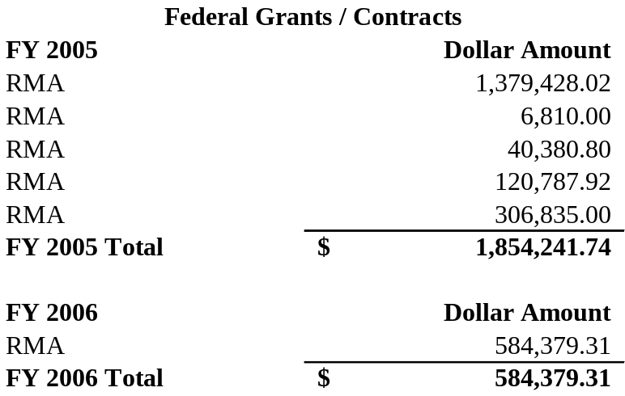


Signature: __________________________________________.
Tim J. Watts
President
Watts and Associates, Inc

Appendix B

Congressional Research Service Memorandum
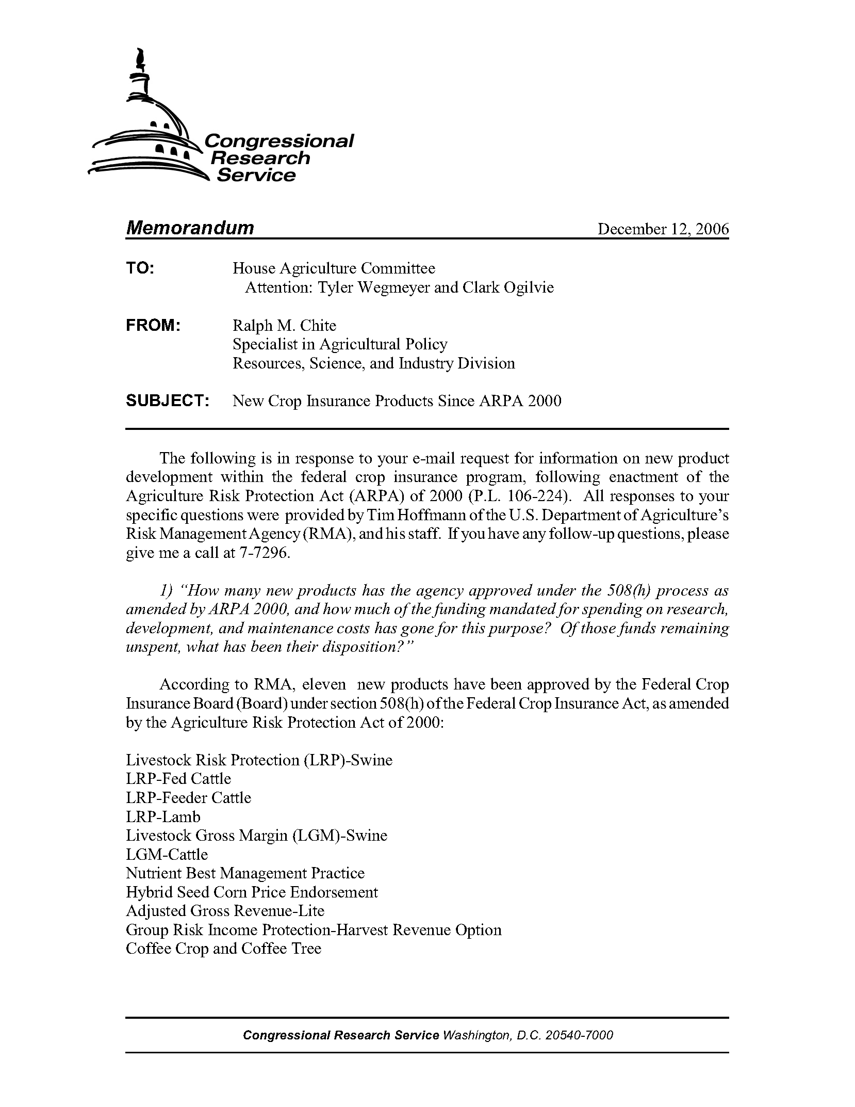
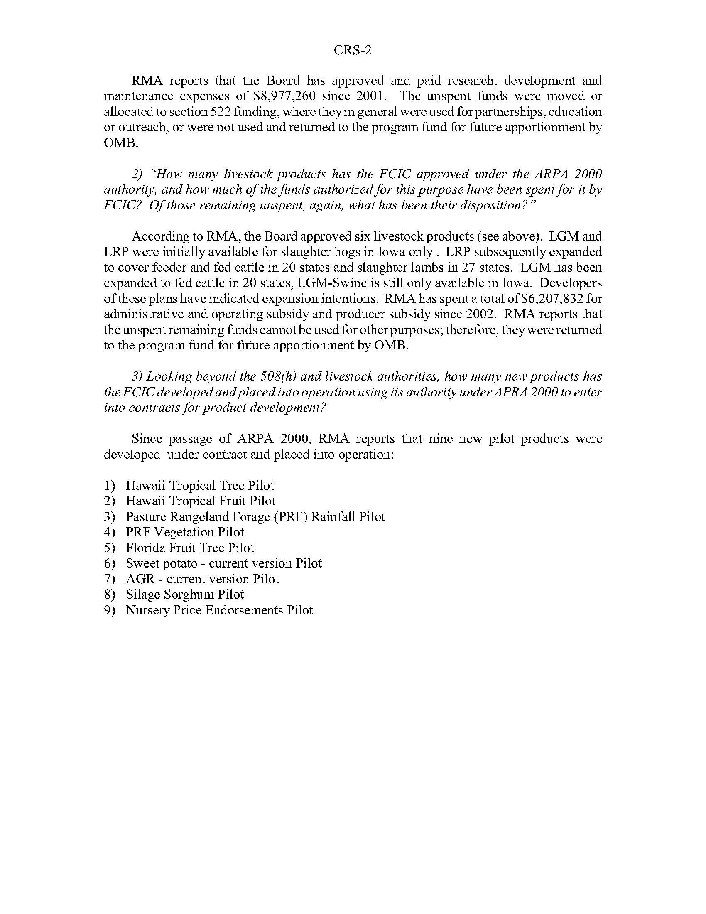

Appendix C

Proposed Legislative Language

Expanding the Safety Net:
As Approach to Making the 508(h) Process
More Friendly to Producer Groups and Developers

Legislative Language:

Section 522 of the Federal Crop Insurance Act (7 U.S.C. 1522) is amended by –

(a) Striking subsection (b)(1) and replacing it as follows:

“(b) Reimbursement of research, development, and maintenance costs
“(1) Research and development reimbursement
“The Corporation shall provide a payment to reimburse an applicant for research and development costs directly related to a policy that –
- Is submitted to the Board following the procedures of paragraph (7) of this subsection or
(B) Is
(i) submitted to the Board and approved by the Board under section 508(h) of this title for reinsurance; and
(ii) if applicable, offered for sale to producers.”

(b) Adding at the end of subsection (b) a new paragraph (7) to read as follows:

“(7) Reimbursement Agreements.

“(i) A person proposing to prepare for submission to the Board under section 508(h) of this Act a crop insurance policy, a provision of policy, or applicable rates of premium, may apply to the Board for a reimbursement agreement.

“(ii) Applications.
“(I) The application for a reimbursement agreement shall consist of such materials as the Board may require, including
- A concept paper that describes the proposal in sufficient detail for the Board to determine whether it satisfies the requirements of subparagraph (II) of this paragraph;
- Statements of support from not less than two experts chosen from among experts approved by the Board as qualified to conduct independent reviews under section 505(e) of this Act, stating that the concept is feasible and achievable from an actuarial and underwriting perspective;

“(II) The Board shall approve the application by majority vote if it finds that:
“(i) The proposal –
  - Provides coverage to a crop, hazard, or region not traditionally or adequately served by the Federal crop insurance program;
  - Provides crop insurance coverage in a significantly improved form;
  - Addresses a recognized flaw or problem in the program; or
  - Introduces a significant new concept or innovation to the program.
- The applicant demonstrates the necessary qualifications to complete the project successfully in a timely manner with high quality, and has pre-qualified for contract payment rates with the General Services Administration; and
- The proposed budget and timetable are reasonable.

“(iii) Agreements.
- Upon approval of the application, the Board shall enter into an agreement with the person for the development of a formal submission meeting the requirements for a complete submission established by the Board under section 508(h) of this Act. Payment for work performed under the contract shall be based on rates previously approved by the General Services Administration, or a fixed price based upon those rates, and the limitations of paragraph (6) of this subsection shall not apply. The parties may terminate the agreement at any time by mutual consent. If the agreement is terminated at any time prior to final approval of the submission, the submitter shall be entitled to payment of all costs incurred to that point, or, in the case of a fixed rate agreement, an appropriate percentage.

“(iv) The Board shall consider any product submitted to it developed under this paragraph under the rules it has established for products submitted under section 508(h) of this Act, except that --
- If the Board ultimately finds the submission to be incomplete under its standards for qualifying for outside expert review and the developer has not corrected the submission after being given an opportunity to do so, the payment due to the submitter under the agreement established under subparagraph (ii) shall be reduced by twenty-five percent.
- If the Board finds that the submission is complete, but the submission fails to win final Board approval, the amount due the submitter will be reduced by 15 percent.
- If the Board approves the submission, the reviewer will be paid 100 percent of the amount due.
- Notwithstanding the limitations of section 505(e)(3) of this Act, the independent experts chosen to conduct reviews of the submission shall include --
  - The Risk Management Agency; and
  - The Office of General Counsel.

