Written Statement for the Record

Jack M. Geller, Ph.D.
President, Center for Rural Policy & Development
Saint Peter, Minnesota

Before the United States House of Representatives
Committee on Agriculture
Subcommittee on Specialty Crops, Rural Development
and Foreign Agriculture

May 1, 2007

The Center for Rural Policy & Development is a not-for-profit, nonpartisan policy research organization dedicated to benefiting Minnesota by providing its policymakers with an unbiased evaluation of issues from a rural perspective.

600 South Fifth Street, Suite 211, Saint Peter, Minn. 56082 – (507) 934-7700
Email: jgeller@ruralmn.org On the web: www.ruralmn.org
Chairman McIntyre, members of the subcommittee, it is indeed an honor to have the opportunity to provide input as you and your colleagues take up the important task of crafting a new farm bill. My name is Jack M. Geller, president of the Center for Rural Policy & Development in Saint Peter, Minnesota. The Center is Minnesota’s only nonprofit, nonpartisan rural policy research center. As such, we are dedicated to researching, understanding and advising Minnesota’s policymakers on the forces that impact rural Minnesotans and the communities they reside in.

My comments this afternoon will be limited in scope and will focus on the importance of having accessible and affordable high-speed telecommunications infrastructure throughout rural America. In that discussion I will touch upon the adoption and deployment of such infrastructure throughout rural Minnesota and what we have learned about the value of having good objective data on the utilization and consequences of broadband technology to Minnesota policymakers, industry executives and rural organizations.

Since the turn of the 21st century, added emphasis has been placed at both state and national levels on the status of the telecommunications infrastructure throughout rural America. As our nation’s economy continues to rapidly transform into a technology-driven, information-based economy, the ability to access advanced telecommunications services has become vital. As FCC Commissioner Michael Copps noted last month after learning of a new OECD report that dropped the United States in its ranking from 12th to 15th among the OECD nations in broadband penetration, “These rankings are not a beauty contest. They’re about our competitiveness as a country and creating economic opportunity or all of our people.” Accordingly, it has become clear that without the advanced telecommunications tools and resources to adequately compete in the national and global marketplace, businesses and industries throughout rural America will continue to be at a serious disadvantage.

But as you know, business applications and economic competitiveness are not the only factors behind the need for these high-speed connections. Unlike the static Internet applications of yesterday, today’s more modern and sophisticated applications are designed with the assumption that the end user has a high-speed or broadband connection. Whether it’s for social networking, personal entertainment, research, or the delivery of public services, modern Internet applications utilize the transfer of extremely large audio, video, data and graphics files that at best will frustrate the dial-up user and at worst, completely overwhelm a dial-up connection and render it useless.

Further, please understand that the need for broadband is not limited to popular video sites as YouTube or audio sites such as iTunes. One area often left out of such discussions are the efforts that state, local and federal governments expend to find efficiencies in the delivery and processing of public services on the Internet. Today we know that a significant percentage of Americans file their incomes taxes online, but we often do not consider that the majority of businesses routinely pay quarterly sales taxes, unemployment taxes and other business taxes on line. In fact, the Internet is quickly becoming the primary method by which businesses interact with their government. Further, today in Minnesota you can purchase your car license tabs, local building and other permits, pay your municipal utility bills and even file for unemployment benefits online. Undoubtedly, our federal, state and local governments will continue to aggressively accelerate their efforts to seek efficiencies by pushing more and more public services onto the Internet. Further, now that we officially have electronic voting machines in many states, don’t be surprised we start hearing about pilot tests of actual online voting before the expiration of this next farm bill. Imagine -- the ability to participate in our democratic process with an Internet connection.

And it is for these very reasons that federal agencies such as the USDA Rural Utilities Service have put funding programs in place to assist rural America in remaining viable, economically competitive – and connected.

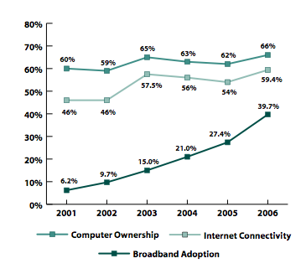
As a result of the Internet’s rapid and functional integration into our daily lives, the Center for Rural Policy and Development decided back in the year 2000 to begin to annually monitor the adoption, diffusion and utilization of these digital technologies throughout rural Minnesota. Working with both government and telecommunications industry groups, we have amassed over the years a valuable longitudinal database which allows both policy makers and industry groups to better understand how rural Minnesotans are engaging these newer digital tools.

Figure 1: Computer ownership, internet connectivity
and broadband adoption in rural Minnesota 2001-2006.

Accordingly, as once can see from Figure 1, while there has been a modest increase in home computer ownership and slightly higher gains in Internet connectivity throughout rural Minnesota households since 2001, there has been an unmistakable linear increase in broadband penetration, as rural Minnesotans switch from their dial-up connections to broadband connections. In fact, at the end of 2006 we reported that 39.7% of rural Minnesota households subscribed to a broadband service. This is just a few a percentage points below the national subscription rate of 42% as reported by the PEW Internet and American Life Project.

Of course, the adoption of high-speed telecommunications services is simply not possible if such broadband services are not accessible and available throughout rural America. And it was for that simple reason that we also began to work with Minnesota’s broadband providers to monitor the deployment of broadband services as well. The outcomes of these monitoring efforts have been valuable to policymakers, broadband advocates and industry officials, as we no longer need to make generalizations based upon case-specific or anecdotal events.
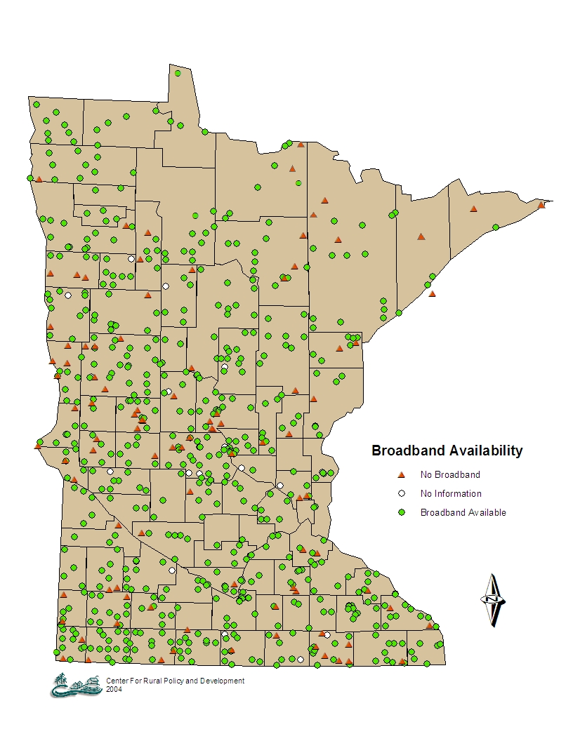
Figure 2. Broadband availability in Minnesota

As one can see from Figure 2, access to broadband services, while not ubiquitous, is quite widespread throughout rural Minnesota; as the green dots on the map designate communities that have access to at least one broadband provider, red triangles represent communities that do not have a broadband provider and a few white dots represent rural markets where we were simply unable to confirm access to broadband services. Overall, more than 85 percent of Minnesota’s rural communities have access to at least one broadband provider and more than one-third have access to competitive broadband services.

Essentially, today in rural Minnesota if you live within the municipal boundaries of our more than 800 cities and towns, there is a very high probability that you will have access to at least one broadband provider. However, we cannot sound so optimistic if you reside outside these municipal boundaries. Across Minnesota’s countryside, accessibility and availability of broadband services is considerably less consistent. And in Minnesota, more than 900,000 residents currently live outside these municipal boundaries.

USDA as the Federal Lead

Among the federal agencies designated to assist rural communities with their advanced telecommunications infrastructure, the USDA Rural Utilities Service is clearly the most comprehensive. With more than $1 billion appropriated, the Rural Utilities Service enables communities through its Rural Broadband Access Loan Program, its Community Connect grant program and its Distance Learning and Telemedicine grant program. Clearly, without the Rural Utilities Service funding, access to advanced telecommunications technologies throughout rural America would be even further behind.

The Need of Better Information

But the reality is that in spite of all this added emphasis on advanced telecommunications services, there is embarrassingly poor information and data on the adoption, diffusion, deployment and utilization of these advanced technologies throughout rural America. Broadband adoption rates and utilization patterns are poorly assessed throughout rural America. This is especially true at the state-level. Agencies such as the National Telecommunications Information Administration occasionally conduct such technology assessments, but they do not differentiate rural areas from urban areas. And even the nationally-recognized PEW Foundation’s Internet and American Life project only occasionally conducts rural assessments. In fact today, the federal government still has no credible list simply identifying which communities do, or do not have access to broadband technology throughout rural America.

There is little doubt that if Rural America is going to successfully compete in this emerging information economy and create vibrant and connected communities, programs such as the USDA/RUS Telecommunications Programs will be essential. Yet, at the same time, simply funding rural infrastructure projects without fully understanding the need, the impact and the consequences will inevitably lead to untargeted and sometimes unnecessary spending. Simply put, when Congress targets federal funds for rural telecommunications infrastructure, it is generally done with some assumptions about the value of such public investments. These assumptions include:

- That Rural Businesses will be more economically competitive with access to advanced telecommunications technology.
- That Rural Communities will be better able to recruit new and retain existing businesses with access to advanced telecommunications technology.
- That Rural Residents will be more connected; enhance quality-of-life opportunities; be able to telecommute; start-up home-based businesses; and more easily access online educational opportunities with these technologies.
- And That Rural Governments will be better able to provide access to public services and serve their constituencies more effectively by enhancing their online services.

Accurate data and information on the availability and consequence of this significant public investment is essential. Such information will help target future investments, establish “best practices” in broadband adoption strategies, and provide the type of information that policymakers at both the state and national levels need to make sound telecommunications policy decisions.

So while the Rural Utilities Service may have accurate information about the number of borrowers and grantees, or loan repayment schedules and loan default rates, more substantive questions go unanswered:

- Are rural communities better able to retain and recruit businesses as a result of these telecommunications investments?
- Are such investments better enabling rural entrepreneurs to start-up new businesses or increase their market share?
- Is the rural regional economy more competitive as a result of USDA’s public investments in telecommunications infrastructure?
- Are rural residents enhancing their online educational opportunities as a result of these public investments?
- Are rural governments better able to offer citizens enhanced choices in the delivery of public services as a result of these public investments?

The answers to questions such as these that address the substantive consequences of public investments in the rural telecommunications infrastructure would be invaluable to policymakers and agency officials in help target future investments.

Recently the Federal Communications Commission validated the importance of such information when they announced their effort to determine whether high-speed Internet access is being made available fast enough, calling it “critical” to the nation’s economy. Specifically, the FCC emphasized the need to assess the availability of broadband service in rural and other under-served areas, along with the need to improve data collection methodologies on wireless broadband services.

Equally, if not most importantly, agencies such as the Rural Utilities Service need such data to provide objective feedback on the impact of their programs, to make the necessary adjustments and modifications that all program managers must make from time to time. And USDA Rural Development state directors also need to better understand the consequence of these telecommunications investments as they coordinate them with their portfolio of housing, infrastructure and business development programs to further advance their important mission throughout rural America.

In closing, allow me to offer the observation that if the USDA Rural Utilities Service were a technology company making such sizeable technology investments, it would be unheard of that it were not spending a sizeable percentage of its revenues on research and development. The need to understand the consequences and outcomes of these public investments is evident. Allow me to suggest that in the case of the USDA Rural Utilities Service, a simple 2-5 percent set-aside of program and loan funds for such research & development would be one the best investment strategies that Congress could make.

Chairman McIntyre, members of the subcommittee, thank you again for this opportunity to address you on this important matter.
Committee on Agriculture
U.S. House of Representatives
Required Witness Disclosure Form

House Rules* require nongovernmental witnesses to disclose the amount and source of Federal grants received since October 1, 2004.

Name: __Jack Mitchell Geller_____________________

Address: __129 Ironwood Court, Mankato, MN 56001___

Telephone: ___507-934-7700___________________________

Organization you represent (if any): _Center for Rural Policy & Development_

1. Please list any federal grants or contracts (including subgrants and subcontracts) you have received since October 1, 2004, as well as the source and the amount of each grant or contract. House Rules do NOT require disclosure of federal payments to individuals, such as Social Security or Medicare benefits, farm program payments, or assistance to agricultural producers:

Source:____________None__________________________ Amount:______0_______

Source:__________________________________________ Amount:_______________

2. If you are appearing on behalf of an organization, please list any federal grants or contracts (including subgrants and subcontracts) the organization has received since October 1, 2004, as well as the source and the amount of each grant or contract:

Source:____________None__________________________ Amount:_______0_______

Source:__________________________________________ Amount:_______________

Please check here if this form is NOT applicable to you: _________________________

Signature:______________________________________

* Rule XI, clause 2(g)(4) of the U.S. House of Representatives provides: Each committee shall, to the greatest extent practicable, require witnesses who appear before it to submit in advance written statements of proposed testimony and to limit their initial presentations to the committee to brief summaries thereof. In the case of a witness appearing in a nongovernmental capacity, a written statement of proposed testimony shall include a curriculum vitae and a disclosure of the amount and source (by agency and program) of each Federal grant (or subgrant thereof) or contract (or subcontract thereof) received during the current fiscal year or either of the two previous fiscal years by the witness or by any entity represented by the witness.

PLEASE ATTACH DISCLOSURE FORM TO EACH COPY OF TESTIMONY.
Committee on Agriculture
U.S. House of Representatives
Information Required From Non-governmental Witnesses

Jack M. Geller Ph.D. is the founding President of the Center for Rural Policy and Development in St. Peter, Minnesota. The Center is Minnesota’s only nonprofit, non-partisan, rural policy research center; and as such, is dedicated to the study of the economic, social and political forces that impact rural Minnesotans and the communities they reside in.

Dr. Geller received his doctorate in rural sociology from Iowa State University in 1986. Since 2001 he has annually conducted statewide studies and has written extensively on the adoption, diffusion and deployment of high-speed Internet (or broadband) services throughout rural Minnesota.

Prior to his appoint at the Center, Dr. Geller served as Director of Health Services Research at the Marshfield Medical Research Foundation (Marshfield, WI), where he assisted in the development of a system-wide telemedicine project that is still in use today.

From 1987-1996 Dr. Geller served as Professor of Community Medicine and Rural Health; and from 1991-1996 he served as Director of the Center for Rural Health at the University of North Dakota School of Medicine & Health Sciences. During his tenure at the University of North Dakota, Dr. Geller helped create and was a governing board member of the “Rural Health Telecommunication Project”; a five-year $4 million federally-funded demonstration project designed as a statewide interactive video system, linking eleven state-supported institutions of higher education throughout the state of North Dakota.

Jack, his wife Diane and their four children reside in rural Mankato, Minn. Township.

