

This document is superseded effect January 2008
by the Federal Depository Library Handbook.

To find the most recent current information go to the new URL located at:

<http://www.fdlp.gov/handbook/index.html>.


U.S. GOVERNMENT PRINTING OFFICE
FEDERAL DEPOSITORY LIBRARY PROGRAM

INSTRUCTIONS TO DEPOSITORY LIBRARIES

Revised July 2000

Library Programs Service
Superintendent of Documents
U.S. Government Printing Office
Washington, DC 20401

U.S. Government Printing Office
Michael F. DiMario, Public Printer

Superintendent of Documents
Francis J. Buckley, Jr.

Library Programs Service
Gil Baldwin, Director

Library Division
Sheila M. McGarr, Chief

Instructions to Depository Libraries

Revised July 2000

Library Programs Service
Superintendent of Documents
U.S. Government Printing Office
Washington, DC 20401
2000

Table of Contents

Preface v

Introduction vii

Chapter 1: Federal Depository Status 1

Chapter 2: Collection Development 5

Chapter 3: Bibliographic Control 11

Chapter 4: Maintenance 19

Chapter 5: Human Resources 27

Chapter 6: Physical Facilities 29

Chapter 7: Public Service 31

Chapter 8: Cooperative Efforts 35

Chapter 9: Regional Services 39

Exhibits 43

Appendix A: Glossary 57

Appendix B: List of URLs for FDLP/GPO Sites 61

Index 65

Preface

The basic operating principles of the Federal Depository Library Program (FDLP) are stated in its authorizing legislation, Title 44, United States Code, Chapter 19. Additional rules, regulations, and guidelines are necessary to successfully accomplish the goals of a program with the complexity and scope of the FDLP. The Instructions to Depository Libraries, together with the Federal Depository Library Manual and the Guidelines for the Federal Depository Library Program form the body of regulations governing the operation of the FDLP.

The Instructions to Depository Libraries are the official rules and regulations of the Federal Depository Library Program. These Instructions are prepared by Library Programs Service staff and form the basis for evaluating depository library operations in self-studies and inspections.

The Federal Depository Library Manual is a practical guide for carrying out FDLP operations in depository libraries. The Manual was prepared by a committee of depository librarians, in conjunction with Library Programs Service staff. It suggests and recommends, rather than prescribes, methods of operation.

The Guidelines for the Federal Depository Library Program, a Manual appendix, state program and performance goals and minimum standards for depository libraries and for the Government Printing Office. They should be referred to when establishing a depository or when writing service and performance policies for an FDLP library.

The Guidelines were prepared by the Depository Library Council to the Public Printer, in conjunction with the entire depository library community, and were endorsed by the Public Printer. The purpose of the Instructions, Manual, and Guidelines is to ensure that Federal Government information products are readily accessible to the public through the FDLP.

Introduction

The Federal Depository Library Program (FDLP) was established by Congress to ensure that the American public has access to its Government’s information (Title 44, United States Code, Chapter 19). For more than 140 years, depository libraries have supported the public's right to Government information by collecting, organizing, and preserving it, and by providing assistance to users.

The FDLP is based upon three principles:

- With certain specified exceptions, all Federal Government information products shall be made available to Federal depository libraries.

- Federal depository libraries shall be located in each State and U.S. Congressional District in order to make Government information products widely available.

- That Federal Government information in all media shall be available for the free use of the general public.

Chapter 19 of Title 44 of the United States Code is the authority for the establishment and operation of the FDLP. Materials received in deposit by libraries remain the property of the U.S. Government. Libraries become the custodians of these resources. The legal responsibilities of Federal depository libraries fall into the broad categories of access, maintenance, and service:

- Providing for free public access to Federal Government information products regardless of format.

- Providing for the proper maintenance of the Federal depository materials entrusted to the individual depository's care.

- Providing service to meet Government information needs of the local community and surrounding area.

As these three areas touch on nearly every aspect of library operations, the Instructions to Depository Libraries are issued in order to give more specific guidance to documents staff. The Instructions are organized into nine chapters. Each chapter deals with a specific aspect of the depository operation.

All depositories must conform to the procedures set forth in these Instructions.

The Instructions to Depository Libraries are the official rules and regulations of the Federal Depository Library Program. Depository librarians must ensure that all personnel concerned with any aspect of the depository operation are made aware of the importance of the Instructions. Depository staff should review the Instructions at least semiannually. Any questions can be sent via askLPS at

- <http://www.access.gpo.gov/su_docs/
fdlp/tools/asklps.html>

or by e-mail at

- <asklps@gpo.gov>.

If you would like an additional copy of the Instructions, an electronic version can be found at

- <http://www.access.gpo.gov/su_docs/
fdlp/pubs/instructions>.

Documents staff may request additional written materials or information by mail, telephone, or e-mail to:

Chief, Depository Services
U.S. Government Printing Office
Library Programs Service (SLLD)
Washington, DC 20401
Phone: (202) 512-1119
Fax: (202) 512-1432
E-mail: asklps@gpo.gov

Chapter 1 Federal Depository Status

- Federal Depository Library Program
- Designation
- Depository Termination Procedure
- Additional Information

A. Federal Depository Library Program

The Federal Depository Library Program (FDLP) originated in the early 1800's when a joint resolution of Congress directed that additional copies of the House and Senate Journals and other documents be printed and distributed to institutions outside the Federal establishment.

From that small beginning, the FDLP has grown into a system of nearly 1,350 Federal depository libraries. These libraries include many of the most prestigious libraries in the country as well as smaller local libraries. With few exceptions, all congressional districts and territories of the United States have at least one Federal depository library.

B. Designation

The FDLP was established to provide Federal Government information products at no cost to designated depository libraries. Depository libraries, in turn, provide local, no-fee public access in an impartial environment with professional assistance to information produced by the Federal Government. While many libraries request status as a Federal depository to benefit their primary patrons (students, judges, residents of a political jurisdiction, etc.), all libraries that receive status make a legal commitment to provide Federal Government information to all of the people of the local U.S. Congressional District or relevant region.

There are two ways in which a library can receive depository status. The first way is through designation by Members of Congress. The second is through designation by other elected or appointed Government officials for certain types of libraries for which there are special provisions in Title 44, United States Code.

Most of the libraries in the FDLP are designated by Members of Congress. Each U.S. Representative can designate up to two libraries if there are vacancies in the Representative’s congressional district. Each U.S. Senator can designate up to two libraries anywhere in the Senator’s state, if there are vacancies available.

Libraries falling under Title 44 provisions, or “by-law” libraries, include:

- Land grant college libraries;
- State libraries;
- Library of the highest appellate court of a state;
- Federal executive department libraries;
- Independent agency libraries;
- Service academy libraries;
- Accredited law school libraries; and
- Libraries specified in a special act of Congress.

The Public Printer designates libraries of land grant colleges; the library of a State’s highest appellate court, State libraries, and law school libraries. The Superintendent of Documents designates Federal agency libraries.

More detailed information can be found in the printed Designation Handbook for Federal Depository Libraries, which is available upon request from the Chief of Depository Services. It also can be found at

- <http://www.access.gpo.gov/su_docs/
fdlp/pubs/desig.html>.

In accepting the privilege of Federal depository library status, the library director has agreed to abide fully by the laws and regulations governing officially designated Federal depository libraries.

C. Depository Termination Procedure

The library has the right to voluntarily relinquish its depository privilege if the library finds that it cannot meet the legal obligations set forth in the Instructions and other administrative directives. After making this determination, the library should address a letter to the Superintendent of Documents stating that the library no longer wishes to be a depository for U.S. Government publications. As each depository library is served by a designated regional depository, the regional should also be notified of this decision.

Correspondence should be addressed to:

Superintendent of Documents
U.S. Government Printing Office (SD)
Washington, DC 20401

A library's depository status may be terminated by the Superintendent of Documents if the library fails to meet the requirements as set forth in the law, or consistently disregards notices and instructions, resulting in unnecessary expense to the Government in administering the program.

Upon termination of the depository privilege, either by request or for cause, the library shall request instructions from its regional depository concerning disposition of the depository publications on hand. The regional has the authority to claim whatever it wishes for its own collection or other selective depository needs in the state or region.

If the library wishes to keep certain publications that were received under the FDLP, it may request to retain them. The library must submit a list of the depository publications it wishes to keep to the regional library. A written request for permanent retention of the materials should accompany the list. Each request will be reviewed on an individual basis and the regional depository will advise the relinquishing depository of the retention decision.

D. Additional Information

Additional information concerning depository designation and/or termination procedures can be obtained by contacting:

Chief, Depository Services
U.S. Government Printing Office
Library Programs Service (SLLD)
Washington, DC 20401
Phone: (202) 512-1119
Fax: (202) 512-1432
E-mail: asklps@gpo.gov

Chapter 2 Collection Development

- Purpose
- Scope of Collection Development
- Selection Tools
- Item Number System
- Updating Selection Profiles
- Selective Housing

A. Purpose

Congress established the FDLP to help fulfill its responsibility to inform the public on the policies and programs of the Federal Government. All depositories share in this responsibility.

Providing no-fee public access to Federal Government information is the guiding principle under which public officials designate depository libraries; therefore, the Federal Government information needs of the general public must influence the collection development of depository libraries.

B. Scope of Collection Development

A majority of libraries that are designated depositories have, as their primary mission, a commitment to serve a particular patron group (students, judges, etc.). While these libraries focus collection development more closely on the needs of their primary patrons, they must not ignore the Federal Government information needs of the general public. Program and performance goals for collection development appear under Section 3 in the Guidelines for the Federal Depository Library Program at

- <http://www.access.gpo.gov/su_docs/
fdlp/pubs/fdlm/guidelin.html>.

Most depositories are designated to serve a particular U.S. Congressional District. The number of depositories in a congressional district, the geographic area of the congressional district, the type of library, and even the existence of established interlibrary cooperative arrangements, could dictate a local public service area other than the U.S. Congressional District. These local public service areas, if different from the congressional district, should be negotiated among neighboring depositories to ensure all areas of the congressional district are served.

All depositories should select or provide electronic access to titles from the "Basic Collection" found in the Federal Depository Library Manual at

- <http://www.access.gpo.gov/su_docs/
fdlp/pubs/fdlm/basic.html>.

Libraries may also purchase a commercial equivalent of depository items. Relevant print and electronic indexes should be available in the depository to facilitate access to the resources of the documents collection.

As it is increasingly difficult for one depository to meet the Federal Government information demands of a varied population, the collection development of a depository should not be considered in isolation. The FDLP is a system of cooperating libraries. All depositories are part of this larger system. The Item Lister at

- <http://www.access.gpo.gov/su_docs/
fdlp/tools/itemlist.html>

and the Documents Data Miner at

- <http://govdoc.wichita.edu/ddm/
GdocFrames.asp>

can be used to identify selections of other depositories.

Depository libraries, either solely or in conjunction with neighboring depositories, will make demonstrable efforts to identify and meet the Federal Government information needs of the congressional district or local area.

One such effort is the formulation and implementation of a written depository collection development policy that specifically articulates the library's strategy for identifying and meeting the Federal Government information needs of the local area. The collection development policy should also address procedures for obtaining documents requested by patrons but not selected by the library; inter-depository coordination of selections; resources available locally; and interlibrary loan services. This policy can be formulated using the same criteria discussed in Chapter 2 of the Federal Depository Library Manual at

- <http://www.access.gpo.gov/su_docs/
fdlp/pubs/fdlm/93fdlm.html#2>.

The Collection Development Guidelines for Selective Federal Depository Libraries, in the Federal Depository Library Manual Supplement also provides guidance. These Guidelines are available at

- <http://www.access.gpo.gov/su_docs/
fdlp/pubs/fdlm/coldev.html>.

Select only those items best suited to the needs of your local area and U.S. Congressional District. Selective depositories are not required to receive all U.S. Government information products that are made available to depositories through the FDLP.

In order to meet public needs, the library's percentage of item number selections should be appropriate for its type and size. An appropriate level of selections should be at least one-half the average item selection rate of libraries of similar type and size. A table of selection rate percentages is published irregularly in Administrative Notes and is available at

- <http://www.access.gpo.gov/su_docs/
fdlp/coll-dev/itemchrt.html>.

Libraries with selection rates below one-half or far in excess of the national average for libraries of similar size and type must document that their selection rate meets public needs in its written collection development policy. However, item selection percentages are only one factor used when assessing effective collection development. Also taken into consideration are the depository's proximity to other depositories, curricula, mission, Internet use, and commercial products acquired.

The transition to a more electronic FDLP will complicate traditional measures of evaluating this category. With more items now moving online, links to important information from the depository web page play a more crucial role. For this reason, links to GPO Access, the FDLP Electronic Collection, and other appropriate links to Government information should be prominently displayed on the library’s web site. The ability to catalog and link to "e-documents" directly from the Online Public Access Catalog (OPAC) will also become more important. Depository staff should stress access over ownership.

C. Selection Tools

The basis for selection is the List of Classes of United States Government Publications Available for Selection by Depository Libraries and the Union List of Item Selections. The List of Classes is a list of currently available products sorted by Superintendent of Documents (SuDocs) classification stem including item number, format, etc. While there may be several products in a variety of media listed under each item number, products can be selected only by item number. The List of Classes is updated semiannually in paper and monthly on the Federal Bulletin Board (FBB) at

- <http://fedbbs.access.gpo.gov/libs/
class.htm>.

The Union List of Item Selections is updated monthly on the FBB at

- <http://fedbbs.access.gpo.gov/libs/
unionl.htm>.
These lists include those series or groups of publications having public interest or educational value which are issued by the various departments and agencies of the U.S. Government. Excluded from the lists are publications issued for strictly administrative or operational purposes which have no public interest or educational value, those classified for reasons of national security, and so-called "cooperative publications" which are documents which must be sold in order to be self-sustaining.

Entries for cooperative publications appear in the Monthly Catalog of United States Government Publications. Their continued existence depends on funds raised by selling copies of the publications. For this reason, printed versions are not available for free distribution through the FDLP. Such titles as the National Union Catalog, Federal Reserve Bulletin, Prologue, and Smithsonian fall within this category.

The Monthly Catalog of U.S. Government Publications consists of bibliographic records of products in all media identified and/or distributed by the FDLP. The Catalog is also available in an abridged paper version. The online Catalog of U.S. Government Publications is updated daily and is available at

- <http://www.gpo.gov/catalog>.

The foundation of the depository collection should come from Chapters 2 and 3 in the Federal Depository Library Manual. These include items that have been identified by practicing depository librarians as suitable for their type and size of library. The Suggested Core Collection list in Appendix A of the Manual can be examined at

- <http://www.access.gpo.gov/su_docs/
fdlp/pubs/fdlm/corelist.html>.

Maps Available for Selection are listed in Appendix B of the Federal Depository Library Manual at

- <http://www.access.gpo.gov/su_docs/
fdlp/pubs/fdlm/93fdlm.html#appB>.

D. Item Number System

Depository libraries select documents by categories. Each category is identified by a unique item number. The item number assigned to a series generally remains the controlling number for that series regardless of change of title, transfer of the series or its publishing agency within the Federal Government, or change in the name of the issuing agency.

An item number assigned to a series may also govern the distribution of closely related series of a similar nature, e.g., numbered manuals with similar content issued by the same agency. In this instance, the library selecting this item would receive the related series as well.

The addition of new series to item numbers is announced on shipping lists and in Administrative Notes Technical Supplement at

- <http://www.access.gpo.gov/su_docs/
fdlp/pubs/techsup >.

The Technical Supplement is searchable on-line via the WEBTech Notes service at

- <http://www.access.gpo.gov/su_docs/
fdlp/tools/webtech.html>.

For agencies whose scope and publications are limited, e.g., Fine Arts Commission, Marine Mammal Commission, etc., one item number has been established to cover all publications issued.

New depositories will begin receiving items they have selected within one month of receipt by GPO of their item selection profile. All other selections are dependent upon the annual item selection update cycle.

Libraries should retain historical files as they may contain information about when an item was selected, dropped, discontinued, superseded, changed format, changed SuDocs class number, sent to a selective housing site, etc. If these data are vital to the administration of the depository operation, be cautious about the disposition of item cards. If item cards are no longer maintained by the library, other means of establishing the item selection history must be in place, e.g., archiving copies of the Item Lister records, maintaining a local database, customizing electronic files from data downloaded from the Federal Bulletin Board, FDLP Desktop, etc.

E. Updating Selection Profiles

Depositories are notified by GPO shortly before each annual item selection update cycle begins. It is important that selections be centrally coordinated within the library and accurate records kept to avoid misunderstandings. Changes to a library's selection profile are made by inputting item numbers using the Amendment of Item Selections procedure at

- <http://www.access.gpo.gov/su_docs/
fdlp/tools/amendment.html>.

Additions to selections may be made only during the annual item selection update cycle or an item survey. All selections should be reviewed regularly to ascertain their appropriateness and to adjust selections to the changing Federal Government information needs of patrons. Depository staff should consult the List of Classes and Administrative Notes Technical Supplement to verify the availability of items.

GPO recommends that a zero-based review be conducted annually, or at least every 2 or 3 years. Zero-based means to review non-selections as well as existing selections for pertinence to one's community information needs using the List of Classes and other selection tools.

If some currently selected items are judged inappropriate for the collection, these items should be deleted from the library’s selection profile promptly. Deletions can be made at any time and become effective within 72 hours of submission. When an item is dropped, however, all materials previously received under the item number unless superseded must still be retained for the statutory five-year retention period before they can be offered on a disposal list to the regional library.

A list of each depository library's selections is available using the Item Lister at

- <http://www.access.gpo.gov/su_docs/
fdlp/tools/itemlist.html>

and the Documents Data Miner at

- <http://govdoc.wichita.edu/ddm/
GdocFrames.asp>.

New item selections from the annual item selection update take effect after October 1. New selections will not be distributed until after that date. Libraries cannot claim new selections before October 1. Publications cannot be furnished retroactively. New selections can only be furnished to libraries as new items are ordered by and printed for the issuing agency.

Regional depository libraries receive nearly all depository items shipped by GPO. Some publications, such as Congressional hearings and the Federal Register, are issued in both paper and microfiche formats. Regionals may select both formats or only one. Selective depositories should depend upon the regional for seldom-used items.

On rare occasions, the Government Printing Office (GPO) receives only a limited number of copies of a publication from a department or agency for distribution to depository libraries. These copies are sent to all designated regional depositories; the remainder is made available to selective depositories through a "special offer" on a first-come, first-served basis. These materials are usually retrospective runs of series. These special offers are announced through Administrative Notes, notices on the depository shipping lists, or on the FDLP Desktop.

Cooperative collection development and interlibrary loan can also provide access within a local area to rarely used items. The Documents Data Miner, a State Plan, or consortia can assist with these activities.

Depository librarians are now permitted to substitute electronic versions as the sole "copy" for some tangible FDLP publications provided the electronic version is complete, official, and permanently accessible. These conditions are outlined in FDLP Guidelines on Substituting Electronic for Tangible Versions of Depository Publications at

- <http://www.access.gpo.gov/su_docs/
fdlp/coll-dev/subguide.html>.

F. Selective Housing

A library may selectively house a percentage of its depository publications at other libraries or institutions. The designated library will still be legally responsible for these materials, and for their receipt, initial processing, and disposition.

The selective housing site must abide by all rules and regulations that govern the FDLP. Their designated library should furnish them with copies of appropriate instructions and manuals. Materials they receive remain the property of the United States Government and are governed by all public access, custody, maintenance, and public service requirements.
If the library director of the designated depository does not administer the site of the selectively housed collection, a Memorandum of Agreement (MOA) must be drawn up outlining the host institution's responsibilities to provide for free public access, and to maintain the records and materials in the documents collection. A model selective housing MOA can be found as Exhibit H or in Chapter 2 of the Federal Depository Library Manual at

- <http://www.access.gpo.gov/su_docs/
fdlp/pubs/fdlm/93fdlm.html#2>.

A copy of the MOA must be sent to the regional librarian and to:

Chief, Depository Services
U.S. Government Printing Office
Library Programs Service (SLLD)
Washington, DC 20401

Chapter 3 Bibliographic Control

- Bibliographic Control
- Shipping List
- Separates
- Processing
- Arrangement
- Claims
- Duplicate Publications and Shipments

A. Bibliographic Control

All depositories are the legally responsible custodians of Federal Government property received through the FDLP. As such, each depository will maintain a holdings record to the piece level of all depository selections received in tangible format.

A comprehensive shelflist in paper or electronic format, or any combination, must be used. Depository holdings records can be part of the entire library's shelflist. The depository documents shelflist does not have to be a separate entity.

GPO encourages on-line processing of documents. On-line processing should conform to GPO's requirements for bibliographic control of depository materials. For guidance, see GPO Guidelines for Online Processing of Depository Documents, at

- <http://www.access.gpo.gov/su_docs/
fdlp/mgt/online-proc.html>.

This record keeping requirement does not mean that a shelflist card must be generated for each piece. For instance, the holdings record for some map series could be comprised of a basic shelflist record for the map series plus checking-off the appropriate quadrangles of maps received on the index map. Chapter 3, Section 3, in the Federal Depository Library Manual, briefly describes technical processing for maps and charts at

- <http://www.access.gpo.gov/su_docs/
fdlp/pubs/fdlm/93fdlm.html#3>.

Chapter 5 in the Manual outlines various bibliographic control methods at

- <http://www.access.gpo.gov/su_docs/
fdlp/pubs/fdlm/93fdlm.html#5>.

For serials, piece level records must be maintained until the items are bound, replaced by microformat, etc. Then a holdings statement can be substituted if space in the paper or electronic database is an issue.

Marked shipping lists do not constitute a record of the library’s depository holdings and should not be used for that purpose.

Cataloging greatly enhances accessibility and patron usage and is recommended for all or part of the documents collection. Documents can be arranged according to the SuDocs classification system, other classification systems, or a combination of systems.

Many documents are extremely time-sensitive. All shipments should be unpacked and processed as they are received. Failure to do so can result in the loss of depository status.

Items not awaiting full cataloging should be processed within 10 working days from receipt of the shipment. Items that await cataloging should be sorted for easy retrieval by staff for patrons. Additional program and performance goals for bibliographic control appear in Section 4 of the Guidelines for the Federal Depository Library Program at

- <http://www.access.gpo.gov/su_docs/
fdlp/pubs/fdlm/guidelin.html>.

B. Shipping List

A complete shipment contains all the items listed on one shipping list. Most selective depositories select only a percentage of the total items available. They receive only those items which match their current selection profile. Selectives often receive several shipments, with their corresponding shipping lists, in a single shipment box. Every depository library receives a copy of each depository shipping list whether or not it selects any of the items listed.

In their shipment boxes, regional depositories receive two copies of most shipping lists. Only one microfiche shipping list is provided to regionals by the microfiche contractors.

GPO sends at least one depository shipment to every library each week. Libraries should immediately notify the Chief, Depository Distribution Division, at (202) 512-1014, if they fail to receive a weekly shipment.

Important and necessary information is often conveyed via the shipping list. Besides listing all the publications in a complete shipment, the shipping list also indicates the item numbers under which the publications were distributed, the titles and series numbers of the publications, the SuDocs classification numbers, and GPO sales information, when applicable. Depository staff should review each list carefully.

Shipping lists are used to inform libraries of new offerings and are also a quick means of informing depository libraries of additions to item numbers. New offerings are included in shipments to depositories whose selection profile indicates an interest in them. (See Exhibits A-F for sample shipping lists.) Documents staff should swiftly delete unwanted new item offerings.

Administrative Notes Technical Supplement contains information on corrections to previous shipping lists, changes to the List of Classes, and other special announcements pertaining to the FDLP.

There are five sequential numbering schemes for the materials distributed from GPO: paper (P), microfiche (M), separates (S), electronic publications (E), and National Imagery and Mapping Agency (NIMA) maps (S).

GPO’s fiscal year begins on October 1 each year. The shipping list numbering sequence re-starts each October. As an example, the sequence of shipping list numbers for fiscal year 2000 is shown below:

Paper | Microfiche | Separates
2000-0001-P | 2000-0001-M | 2000-0001-S
2000-0002-P | 2000-0002-M | 2000-0002-S
Electronic | NIMA Maps
2000-0001-E | 2000-2001-S
2000-0002-E | 2000-2002-S

The first four digits indicate the fiscal year; the next number is the sequential number of the shipping list, and the letter indicates the medium of the materials included on that shipping list.

U.S. Geological Survey (USGS) map shipping lists accompany map shipments to selecting libraries. All libraries receive all USGS shipping lists in the GPO shipment boxes as issued.

C. Separates

Separates are materials that cannot be placed in regular shipment boxes, usually because of their size or shape. Separates include maps and charts shipped from GPO, pre-packaged publications, and over-sized publications. Separate shipping lists are produced and sent in regular shipment boxes after the separates have been shipped. Separate shipping lists are clearly marked and have their own shipping list numbering sequence. (See Exhibit D.)

Libraries should immediately notify the Chief, Depository Distribution Division, at (202) 512-1014, if they fail to receive a separate shipping list within 4 weeks after receiving the separate publication, or contact

- <asklps@gpo.gov>.

D. Processing

Upon receipt of a shipment box, the shipping lists should be logged in to ensure that all shipping lists in all formats have been received. A copy of a missing or damaged list can be obtained from:

- GPO/SUNY Buffalo partnership site at
<http://ublib.buffalo.edu/libraries/
units/cts/acq/gpo/>;

- Federal Bulletin Board at <http://
fedbbs.access.gpo.gov/fdlp01.htm>;

- U.S. Fax Watch at (202) 512-1716;

- askLPS at <http://www.access.gpo.
gov/su_docs/fdlp/tools/asklps.html>;

- a neighboring depository;

- the regional library.

The List of Contractor-Issued Microfiche Shipping Lists, which also provides status reports, is available at

- <http://www.access.gpo.gov/su_docs/
fdlp/tools/msl>.

The contents of shipment boxes should immediately be checked against the shipping lists and against the item numbers currently selected. Chapter 5 of the Federal Depository Library Manual at

- <http://www.access.gpo.gov/su_docs/
fdlp/pubs/fdlm/93fdlm.html#5>

provides advice on processing incoming shipment boxes.

If a SuDocs classification number is questioned, check the paper Administrative Notes Technical Supplement or WEBTech Notes database at

- <http://www.access.gpo.gov/su_docs/
fdlp/tools/webtech.html>

and in the Catalog of U.S. Government Publications at

- <http://www.gpo.gov/catalog>.

Also review the full bibliographic record for subfield "z" in the "086" field for a canceled classification number before contacting GPO for clarification. The GPO Classification Manual at

- <http://www.access.gpo.gov/su_docs/
fdlp/pubs/classman>

can be consulted for further information.

Shipping lists do not have to be maintained after they have been initially checked as they are archived online by GPO. Many depository libraries, however, find it useful to retain them for approximately six months.

The library must mark all depository materials, regardless of format, in some manner to distinguish these items from non-depository materials. All depository materials should be dated with the shipping list date, date of receipt, or the date of processing. The date will identify depository material eligible for discarding five years after receipt.

The SuDocs classification number should be placed on all documents even if other classification systems are used. Use of the SuDocs number helps to identify materials from SuDocs citations and facilitates updating and discarding procedures. As the SuDocs number is commonly used by many other depository libraries, it provides a specific identification for borrowing and simplifies compiling or checking discard lists.

E. Arrangement

Arrangement of depository materials should conform with professionally accepted library standards and the Instructions. The arrangement should facilitate the practical use of the depository collection.

There are many advantages to using the SuDocs classification system. Librarians have found the SuDocs class numbers to be a practical and economical method for organizing Federal Government documents, and most depositories arrange the majority of their documents holdings in SuDocs classification number order. However, Federal Government publications can easily be made an integral part of library collections under any other arrangement.

F. Claims

If selected items on the shipping list are missing from the shipment, they should be claimed immediately. A raincheck, which is a form issued to depositories when insufficient copies are received for shipment, may be included in the shipment box. Only the items on a shipping list can be claimed. The shipping list is the claim form.

To claim publications missing from a shipment, use the shipping list/claim form. (See Exhibits A-F.) The form may be mailed or faxed to GPO, U.S. Geological Survey, or to the microfiche contractor depending on the requirements for that item.
Claims should be faxed whenever possible. Use the shipping list/claim form only to request publications selected but not received. Claims for items not selected will be returned unfilled.

Claims should not be made for publications selected in the annual item selection update cycle but whose selection is not yet in effect. There is a two-month delay between the deadline for returning item selection changes to GPO (annual item selection update cycle) and the date on which the amended selections become effective, which is October 1. Claims cannot be used to replace publications lost, stolen or mutilated after receipt by the library.

Always give complete information (i.e., item number, SuDocs classification number, correct series or publication title, issuing agency, and depository library number, etc.) when contacting GPO about depository publications. Additional information on how and when to contact the Government Printing Office can be found in Chapter 1 of the Federal Depository Library Manual or Contacts at

- <http://www.access.gpo.gov/su_docs/
fdlp/tools/contacts.html>.

All claims for non-receipt of publications must be submitted within 60 days from receipt of the shipping list. Claims for entire missing shipments also have a 60-day deadline. All claims should be made as soon as possible.

Do not claim "raincheck" items. When these publications are reprinted they will be distributed to the libraries. Except for the few remaining “Direct Mail” titles, do not use any method other than the shipping lists to claim depository materials. Do not make a second claim for the same item. Instead, use the askLPS web-based inquiry service at

- <http://www.access.gpo.gov/su_docs/
fdlp/tools/asklps.html>

to check the status of a claim or to submit a claim for a “Direct Mail” title. For chronic claim problems, contact the Chief of the Depository Distribution Division on (202) 512-1014 or use e-mail at

- <asklps@gpo.gov>.

The Library Programs Service of the Government Printing Office honors claims as long as a supply of claims copies remains available during the 60-day claim period, and will make every effort to provide fast and accurate service to depository libraries. However, as GPO retains only a few claims copies, the supply can be quickly exhausted. A claim form will be returned to a depository library stamped "claims copies exhausted" if GPO cannot honor the claim.

Libraries are allowed to claim only those items that they select and did not receive. Due to the limited number of claims copies available, every mistaken claim may deprive another library of a legitimate claim copy.

If the library receives a defective copy of a publication, make a claim for the publication just as if it were never received. Keep the defective copy until the claim copy is received. Once the library has replaced a defective copy with a claims copy, the defective copy may be discarded. Do not send the defective copy to GPO and do not offer it on a discard list to the regional.

To claim a publication selected but not received:

- Draw a circle around the shipping list entry of the item being claimed.

- Check every claim made against the library’s Item Lister profile.

- Stamp the shipping list with the library’s depository number/date received stamp in the upper right corner of the shipping list.

- Fill out the bottom portion of the shipping list completely, including:

- documents librarian's signature
- depository library number
- library name.

- Keep a copy of the shipping list at least until the claim has been acted upon by GPO.

- Fax or mail claims to GPO, the U.S. Geological Survey, or the appropriate microfiche contractor as indicated on the shipping list.

If you choose to use the U.S. Postal Service, mail the original copy of the shipping list to the following address:

- For paper, electronic, and separate publications, and for maps (except USGS maps), mail to:

U.S. Government Printing Office
Library Programs Service (SLDM)
Claims
Washington, DC 20401

- For microfiche, mail to:

Contractor's name
Contractor's address
Any town, US 12345

- For U.S. Geological Survey claims, fax or mail to:

U.S. Geological Survey
MS 306, ATTN: Receiving
Denver, CO 80225
Fax: (303) 202-4694

To fax claims to GPO, use (202) 512-1429 only. Faxing to any other number delays claims.

G. Duplicate Publications and Shipments

If the library receives a duplicate copy of a publication, the duplicate may be discarded immediately or offered on a discard list to the regional library. If, however, it is substantial in size or a popular publication, please telephone the Depository Distribution Division immediately on (202) 512-1014 or use e-mail to

- <asklps@gpo.gov>,

to obtain a mailing label to return it to GPO. It is important to remember that when one library receives a duplicate shipment or publication, it probably means that some other library has not received a shipment.

If the library should receive a duplicate shipment, please check the box's mailing label and the depository library number written on one of the box's flaps, to determine if the shipment should have gone to another library. The flap number is the correct indication of the depository, not the mailing label. A depository receiving an incorrect shipment can locate the address of the correct library by using the flap number and the online directory at

- <http://www.access.gpo.gov/su_docs/
fdlp/tools/ldirect.html>.

If duplicates become a chronic problem, please contact the Depository Distribution Division immediately.

Chapter 4 Maintenance

- Proprietary Interest
- Insuring Depository Collections
- Discards-General Information
- Superseded Publications
- Discards by Selective Depositories
- Discards by Regional Depositories
- Discards by Federal Libraries
- Discards by Highest State Appellate Court
- Secondary Copies
- Substitution of Depository Materials
- Microfiche
- Maps
- Posters
- Electronic Products

A. Proprietary Interest

All Government publications supplied to depository libraries under the FDLP remain the property of the United States Government and may not be disposed of, except as outlined in Chapter 4 of these Instructions. All depository materials must be housed in a manner that facilitates preservation and access.

Program and performance goals for maintenance of the depository collection appear under Section 5 in the Guidelines for the Federal Depository Library Program at

- <http://www.access.gpo.gov/su_docs/
fdlp/pubs/fdlm/guidelin.html>

and in Chapter 6, Section 1 in the Federal Depository Library Manual at

- <http://www.access.gpo.gov/su_docs/
fdlp/pubs/fdlm/93fdlm.html#6>.

Each depository library is entrusted with the custody of depository materials and must ensure they are properly preserved and protected from theft, deterioration, mold, etc. As a minimum standard for the care and maintenance of depository property, the Government Printing Office insists that their maintenance be no less than that given to commercially purchased publications.

Depository materials that are lost, worn out, or damaged should be subject to the same replacement policy that the library maintains for non-Government materials. The depository must pay for replacement copies. Claims should not be made for this material.

Many Federal Government agencies find it necessary to issue publications unbound or in paper covers. Libraries are expected to include these publications in their binding program, along with books, periodicals, and other privately purchased materials. Binders are not furnished for loose-leaf material unless the issuing agency includes them as part of its publication. Loose-leaf materials must be updated in a timely manner or de-selected.

B. Insuring Depository Collections

It would be both advisable and prudent to carry insurance covering the Federal depository part of a library's holdings. If the depository collection were to suffer any loss as a result of negligence on the part of the library, the Government could make a claim against the library for the amount of loss. Thus, depository libraries have an insurable interest, although GPO is not in a position to provide guidance as to the appropriate formula for establishing the level of coverage.

As a minimum standard for the care and maintenance of depository property, the protection given to depository materials must be no less than that given to commercially acquired publications. Most libraries carry insurance and base their insurance estimates on the cost of replacing a similar number of volumes from their commercially acquired collections. A blanket policy may therefore be sufficient. Also, as the institution responsible for the maintenance of these materials, the library should make all necessary claims, just as if it owned the materials.

In the event of a natural disaster, arson, flood, etc., the library must immediately inform the Superintendent of Documents in writing. The library must then make every reasonable effort to replace or repair the Federal Government property that has been lost or damaged.

As GPO does not maintain retrospective stock, the library might find it difficult to completely replace all missing items. As a minimum effort, however, State discard lists, GPO's Sales Program, the national "Needs and Offers" list, and commercial vendors should be canvassed in an attempt to replace those materials lost.

C. Discards-General Information

Documents distributed through the FDLP are, and remain, Government property. Depository libraries are entrusted with the maintenance of these materials while they are in the custody of the library. Depository libraries may discard these materials only in the manner prescribed by these Instructions or at the direction of a GPO official. Failure to conform to proper discard procedures can result in loss of depository status and/or legal action against the responsible parties.

The Government Printing Office is entrusted by the Congress with the stewardship of depository materials, both as tangible property and as intellectual property for free distribution and public use. Only the Public Printer, the Superintendent of Documents, or their agents can legitimately order a library to withdraw a document from its depository holdings. The Superintendent of Documents may order documents withdrawn for reasons of national security, incorrect or misleading information in a publication, or for any other cause deemed to be in the public's interest.

From time to time, the Superintendent of Documents will ask depositories to return a specific publication to GPO, or destroy it, because it is defective, or for other reasons. A letter from the Superintendent of Documents will be placed in shipment boxes and will also appear in Administrative Notes. Libraries must comply with such requests before the GPO deadline.

Libraries cannot materially or financially benefit from the disposal of depository holdings, as these materials remain Government property. After following the procedures listed below, the depository materials entrusted to the library may be sold as publications or as waste paper. The proceeds of the sale, together with a letter of explanation, must be sent to the Superintendent of Documents. Depository materials may never be bartered for goods or services.

Only the first copy of a publication is considered the depository copy. The depository copy must be discarded according to the procedures set forth in the Instructions. Any additional copies (duplicates), preprints (after the final copy has been printed) or reprints, are collectively referred to as "secondary" copies and should be disposed of according to the procedures described in Section I, Secondary Copies, below.

D. Superseded Publications

Superseded materials should be systematically identified and removed. If retained for historical purposes, they should be marked as superseded.

Publications, maps, CD-ROMs, and other depository materials that are superseded may be treated as secondary materials as soon as the update or the final version of the publication is distributed by GPO. Individual titles, serials, and series can be found in the Superseded List at

- <http://www.access.gpo.gov/su_docs/
fdlp/pubs/fdlm/suplist>.

The instructions in Sections A, B, C, and D of this chapter apply to all depository libraries.

E. Discards by Selective Depositories

Title 44, United States Code, Section 1912, authorizes regional depositories to permit selective depository libraries for which they have responsibility to dispose of Government publications which have been retained for at least five years from receipt. Discarding is a privilege granted by the regional and not a right of the selective. The regional library may refuse to grant permission for disposal of any publication that it feels should be kept by one of its depositories for a longer period of time.

The instructions contained in section E apply to all selective depositories except for Federal agency libraries and the libraries of the highest appellate court of the states. These libraries are covered in Sections G and H respectively.

Depository libraries not served by a designated regional depository library must permanently retain one copy of all Government publications received through depository distribution. The only exceptions are for superseded publications, and those issued later in another format (bound, microfiche, or electronic media). Government publications received from sources other than the FDLP may be disposed of as secondary copies or at the discretion of the individual libraries.

Depository libraries served by a regional depository may dispose of any non-superseded publication which has been retained for at least five years from receipt, only after obtaining permission and receiving instructions for such disposition from the regional depository designated to serve their area. Provided permission is received from the regional, a title may be disposed of before five years when an electronic equivalent is substituted from the Substitution List: Official FDLP Permanent Full-Text Databases at

- <http://www.access.gpo.gov/su_docs/
fdlp/coll-dev/subguide.html>.

Because of the various methods of record keeping employed (manual files, online records, etc.), selective depositories must obtain guidance from their regional depository library on the format and procedures to be followed in formulating discard lists.

After adhering to the regional's discarding procedure, the selective library may treat the offered publication as a secondary copy, if neither the regional library nor the selective libraries in the State wish to obtain it. See Section I, below, for procedures for handling secondary copies. Depositories are encouraged to participate in the national “Needs and Offers” list at

- <http://docs.sewanee.edu/nando.
html>.

F. Discards by Regional Depositories

All regional depositories must retain at least one copy of every publication received through depository distribution, except for those publications listed as superseded in the Superseded List. The regional should treat those discards from its library as "secondary" publications.

Under the FDLP Guidelines on Substituting Electronic for Tangible Versions of Depository Publications, maintaining a tangible copy within a state or region of titles from the Substitution List: Official FDLP Permanent Full-Text Databases is still part of a regional's mission. A Memorandum of Agreement between the regional and another depository is a mechanism to ensure that a tangible copy is available in perpetuity.

The regional library plays a primary role in the disposal of depository materials. The responsibilities of regional libraries regarding the handling of selective depository discards are detailed in Section C of Chapter 9 of these Instructions.

G. Discards by Federal Libraries

Depository discard procedures are different for Federal agency libraries. Depository libraries within executive departments and independent agencies of the Federal Government, as well as Federal Court libraries, may dispose of unwanted Federal Government publications after offering them to the Exchange and Gift Division of the Library of Congress. The Library of Congress accepts surplus paperbound and hardbound books in accordance with 36 CFR 701.33(4), and only in specific categories.

If agency regulations permit, the library is encouraged to also offer depository materials to the nearest regional library. Federal libraries wishing to dispose of depository materials should contact the Exchange and Gift Division of the Library of Congress for directions on discarding.

Specific instructions must be obtained from the following address:
Receiving and Routing Section
Exchange and Gift Division
Library of Congress
Washington, DC 20540-4280
Phone: (202) 707-9514
Fax: (202) 707-2086

- Discards by Highest State Appellate
Court Libraries

Although Section A of this chapter refers to all Federal depository libraries, the highest state appellate court libraries that have been designated under Section 1915 of Title 44, United States Code, have special rights. Under Federal law, they are not obligated to provide for free access; they do not have to retain publications for five years before discarding; and they do not have to discard depository materials through the regional library. All depository materials remain the property of the United States Government. Depository libraries that were designated under the provisions of Section 1915 will discard their depository holdings under the provisions established for discarding secondary copies in Section I of this chapter.

I. Secondary Copies

Secondary copies are defined as depository materials which are duplicates (including reprints), superseded (including preprints), unrequested documents sent from GPO by mistake, or the depository holdings of the highest appellate court of the state libraries.

Libraries have the option of offering secondary copies to the regional library or on statewide discard lists, if the regional so desires. All depository libraries should offer any secondary publications of value through the national Needs and Offers list. This web-based list and instructions for submission can be viewed at
- <http://docs.sewanee.edu/nando.
html>.

Placing secondary depository copies on the Needs and Offers list makes the best use of Government publications for the benefit of all depository libraries.

After this procedure has been followed to its conclusion, the library is then free to offer these depository materials to any public library or educational institution in the vicinity. Failing to find such a recipient after reasonable effort, the library may dispose of or recycle the various Government information products in all media at its discretion.

J. Substitution of Depository Materials

Permission is granted to all designated depositories to substitute purchased microcopies and CD-ROMs for any depository holdings prior to the expiration of five years, provided that they are properly referenced, can be readily located, and are easily accessible to users. Proper reading equipment must be available for their use.

As previously mentioned, with approval from the regional, permission is also granted for depositories to substitute electronic-only versions of some publications in tangible form. Guidelines have been issued for electronic substitution and can be reviewed at

- <http://www.access.gpo.gov/su_docs/
fdlp/coll-dev/subguide.html>.

The substitute copies will then be treated as depository materials for the period of time that the library would have retained the original publications and they will be subject to the same rules and regulations that govern the care, treatment, and public access to depository materials during that time period.

As all depository materials remain the property of the United States Government, the original depository holdings replaced by acquired copies must be offered to the regional library per Chapter 4, Section I of these Instructions. Substitute copies may be removed or disposed of only by following established procedures for all depository holdings. Libraries may not barter or exchange the original depository paper copy for a substitute. If disposition is by sale, the proceeds of that sale must be returned to the Superintendent of Documents.

K. Microfiche

Microfiche are processed, handled, and discarded following the procedures set forth for other documents and the regional library’s disposition guidelines.

The recommended storage temperature for microform collections is 68° F with a constant humidity level of 40%. The most important factor to consider is constancy; the temperature and humidity range should not fluctuate often, and not beyond 75° F or 50% humidity.

For this reason, it is recommended that microforms not be stored on outer walls, nor on the ground or top floors of a building; they should be kept away from air vents, radiators, and direct sunlight. Temperatures and humidity higher than the recommended levels can create fungal growth, blemishes, and chemical deterioration. Temperatures lower than recommended can cause brittleness.

Microfiche must be stored vertically (on edge and upright) in acid-free containers. The envelopes in which the Government Printing Office microfiche is shipped are acid-free, as are the inserted dividers. All paper products used in the storage of microforms (boxes, dividers, labels, envelopes) should have a pH factor of 7.0 or above.

Steel cabinets made with baked-on inert enamel finishes, stainless steel, or aluminum are recommended as storage facilities. They should have a fire rating of at least one hour. Plastic boxes, unless constructed of non-deteriorating plastic, can adversely affect microfiche. Silver halide microfiche should not be stored in the same cabinets as diazo or vesicular microfiche.

One hundred microfiche require approximately 1 inch of space in a 4" x 6" drawer (exclusive of filing guides, envelopes, and dividers). One inch of space in a drawer accommodates approximately 75 sheets of microfiche with envelopes.

Storage areas should have permanently installed smoke and heat detectors operating at all times to warn of fire. Dry chemical and carbon dioxide extinguishers should be available.

Do not use rubber bands or paper clips to store microfiche. Rubber bands often contain sulfur and are particularly damaging to microfiche over extended periods of time.

Additional information is available in Section 2 of Chapter 6 in the Federal Depository Library Manual at

- <http://www.access.gpo.gov/su_docs/
fdlp/pubs/fdlm/93fdlm.html#6>.

L. Maps

Maps are processed, handled, and discarded following the procedures set forth for other documents.

Sheet maps and charts should be housed flat, in sturdy, acid-free map cases. Only those maps pre-folded by the publisher may be stored folded. Maps can be stored in either vertical or horizontal map cases. Smaller maps that accompany other publications may be housed with the publication on the shelf or separately in a map case. If the map is housed separately from its parent publication, this fact should be noted in the depository holdings record and on the item.

Maps are often housed in a different location some distance away from the rest of the documents collection. If this other location is not under the administrative control of the depository library, a selective housing Memorandum of Agreement must be initiated between the depository and the selective housing site. Additional information on selective housing of depository materials appears in Chapter 2, Section 2 of the Federal Depository Library Manual at

- <http://www.access.gpo.gov/su_docs/
fdlp/pubs/fdlm/93fdlm.html#2>.

Maps are subject to the same processing procedures as other depository materials. It is the library's responsibility to ensure that maps that arrive through the FDLP are handled according to the rules and regulations established in these Instructions, whether the maps are housed directly in the library or selectively housed off-site. Helpful hints appear in Chapter 3, Section 3 of the Federal Depository Library Manual at

- <http://www.access.gpo.gov/su_docs/
fdlp/pubs/fdlm/93fdlm.html#3>.

M. Posters

Posters are processed, handled, and discarded following the procedures set forth for other documents. They should be housed flat and not folded or kept rolled. The preservation and proper housing of posters need not prevent them from being viewed by the public. Documents usage is a goal of the Federal Depository Library Program. Display posters whenever possible. Depositories may circulate or selectively house individual posters or series of posters at other libraries, schools, or other institutions where they might be seen and used.

N. Electronic Products

As with other depository material, there can be no disparity of treatment of electronic products vis-a-vis other library materials. As a minimum standard, the maintenance of electronic media distributed through the FDLP should be comparable to maintenance standards established for electronic media acquired by the library through commercial sources.

Owing to the delicate nature of electronic materials, they should be housed in environments that protect them from bending, scratching, or crushing. Exposure to dust, temperature extremes, and magnetic fields (such as telephones, security strip desensitizers, etc.) should be avoided.

Libraries should obtain furniture or equipment that is specifically designed for using and housing electronic products. The preferred solution is an arrangement that both protects the product and allows it to be readily accessible through local area networking. All electronic products that are stored in cabinets should be placed in a covering such as the jewel cases or protective sleeves for CD-ROMs.

Chapter 4 in the Federal Depository Library Manual provides program and procedural guidance and can be found at

- <http://www.access.gpo.gov/su_docs/
fdlp/pubs/fdlm/93fdlm.html#4>.

Chapter 5 Human Resources

- Responsible Officials
- Staffing
- Training

A. Responsible Officials

The Director of the library designated as a Federal depository is responsible for ensuring that the depository operation conforms to the legal requirements of the Federal Depository Library Program. The Director or the Director's designee (the documents coordinator) is responsible for the coordination of all depository activities within the library.

These activities include bibliographic control, reference services, training, collection development, maintenance, and other administrative responsibilities.

Program and performance goals for human resources are stated in the Guidelines for the Federal Depository Library Program at

- <http://www.access.gpo.gov/su_docs/
fdlp/pubs/fdlm/guidelin.html>.

The responsible official should be a professional librarian and responsible to the library administration. Any depository collection and/or operation outside the jurisdiction of the Director of the designated library must be covered by a selective housing Memorandum of Agreement (MOA). MOAs are discussed in Chapter 2, Section F of the Instructions and Chapter 2, Section 2 of the Federal Depository Library Manual at
- <http://www.access.gpo.gov/su_docs/
fdlp/pubs/fdlm/93fdlm.html#2>.

B. Staffing

Both professional and paraprofessional staffing levels must be sufficient, in terms of hours allocated to the depository and in staff expertise, to meet depository responsibilities detailed in these Instructions. Professional and technical support staff should be added depending on the size and scope of the library and methods of organization of the collection.

Public service coverage for members of the general public using depository resources must be comparable, in terms of hours of service, degree of assistance and professional expertise of staff, to that service given to the library's primary patrons.

C. Training

The library is responsible for providing training for all staff involved in depository operations. Opportunities and resources should be provided for the initial and continuing education of staff on depository responsibilities and operations. Cross training staff will enhance depository services to the general public.

In order to ensure an efficient and effective depository operation, depository staff members should attend local and national meetings devoted to depository related issues. If local depository interest groups have not been established, then the library should consider initiating such a group.

GPO sponsors three continuing education events annually:

- The Interagency Depository Seminar is held each spring in Washington, DC. The seminar is designed for documents staff with 3 or fewer years experience handling government information.

- Each fall, in the Washington, DC metropolitan area, the 3-day Federal Depository Library Conference is held in conjunction with the fall Depository Library Council meeting.

- Each spring, at a site outside Washington, DC, a smaller number of programs are held in conjunction with the spring Depository Library Council meeting.

Chapter 6 Physical Facilities

- Physical Access
- Housing
- Equipment
- Signage

A. Physical Access

Depository operations must be entirely situated in an environment that provides access to and usage of depository resources. The depository operations area should be well lighted, comfortable, attractive, clean, and have sufficient work space and seating for depository patrons.

Documents must be retrievable within 24 hours if they are stored off-site. All facilities housing depository materials must meet the standards set forth in the Americans with Disabilities Act.

Program and performance goals for physical facilities can be found in Section 7 of the Guidelines for the Federal Depository Library Program at

- <http://www.access.gpo.gov/su_docs/
fdlp/pubs/fdlm/guidelin.html>.

B. Housing

Adequate housing must be provided to properly house all depository materials regardless of format. This housing must be sufficient to control, protect, and preserve all depository holdings regardless of format.

Map cases, microfiche cabinets, CD-ROM storage units, etc., are examples of appropriate housing. Depositories can house documents in facilities other than the official depository library. These off-site facilities must conform to these standards. Additional guidance can be found in Chapter 4 of these Instructions.

C. Equipment

The depository library must have equipment for the public and staff to view and use government information in all media. The capability to download, copy, and print must be provided. Microfiche readers and reader printers must be available to the public.

Consult the Recommended Specifications for Public Access Workstations in Federal Depository Libraries issued by GPO annually to assist libraries with new computer equipment purchases. The latest specifications are located at

- <http://www.access.gpo.gov/su_docs/
fdlp/computers/rs.html>.

All depository libraries are required to meet minimum technical requirements as revised and published in Administrative Notes and on GPO Access. The latest requirements are posted at

- <http://www.access.gpo.gov/su_docs/
fdlp/computers/mtr.html>.
The depository operation should be sufficiently equipped to ensure access to depository holdings regardless of format within 24 hours.

A personal computer that meets or exceeds the latest minimum technical requirements is highly recommended for use by the documents staff to ensure effective depository administration.

Adequate space away from public service areas should be allocated for processing new depository materials. The documents coordinator and depository staff members should have non-public work areas.

D. Signage

Signage and other physical facilities of the library and parent institution cannot inhibit public access. Signage should be employed to facilitate access to depository materials.

Chapter 7 Public Service

- Access
- Reference Service
- Referrals
- Public Awareness

A. Access

Free access as defined by GPO means that any member of the general public can use Government information products in all media at the library without impediments. Providing free access by the general public to the resources of the documents collection, including electronic resources, is a fundamental obligation of all Federal depository libraries (except for the highest State appellate court libraries).

During a depository library inspection, LPS will use a functional approach to determine compliance with the Minimum Technical Requirements for Computer Workstations. Inspectors will focus on the library's ability to provide public access to CD-ROMs, the FDLP Electronic Collection and GPO Access. The method selected by the depository library to meet this public access requirement is a local determination.

Access policies, posting of signs, World Wide Web pages, and public service hours for depository patrons must conform to this requirement. Depository libraries must ensure that their security or access policies, or those of their parent bodies, do not hinder public access to depository materials.

Identification may be requested of patrons, but cannot be required to use depository materials. Staff must be mindful of local, state, and Federal privacy laws.

Depository libraries shall post a sign or the depository emblem in a prominent location, preferably visible from the exterior of the library, indicating the library is a Federal depository and Government information products can be used by the general public without charge. Free decals can be obtained by writing to: U.S. Government Printing Office, Promotion and Advertising Branch, Stop: SM, Washington, DC 20401.

Signage or any verbal, electronic, or tangible message that limits access to a depository library must be amended to exempt members of the public wishing to use the library’s depository collection. Requests for recommendations on appropriate signage may be directed to the Chief, Depository Services, at

- <asklps@gpo.gov>.

Depositories are not required to serve patrons who do not have a depository-related need to be in the library. Depository users must adhere to the same standards of behavior expected of other library patrons. Libraries that implement age restrictions usually do so for reasons that should be handled by a library’s code of conduct policy. Use of the depository collection cannot be used as a pretext to circumvent library policies or Title 44, USC, Chapter 19.

GPO recognizes legitimate security concerns of depository libraries and has permitted various methods for administrators to heighten security for their facilities and personnel. Permissible actions include asking users to sign a guest register, asking questions that screen users to make sure that the library has what they need, and even escorting users to the depository collection.

Such actions in no way violate the responsibility of depository libraries to provide free access to the depository collection to the general public under 44 USC section 1911. Under a strict interpretation of the statute, the public patron may be restricted to using only the depository collection. Additionally, depository libraries have the right to bar or remove any individual who poses a threat to library staff, other patrons, or the security of their collections.

The library director or the director's designee should ensure that all appropriate employees are aware of the free access requirements of Federal depository libraries. If there is any question that current access procedures at a depository could be seen as inhibiting free public access, the library should contact GPO at the address below:

Chief, Depository Services
Library Programs Service (SLLD)
U.S. Government Printing Office
Washington, DC 20401
Phone: (202) 512-1119
Fax: (202) 512-1432
E-mail: asklps@gpo.gov

Libraries that offer night and weekend service hours to their primary clientele must provide comparable service hours to depository patrons.

Publications, loaned to other libraries or institutions on an extended loan basis (selective housing), must be made available for use by the general public within 24 hours of the initial request. Circulation of depository materials is not required but is encouraged.

All depositories should have a written Internet use policy that follows the guidelines established for FDLP participants. Acceptable components are available at

- <http://www.access.gpo.gov/su_docs/
fdlp/mgt/iupolicy.html>.

Program and performance goals for public service appear in Section 8 of the Guidelines for the Federal Depository Library Program at

- <http://www.access.gpo.gov/su_docs/
fdlp/pubs/fdlm/guidelin.html>.

B. Reference Service

Depositories are located in libraries so that members of the general public will have access to reference tools, knowledgeable librarians, and other library resources. A professional librarian should be available to handle depository reference requests.

Reference service offered to members of the general public using the depository must be comparable to the reference service provided to the library's primary patrons. Competent ready reference service, indexes, and other tools to locate Government information in the collection should be available to all depository patrons. Patrons must be able to locate specific documents in the depository by title and/or class number or other access point.

Depository staff must ensure access to depository materials regardless of format. All depository libraries should have a written policy regarding public services for Government information in electronic formats. This policy should contain provisions for no-fee access to computer workstations with CD-ROMs, diskettes, and the Internet.

For additional information, consult Depository Library Public Service Guidelines for Government Information in Electronic Formats at

- <http://www.access.gpo.gov/su_docs/
fdlp/mgt/pseguide.html>.

Each year, some depository libraries undergo remodeling, undertake a move or otherwise find their operations disrupted. Even under these circumstances, depositories have a fundamental responsibility to keep depository services fully available to the public.

Contingency plans should be prepared, including alternative strategies to be used to fulfill Government information requests and techniques for notifying primary clientele, other libraries, and the public. GPO's guidance is available at

- <http://www.access.gpo.gov/su_docs/
fdlp/mgt/remodel.html>.

C. Referrals

The Federal Depository Library Program functions best as a system of cooperating libraries. As few depositories have comprehensive documents collections, depositories must be able to depend on one another to supply infrequently requested materials. Libraries should have some familiarity with the resources available in neighboring depository libraries and at the regional library.

To assist librarians with referrals, there are several services and tools, for example, the Catalog of U.S. Government Publications at

- <http://www.gpo.gov/catalog>

the Locate Libraries function at

- <http://www.gpo.gov/libraries>

and the Library Directory, which links to Item Lister, at

- <http://www.access.gpo.gov/su_docs/
fdlp/tools/ldirect.html>.

D. Public Awareness

Public service begins with public awareness. Every effort should be made to ensure that the depository collection is used, and that publications are not merely stored or placed in inaccessible locations. Depository promotion should extend to all potential user groups. Depository outreach in the surrounding communities should be ongoing.

Activities that increase the visibility of the depository and its resources, such as cataloging documents and developing documents web pages, are encouraged. Chapter 7 in the Federal Depository Library Manual at

- <http://www.access.gpo.gov/su_docs/
fdlp/pubs/fdlm/93fdlm.html#7>

and the published Proceedings of the Federal Depository Library Conferences provide information on promotional activities at

- <http://www.access.gpo.gov/su_docs/
fdlp/pubs/proceedings>.

Library web pages are an excellent way to publicize depository collections and services. Information on web pages must not conflict with the provisions of Title 44, United States Code, Chapter 19, Instructions to Depository Libraries, or other written policies of the depository library.

Depository libraries are encouraged to develop home pages or bookmarks for Government information and to work cooperatively with other depository libraries in their area to provide links to prominent or useful sites for the general public.

Chapter 8 Cooperative Efforts

- Program Administration
- Regional/Selective Cooperation
- Local Cooperation
- Communications with GPO

A. Program Administration

In order to ensure the effective functioning of the FDLP, depository libraries are expected to cooperate with GPO, their regional library and neighboring depositories. The documents coordinator must have a thorough knowledge of the current Instructions to Depository Libraries.

Program and performance goals for cooperative efforts appear in Section 9 of the Guidelines for the Federal Depository Library Program at

- <http://www.access.gpo.gov/su_docs/
fdlp/pubs/fdlm/guidelin.html>.

The FDLP library is responsible for periodically reviewing and updating its directory information through the FDLP website at

- <http://www.access.gpo.gov/su_docs/
fdlp/tools/ldirect.html>.

It is paramount the GPO be informed of any changes in this information.

Title 44, United States Code, Section 1909, requires all depository libraries to report on their condition every two years. The Government Printing Office uses the Biennial Survey of Depository Libraries questionnaire as its vehicle to fulfill this legal obligation.

All depository libraries are required to answer the questionnaire fully and submit it promptly to the Superintendent of Documents. Failure to return the Biennial Survey will result in a Noncompliance rating in the Cooperative Efforts category on the next Inspection Report and can contribute to the loss of a library's depository status.

Investigations of the conditions in depository libraries are required by Title 44, United States Code, Section 1909. The Superintendent of Documents' inspection program is designed to ensure that depository libraries fulfill their obligations under Title 44 and under the regulations established in these Instructions.

The initial investigation is an evaluation of a mandatory self-study periodically submitted by the documents coordinator. If need is indicated, an on-site inspection will be conducted by a library inspector representing the Superintendent of Documents.

Inspections and reviews of self-studies are conducted by experienced depository librarians. The Inspection Report and Self-Study Evaluation are based on these Instructions to Depository Libraries and on the Guidelines for the Federal Depository Library Program. The Instructions and Guidelines are the accepted standards of depository library practice identified by the Depository Library Council to the Public Printer.

Selective depositories are rated in collection development, bibliographic control, maintenance, human resources, physical facilities, public service, and cooperative efforts. Regional depositories are also rated on fulfilling their regional responsibilities. Depository operations which earn non-compliance ratings in three or more of these categories are placed on probationary status for not less than six months under provision of Title 44, United States Code, Section 1909. To determine whether the depository operation is restored to good standing, it is re-inspected. If the probationary library has failed to eliminate most of the deficiencies and remains non-compliant after its second inspection, the Superintendent of Documents may rescind the library's depository status.

A Self-Study Evaluation is sent to the documents coordinator and regional librarian prior to an on-site inspection. The library director, documents coordinator, and the regional librarian each receive a copy of a Self-Study Evaluation if no inspection is scheduled. The Inspection Report is mailed to the library director, documents coordinator, and the regional librarian.

Additional information on the inspection process can be found in Chapter 8 of the Federal Depository Library Manual at

- <http://www.access.gpo.gov/su_docs/
fdlp/pubs/fdlm/93fdlm.html#8>.

Self-study information is available from the FDLP Desktop at
- <http://www.access.gpo.gov/su_docs/
fdlp/selfstudy/>.

B. Regional/Selective Cooperation

The effectiveness of the FDLP depends on close cooperation between selective Federal depositories and their regional Federal depository. Regionals play a vital role in the FDLP and their unique role is detailed in the following chapter.

Selective depositories must follow the direction of their regional librarian when discarding depository materials. In order to reduce the burden on regional depository operations, discards of depository materials should be done on a regular basis, annually at a minimum.

C. Local Cooperation

The FDLP functions best as a system of cooperating libraries. No single depository can meet all potential community needs. Frequent communication among neighboring depositories is encouraged. Depository collection development, promotional activities, and continuing education activities should be accomplished in conjunction with neighboring depositories.

To foster accurate referrals and build balanced collections, depository staff should have some knowledge of the resources of neighboring depositories. Interlibrary loan should be facilitated between depositories. GPO encourages the development of State Plans, depository union lists, and other cooperative projects. GPO and its partners have developed web tools, e.g., Item Lister and Documents Data Miner, to assist cooperative ventures.

D. Communications with GPO

All responses to GPO surveys, etc., must be returned in a timely manner. This includes, but is not limited to, item surveys, self-studies, the Biennial Survey, and the annual item selection updates.

When writing, faxing, or e-mailing to the Superintendent of Documents and the Library Programs Service, always mention that the institution is a depository library, and include the assigned depository library number on all correspondence. Use the depository library number that appears in the Federal Depository Library Directory. Each depository library number is comprised of four digits, sometimes followed by an assigned letter. If a library number includes an assigned letter, the letter must be used.

Depository staff are encouraged to use the askLPS service via e-mail at

- <asklps@gpo.gov>

or at

- <http://www.access.gpo.gov/su_docs/
fdlp/tools/asklps.html>

for questions and problem resolution.

In some instances, GPO staff will request the use of GPO Form 3794 "Depository Library Inquiry Form." (See Exhibit K for sample and instructions.) This will significantly expedite GPO's response to the inquiry.

Some inquiries result in corrections to SuDocs classification numbers, item numbers, etc. These changes are published in Administrative Notes Technical Supplement and posted to WEBTech Notes at

- <http://www.access.gpo.gov/su_docs/
fdlp/tools/webtech.html>.

Chapter 9 Regional Services

- Designation
- Responsibilities
- Discard Listing Process
- Regional Administration
- Regional Consultation

A. Designation

Libraries designated to be regional depositories must already be Federal depositories and signify their interest in being designated a regional. Designation as a regional depository requires prior approval by the library authority of the State or Commonwealth. A U.S. Senator or Resident Commissioner must make the designation. No more than two regionals may be designated for each State or Commonwealth.

Program and performance goals for regional libraries appear in Section 10 of the Guidelines for the Federal Depository Library Program at

- <http://www.access.gpo.gov/su_docs/
fdlp/pubs/fdlm/guidelin.html>.

B. Responsibilities

In addition to fulfilling the requirements of selective depositories, regional depositories must receive and retain at least one copy of all Government publications made available under the FDLP in printed form, microfacsimile, or tangible electronic format. Regionals may discard depository materials that have been authorized for regional discard by the Superintendent of Documents, such as superseded items, those later issued in bound form, and under certain conditions substituting electronic for tangible versions at

- <http://www.access.gpo.gov/su_docs/
fdlp/coll-dev/subguide.html>.

The principal responsibility of a regional depository library is to ensure the comprehensiveness and integrity of the State's or region's Federal depository resources. The regional can accomplish this in two ways:

- Purposeful collection development aimed at developing a comprehensive Government documents collection under the control of the regional library; and,

- Supervising the discard listing process in the State or relevant region to ensure that useful documents are retained or offered to other selectives.

Development of a comprehensive Government documents collection can be greatly aided by developing a State Plan for Federal documents. Helpful hints on developing a State Plan can be located at

- <http://www.access.gpo.gov/su_docs/
fdlp/pubs/proceedings/98pro2.html>.

By law, designated regional depositories must provide interlibrary loan and reference service to both depository and non-depository libraries within the region they serve. Regional libraries should be able to duplicate microfiche, CD-ROMs, and floppy diskettes for selectives.

C. Publication Disposal Process

Title 44, United States Code, Section 1912, authorizes regional depositories to permit selective depository libraries for which they have responsibility to dispose of Government publications which have been retained for at least five years. Discarding is a privilege granted by the regional and not a right of the selective. The regional library may refuse to grant permission for disposal of any publication that it feels should be kept by one of its depositories for a longer period of time.

The regional library should issue detailed written instructions to its selectives on the prescribed discard procedures. Upon request for permission to dispose of publications, the regional library may ask the selective depository to prepare a list of the publications. This list can contain the current item number, series title, SuDocs classification number, extent of the holdings to be disposed of, and any other relevant information needed by the regional librarian.

Other discard approval options that regionals may consider are:

- An in-person review by the regional of publications to be discarded; and/or

- Require selectives to check discards against the regional’s or a union “needs” list. A regional may also exempt specific categories or formats from the listing requirement.

The instructions should deal only with procedures deemed necessary for the efficient operation of depositories within their jurisdiction, to enable the libraries to better serve the needs of the community. Ideally, such instructions are part of a State Plan and have been negotiated between the regional library and the selective libraries.

If a list is required, the regional librarian will check the disposal lists for any publications that may be missing from the regional Government publications collection. The regional should ensure that at least one copy of all Government publications made available through the FDLP, in paper, microfiche, or tangible electronic format, (except those authorized to be discarded by the Superintendent of Documents) are retained by a depository within the State or region. Regionals should retain the selective's discard lists or other requests for disposal for one year after the discards have been made.

In reviewing the materials to be discarded, the regional librarian should keep in mind that the intent of the law is not just that the regional itself should have a comprehensive collection, but that discarding does not significantly erode the effectiveness of the State's Federal depository library resources. It is acceptable for a regional to refuse a selective's request to discard materials if the publications offered for discard should be available in that part of the State, or that the State as a whole should have more than one (regional) copy of that particular publication, or for any other justifiable reason.

A State Plan for Federal Government publications collection development should provide the framework for determining what is acquired by whom. The State Plan should also address statewide implications of substituting electronic-only versions of depository publications for heretofore tangible versions. As noted above, the regional must ensure a tangible version is maintained within the State or region.

Selective depository libraries must be instructed that disposition of unwanted Federal Government publications should be made in the following prescribed manner. Publications should first be offered to other depository libraries in the State or States served by the regional. Selectives are then encouraged to post the materials on the Needs and Offers list website, and offer the publications to a non-depository library or educational institution in the area which would be able to make them available to the public. If a list of available publications was not produced by a selective depository, they must submit a written description to the regional of the methods used to offer materials to other institutions.

After making a reasonable effort to find a recipient, documents may be disposed of in any appropriate manner. However, if such disposition takes the form of a sale, either as second-hand books or waste paper, the proceeds, along with a letter of explanation, must be sent to the Superintendent of Documents, since all depository publications remain the property of the United States Government.

If a depository library relinquishes its status, the regional will instruct the library regarding the disposition of its depository collection. This disposition should be made as noted above. However, at the regional's discretion the library may be permitted to retain all or part of its depository collection.
D. Regional Administration

Regional libraries should maintain a file for each of the selective depositories they serve. Each file should include copies of a self-study, Self-Study Evaluation, Inspection Reports, selective housing agreements, correspondence, disposal requests, and other relevant information.

Regional depository libraries have no jurisdiction over depository libraries in the various agencies of the Federal Government or the highest appellate court in the state. Federal agency depository libraries are designated by Title 44, United States Code, Section 1907 and are responsible only to the Superintendent of Documents and their parent agency. In the spirit of cooperation, the regional library is encouraged to invite representatives from Federal agency depository libraries to participate in local depository-related meetings.

Regionals as well as selectives have the right to selectively house depository materials at locations other than the designated library. Information concerning selective housing is available in Chapter 2, Section F of these Instructions and Chapter 2, Section 2 of the Federal Depository Library Manual at

- <http://www.access.gpo.gov/su_docs/
fdlp/pubs/fdlm/93fdlm.html#2>.

E. Regional Consultation

Regional librarians are fully involved in the designation and termination of selective depository libraries. Before a library formally applies for status as a depository, the librarian applying for status is urged by the Government Printing Office to contact and consult with the regional librarian. The regional depository is responsible for giving new depositories any necessary information regarding interlibrary loan, reference, and other services the regional provides.

The continuing education of all documents librarians in the State or region is in the self-interest of the regional library. Regional libraries should take a leadership role in organizing documents-related workshops and meetings.

The regional librarian should be familiar with each depository's operation and be able to assess the needs of the selectives they serve. This can be achieved through periodic visits, regular communication, and by reading self-studies, Self-Study Evaluations, and Inspection Reports.

Regional librarians should also take an active part in the inspection process. They should make every effort to accompany the GPO library inspectors on their periodic inspection visits. Regional librarians also benefit from this unique opportunity to observe the entire depository operation in their area. At a minimum, they should contact the libraries before and after an inspection to offer assistance.

Exhibits

- Depository Shipping List - Paper

- Depository Shipping List - Microfiche

- Depository Shipping List - Electronic

- Depository Shipping List - Separates

- Depository Shipping List – NIMA Maps

- Depository Shipping List – USGS Maps

- Administrative Notes Technical Supplement

- Selective Housing Memorandum of Agreement

- Surveys

- Amendment of Item Selections

- Depository Library Inquiry Form

Exhibit A
Depository Shipping List – Paper

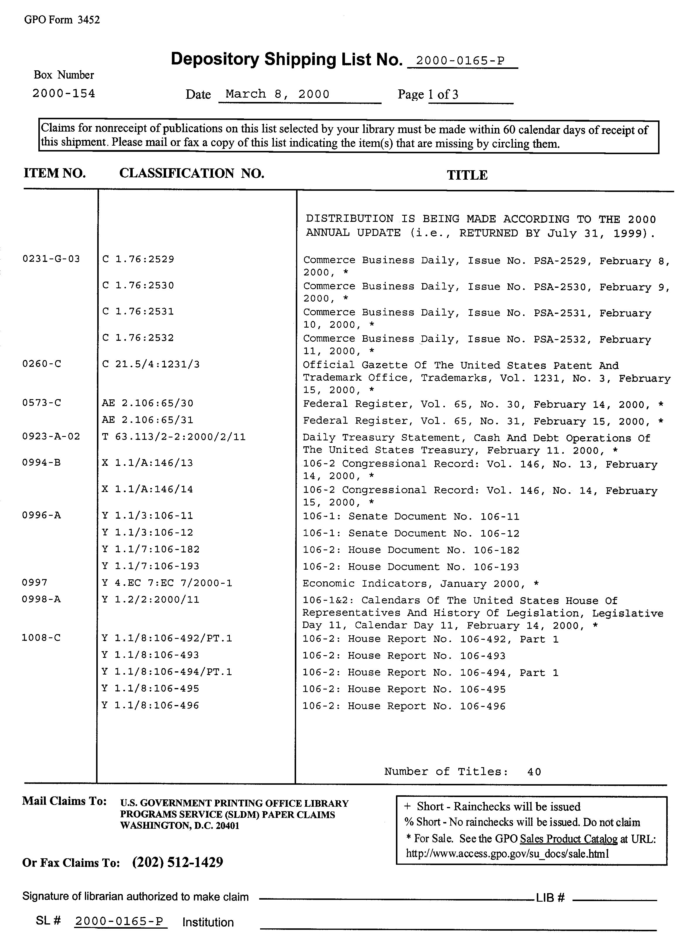
Exhibit B
Depository Shipping List – Microfiche

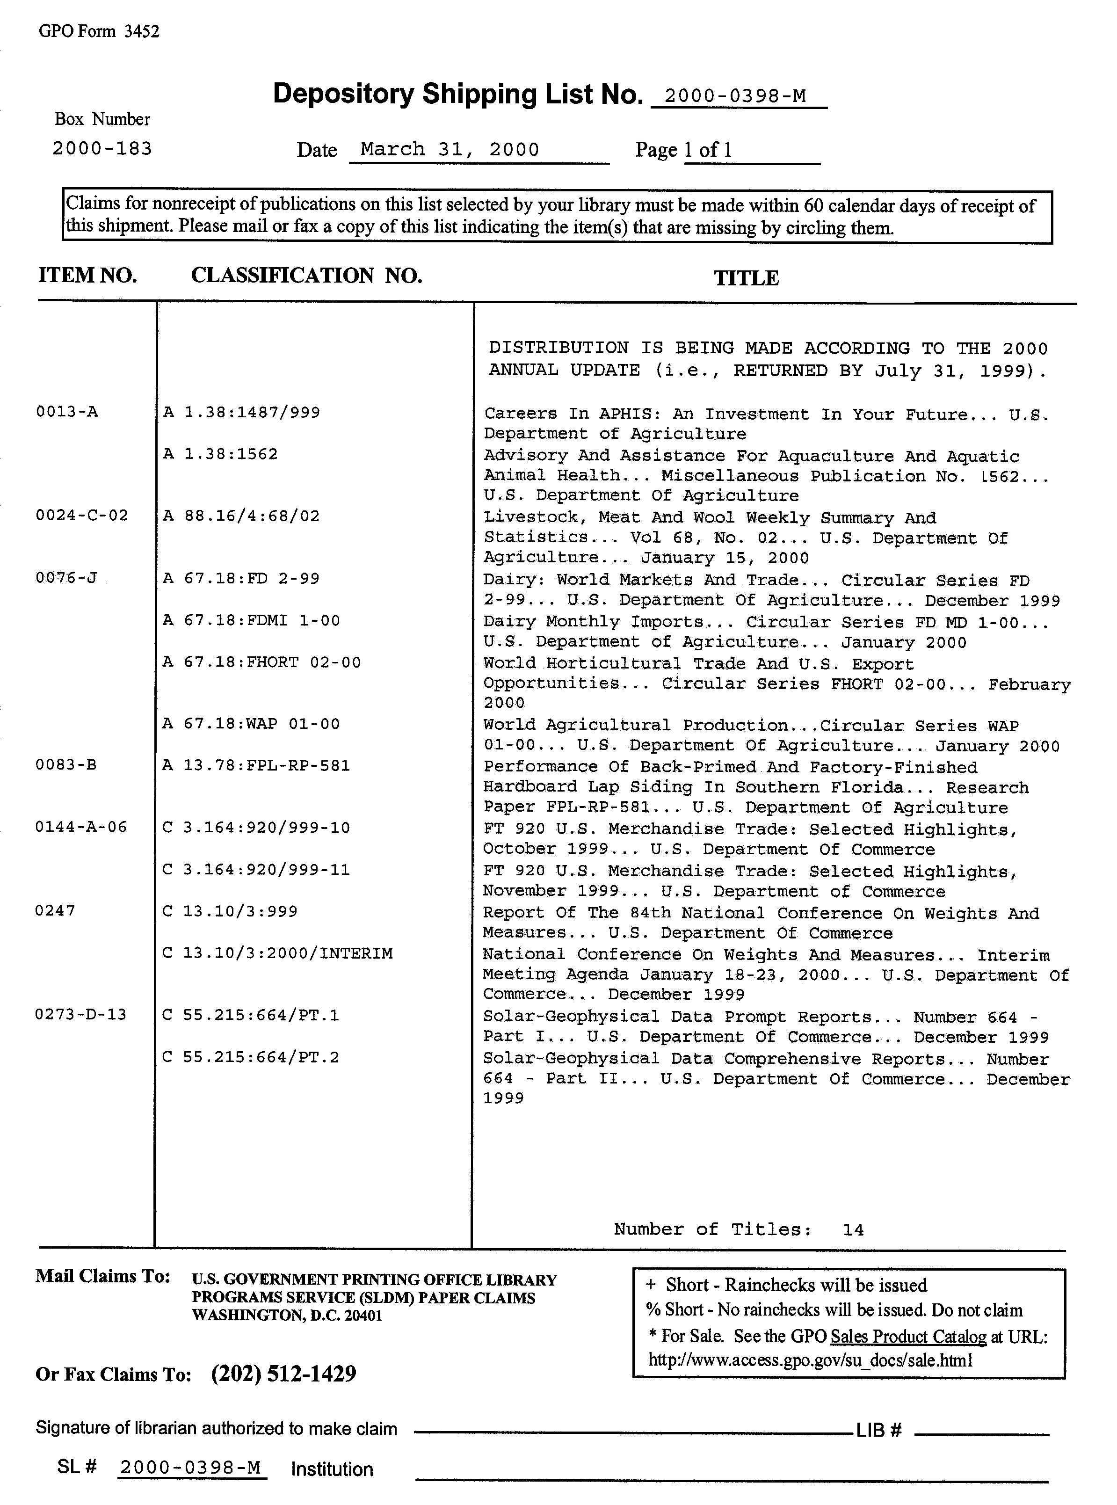
Exhibit C
Depository Shipping List – Electronic

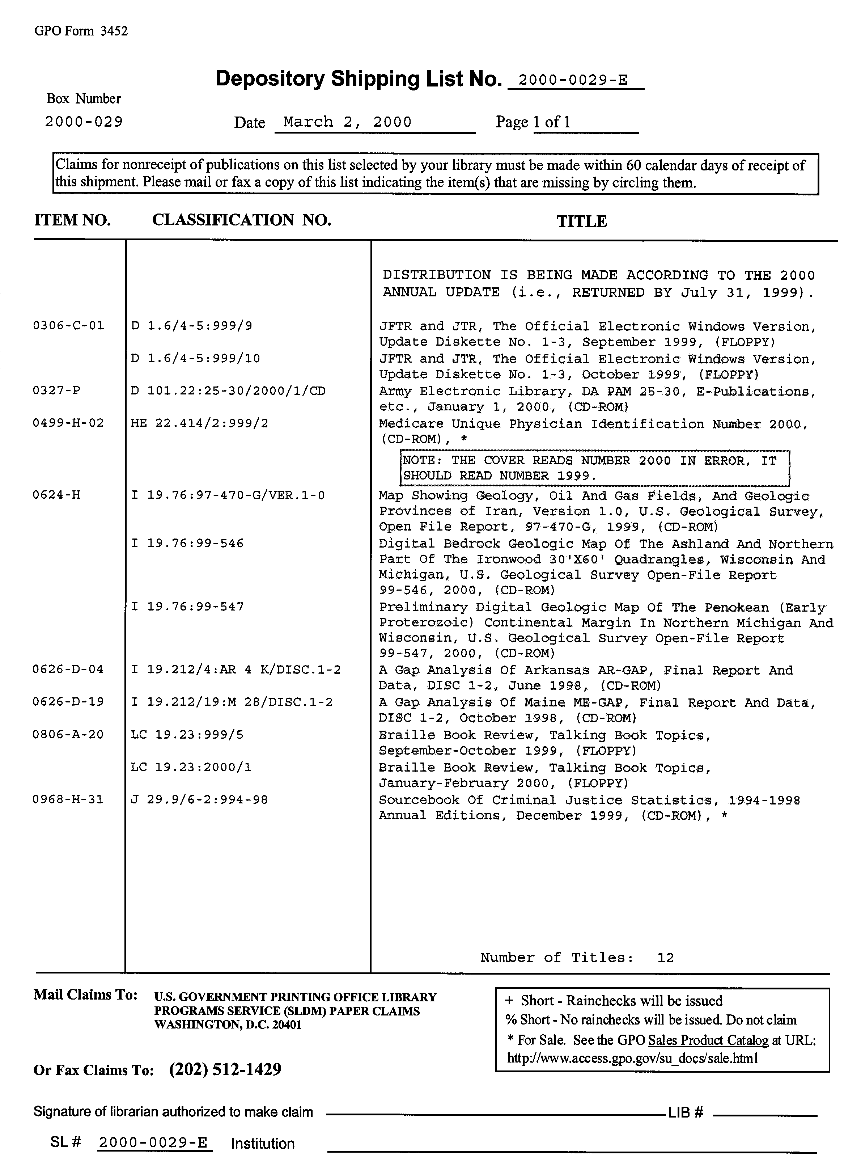
Exhibit D
Depository Shipping List – Separates

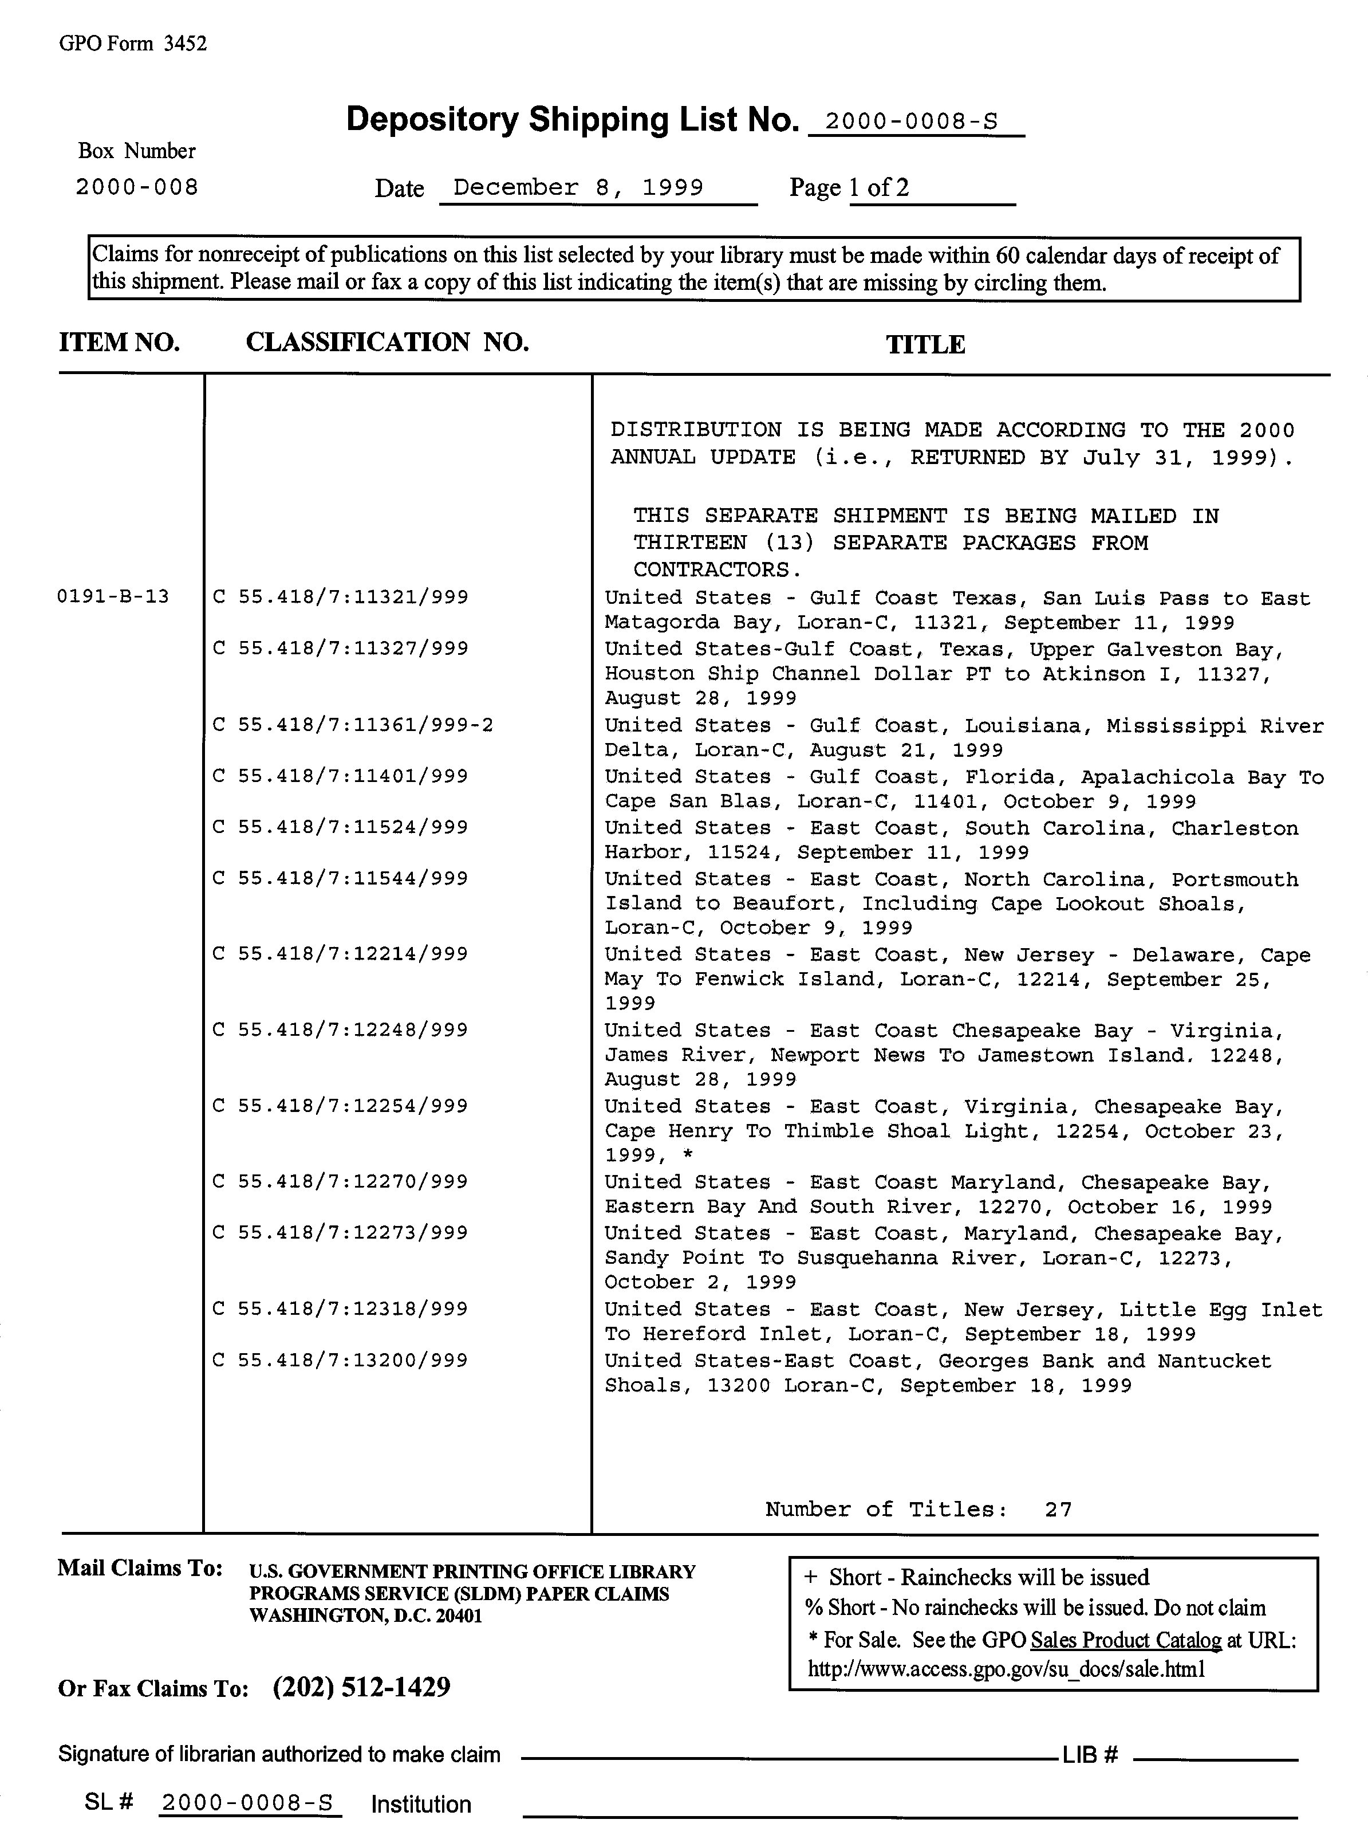
Exhibit E
Depository Shipping List – NIMA Maps

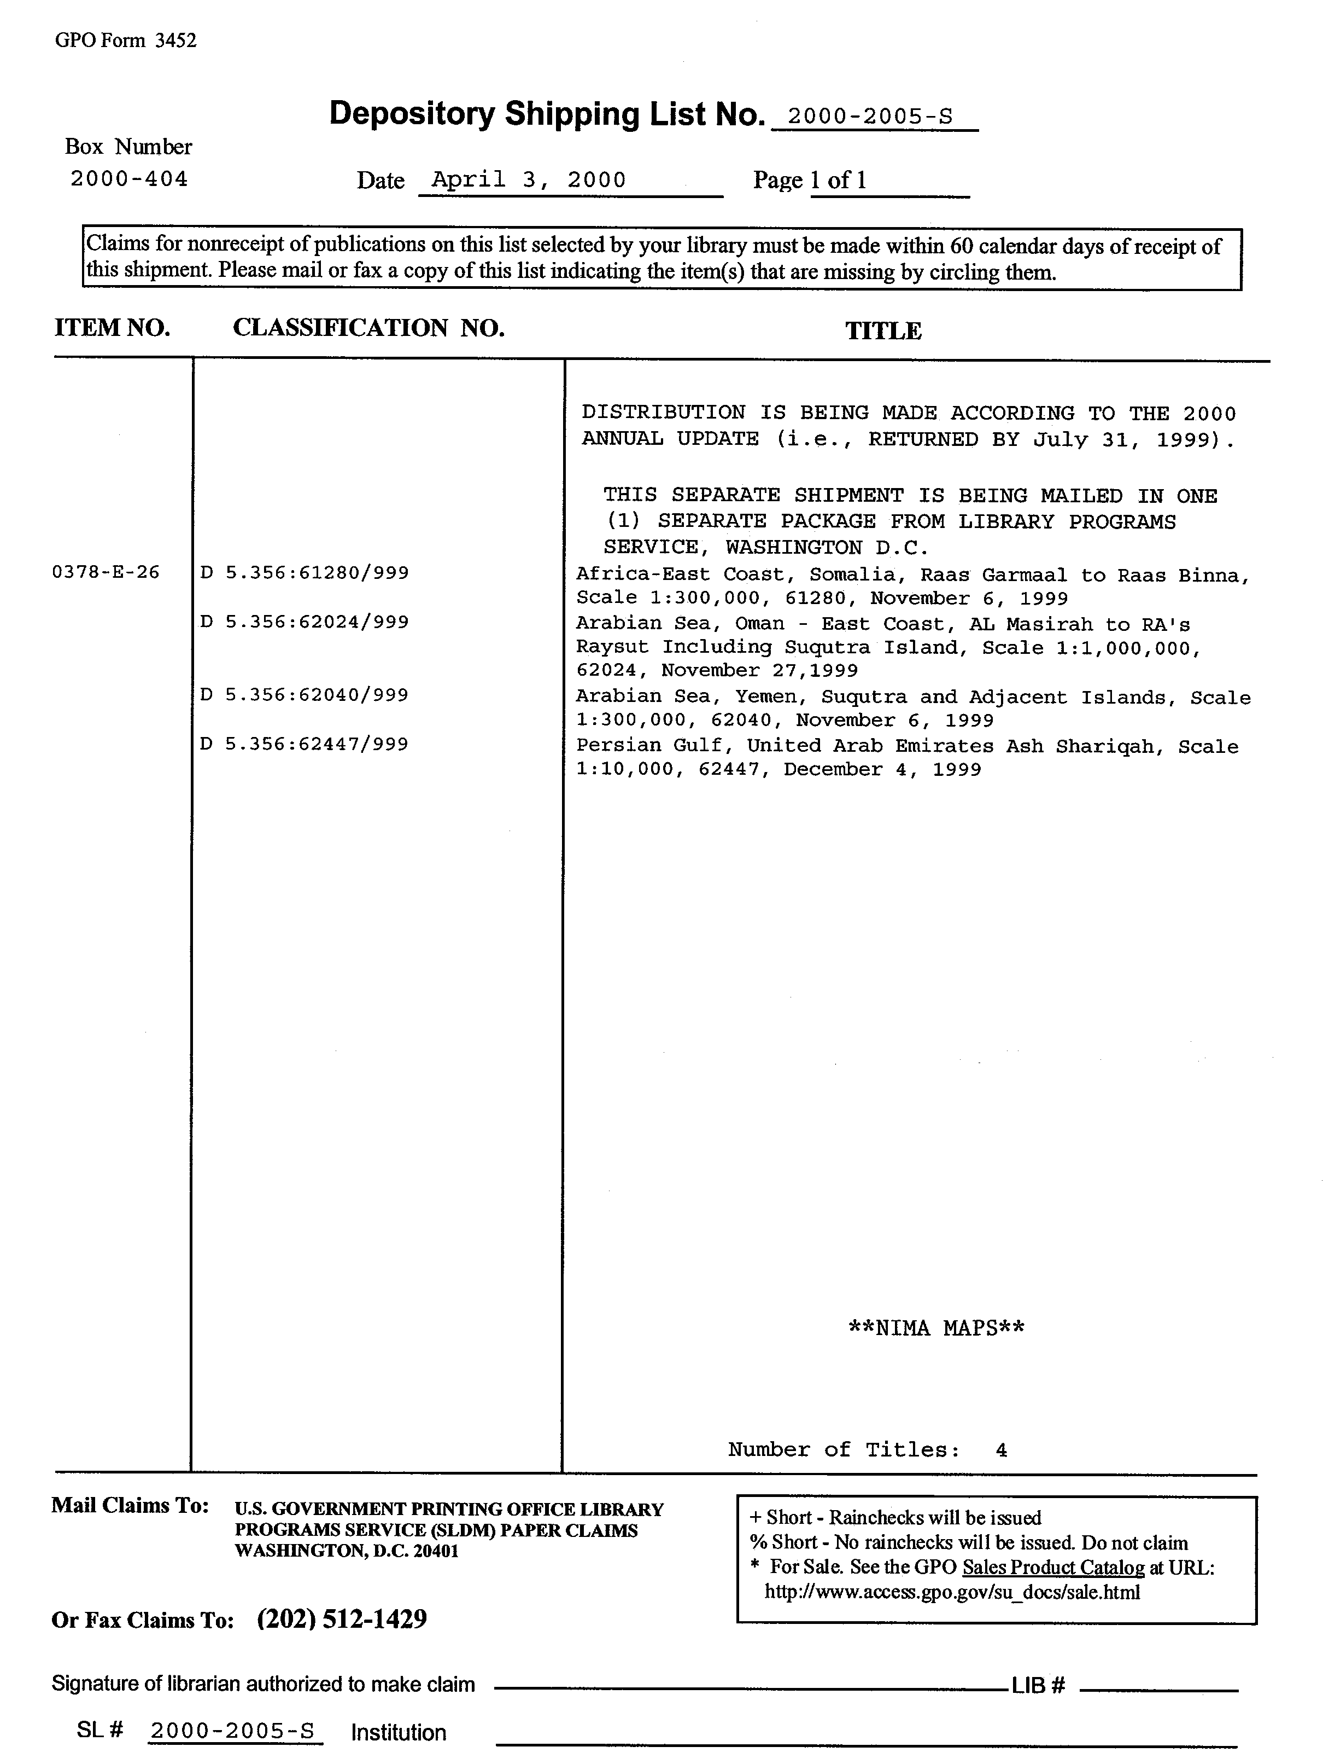
Exhibit F
Depository Shipping List – USGS Maps

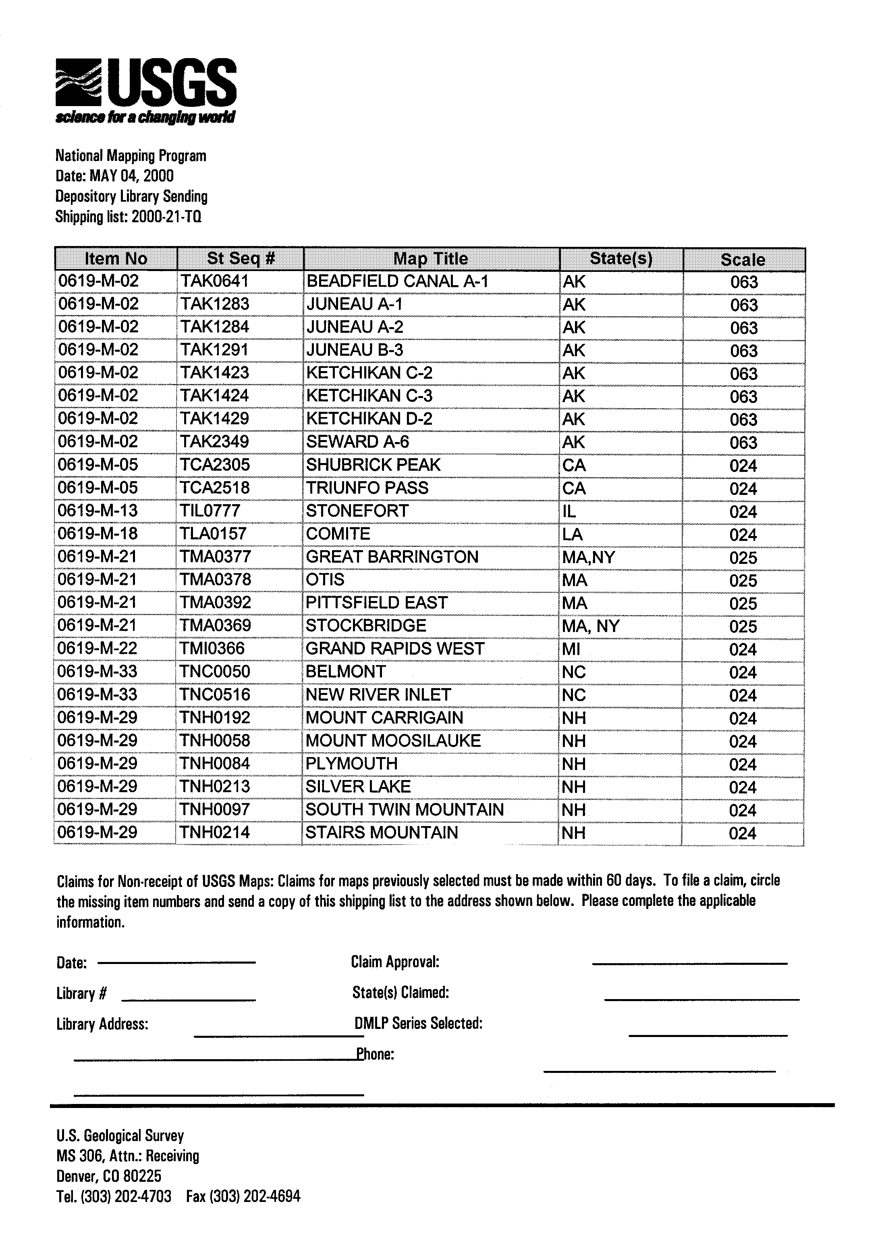
Exhibit G
Administrative Notes Technical Supplement

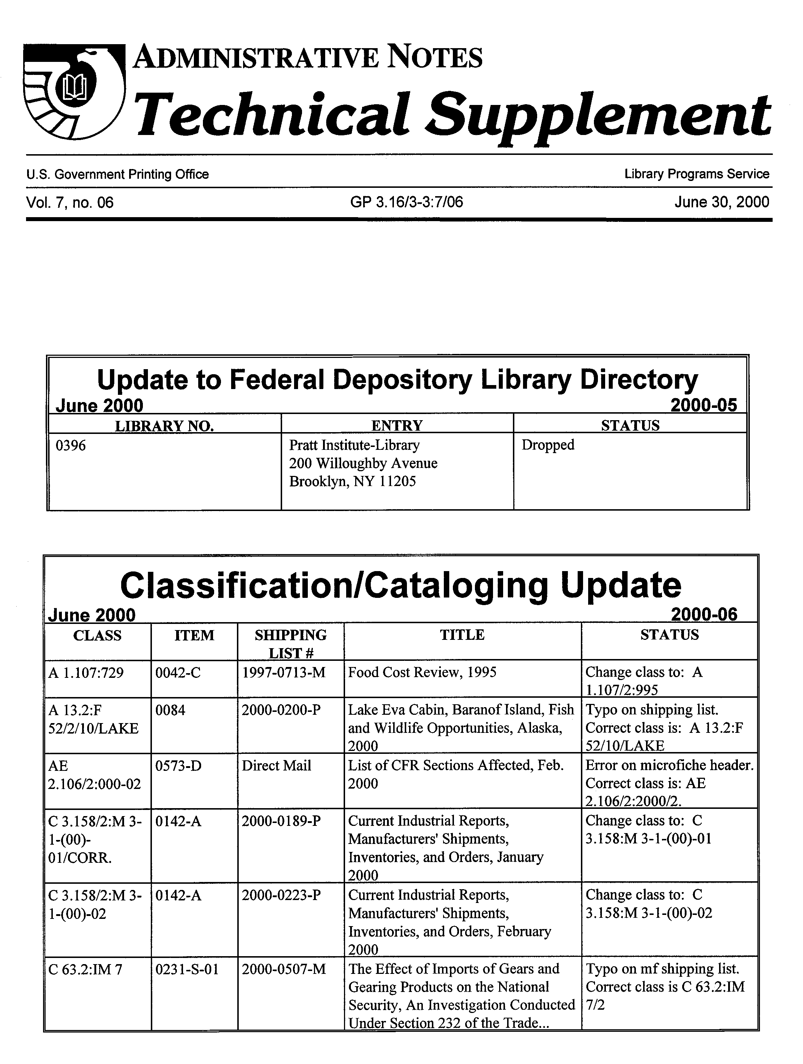
Exhibit H
Selective Housing Memorandum of Agreement

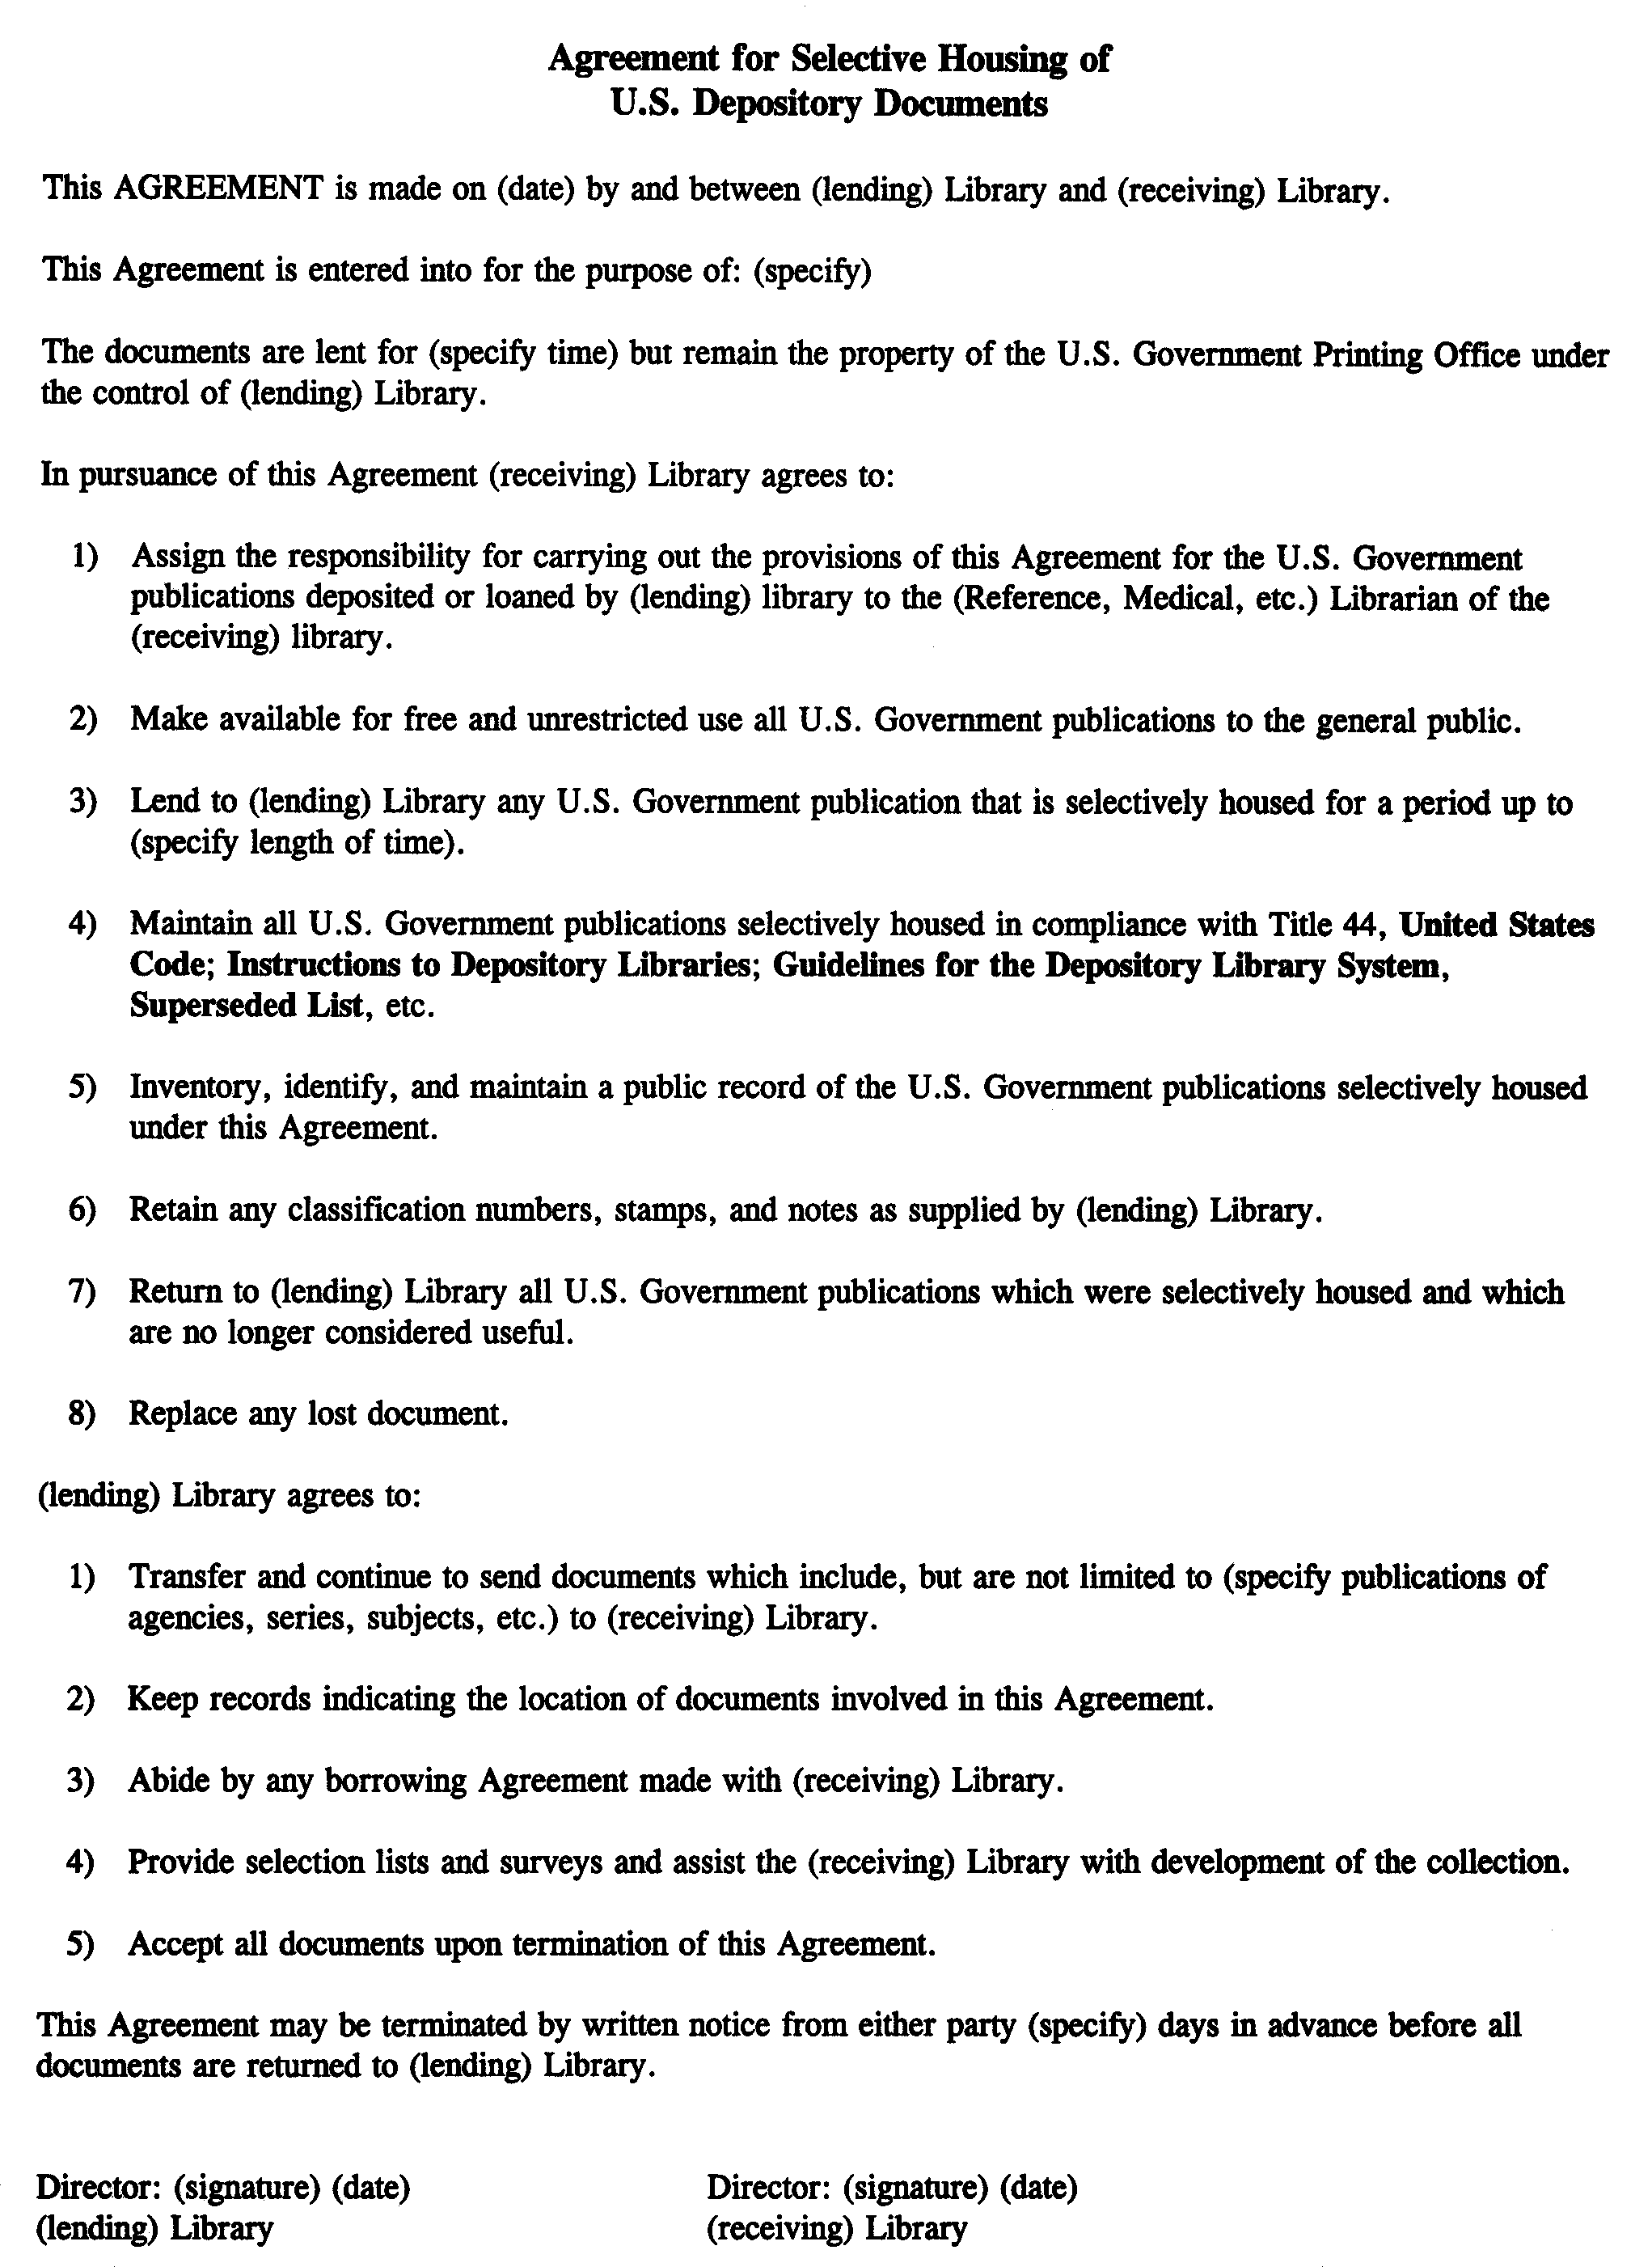
Exhibit I
Surveys

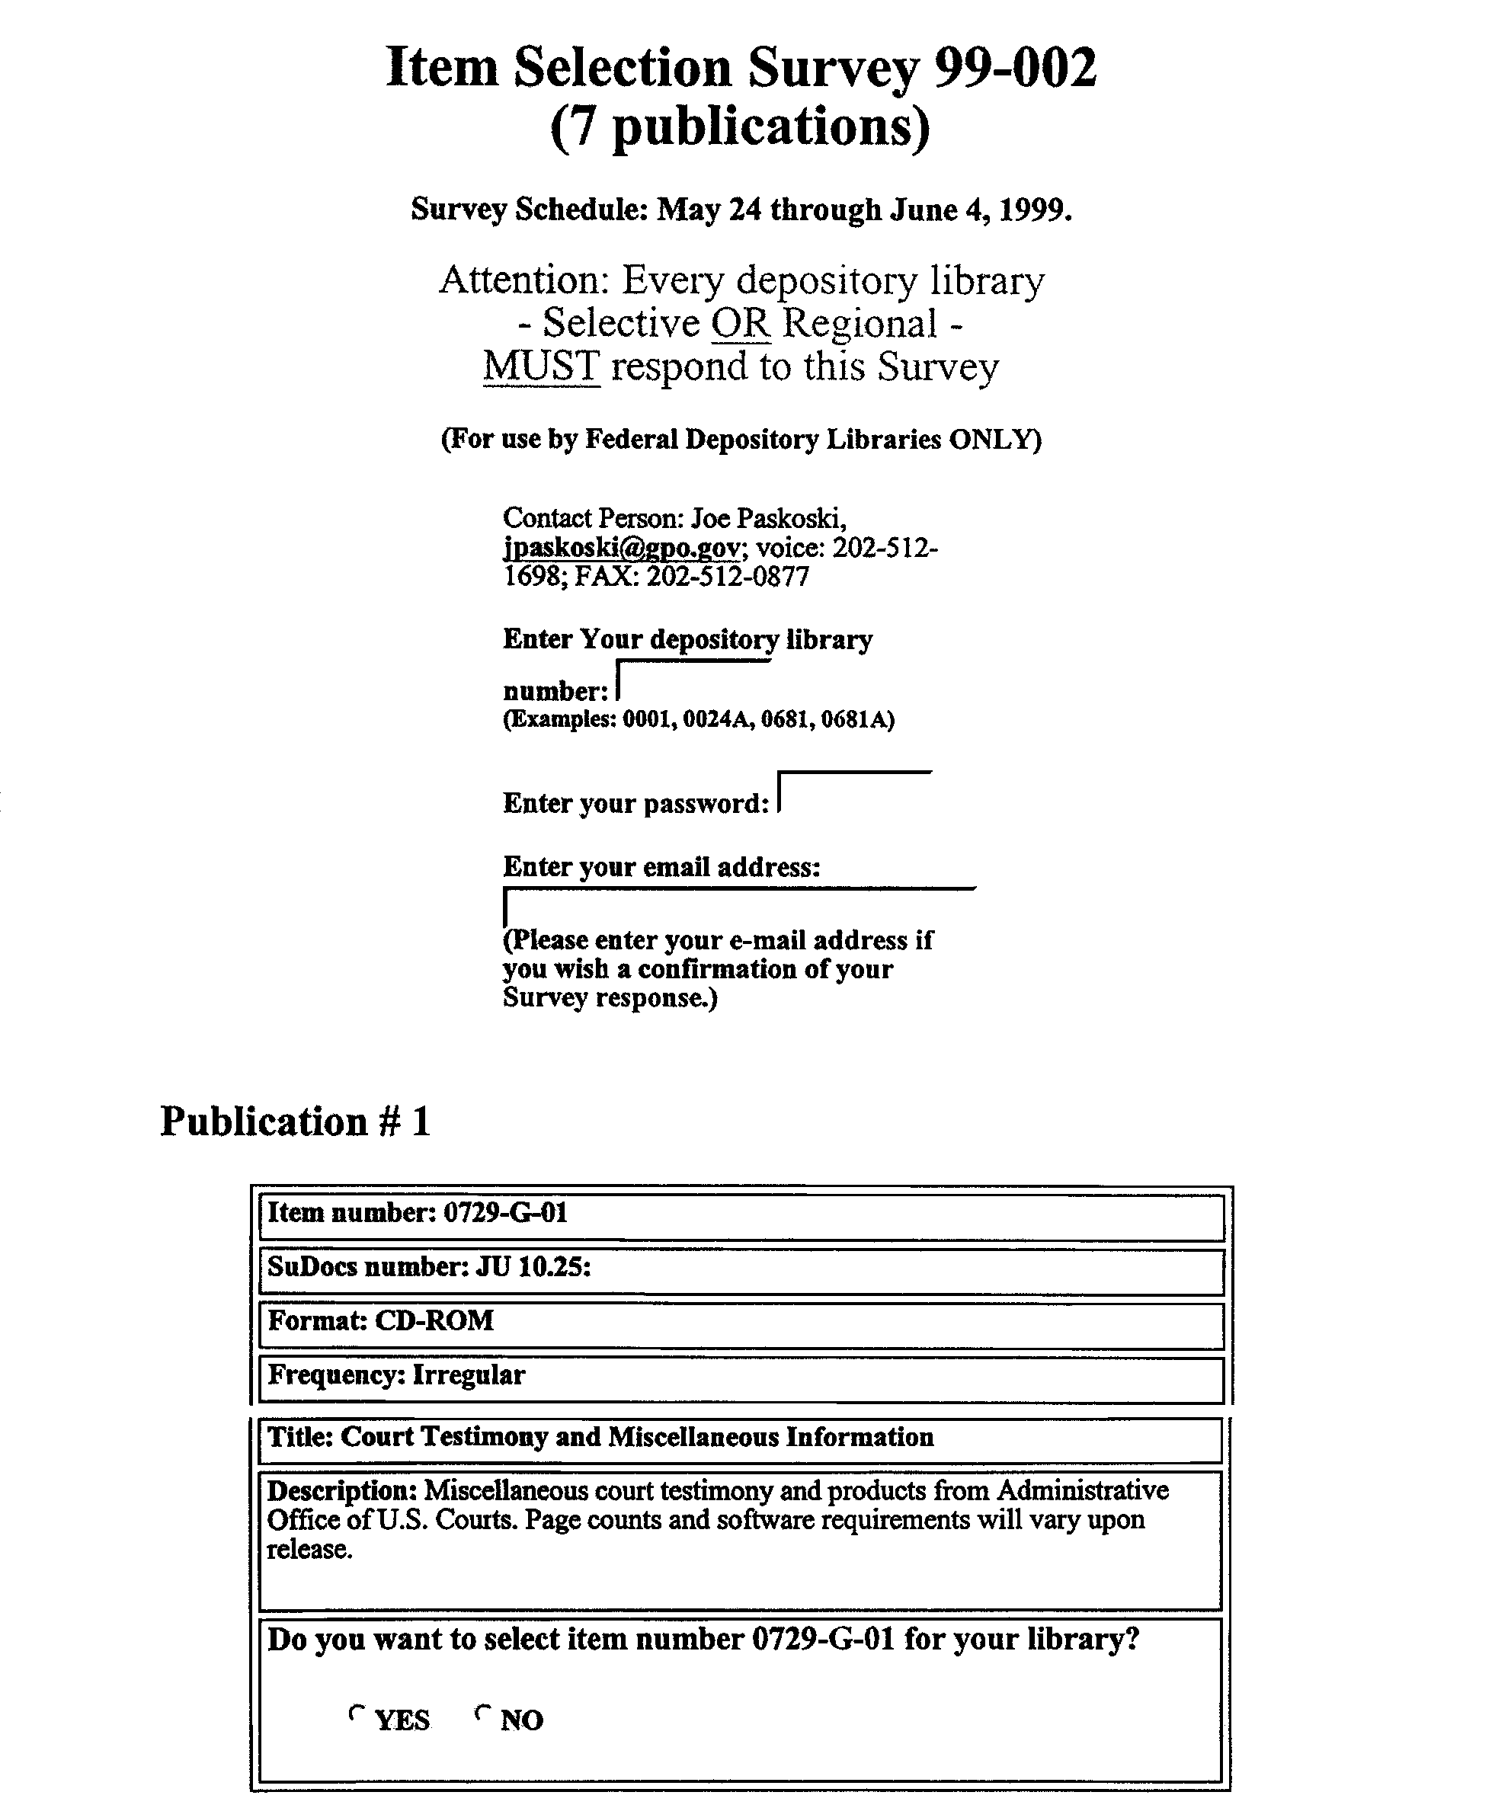
Exhibit J
Amendment of Item Selections

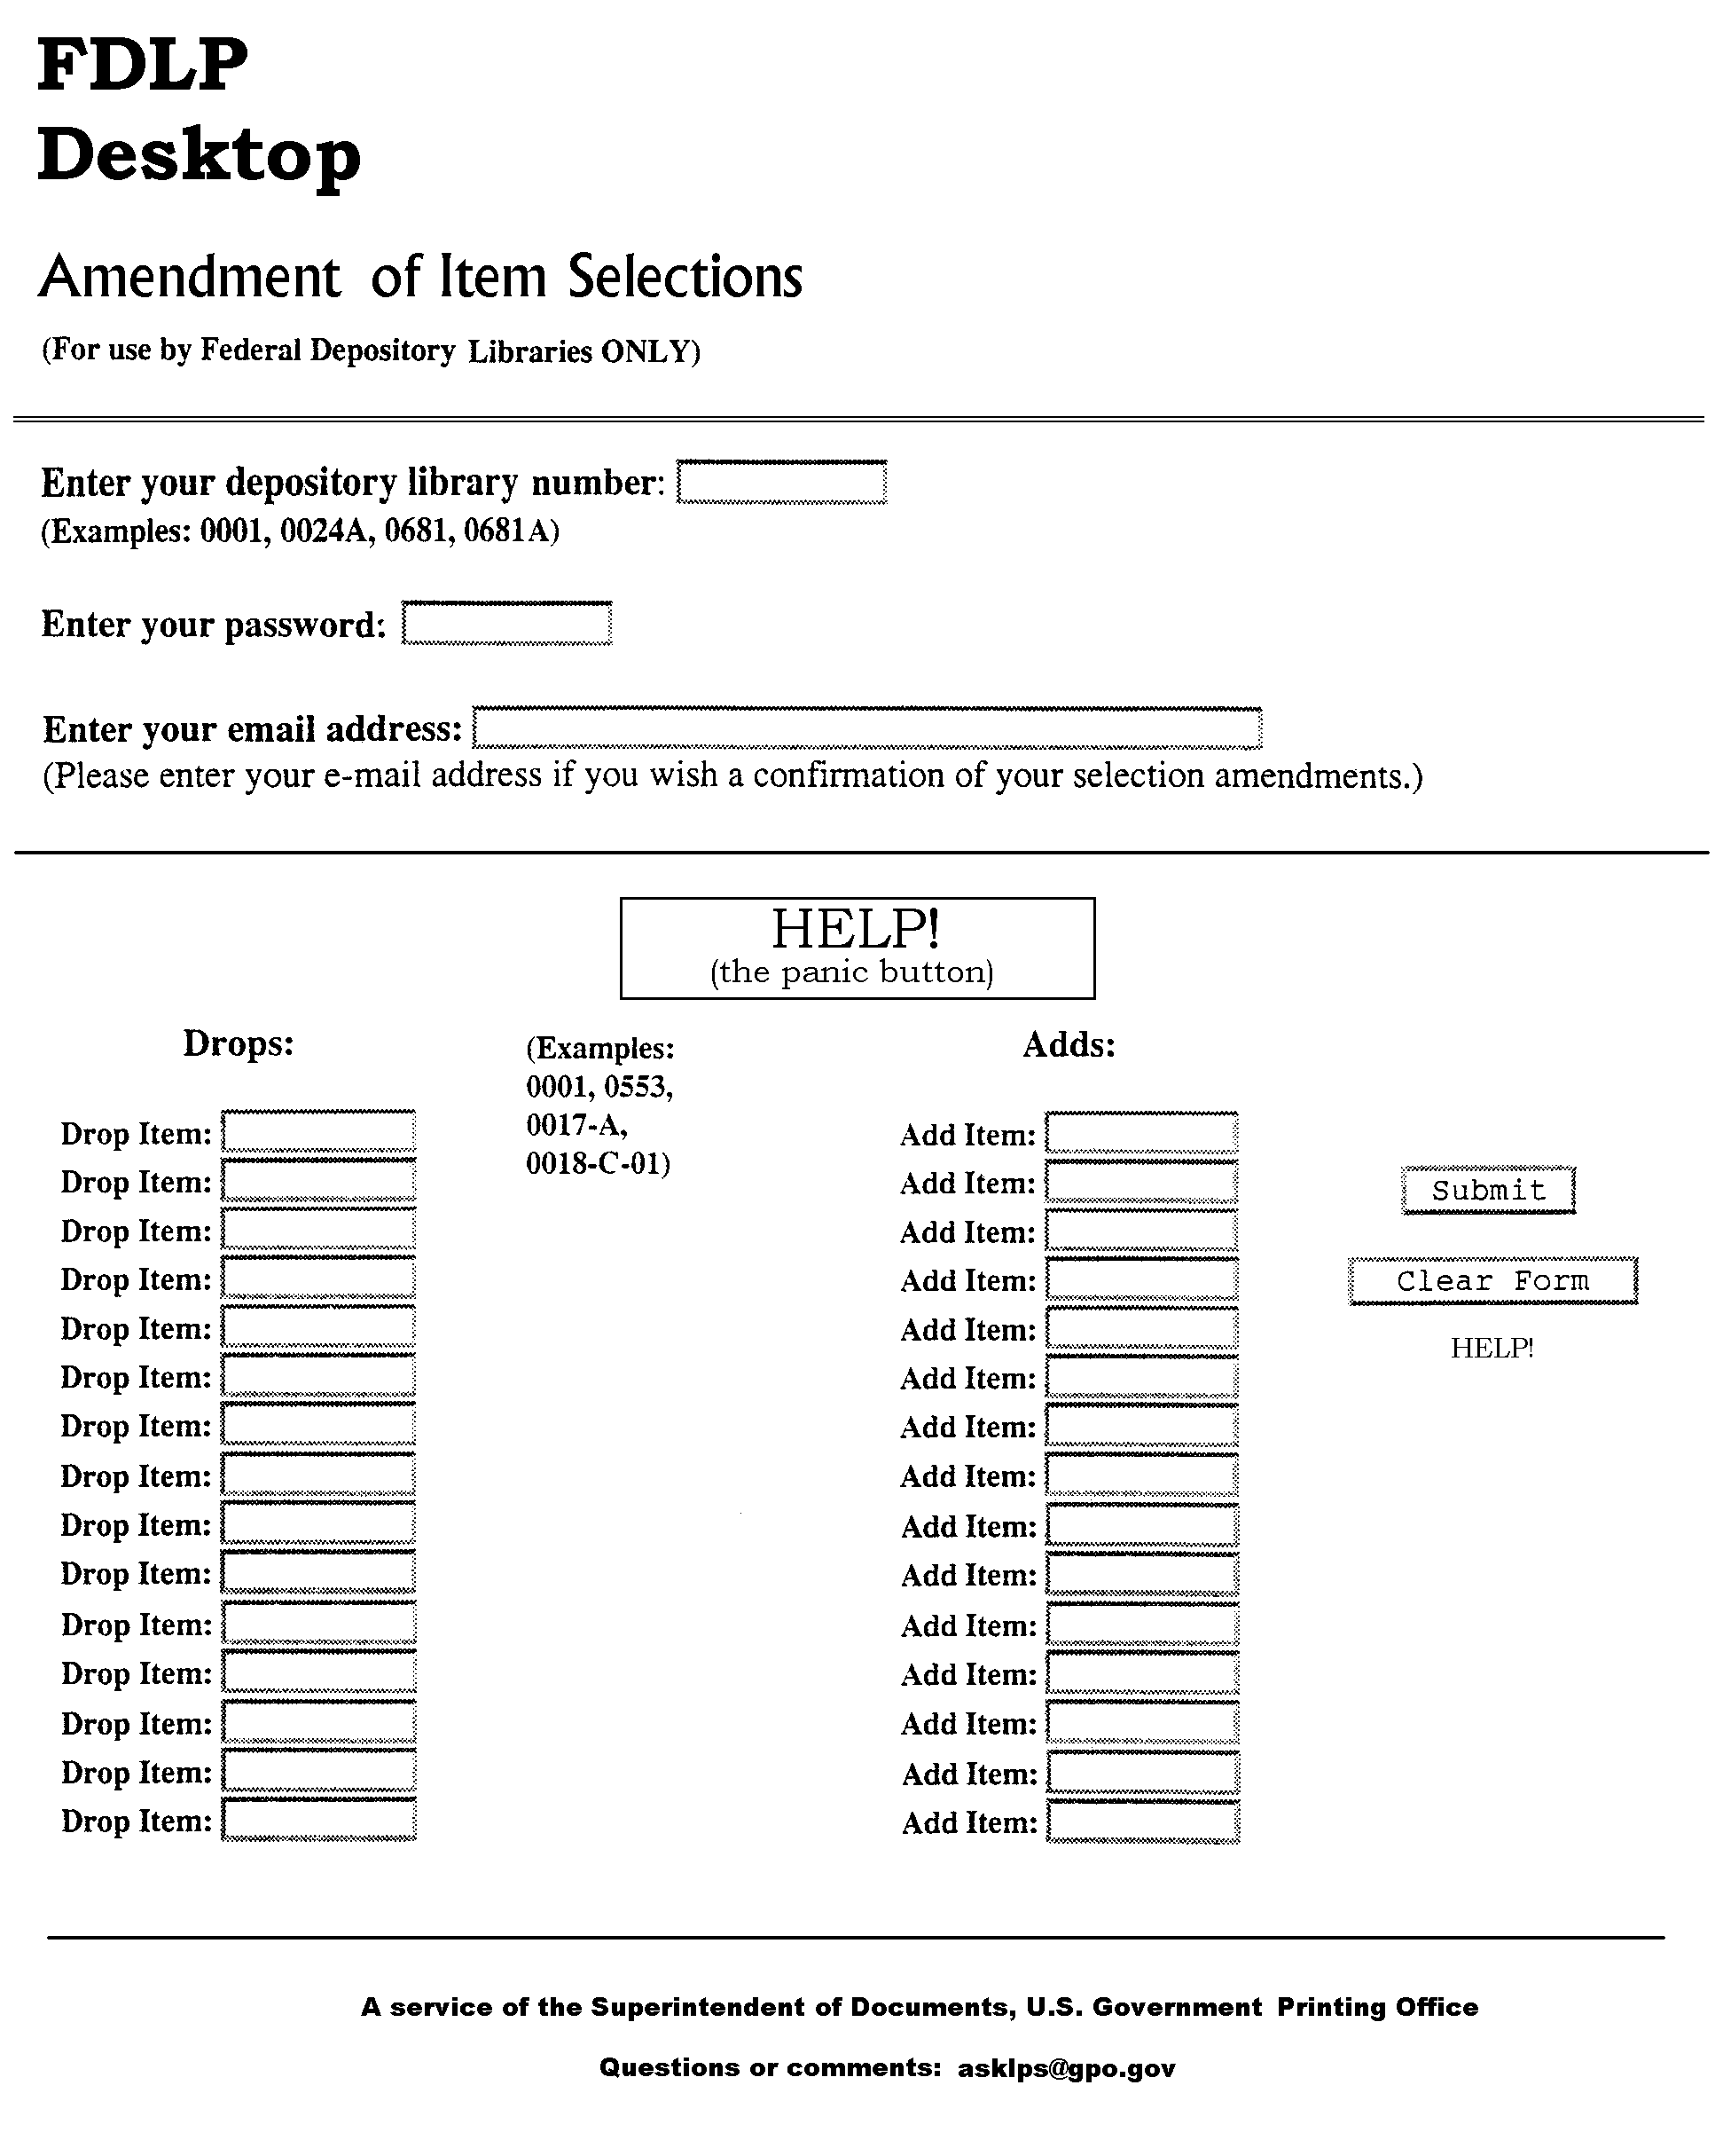
Exhibit K
Depository Library Inquiry Form

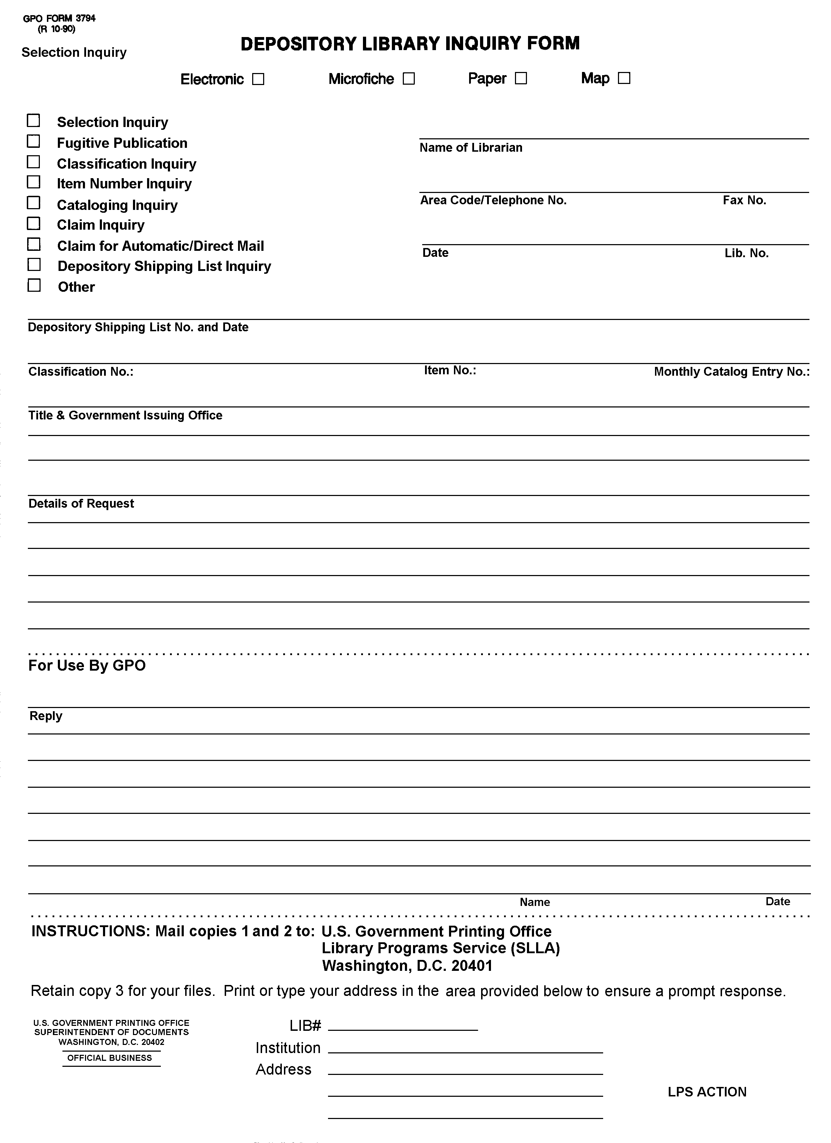

Appendix A – GLOSSARY

Administrative Notes | Monthly policy newsletter of the FDLP (GP 3.16/3-2:) providing information on topics related to Federal Government information
Administrative Notes Technical Supplement | Monthly newsletter containing updates and corrections for item numbers, SuDocs classification numbers, etc. (GP 3.16/3-3:)
Biennial Survey | Legally mandated GPO survey of conditions in depository libraries conducted every other year
Catalog of U.S. Government Publications | Web version of the Monthly Catalog of United States Government Publications
Claim | Depository library's request for an item rightfully due if selected under the FDLP but not initially received
Cooperative Publication | Government publication required to be self-sustaining (cost recovery) through sale; not available for free distribution through the FDLP
Depository | Library designated by Congress or by law to receive government information products without charge provided the library meets certain conditions
Depository Library Number | Unique number assigned to each depository library to record selections, distribute materials, maintain directory information, etc.
Direct Mail | Depository material mailed directly to the library from the printing contractor, i.e., not in shipment boxes or listed on a shipping list
Discards | Unwanted materials disposed of through regional depository after retaining 5 years
Documents Data Miner | Web collection management tool for depository libraries and a partnership between GPO and Wichita State University
Federal Depository Library Manual | Practical guide for the operation of a depository library (GP 3.29:D 44/)
Federal Depository Library Program (FDLP) | Federal program of disseminating U.S. Government information products in all media to participating libraries
Guidelines | Program and performance goals for Federal depository libraries and GPO
Inspection | Formal on-site audit by GPO inspectors of a depository library’s operation to determine compliance with the Instructions to Depository Libraries and Title 44, U.S. Code
Instructions to Depository Libraries | Official rules and regulations of the FDLP (GP 3.26:D 44/)
Item Lister | Web collection management tool that lists an individual library's selected (or non-selected) item numbers
Item Number | Control number assigned to titles or groups of titles (by agency) that are available for selection in the FDLP
List of Classes | List of current titles and/or categories arranged by SuDocs number including item number and format that are available for selection by depository libraries (GP 3.24:)
Memorandum of Agreement (MOA) | Formal document outlining the duties of the depository library and a recipient library of depository materials under their care
Monthly Catalog of United States Government Publications | Catalog of bibliographic records of Federal agency publications including those distributed in the FDLP (GP 3.8/8:)
Needs and Offers | List of an individual depository's discards (offers) and/or needs for missing materials
Public Printer | Government official, appointed by the President and confirmed by the Senate, in charge of the Government Printing Office
Raincheck | Form issued to depositories when depository copies are insufficient for initial distribution
Regional depository | Specially designated depository chiefly responsible for the integrity and comprehensiveness of a state or region's depository collection of U.S. Government information
Retention, 5-Year | Statutory minimum period of time depositories must keep materials received under the FDLP unless superseded or replaced by another format
Selective depository library | Receives only those item numbers that fulfill government information needs of primary clientele and the public within a geographic area
Secondary Copies | Depository items that are duplicates, superseded or sent by GPO in error. Or depository holdings of the highest state appellate courts and Federal agencies that are not bound by the 5-year retention rule
Selection Profile | An individual depository's composite profile of its selected item numbers
Selective Housing | Extended loan of depository materials from a designated library to one that is not a depository
Self-Study | A depository's self-assessment reviewing its operation and determining compliance with standards in advance of a possible on-site inspection
Separate Shipments | Depository items deemed inappropriate for shipment in regular depository boxes. Their shipping lists follow in regular shipment boxes
Shipping List | Itemized list of all items sent to a regional depository in one shipment
State Plan | Statewide guidelines for cooperative collection development, disposition, promotion, and other services for depository libraries
SuDocs Classification | A system of classification of agency publications for their management and control by libraries, authorized by the Superintendent of Documents
Superintendent of Documents | Government official in charge of GPO's FDLP and sales program appointed by the Public Printer
Superseded List | List of document titles or series that are regularly replaced by new editions (GP 3.2:Su 7/)
Superseded Materials | Depository titles regularly updated whose old editions may be discarded without prior approval and before 5 years have elapsed
Title 44, U.S.C., Chapter 19 | Part of the United States Code authorizing the FDLP
WEBTech Notes | Interactive online resource to locate information that has appeared in Administrative Notes Technical Supplement
Weeding | Regular maintenance program whereby a depository's unwanted publications are listed and approval sought for their disposal

Appendix B: List of URLs for FDLP/GPO Sites

Administrative Notes Technical Supplement | http://www.access.gpo.gov/su_docs/fdlp/pubs/techsup
Administrative Notes, Manuals, etc. | http://www.access.gpo.gov/su_docs/fdlp/pubs
Amendment of Item Selections | http://www.access.gpo.gov/su_docs/fdlp/tools/amendment.html
askLPS | http://www.access.gpo.gov/su_docs/fdlp/tools/asklps.html
Basic Collection | http://www.access.gpo.gov/su_docs/fdlp/pubs/fdlm/basic.  html
New Electronic Titles | http://www.access.gpo.gov/su_docs/locators/net/index.html
Catalog of U.S. Government Publications | http://www.gpo.gov/catalog
Collection Development Guidelines for Selective Federal Depository Libraries | http://www.access.gpo.gov/su_docs/fdlp/pubs/fdlm/coldev.html
Contacts | http://www.access.gpo.gov/su_docs/fdlp/tools/contacts.  html
Core collection list | http://www.access.gpo.gov/su_docs/fdlp/pubs/fdlm/  corelist.html
Designation Handbook for Federal Depository Libraries | http://www.access.gpo.gov/su_docs/fdlp/pubs/desig.html
Documents Data Miner | http://govdoc.wichita.edu/ddm/GdocFrames.asp
FDLP Desktop | http://www.access.gpo.gov/su_docs/fdlp  or  http://www.gpo.gov/fdlpdesktop
FDLP Desktop – Processing Tools | http://www.access.gpo.gov/su_docs/fdlp/tools
FDLP Electronic Collection | http://www.access.gpo.gov/su_docs/fdlp/ec
FDLP Guidelines on Substituting Electronic for Tangible Versions of Depository Publications | http://www.access.gpo.gov/su_docs/fdlp/coll-dev/subguide.html
Federal Depository Library Manual | http://www.access.gpo.gov/su_docs/fdlp/pubs/fdlm
GPO Classification Manual | http://www.access.gpo.gov/su_docs/fdlp/pubs/classman
GPO/SUNY Buffalo partnership site | http://ublib.buffalo.edu/libraries/units/cts/acq/gpo/
Guidelines for the Federal Depository Library Program | http://www.access.gpo.gov/su_docs/fdlp/pubs/fdlm/  guidelin.html
Instructions to Depository Libraries | http://www.access.gpo.gov/su_docs/fdlp/pubs/instructions
Internet Use Policy | http://www.access.gpo.gov/su_docs/fdlp/mgt/iupolicy.html
Item Lister | http://www.access.gpo.gov/su_docs/fdlp/tools/itemlist.html
List of Classes | http://www.access.gpo.gov/su_docs/fdlp/pubs/loc
List of Contractor-Issued Microfiche Shipping Lists | http://www.access.gpo.gov/su_docs/fdlp/tools/msl
LPS Contacts | http://www.access.gpo.gov/su_docs/fdlp/tools/contacts.  html
Minimum technical requirements | http://www.access.gpo.gov/su_docs/fdlp/computers/mtr.  html
Needs & Offers | http://docs.sewanee.edu/nando.html
Online Processing Guidelines | http://www.access.gpo.gov/su_docs/fdlp/mgt/online-proc.html
Proceedings of the Federal Depository Library Conferences | http://www.access.gpo.gov/su_docs/fdlp/pubs/proceedings
Public Service Guidelines for Electronic Formats | http://www.access.gpo.gov/su_docs/fdlp/mgt/pseguide.  html
Recommended Specifications for Public Access Workstations in Federal Depository Libraries | http://www.access.gpo.gov/su_docs/fdlp/computers/rs.html
Remodeling Guidelines | http://www.access.gpo.gov/su_docs/fdlp/mgt/remodel.html
Sales Product Catalog | http://www.gpo.gov/sales
Selection rate percentages | http://www.access.gpo.gov/su_docs/fdlp/coll-dev/itemchrt.html
Self-Study | http://www.access.gpo.gov/su_docs/fdlp/selfstudy
Shipping Lists, SUNY-Buffalo partnership | http://ublib.buffalo.edu/libraries/units/cts/acq/gpo/
State Plan | http://www.access.gpo.gov/su_docs/fdlp/pubs/proceedings/98pro2.html
Subject Bibliographies | http://www.access.gpo.gov/su_docs/sale/sale100.html
Substitution Guidelines: Electronic for Tangible Versions | http://www.access.gpo.gov/su_docs/fdlp/coll-dev/subguide.html
Substitution List: Official FDLP Permanent Full-Text Databases | http://www.access.gpo.gov/su_docs/fdlp/coll-dev/substitutions.html
Superseded List | http://www.access.gpo.gov/su_docs/fdlp/pubs/suplist
Union List of Item Selections | http://fedbbs.access.gpo.gov/libs/unionl.htm
WEBTech Notes | http://www.access.gpo.gov/su_docs/fdlp/tools/webtech.  html

Index

Access v, vii, 1, 5, 9, 10, 19, 23, 29-30, 31-34
Acid-free containers 24, 25
Additions to item numbers 12
Additions to item selections 9
Administrative Notes 6, 8, 9, 20, 29, 57, 61
Administrative Notes Technical Supplement 9, 12, 14, 37, 51, 57, 61
Amendment of Item Selections 8, 54, 61
Americans with Disabilities Act 29
Annual item selection update 8-9, 15, 37
Arrangement of publications 14
askLPS vii, 13, 15, 16, 31, 37, 61
Basic collection 5, 61
Bibliographic control 11-17, 27, 36
Biennial survey 35, 37, 57
Binding 19
Catalog of U.S. Government Publications 7, 14, 33, 57, 61
Cataloging 11, 12, 33
CD-ROM 21, 23, 26, 29, 31, 33, 40
Circulation 32
Claims 14-16, 19, 20
Classification 7, 12, 14, 59
Collection development 5-10, 27, 36, 39, 40, 59, 61
Communications with GPO viii, 2, 14-17, 37
Communications with Regionals 2, 9, 10, 16, 21-24, 36
Congressional district vii, 1, 5, 6
Cooperation 36, 41
Cooperative collection development 9, 59
Cooperative publications 7, 57
Core collections 7, 61
Custody 10, 19, 20
Dating depository materials 14, 16
Decals 31
Defective publications 15, 20
Deletions (Item numbers) 9
Depository emblem 31
Depository Library Inquiry Form 37, 55
Depository Library Public Service Guidelines for Government Information in Electronic Formats 33, 62
Depository promotion 33, 35, 36, 59
Depository status 1-2
Depository termination procedure 2, 41
Designation 1-2, 39, 41, 61
Direct mail 15, 57
Discards 20-23, 36, 40, 57, 58
Documents Data Miner 6, 9, 36, 57, 61
Duplicate publications 16-17, 21, 23, 58
Duplicate shipments 16-17
Electronic FDLP 7
Electronic products 25-26
Electronic publications 12
Equipment 23, 25, 29-30
Exchange and Gift Division (Library of Congress) 22-23
Fax 15, 16
Fax Watch, U.S. 13
FDLP Desktop 8, 9, 36, 61
FDLP Electronic Collection 7, 31, 61
FDLP Guidelines on Substituting Electronic for Tangible Versions of Depository

Publications 10, 22, 61
Federal Bulletin Board 7, 8, 13
Federal Depository Library Manual v, 5-8, 10-11, 13, 15, 19, 24-27, 34, 36, 41, 57, 61
Federal Depository Library Program v, vii, 1, 25, 27, 33, 57
Five-year retention 9, 58
Free public access vii, 10, 32
Government property 11, 20, 21
GPO Access 7, 29, 31
GPO Classification Manual 14, 61
GPO form 3794, Depository Library Inquiry Form 37, 55
GPO Guidelines for Online Processing of Depository Documents 11
Guidelines for the Federal Depository Library Program 5, 12, 19, 27, 29, 32, 35, 36, 39, 62
Holdings record 11
Housing 25, 29
Human resources 27-28, 36
Index map 11
Inquiry service 15
Inspection v, 31, 35-36, 42, 58
Insuring depository collections 19-20
Interlibrary loan 6, 9, 36, 40, 42
Internet use policies 32, 62
Item Lister 6, 8, 9, 16, 33, 36, 58, 62
Item number deletion 9
Item number selection 6-9, 12, 15, 32, 54, 59, 61
Item number system 8
List of Classes 7, 9, 12, 58, 62
List of Contractor-Issued Microfiche Shipping Lists 13, 62
Substitution List: Official FDLP Permanent Full-Text Databases 22, 62
Local community vii
Local cooperation 36
Locate Libraries 33
Loss of depository status 36
Maintenance vii, 10, 19-26, 27, 36, 59
Maps 8, 11, 12, 13, 16, 21, 25, 49, 50
Memorandum of Agreement (MOA) 10, 22, 25, 27, 52, 58
Microfiche 9, 12, 13, 14, 16, 21, 24, 46
Minimum technical requirements 29-30, 31, 62
Monthly Catalog of United States Government Publications 7, 57, 58
Natural disasters 20
Needs and Offers list 20, 22, 23, 41, 58
New series notification 8
OCLC subfields 086 & z 14
Online processing 11
Outreach 33
Over-sized publications 13
Paper clips on microfiche 24
Physical access 29
Physical facilities 29-30, 36
Piece level holdings record 11
Posters 25
Pre-packaged publications 13
Preprints 21, 23
Preservation 19, 25
Probationary status 36
Proceedings of the Federal Depository Library Conferences 34, 62
Processing 10, 11, 13-14, 30
Promotion and Advertising Branch, GPO 31
Proprietary interest 19
Public access vii, 1, 5, 10, 24, 30, 31, 32
Public awareness 33
Public Printer v, 2, 20, 58
Public service vii, 10, 31-34, 36
Public service area 5, 30
Raincheck 14, 15, 58
Recommended Specifications for Public Access Workstations in Federal Depository

Libraries 29, 62
Reference service 27, 32, 40
Referrals 33, 36
Regional services 39-42
Relinquishing depository status 2, 41
Replacement copies 15, 19, 20, 24
Reprints 21, 23
Responsible officials 27
Retention, 5-year 9, 58
Rubber bands on microfiche 24
Secondary copies 21-23, 58
Selection (Item numbers) 6-9, 15, 37, 54, 61
Selection profile 8, 9, 12, 59
Selection rate 6, 62
Selective housing 8, 10, 25, 27, 32, 41, 52, 59
Self-study 35, 36, 41, 42, 59, 62
Separate shipping list 12, 13, 48, 59
Separates 13, 16, 59

Service to general public vii, 10, 27, 31-34, 36
Service to primary patrons 1, 5, 27, 32
Shipping list 8, 9, 11-16, 45-50, 59, 62
Signage 30, 31
Special offers (selections) 9
Staffing 27
State plans 9, 36, 39, 40, 41, 59, 62
Substitution of depository materials 10, 22, 23-24, 39, 41, 61, 62, 63
Superintendent of Documents 2, 20, 31, 24, 35, 36, 39, 40, 41, 59
Superintendent of Documents classification 7, 12, 14, 15, 37, 40, 57, 59, 61
Superseded publications 8, 9, 21, 22, 23, 39, 58, 59, 63
Termination of depository status 2, 41
Title 44, United States Code v, vii, 1, 21, 23, 32, 34, 35, 36, 40, 41, 59
Training 27-28
U.S. Congressional district vii, 1, 5, 6
U.S. Fax Watch 13
U.S. Geological Survey 13, 14, 16
Union List of Item Selections 7, 63
Web pages 7, 31, 33, 34
Weeding 59
Zero-based review 9

