President’s Environmental Youth Awards  Today’s Youth Protecting Tomorrow’s Environment | K-12th grade students
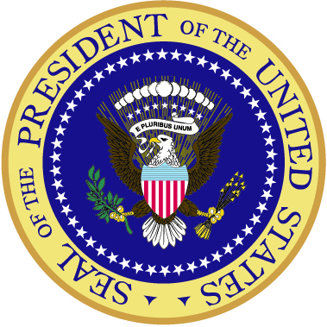
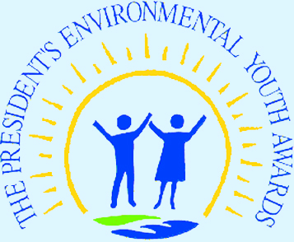
The President’s Environmental Youth Awards (PEYA) promote awareness of our nation’s natural resources and encourage positive community involvement. Since 1971, the President of the United States has joined with the U.S. Environmental Protection Agency to recognize young Americans for protecting our nation’s air, water, land, and ecology. Each year the PEYA program honors a wide variety of environmental projects developed by young individuals, school classes (kindergarten through high school), summer camps, public interest groups, and youth organizations to promote environmental awareness.
At a PEYA awards ceremony, the EPA Administrator said that “These young people are leading the way in the protection of public health and the environment. Through these projects and their commitment, these students are setting an example for all of us in making our communities cleaner and healthier.”
Youth who submit an application will receive a signed certificate from the President of the United States. One outstanding project in each of the 10 EPA regions will be selected to receive a presidential plaque and to attend an EPA-sponsored award ceremony.

Complete instructions on how to apply for a PEYA are provided on page 2.
Your project – or one you are sponsoring – could be an award winner. Encourage one or more students you know to apply for a PEYA and see what a difference they can make for the environment with an award-winning project. Applicants from all 50 states and U.S. territories are eligible to compete for an award.
How the Program Works
The PEYA competition has two parts — a regional certificate and a regional award. The regional certificate program is conducted year-round. Therefore, applications for this program can be submitted at any time. All qualified applicants will receive a certificate signed by the President honoring them for their efforts to protect human health and the environment.
The regional award program is conducted once a year. Following the December 31 deadline, the regional awards panel for each of EPA’s 10 regional offices reviews applications to select the winner. The 10 regional award winners receive a presidential plaque at an EPA-sponsored award ceremony in Washington, D.C.
How to Apply
A blank application is provided in this brochure. An electronic version of this document can be viewed or downloaded in portable document format (pdf) at EPA’s PEYA Web site at www.epa.gov/peya. Past projects have included building nature trails, reversing the decline of endangered species, starting recycling programs, restoring native habitats, creating schoolyard habitats, and many other creative, sustainable efforts. To learn more about past award-winning projects, please visit the PEYA Web site.
The Application
How PEYA Projects are Judged
Each application under consideration for a regional award is evaluated by a regional awards panel. The panel members are usually EPA staff who review and evaluate each application based on the criteria. A maximum of 100 points can be awarded to a given application.
Evaluation Criteria
Extent to which the project was designed, coordinated, and implemented due to the young person's or persons' initiative. Explain how the project was created and completed through the initiative of the student participant or participants. The impetus and driving force for the project must be the student or students, not the sponsor.
25 points
Environmental need for the project and appropriateness.
20 points
Positive environmental impact on the local community and society, and the long-term environmental benefits derived from the project. Describe how the project positively affected the community and any long-term environmental benefits or outcomes of the project.
15 points
Were the goals accomplished? List the goals of the project and how they were accomplished.
15 points
Positive ways in which other groups or individuals were involved to provide funds, resources, or publicity. Describe the positive ways that the project involved others in the community. Identify community resources, expertise, leadership, or publicity used.
10 points
Project innovation. Describe how the participant(s) used innovative approaches to achieve positive results.
10 points
Soundness of approach, rationale, and scientific design (if applicable).
5 points
Step 1: Review the Eligibility Criteria
• Project is completed while the student(s) are in kindergarten through 12th grade.
• Student(s) are citizens of the United States or its territories or have been lawfully admitted for permanent residency.
• Project is sponsored by at least one adult.
Step 2: Complete an Application
• Sponsor must sign and date page A-1 of the application.
• Project must be summarized on the pages provided in the PEYA application form (no more than 300 words). A more detailed description of the project, addressing the evaluation criteria, should be included separately on 3 to 5 pages of 8½- by 11-inch paper.
• Typed, double-spaced applications are recommended. The applicant should type or write on only one side of each page.
• Project must be described based on the criteria (see column to the right). These criteria will be used by a regional awards panel to evaluate the application.
Applicants are encouraged to submit photographs, newspaper articles, and other supporting materials if they provide a more comprehensive view of the project.
Step 3: Mail the Application
• Each application must be mailed to the regional PEYA coordinator. Applications cannot be submitted electronically.
• A current mailing address for each regional PEYA coordinator is provided in the application (see page 3).
Application Deadline
For the regional certificate program, applications may be submitted at any time during the year. For the regional award program, the deadline for submitting applications is December 31 of each year.
A note about sponsors. Each young person or group of young people applying for the PEYA program must be represented by a sponsor. The sponsor must be an adult and may be a parent, teacher, youth group adviser, summer camp counselor, community leader, or other interested individual. The adult sponsor plays an important role in helping a young person or group of young people carry out a project and apply for a PEYA. Typically, a sponsor offers suggestions and advice throughout the project to: develop a sound project approach; implement the project; work with other groups and individuals in the community; complete the application form(s); and prepare accompanying materials. The sponsor must also sign and date the application.
Questions about the role of a sponsor should be directed to your regional PEYA coordinator.

EPA Regional PEYA Coordinators
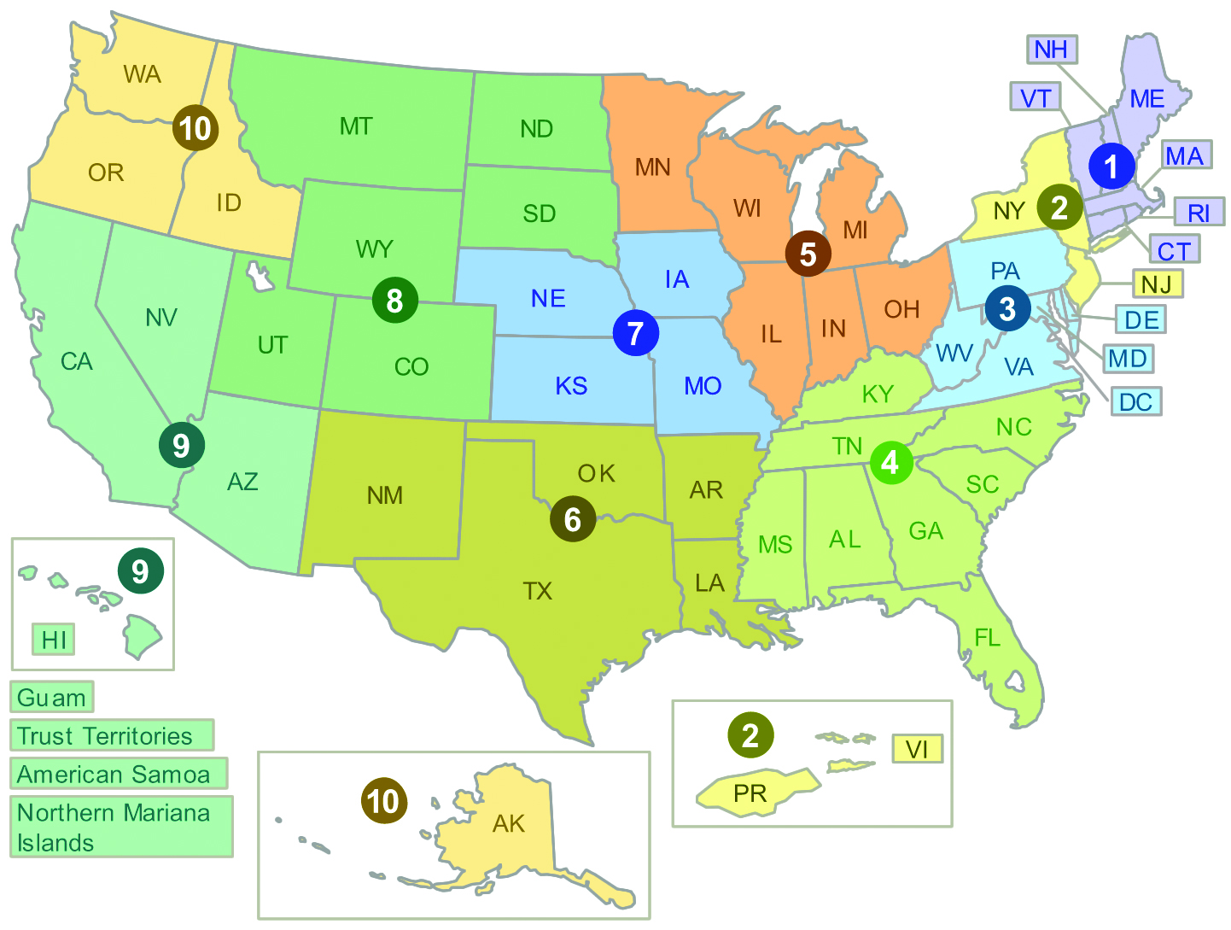

Region 1
CT, MA, ME, NH, RI, VT
Kristen Conroy
U.S. EPA
One Congress Street, Suite 1100 (SAA)
Boston, MA 02114-2023
(617) 918-1069
E-mail: conroy.kristen@epa.gov

Region 2
NJ, NY, Puerto Rico, U.S. Virgin Islands
Cecilia Echols
U.S. EPA
290 Broadway, 26th Floor
New York, NY 10007-1866
(212) 637-3678
E-mail: echols.cecilia@epa.gov

Region 3
DE, MD, PA, VA, WV, DC
Ellen Lucchetti
U.S. EPA
1650 Arch (3PA00)
Philadelphia, PA 19103-2029
(215) 814-3287
E-mail: lucchetti.ellen@epa.gov

Region 4
AL, FL, GA, KY, MS, NC, SC, TN
Kathy Armstrong
U.S. EPA
Sam Nunn Atlanta Federal Center
61 Forsyth Street, S.W.
Atlanta, GA 30303-8960
(404) 562-8225
E-mail: armstrong.kathy@epa.gov

Region 5
IL, IN, MI, MN, OH, WI
Megan Gavin
U.S. EPA
77 West Jackson Boulevard (AT-18J)
Chicago, IL 60604-3507
(312) 353-5282
E-mail: gavin.megan@epa.gov

Region 6
AK, LA, NM, OK, TX
Patty Senna
U.S. EPA
1445 Ross Avenue
Suite 1200 (6XA-CI)
Dallas, Texas 75202-2733
(214) 665-7178
(800) 887-6063
E-mail: senna.patty@epa.gov

Region 7
IA, KS, MO, NE
Denise Morrison
U.S. EPA
901 North 5th Street
Kansas City, KS 66101-2907
(913) 551-7402
E-mail: morrison.denise@epa.gov

Region 8
CO, MT, ND, SD, UT, WY
Wendy Dew
U.S. EPA
1595 Wynkoop Street
Denver, CO 80202-2466
(303) 312-6605
E-mail: vigil.christine@epa.gov

A note about the PEYA coordinators. EPA has 10 regional offices, each responsible for several states and some of which are responsible for U.S. territories. In each regional office there is a coordinator who manages the PEYA program for that region. The coordinator answers any questions about the program, oversees the review of submitted applications, and works with the sponsors on follow-up activities.

Region 9
AZ, CA, HI, NV, American Samoa,
Guam, Mariana Islands, Palau
Sharon Jang
U.S. EPA
75 Hawthorne Street (OPA-2)
San Francisco, CA 94105
(415) 947-4254
E-mail: jang.sharon@epa.gov

Region 10
AK, ID, OR, WA
Sally Hanft
U.S. EPA
1200 Sixth Avenue (ETPA-086)
Suite 900
Seattle, WA 98101
(206) 553-1207
(800) 424-4372 (Region 10 only)
E-mail: hanft.sally@epa.gov

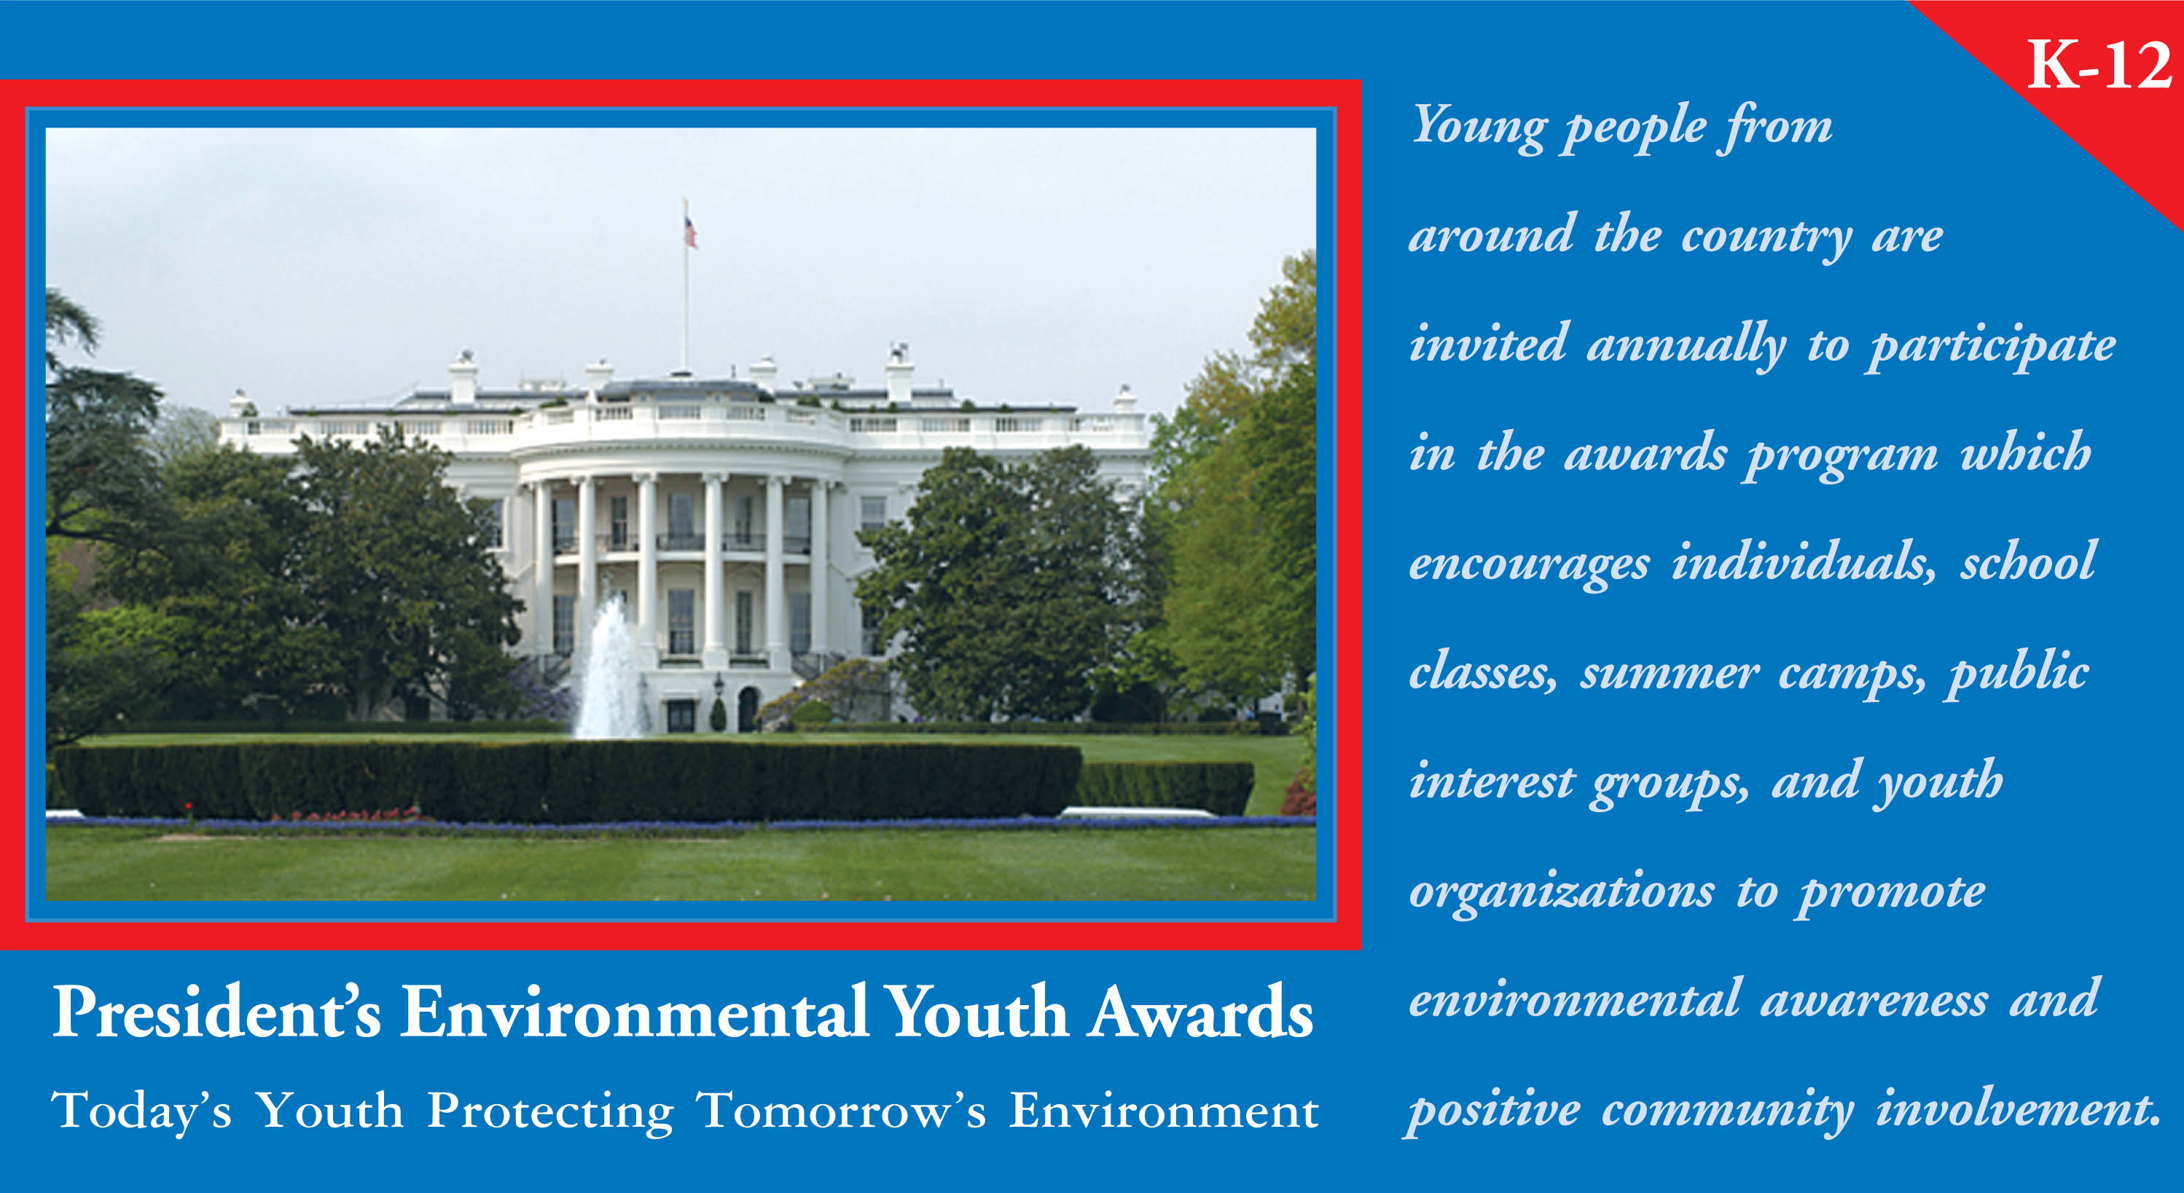

All eligible applicants will receive a certificate signed by the President of the United States honoring them for their efforts in public health and environmental protection. To be considered for the regional award program, applications must be postmarked by the December 31 deadline and mailed to the appropriate Regional PEYA Coordinator.
Individual/Group/School Name | Eligibility Guidelines  ✓ Project is completed while students are in kindergarten through 12th grade  ✓ Participants are citizens of the United States, its territories, or lawfully admitted to the U.S. for permanent residency  ✓ The project is sponsored by at least one adult.

Title of Project

Number of regional certificates requested

Participants
List the names, addresses, and grade levels of the youth participants. Please continue on a separate sheet, if necessary.

Name
Address
City, State, Zip
Age |  | Grade

Name
Address
City, State, Zip
Age |  | Grade

Name
Address
City, State, Zip
Age |  | Grade

Name
Address
City, State, Zip
Age |  | Grade

Name
Address
City, State, Zip
Age |  | Grade

Name
Address
City, State, Zip
Age |  | Grade

Sponsors
List the name(s) of the adult sponsor(s). Application must be signed by the adult sponsor or sponsors.

Name |  |  | Name
Address |  |  | Address
City, State, Zip |  |  | City, State, Zip
Home Telephone |  |  | Home Telephone
Business Telephone |  |  | Business Telephone
E-mail |  |  | E-mail
Signature |  |  | Signature

Date project began |  |  |  |  |  |  | Please indicate what you applying for:
Date project ended |  |  |  |  |  |  |  | Regional Certificate Only
Did project receive press coverage? |  |  | Yes |  | No |  |  | Regional Awards Program
If “yes”, attach press clippings. |  |  |  |  |  |  |  | Applicants for the regional awards program are advised to refer to the evaluation criteria when describing their project. EPA Regional Award Panels cannot make site visits, so applicants are encouraged to creatively present a comprehensive view of the project.
Description of the Project
Please provide a short summary or abstract (no more than 300 words) of the project and identify the results achieved. The purpose and goals of the project should be included in the summary. A more detailed description of the project, addressing the evaluation criteria, should be included separately on 3 to 5 pages of 8½- by 11-inch paper.

