User’s Guide: Spreadsheet Application
for Calculating Disproportionality Measures

Introduction
The 1997 reauthorization of the Individuals with Disabilities Education Act (IDEA) requires states to address significant disproportionality where it occurs. States are instructed to collect and examine data to assess whether any racial/ethnic groups are disproportionately represented in special education disability and educational environment categories.
Westat created this Excel spreadsheet application as a tool to aid states in their assessment of racial/ethnic disproportionality. The application calculates several disproportionality measures, including composition, relative difference in composition, risk, the risk ratio, and a weighted risk ratio. It can calculate these measures for the state overall and each district within the state.
This user’s guide is divided into four parts:
- Part I. Overview of the Spreadsheet Application,
- Part II. Data Requirements for the Spreadsheet Application,
- Part III. Instructions for Using the Spreadsheet Application, and
- Part IV. Educational Environment Data: Additional Instructions.
Part I. Overview of the Spreadsheet Application
The spreadsheet application is composed of seven sheets: (1) Main Menu, (2) IDEA Data, (3) Comparison Data, (4) Composition, (5) Risk, (6) Work, and (7) Help. Some of these sheets require user input while others display the results of the analyses. Below is an overview of each sheet. More detailed information about these sheets and how to use the application is provided in the sections that follow.
Input sheets:
- Main Menu
- Use this sheet to:
        - Describe your data by choosing and entering labels.
        - Tell the application whether you are including state totals as part of your data (see Data Requirement section below for more information).
        - Run the application by clicking on the “Calculate” button.
        - Save your file by clicking on the “Save As” button.
        - Clear your data and/or results sheets by selecting one of the clear options and clicking on the “Clear” button.
- IDEA Data
- Paste your district-level IDEA data onto this sheet (i.e., race/ethnicity data for a specific disability or educational environment category).
- Comparison Data
- Paste your district-level comparison data onto this sheet (i.e., race/ethnicity enrollment or population data).
Results sheets:
- Composition
- This sheet displays the racial/ethnic composition of the IDEA category, the racial/ethnic composition of the comparison group, and the relative difference in composition for each district and the state overall.
- Risk
- This sheet displays risk, the risk ratio, and a weighted risk ratio for each racial/ethnic group for each district and the state overall.
- Work
- Work1
        - The Work1 sheet displays your sorted IDEA and comparison data and totals for each and identifies districts with missing data.
- Work2
        - When analyzing educational environment data, the application creates an additional sheet: Work2 (see the Educational Environment Data: Additional Instructions section below for more information about analyzing educational environment data).
        - The Work2 sheet displays your sorted IDEA data, the data you previously entered for the All Disabilities category and totals for each and identifies districts with missing data.
- Help
- This sheet explains the error messages you may encounter while using the application.
Part II. Data Requirements for the Spreadsheet Application
- Data format
- The spreadsheet application analyzes district-level data for one IDEA category (e.g., mental retardation, >60% outside the regular classroom, etc.) at a time.
- Your IDEA and comparison data must be organized so that each row is the data for one district and each column is the data for one of the five race/ethnicity categories.
- Your district rows do not have to be sorted in any particular order (i.e., alphabetical, ascending, descending, etc.); your IDEA data and comparison data will be sorted and the districts matched up before the application conducts any analyses.
- The five race/ethnicity category columns appear in alphabetical order.
- District identifiers
- Every district row must have a unique identifier.
- If one or more districts do not have an identifier (i.e., the ID cell is blank), all districts from that row down will be excluded from the analyses.
- The same unique identifier must be used to identify a district on both the IDEA Data and Comparison Data sheets.
- Missing data
- Only numerical values will be analyzed; a text value in any cell will result in an error message.
- The application reads blank cells or cells with periods as missing data. No other values are recognized as missing data (e.g., -9, –, *, etc.).
- Although the application will function if you have missing data, the results for any districts with missing data and the state overall will be invalid since calculations will be based on incomplete data.
- Cells with missing data are highlighted in red on the Work sheet(s).
- Blank rows will result in invalid results. If there are blank rows, all districts after the first blank row will be excluded from the analyses.
- Including state totals with your data
- You have the option of providing state totals as part of your IDEA and/or comparison data.
- You must indicate on the Main Menu whether your data include state totals.
- If you choose not to provide state totals:
- The application will calculate state totals by summing the district data; these calculated state totals will be used in the analyses.
- If you mistakenly indicate on the Main Menu that you provided state totals, the last district row will be treated as your state totals.
- If you choose to provide state totals:
- The application will use your state totals in the analyses.
- The last row of data must be your state totals.
          - If your state totals appear elsewhere in your data, they will be treated as district data, and your last row of district data will be treated as your state totals.
          - If you mistakenly indicate on the Main Menu that you did not provide state totals, your state totals will be treated as district data.
          - Do not include any blank rows before your state totals row.
- Your state totals row must have a unique identifier.
          - If this row does not have an identifier (i.e., the ID cell is left blank), the application will treat the state totals row as a blank row; it will use the last row with an identifier as your state totals.
          - The application will compare your state totals to the totals calculated by the summing the district-level data. Discrepancies between the totals will result in an error message and will be highlighted in yellow on the Work sheet(s).
Part III. Instructions for Using the Spreadsheet Application
Opening the spreadsheet:
- Open the spreadsheet document in Excel.
- A popup message will appear warning you that the application contains macros. You must enable the macros for the application to function.
- Click on the “Enable Macros” button to continue.
Input sheets:
- The spreadsheet should open to the Main Menu page. If it does not, click on the Main Menu tab.
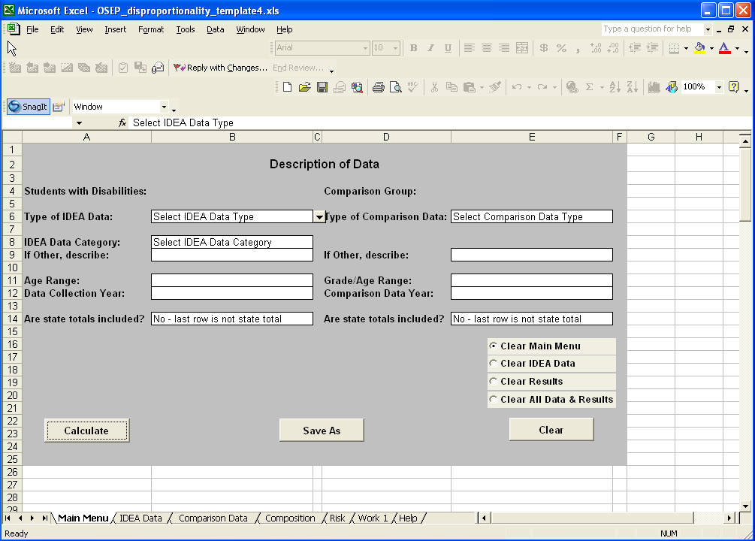
- Use the Main Menu to describe your data:
- You must select an IDEA data type, an IDEA data category, and a comparison data type; not completing these fields will result in error messages. You must also indicate whether you are providing state totals. The remaining fields are optional and will be used by the application to describe your data on the results sheets.
- Under the heading “Students with Disabilities”:
        - Select the type of IDEA data you plan to analyze (i.e., child count or environment).
        - Select the IDEA data category you plan to analyze (e.g., mental retardation, more than 60%, etc.).
          - If you select “Other” for either the IDEA data type or the IDEA data category, you should describe the data in the “If Other, describe” cell.
        - Describe the age range of your data (e.g., 6-though 21-year-olds).
        - Describe the collection year of your data (e.g., 2004).
        - Indicate whether your IDEA data include state totals.
- Under the heading “Comparison Group”:
        - Select the type of comparison data you will be providing (i.e., enrollment or population).
          - If you select “Other” for your comparison data type, you should describe the data in the “If Other, describe” cell.
        - Describe the age/grade range of your data (e.g., pre-kindergarten through 12th grade).
        - Describe the collection year your data (e.g., 2004).
        - Indicate whether your comparison data include state totals.
- Click on the IDEA Data sheet tab.
- Paste either your district-level child count or educational environment data for the IDEA data category into the cells. Make sure these data match the data type you selected on the Main Menu.
- Click on the Comparison Data sheet tab.
- Paste either your district-level enrollment or population data into the cells. Make sure these data match the data type you selected on the Main Menu.
- Return to the Main Menu by clicking on the tab.
- Click on the “Calculate” button to run the application.
Results sheets:
- Go to the Work sheet(s) by clicking on the tab:
- Examine the sheet(s) for missing data (indicated in red).
- If you provided state totals, verify that your reported totals match the calculated totals (discrepancies are highlighted in yellow).
- If you find any problems, go to the IDEA Data and/or Comparison Data sheets, revise your data, and then re-run the analyses by clicking on the “Calculate” button on the Main Menu sheet. Repeat these steps until you no longer find problems.
- Go to the Composition and Risk sheets by clicking on the tabs
- The number of districts included in the analyses is listed at the top of these sheets as part of the title. Verify that the number of districts analyzed matches the number of districts you planned to analyze. If the numbers do not match, revise your data and re-run the application.
- These sheets include the results for each district and for the state overall. The results for the state will be located after the results for all of your districts; state results are labeled either “All (using summed totals)” or “All (using reported totals)” depending on whether you included state totals as part of your data.
Saving and clearing your data:
- To save your results, return to the Main Menu and click on the “Save As” button. You will then be able to name your file and choose where you want it to be saved.
- When saving your results, you cannot name your file “OSEP_disproportionality_template.xls” because this file name refers to the spreadsheet application template. You must choose a different file name to save your results.
- To clear either your data and/or result sheets, go to the Main Menu, select one of the clear options, and click on the “Clear” button. The clear options are as follows:
- “Clear Main Menu” – clears all of the data labels and resets the Main Menu options.
- “Clear IDEA Data” – deletes data on the IDEA Data sheet and deletes the results from the Composition, Risk, and Work sheets.
- “Clear Results” – deletes the results from the Composition, Risk, and Work sheets.
- “Clear All Data & Results” – deletes the data/results from all sheets (IDEA Data, Comparison Data, Composition, Risk, and Work sheets).
Part IV. Educational Environment Data: Additional Instructions
You must analyze your total child count data before analyzing your educational environment data.
- To analyze your total child count data:
- On the Main Menu sheet, select “Child Count” as your IDEA data type.
- Select “All Disabilities” as your IDEA data category.
- Select the type of comparison data you will be providing (i.e., enrollment or population).
- Paste your All Disabilities data onto the IDEA Data sheet and your comparison data onto the Comparison Data sheet.
- Return to the Main Menu and click on the “Calculate” button.
- After analyzing your All Disabilities data, you can analyze your educational environment data using the instructions from Part III (summarized briefly below).
- On the Main Menu sheet, select “Environment” as your IDEA data type.
- For the IDEA data category, select the educational environment category you plan to analyze.
- Select the type of comparison data you will be providing (i.e., enrollment or population).
- You do not have to provide your total child count data again. When you analyzed the All Disabilities category, the application stored these data and will use them in the educational environment analyses.
- Paste your educational environment data onto the IDEA Data sheet.
- Paste your comparison data (i.e., enrollment or population) onto the Comparison Data sheet.
- Return to the Main Menu and click on the “Calculate” button.
- Once you have analyzed your All Disabilities data, they remain available for use by the application even if you analyze other IDEA data categories.
  - When you analyze an educational environment category, the application uses the data from your most recent analysis of the All Disabilities category.
- After analyzing an educational environment category, make sure to review your All Disabilities data on the Work2 sheet.
          - Verify that your All Disabilities data are consistent with your educational environment data with regard to the data collection year and age range.
          - If the data are not consistent, re-analyze the All Disabilities category using the appropriate data before continuing with your educational environment analyses.
    - Selecting the last clear option “Clear All Data & Results” will delete your All Disabilities data.
- You will have to re-analyze your All Disabilities data before analyzing your educational environment data.
- If you select any of the other clear options, your All Disabilities data will remain available.
Questions or Problems?
This spreadsheet application assumes a basic knowledge of Excel. If you have questions about the disproportionality spreadsheet application that are not specific to the use of Excel, please email them to ideadata@westat.com.

Westat’s technical assistance document, Methods for Assessing Racial/Ethnic Disproportionality in Special Education: A Technical Assistance Guide, provides more information about these measures, including step-by-step instructions on how to calculate them, discussions of how to interpret each, and a summary of their strengths and weaknesses. This document is available at https://www.ideadata.org/index.html.
An OSEP/Westat disproportionality task force recommended that states use enrollment data when calculating disproportionality because these data are available at the state and district levels. Population data may not be readily available at the district level. States should use the same comparison data for all levels of analysis.
When analyzing educational environment data, the application uses your comparison data (i.e., enrollment or population) to calculate the relative difference in composition (i.e., the racial/ethnic composition of the educational environment category is compared to the racial/ethnic composition of the comparison data). The application uses your total child count data to calculate risk and the risk ratio (both unweighted and weighted). For more information about how these measures are calculated, see Westat’s technical assistance document, Methods for Assessing Racial/Ethnic Disproportionality in Special Education: A Technical Assistance Guide, available at https://www.ideadata.org/index.html.

