TIMELINE

15,000 B.C. – Paleo-Indians
are first people in this area. Most of refuge was inland with grasses and large mammals. Earliest artifacts are found in Mounds trail area consisting of very simple projectile points used for hunting. Early pottery found on refuge is heavy, mostly utilitarian with clay and sand mixed in it.

900 A. D. – Burial Mounds
Mounds are constructed, many with numerous artifacts: shark teeth pendants, projectile points, scrapers, bone hooks, and clay figurines. A National Register of Historic Place, the Bird Hammock site contains important burial mounds and middens. Decorative Swift Creek pottery have been discovered on the refuge.
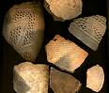
1,000 - 1600 A. D. – Apalachee Indians
They developed a large agricultural society located inland around present day Tallahassee. The refuge area was used for fishing camps, where some of their distinctive pottery was found. Spanish explorers encountering the Apalachee left early 16th century items including trading beads and bells.

1528: Panfilo de Narvaez.
Tired from fighting the Apalachee and low on supplies, the expedition converted their weapons into tools, set up a working forge and made four crude wooden boats. Only four survived.

1539 – Hernando de Soto.
Wintering near Tallahassee, Desoto's men find the remnants of Navarez’s camp. They hung large “yellow pennants” to mark the mouth of the St. Marks River for Desoto's supply fleet.

1679 – Fort San Marcos de Apalachee.
Built to protect St. Marks port, it was raided by French pirates in 1680. Built and rebuilt many times it was used as a fort through the Civil War.

1758– Spanish Tower In 1758, the whole Spanish garrison, about forty men, were drowned in a hurricane. The fort was rebuilt out of stone with a signal tower built across the river, possibly the first lighthouse in the present United States.

1799-1803 Nation of Muskogee
Led by William Bowles, a large band of Creeks declared the independent sate of Muskogee. They looted trade stores, captured Fort St. Marks briefly, and operated four privateers out of Apalachee Bay.

1818 – Andrew Jackson
Seizing the Spanish fort at St. Marks, Andrew Jackson executed two British citizens accused of inciting the Indians: Robert Armbrister and Alexander Arbuthnot, a 70-year-old Scottish Indian trader.

1818 – Wakulla’s Pocahontas.
Captured by Prophet Francis, U. S. soldier, Duncan Mc Krimmon, was saved by Francis’ daughter Melee, who begged for his life.

1831– First St. Marks Lighthouse Due to navigational hazards, Congress authorized a lighthouse at the mouth of the St. Marks river. Built, rejected and
rebuilt, it was finally completed in 1831.

1837 – Port Leon.
Established on St. Marks River as a rival to the port of St. Marks, It was three miles closer to the Gulf. Wakulla County seat and terminus of Tallahassee Railroad, it was destroyed by hurricane in 1843.

1842 – Second Lighthouse
The St. Marks lighthouse was rebuilt at its present location.
Thirteen died there in 1843 hurricane. It has withstood over
a hundred storms.

1861-65 – Union Blockade.
The Union blockaded Apalachee Bay, greatly restricting trade into St. Marks. Near the lighthouse, Confederates erect Ft Williams which was destroyed by the Union fleet. The lighthouse lens was removed but the tower suffered heavy damage.

1861 – Confederate Salt works. Salt was a valuable commodity to the South for preserving meat. There were many salt works in the Apalachee bay area. Remnants are still visible today.
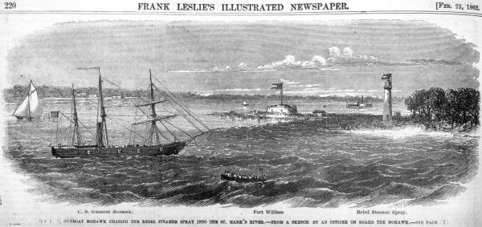
March 12, 1865 – Battle of Natural Bridge. In March 1865, Union General Newton safely landed almost 1,000 men near the lighthouse. Attempting to cross the river at Natural Bridge they were stopped by Confederate forces.

1866 Lighthouse Rebuilt
Damaged by storms and war the lighthouse was rebuilt exceptionally strong. The keeper’s house was attached to the tower for added support. The house has four foot thick walls and a twelve foot base. The tower is double walled, and a new lens was installed.

1890s Naval Stores
Turpentine and lumber became an important industry, while some were shipped by boat, most went by the railroad.

1915 – Wakulla Beach Hotel
Built in East Goose Creek. It has been rebuilt twice due to storms. Remnants of the third hotel are still visible.

1928 – Steam Yacht “Joker.”
A steam yacht turned to WWI sub-chaser, then used by Florida Shellfish Commission, the “Joker” burned and sank near St. Marks lighthouse channel.

1930s – Logging and Turpentine Industry.
Traces of old logging tram roads, such as the sawdust pile on the Wakulla unit. “Cat faced” turpentine trees can still be found on the refuge.

1931 – St. Marks Migratory Bird Refuge President Herbert Hoover signed an Executive Order to designate 53.2 acres for a refuge under the Department of Agriculture.

1933 – St. Marks CCC Camp.
This camp was located in Woodville and work begun on 18 miles of dikes, creating over 4,000 acres of freshwater marsh.

1936 – Refuge Expands
Negotiations begin for the Wakulla Unit with the Reed Lumber Company. By 1938 the Panacea Unit was added.

1941 – Newport, World War II.
A small shipyard was constructed at Newport and made landing craft. Stationed at St. Marks was a “crash boat” unit that rescued survivors from planes and shipwrecks.

1953 – Goose Project Begins. Three 100 acre fields are cleared to farm chufa to attract geese. In 1955 a flock of 25,000 Canada geese wintered on the refuge.

1972 – Otter Lake Recreation Area.
Due to a successful drive in part from local school children, State Rep Don Fuqua obtains $170,000 to fix up Otter Lake Recreation area for local residents.

1975 – St. Marks Wilderness Area
Congress designated approximately 17,746 acres as Wilderness.

1820s – 1980s – West Goose Creek Seine Yard. Early visitors from south Georgia made the several days journey in covered wagons. At the Goose Creek seine yard thousands of mullet would be beach seined during the fall and winter months.

