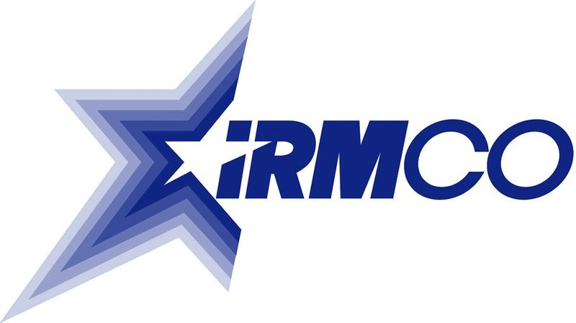

Past IRMCO Award Winners

Individual

2004 Wesley C. Miller Department of the Army

2003 Hari Bezwada Department of the Army

2002 Janice Haith Air Force Central Adjudication Facility
Department of the Air Force

2001 Walter L. Warnick Department of Energy

2000 Sandra N. Bates General Services Administration

1999 Douglas J. Domin Federal Bureau of Investigation

Department of Justice

1998 Major David E. Dodd Department of the Army

1997 Mary Ellen Condon Department of Justice

Team

2004 e-Payroll Team Department of the Interior

2003 Trademark Postal Team Patent and Trademark Office
US Postal Service

2002 New York Field Division’s World Office of the Inspector General
Trade Center Response Team Social Security Administration

2001 Customs Modernization US Customs Service
Source Selection Team

2000 Combined CNA Index System Federal Bureau of Investigation

(CODIS) Program Team Department of Justice

1999 Enterprise Software Initiative Department of Defense

Working Group and Acquisition
Volunteer Team

1998 Consumer Information System Federal Trade Commission
Project Team

