General Services Administration

E-GOVERNMENT LESSONS LEARNED: Government without Boundaries

September 2008

Table of Contents

Table of Contents 1
Introduction 2
Purpose 2
Background 2
Timeline of Major E-Government Events 3
Approach 3
High Level Findings 4
Lessons Learned 4
Partner Collaboration 5
Initiative Management 6
Internal Collaboration 7
Personnel 8
GSA Leadership 9
OMB Relations 10
Concluding Thoughts 11
Appendices 12
Questionnaire Template 12
Participants 13
Contact Information 14

Introduction

Purpose

As a managing partner of five E-Government initiatives and two lines of business (LoBs), the U.S. General Services Administration (GSA) played a leading role in improving information technology for the federal government, citizens, and businesses. From these experiences, GSA gained extensive knowledge how to launch and successfully manage cross-agency initiatives, and, specifically, E-Government initiatives. The purpose of this report is to capture GSA’s lessons learned in cross-agency management for use on future efforts and document best practices for use throughout government.

Background
Early in its tenure, the Bush Administration established a comprehensive management approach called the President’s Management Agenda (PMA). The PMA focused on improving the overall effectiveness of the services the federal government provides. The PMA contains five core elements: performance improvement, human capital management, competitive sourcing, improving financial performance, and E-Government. E-Government, broadly defined by the Office of Management and Budget (OMB), is focused on “improving how the government provides services internally and externally to citizens, businesses, and state and local governments.”
To realize these goals, OMB along with the President’s Management Council (PMC), established 25 E-Government initiatives to improve services through the application of technology. The projects fall across five broad areas, or portfolios: Government to Citizen, Government to Business, Government to Government, Internal Efficiency and Effectiveness, and E-Authentication (which cuts across all of the other portfolios). As a result of additional budget and enterprise architecture data analysis, OMB launched three lines of business (LoBs) initiatives – IT infrastructure, financial management, and security.
In general, the 25 initiatives tend to focus on specific business processes, applications, and/or web portals, while the LoBs tend to focus on broader, less specific processes and/or services. The culmination of the initiatives and LoBs are the key activities in strategically leveraging IT for more effective and efficient government.
GSA is the managing partner for five initiatives: E-Authentication, E-Travel, Federal Asset Sales, Integrated Acquisition Environment, USA Services, and for two LoBs: Financial Management and Information Technology Infrastructure.

Timeline of Major E-Government Events
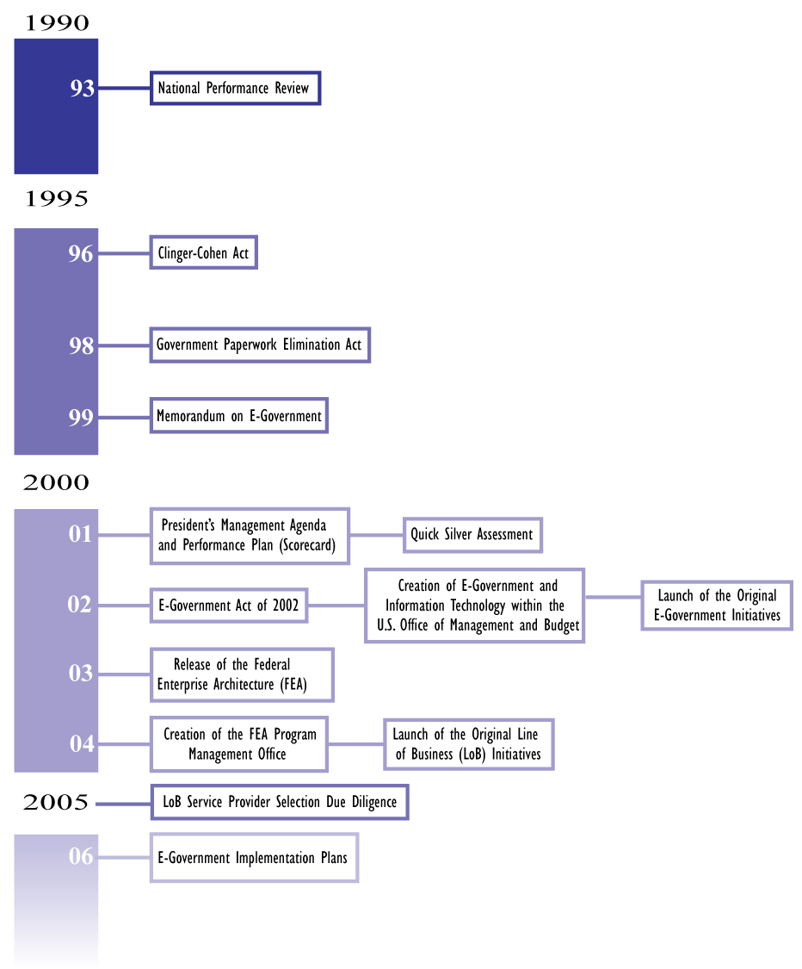

Approach
The GSA E-Government Program Management Office (PMO) staff interviewed representatives from the seven GSA led initiatives and LoBs. Interview questions focused on challenges, mitigation strategies, and recommendations for improving future initiatives (see appendix). The PMO staff conducted interviews during a two-week period in May, with interviews lasting from 30 to 90 minutes. After the interviews were completed, the PMO staff analyzed the information provided and identified common themes applicable across all the initiatives. On May 15, 2008, the five initiatives and two LoBs, along with members of the PMO staff, conducted a summit to discuss the interview findings, provide clarifications, and add additional insights. The PMO then consolidated the information into this report.

High Level Findings
Summit participants recognized key success factors for each of the following groups as they relate to effectively managing cross-agency initiatives.
GSA | OMB | Partner Agencies
- Demonstrate leadership commitment to initiatives  - Appoint a sustainable executive sponsor  - Keep initiatives highly visible for all GSA senior leadership  - Define/understand long-term success  - Realign organizations (where needed) if there is no natural fit –create/consolidate new management office  - Ensure the initiatives are appropriately staffed and funded  - Centralize administrative activities ,e.g., managing the Memorandum of Understanding/ Agreement Process | - Enforce/create policies to enable the initiatives to be successful – let the agencies run the initiatives  - Consolidate reporting  - Provide dedicated support and serve as advocates for process improvements  - Define/understand long-term success and hold all agencies accountable  - Drive agencies top down commitment | - Provide clarity to commitment  - Ask for status reports  - Use initiative/LoB as “training” opportunities for staff  - Provide dedicated, detailed full-time resources  - Give significant participation down to middle management by top executives

Lessons Learned
Based on the interview responses, most insights and comments fell into six themes in the table below. A theme is characterized by a common area for improvement or continued leverage.
Partner Collaboration | Activities and tactics most effective in garnering partner participation, collaboration, and sponsorship
Initiative Management | Activities and tactics that enable Program Managers (PMs) to be successful
Internal Collaboration | Activities and tactics that foster initiative and LoB success within GSA
Personnel | How initiatives and LoBs deal with resource and staffing challenges
GSA Leadership | Involvement of GSA senior leadership necessary for initiative and LoB success
OMB Relations | Approaches most successful in working with OMB
Throughout the data collection process, the interview team developed action-focused lessons learned. Some lessons learned are specific to the maturity level of an initiative; others are only relevant to specific initiative types, such as systems implementations or standard setting initiatives. We included the most relevant lessons learned for all of the initiatives, meaning not all information from the interviews and the summit is included.

Partner Collaboration

Implement strong governance at multiple levels
Be open and honest in your agenda.
Governance models specify decision rights and accountability, and require GSA and program level leadership to be effective. Equally important is working with stakeholders to develop a collaborative, mutually accountable process for implementing the governance structure at all levels – executive, functional, and implementation. Effective governance, developed with all key stakeholders, improves the likelihood of shared ownership and success.
Within the governance structure, develop clear escalation protocols. Escalation protocols should address actions to take with a stakeholder – ranging from when a dispute first occurs to when a dispute intensifies to where external party involvement is required.

Understand the source of agency resistance
Agency non-compliance or lack of participation is often an indication of underlying issues. It may be that agencies are unable to participate because of legislative constraints, conflicting priorities within agencies, or a misunderstanding of requirements. Once these underlying issues are surfaced, initiatives can implement tailored strategies to mitigate specific agencies challenges.

Develop one-on-one relationships
Develop one-on-one relationships with initiative stakeholders. Initiatives that establish open and honest agendas and agreements with inter- and cross-agency partners are more likely to be successful.
Constantly involve your partner agencies
Constant communication, recognizing participation and success, acknowledgement of flaws, flexibility, and readiness to learn are all characteristics contributing to partner agencies becoming engaged in the initiatives’ goals. Through partner involvement, initiatives that created a shared sense of responsibility and accountability had greater success with meeting agencies milestones.

Create a community of practice
The creation of a community of practice centralizes expertise that serves as an internal and external resource for each initiative. Internally, practices become more defined and used across the initiatives. Externally, the community of practice creates a learning opportunity for other agencies and governments.

Involve your partner agencies in funding model development
The development of an initiative’s funding model is time consuming and resource intensive. To aid in partner acceptance, initiatives must collaborate with agencies in creating funding models that are transparent and fair.

Initiative Management

Develop measures that are meaningful to your customers
Performance measures provide valuable information for stakeholders on an initiative’s progress. Measures are an excellent way to demonstrate value, align stakeholder and customer expectations, and provide early indication of program successes and obstacles.
If you are not getting what you need, it is time to change course.
- Ask the customer at the onset of the initiative to provide criteria for prioritization.
- Develop measures and targets with customer and stakeholder input – this involves other key players in the success of the initiative.
- Establish regular meetings to review performance, and, if indicated, take corrective action as early as possible.
- Create measures that are actionable, understandable, reasonable, attainable, and are not a burden to collect.
- Develop a structured process to continually assess measures driving performance.

Develop a marketing and communications plan and integrate it into your implementation prior to the start of your initiative
A marketing and communications plan helps initiatives target stakeholders, create clear messages, and define appropriate mechanisms. All tactics, particularly those regularly scheduled or conducted need to be incorporated into the project plan so communication becomes an integral part of the initiative. Initiatives need to develop and manage their brand.
Develop an elevator speech, or marketing speech, that can be delivered in the time span of an elevator ride (for example, 30 seconds or 100-150 words). Make sure it includes the goal of the initiative is, what it is doing, and what the benefits are. Make sure everyone related the project knows the elevator speech; every interaction at any level is an opportunity to communicate.

Leverage GSA capabilities, such as working funds, project management and acquisition expertise, and network of relationships
Leveraging GSA strengths, such as acquisition management, using existing working capital funds, project management, and network of relationships is a powerful built-in capability to increase the likelihood of success. Embedded GSA subject matter experts on the integrated project team are also a key component. Leverage existing capabilities and solutions.

Anticipate funding interruptions
Initiative funding is subject to many internal and external factors: unforeseen costs, insufficient funding models, continuing resolutions, etc. Initiatives have developed several ways to deal with this challenge:
- Estimate periods of low funding and adjust the project plan to allow for continued support.
- Leverage non-cash resources such as in-kind contributions, detailees, and direct cost reimbursements.
- Prepare multiple funding scenarios with risk level assessments in case of funding gaps.

Where applicable, leverage private sector for government benefit
Several initiatives have incorporated private sector strengths into their operating models. As appropriate for the solution being created, initiatives might consider use the marketplace to generate innovative approaches, drive costs down, and define customer service levels.

Internal Collaboration

At the beginning of a new program, it is important to establish a centralized PMO as an incubator
Early in a program’s lifecycle, a centralized PMO provides a number of benefits: a focus on managing external stakeholder and information needs, funding and administrative management support, and common management and leadership. A centralized PMO also helps insulate initiatives from forces, internal and external, that may be resistant to change.
Establish creative solutions.

Share best practices among the initiatives through regular E-Government initiative and LoB meetings
Sharing best practices throughout all E-Government initiatives helps communicate initiative successes to internal and external stakeholders. Quarterly reviews, for example, create a formal forum for initiative staff and senior level staff members to identify and mitigate potential pitfalls/risks.

Define your business approach first, then purchase technology
Several initiatives related the unintended consequences of moving too quickly to a technical solution. The initiatives faced unmet requirements, lack of flexibility in the solution, and a perception of misalignment with users.

Establish a mentoring program
E-Government initiatives face many of the same challenges: partner collaboration, project management, communications, and technical solutions, to name a few. Initiatives are often at different levels of maturity based on when they were created, rates of progress, and the complexity of the issue. A formal mentoring program leverages the knowledge and experience of more mature initiatives by providing a mechanism for initiatives to discuss specific challenges and issues.

Personnel

Plan for turnover through succession planning and talent scouting
Support at the executive and
middle management levels is
critical for success.
Initiative PMs must continually plan for project turn over and shifting experience and expertise needs. This planning may include preparing more junior team members for greater responsibilities, identifying experts in other parts of the government, and locating and attracting resources from outside the government.

Document standard operating procedures to capture institutional knowledge
Document standard operating procedures that capture the initiative’s activities. This is helpful for newly recruited staff to understand the initiative’s background. Management personnel can also use the standard operating procedures as a foundation for periodically review program processes for improvement.

Build skills through training and rotations to develop cross-discipline capabilities
Rotational assignments provide opportunities to educate agency representatives on the benefits and goals of the initiative, and to foster a sense of improvement from a governmentwide perspective, the “big hat” view. They also provide initiatives with insight into the challenges and issues faced by agencies. On an individual level, rotations provide federal employees access to and experience in new functional areas. This helps to create “ambassadors” among disciplines; someone who understands programmatic issues, technology, and business challenges, and can share that understanding and knowledge with others.

Share pool of subject matter experts
Some initiatives require skill sets and competencies that are in high demand. As a way to overcome scarce resources, initiatives could share experts across projects. This approach allows agencies to receive the benefit of experts, allows for shared costs, and provides the expert with broader experience. Expertise could be based on certifications, experience with similar projects, and educational experience; and could come from either the public or private sector.

Have a succession plan
As with any initiative, PMs must plan for personnel turnover and leadership changes. A succession plan focuses PMs on identifying future project leaders, highlights the need for PMs to provide future leaders with the capabilities, experiences, and training to be successful.

GSA Leadership

Provide opportunities for recognition and encouragement
When leadership recognizes initiative and individual success and accomplishments, they:
- Energize the team,
- Demonstrate commitment and engagement, and
- Reinforce a performance culture.
Recognition processes could combine scheduled events with ad hoc awards to provide consistency as well as flexibility.

Develop trust with leadership to avoid micromanagement
Seek management personnel
who will enforce your ability
to take calculated risks.
Micromanagement is often a result of a lack of trust between those with oversight responsibility and those doing the work. To build this trust and avoid counterproductive activity, leaders and managers must commit to regular briefings focused on sharing information and solving problems. Clear and continual communications between stakeholders and demonstrated follow-through by leaders are critical components that enable success.

Construct an environment that allows for risk-taking
E-Government initiatives and LoBs represent a new way of tackling government management problems – cross-agency collaboration with agency ownership. Being a PM on one of these initiatives comes with a high project and personal risk. PMs are faced with change management challenges (cross-agency collaboration); technical obstacles (new technologies and interface issues); and complex project management and funding issues. GSA leadership must support PMs when they learn and try new and innovative approaches, and resist punishing PMs when some approaches fail. This is particularly important when PMs implement sound risk management processes and take on risks that are informed.

Keep initiatives focused on setting business approaches first, then define enabling technology
GSA leadership plays a vital role in defining what initiative goals are, and holds a vested interest in the success of the initiative. Leadership can provide much needed perspective to initiatives, specifically regarding pitfalls to avoid and ways to encourage participation. More importantly, leadership can help initiatives stay focused on the long-term impact by providing critical business thinking and judicious oversight.

Create “seed money” funding to support newly started initiatives
Initiatives often need resources to develop the structures and processes to launch successfully. A “seed money” fund would provide resources during the critical early stages of an initiative’s development. This fund could be modeled on the venture capital industry; initiatives compete for scarce resources based on criteria such as benefit to customer, return on investment, and likelihood of success.

OMB Relations

Use a charter to set the foundation
Initiative charters define and address fundamental governance and reporting issues. Effective charters unambiguously lay out roles, responsibilities, and address issues such as voting, communication, requirements development, and procedures. OMB can support this process by providing best practices from other government initiatives and provide input into charter content.
The more open you are the more likely they are to listen and assist
in a solution.

Be clear on roles and responsibilities
Establish roles and responsibilities for OMB and program staff to ensure both parties are aware of each other’s expectations, while keeping in mind one size does not fit all.

Engage in constant and open dialogue
There is no such thing as over communication. The more OMB understands the challenges and opportunities that face the initiative, the better equipped they are to provide support and guidance. When OMB relations are based on open and frequent communication, it is more likely “hidden agendas” can be moved from competing interests into a collaborative problem-solving arena. Communication tactics include regular meeting times, participation in governance, preview of initiative materials, and early notification of challenges and/or potential failures.

Reinforce/support agencies
Initiatives must work with numerous stakeholders, particularly other agencies, to achieve their missions. If initiative leads are only seen as enforcers of compliance, they lose credibility with the organizations in which change must take place. Initiatives must maintain a governmentwide perspective while understanding the challenges faced by agencies.

Harmonize data collection to meet multiple reporting requirements
The initiatives noted that reporting requirements are burdensome given the multiple audiences that require project information (e.g. Exhibit 300s, OMB E-Government data calls , the GSA Chief Information Officer, reports to Congress, GAO, or the Inspector General). If possible, using the same information for multiple reports maintains the consistency of the data, reduces collection burden, and saves time and effort.

Define what success looks like from the beginning
Take time at the outset of an initiative to fully describe the desired end state. The description of success can be used to prioritize initiatives, communicate with stakeholders and validate direction. As the initiative matures, it must revisit and upgrade its definition of success to be in line with the changing environment and stakeholder needs.

Concluding Thoughts
Interagency collaboration has long been a part of GSA’s role in government. The PMA’s E-Government program has required many more agencies to embrace this type of cross-agency thinking. This “big hat” perspective is one of the hallmark accomplishments of E-Government. Regardless of what comes next – whether it is called E-Government, Networked Government, Digital Government or any other name – citizens’ expectations from government will only increase. We are confident the strategic use of technology to provide better services will continue to be a vital strategy to improving the way government serves its citizens.

Appendices

Questionnaire Template

GSA E-Government Interview Guide
May/June 2008
Interviewee:
Interviewer(s):
Initiative:

All interviews are confidential – nothing you share will be attributed directly to you.

Questions
- Tell us about your initiative at a high level:
  - What is its ultimate purpose?
  - Who is the primary customer or beneficiary?
- What are you most proud of? What is the initiative’s greatest accomplishment?
- What about your initiative’s structure/relationships is working well?
- What were the biggest challenges/barriers facing your initiative?
- If you could go back in time to when you first joined the initiative, what 3 pieces of advice would you give to yourself knowing what you know now?
- Where do you think this initiative will be in 2 years? What advice do you have for making this initiative a part of how the government does business?
- What could GSA do to better manage its portfolio of E-Government initiatives?
- At this time is there additional information you would like to provide that we have not covered?

Participants

Office of the Chief Information Officer
Casey Coleman
Katie Lewin
Dennis Papula
Michael Seckar
Teresa Sorrenti

Office of Governmentwide Policy
Robert Holcombe
Keith Thurston

E-Authentication
Myisha Frazier-McElveen
Jane McInerney

E-Travel
Timothy Burke
Thomas Cumber
Frank Robinson

Federal Asset Sales
Melissa Bouldry
Steven Rosen

Integrated Acquisition Environment
Christopher Fornecker
William Perry
Annette Shinafelt
Earl Warrington

USA Services
Martha Dorris
Robert Smudde
Stuart Willoughby

Financial Management LoB
Dianne Copeland
Karen Haus

Information Technology Infrastructure LoB
Eric Won

Contact Information

Office of the Chief Information Officer
General Services Administration
1800 F Street NW
Washington, DC 20405
(202) 501-1000

A stakeholder is any entity or person with something to “gain or lose” as a result of the initiative.

