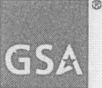 GSA Office of the Chief Acquisition Officer
GSA ACQUISITION LETTER V-05-17 Supplement 3
DEC 28 2005
MEMORANDUM FOR ALL GSA ACQUISITION ASSOCIATES
FROM: For ROGER D.WALDRON 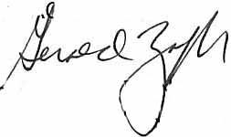
ACTING DEPUTY CHIEF ACQUISITION OFFICER
OFFICE OF THE CHIEF ACQUISITION OFFICER

SUBJECT: Class Deviation Applicable to Acquisitions for Hurricane Katrina Rescue and Relief Efforts
Paragraph 4 of the Class deviation stated that the increase in the micro-purchase threshold for procurements of commodities or services to be used in support of Hurricane Katrina rescue and relief operations would remain in effect until repealed by Congress. The increase was found in section 101 of the Second Emergency Supplemental Appropriations Act to Meet Immediate Needs Arising From the Consequences of Hurricane Katrina, 2005 (Pub. L. 109-62).
Supplement 1 to the class deviation restored the Katrina-related micro-purchase threshold to $15,000, except under exceptional circumstances when, with the approval of the Senior Procurement Executive and after consultation with the Deputy Director, Office of Management and Budget the $250,OOO threshold could be applied.
On November 30, 2005, President Bush signed the "Transportation, Treasury, Housing and Urban Development, the Judiciary, the District of Columbia, and Independent Agencies Appropriations Act, 2006 (Public Law 109-115)." Section 723 of that Act repealed in full Section 101 of Pub. L. 109-62. Therefore, effective November 30, 2005, the micro-purchase threshold is restored to $15,000 for all acquisitions for Hurricane Katrina rescue and relief efforts entered into after that date.
U.S. General Services Administration 1800 F Street, NW Washington, DC 20405-0002 www.gsa.gov

