Smoke-free Home Pledge:
Planning Guide for Pledge Events


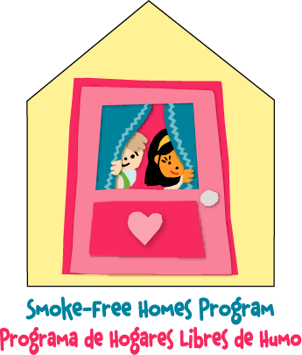

What is the Smoke-free Home Pledge Campaign and why is it important?
The Smoke-free Home Pledge Campaign is designed to educate parents and caregivers about health risks to children from secondhand smoke exposure and encourage them to commit to providing a smoke-free environment in their homes and cars.

An estimated 11 percent of U.S. children 6 years of age or younger are regularly exposed to secondhand smoke in the home. Protecting children from secondhand smoke is especially important because their bodies are growing and developing. Exposure to secondhand smoke can cause children to experience more respiratory infections such as bronchitis and pneumonia, and middle-ear infections, and more frequent and severe asthma attacks. Secondhand smoke exposure has also been linked to low birth weights and Sudden Infant Death Syndrome also known as SIDS.

Why conduct a pledge event?
A pledge event provides a great opportunity to interact with families, caregivers, and other stakeholders. One-on-one interaction is often the most effective way to educate individuals, ensure that they understand the key messages, and encourage them to take the Smoke-free Home Pledge.

What is included in this planning guide?

This guide provides basic tools and templates for use at any type of pledge event -- health fairs, school or community functions, conferences, or any other event where you can make a difference. These tools offer a simple and organized way for you to encourage, document, and track pledges. (Click on the underlined text below to go directly to the tool or template.)

- Event Log: Document all of the details of your event on the Event Log to help track your progress. Event Log

- Pledge Sheet: Track all of the pledges from your event on this simple tracking sheet. The information requested on the tracking sheet will provide you with a complete, consistent list of pledges, enabling you to easily send follow-up materials and track the results of your event. If you would like to give a Smoke-free Home Kit to individuals who have taken the pledge, order up to 125 of them at 1-800-490-9198 (nscep@bps-lmit.com). Pledge Sheet

- Pledge Card: Provide a quick and easy way for participants to take the Smoke-free Home Pledge with the customizable Pledge Card. As with the Pledge Sign, make it your own by adding your logo, text, or graphic. These cards are great for securing and tracking pledges onsite, and the individual Pledge Card allows pledge-takers to keep their personal information private. Each sheet contains two pledge cards. Pledge Card

- Pledge Sign: Grab the attention of event participants with the Pledge Sign. Customize it to meet your needs by adding your organization’s logo, text, or graphic. The standard 8.5” x 11” design fits most acrylic sign holders. Black and white and color versions of the Pledge Sign are provided in this guide. Pledge Sign

How do I use these tools?
Consider the following suggestions for your event:

- On your display table, provide Pledge Cards and the Pledge Sheet for participants to pledge onsite or take materials home.

- Inform participants that they can take the Smoke-free Home Pledge at any time online at www.epa.gov/smokefree.

- Fill out the Event Log, which can serve as a record of your activities and achievements.

- If you have any questions or need help with the Smoke-free Home Pledge Campaign, contact the Pledge Coordinator (202-343-9370) or EPA’s regional offices. See www.epa.gov/iaq/whereyoulive.html for a complete listing.

What other secondhand smoke related products are available?
Additional Smoke-free Home Pledge resources are available through the National Service Center – Environmental Publications. To order materials by phone (1-800-490-9198) or e-mail (nscep@bps_lmit.com).

Suggested resources for your Smoke-free Home Pledge event include:

- Smoke-free Home Pledge Brochure and related posters
- Smoke-free Home Kit
- Community Action Kit

You can also visit www.epa.gov/smokefree for details on related videos, speaker’s kits, and other publications.

Important Note: Fonts and graphics may shift or change depending on your computer and/or software.

Copyright Information: All parts of this document may be modified to suit your needs.

Need Help? Contact the Pledge Coordinator at 202-343-9370.

Take the Smoke-free Home Pledge

Event Log

Event name:

Sponsor:
Date(s) of event:
Name of your organization:
Name of event coordinator:
Contact information for event coordinator:
Number of pledges and corresponding ZIP Codes:

(Example: 20 pledges for ZIP Code 12345)

Number of Smoke-free Home Kits you plan to mail:
Estimated total number of attendees/participants at the event:
Comments:

Smoke-free Home Pledge Sheet
I pledge to protect children from the health risks of secondhand smoke by keeping my home and car smoke-free.
Place your organization’s logo or graphic here (be sure to delete this text)
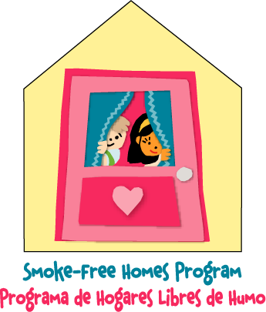

REQUIRED FOR PLEDGE |  |  |  | OPTIONAL: USE ONLY IF YOU PLAN TO MAIL A PLEDGE KIT
# of kids at home  (birth-6 yrs) | Has smoking been allowed in home? (circle) | NAME (please print) | ZIP CODE | STREET ADDRESS | CITY, STATE | SIGNATURE
 | Yes / No
 | Yes / No
 | Yes / No
 | Yes / No
 | Yes / No
 | Yes / No
 | Yes / No
 | Yes / No
 | Yes / No
 | Yes / No

Take the Smoke-free Home Pledge

Number of young children (birth-6 yrs. old) in the home:________

Has smoking been allowed in the home or car (by family or visitors): Yes No

I, ___________________________, on ____________,__________,
(Your name here) (Date) (ZIP Code)

pledge to protect children from the health risks of secondhand smoke by keeping my home and car smoke-free.

Would you like a Smoke-free Home Kit mailed to you? Yes No
Name:______________________________________________________
Address:____________________________________________________
City:_______________________State:_____ZIP Code:_______________

Congratulations on making your
Place your organization’s logo or graphic here (be sure to delete this text)

home and car smoke-free!
www.epa.gov/smokefree
(Or use your organization’s website/hotline)

Take the Smoke-free Home Pledge

Number of young children (birth-6 yrs. old) in the home:________
Has smoking been allowed in the home or car (by family or visitors): Yes No

I, ___________________________, on ___________,___________,
(Your name here) (Date) (ZIP Code)

pledge to protect children from the health risks of secondhand smoke by keeping my home and car smoke-free.

Would you like a Smoke-free Home Kit mailed to you? Yes No
Name:______________________________________________________
Address:____________________________________________________
City:_______________________State:_____ZIP Code:_______________

Congratulations on making your
Place your organization’s logo or graphic here (be sure to delete this text)
home and car smoke-free! !
www.epa.gov/smokefree
(Or use your organization’s website/hotline)

