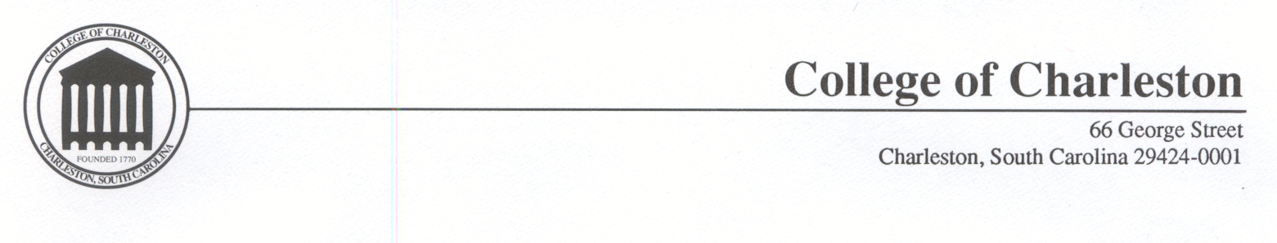
November 6, 2002

The Honorable Rita Colwell, Ph.D.
Director
National Science Foundation
4201 Wilson Boulevard
Arlington, VA 22230

Dear Dr. Colwell:

We are pleased to submit the report of the Advisory Committee for GPRA Performance Assessment (AC/GPA). It was the unanimous judgment of the Committee that for the retrospective portfolio NSF demonstrated significant achievement for all indicators in all three strategic outcome goals (People, Ideas, Tools). The Committee also concluded that the Prospective portfolio was well positioned to support these three goals in the future and the interests of the nation will continue to be well served.

As you know, NSF created this process as an “experiment, ” without models or other templates to follow. While the Committee has made a number of observations, suggestions and recommendations for the future, we believe this new process represents a positive and welcome change. The Committee recommends that it be continued through at least one more cycle with the suggested improvements.

This report represents the collective work of a large group of individuals, the members of the Committee, all of whom worked with a level of commitment and diligence that we have rarely encountered. Each of them made major contributions to the report and collectively we believe they have set a new standard for the work of advisory committees. It was an honor and a privilege for us to lead this effort. In addition, many members of the NSF staff were instrumental in enabling our work and we are truly grateful for their assistance.

We would be happy to talk with you or others about any aspect of this report. We hope it will be helpful to NSF as it completes its Accountability Report.

Sincerely,

Carolyn W. Meyers Norine E. Noonan

Carolyn W. Meyers, Ph.D. Norine E. Noonan, Ph.D.
Provost and Vice Chancellor for Dean
Academic Affairs School of Science and Mathematics
North Carolina A&T University

Enclosure: Report of the Advisory Committee for GPRA Performance Assessment

