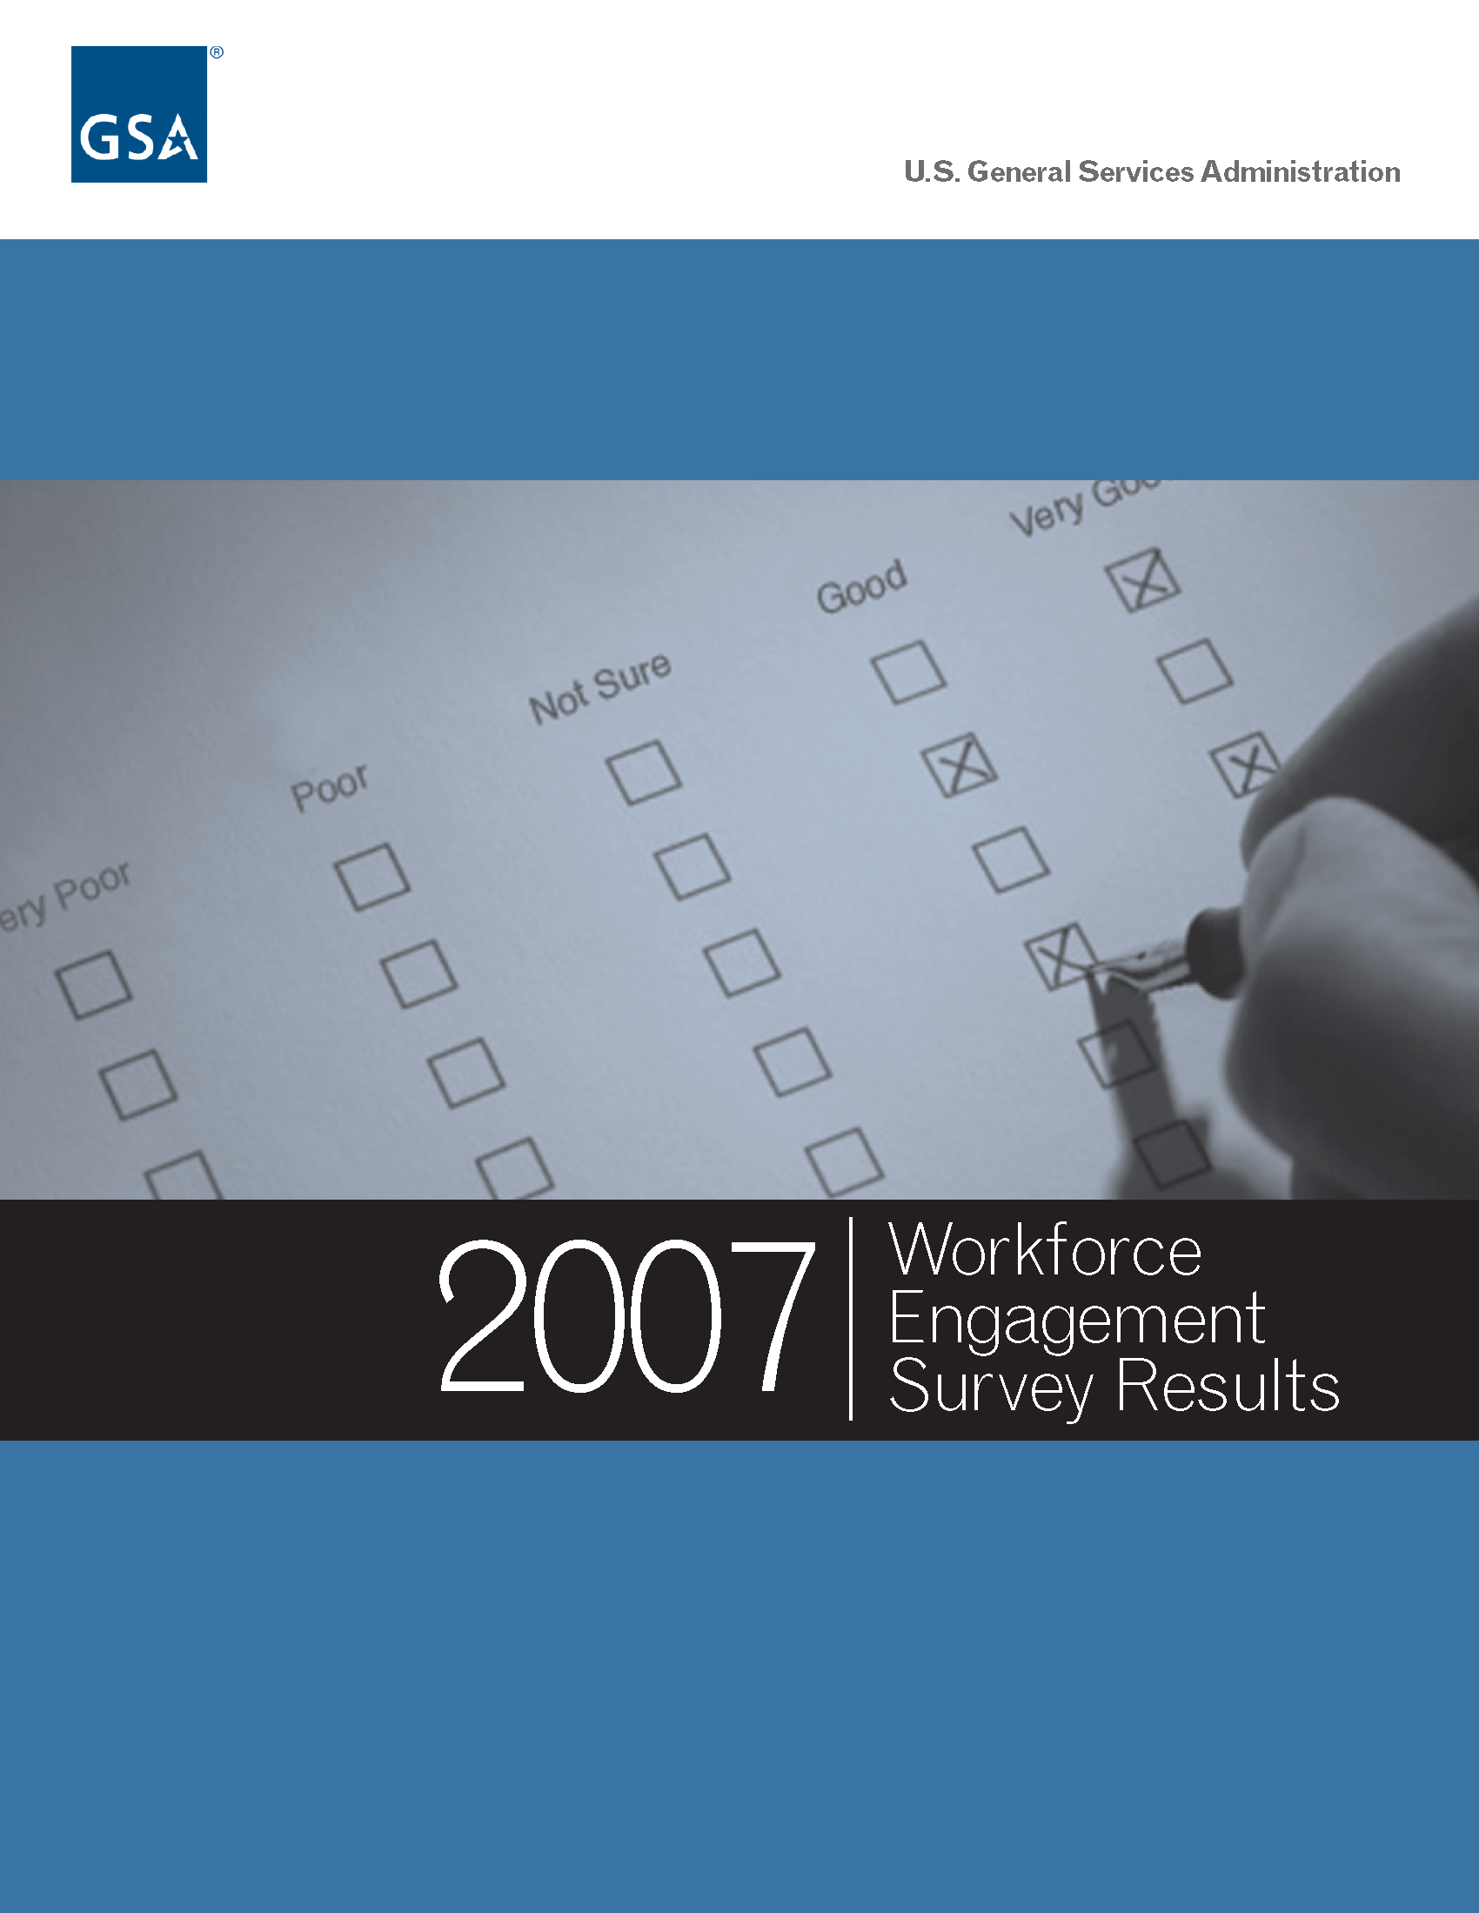
Introduction

In 2004, Congress mandated that all Federal agencies conduct annual surveys of their employees. The purpose of these surveys is to gain an understanding of employee perceptions about their work environment and to assess how successful agencies are in managing their human capital. This survey requirement helps support a key component of the President’s Management Agenda (PMA), which focuses on the strategic management of human capital.
Workforce Engagement at GSA

Long before the Congressional mandate, GSA recognized the importance of periodic employee feedback as key to organizational success. GSA conducted several annual employee surveys of its workforce starting in 1998 in one large organizational area and later expanded the surveys agency-wide. All of these surveys focused on several key areas essential to organizational health and performance; having the tools to accomplish the work; receiving performance evaluations and recognition; being provided opportunities for development and growth; and how employees view their peers. The information gained from these surveys helped diagnose problem areas and were used to design action plans to address them.

GSA conducted its first agency-wide survey in Fiscal Year 2002. Besides measuring employee attitudes about their work environment, the survey also provided information to differentiate top-performing organizations from average and low performing ones. Across the Agency, GSA managers and employees met to discuss the survey results and determine areas where they could capitalize on their strengths as well as focus on areas needing improvement. The results of some of these discussions were good practices that GSA workgroups found effective in increasing and enhancing the level of employee engagement. These approaches were incorporated into a Good Practice brochure shared agency-wide. The good practices identified were recognized as those used by many other high performing organizations.
By 2004, GSA had administered its workforce engagement survey for the third time and for the third straight year, the results showed increased progress in moving GSA closer to its goal of becoming a consistently high performing organization. GSA’s top-scoring organizations (those scoring at the 75th percentile) outperformed others in a database of worldwide participants.

Federal Human Capital Survey

The Office of Personnel Management (OPM) administers the Federal Human Capital Survey (FHCS) biennially during even years. This survey supports the PMA in the strategic management of human capital and assesses employee satisfaction with:

- Leadership policies and practices;
- Work environment;
- Rewards and recognition;
- Opportunity for development and growth;
- Opportunity to contribute to achieving organizational mission.
In the 2004 FHCS report, GSA was listed among the Top 10 "Best Places to Work in the Federal Government". The agency ranked in fifth place or better in seven categories. Specifically, GSA was second out of all departments and agencies for Family Friendly Culture and Benefits; third in Work/Life balance, Training and Development, and Strategic Management; and fourth in Effective Leadership and Teamwork. Similarly, the results of the 2006 FHCS placed GSA among the Top 10 agencies across the Federal government in Leadership and Knowledge Management, Talent Management, and Job Satisfaction.

GSA’s 2007 Workforce Engagement Survey

In August of 2007, GSA again conducted a census survey of its employees. The survey, otherwise known as the Workforce Engagement Survey, provided critical feedback on several factors that influence workers’ ability to accomplish their work. Administered to 11,037 employees, the survey was completed by 7,779 employees for a response rate of approximately 71%.

Overall, GSA employees provided favorable ratings (50 percent or higher) in all major categories. Favorable response choices include “Strongly Agree” and “Agree” for the majority of the categories. Job Satisfaction Category’s favorable response choices are “Very Satisfied” and “Satisfied.”

The five major categories surveyed were: Personal Work Experience; Recruiting, Development, and Retention; Performance Culture; Leadership; and Job Satisfaction. Results are shown in the figure below:

GSA Overall 2007 (Number of Respondents = 7,779)
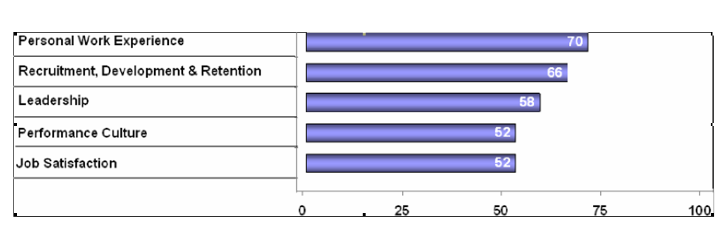
In the Personal Work Experience Category, the survey results indicated that employees were given opportunities to improve their job skills, liked their work, and had confidence and trust in their supervisor.

In the Recruiting, Development, and Retention Category, employees indicated that they possessed the relevant knowledge and skills to accomplish organizational goals. Employees generally felt the Agency supported training and development to enhance job skills. The results further revealed that employees are happy with their work environment. Two of the highest favorable responses indicated that employees felt their work related to GSA’s goals and priorities, and that their work is important.

The Performance Culture Category results indicated that employees felt their recent performance appraisals were fair. Employees also indicated that GSA supports their need for a balance between work and family issues.

Employees rated the Leadership Category high in effectively communicating organizational goals and priorities, assigning reasonable workloads, and taking measures to protect employees from health and safety hazards.

In the Job Satisfaction Category, employees were overall very satisfied with their jobs, the training opportunities offered, and their pay.

Key Strengths to Maintain

Based on the overall survey results, numerous key strengths were identified:

- GSA employees feel their work is important, and they like the kind of work
they do
- Employees are aware of how their work relates to the agency’s goals and
priorities, and they’re held accountable for achieving results
- Physical working conditions are viewed quite favorably
- People cooperate to get the job done
- Employees are provided an opportunity to improve their skills
- Employees indicated their work gives them a sense of personal
accomplishment
- Employees like the work they do
- They have trust and confidence in their supervisor
- They feel their immediate supervisor is doing a good or
very good job
- They feel their work is related to GSA goals and priorities
- The work they do is important
- Physical working conditions permit employees to perform
their job well
- Supervisors support employee development
- Their talents are used well in the workplace
- Employees also report training needs are assessed
- They are held accountable for results
- Performance discussions with their supervisor are considered
worthwhile
- Supervisors work well with people of different backgrounds
- Supervisors are considerate of the balance between work
and family needs
- Employees understand how performance levels are assigned
- Employees are protected from health and safety hazards on
the job
- Employees believe their workloads are reasonable
- Managers are communicating the goals and objectives of the
organization
- The organization has prepared employees for potential
security threats

Conclusion

GSA takes pride in the results of the results of its 2007 GSA Workforce Engagement Survey. This survey shows that GSA employees are satisfied and motivated to do their jobs, and provides further evidence why GSA has continuously been recognized as one of the best places to work.

