united states government
M E M O R A N D U M

directorate for mathematical and physical sciences

Date: March 28, 2005
From: Assistant Director, MPS
Subject: Response to the Division of Astronomical Sciences Committee of Visitors Report
To: MPS Advisory Committee

Please find attached the MPS response to the Committee of Visitors (COV) report from the 22-24 February 2005 COV review of the Division of Astronomical Sciences. The review was thorough and insightful, and the findings will be very helpful to me and to the Division of Astronomical Sciences in fulfilling our responsibilities to the scientific community and to the nation.

The Division of Astronomical Sciences drafted the attached response, and I concur with its content. I therefore adopt it as the official response of the MPS Directorate. I hope the full MPS Advisory Committee finds this COV review and the MPS response useful and acceptable.

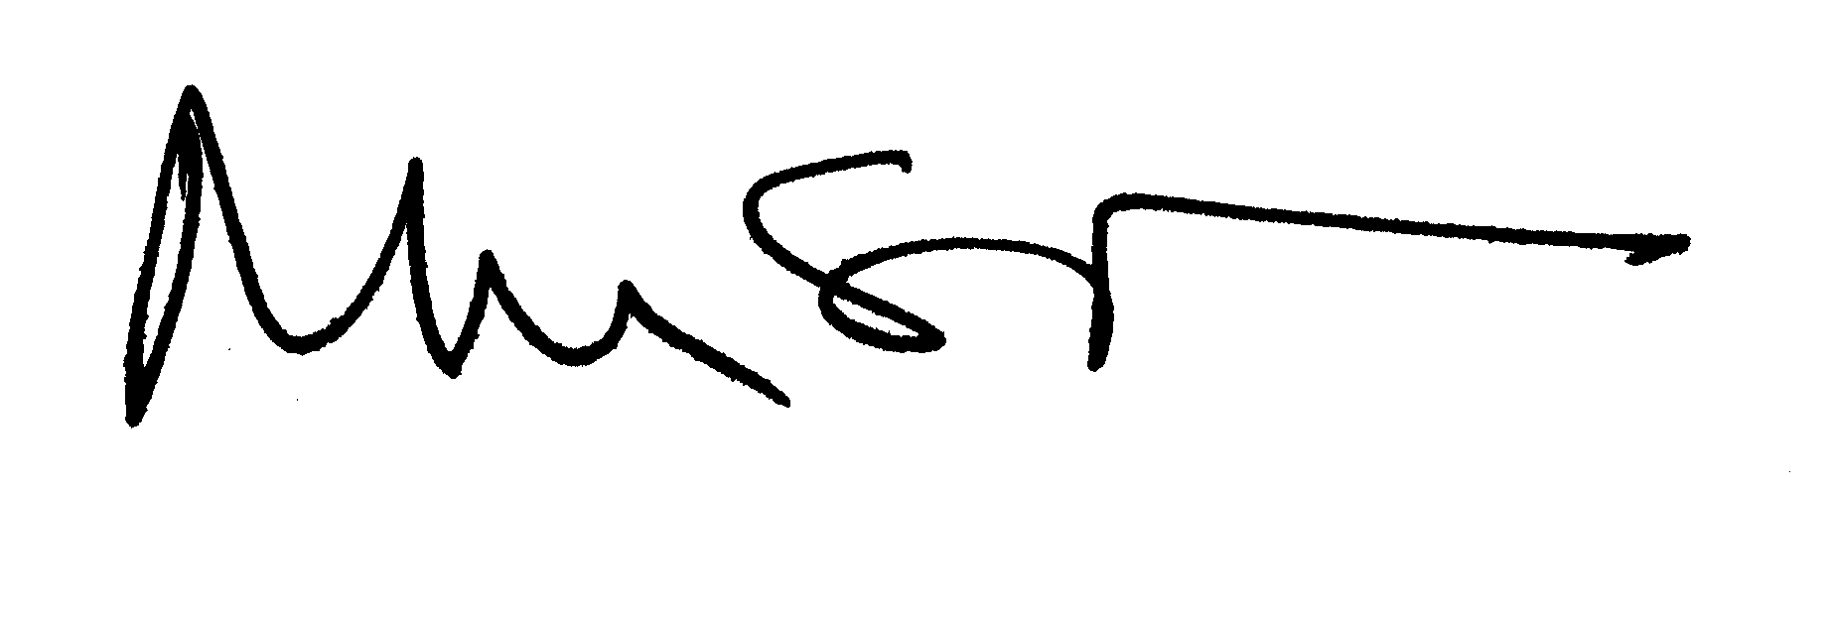
Michael S. Turner
Assistant Director

Attachment: Response to Division of Astronomical Sciences COV Report of 2005
Response of the Division of Astronomical Sciences
to the Committee of Visitors 2005 Report

The Division of Astronomical Sciences thanks the FY2005 Committee of Visitors for their thoughtful and thorough report and is pleased with its complimentary and constructive tone. AST, too, felt that the meeting represented a constructive dialogue between the Division and representatives of the community that we serve. AST greatly appreciates the willingness of the members to serve and were impressed by the interest and dedication they exhibited in the very full and very intense three-day meeting.

Addressing the specific recommendations, stated here verbatim:

AST Division Management

- The COV recommends that the Division be given positions for additional scientific personnel in order to decrease the workload currently imposed on Division staff, to ensure adequate oversight and program management, and to allow progress on new programs and projects being generated in the community.

The Division agrees that the current workload on AST staff is very high, and is fortunate to have outstanding and dedicated staff committed to furthering the Division’s goals under these difficult circumstances. In 2001, the Division carried out a staffing study that has guided the evolution of our organization and has made some progress in converting existing positions upon vacancy to positions that better meet the Division’s need, although with no increase in FTE’s allocated to the Division. However, we have reached the limit of what can be accomplished simply by re-assigning or converting positions.

We agree that additional scientific staff are needed for the Division. The increased number of proposals coming from the community, the increasingly complex projects underway, and the future projects being planned in the community have stressed our current scientific staff to an unreasonable level. The lack of time and resources to carry out appropriate oversight of facilities and large projects poses serious risks to these projects and the Division’s ability to perform the review of proposals in a timely and responsible way.

The Division continues to discuss these staffing needs with the Office of the Assistant Director of MPS, and has received indications recently that additional positions are expected to be forthcoming by the beginning of FY2006.
Strategic Planning and Implementation

- The COV strongly supports the planned Senior Review as the proper next step in the planning process.

- The COV recommends that the Division continue to identify and lead development of appropriate joint interagency initiatives.

- The COV recommends that the Senior Review focus on establishing a sustainable balanced program that is driven by science inquiry rather than the current wavelength-based structure.

The Division appreciated the thoughtful, substantive discussion with the COV concerning the background, goals, and process for the Senior Review. We welcome the support given by the COV for our taking this major, but necessary, step in planning for and implementing the recommendations of the Decade Survey. Our goal is, indeed, a sustainable, balanced program.

We believe that the Senior Review, as described to the COV, will be an effective means to examine the balance among all of our activities, and provide a program that is driven by science inquiry and not by any wavelength-based structure.

The Challenge of New Facilities

- The COV endorses the Division’s new strategic plan to build a sustainable program using a community-based process that considers the scientific merits of extant facilities and programs as well as the advances that can be realized with new instruments and other initiatives.

- The COV strongly concurs with the recommendation of the AANM report and the conclusion of the Division that the AST grants program (AAG) should be maintained at or above its current funding level despite the severe budget pressure presented by ALMA and other proposed large facilities.

- The COV recommends that the Division continue to aggressively pursue its approach to the priority initiatives of the AANM report with a flexible, balanced response. This response should both advance the development of facilities and take advantage of opportunities associated with the scientific goals of those facilities to increase support for grants by means articulated in the AANM Decadal Survey and appropriate to the Division.

As the Division proceeds with the Senior Review and the formulation of the program for the coming years of the decade, we will take care to retain the touchstone of a healthy and growing grants program. The AAG represents both the capacity to capitalize on the power of new facilities for research and the source function for new ideas and the people to realize them in the next decade. It is exactly this capacity, for the present and for the future, that we must increase through the balanced response that the COV recommends. We fully agree and pledge to continue working closely with the community to consider, and trade if judged appropriate, the merits of the elements of our existing program in comparison to the value of new instruments or approaches.

Programs

- The COV recommends that the Division continue and expand its leadership role in fostering the next generation of scientists poised to take full advantage of new facilities.

The Division is gratified to hear that the COV recognizes the important role AST plays in fostering and supporting the future generations of scientists. With new facilities such as ALMA, and new resources such as the NVO soon to become available, the Division expects to continue its efforts to ensure that students and early career scientists become experienced users of new tools and are enabled to take full advantage of new facilities.

- The COV recommends that the Division continue to explore ways to unify and expand the EPO efforts within and across observatory enterprises.

The EPO and PIO offices of our national observatories (NOAO, NRAO) and Gemini Observatory are in frequent contact through informal correspondence of key personnel and through more formal annual meetings and workshops of their staff and the staff of interested private observatories. In the last several years, they have initiated (and received AST funding for) larger workshops on topics such as “Public Understanding of Science” that have brought together those in the larger astronomical community interested and concerned about these issues. The Division will continue to work with the national observatories and AST-funded large projects with significant EPO activities (such as NVO and VERITAS) to identify ways for them to share their experiences and successful programs, and provide funding to the extent possible to initiate and maintain these efforts. The Division is also beginning discussions with EHR program officers to identify common interests and explore ways in which the two offices can work together to foster activities within their communities.

- The COV encourages the Division to aggressively defend the spectrum allocations for scientific research and to expand efforts to keep the astronomical community apprised of critical issues.

The Division agrees that the activities of NSF in the area of Electromagnetic Spectrum Management are critical and has recently taken action to increase the number of staff in AST responsible for addressing these issues. With the help of these additional people, the Division expects that it will be able to expand its activities to educate and inform the astronomical community of critical issues in spectrum management.

- Additional information to PIs regarding context of funding decision is desirable. There were some cases of disconnects between the individual reviews and panel summaries as documented.

The Division’s policy is to make every attempt to contact PI’s personally with notification of the funding decision before the official declination letter goes out, and program officers have used these phone calls or emails to provide information on the rationale for the funding decision that may not be included in individual reviews, but that often appears in the program director’s analysis. In many cases we do succeed in providing this context to PI’s, though not in a written form. The Division had been considering utilizing a feature of the electronic jacket, the “context statement”, that is released to the PI along with the reviews and panel summaries as a way of providing a more complete discussion of the review process and anticipated success rate. As a result of conversations with the COV, the Division has now instituted the use of context statements for all proposals to the Astronomy & Astrophysics Research Grants programs in FY2005, and will continue this practice, as well as attempting personal notification to all PI’s, in the future.

The COV found that the processes used to solicit, review, recommend, and document proposal actions were done with the highest level of integrity, both with respect to the sensitivities of the proposers and to the merit of the science. The committee took special note of the care with which thorough summaries of proposal evaluations and decisions were documented by the Program Officers. {However}

- There are concerns with respect to the consistency with which merit review Criterion II (i.e., “broader impacts”) is being applied in the review panels. COV members found examples in their review of the jackets of reviewers who injected broader impacts rationale where this rationale was not provided explicitly in the proposal.
- Broader impacts criterion sometimes not explicitly addressed in individual reviews.

The Division continues to work with the astronomical community to help them understand the “broader impact” review criterion and to address it in their proposals and to incorporate consideration of it in their reviews. As noted in this and the previous COV report, progress is being made, but examples are still found in which both PI’s and reviewers do not fully address both review criteria. The Division takes special care to instruct all of its review panels to consider both review criteria and will continue to do so, as well as to remind panelists to not assume the PI will undertake activities that are not explicitly stated in the proposal. The Division will also continue its efforts to educate the astronomical community with regard to NSF review criteria.

Response to the 2002 COV report

- Continued education within the astronomical community of opportunities to apply for NSF-wide programs is needed. To this end, utilization of the Division’s website for providing information about these programs is encouraged. At the same time, the astronomical community must assume greater responsibility in making fuller use of the Division staff for education about these opportunities.

AST agrees that the astronomical community could take better advantage of NSF-wide funding opportunities, and will continue to foster more understanding of these opportunities. The Division will use its regular town hall discussions at the American Astronomical Society meetings and regular contributions to the AAS newsletter, and will work with the Society to identify other vehicles to disseminate more detailed information. AST will also look for ways to populate the newly designed NSF web site to include information on NSF-wide programs as well as Divisional opportunities.

